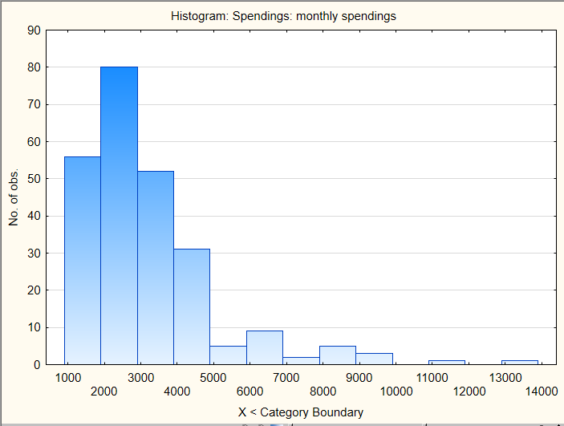
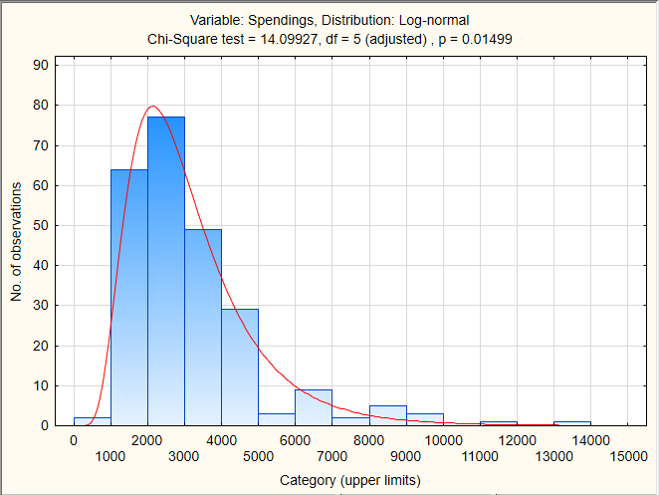
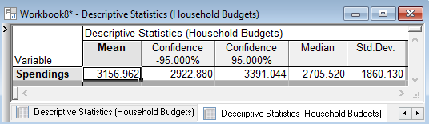
- The average household spending in this group was 3156.962 Euro.
- The population (all households of this type in the region) has the mean value somewhere between 2922.88 Euro and 3391.04 Euro. This is 95% C.I.
- Half of the families have spendings smaller than 2706.52 Euro.
- The spending of an individual household differs from the mean income by 1860.13 Euro on average. This amount is 59% of the average.

