ESTIMATION
Non-parametric estimation – estimation of distribution
Let’s consider variable “Income”
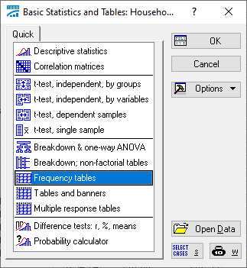
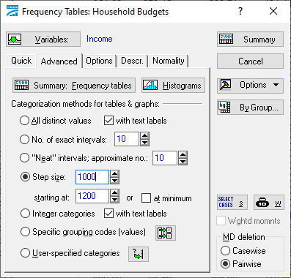
Graphs Histograms
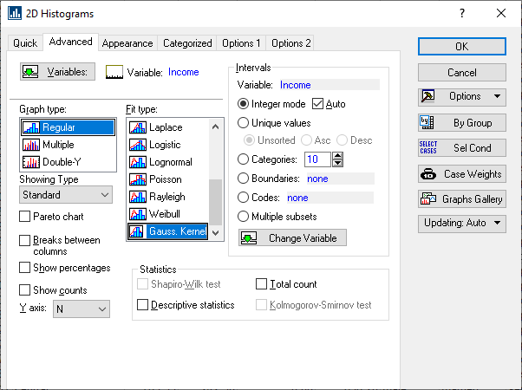
Statistics Distribution Fitting
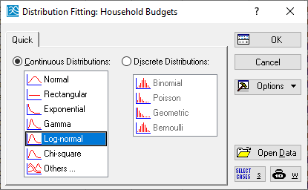
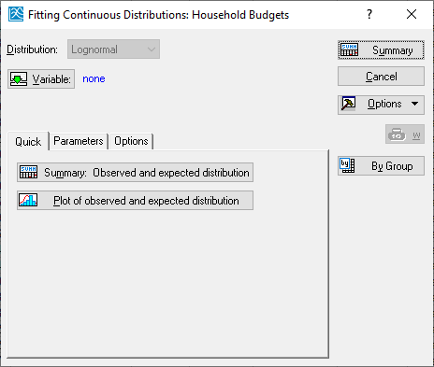

PARAMETRIC ESTIMATION -= estimation of parameters

Statistics Basic Statistics/Tables
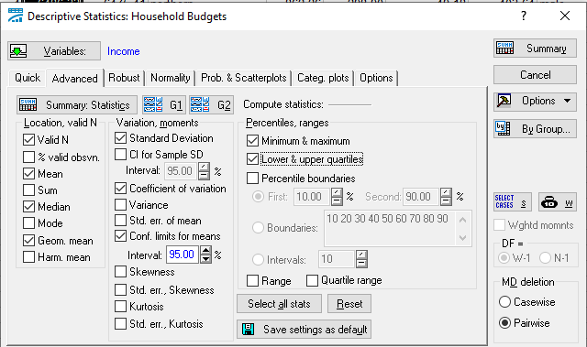
- The average income in this group of households was 3283 Euro
- The population (all families of this type in Poland) has the mean value somewhere between 3065 and 3499. This is 95% C.I.
- It is typical that geometric mean is smaller than arithmetic AVERAGE (2952)
- Half of the families have income smaller than 2820. 25% of households have income smaller than 2160, and 25% higher than 3296.
- The income of an individual household differs from the mean income by 1724 Euro on average. This amount is 53% of the average.

- Consider variable Spendings
- Draw a histogram
- Fit lognormal distribution to it
- Estimate mean, C.I. for mean, median and standard deviation. Write interpretation to these measures.
- Put results in Word file with your Surname as file name (Sokolowski.docx)
- Send this file to sokolows@uek.krakow.pl

