CHI-SQUARE TEST FOR INDEPENDENCET
Two variables measured in nominal scales (“names”)

Ho: The percentage of working people (among those who applied for loan) is the same in men and women

X – sex(v3)
Y – employed(v1)

Statistic Basic Statistics/Tables
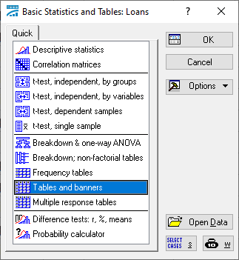
Ok
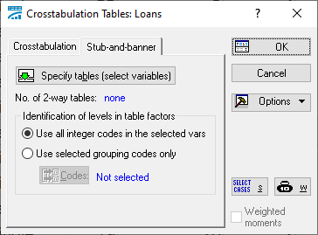
Specify tables (select variables)
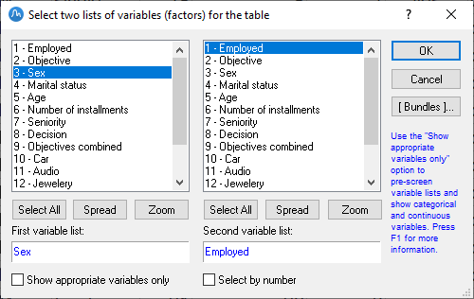
Ok
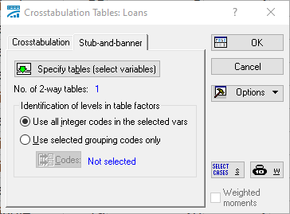
Ok
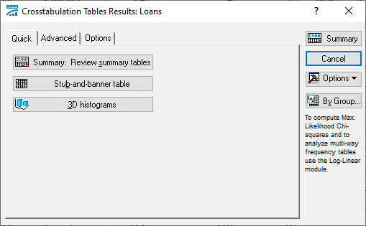
Go to Options
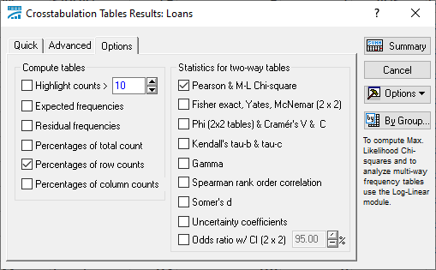
Go to Advanced
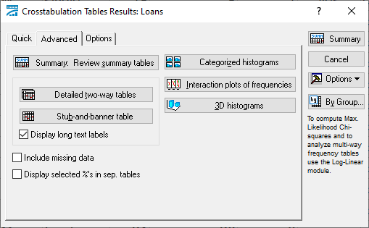
Detailed two-way tables
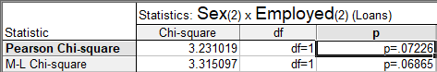
Pearson Chi-square has been calculated by the classical Pearson’s formula
M-L Chi-square has been calculated by maximum likelihood approach
Recommendation: use M-L version which is more robust against small sample sizes
P = 0.0687
We observe a tendency for the difference
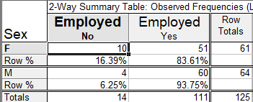
More men are employed than women , but the difference is not fully significant
CORRELATION COEFFICIENT (PEARSON)
All variables must be measured in strong scales(“numbers”)
We are calculating r’s between pairs of variables, and results are stored in correlation matrix.
Statistics Basic Statistics/Tables
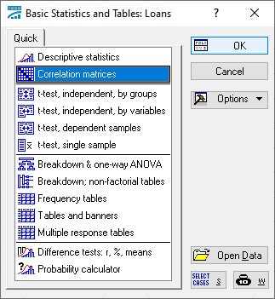
Ok
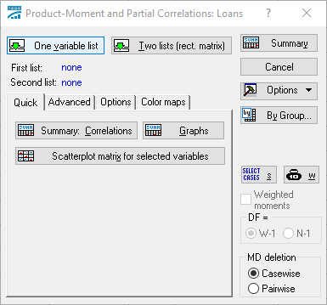
One variable list – correlations for all pairs of variables
Two lists – correlations for variables from the first list with variables from the second one

One variable list
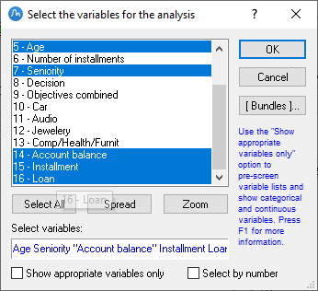
Ok
Options
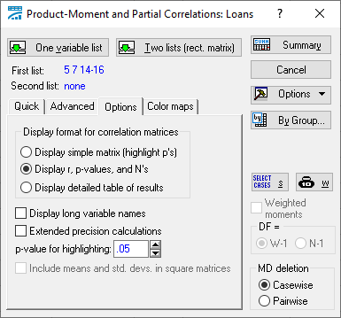
Summary
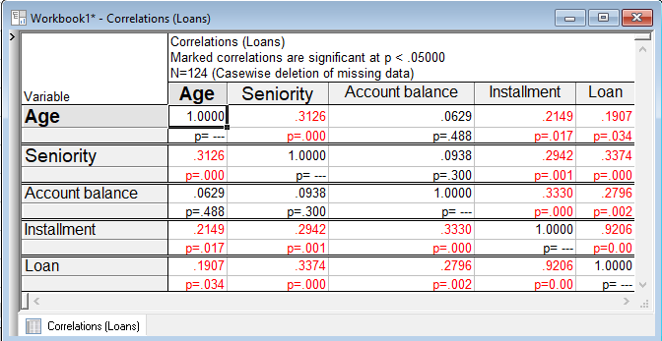
Scatter diagram(Scatterplot)

Graphs Scatterplot
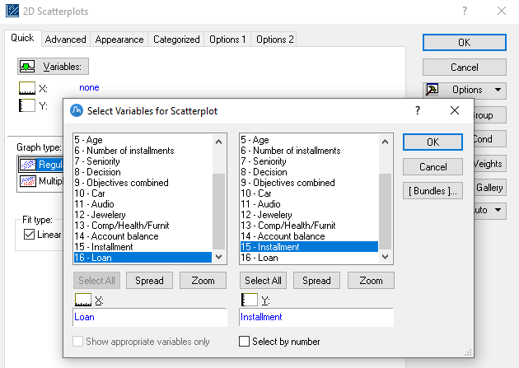
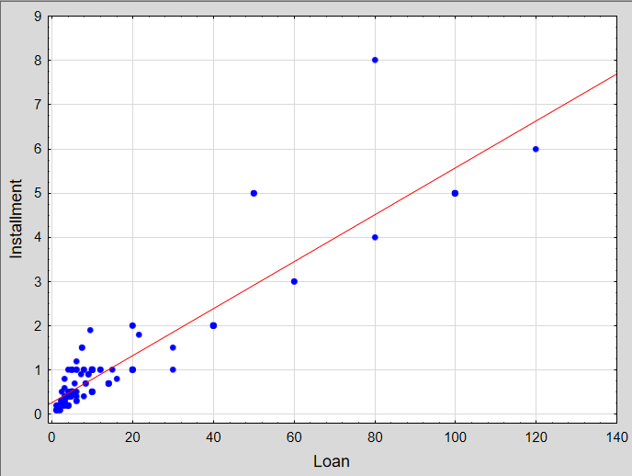

RANK CORRELETION
Statistics Nonparametrics
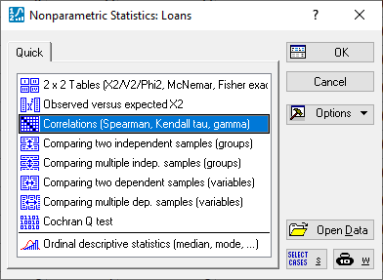
OK
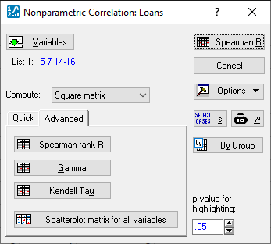
Spearman rank R
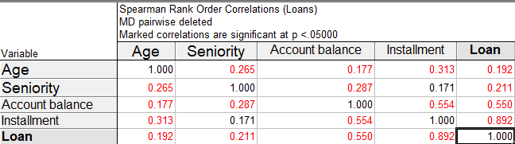
Kendall rank correlation (tau)
