

**ASIA PACIFIC INSTITUTE OF INFORMATION**

**TECHNOLOGY**

**Level 4**

COMP40004

**WEB DEVELOPMENT AND OPERATING SYSTEMS**

**Individual Assignment**

Turtle hatcheries in Sri Lanka -assignment 03

Yevin Rajapakse

CB-012213

13th August 2023

Link to my page - <https://yevinraja.github.io/yevinrajapakse.github.io/>

This report will give you a brief idea about how I continued making my webpage which was previously done in semester 01 but with the help of JavaScript mainly. As required I made a webpage for a ticket ordering system which consists of 04 pages.

With the help of my Webpage any customer will be able to order any number of tickets at a time which is most suitable and convenient to him, Time slots can be seen divided into 2 parts such as normal and peak hours, after providing the customers details and the payment details it will take him to the confirmation page which shows all the required information which the consumer will need when entering the venue.

The **04 pages** in my website,

1. Tickets ordering page
2. Customer details page
3. Payment details page
4. Confirmation page

Tickets ordering page

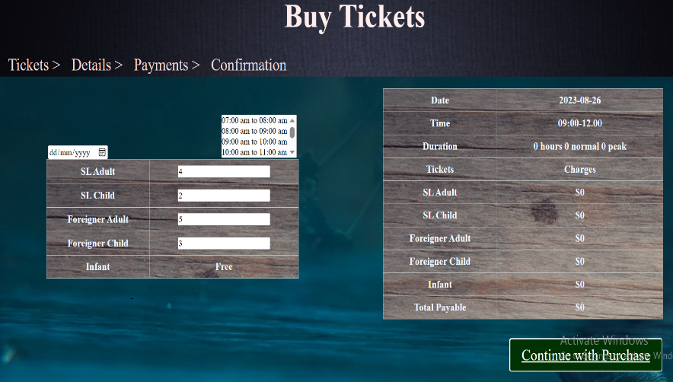

In this page you can see a navigation bar which takes you to the main 4 pages.

In the guests table you can find a calendar and different time slots which you can easily choose (to select multiple time slots press the **shift key** and select).

After that select the number of visitors whether it’s a SL adult, child or Foreign adult, child or an infant. (Infants are free of charge) All of this information will be updated to the summary table at that moment

Customer details page

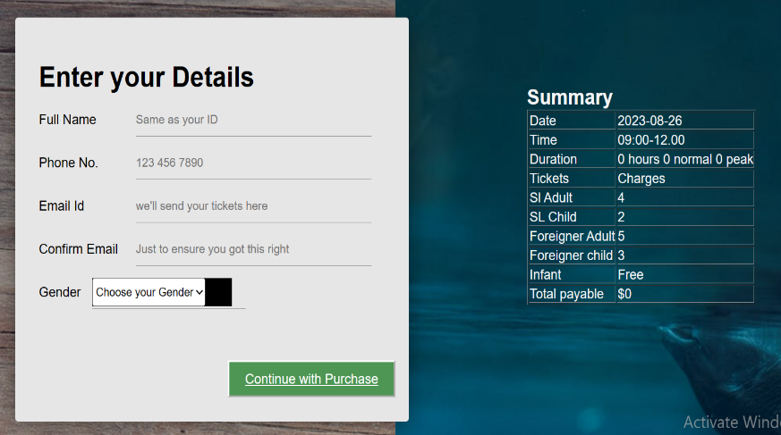

As you can see in this page you can fill all your personal information which includes your Name, Phone No, Email ID and your gender.

As seen below I have used some validations as given to us in the assignment which makes the webpage more secure and look better.

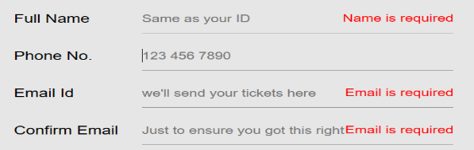

Payment details page

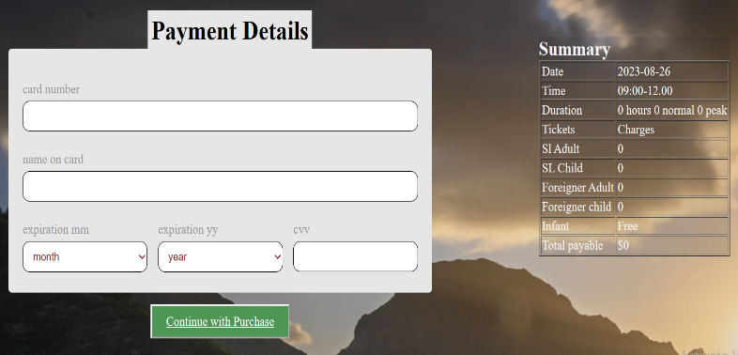

In this page you only have to fill 5 slots which makes it more convenient to the customer and these slots are the Card number (the most important), Name on Card, Card CVV and the expiration month and the year.

After filling the above and clicking on the ‘continue with purchase’ button it will take the customer to the last page which is the confirmation page

Confirmation page

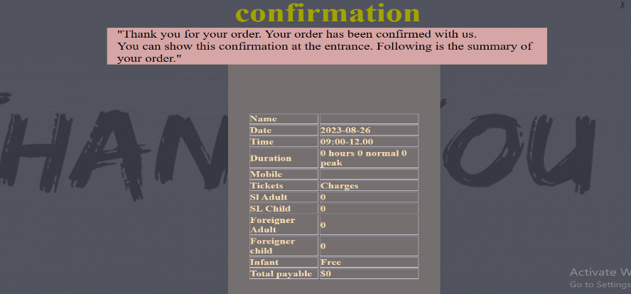

This page shows you all the important items which you will need when entering the venue including the ticket details and the customer details.

After this page the customer can check out and get ready for his/hers vacation.

ENJOY!!!

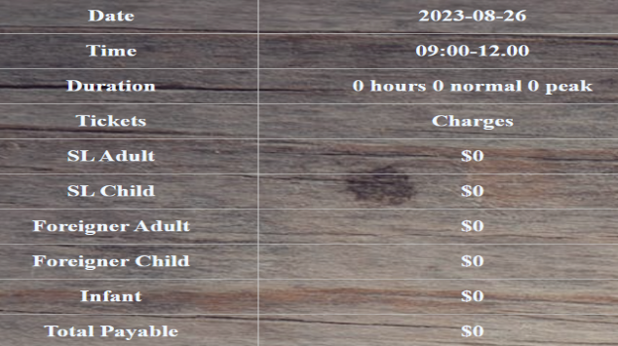*As given in the assignment I have been able to put an summary table to each page which makes it easier for the consumer to get an idea about the Dates, Times, No. of tickets etc.….

I have used both **Local** and **Session** Storage to get the information to the summary table.

**Test Results**

|  |  |  |
| --- | --- | --- |
| **Accessibility  Testing** | C:\Users\User\Pictures\Screenshots\Screenshot (158).png | |
| **CSS Validity** | C:\Users\User\Pictures\Screenshots\Screenshot (156).png | |
| **HTML Validity** |  | |
| **Lighthouse Testing** | | C:\Users\User\Pictures\Screenshots\Screenshot (160).png |

In Conclusion I have made a fully functioning webpage which includes a Turtle Hatchery Webpage which gives the consumer and idea about the turtle hatchery, types of turtles and the different venues which the consumer can visit. There is also an ticket ordering system for the customer to choose his preferred date and venue, the number of tickets and an webpage to give his personal information and the payment details