Build Boost 1.45.0 with MinGW

Copy or install mingw32 to C:\MinGW
Because boost script guess toolset by this path.

build bjam
cd D:\yewberry\boost_1_45_0\tools\build\v2\engine\src
build mingw
find bjam.exe in D:\yewberry\boost_1_45_0\tools\build\v2\engine\src\bin.ntx86

bulid boost
bjam toolset=gcc variant=debug link=static runtime-link=shared threading=multi --build-dir=D:\yewberry\temp --with-thread
bjam toolset=gcc variant=release link=static runtime-link=shared threading=multi --build-dir=D:\yewberry\temp --with-thread

Exception raises when debug Qt application in Eclipse
[New Thread 2232.0x9e4]
gdb: unknown target exception 0xc0000135 at 0x7c987406

Put QtCored4.dll QtGuid4.dll in debug directory.

Always stop on main when debug in Eclipse
Uncheck “Stop on startup at:”
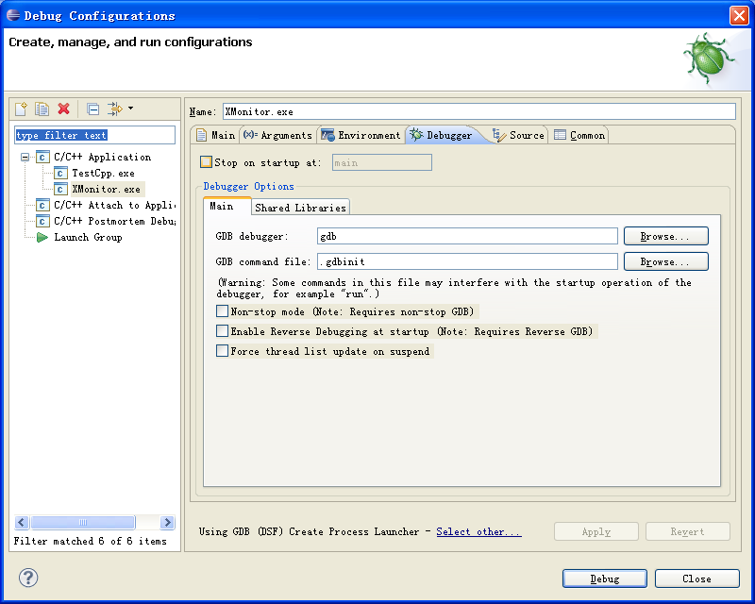

Eclipse CDT include and lib settings
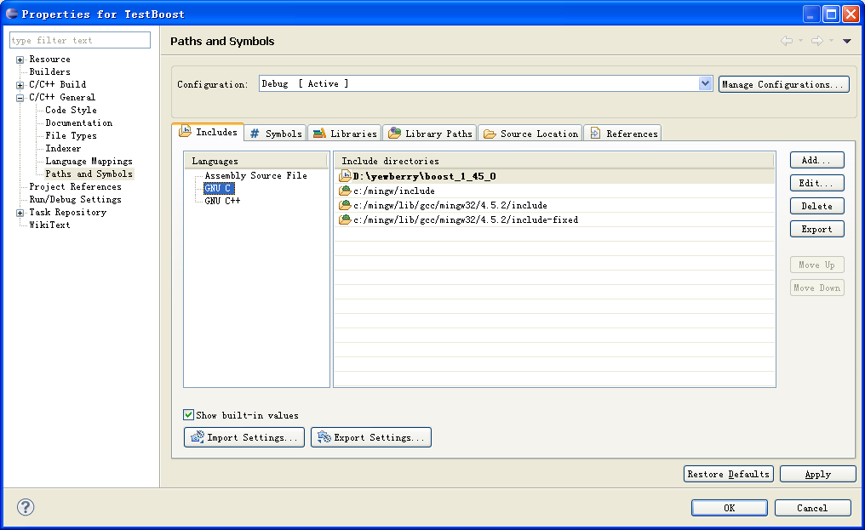

Eclipse CDT auto compile
