Build Boost 1.45.0 with MinGW

Copy or install mingw32 to C:\MinGW
Because boost script guess toolset by this path.

Build bjam
cd D:\yewberry\boost_1_45_0\tools\build\v2\engine\src
build gcc
find bjam.exe in D:\yewberry\boost_1_45_0\tools\build\v2\engine\src\bin.ntx86

Bulid boost
bjam toolset=gcc variant=debug link=static runtime-link=shared threading=multi --build-dir=D:\yewberry\temp --with-thread
bjam toolset=gcc variant=release link=static runtime-link=shared threading=multi --build-dir=D:\yewberry\temp --with-thread

Exception raises when debug Qt application in Eclipse
[New Thread 2232.0x9e4]
gdb: unknown target exception 0xc0000135 at 0x7c987406

Put QtCored4.dll QtGuid4.dll in debug directory or project directory.

Always stop on main when debug in Eclipse
Uncheck “Stop on startup at:”
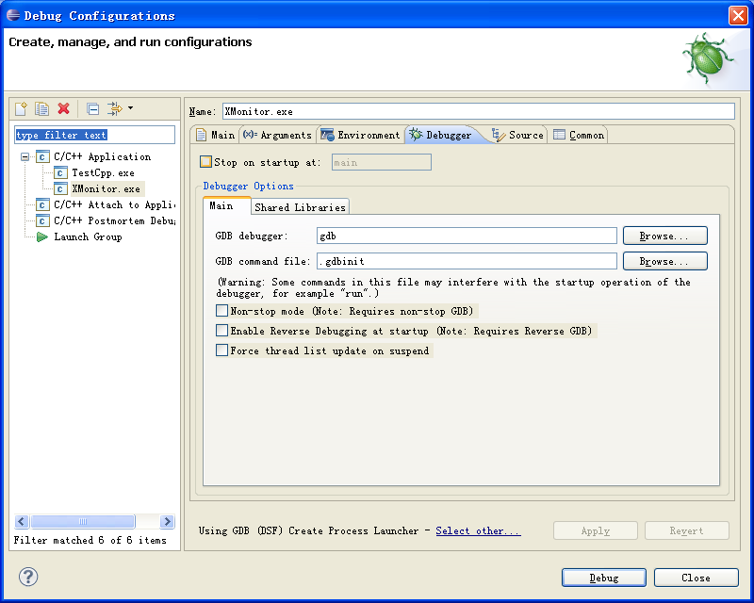

CDT include and lib settings
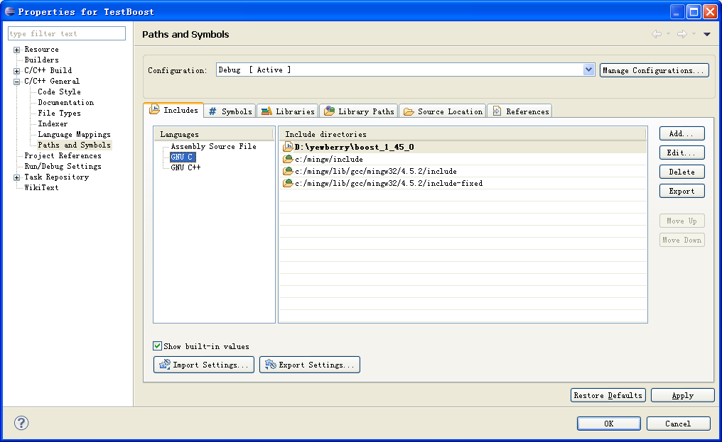

CDT auto compile
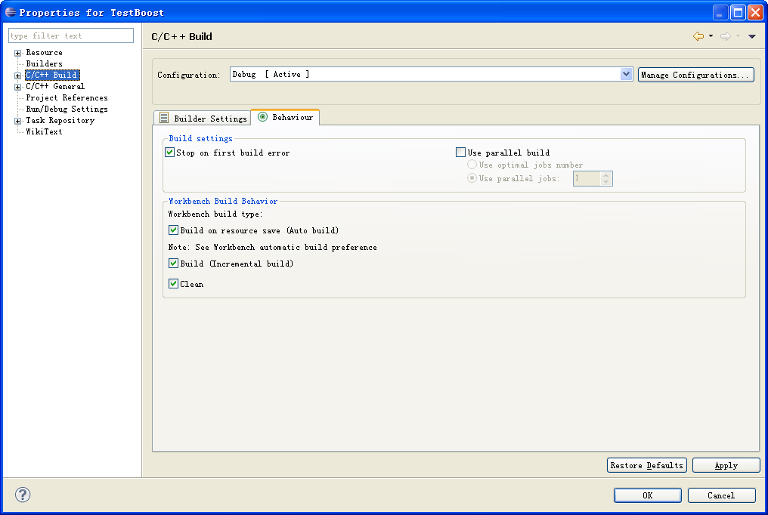

Set MY Workspace path
C:\MinGW\msys\1.0\bin;C:\MinGW\bin;D:\yewberry\Qt\2010.05\qt\bin;

Compile libssh2

Compile OpenSSL
- Prepare
a)MinGW MSYS and put their bin dir into path
b) openssl-1.0.0d.tar.gz from http://www.openssl.org/
c) ActivePerl from http://www.activestate.com/perl
- perl Configure mingw
- make
After build is finished you should have openssl.exe file in the apps directory, and two library files libssl.a and libcrypto.a in the toplevel directory

Modify libssh2-1.2.7\win32\Makefile.win32
a) you can set env var or just modify makefile. Set ZLIB_PATH and OPENSSL_PATH
# Edit the path below to point to the base of your Zlib sources.
ifndef ZLIB_PATH
ZLIB_PATH = D:/yewberry/zlib125-dll
endif

# Edit the path below to point to the base of your OpenSSL package.
ifndef OPENSSL_PATH
OPENSSL_PATH = D:/yewberry/openssl-1.0.0d
endif

b)Modify include path and lib for zlib and openssl
INCLUDES = -I. -I../include
INCLUDES += -I$(OPENSSL_PATH)/ -I$(OPENSSL_PATH)/include/

ifdef LINK_STATIC
LDLIBS += $(OPENSSL_PATH)/libcrypto.$(LIBEXT) $(OPENSSL_PATH)/libssl.$(LIBEXT)
else
LDLIBS += $(OPENSSL_PATH)/out/libeay32.$(LIBEXT) $(OPENSSL_PATH)/out/libssl32.$(LIBEXT)
endif

ifdef WITH_ZLIB
INCLUDES += -I$(ZLIB_PATH)/include/
LDLIBS += $(ZLIB_PATH)/lib/zdll.lib
endif

Compile libssh2
cd libssh2-1.2.7\win32
make lib

