Name | Chong Yew Sze
Student ID | 35400552
Studio Session | Tutorial 05 (Friday 2-4pm)

Part A: URL of the Visualisation
https://yewsze.github.io/Data-Visualisation-2/

Part B: Domain Description

Describe your domain chosen for DV II
The visualisation focuses on Outdoor Recreation Participation in Australia. It focus on how adults take part in physical activity outdoors, who takes part, where it happens, and how it connects to the places and industries that depend on it. The page begins with national participation, narrows to the people and activities involved, and then moves to the places where outdoor activity takes place. It closes with the Northern Territory’s national parks and the wider tourism economy.

Describe the Why and Who aspects of your DV II
Why:
Many Australians assume that a country with beaches, bushland and parks is naturally active. Yet participation is uneven across age groups, employment groups and states, and the reasons people take part vary. The visualisation addresses this need by showing who is outdoors, what they do and where they do it. Its aim is to show that outdoors is not just a place for people but part of how they live. The page communicates this through a story rather than acting as an expert exploration tool.
Who:
The audience is the average Australian adult, with no statistical background. Text lines are short, terms such as “participation rate” and “organised activity” are explained in plain language, and every chart carries a short annotation stating its main finding. It is also relevant to anyone curious about how Australians spend their leisure time, including local residents and domestic visitors.

Describe the “What” aspect of your DV II
The data comes from the below sources:
- Australian Bureau of Statistics. (2023, December 1). How Australian generations spent their time on recreation and leisure.
https://www.abs.gov.au/articles/how-australian-generations-spent-their-time-recreation-and-leisure
- Australian Sports Commission. (n.d.). AusPlay results. Clearinghouse.
https://www.ausport.gov.au/clearinghouse/research/ausplay/results
- Director of National Parks. (2025). Director of National Parks annual report 2024-25. Department of Climate Change, Energy, the Environment and Water.
https://www.dcceew.gov.au/sites/default/files/documents/dnp-annual-report-2024-25.pdf
- Department of Tourism and Hospitality. (n.d.). Park visitor data. Northern Territory Government.
https://dth.nt.gov.au/parks-and-wildlife/parks-and-wildlife-statistics-and-research/park-visitor-data"
- Australian Bureau of Statistics. (2025, December 17). Australian National Accounts: Tourism Satellite Account, 2024-25.
https://www.abs.gov.au/statistics/economy/national-accounts/tourism-satellite-account/latest-release
- Zhao, S. (n.d.). Australian spatial data. GitHub.
https://github.com/sherwinzxw/australian-spatial-data

Describe the “How” aspect of your DV II
Chart 1: Six in Seven Aussies Are Active (Pictogram)
- Why:
To open the story with a positive headline: most adults take part in physical activity.
- How:
Rows of person icons, with active adults as filled icons in a strong colour and the rest in grey. Counting icons is easier than reading a percentage, so the “6 in 7” message lands without axes or statistics.
Chart 2: Share of adults by activity level, Australia, 2025 (Waffle Chart)
- Why:
To follow the headline with the exact share of adults who are active, so the viewer sees the precise ratio behind it.
- How:
A 10 x 10 grid of 100 squares, where each square is 1% of adults. Active and not-active squares use two distinct colours, so the split reads at a glance. Equal-sized squares let readers judge the proportion without reading a number.

Chart 3: Most popular activities among adults, ranked by participation, 2025 (Ranked Bar Chart)
- Why:
To show which activities draw the most adults and where outdoor activities sit among them.
- How:
Horizontal bars sorted from highest to lowest participation, with long activity names readable on the left. A category filter lets users narrow the list to core outdoor activities. Bar length on a common baseline is the most accurate channel for comparing rates.
Chart 4: Type of activity by age group, share of adults, 2025 (Normalised Stacked Bar Chart)
- Why:
To show whether adults are active through sport, non-sport activity, both, or neither, and how these changes with age.
- How:
One bar per age group, each scaled to 100% and split into the four groups. Normalising makes age groups of different sizes directly comparable, and the “neither” segment shows how many adults are not active at all.
Chart 5: Population Pyramid of Adults Who Are Active at Least Once a Year, 2025 (Population Pyramid)
- Why: To compare male and female participation across age groups at a glance.
- How: Two back-to-back horizontal bars per age band, one for men and one for women, showing the share of adults active at least once a year. The mirrored layout makes gender gaps easy to see within each age band and across age.
Chart 6: Participation in core outdoor activities by age group, 2025 (Heatmap)
- Why: To show where each core outdoor activity peaks across age groups.
- How: A grid with activities as rows and age groups as columns, with cell colour (a sequential scale) showing participation. Colour makes it easy to scan a large grid for patterns, and a tooltip gives the exact value.
Chart 7: Main reasons for taking part, by age group, 2025 (Heatmap)
- Why: To show how motivations, such as fitness, enjoyment or socialising, shift across age groups.
- How: The same grid layout as Chart 6 but with motivations as rows. Reusing the layout means readers already know how to read it, and a shared colour scale helps them spot which reasons matter most to each age group.
Chart 8: How activity is organised, by age group, 2025 (Alluvial Chart)
- Why:
To show how adults of different ages take part in organised and informal activity, and which kinds of organisations they use.
- How:
Age groups on the left flow into how the activity is organised, with the width of each band showing the number of adults. The flows let viewers follow one age group through to its organisation type, which a bar chart can’t show in one view.
Chart 9: Rank of places where adults are active, by age group, 2025 (Bump Chart)
- Why:
To bridge from people to places by showing that public space is where much of the activity happens.
- How:
Lines trace the ranking of all nine places for activity across age groups. “Public space” is highlighted in one colour and all other places are grey, so the viewer follows one line while the rest stay as context. Rank is shown rather than percentage so changes in order stand out.
Chart 10: Adults Activeness by State and Territory, 2025 (Multiple Choropleth Map)
- Why:
To show how adult participation differs across states and territories.
- How:
Three maps of the same geography, one each for at least once a year, at least once a week and three or more times a week, shaded by participation rate. Repeating the same map lets the viewer compare frequency levels directly, and a sequential colour scale suits rates.
Chart 11: National Parks and Reserves in the Northern Territory, by region (Dot Map)
- Why:
To move the story from the national view to specific places and show where NT parks are located.
- How:
Park locations as points over a pale NT basemap, coloured by NT region, with neighbouring states as muted context. Points suit locations because they keep each park distinct without implying area.
Chart 12: Most Visited Parks and Reserves in the Northern Territory, 2024-25 (Proportional Symbol Map)
- Why:
To show which NT government parks are the busiest, so the viewer sees that visitors concentrate in a few places.
- How:
Circles placed at each park and sized by visitor numbers, covering the top 11 parks. Area encodes the count, so the big destinations stand out immediately and the map doubles as a ranking.
Chart 13: Activity level of adults by employment status, 2025 (Mosaic Plot)
- Why:
To show how often adults are active, and how employment status changes the picture.
- How:
Columns for each activeness level (at least once a year and so on), with column height showing the percentage of adults and each column split by employment status. This shows both how common each frequency is and who makes it up, in one view.

Chart 14: Output of sport and recreation services in tourism, Australia (Area Chart)
- Why:
To close the story by showing that sport and recreation support tourism output, not just personal well-being.
- How:
An area chart of sport and recreation services output over time, with the 2020–21 pandemic drop annotated. The filled area shows the size of the industry as well as its trend, which supports the conclusion that the outdoors is part of how Australians live.

Part C: Sketch
https://github.com/yewsze/Data-Visualisation-2/blob/main/sketch%202.pdf

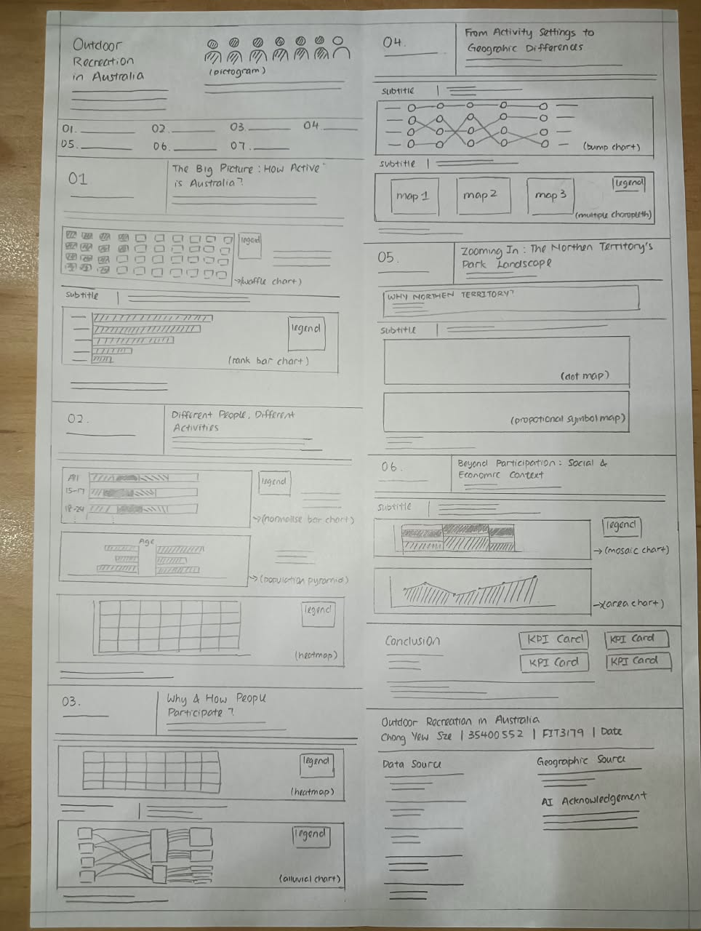

Part D: Full-size screenshot of your DV II
