**WangXiao**

[wangxiao2020@stu.xjtu.edu.cn](mailto:wangxiao2020@stu.xjtu.edu.cn)

Xi'an Jiaotong University China

PhD candidate

# Plan

I am keen to secure a **Visiting Scholar position**(Funded by the Chinese Scholarship Council (**CSC**), and holding a certified **English proficiency qualification**) within your team, commencing from **either December 2024 or 2025**, for a period of **two years**. During this tenure, I aspire to engage in extensive research work focused on **motion planning and manipulation skill development for mobile** **manipulator**.

Please consider my application for this opportunity, and I look forward to the possibility of collaborating with your team to advance cutting-edge research in the field of robotics.

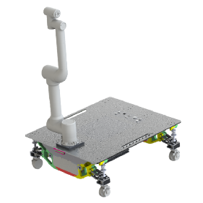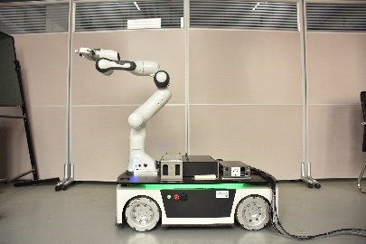

# Research interests

**Impedance Control of Mobile Manipulators**

**Motion Planning of Mobile Manipulators**

**Autonomous Navigation and Control Systems**

**Robot skills**

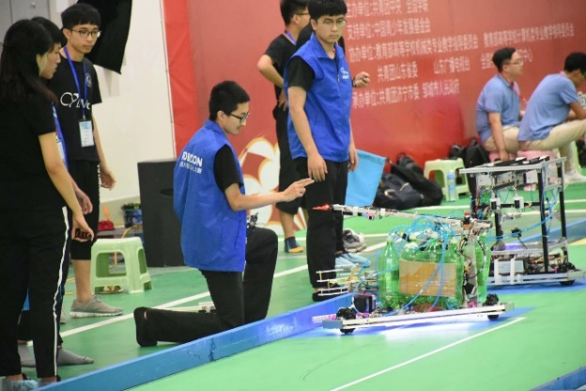**Competition**

**ROBOCON National First Prize**

**ROBOCON Provincial First Prize**

**Traffic science National Third Prize**

**Challenge Cup Provincial First Prize**

**Huawei Embedded Competition National Third Prize**

**Intelligent Transportation National Third Prize**

**Internet Plus Provincial Second Prize**

**Energy Conservation National Third Prize**

**All other minor awards are detailed in the attached document**

# Skill

## Code: C++,ROS,STM32……

## Mechanical Drawing: Solidworks

# Code

## Impedance Control, Dynamic(Newton Euler MDH), MPC

## Nullspace control, Swerve drive https://github.com/yeying256/robot_dynamic_cal

## ROS_control, robot_hw https://github.com/yeying256/agv_sim_hs

## Gaussian Process Trajectory Planning, Cubic Spline Interpolation https://github.com/yeying256/traj_plan_wx

## STM32 AGV https://github.com/yeying256/agv_stm32

# Video

**Robotics** https://www.bilibili.com/video/BV1zK411Z7jx/

**STM32** https://www.bilibili.com/video/BV1sZ4y1y7o2/

**Motion plan** https://www.bilibili.com/video/BV1tF4m1F7Ws/