HW3

ID:38

3.2

$pnorm(-1.13,mean=0,sd=1,lower.tail=FALSE)$

0.8708

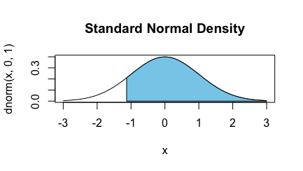

$pnorm(0.18,mean=0,sd=1)$

0.5714

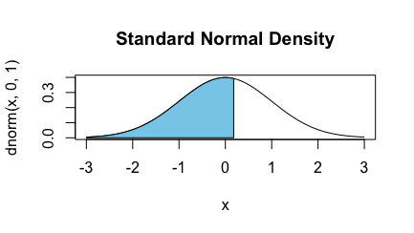

$pnorm(8,mean=0,sd=1,lower.tail=FALSE)$

6.220961e-16

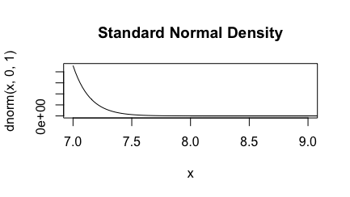

$pnorm\left(0.5,mean=0,sd=1\right)-pnorm(-0.5,mean=0,sd=1)$

0.3829

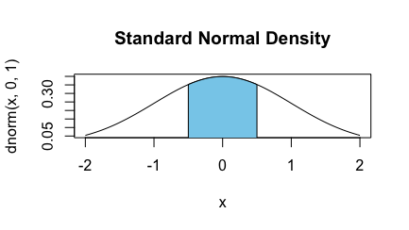

3.10

Let $X$ = the height of a 10-year-old child. According to problem, we know that

$\operatorname{Pr}\left(X<48\right)=pnorm\left(48,mean=55,sd=6\right)= 0.1218$

1. $\operatorname{Pr}\left(60<X<65\right)=pnorm\left(65,mean=55,sd=6\right)$- $pnorm\left(65,mean=55,sd=6\right)=0.1545$
2. The height cutoff for “very tall” is $qnorm\left(0.1,mean=55,sd=6,lower.tail=FALSE\right)=62.6893$
3. The percentage of 10 year olds cannot go on this ride is $pnorm\left(54,mean=55,sd=6\right)=0.4338$

3.12

1. The percent of passenger vehicles travel slower than 80 miles/hour is $pnorm\left(80,mean=72.6,sd=4.78\right)=0.9392$
2. The percent of passenger vehicles travel between 60 and 80 miles/hour is

$pnorm\left(80,mean=72.6,sd=4.78\right)- pnorm\left(60,mean=72.6,sd=4.78\right)$ =0.9350

1. The fastest 5% of passenger vehicles travel is $qnorm\left(0.05,mean=72.6,sd=4.78,lower.tail=FALSE\right)=80.4624$
2. $pnorm\left(70,mean=72.6,sd=4.78\right)=0.7058$. Nearly 29.15% of passenger vehicles travel above the speed limit on this stretch of the I-5

3.20

$\operatorname{Pr}\left(sample 2 females with replacement from 10 people\right)=\frac{1}{2}×\frac{1}{2}=\frac{1}{4}$

$$\operatorname{Pr}\left(sample 2 females without replacement from 10 people\right)=\frac{C_{5}^{2}}{C_{10}^{2}}=\frac{2}{9}$$

$\operatorname{Pr}\left(sample 2 females with replacement from 10,000 people\right)=\frac{1}{2}×\frac{1}{2}=\frac{1}{4}=0.25$

$$\operatorname{Pr}\left(sample 2 females without replacement from 10,000 people\right)=\frac{C_{5000}^{2}}{C_{10000}^{2}}=\frac{4999}{19998}=0.24998$$

1. The assumption is reasonable because if the sampling size is fairly small compared to the population, there is little difference between replacement or not. Therefore, when population is large enough, we can safely treat individuals as independent case.

3.26

1. Since the experiments are independent and the number of experiments is fixed and the results of experiment are only success or not, we can use binomial distribution for this case.

$dbinom\left(97,100,0.9\right)=0.0059$

$dbinom\left(3,100,0.1\right)=0.0059$

$pbinom\left(1,10,0.9,lower.tail=FALSE\right)=1$

$pbinom\left(3,10,0.1\right)=0.9872$

3.28

1. According to the previous question, we know that we can use binomial distribution to analyze the problem. $μ=120×0.9=108$, $σ=\sqrt{120×0.0×0.1}≈3.2863$

Therefore, 108 people out of the sample are expected to have had chickenpox in their childhood. The standard deviation is 3.2863

1. No, I am not surprised. Because the probability of such case is $dbinom\left(105,120,0.9\right)=0.07420$
2. The probability that less than 105 people out of sample have had chickenpox in childhood is $pbinom\left(105,120,0.9\right)=0.2182$. This case contains that the case of part (b).

3.30

This event is binomial distribution, then the probability of such case is

$$pbinom\left(1500,15000,0.09,lower.tail=FALSE\right)=1.173433e-05$$

3.36

$\frac{3}{4}×\frac{3}{4}×\frac{1}{4}=\frac{9}{64}$

1. Pr(3 right) = $C_{5}^{3}×{(\frac{1}{4})}^{3}×{(\frac{3}{4})}^{2}$

Pr(4 right) = $C_{5}^{4}×{(\frac{1}{4})}^{4}×{(\frac{3}{4})}^{1}$

Pr(3 or 4 right) = Pr(3 right) + Pr(4 right)

= $dbinom\left(3,5,0.25\right)+dbinom(4,5,0.25)$

=0.1025

1. This means that Robin needs to have at least 3 right answers: $pbinom(2,5,0.25,lower.tail=FALSE)$ =0.1035