**CSCI 3260 Project Report**

YE Zhizhen 1155046993

SONG Yang 1155046870

**Functionality we have implemented**

Basic:

1. Track drawing: we implement a track which is C1 continuity. And a track with withC0. The track also has adaptive number of boards.
2. Train drawing: we provide two version of train. Classical and Roller Coaster for user to choose.
3. Train oriented correctly.
4. Ride view from the train.
5. Scenery drawing: we have a small house, a hot-air balloon, a windmill, some tree and a firework on the ground.
6. Speed control.

Extra:

1. Arc-length. With the toggle on, train moves according to arc-length.
2. More carriages added on the train. You can add and delete train using the panel.
3. Physics. The train moves according to physical laws
4. Other cool effect: particle system. You can see a colorful firework. And the fog can be triggered by toggles.

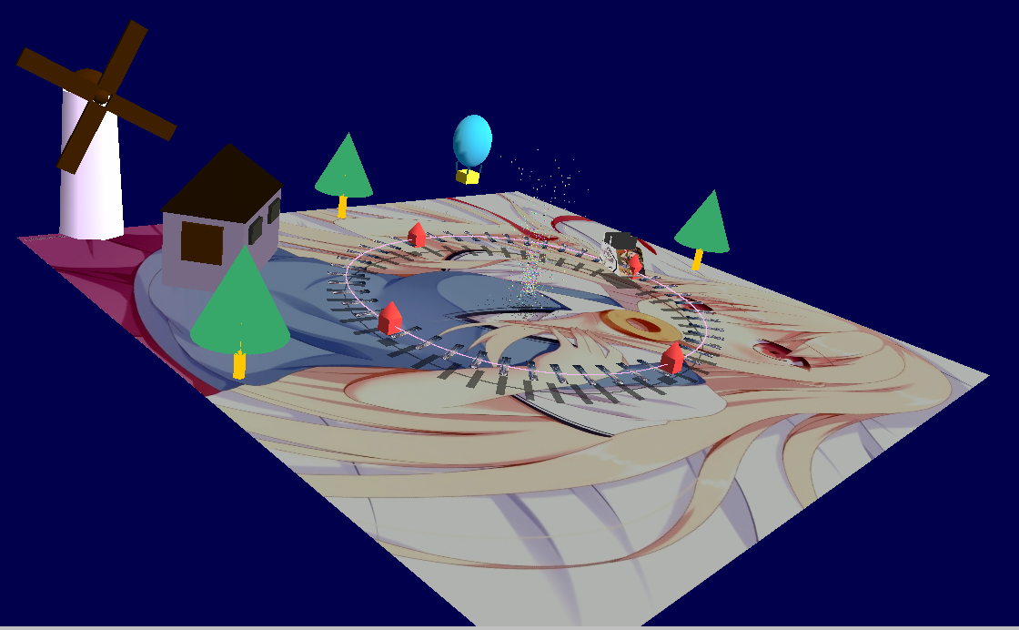

Figure 1: Overview

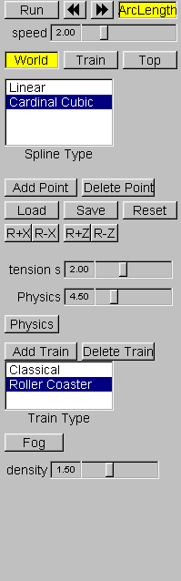

Figure 2: Control Panel

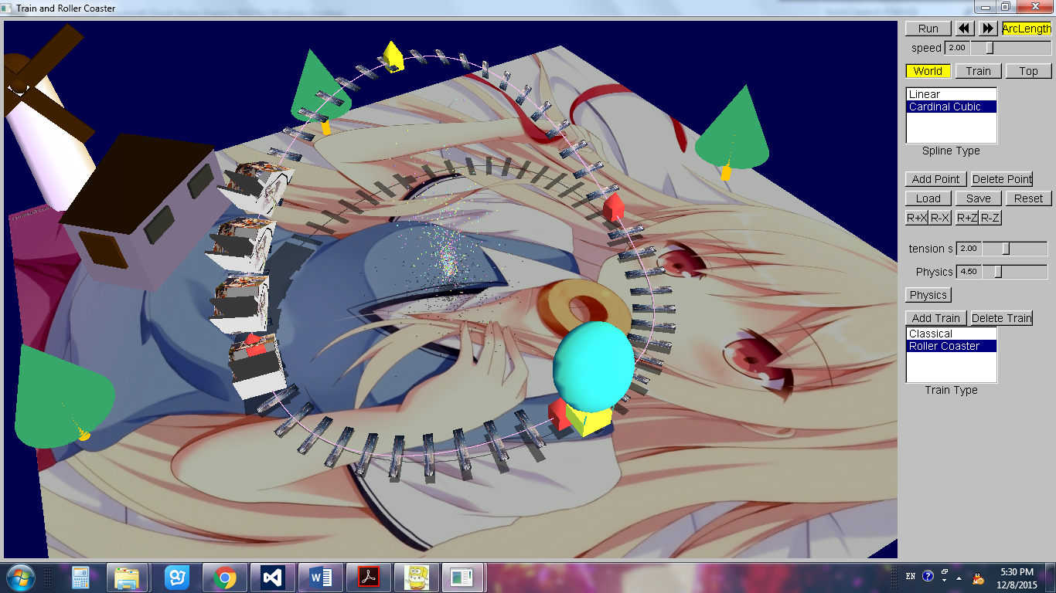

Figure 3: Add Train with height

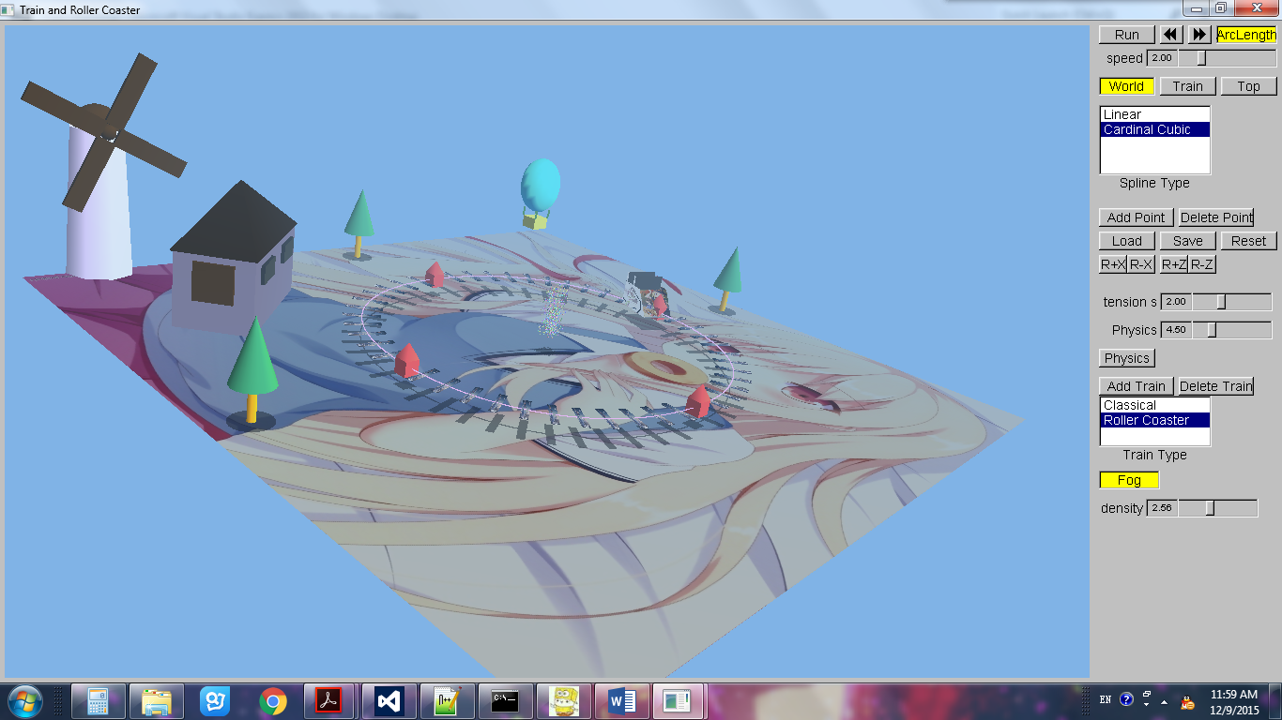

Figure 4: Fog Overview