Fishbone Diagrams of Sample Defects and Test Cases
Test Centered
These defects center on the probable reason for a particular test outcome.
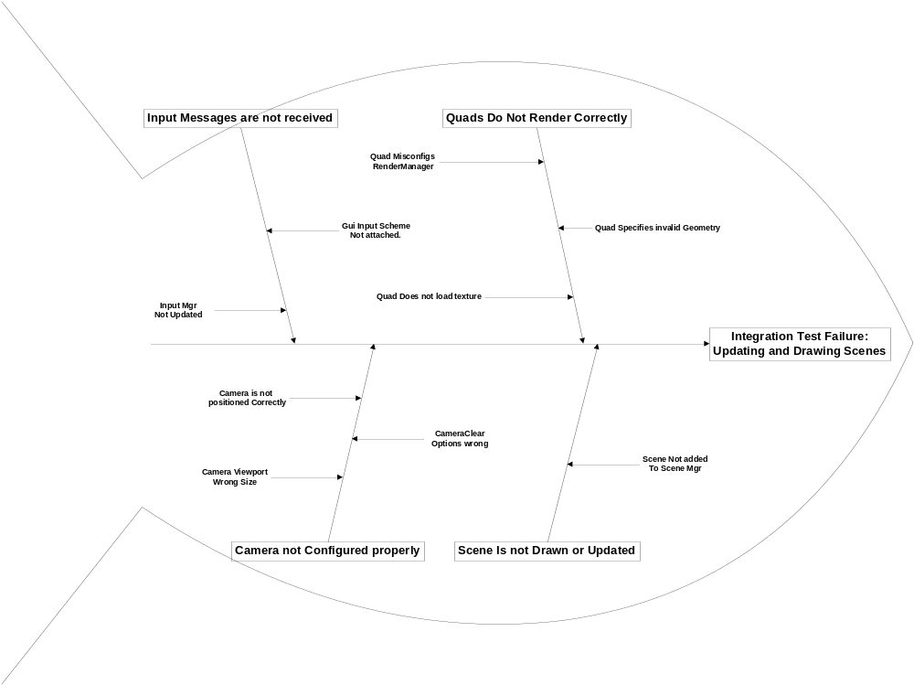
The problem with Big Bang Testing is that since there are multiple components involved, there may be many factors contributing to the test failure. The fishbone diagram allows us to map out these causes for investigation.

Defect Centered

These fishbone focus on the defects of our project. They are intended to find the probable cause of the defect.
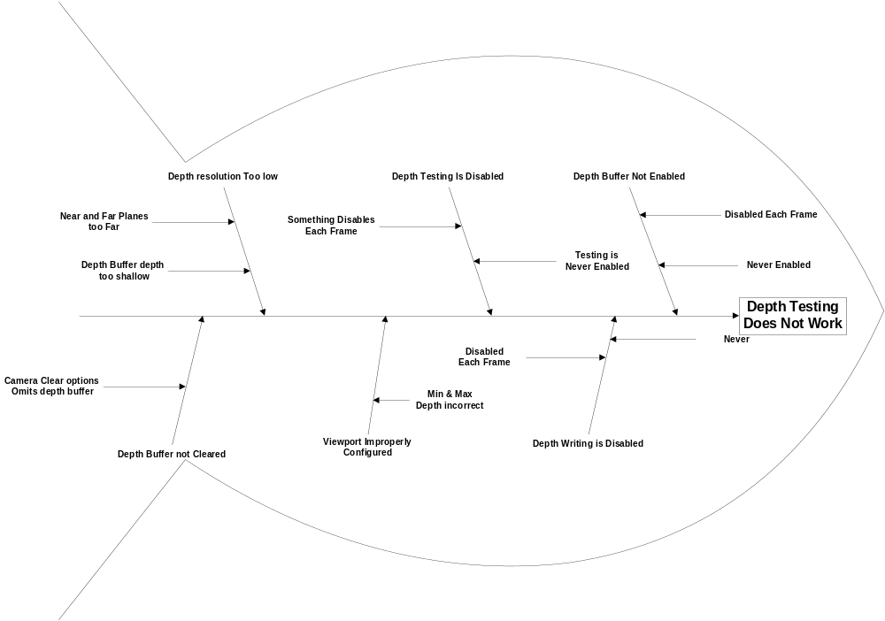
Critical
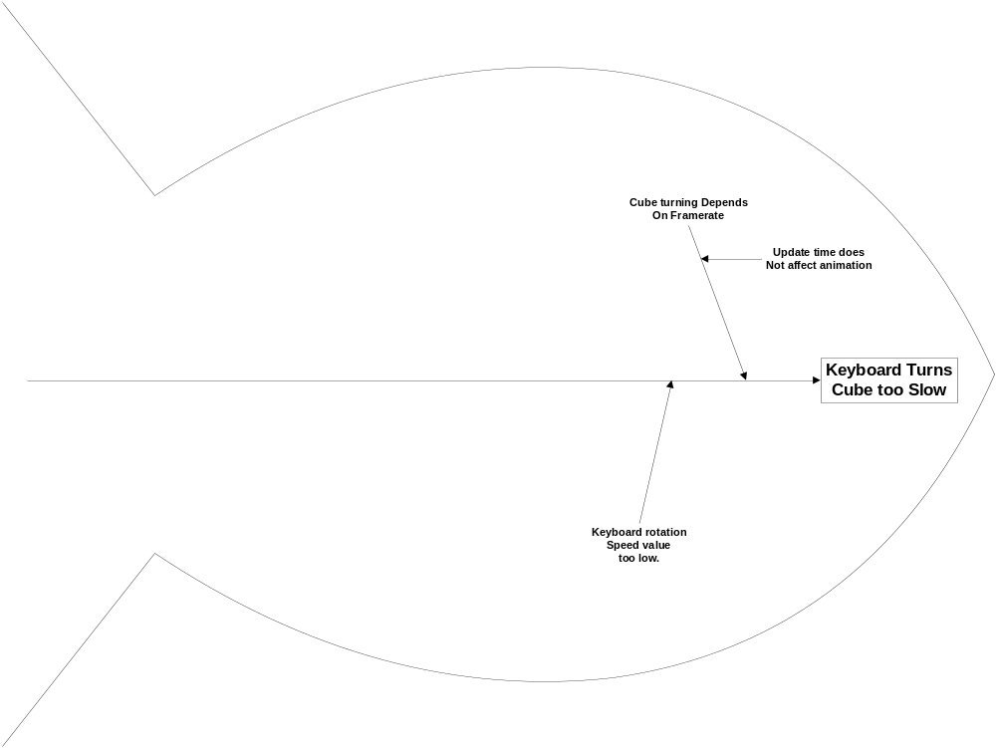
Minor
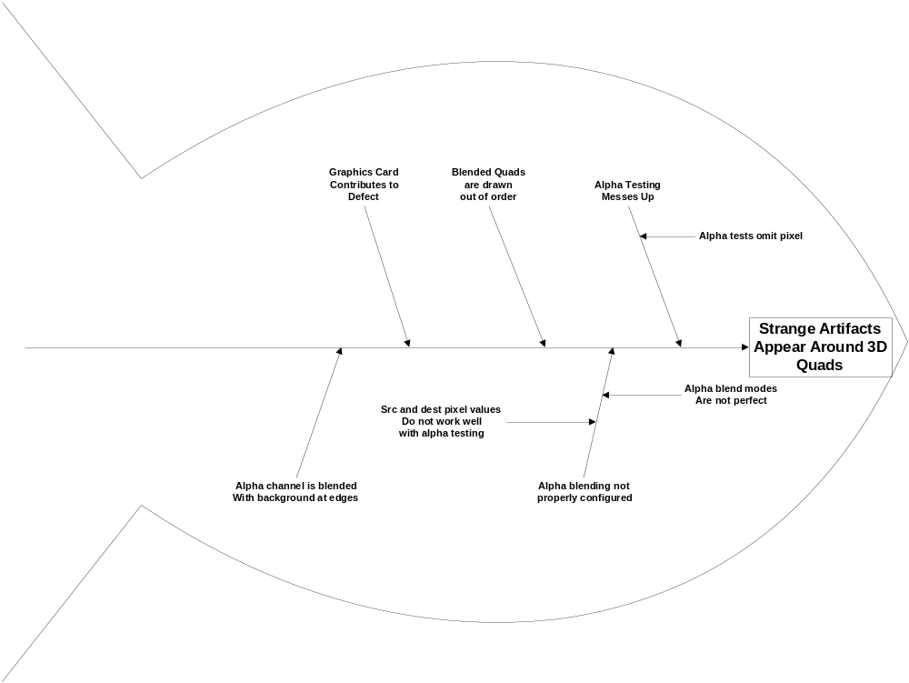Tolerable

