Chris Boyle, Chris Lockhart, Steven Shofner, Jason Spruill
CECS 550
Homework #2
Task 1:
- Outline a High level appropriate Design or Software Architecture for your project. How do the requirements match with the chosen architecture?

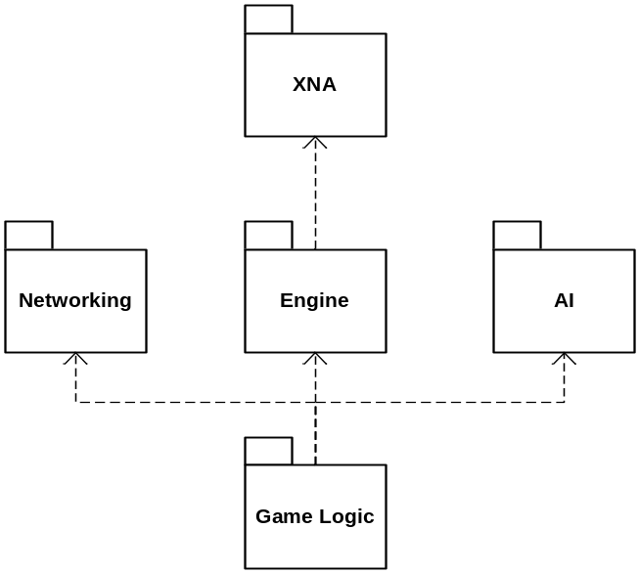

The requirements match the chosen architecture very well; like our requirements, our architecture are divided into separate function groups. Each group will satisfy its own requirements. As a whole, each component will satisfy all the requirements.

- Identify the types of design goals or tasks that solve specific problems. From these identify the software patterns that will be useful in your project.

There are many design goals in the project. If you scan the Engine Design Document, you find is some places where the design goals are alluded. In addition, any software patterns are mentioned there as well.
- Prepare a complete UML based Software Design, with the following diagrams:
  - A Class diagram. (Are the good classes in Task 1 in here? Explain.)
  - Use cases and corresponding Use Case diagrams
  - Sequence Diagrams
  - State Charts or Dynamic Diagrams
  - Collaboration Diagrams (optional)
  - Timing Diagrams (Optional)
  - Flow Charts for major complex methods (where needed)
See UML Diagrams in separate folder.
- Mark the portions of the diagram where the Voice of the Customer (in requirements or otherwise) is addressed.
See UML Diagrams in separate folder.
- Organize the Software Design Document to follow the IEEE 830 -99 and augment the same with the various UML diagrams, by reference or link. Are other libraries, packages used in your design?
See the three design documents:
- Ragade’s Cube SDD
- Engine SDD
- Networking SDD
- Which of these diagrams are candidates for testing during the development?
All class diagrams are candidates for testing. Class diagrams define the communication and contracts between classess and are essential to the working product. Therefore, the class diagrams should be used as a road map for testing. The sequence diagrams will define the way an operation will proceed and is less important, especially if the goal was appropriately met but differs from the actual sequence of events. That is not to say sequence diagrams are not important, they define the order and process of events at design time, as with everything they are subject to change.

And finally, well documented use cases are important for testing. The final product should meet all of the use cases described for a program. This will ensure all the requirements of the software are met. For our application, time has limited us to spend more effort on strict systematic operation design rather than filling out our use cases. Use cases are important for testing a programs required functionality, but they are not essential to documenting the way a program operates technically and internally. Given our time, we thought it was better to focus primarily on the internal design properties as opposed to external facing requirements (like use cases.) Now when, we outline our test plan, you better believe we will have our use cases fleshed out.

All in all, all of our diagrams need to be tested as we have opted to do the minimum kinds.
Task 2:
- Identify the types of design defects that could be great risks.
Design defects that could prove to be great risks include the following:
  - A lack of anti-cheating and/or anti-hacking considerations in a multiplayer game
  - A model of communicating each player’s cube state in a multiplayer game that does not allow for mistakes or errors
  - Overly strict adherence to the classic Rubik’s Cube game, appealing only to a very small population of clients
  - An imprecise means of input target selection (i.e. ‘if the cube is behind a button and there is a mouse-click over the button, does the cube react or does the button react?’)
  - An AI that is either too smart to be defeated by a mere mortal or too dumb to pose a challenge to the rankest amateur
  - A clumsy, clunky, or unintuitive control scheme
  - Over-design; abstracting classes that have very specific uses, for example
- Allocate review responsibilities as appropriate.
The review responsibilities that our engineering team has assigned are elegantly simple. Each individual component that a member is developing is assigned a second member, an observer, who regularly monitors the progress, code form, efficiency, and relevance of said component. Furthermore, every one to two weeks, the entire team meets and each member showcases the components that he had been working on. Finally, whenever a member commits updates to his component to source control, a build is immediately performed, resulting in to-the-minute notification of compile-time errors introduced by a user’s changes.

- Identify a change management policy and how changes to the review date have been handled.
Code change management is handled by a Subversion-powered source control server. A build is performed whenever code is checked in, resulting in immediate feedback as to the effectiveness and validity of the changes being made. The general policy regarding build-breaking check-ins is that the member checking the code in is responsible for finding out where the problem occurs and spearheading efforts to fix it.
Requirements change management is at present handled by a Google Code issue tracker. Generally speaking, in order for a change in design to be accepted unanimous agreement – or at least unanimous consent – among the members is required. A Microsoft Project document, updated each meeting, is used to assist members in the budgeting of time. This document plays a large role in accommodating changes to the review date, providing an easy means of analyzing work loads and determining the optimal reallocation of time, resources, and feature list to meet such dynamic changes as a modified review date.
Task 3:
Generate an Operational Profile of your design, for each of your major Use Cases. Recall that an Operational Profile prioritizes various portions of your design (by modules, classes, subsystems as appropriate). These priorities may be based on criticality, frequency of usage, and the effort needed to have a valid set.
Highest | 5
Lowest | 1

 | Criticality | Frequency of Use
Client
New Game | 5 | 5
Change Options | 1 | 2
Connect to Server | 5 | 3
Server
Create Game | 4 | 2
Join Game | 2 | 4
Scene Graphics
Display Cube | 5 | 5
Display Animations | 5 | 5
GUI Interface
Display Controls | 5 | 5
Interact Controls | 5 | 5
Input
Accept Controller Input | 5 | 5
Interact with Game | 5 | 5
Sound
Play Sound | 2 | 5

These are estimations of what components the typical user may use when running the application. Of course, all graphics and input controls are the most important of the game, in which the user will be using to interact with the game constantly. Sound, however, does not play a big role in the way the game is played, but would add more effect to the game.
The client will allow the player to start a new game, change options, and connect to a server. The user will always start a new game in order to user the applications main functionality. The user will once in a while, change options to the game, and play. Options will be saved and will not be needed to change again until the user feels it needs to be. The user will connect to the server when he would like to initiate games online. This is not very high since not everyone will be playing the game online and that the internet is not always accessible wherever one goes.
When the user gets on the server, he may do one of two things, create or join a game. It makes more sense that a user will more likely join a game than create since, that each session will handle four players, one of which created the game, three joined. However, it is more important that creating game works. How can one join a game if it cannot be created.
Task 4:
Create a list of major error categories for your project. (Recall these are not just the compiler errors. These are design errors, process mismatches, plan changes and mismatches, documentation faults, version changes, architectural glitches etc. Think of the various life cycle phases.) Track these errors and log these as these errors occur. Note their categories (types).
Each error category is based on general program areas/functionalities/behaviors. Each category typically corresponds to a specific code region, however, it is possible for error categories and faults to concern more than one part of the code. The categories are also hierarchically arranged from general categories to specific.
Also note that the categories do not require issues to be faults! Work items are permitted to go in the different categories.
Ideally, status tracking of each item should include number of estimated hours for completion and hours completed.

Specific Categories

Client – Main Category for client side bugs.

Engine – issues dealing with the engine specifically.

Input – All issues relating to input should be placed here.

Rendering-issues with rendering should be placed here.

SceneGraph – Problems with the scene graph or any of its parts should be placed in this category.

StateManagement- Issues with the state system should go here

GUI- GUI problems will use this category.

Picking- any problems suspected to be picking related go here.

UI – General category for reporting problems that have to do with on screen display. This usually will be visual errors but can include faults within UI code too.

Fit and Finish- issues relating to the view of a screen, not faulty functionality

Task 5:
Calculate Design metrics such as the McCabe’s Complexity, other Object Oriented Metrics, Cohesion metrics etc. based on your design diagrams.

Engine
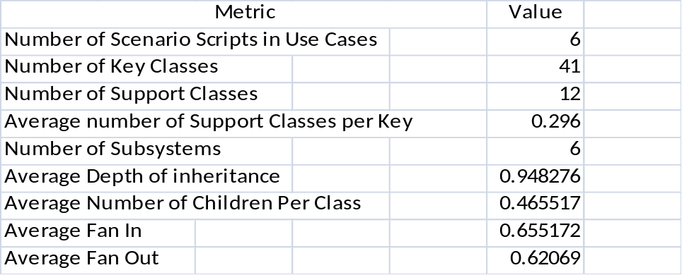
Ragade’s Cube
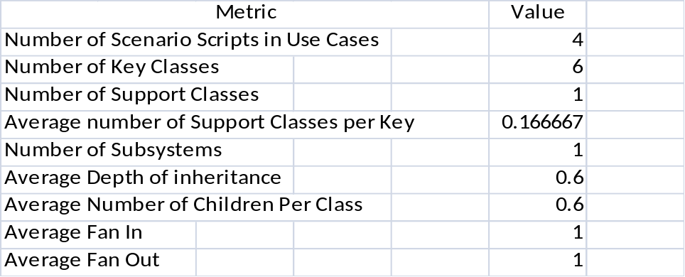
Networking
