

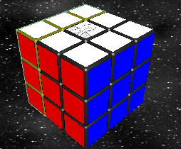
Ragade’s Cube is an intense, head-to-head Rubik’s Cube challenge for one to four players. The game is deceptively simple. Initially, each of the cube’s six faces consists of nine squares of the same color. Each face is then rotated approximately 26 times, scrambling the cube. This rotation is identical for all players in a multi-player game; each player must solve the same cube configuration.
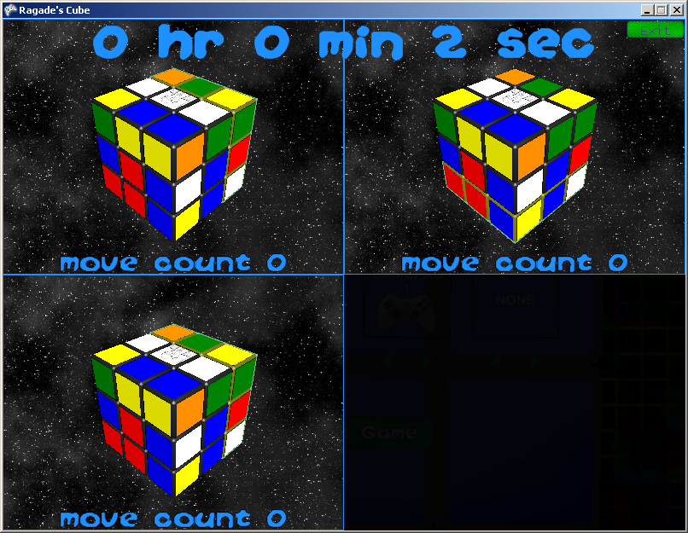

Whenever a face is rotated, the colored squares adjacent to that face, residing on other faces, move along with the face. The deceptively simple goal is to return the cube to its initial state – six sides containing nine squares of the same color.
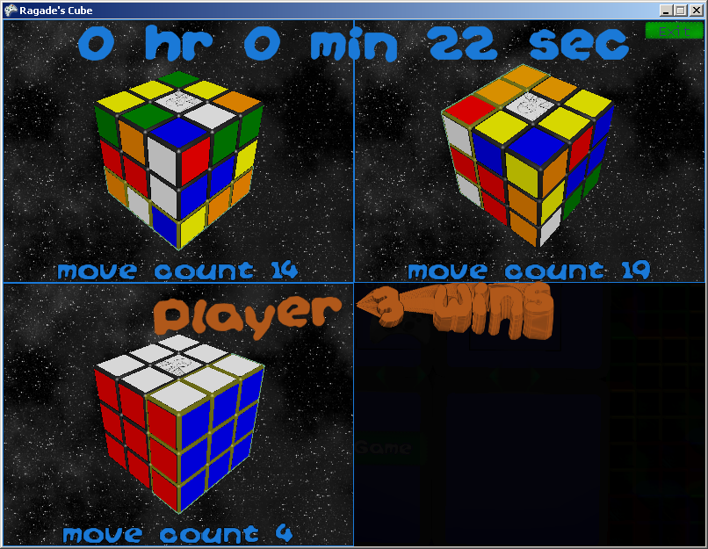

Menu Navigation
To begin a new game, simply press the “New Game” button from the Main Menu. At this point the “New Game” screen will be displayed. Simply choose your players and press the “Start Game” button, and the game will begin. Please note that multiple players cannot use the same device.
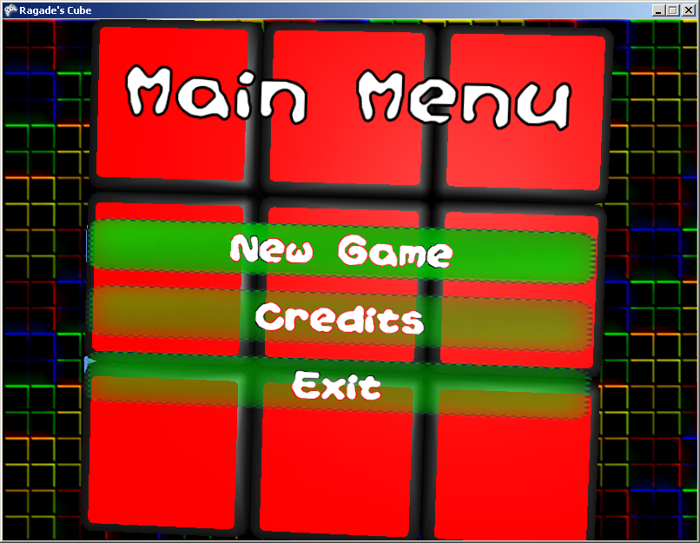
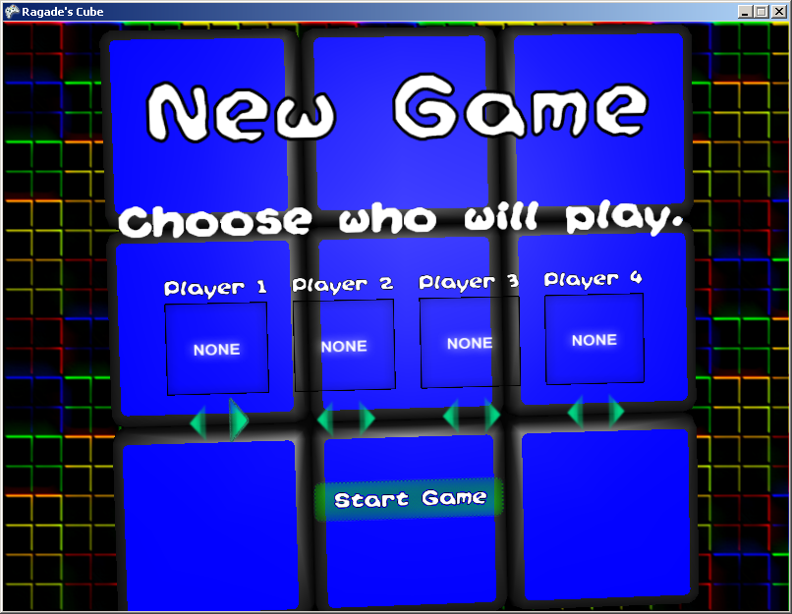
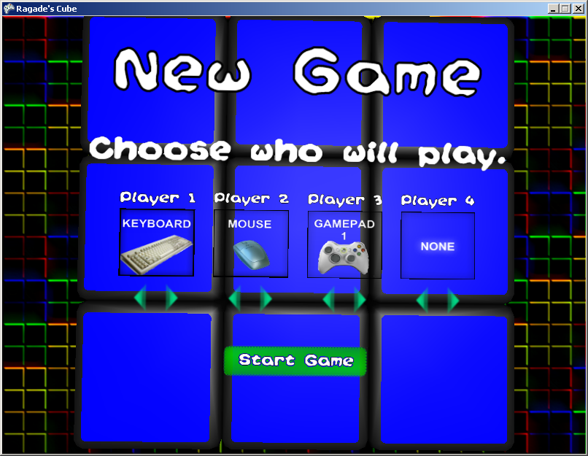

To see the credits, press the “Credits” button from the Main Menu.
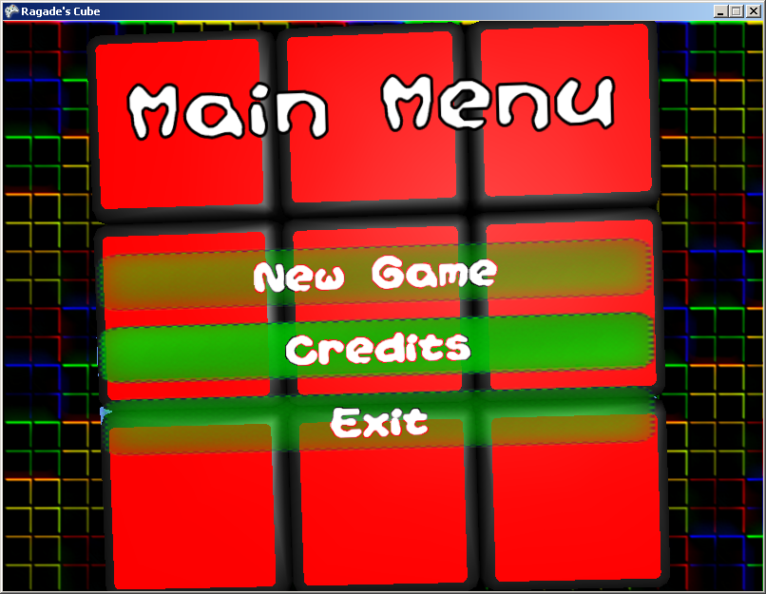
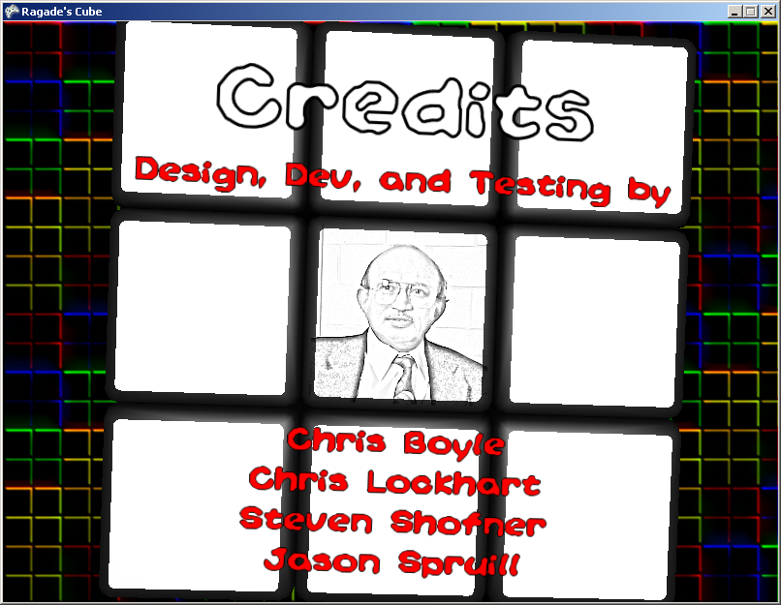
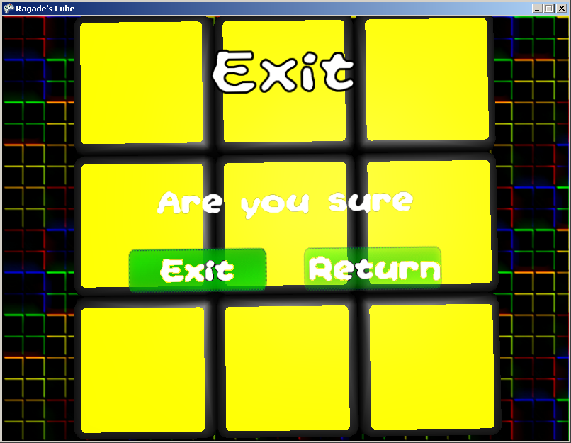

To exit the game, press the “Exit” button from the main menu. In the prompt that is shown, press the “Exit” button again. If you change your mind and want to keep playing, hit the “Return” button on the prompt.

Input
Keyboard Mouse Gamepad
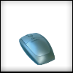
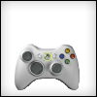
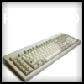

Left Analog – Move selection
A – Activate Selection
B – Back
Arrow Keys – Move selection
Enter – Activate selection
ESC – Back
Left-Click – Activate item under cursor

The Game Screen

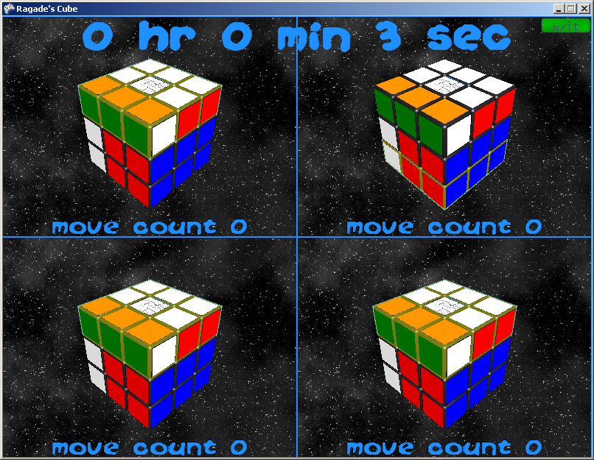

Each player has their own quadrant of the screen. Player 1 is in the upper-left corner. Player 2 is in the upper-right corner. Player 3 is in the bottom-left corner. Player 4 is in the bottom-right corner.

Each player has their own cube and move count in their quadrant. The move count is incremented each time a face is rotated.

At the top of the screen is the current time.

If there is a mouse player, then there is an EXIT button in the upper-right corner. The player using the mouse can click on this button to return to the main menu.
Gameplay
There are three devices that can be used to play the game – a PC keyboard, a PC mouse, and an XBox 360 gamepad.
Keyboard Controls
Shift-W – Rotate camera toward top
Shift-A – Rotate camera toward left
Shift-D – Rotate camera toward right
Shift-S – Rotate camera toward bottom

W – Select top face
A – Select left face
D – Select right face
S – Select bottom face
F -- Rotate Face Counter-Clockwise
Shift-F -- Rotate Face Clockwise
Tab – Orient face to top
ESC – Return to main menu

Mouse Controls
Left-Click – Rotate Face Counter-Clockwise
Right-Click – Rotate Face Clockwise
Left-Click-and-Drag – Rotate Camera
Left-Click and Right-Click – Orient face to top
Click on Quit Button – Return to main menu

Gamepad Controls
Left Analog – Change Selection
LT + Left Analog – Rotate Cube
START – Return to main menu

LB – Rotate Face Counter-Clockwise
RB – Rotate Face Clockwise
A – Orient face to top

