Software Requirements Specification

for

Ragade’s Cube

Version 1.0

Prepared by:
Steven Shofner,
Jason Spruill,
Chris Lockhart,
Chris Boyle

University of Louisville

Created: September 2, 2007
Table of Contents
Table of Contents ii
Introduction 1
Purpose of the requirements document 1
Scope of the product 1
Definitions, acronyms, and abbreviations 1
References 2
Overview 3
Overall Description 3
Product Perspective 3
System Interfaces 3
User Interfaces 4
Hardware Interfaces 6
Software Interfaces 6
Communications Interfaces 7
Operations 7
User Characteristics 8
Client 8
Server 8
Constraints 9
Assumptions and dependencies 10
Apportioning of requirements 11
Specific Requirements 11
Functional requirements 11
Cross Platform Requirements 12
PC Specific Requirements 30
Xbox 360 Specific Requirements 39
Performance Requirements 39
Software system attributes 39
Availability 39
Security 39
Maintainability 41
Portability 41

Introduction

Purpose of the requirements document
This document is a thorough introduction to the concepts, techniques, and ideas behind the intended functionality and design of the Ragade’s Cube game, scheduled to release in December 2007. The intent is to communicate to potential server sites, potential vendors, and potential investors the soundness of the design as well as the entertainment value that the project shall bear at its completion.

Scope of the product
Ragade’s Cube is an intense, head-to-head Rubik’s Cube clone. The game is a test of the pattern recognition skills of a single player and a test of the player’s understanding of the rotation algorithms involved in the Rubik’s Cube game.
The product is much more than a simple virtual Rubik’s Cube. In addition to a single player grappling with a Rubik’s Cube, this game shall allow up to four players to compete with one another in solving an identical cube of variable size. Furthermore, a computer player of variable difficulty may be added to any game. These competitors may, depending upon the game mode, compete on the metrics of either time taken or number of individual moves taken to reach the completed state.
The software shall provide a server-client interface among players, as well as various forms of input including gamepad and mouse-and-keyboard.
The product is developed using Microsoft’s XNA Game Studio Express, a C# development environment that allows access to Microsoft’s XNA framework. The XNA framework will provide all of the functionality for displaying the cube in three dimensions along with sound and user input.

Definitions, acronyms, and abbreviations
There are a few terms that should be defined more precisely for clear and concise reading of this document.
- XNA – XNA is a set of .NET tools designed by Microsoft to assist in game development. The acronym is short for the circular phrase, “XNA’s Not Acronymed.” See the official Microsoft XNA FAQ page at http://msdn2.microsoft.com/en-us/directx/aa937793.aspx for more details.
- .NET – The .NET Framework is an application framework designed by Microsoft to encourage and facilitate language independent source code.
- ClickOnce – A deployment technology that enables self-updating Windows-based applications that can be installed and run with minimal user interaction.
- Rubik's Cube – The Rubik’s Cube game is a famous puzzle game that tests the player’s algorithm development and execution abilities. The classic Rubik’s Cube is a cube consisting of three-by-three-by-three smaller cubes with each external side possessing a color. Any face, including internal and external, vertical and horizontal faces – containing 3x3x1 smaller cubes may be rotated clockwise or counter-clockwise. All faces of the smaller cubes that do not face the outside are uncolored and do not affect game play. The goal of the game is to rotate the faces of the larger cube until each side of the larger cube is comprised of a contiguous color. Alternative versions include a cube that is four-by-four-by-four or five-by-five-by-five, and a cube that has a picture in the center smaller cube of each side that must be right-side-up for the puzzle to be considered complete.
- “The Cube” – The n-by-n-by-n cube of smaller “cubelets” around which game play is centered is often referred to as simply the “Cube”.
- “Cubelets” – The term “Cubelets” refers simply to the smaller cubes, most with one, two, or three colored sides, that “the Cube” is comprised of.
- Ragade’s Cube – Ragade’s Cube is the software product that this document describes.
- SAU – Server Adminsitrator User; the administrator of a server, who runs the server.exe file and makes changes directly to the server.ini file to determine the settings of the server.

References
- The project Wiki – http://rubiks-cube-challege.googlecode.com
- The Microsoft FAQ page on XNA – http://msdn2.microsoft.com/en-us/directx/aa937793.aspx
- ClickOnce deployment – http://msdn2.microsoft.com/en-us/library/t71a733d(VS.80).aspx

Overview
The rest of the document contains a general description and functional specification of the Ragade’s Cube game.

Overall Description

Product Perspective
The Ragade’s Cube is a unique game when compared with other puzzle-type applications. The multi-player ability of the game sets it apart by allowing the user to have a more entertaining and social experience.

System Interfaces
To allow the multi-player experience and allow for a modular design, the application is broken into several major pieces.
- The Client – The application component that the user executes and interacts with.
  - Input Component – Handles all input devices that interact with the client.
  - Sound Component – Interacts with the system audio components.
  - Graphics Component – Deals with displaying and rotating the game cube for each player, in 3d.
  - Networking Component – Manages the messages that are sent back and forth from the client and the server.
  - Game State Managing Component – Interacts with the game engine to determine the specific results of a given sequence of input. Guides game flow.
  - Game Engine – The foundation upon which all other components rest, providing specific services, functionality, and logic to the game in question.
- AI Component – Acts as a separate player but is controlled by various algorithms that are implemented.
- The Server – The facilitator of networked multi-user play that acts as a mediator for interactions between each connected client.
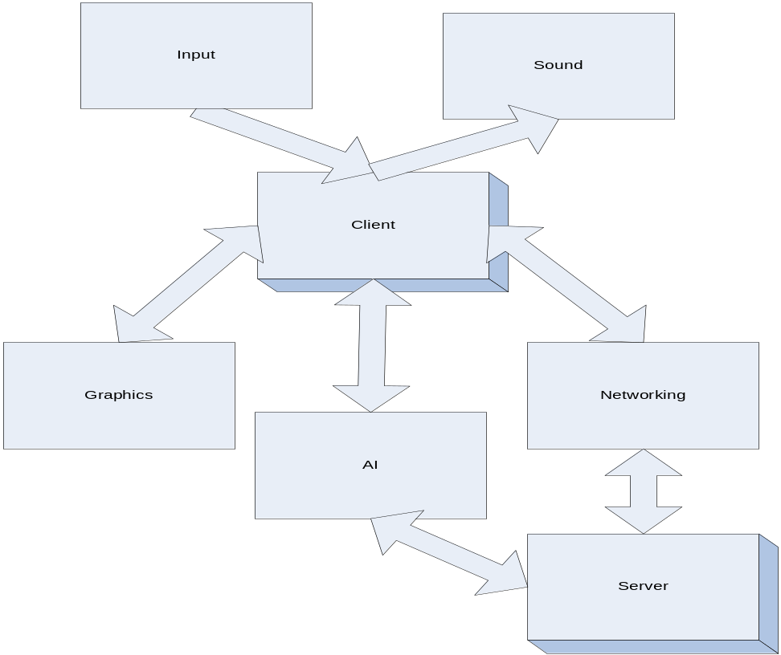

Figure 1

User Interfaces
The game client will have four primary game states, each with its own graphical user interface. Each of these will allow certain functionality to allow the user to set and use the program as he pleases.

Main Menu
The Main Menu will be the first game state the user enters when running the program. He will be able to select amongst the other three game states from this window. He will also be able to exit the program from this state, at which point the program will shut down. A possibility of what the view could look like is displayed below.
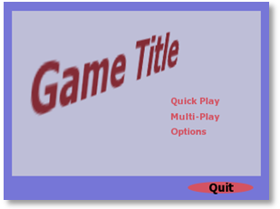
Figure 2

Game Play
The Game Play state is where the actual game play takes place. This will allow the user to view the virtual cube and manipulate it based on the input chosen. When this mode starts up, it will run through the options set by default or by the user, which will determine how the game is played. The mode will keep the user updated on time on puzzle and number of moves. A possible view of the Game Play Mode is displayed below.
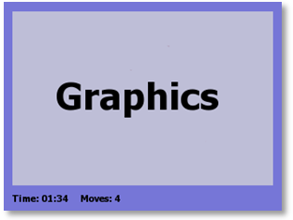
Figure 3

Network Play
In this state, the user will be able to connect to another computer running a server. The server will have options set by the user, or default options in the absence of user changes. Once a client connects, the options are set by the server. The network play will allow chat for the users in any sub-state, while waiting for the server to initiate the game. When the game launches, it will go into the game play state with network ability. The user may watch the other players manipulate their cubes while he manipulates his in real time.

Options
In this state, the user will be able to view and change various settings, including audio settings, control settings, and network settings.

Hardware Interfaces

Input Sources
The game will have three different sources of input: the keyboard, the mouse, and XBOX 360 controller. Since Ragade’s Cube will be designed for both the computer and the Xbox 360, there will be various input options for both platforms.
The various input devices that shall be used between these two platforms:
- Keyboard
- Mouse
- Xbox 360 Gamepad

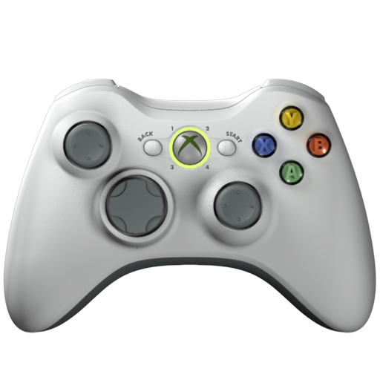
Figure 4

Software Interfaces
The game will have the ability to run and interact with two separate software components: the client and the server. The client/server interactions will allow multi-player match play.

Client
In the client mode, the application will not attempt to connect to the server until the user requests to. The user will need to know the IP address of the hosting server in order to request a connection. The client will wait for the server to initiate the game; the client will then create its own instance of the playing field and send a live data feed to the server. Once the session is completed, the client will send the final value of the metric used in that session for comparison to reveal the winner.

Server
In the server mode, the application will read a server setting file and immediately begin listening for connections. The SAU will need to know the host IP address of the server to give to other potential players. The server will not allow more than four clients to connect simultaneously to a single gaming session. When a game session is created, the client creating the session on the server will specify the game parameters, which shall be used by all clients subsequently connecting to that session. After the session has been initialized, the client responsible for its creation shall have no more privileges than any other client. The server will start the game after the completion of a countdown, beginning as soon as the allotted number of players have joined. The server will receive data from the clients and send data pertaining to user movement to all clients to communicate the current state of the play field. Once the game session reaches a final state the server will communicate the final state of that session to all clients.
The players may leave anytime while playing on the server. If the server drops, the game is over. If a client drops while the session is still running, the cube maintained by that client shifts to AI control with a difficulty level specified by the client that created the game session and the game continues.

Communications Interfaces
The TCP/IP protocol will be used to provide reliable client/server connections. The communications port used to establish the connection will have a by default value which the client user can change at runtime and the SAU can change before runtime in the settings file.

Operations

Deployment/Installation

PC Game
Deployment for a PC build will require the use of Microsoft’s ClickOnce technology. This technology will compile and automatically publish each build to a specific location on a web server. Each time the game application begins, the web server is checked to see if a newer version of the game exists and updates the local copy accordingly.

XBOX 360
Deployment for the XBOX 360 will force the user to install manually.

Un-installation

PC Game
Un-installation of the game will require the user to:
- Go to the Windows Control Panel
- Go to Add or Remove Programs
- Click on the application in the application list
- Click on the "Uninstall" button that appears

XBOX 360
Un-installation of the game from the XBOX 360 will require the user to:
- Go to the XNA game menu
- Go to My Games
- Select and delete the game from the game list

User Characteristics

Client
The users will be expected to have some knowledge of interacting with a Windows-based computer involving such tasks as: installation/un-installation of software, using the Internet, and dealing with network ports. It may also be advantageous for the user to be able to install a XBOX 360 controller through the USB interface.

Server
Users who will be using the server mode of this software will need some degree of familiarity with terminal based game server administration. Checking server logs may be necessary to locate inappropriate activity and take the necessary action to resolve issues.

Constraints

Regulatory Policies
Various regulatory policies will be in place for development and distribution of the application. The distribution of the source code and the compiled version of the software will require the conformance to the license of any third-party components used. If the license cannot be followed, then the component must not be used or permission from the original author must be granted.

Hardware Limitations
The application must be run on a computer with a graphics card that supports at least Shader Model 1.1 and DirectX 9.0c. A network connection is required for game play spanning multiple computers.

Interfaces to other applications
The game will not have to interface with other applications.

Parallel Operation
If the game is running in a networked mode, it will require the existence of both a server and various clients. The client/server model can exist in various forms.

Dedicated Server
Running in dedicated server mode, a group of clients will be able to connect to a main server that will facilitate multi-user game play. The major benefit of running in this mode would be an increased amount of throughput that can be transferred from client to server. The entire system would become more responsive and therefore game play would be improved. The disadvantage of this type of connection is that an actual dedicated server would need to be set up and available to the users. This would require an investment in a computer to run the server application.
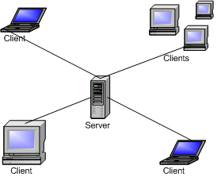
Figure 5

Non-dedicated server
Running the application in networked mode without the availability of a dedicated server would require at least one computer to run as both a client and a server. Because one computer will have the processing requirement of both the client and the server, the entire system will tend to have poorer performance. This is not the recommended way to run in networked mode.
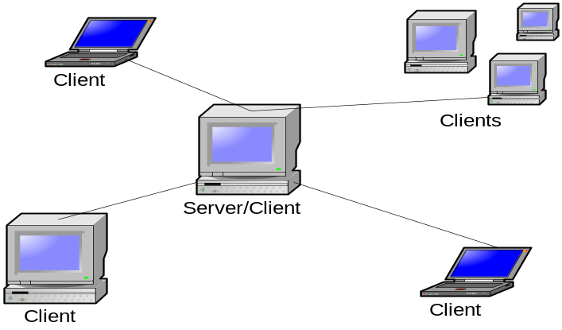
Figure 6

Assumptions and dependencies
The user shall be assumed to be running Windows XP SP2 or a newer edition of Windows in order for the installation procedure of the Windows version of the program to function. Alternatively the user shall be expected to be running an XBOX 360 capable of installing and running an XNA application. The program itself shall determine which of these assumptions to rely upon, and it shall fail if neither is true.

Apportioning of requirements
There are certain features that could be possible for this project but will have to be delay for later consideration:
- Networking over Xbox Live on the Xbox 360 – the XNA framework does not provide the ability for networked game play on the Xbox 360. This problem will be fixed on the 2.0 release of XNA that will be release in December 2007.
- Other Input Devices – Adding additional input devices for the game can be possible due to the abstract design of the input component. Adding an additional device should be simple and practical for a later team project.
- Generalized puzzle gaming engine – there are many components in the design of the Rubik’s cube game. Many of these components can be duplicated in other games that function in the same manner. It would be convenient if the components communicated through an abstract framework so that many other types of puzzle games can be played.

Specific Requirements
The specific requirements are to be used by the designers to verify that the requirements of the system have been satisfied. The specific requirements for this system are defined as functional requirements, design constraints, software system attributes, and security. The requirements define every possible input and output the system has to handle.

Functional requirements
The functional requirements define the various inputs that the system will take and the outputs that it must respond with. Validity of inputs, sequence of operations, exception handling, and relationship with other components are all defined in this section.
Each requirement is classified by priority and criticality:
- Priorities:
  - Priority 0: Fix immediately (within 24 hours)
  - Priority 1: Must fix
  - Priority 2: Should fix
  - Priority 3: Fix for Fit and Finish
  - Priority 4: Fix last
- Criticalities:
  - Criticality 0: Extremely critical to the success of the application
  - …
  - Criticality 4: Not very critical

Cross Platform Requirements
The cross platform requirements are requirements that exist on all possible systems, including a Windows PC and Xbox 360.

Client
The requirements specified in this section deal with the client application.

Sound
The requirements specified in this section deal with the sound subsystem of the client. The sound subsystem interfaces with the audio component on the system and can play sounds.

The sound subsystem shall provide an interface to a system’s audio components to play sound for corresponding events on a screen.

Classification
Issue #: | 1
Priority: | 4 – Fix Last
Criticality: | 4 – Not very critical

Requirement Definition
Validity check on inputs: | Check to see if a system event id is registered with the subsystem.
Sequence of operations: | - Check to see if the system event id is registered.  - Load the corresponding sound file into memory based upon the event id.  - Play the sound.
Exception handling: | If an exception is thrown then no sound will be played.
Relationship out/in: | The relationship between the event id input and the sound output will be managed by a hash table in local memory.

Description
For most events that occur during the operation of the system, there should be a corresponding sound to accompany the event. This only enhances that experience for the user and adds no real functionality to the application.

Input
The input subsystem handles input events that interact with the game. The subsystem will parse the events into something that the core can understand.

The client shall receive events from an input source and relay the data to the core.

Classification
Issue #: | 2
Priority: | 1 – Must Fix
Criticality: | 1 – Very Critical

Requirement Definition
Validity check on inputs: | No validity check is needed because the XNA framework deals with most of the input management problems. If invalid input is coming from an input source, the XNA framework will deal with this.
Sequence of operations: | - Receive a request from another subsystem to check for any possible inputs.  - Read the input data from all possible inputs.  - Convert the read input data into a data structure that can be read by the core.  - Inform the core that an input event occurred.
Exception handling: | Typically no exceptions should occur. In the case that an exception does happen, the subsystem will ignore the current inputs.
Relationship out/in: | The subsystem will take a snapshot of the current state of the possible inputs and convert it into a data structure that can be read internally.

Description
The input handling system for the application is an integral part of the application. In order for the user to interact and user the program, this subsystem needs to function property on the platform that it is running on.
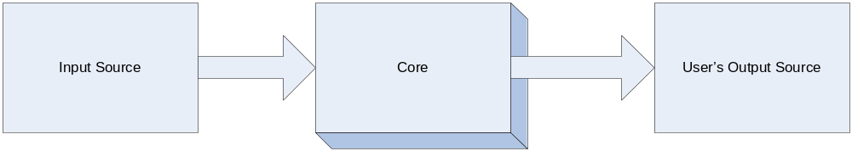
Figure 7

GUI
The requirements specified in this section deal with the GUI and the various screens that need to be displayed while running the application.

The GUI shall provide game menus that allow the user to begin game play and select options.

Classification
Issue #: | 3
Priority: | 1 – Must Fix
Criticality: | 1 – Very Critical

Requirement Definition
Validity check on inputs: | The current state of the game state manager will determine what the next menu/screen will be displayed.
Sequence of operations: | - The next game state is determined.  - The state is handled in the game loop and requested to draw on the screen.
Exception handling: | If no states are available, the game with exit. If a state’s graphic has trouble loading, a message will be displayed to the user and the system will shutdown.
Relationship out/in: | The next available state provided by the state manager will be the current screen displayed.

Description
There are various menus that allow a user to navigate through the game. The menus shall provide the user easy access to change the various options for game play and to start a new game session.

The GUI shall provide a cursor to select menu items.

Classification
Issue #: | 4
Priority: | 3 – Fix for Fit and Finish
Criticality: | 3 – Somewhat critical

Requirement Definition
Validity check on inputs: | An input event will be passed to the current state. The state will handle the logic to highlight a section of code.
Sequence of operations: | - The input subsystem will generate an event.  - The current state receives the input event and determines if it intersects with an object on the screen (ie. Menu item)  - If intersection, the next draw request will include a type of highlighting for the text.
Exception handling: | No exceptions are expected.
Relationship out/in: | The input event will determine if a menu item could possibly be highlighted.

Description
The GUI should provide a cursor where the enter button, left mouse click, or ‘A’ button on the game pad will select the menu item and move along to the next possible program section. If the “Escape” button or ‘B’ button on the gamepad is selected, then the user should be sent back to the previous menu screen.

The client shall highlight either a row or column when the game Cube is displayed during game play.

Classification
Issue #: | 5
Priority: | 1 – Must fix
Criticality: | 1 – Very Critical

Requirement Definition
Validity check on inputs: | An input event will be passed to the current state. The state will handle the logic to highlight a section of code.
Sequence of operations: | - The input subsystem will generate an event.  - The current state receives the input event and determines if it intersects with an object on the screen (ie. Menu item)  - If intersection, the next draw request will include a type of highlighting for the text.
Exception handling: | No exceptions are expected.
Relationship out/in: | If the input event does not determine a new cursor position, the cursor will remain at its current position.

Description
The user needs to be able to determine which column is currently selected and how to correctly interact with the cube. There should be the ability to move the highlight cursor to different columns and rows.
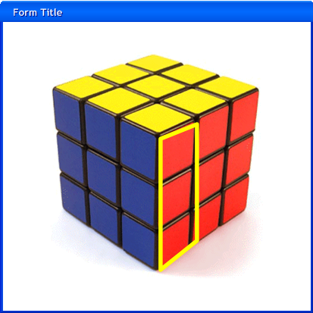
Figure 8

The GUI shall display the cubes of each player in a split screen format.

Classification
Issue #: | 6
Priority: | 1 – Must fix
Criticality: | 3 – Somewhat critical

Requirement Definition
Validity check on inputs: | ???
Sequence of operations:
Exception handling:
Relationship out/in:

Description
The split screen is important so that the user will know his current state in the game. In the cases of networked sessions, thorough testing is necessary so that each cube accurately represents the current state for each user.
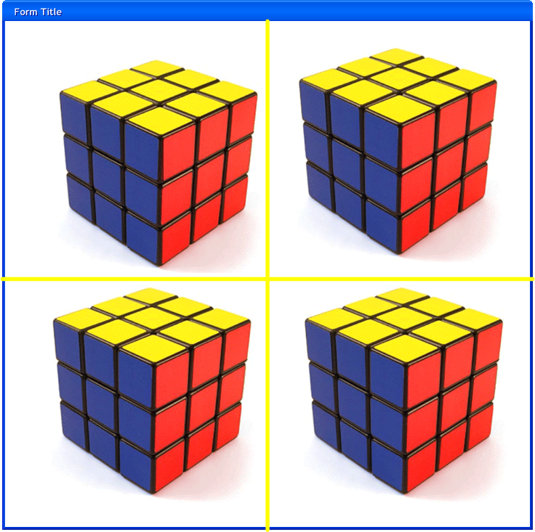
Figure 9

The GUI shall accurately display statistics for each user on the screen.

Classification
Issue #: | 7
Priority: | 3 – Fix for Fit and Finish
Criticality: | 3 – Somewhat critical

Requirement Definition
Validity check on inputs: | Inputs are Move Count, Count Down Timer. They are valid Integers.
Sequence of operations: | - Load user’s data in real-time  - Load raster font  - Display Data
Exception handling: | None required
Relationship out/in: | User data comes in, user data is displayed.

Description
The statistics for each user that will be displayed is: number of moves and total time.
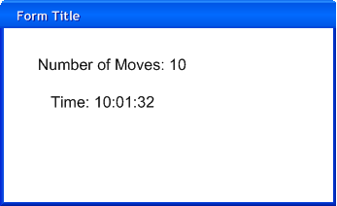
Figure 10

Core
The requirements specified in this section deal with the core of the application. The core controls the entire flow and logic of the application.

The core should interpret input events in a logical order.

Classification
Issue #: | 8
Priority: | 3 – Fix for Fit and Finish
Criticality: | 3 – Somewhat critical

Requirement Definition
Validity check on inputs: | Takes only expected user input data. Filter others.
Sequence of operations: | - Recive mapped input  - Respond appropriately based on state
Exception handling: | None required.
Relationship out/in: | User Input data is handled appropriately by state.

Description
- Show a pause screen when either the “Select” button on the game pad is selected or the “Escape” button is pressed on the key board.
- Rotate the game cube 90 degrees when the enter button, left mouse click, or ‘A’ button on the game pad is selected.
- Move the cublet highlight cursor when the mouse is moved or the directional pad moves the cursor.
  - Column is selected:
    - When the cursor is requested to move:
      - Left or right.
        - If at the left border the entire cube will shift 90 degrees to the right as to change the current face of the cube.
        - If at the right border the entire cube will shift 90 degrees to the left as to change the current face of the cube.
        - If not at border to currently selected column will move to the requested column.
      - Up or down:
        - If up the entire cube will shift 90 degrees to the south as to change the current face of the cube.
        - If down the entire cube will shift 90 degrees to the north as to change the current face of the cube.
      - When the shift button, right mouse button, or “LT” button on the game pad is pressed, the currently selected row is selected by the highlighted.
      - If the current row is ambiguous then the top row is always selected (typically the row will only be non-ambiguous when using the mouse).
    - Row is selected:
      - When the cursor is requested to move:
        - A column is selected to move up or down:
          - If at the top border the entire cube will shift 90 degrees to the south as to change the current face of the cube.
          - If at the bottom border the entire cube will shift 90 degrees to the north as to change the current face of the cube.
          - If not at border to currently selected column will move to the requested row.
        - A column is selected to move left or right:
          - If left the entire cube will shift 90 degrees to the west as to change the current face of the cube.
          - If right the entire cube will shift 90 degrees to the east as to change the current face of the cube.
        - When the shift button, right mouse button, or “LT” button on the game pad is pressed, the currently selected column is selected by the highlighted.
        - If the current row is ambiguous then the left column is always selected (typically the row will only be non-ambiguous when using the mouse).

The core will elicit certain services from a game engine.

Classification
Issue #: | 9
Priority: | 3 – Fix for Fit and Finish
Criticality: | 3 – Somewhat critical

Requirement Definition
Validity check on inputs: | No quantifiable inputs
Sequence of operations: | - Not linear sequence
Exception handling: | N/A
Relationship out/in: | Specific game logic makes use of game services through the engine.

Description
- Scene Management
- Scene Rendering
- Picking (Item Selection)
- Game loop logic
- Input Extraction

The CORE SHALL HAVE THE ABILITY TO MANAGE INPUT EVENTS FROM THE INPUT SUBSYSTEM

Classification
Issue #: | 10
Priority: | 3 – Fix for Fit and Finish
Criticality: | 3 – Somewhat critical

Description
The core will need to watch the input devices and provide information about input events.

The core shall manage the game screen flow using states.

Classification
Issue #: | 11
Priority: | 3 – Fix for Fit and Finish
Criticality: | 3 – Somewhat critical

Description
The user will experience the application through the currently active state. The active state will define the current:
- Scene
- Input scheme
- Specific state game logic
The states will also define the transition to other states and when they are invoked.

Gameplay
The requirements specified in this section deal with various game play functionalities for the game.

The client shall allow multiple players to participate and compete against each other

Classification
Issue #: | 12
Priority: | 2 – Should fix
Criticality: | 1 – Very critical

Requirement Definition
Validity check on inputs: | The game players are added to a game session.
Sequence of operations: | - Once all game players are added to a game session the game can start.  - The game starts.
Exception handling: | No exceptions are expected.
Relationship out/in: | The game players that are added are the ones that will play in the game.

Description
Different modes of multiplayer can be accessible from the Multiplayer menu item in the Main Menu Screen.
During game play, all multiplayer modes have:
- players start with same cube configuration for
- players compete for the same goal
- the ability for up to 4 players to play
- the option for computer players to participate
Multiplayer configurations will be set through subsequent submenu screens.

The client will have the following game states and game flow.

Classification
Issue #: | 13
Priority: | 1 – Must Fix
Criticality: | 1 – Very Critical

Requirement Definition
Validity check on inputs: | The current game state object is on determined by the game state manager.
Sequence of operations: | - State Specify state transition where appropriate  - The state manager will deactivate the current state and activate the one specified.
Exception handling: | Will not accept null states.
Relationship out/in: | Specify a state to be transitioned.

Description
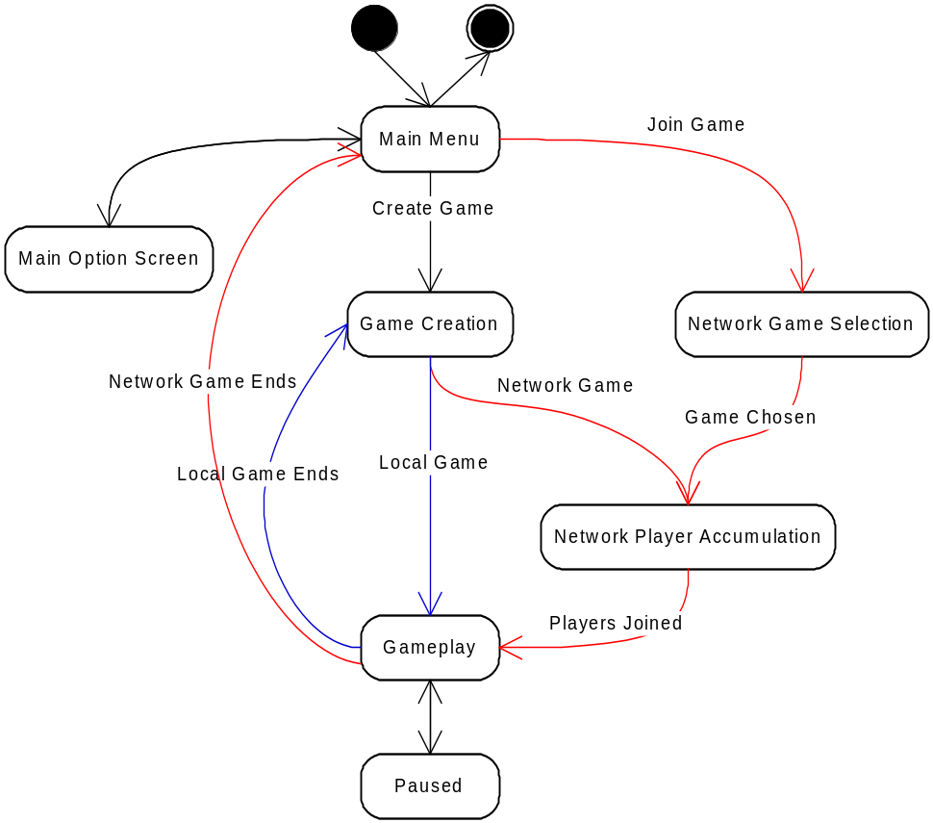
Figure 11
States specify state transitions within the state’s specific game logic code. A state will transition to another state when it deems appropriate.

Artificial Intelligence
The requirements specified in this section deal with the artificial intelligence that has the ability to solve the Rubik’s Cube.

The AI shall have a common interface that will allow it to interface to multiple components.

Classification
Issue #: | 14
Priority: | 2 – Should fix
Criticality: | 3 – Somewhat critical

Requirement Definition
Validity check on inputs: | The AI will be given a game cube and an algorithm to use.
Sequence of operations: | - The AI will be initialized.  - The AI is ready for manipulation.
Exception handling: | No exceptions are expected.
Relationship out/in: | The cube is what will be solved and the algorithm needs to have some good variation to really give the effect of different levels of complexity.

Description
Both the client and the server need to take advantage of the AI during a game session and AI component should be able to instantiated with any other component.
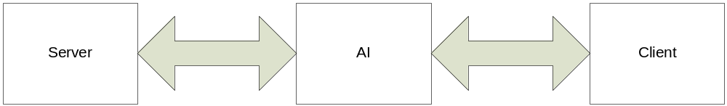
Figure 12

The AI shall be able to solve the main game cube in different levels of expertise.

Classification
Issue #: | 15
Priority: | 2 – Should fix
Criticality: | 3 – Somewhat critical

Requirement Definition
Validity check on inputs: | The AI will be given a game cube and an algorithm to use. The algorithm will provide the variable levels of expertise.
Sequence of operations: | - The AI is initialized.  - The best path for solving the cube is picked.  - The AI waits its turn and solves the cube.
Exception handling: | No exceptions are expected.
Relationship out/in: | The cube is what will be solved and the algorithm needs to have some good variation to really give the effect of different levels of complexity.

Description
The AI component should have the ability to manipulate the game cube. While the manipulations should not be random, the algorithms that are used to solve should be of variable expertise. For example, the beginner AI should solve the game cube slower than the expert AI.

PC Specific Requirements
The requirements that are specified in this section deal with on requirements that affect the PC.

Client
The requirements in this section deal with the client.

Networking
The requirements in the section deal with the networking subsystem.

The networking shall provide interactions with a game server in order to start game sessions against multiple clients across at TCP/IP connection.

Classification
Issue #: | 16
Priority: | 2 – Should fix
Criticality: | 3 – Somewhat critical

Requirement Definition
Validity check on inputs: | The networking subsystem takes a Server reference. The reference is checked to see if a valid connection exists.
Sequence of operations: | - A server reference is found.  - The client registers with the server.  - The client joins or creates a game session.
Exception handling: | An exception is caught if a game cannot be started. This will be relayed back to the user and another chance will be given to start another game.
Relationship out/in: | The server reference is the server that the networking subsystem interacts with.

Description
The client will interact with a server to:
- Create a game with a custom configuration
- Allow players to join a or observe a game
- Send current player data to update other player’s client screens
  - Executed moves
  - Move count
  - Player statistics
- Send Synchronization Messages
  - Start game
  - Cube completed
  - End game
- Allow chat among the players - Players will be able to send text messages to one another during game play.

Server
The requirements specified in this section describe the server system.

The server shall mediate games between the clients.

Classification
Issue #: | 17
Priority: | 1 – Must fix
Criticality: | 1 – Very Critical

Requirement Definition
Validity check on inputs: | The clients register with the server. The clients meta data is checked for validity (like IP Address).
Sequence of operations: | - The client registers.  - The client starts a game session or joins an existing game session.  - The server starts the game.  - The server determines when the game is finished.
Exception handling: | No exceptions are expected.
Relationship out/in: | The clients that are registered are the clients that are allowed to play in the games.

Description
The server will serve as a mediator and manage game session between clients. Each client will have the ability to create a new game session and other clients will have the ability to join the created session. Only up to four separate players can join a game session.

The server shall close a game session when there are zero connected clients.

Classification
Issue #: | 18
Priority: | 1 – Must fix
Criticality: | 1 – Very Critical

Requirement Definition
Validity check on inputs: | The clients need to be checked to see if their connections remain valid.
Sequence of operations: | - If no clients are found connected, the game session is cleaned up.  - No more clients are allowed to join the game session.
Exception handling: | No exceptions are expected.
Relationship out/in: | The clients are in the connected client list are used to determine the active connections.

Description
The server shall clean up any opened connections when all of the clients are finished with a session.

The server shall allow connected clients in a game session to restart the same game session when one completes.

Classification
Issue #: | 19
Priority: | 1 – Must fix
Criticality: | 1 – Very Critical

Requirement Definition
Validity check on inputs: | The clients need to be checked to see if their connections remain valid.
Sequence of operations: | - The clients are checked for validity.  - The game is requested to restart.
Exception handling: | No exceptions are expected.
Relationship out/in: | The clients that remain are the clients that will play in the next game.

Description
The exact game session will keep restarting until all of the clients disconnect.

The server shall start at the command line with a command that can request the used port.

Classification
Issue #: | 20
Priority: | 1 – Must fix
Criticality: | 1 – Very Critical

Requirement Definition
Validity check on inputs: | The port number specified must be a number. Otherwise, it should be ignored.
Sequence of operations: | - The arguments are parsed from the command line.  - The port number, if available, needs to be parsed from a string to an int.  - The channel for the port should be registered on the computer.
Exception handling: | An exception will be thrown if the port number is invalid.
Relationship out/in: | The port number specified will be the same port that will be used for connections.

Description
It is important the user has the ability to change the port because sometimes a port is unable to unblock on a PC or some unforeseen issue.

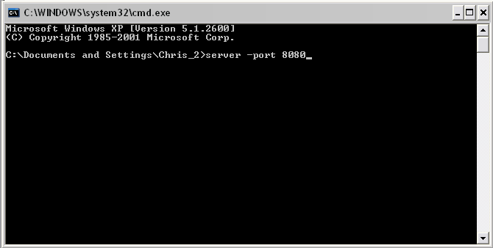
Figure 13

The server shall keep an accurate log of activities that will flush to a file every twenty minutes.

Classification
Issue #: | 21
Priority: | 2 – Should fix
Criticality: | 3 – Somewhat critical

Requirement Definition
Validity check on inputs: | An internal log of activities is kept in local memory.
Sequence of operations: | - The internal log is flushed into a file.  - The file is named based off the current date/time stamp.
Exception handling: | If the file write is unsuccessful, the log data will be lost.
Relationship out/in: | The log activities internally and on the disk should be the same.

Description
The log is used to determine if certain IP address or other activities are causing the system problems. This allows a system administrator to deal with possible issues.

The server shall block an IP Address that tries to connect more than 10 times a minute.

Classification
Issue #: | 22
Priority: | 3 – Fix for Fit and Finish
Criticality: | 3 – Somewhat critical

Requirement Definition
Validity check on inputs: | The input will be a particular IP address that should be of the correct form. If not then the connection will be denied.
Sequence of operations: | - The connection will be requested.  - An IP address is determined.  - A request connection log is checked to determine any overuse activity.  - If overuse is determined, the IP address will be added to the temporary block list.
Exception handling: | No exceptions are expected.
Relationship out/in: | The IP address that is provided by the new connection will provide the key to see if the address should be blocked or not.

Description
The block on the IP Address will only last for 60 minutes but should be enough to deal with suspicious activity.

The server shall read an XML file of blocked IP Addresses located in its root directory before the application starts.

Classification
Issue #: | 23
Priority: | 3 – Fix for Fit and Finish
Criticality: | 3 – Somewhat critical

Requirement Definition
Validity check on inputs: | The validity of the XML file will be checked by the DOM XML parser. If an error occurs, the file will not be parsed and an error flag will be set. Then the schema will be checked for validity.
Sequence of operations: | - The validity of the file will be determined.  - The IP address list will be enumerated and added to internal memory.  - The system is now ready to block particular IP addresses.
Exception handling: | If any errors occur during the parsing process, an exception will be caught and then re-thrown.
Relationship out/in: | The infile that is read contains IP addresses that need to be blocked by the server.

Description
The XML file will contain the IP addresses that are deemed a hazard by the system administrator.

Xbox 360 Specific Requirements
There are no specific requirements for the Xbox 360 currently.

Performance Requirements
Specific performance requirements have not been set.

Software system attributes

Availability
The availability of the system has different levels for the different modes of play:
- Local User Play – The system should be available 100% of the time. There are no outside dependencies that would affect the local user to play the game. The only part of the application that can be unavailable is when a connection cannot be made to ClickOnce update server, in which the software cannot be updated.
- Network User Play
  - The system availability is affected by two different factors:
    - A reliable internet connection.
    - A dependable server that hosts the network play.
  - In the case of unavailability, the client will continuously check for a connection to the requested server until a timeout of 60 seconds or the cancel button is clicked by the user.

Security
Security issues are extremely important to consider for networked game play and ClickOnce software updates. The security threats fall into three separate categories:
- Confidentiality. User information that can disclose personal data should not be viewable via unauthorized access.
- Integrity. Threats that can damage or corrupt the application data.
- Availability. Threats that restrict access to the software or data.
These security issues are dealt with three classes of security controls:
- Ensure attacks are unsuccessful.
  - Network Play - This is solved by encrypting all application data that is sent from computer to computer. The cryptographical technique to be used has yet to be determined.
  - ClickOnce Deployment - This is solved by using unique hash signatures for all files that are used in the application. When the application performs the update, the hash signature for the file is checked for its validity.
- Detect and repel attacks.
  - Network Play – The server has the ability to detect and log unusual patterns of activity. If a certain IP address is causing too many errors in a short period of time, it will be blocked for an appropriate amount of time. The system administrator for the server has the responsibility to check these logs for long term patterns and a full scale IP address block is needed.
  - ClickOnce Deployment – Detection techniques have yet to be determined.
- Recovery from problems.
  - Network Play – Recovery techniques have yet to be determined.
  - ClickOnce Deployment – If an application update is determined to be unsuccessful the application the previously installed application will still be available to use. In that case, network play will be unavailable to ensure that game play is consistent.

Maintainability
Maintenance requirements have not been set yet.

Portability
The code that is written for this application is portable across:
- Windows XP Service Pack 2 and higher
- XBOX 360
Because the code is written in C# and makes use of the .NET common language interface, there should be no issues in the portability of code across those platforms. One possible issue is that XBOX 360 uses a smaller subset of the .NET framework called the compact framework. The possible issues should not affect any part of the application development.

