Software Requirements Specification
for
Ragade’s Cube
Version 1.0
Prepared by:
Steven Shofner,
Jason Spruill,
Chris Lockhart,
Chris Boyle
University of Louisville
Created: September 2, 2007
Table of Contents
Table of Contents ii
Revision History ii
1. Introduction 1
1.1 Purpose of the requirements document 1
1.2 Scope of the product 1
1.3 Definitions, acronyms, and abbreviations 1
1.4 References 2
1.5 Overview 2
2. Overall Description 2
2.1 Product Perspective 2
2.1.1 System Interfaces 2
2.1.2 User Interfaces 3
2.1.3 Hardware Interfaces 5
2.1.4 Software Interfaces 6
2.1.5 Communications Interfaces 6
2.1.6 Operations 6
2.2 User Characteristics 7
2.2.1 Client 7
2.2.2 Server 7
2.3 Constraints 7
2.4 Assumptions and dependencies 9
2.5 Apportioning of requirements 9
3. Specific Requirements 10
3.1 External Interfaces 10
3.2 Functional requirements 10
3.2.1 Client Mode 10
3.2.2 Server Mode 13
3.3 Performance requirements 14
3.4 Software system attributes 14
3.4.1 Availability 14
3.4.2 Security 14
3.4.3 Maintainability 15
3.4.4 Portability 15
4. Supporting Information 15
4.1 Appendixes 15

Revision History
Name | Date | Reason For Changes | Version
Chris Boyle | 09/02/07 | Initial Revision | 0.1

Introduction

Purpose of the requirements document
This document is a thorough introduction to the concepts, techniques, and ideas behind the intended functionality and design of the Ragade’s Cube game, scheduled to release in December 2007. The intent is to communicate to potential server sites, potential vendors, and potential investors the soundness of the design as well as the entertainment value that the project shall bear at its completion.

Scope of the product
Ragade’s Cube is an intense, head-to-head Rubik’s Cube clone. The game is a test of the pattern recognition skills of a single player and a test of the player’s understanding of the rotation algorithms involved in the Rubik’s Cube game.

The product is much more than a simple virtual Rubik’s Cube. In addition to a single player grappling with a Rubik’s Cube, this game shall allow up to four players to compete with one another in solving an identical cube of variable size. Furthermore, a computer player of variable difficulty may be added to any game. These competitors may, depending upon the game mode, compete on the metrics of either time taken or number of individual moves taken to reach the completed state.

The software shall provide a server-client interface among players, as well as various forms of input including gamepad and mouse-and-keyboard.

The product is developed using Microsoft’s XNA Game Studio Express, a C# development environment that allows access to Microsoft’s XNA framework. The XNA framework will provide all of the functionality for displaying the cube in 3 dimensions along with sound and user input.

Definitions, acronyms, and abbreviations
There are a few terms that should be defined more precisely for clear and concise reading of this document.

- XNA – XNA is a set of .NET tools designed by Microsoft to assist in game development. The acronym is short for the circular phrase, “XNA’s Not Acronymed.” See the official Microsoft XNA FAQ page at http://msdn2.microsoft.com/en-us/directx/aa937793.aspx for more details.
- .NET – The .NET Framework is an application framework designed by Microsoft to encourage and facilitate language independent source code.
- ClickOnce – A deployment technology that enables self-updating Windows-based applications that can be installed and run with minimal user interaction.
- Rubik's Cube – The Rubik’s Cube game is a famous puzzle game that tests the player’s algorithm development and execution abilities. The classic Rubik’s Cube is a cube consisting of three-by-three-by-three smaller cubes with each external side possessing a color. Any face, including internal and external, vertical and horizontal faces – containing 3x3x1 smaller cubes may be rotated clockwise or counter-clockwise. All faces of the smaller cubes that do not face the outside are uncolored and do not affect game play. The goal of the game is to rotate the faces of the larger cube until each side of the larger cube is comprised of a contiguous color. Alternative versions include a cube that is four-by-four-by-four or five-by-five-by-five, and a cube that has a picture in the center smaller cube of each side that must be right-side-up for the puzzle to be considered complete.
- “The Cube” – The n-by-n-by-n cube of smaller “cubelets” around which gameplay is centered is often referred to as simply “the Cube.”
- “Cubelets” – The term “Cubelets” refers simply to the smaller cubes, most with one, two, or three colored sides, that “the Cube” is comprised of.
- Ragade’s Cube – Ragade’s Cube is the software product that this document describes.
- Ragade – The code smell detector.
- SAU – Server Adminsitrator User; the administrator of a server, who runs the server.exe file and makes changes directly to the server.ini file to determine the settings of the server.

References
- The project Wiki – http://rubiks-cube-challege.googlecode.com
- The Microsoft FAQ page on XNA – http://msdn2.microsoft.com/en-us/directx/aa937793.aspx
- ClickOnce deployment – http://msdn2.microsoft.com/en-us/library/t71a733d(VS.80).aspx

Overview
What follows is the specific description and specifications of the Ragade’s Cube game. Particular focus is on the functions and interfaces of the software package, the target audience, the specific constraints as well as assumptions and dependencies that may affect the project, requirements that may be delayed as well as those that are expected to be completed by the end of the project’s fourth month of production, logical requirements, aspects of reliability, availability, security, maintainability, and portability, system modes and user classes, and objects, features, stimuli, responses, functional hierarchies, a
Finish this!

Overall Description

Product Perspective
The Ragade’s Cube is a unique game when compared with other puzzle-type applications. The multi-player ability of the game sets it apart by allowing the user to have a more entertaining and social experience.

System Interfaces
To allow the multi-player experience and allow for a modular design, the application is broken into several major pieces.

- The Client – The application component that the user executes and interacts with.
  - Input Component – Handles all input devices that interact with the client.
  - Sound Component – Interacts with the system audio components.
  - Graphics Component – Deals with displaying and rotating the game cube for each player, in 3d.
  - AI Component – Acts as a separate player but is controlled by various algorithms that are implemented.
  - Networking Component – Manages the messages that are sent back and forth from the client and the server.
  - Game State Managing Component – Interacts with the game engine to determine the specific results of a given sequence of input. Guides game flow.
  - Game Engine – The foundation upon which all other components rest, providing specific services, functionality, and logic to the game in question.
- The Server – The facilitator of networked multi-user play that acts as a mediator for interactions between each connected client.

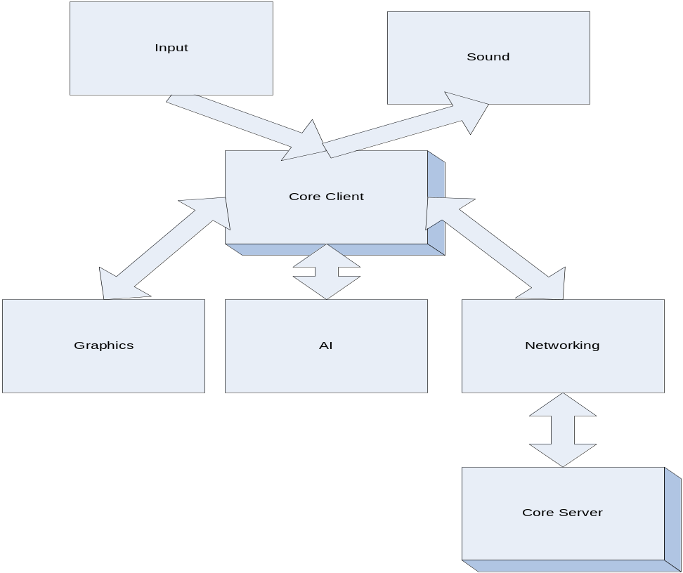

Figure 1

User Interfaces

The game client will have four primary game states, each with its own graphical user interface. Each of these will allow certain functionality to allow the user to set and use the program as he pleases.

Main Menu
The Main Menu will be the first game state the user enters when running the program. He will be able to select amongst the other three game states from this window. He will also be able to exit the program from this state, at which point the program will shut down. A possibility of what the view could look like is displayed below.

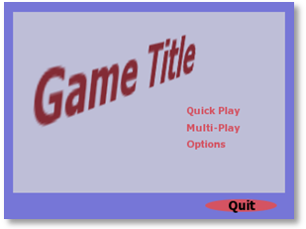
Figure 2

Game Play
The Game Play state is where the actual game play takes place. This will allow the user to view the virtual cube and manipulate it based on the input chosen. When this mode starts up, it will run through the options set by default or by the user, which will determine how the game is played. The mode will keep the user updated on time on puzzle and number of moves. A possible view of the Game Play Mode is displayed below.

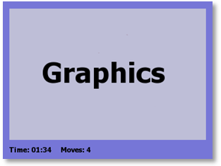
Figure 3

Network Play
In this state, the user will be able to connect to another computer running a server. The server will have options set by the user, or default options in the absence of user changes. Once a client connects, the options are set by the server. The network play will allow chat for the users in any sub-state, while waiting for the server to initiate the game. When the game launches, it will go into the game play state with network ability. The user may watch the other players manipulate their cubes while he manipulates his in real time.

Options
In this state, the user will be able to view and change various settings, including audio settings, control settings, and network settings.

Hardware Interfaces

Input Sources
The game will have three different sources of input: the keyboard, the mouse, and XBOX 360 controller. Since Ragade’s Cube will be designed for both the computer and the Xbox 360, there will be various input options for both platforms.
The various input devices that shall be used between these two platforms are as follows
- Keyboard
- Mouse
- Xbox 360 Gamepad

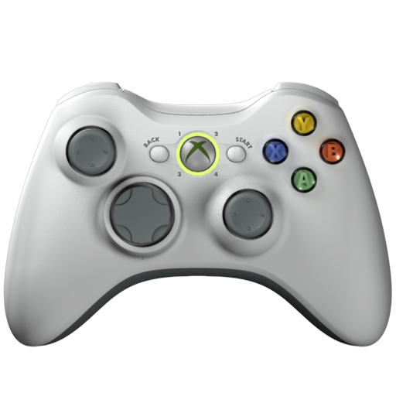
Figure 4

Software Interfaces
The game will have the ability to run and interact with two separate software components: the client and the server. The client/server interactions will allow multi-player match play.

Client

In the client mode, the application will not attempt to connect to the server until the user requests to. The user will need to know the IP address of the hosting server in order to request a connection. The client will wait for the server to initiate the game; the client will then create its own instance of the playing field and send a live data feed to the server. Once the session is completed, the client will send the final value of the metric used in that session for comparison to reveal the winner.

Server

In the server mode, the application will read a server setting file and immediately begin listening for connections. The SAU will need to know the host IP address of the server to give to other potential players. The server will not allow more than four clients to connect simultaneously to a single gaming session. When a game session is created, the client creating the session on the server will specify the game parameters, which shall be used by all clients subsequently connecting to that session. After the session has been initialized, the client responsible for its creation shall have no more privileges than any other client. The server will start the game after the completion of a countdown, beginning as soon as the allotted number of players have joined. The server will receive data from the clients and send data pertaining to user movement to all clients to communicate the current state of the play field. Once the game session reaches a final state the server will communicate the final state of that session to all clients.

The players may leave anytime while playing on the server. If the server drops, the game is over. If a client drops while the session is still running, the cube maintained by that client shifts to AI control with a difficulty level specified by the client that created the game session and the game continues.

Communications Interfaces
The TCP/IP protocol will be used to provide reliable client/server connections. The communications port used to establish the connection will have a by default value which the client user can change at runtime and the SAU can change before runtime in the settings file.

Operations

Deployment/Installation

PC Game

Deployment for a PC build will require the use of Microsoft’s ClickOnce technology. This technology will compile and automatically publish each build to a specific location on a web server. Each time the game application is started, the web server is checked to see if a newer version of the game exists and updates the local copy accordingly.

XBOX 360
Check on requirements.

Un-installation

PC Game
Un-installation of the game will require the user to:
- Go to the Windows Control Panel
- Go to Add or Remove Programs
- Click on the application in the application list
- Click on the "Uninstall" button that appears

XBOX 360
Un-installation of the game from the XBOX 360 will require the user to:
- Go to the XNA game menu
- Go to My Games
- Select and delete the game from the game list

User Characteristics

Client
The users will be expected to have some knowledge of interacting with a Windows-based computer involving such tasks as: installation/un-installation of software, using the Internet, and dealing with network ports. It may also be advantageous for the user to be able to install a XBOX 360 controller through the USB interface.

Server
Users who will be using the server mode of this software will need some degree of familiarity with terminal based game server administration. Checking server logs may be necessary to locate inappropriate activity and take the necessary action to resolve issues.

Constraints

Regulatory Policies
Various regulatory policies will be in place for development and distribution of the application. The distribution of the source code and the compiled version of the software will require the conformance to the license of any third-party components used. If the license cannot be followed, then the component must not be used or permission from the original author must be granted.

Hardware Limitations
The application must be run on a computer with a graphics card that supports at least Shader Model 1.1 and DirectX 9.0c. A network connection is required for game play spanning multiple computers.

Interfaces to other applications
The game will not have to interface with other applications.

Parallel Operation
If the game is running in a networked mode, it will require the existence of both a server and various clients. The client/server model can exist in various forms.

Dedicated Server

Running in dedicated server mode, a group of clients will be able to connect to a main server that will facilitate multi-user game play. The major benefit of running in this mode would be an increased amount of throughput that can be transferred from client to server. The entire system would become more responsive and therefore game play would be improved. The disadvantage of this type of connection is that an actual dedicated server would need to be set up and available to the users. This would require an investment in a computer to run the server application.

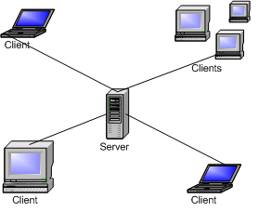
Figure 5

Non-dedicated server
Running the application in networked mode without the availability of a dedicated server would require at least one computer to run as both a client and a server. Because one computer will have the processing requirement of both the client and the server, the entire system will tend to have poorer performance. This is not the recommended way to run in networked mode.

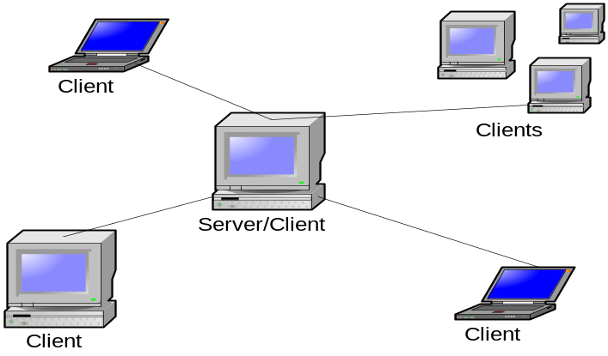
Figure 6

Assumptions and dependencies
The user shall be assumed to be running Windows XP SP2 or a newer edition of Windows in order for the installation procedure of the Windows version of the program to function. Alternatively the user shall be expected to be running an XBox 360 capable of installing and running an XNA application. The program itself shall determine which of these assumptions to rely upon, and it shall fail if neither is true.

Apportioning of requirements
- Networking over Xbox Live
- Other Input Devices
- Generalized puzzle gaming engine

Specific Requirements
<This template illustrates organizing the functional requirements for the product by system features, the major services provided by the product. You may prefer to organize this section by use case, mode of operation, user class, object class, functional hierarchy, or combinations of these, whatever makes the most logical sense for your product.>

Functional requirements
In the model used in this project, the server simply serves as a mediator between clients. A single server may have zero to many simultaneous gaming sessions. A gaming session is begun on the server on command by a client, who also sets the parameters of the gaming session at this point. The session begins in a waiting-for-players state. The client who created the gaming session has no special privileges. The session ends when no players remain waiting for the game to begin. The session moves to a countdown state when the number of players specified on session creation have joined. At the end of the countdown state, the in-game state begins.

Client Mode

The client shall receive an event from an input source and perform the appropriate action.
The client will have the ability to take input from a source, like a keyboard or game controller, and appropriately perform an action based upon the current screen state. For example, if the user’s screen is showing a menu screen and the user presses ‘A’ on the game pad, the menu should cause some type of response on the screen.

The appropriate response depends on the situation.

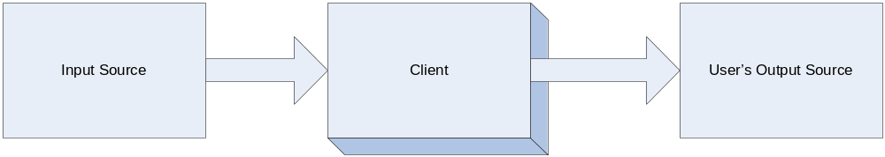

Figure 8

Menu is displayed
The client provide a cursor where the enter button, left mouse click, or ‘A’ button on the game pad will select the menu item and move along to the next possible program section. If the “Escape” button or ‘B’ button on the gamepad is selected, then the user should be sent back to the previous menu screen.

Game screen is shown
The client will:
- Show a pause screen when either the “Select” button on the game pad is selected or the “Escape” button is pressed on the key board.
  - The pause screen will be another menu that will allow the user to:
    - Exit the current application.
    - Change sound options.
    - Change display options.
- Rotate the game cube 90 degrees when the enter button, left mouse click, or ‘A’ button on the game pad is selected.

- Move the cublet highlight cursor when the mouse is moved or the directional pad moves the cursor.
  - Column is selected:
    - When the cursor is requested to move:
      - Left or right.
        - If at the left border the entire cube will shift 90 degrees to the right as to change the current face of the cube.
        - If at the right border the entire cube will shift 90 degrees to the left as to change the current face of the cube.
        - If not at border to currently selected column will move to the requested column.
      - Up or down:
        - If up the entire cube will shift 90 degrees to the south as to change the current face of the cube.
        - If down the entire cube will shift 90 degrees to the north as to change the current face of the cube.
    - When the shift button, right mouse button, or “LT” button on the game pad is pressed, the currently selected row is selected by the highlighted.
      - If the current row is ambiguous then the top row is always selected (typically the row will only be non-ambiguous when using the mouse).
  - Row is selected:
    - When the cursor is requested to move:
      - A column is selected to move up or down:
        - If at the top border the entire cube will shift 90 degrees to the south as to change the current face of the cube.
        - If at the bottom border the entire cube will shift 90 degrees to the north as to change the current face of the cube.
        - If not at border to currently selected column will move to the requested row.
      - A columns is selected to move left or right:
        - If left the entire cube will shift 90 degrees to the west as to change the current face of the cube.
        - If right the entire cube will shift 90 degrees to the east as to change the current face of the cube.
    - When the shift button, right mouse button, or “LT” button on the game pad is pressed, the currently selected column is selected by the highlighted.
      - If the current row is ambiguous then the left column is always selected (typically the row will only be non-ambiguous when using the mouse).
- Go back to the main menu screen when a game is over.

The client shall highlight either a row or column when the game Cube is displayed during game play.
The user needs to be able to determine which column is currently selected and how to correctly interact with the cube. There should be the ability to move the highlight cursor to different columns and rows.
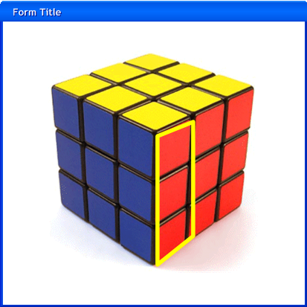
Figure 9

The client shall display the cubes of each player in a split screen format.
The split screen is important so that the user will know his current state in the game. In the cases of networked sessions, thorough testing is necessary so that each cube accurately represents the current state for each user.
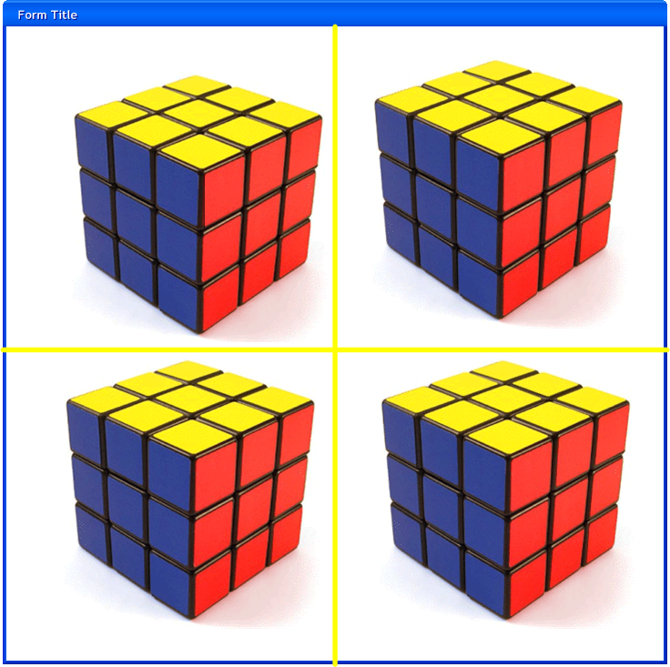
Figure 10

The client shall accurately display statistics for each user on the screen.
The statistics for each user that will be displayed is: number of moves and total time.
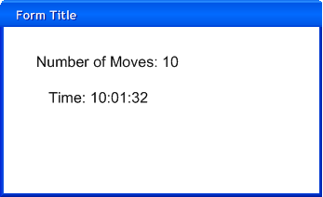
Figure 11

Server Mode

The server shall start at the command line with a command that can request the used port.
It is important the user has the ability to change the port because sometimes a port is unable to unblock on a PC or some unforeseen issue.

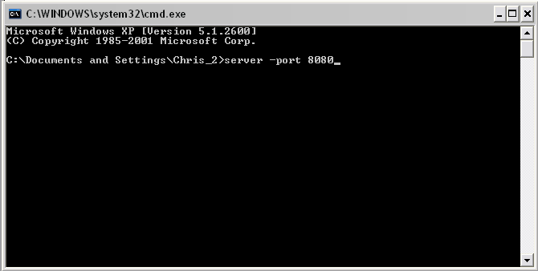
Figure 12

The server shall keep an accurate log of activities that will flush to a file every twenty minutes.
The log is used to determine if certain IP address or other activities are causing the system problems. This allows a system administrator to deal with possible issues.

The server shall block an IP Address that try to connect more than <<NUMBER>> a minute.
The block on the IP Address will only last for <<NUMBER>> minutes but should be enough to deal with suspicious activity.

The server shall read an XML file of blocked IP Addresses located in its root directory before the application starts.
The XML file will contain the IP addresses that are deemed a hazard by the system administrator.

Performance requirements
There are no performance requirements yet.

Software system attributes

Availability
The availability of the system has different levels for the different modes of play:

- Local User Play – The system should be available 100% of the time. There are no outside dependencies that would affect the local user to play the game. The only part of the application that can be unavailable is when a connection cannot be made to ClickOnce update server, in which the software cannot be updated.
- Network User Play
  - The system availability is affected by two different factors:
    - A reliable internet connection.
    - A dependable server that hosts the network play.
  - In the case of unavailability, the client will continuously check for a connection to the requested server until a timeout of 60 seconds or the cancel button is clicked by the user.

Security
Security issues are extremely important to consider for networked game play and ClickOnce software updates. The security threats fall into three separate categories:

- Confidentiality. User information that can disclose personal data should not be viewable via unauthorized access.
- Integrity. Threats that can damage or corrupt the application data.
- Availability. Threats that restrict access to the software or data.

These security issues are dealt with three classes of security controls:

- Ensure attacks are unsuccessful.
  - Network Play - This is solved by encrypting all application data that is sent from computer to computer. The cryptographical technique to be used has yet to be determined.
  - ClickOnce Deployment - This is solved by using unique hash signatures for all files that are used in the application. When the application performs the update, the hash signature for the file is checked for its validity.
- Detect and repel attacks.
  - Network Play – The server has the ability to detect and log unusual patterns of activity. If a certain IP address is causing too many errors in a short period of time, it will be blocked for an appropriate amount of time. The system administrator for the server has the responsibility to check these logs for long term patterns and a full scale IP address block is needed.
  - ClickOnce Deployment – Detection techniques have yet to be determined.
- Recovery from problems.
  - Network Play – Recovery techniques have yet to be determined.
  - ClickOnce Deployment – If an application update is determined to be unsuccessful the application the previously installed application will still be available to use. In that case, network play will be unavailable to ensure that game play is consistent.

Maintainability
Maintenance requirements have not been set yet.

Portability
The code that is written for this application is portable across:
- Windows XP Service Pack 2 and higher
- XBOX 360

Because the code is written in C# and makes use of the .NET common language interface, there should be no issues in the portability of code across those platforms. One possible issue is that XBOX 360 uses a smaller subset of the .NET framework called the compact framework. The possible issues should not affect any part of the application development.

Supporting Information

Appendixes

