环境准备

安装nodejs/npm STABLE

安装Webstorm 2016.1

npm config set strict-ssl false

npm config set proxy http://175.6.4.89:18088

npm install

如果出现 npm ERR! Error: write EIO, 在cmd里面执行chcp 850, 然后继续 npm install

学习流程

1. Read the [Architecture Overview](https://angular.io/docs/ts/latest/guide/architecture.html) to get the big picture.
2. Try the [QuickStart](https://angular.io/docs/ts/latest/quickstart.html). The QuickStart is the "Hello, World" of Angular 2. It shows us how to setup the libraries and tools we'll need to write any Angular app.
3. Take the Tour of Heroes [Tutorial](https://angular.io/docs/ts/latest/tutorial) which picks up from where the QuickStart leaves off and builds a simple data-driven app. Simple, yes, but with the essential characteristics we'd expect of a professional application: a sensible project structure, data binding, master/detail, services, dependency injection, navigation, and remote data access.

Return to the Basics section and continue in the suggested order:

1. [Displaying Data](https://angular.io/docs/ts/latest/guide/displaying-data.html) explains how to get information on to the screen.
2. [User Input](https://angular.io/docs/ts/latest/guide/user-input.html) covers the basics of responding to user behavior.
3. [Forms](https://angular.io/docs/ts/latest/guide/forms.html) handle user data entry and validation within the UI.
4. [Dependency Injection](https://angular.io/docs/ts/latest/guide/dependency-injection.html) is the way we build large, maintainable applications from small, single purpose parts.
5. [Template Syntax](https://angular.io/docs/ts/latest/guide/template-syntax.html) is a comprehensive study of Angular template HTML.

架构[Architecture Overview](https://angular.io/docs/ts/latest/guide/architecture.html)

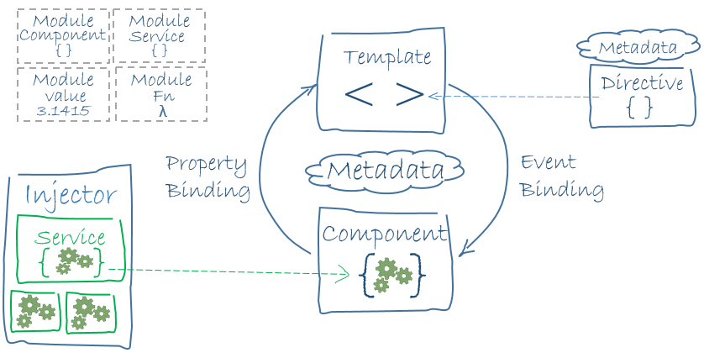

1. [Module](https://angular.io/docs/ts/latest/guide/architecture.html#module)
2. [Component](https://angular.io/docs/ts/latest/guide/architecture.html#component)
3. [Template](https://angular.io/docs/ts/latest/guide/architecture.html#template)
4. [Metadata](https://angular.io/docs/ts/latest/guide/architecture.html#metadata)
5. [Data Binding](https://angular.io/docs/ts/latest/guide/architecture.html#data-binding)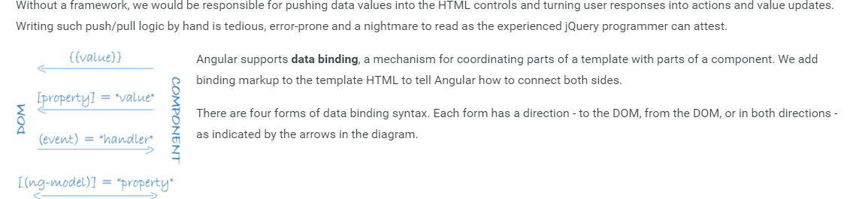
6. [Service](https://angular.io/docs/ts/latest/guide/architecture.html#service)
7. [Directive](https://angular.io/docs/ts/latest/guide/architecture.html#directive)
8. [Dependency Injection](https://angular.io/docs/ts/latest/guide/architecture.html#dependency-injection)

Angular 1 & 2 代码规范

<https://github.com/johnpapa/angular-styleguide>