Department of Data Science Results Analysis Report

Introduction
This report presents an analysis of student performance data to evaluate trends across different subjects and sections. Key insights include pass/fail distributions, average scores by subject, and overall section-wise performance.

Abstract
This project is a Department of Data Science Results Analysis that processes student performance data to generate insights on pass/fail counts by section and subject. The project includes visualizations that display results breakdown across different sections, helping in analyzing academic performance trends and identifying areas of improvement.

Features
- Section-wise Pass/Fail Analysis: Visualizes the number of students who passed or failed in each subject, separated by section.
- Subject-wise Performance Comparison: Compares performance metrics across subjects to give a clear view of student strengths and weaknesses.
- Data Cleaning & Transformation: Prepares raw data by handling missing values and converting data types as needed.
- Interactive Data Visualization: Generates visual charts (bar plots) to illustrate performance statistics.

Dataset
The dataset includes columns such as:
- Roll Number, Name, Section
- Subject names (e.g., BEFA, DM, OS, DBMS, DPA) with corresponding status columns (Befa_Status, Dm_Status, etc.)
- Total_Marks, SGPA, CGPA, Subjects_due

Abbreviations:
BEFA - Business Economics and Financial Analysis
DM - Discrete Mathematics
OS - Operating Systems
DBMS - Database Management Systems
DPA - Data Preparation and Analysis
ES - Environmental Science
SD-Lab - Skill Development Lab

Project Structure
- data.csv: Contains the student performance data used in this analysis.
- DataScience-Results-Analysis.ipynb: Jupyter Notebook with data processing, analysis, and visualization code.
- app.py: Contains the Selenium code for Data Scraping

Insights and Findings
1. Subject-Wise Average Marks
Insight: Subjects such as `OS-Lab`, `DBMS-Lab`, and `SD-Lab` have higher average marks
compared to theory subjects like `DM` and `DBMS`.
2. Subject-Wise Pass/Fail Counts
Insight: Higher pass percentages were observed in subjects like `DPA` and `BEFA`, while `DM` had a lower pass percentage.

3. Section-Wise Pass/Fail Counts
Insight: Sections like ‘A’ and ‘C’ has high and equal no. of students passed and the ‘B’ section has the high inn no. of students failed

4. Subject-Wise Pass/Fail Counts - Section-Wise
Insight: Higher pass percentages were observed in subjects like `DPA` and `BEFA`, while `DM` had a lower pass percentage in each Section.
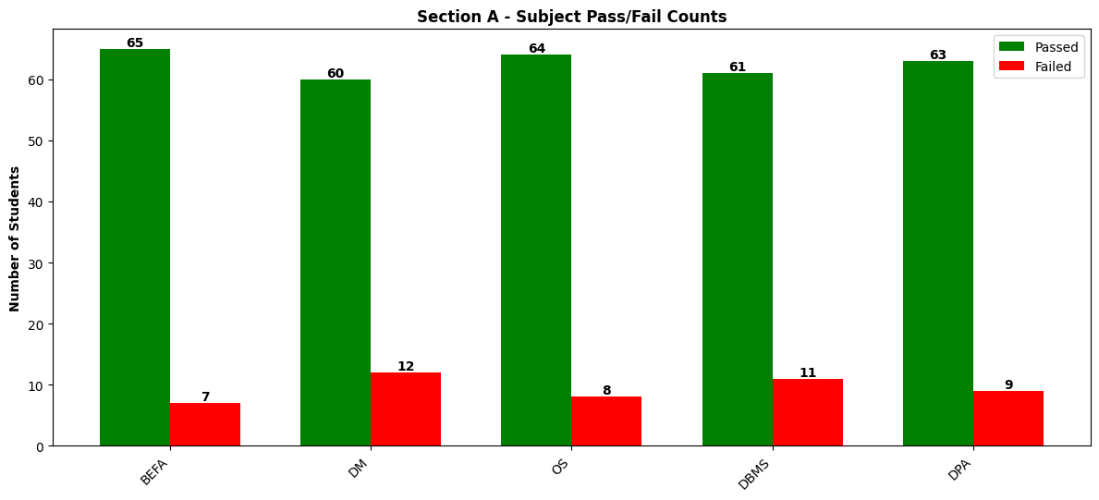
5. Top 10 Students by CGPA and SGPA
Insight: Students with high SGPA and CGPA tend to have consistently strong marks across multiple subjects.
- Top 10 Students by SGPA
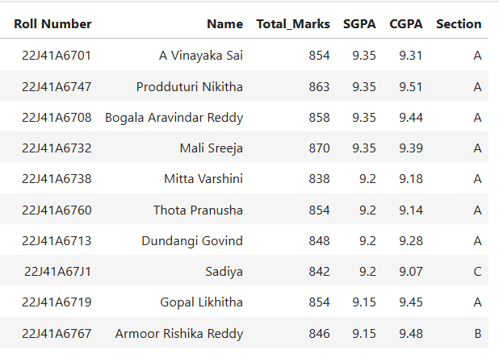
- Top 10 Students by CGPA
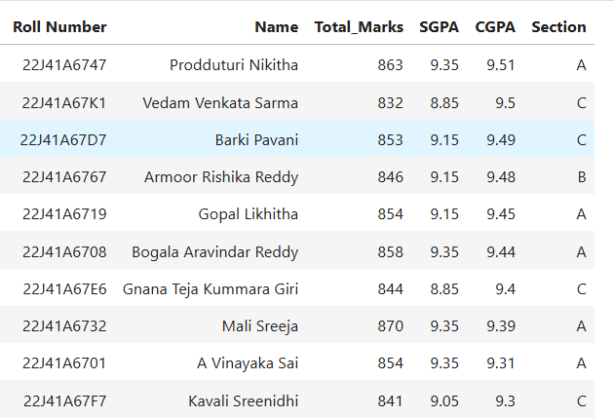
6. Section-Wise Pass Percentage
Insight: Section `A` had a slightly Higher pass rate while Section `B` had a slightly lower pass rate than Sections `A` and `C`, with room for improvement in theoretical subjects.
7. Subject wise pass percentage
8. Section-wise Analysis of Detained Students
Insight: Section A has higher detention rate
