**H-bridge motor driver**

**214487**

* An H-bridge motor driver circuit is an electronic circuit that allows a voltage to be applied across a load (typically a DC motor) in either direction. This enables bidirectional control of the motor—forward, reverse, brake, and coast—making it essential in robotics, automotive systems, and industrial applications.

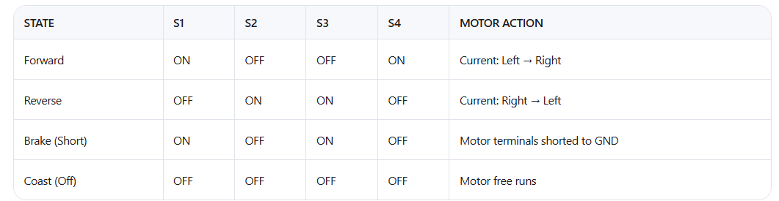

**✅ Why Use MOSFETs in an H-Bridge?**

**1.** High Efficiency (Low Power Loss)

* MOSFETs are voltage-controlled devices, meaning they require very little gate current to turn on.
* In contrast, BJTs are current-controlled and require continuous base current, which wastes power.
* This makes MOSFETs much more energy-efficient, especially in battery-powered systems (e.g., robots, drones).

**2.** Low On-Resistance (Rds(on))

* Modern MOSFETs have very low drain-to-source resistance when turned on.
* Example: A typical power MOSFET might have Rds(on) = 0.01 Ω.
* Power loss = I² × R → so low R means less heat, higher efficiency.
* This allows handling high currents without excessive heating.

**3.** Fast Switching Speed

* MOSFETs can switch on and off very quickly (nanosecond range).
* This is essential for PWM (Pulse Width Modulation) motor speed control.
* Faster switching reduces transition losses and improves efficiency.

**4.** Better Thermal Performance

* Due to lower power dissipation, MOSFETs run cooler than BJTs at the same current.
* Less heat means smaller or no heat sinks in many cases.

**5.** Scalability to High Power

* MOSFETs are available in a wide range of voltages (up to 100s of volts) and currents (10s to 100s of amps).
* They can be paralleled easily to handle even higher currents.

**6.** Ideal for High-Side Switching (with proper driver)

* In an H-bridge, two transistors switch on the "high side" (connected to +V).
* N-channel MOSFETs are preferred due to lower Rds(on), but need a gate voltage higher than the source.
* This is achieved using a bootstrap circuit or a dedicated gate driver IC.
* The freewheeling diode provides a safe path for the inductive current to "freewheel" or circulate when the switch turns off.

**Example: Motor turning OFF**

1. MOSFET (Q1) turns off.
2. Motor tries to keep current flowing (due to inductance).
3. Voltage at motor terminal reverses (negative spike).
4. Freewheeling diode (e.g., D2) becomes forward-biased.
5. Current flows through the diode, safely returning to the supply or ground.
6. Energy dissipates slowly as heat in the circuit resistance.

The gate control system:

**1. 🔄** Bidirectional Motor Control

The most important reason!

An H-bridge lets you:

* Drive a DC motor forward
* Drive it backward
* Stop or brake the motor
* Coast (let it spin freely)

This is impossible with a simple switch or single transistor.

**🔧 Example: Robot Car**

* Left wheel forward → right wheel reverse → turn left
* Without an H-bridge, you can’t reverse direction easily.

**2. ⚡️** Efficient Power Control via PWM

H-bridges support Pulse Width Modulation (PWM) to control motor speed.

* By varying the duty cycle of the signal, you can:
  + Run motor at 10%, 50%, or 100% speed
  + Save energy
  + Reduce heat

💡 No need for resistors or variable transformers — just digital control!

**3. 🔋** High Efficiency & Low Heat

Using MOSFETs in an H-bridge:

* Have very low on-resistance (Rds(on))
* Generate minimal heat when switching
* Are voltage-controlled, so they don’t waste power like BJTs

→ This means:

* Longer battery life
* Smaller heatsinks
* Cooler operation

Perfect for battery-powered devices (drones, robots, RC cars).

**4. 🔐** Built-in Protection Features

Modern H-bridge ICs include safety features:

* Shoot-through protection (prevents short circuits)
* Overcurrent shutdown
* Thermal shutdown
* Undervoltage lockout

These protect your system from damage due to faults.

**5. 🤖** Essential for Automation & Robotics

Robots need precise movement:

* Forward/backward
* Turning
* Stopping smoothly
* Speed control

Without an H-bridge, you’d need mechanical gears or multiple motors — inefficient and bulky.

✅ H-bridge enables smart, compact, programmable motion control.

**6. 📱** Easy Integration with Microcontrollers

You can control an H-bridge using:

* Arduino, Raspberry Pi, ESP32
* Just 2–4 digital pins per motor

BJT

NPN

his is a two-stage common-emitter amplifier or series voltage regulator.

**Stage 1: Q1 (Common-Emitter Amplifier)**

* Input: V1 via R1
* Biasing: R1 and R3 divide voltage
* Q1 amplifies the input signal

**Stage 2: Q2 (Emitter Follower or Buffer)**

* Driven by Q1’s collector
* Acts as buffer or current booster
* Output: At Q2’s emitter (or collector)

Pnp

This is a shunt-type voltage regulator or overvoltage clamping circuit using two PNP transistors.

**How It Works:**

1. Zener diode D1 sets a reference voltage.
   * Assume D1 is 5.6V Zener (common value).
2. When input voltage (Vi) rises above ~5.6V + Vbe (~0.7V), the base of Q1 becomes more positive than its emitter.
3. Q1 turns ON → conducts current through R1.
4. Q1's collector pulls base of Q3 high, turning Q3 ON.
5. Q3 sinks current from Vo → pulls Vo down → limits output voltage.
6. R3 and R4 form a divider that feeds back to control Q3.

**📊 Waveform Comparison**

|  |  |  |
| --- | --- | --- |
| Output Voltage (Vo) | Clamped at ~6V | Drops to 0V |
| Load Current | Decreases gradually | Spikes then drops |
| Fault Current | Near zero | Very high |
| Power Dissipation | Moderate | High |
| Recovery | Automatic | Manual (replace fuse) |

|  |  |  |
| --- | --- | --- |
| Action | Disconnects load from supply | Shorts supply to ground |
| Risk Level | Low | High |
| Suitability | Consumer electronics, sensors | Industrial, power systems |
| Complexity | Medium | Simple |
| Cost | Slightly higher (needs two transistors) | Lower |
| Reliability | High | Medium (depends on fuse) |

**🎯 Key Differences**