**Basic： 0.0 Goal： 6.5**

**Question：**

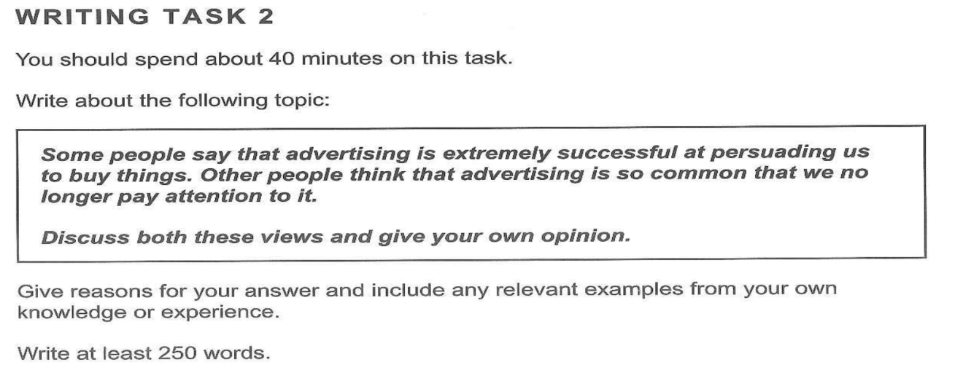

**Some people say that advertising is extremely successful at persuading us to buy things.**

|  |  |
| --- | --- |
| Question type | Both sides + opinion |
| Topic | 1. Some people say that advertising is extremely successful at persuading us to buy things. 2. Other people think that advertising is so common that we no longer pay attention to it. |
| Real writing tasks | 1. Discuss the reasons why people think advertising is extremely successful at persuading us to buy things. 2. Discuss the reasons why others believe that advertising is so common that we no longer pay attention to it. 3. Discuss your opinion whether advertising is extremely successful at persuading us to buy things OR advertising is so common that we no longer pay attention to it. |
| Synonyms for the key word in the topic  Some people say that advertising is extremely successful at persuading us to buy things. Other people think that advertising is so common that we no longer pay attention to it.  advertising - commercials, promotions, advertisements  successful - effective, prosper, thrive  persuading - convince, tempt, stimulate  Buy- purchase, acquire, order, possess  Things - material possessions, goods, products  common - usual, typical, many, frequent, ordinary,  pay attention - focus, catch attention, see, watch | |

**Student answer：**

People have different views about whether advertisements are attracting their attention or ignored by them. While most of the advertising is boring or even disgusting, some of it is fascinating and does have a positive effect.

On the one hand, according to some groups, advertisements no longer the factor that drives the market to buy. the majority of advertisements consumers see nowadays are meaningless and ordinary. The contents and styles of them are repetitive, and some of them even copied the forms of others’. Furthermore, people are more and more rational when shopping, which means they tend to buy necessities rather than unpractical goods. The shiny advertising no longer plays a central role in appealing to people. For example, there are various advertisements for different kinds of pencils and pens. However, these writing materials cannot be magical, so choosing some affordable products are adequate for most smart and practical individuals.

On the other hand, Others argue that commercials help brands drive high volume of sales. some advertising is indeed unique and creative, which makes the products outstanding and prevalent. For instance, some advertisements shown in the apple special event are truly cool and wonderful, and customers will be persuaded to buy an iPhone or iPad successfully if they are enthralled by the advertising videos. The reason why some advertising is terrific is that some companies spend plenty of time and money on making it as well as their products. As a consequence, the amazing advertisements help to boost sales, and the products live up to their fame.

In conclusion, I can understand why people are tired of common advertisements, but it seems to me that some typical advertising is worthwhile and desirable.



Word count: 260

如果想了解雅思考官是怎么给写作评分的，[可以按住CTRL键点这里了解](http://video.itongzhuo.com/03c6d3c6040c465683630a9304ec1bc7/9900328d2c824744bdb24a3d6617c227-702ea4d234a0e7352569e089bfa681af-fd.mp4)

如果想扫掉关于作文估分的几个地雷，[可以按住CTRL键点这里了解](http://video.itongzhuo.com/6ebeca47130945b293d7f1f0d798a10b/38ea38bce2e548b996046c2174171340-09a6ffb8f74c1515a8d8ce4a94d25a80-fd.mp4)

|  |  |  |
| --- | --- | --- |
|  |  | **Overall Positive Assessment** |
| **Task Response** | **7** | The introduction paraphrases the question and presents a clear opinion. The writer’s opinion is supported in the body of the essay, particularly on the 2nd side on why advertising cannot make people pay attention to. The conclusion restates the writer’s opinion. |
| **Coherence and Cohesion** | **6** | There is a standard arrangement of an essay; introduction with thesis statement; paragraphs; conclusion. |
| **Lexical Resource** | **6** | You were able to use express yourself with proper English for most parts. |
| **Grammatical Range and Accuracy** | **7** | uses complex structures; produces errors but do not affect meanings |
| **Overall Band Score** | **6.5** | **COMPETENT user** |

|  |  |
| --- | --- |
| **Suggestion** | |
| TR | **WEAK POINT: FORMAT**  **SUGGESTION:**   1. **Discussion + opinion question tips**  * **Identify both sides/arguments [there are always 2]** * **Find supporting points for both sides** * **Discuss both sides, not just the side you agree with. Follow instructions.** * **The 2 sides must be presented based on others’ views and not yours.** Your opinion can be clarified again in the conclusion and/or separate opinion paragraph. * **Balance the discussion of both sides.** Even if you agree with one side only, do not compromise the opposite. If this was purely opinion essay, it is fine. But discuss both views should be balanced and no bias should be apparent. * Do not contradict that views whether you agree or not. Focus on discussing the truth of the views. * The opinion can be “elaborated” in a separate opinion paragraph, while it is also fine to present opinion in the conclusion. * Preferably, it is best to have a separate opinion BP if your opinion is objective or balanced [agree both sides] OR different from the 2 views given because you can elaborate the reason which the examiner will have to understand. When having a separate opinion BP, you may or may not write or have a conclusion anymore. * Meanwhile, stating the choice briefly in the conclusion is preferable when you agree with one side and you have explained it clearly and strongly in its body paragraph. * *To summarize: discuss both views: --give equal arguments --recognize that it's the view of others - balanced ideas ***writing that one outweighs the other [when one side has 2, the other has 1 point] might lead to a wrong structure as the students might fail to address the 2 sides equally as per real writing tasks  *give your opinion  = choose which side you agree with and state this in the introduction and conclusion/ or you can have a a separate body paragraph for this = separate the paragraph for this to show that you recognize the two first before you give your own opinion*   **POSITIVE OUTCOME OF THESE CHANGES: knowing the different types of questions; how to attack them and format will give you confidence because you never know what you’ll get in the actual exam.** |
| CC | **WEAK POINT 1: FORMAT**  **SUGGESTIONS: Use appropriate structure - there are several types of question that you need to learn and they all have different / unique even standard structures to follow.**   * **Please take note the possible structures for this question type:**   **5 paragraph essay**   * 1. Introduction - state your clear opinion   2. Body #1 - 1st view - objective [other people’s view]   3. Body #2 - 2nd view - objective [other people]   4. *Body #3 - [In my opinion] explain YOUR opinion/reasons for choosing a side or both   5. Conclusion - [In conclusion] restate opinion   **4 paragraph essay with conclusion BP *this is yours as revised\***   1. Introduction - state your clear opinion 2. Body #1 - 1st view - objective [discuss others’ view] 3. Body #2 - 2nd view - objective [discuss others’ view]    1. Conclusion - [In conclusion] restate opinion   **4 paragraph essay with separate opinion BP/no conclusion BP**   1. Introduction - state your clear opinion 2. Body #1 - 1st view - objective [discuss others’ view] 3. Body #2 - 2nd view - objective [discuss others’ view] 4. In my opinion - restate opinion + explain   **POSITIVE OUTCOME OF THESE CHANGES:** Given that you already have a favored system , that’s fine. By all means do so! Practice and see what you feel most comfortable doing given the time limit of 40 minutes without compromising your response |
| LR | **WEAK POINT: NOTICEABLE SPELLING MISSES**  **SUGGESTIONS:**  For the purposes of succeeding in IELTS, it is best to be accurate with your words. By that, I mean you should be able to use the correct word for each situation rather than an incorrect word. This may seem obvious, but in fact many IELTS students get obsessed with learning as many words as possible, and they don’t focus on how to use them. The problem there is that you may have learned an interesting word, but if it is not accurately used, then it is just another mistake in your essay, and it may cause your score to be reduced.   *  Spelling words incorrectly *  Using the wrong word/phrase *  Repeating the same word too often   As an IELTS tutor, I see this every day. My students often write a passage using the most advanced vocabulary that they know in order to impress me, but doing so causes them to make completely incorrect sentences. Sometimes the inaccuracy is so extreme that a perfectly good sentence, which would have helped them achieve a very high score, becomes utterly unreadable. **Will you lose points if you make spelling mistakes in your IELTS WRITING test?** We know that spelling is important in [Listening](http://answers.scottsenglish.com/discussion/209/is-correct-spelling-important-in-my-ielts-toefl-or-toeic-test/p1) and [Reading](http://http//answers.scottsenglish.com/discussion/209/is-correct-spelling-important-in-my-ielts-toefl-or-toeic-test/p1) but what about Writing?  Does every word have to be spelled correctly?  The good news is you can make a few spelling mistakes and still get a high score - IELTS calls them 'slips'. In other words, just one or two small mistakes that do not affect meaning will have no impact on your score.  Here is what IELTS states in relation to spelling and the matching band scores:  **Band 8:**produces **rare errors in spelling**   **Band 7:** may produce **occasional errors in...spelling** and/or word formation  **Band 6:** makes **some errors in spelling...**but they do not impede (stop) communication (meaning)  **Band 5:** may make **noticeable errors in spelling...**that may cause some difficulty for the reader  Clearly, you can make spelling errors in your writing. How many spelling errors you make will impact your IELTS Writing band score.  The problem is that spelling in English is notoriously difficult. The only effective way of improving your spelling is to learn words one by one. Start by looking at the written work you have done in the past, and which has been marked by a teacher. Look for the words you misspelled and write them in a column on the left hand side of a piece of paper. Then try this simple and effective four-stage method to learn the spelling of each word:   * Look at the word. * Cover the word with a piece of paper. * Write the word. * Check whether your spelling is correct. * If your spelling is incorrect, repeat the process.   **POSITIVE OUTCOME OF THIS CHANGE:** Spelling is important not just in IELTS Writing but in IELTS Reading and IELTS Listening too. If you spell a word wrongly in the Listening test, you will not get the mark. In the Writing test, you will be judged on your ability to spell correctly. It gives a lasting impression to the examiner about your output. |
| GRA | **WEAK POINT 1: USE OF ARTICLES**  **SUGGESTION:**  **DEFINITE AND INDEFINITE ARTICLES**  In English there are three articles: a, an, and the. Articles are used before nouns or noun equivalents and are a type of adjective. The definite article (the) is used before a noun to indicate that the identity of the noun is known to the reader. The indefinite article (a, an) is used before a noun that is general or when its identity is not known. There are certain situations in which a noun takes no article.  As a guide, the following definitions and table summarize the basic use of articles. Continue reading for a more detailed explanation of the rules and for examples of how and when to apply them.  Definite article  **the** (before a singular or plural noun)  Indefinite article  **a** (before a singular noun beginning with a consonant sound) **an** (before a singular noun beginning with a vowel sound)  Count nouns - refers to items that can be counted and are either singular or plural  Non-count nouns - refers to items that are not counted and are always singular   |  |  |  | | --- | --- | --- | |  | COUNT NOUNS | NON-COUNT NOUNS | | **Rule #1** Specific identity not known | a, an | (no article) | | **Rule #2** Specific identity known | the | the | | **Rule #3** All things or things in general | (no article) | (no article) |     **POSITIVE OUTCOME OF THIS CHANGE:  while oftentimes, articles can be minor misses, too much mistakes can dull the discussion. Naturally knowing the rules of this will provide the paper preciseness and you as a writer will express fluency even to so-called "minor" parts of grammar. This gives good impression** |