***Dent and Buckle Learjet 60***

Table of contents

**1.** **Objective** 3

**2.** **Scope** 3

**3.** **Definitions and Abbreviations** 3

**4.** **Reference Documents** 3

**5.** **Description** 4

5.1.1. Types of Damage 5

5.1.2. Purpose of the review 5

5.1.3. Damage Focus 5

5.1.4. Conclusion 6

**6.** **Records** 6

**7.** **Attached Document.** 8

# **Objective**

The purpose of this report is to help ensure the airworthiness of the Learjet 60 aircraft by performing a Dent and Buckle study, the work is performed by keeping a record of any damage, dents, deformations or repairs that have been carried out on the aircraft. This study provides a comprehensive view of the structural condition of the aircraft.

# **Scope**

Includes an index, QR, 2D pictures, an overview table, and information such as aircraft registration, report date, and damage description.

The scope of the project will take into account the following

* Safety Assurance.
* Regulatory Compliance.
* Logging Repairs.
* Recording Damage.
* Assessment and Repair.

Records aircraft damage and repairs, and ensures flight crew that maintenance has assessed structural damage.

# **Definitions and Abbreviations**

* **CONICSO:** Company dedicated to Reliability and Engineering in Operational Safety Consulting.
* **SMS:** Safety Management System.
* **SRM:** Structural Repair Manual.
* **RAC:** Aeronautical Regulations of Colombia.

# **Reference Documents**

* Structural Repair Manual Learjet 60.
* Colombian Aeronautical Regulations - RAC 4 Airworthiness and Aircraft Operation Standards.

# **Description**

The structural inspection was carried out as shown in figure 1, starting with the nose, the left side of the aircraft, going over the entire front of the nose and clockwise, the structure of the aircraft was identified, the wings, flaps and ailerons were checked, then a check was made on the upper part of the fuselage and the lower part and finally the study was completed by checking vertical and horizontal stabilization.

This route was designed considering strategic points where possible damages to the aircraft were fully visualized.

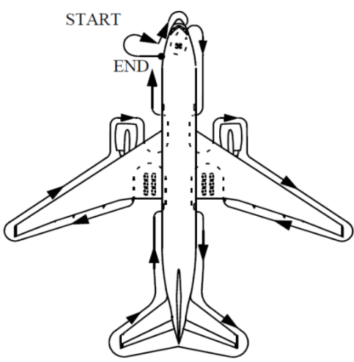

Figure . 360° - Walk Around

### Types of Damage

The following types of damage will be analyzed, verified and measured in order to identify whether they are permissible for operation or, otherwise, to be referred to the maintenance department.

* Fasteners.
* Cracks.
* Deformation.
* Corrosion.
* Dents.
* Scratches.
* Nicks.
* Fittings and Forgings.

### Purpose of the review

In compliance with current Operational Safety regulations, a structural mapping study is carried out in order to identify, through inspections, possible damage to the aircraft that does not affect the aircraft's (the Learjet 60-317) airworthiness.

### Damage Focus

A general study of the entire structure of the aircraft was carried out, including the fuselage, top and bottom, wings, stabilizers, among others. The evaluation included the identification of possible dents, imperfections, scratches, damage that could affect the airworthiness of the Learjet 60-317 aircraft.

A thorough inspection of possible damage was carried out, as well as its future implications, which were measured depending on the type of damage by depth, length and width, possible corrosion or missing structural components were verified. Tools such as a depth gauge were also used to measure the depth of the damage under a reference surface, a vernier caliper to measure the dimensions of small damages and thus know their interior and exterior diameters with a high degree of precision, a tape measure to measure lengths on straight surfaces, among others. This evaluation was detailed by extension and location, which allowed to know imperfections that could have significant implications on the aerodynamic resistance, structural stability and operational efficiency of the aircraft. The study included a folder with photographic documentation, a damage report, and a program developed in-house which will allow traceability of damage over time.

In the RAC 4 (**Airworthiness and Aircraft Operation Standards**) there are some standards which provide information such as airworthiness responsibility, basic structure, maintenance records, among others, where they provide and facilitate a follow-up to minimize damages to the aircraft.

In the RAC 4 at **Section 4.5.7.2 Airworthiness Responsibility** says that each certificate holder is responsible to maintain the aircraft airworthiness including aircraft structures, engines and propellers.

### Conclusion

The detailed damage assessment of the Learjet 60-317 aircraft highlights the critical importance of this process to ensure its structural integrity and safety. The inspection not only seeks to identify this damage, but also to thoroughly understand its extent and potential implications for the aircraft's performance. This not only meets safety and airworthiness standards, but also provides a sound basis for making informed decisions on any necessary corrective action. The visual documentation generated during the walkaround, and identification of damage will facilitate effective communication between maintenance personnel and other stakeholders, ensuring that the aircraft is maintained in optimum condition for safe and efficient aircraft operations.

It is worth noting that the personnel in charge of the aircraft are reminded that it is advisable to paint it because during the inspection many spaces were found without its protection.

# **Records**

In the following illustration is shown the damages that were found during the inspection.

Figure 2 Located damages in Left View.

Figure 3 Located damages in up view.

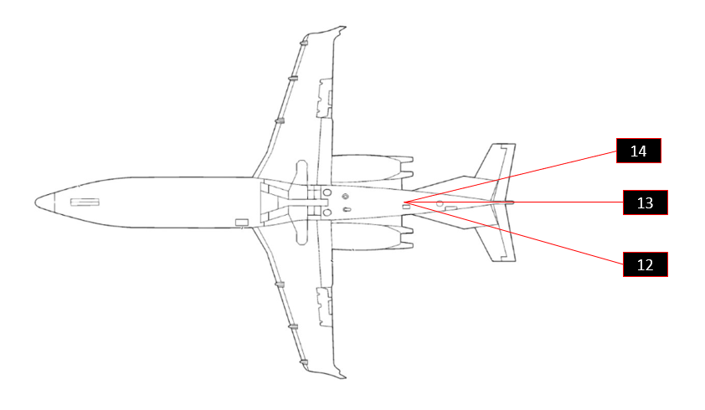

Figure 4. Located damages in down view.

All the items are listed in the file named as DENT&BUCKLE.xlsx

During the analysis, it was found that most of the damages are into the limits given by the manufacturer, and the other ones are controlled by the operator.

# **Attached Document.**

To close this report, the document DAMAGE CHART (DENT & BUCKLE) is attached.