***Dent and Buckle Learjet 60***

Table of contents

**1.** **Objective** 3

**2.** **Scope** 3

**3.** **Definitions and abbreviations** 3

**4.** **Reference documents** 3

**5.** **Description** 4

5.1.1. Purpose of the review 5

5.1.2. Damage focus 5

5.2. Conclusion 6

**6.** **Records** 6

**7.** **Attached Document.** 7

# **Objective**

The objective of this report is to comprehensively determine and analyze the scope of the Learjet 60 Dent and Buckle (Learjet 60), to identify opportunities for improvement, thus providing a comprehensive view that serves as a basis for strategic decision making and optimization of available resources.

# **Scope**

The processes that directly impact the operation are contemplated.

Likewise, this document involves any fiscal personnel related to the company's Operational Safety.

* Company personnel: Engineers and maintenance technicians.
* Pilots: Captains and co-pilots operating Learjet 60.
* Customers: Owners and operators.

# **Definitions and abbreviations**

**CONICSO:** Company dedicated to Reliability and Engineering in Operational Safety Consulting.

**SMS:** Safety Management System.

**SRM:** Structural Repair Manual.

**RAC:** Aeronautical Regulations of Colombia.

# **Reference documents**

* Structural Repair Manual Learjet 60.
* Colombian Aeronautical Regulations - RAC 4 Airworthiness and Aircraft Operation Standards.

# **Description**

The process began with a walk around the Learjet 60-317 aircraft. Illustration 1 provides a detailed visual guide of the path to be followed during the inspection. It can be said that all parts of the hatches, wings, fuselage and stabilizers were checked for imperfections such as Scratch, Nicks, Dents, and Painting in general. At this stage, the damages of the Aircraft were observed in a complete way.

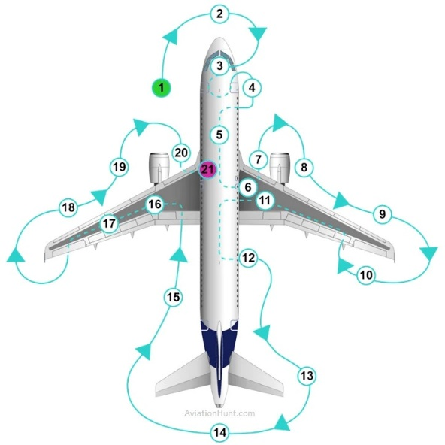

Figure 1 Walk Around

Aircraft locations checked

Types of Damage

This route was designed considering strategic points where possible damages to the aircraft were fully visualized.

### Purpose of the review

The primary purpose of this review is to examine all external components of the aircraft to ensure their condition and compliance with Operational Safety and Airworthiness standards. This specific approach seeks to ensure the structural integrity of the Learjet 60-317 aircraft.

### Damage focus

An initial evaluation was carried out where damages such as Scratch, Nicks, Dents, and Painting in general were found. It constitutes an essential component of the evaluation of its general condition. Dents, being visual imperfections on the surface of the aircraft, and buckles, manifested as structural deformities, are considered critical due to their potential impact on the structural integrity, the rest of the damages caused are highly visible. This close attention is not only limited to the superficial detection of such damage, but also involves a detailed assessment of its extent and location. The extent and location of these imperfections can have significant implications on the aerodynamic drag, structural stability, and operational efficiency of the aircraft. Therefore, the assessment seeks not only to identify their presence, but also to determine their extent and potential consequences, thus contributing to an analysis of the aircraft's operational safety and facilitating informed decisions on the corrective actions necessary to maintain optimum fendering and performance standards. A folder with the evidence of the most relevant damages is included.

In the RAC 4 (**Airworthiness and Aircraft Operation Standards**) there are some standards which provide information such as airworthiness responsibility, basic structure, maintenance records, among others, where they provide and facilitate a follow-up to minimize damages to the aircraft.

In the RAC 4 at **Section 4.5.7.2 Airworthiness Responsibility** says that each certificate holder is responsible to maintain the aircraft airworthiness including aircraft structures, engines and propellers.

## Conclusion

The detailed damage assessment of the Learjet 60-317 aircraft highlights the critical importance of this process to ensure its structural integrity and safety. The inspection not only seeks to identify this damage, but also to thoroughly understand its extent and potential implications for the aircraft's performance. This not only meets safety and airworthiness standards, but also provides a sound basis for making informed decisions on any necessary corrective action. The visual documentation generated during the walkaround, and identification of damage will facilitate effective communication between maintenance personnel and other stakeholders, ensuring that the aircraft is maintained in optimum condition for safe and efficient aircraft operations.

# **Records**

In the following illustration is shown the damages that were found during the inspection.

Figure 2 Located damages in Left View.

Figure 3 Located damages in up view.

All the items are listed in the file named as DENT&BUCKLE.xlsx

During the analysis, it was found that most of the damages are into the limits given by the manufacturer, and the other ones are controlled by the operator.

# **Attached Document.**

To close this report, the document DAMAGE CHART (DENT & BUCKLE) is attached.