Anatomy-Guided Masking for JEPA Representations on Retinal OCT: Segmentation-Free Guidance Matches a Segmenter
Abstract
In 3D retinal OCT, we test whether masked predictive pretraining benefits from directing predictor targets toward the tissue that carries the diagnosis. From one shared I-JEPA checkpoint, we continue six masking policies under a matched schedule, varying target placement, and evaluate each encoder with the same frozen linear-probe protocol for glaucoma classification (FairVision, $N=3000$). Because each policy was continued once, the results describe these runs rather than an expected ranking over retrainings. Region matters: aiming the same rectangles (same shapes, sizes and counts) at retinal tissue rather than at the whole frame improves AUC by $+0.0120$ over unguided masking at the matched epoch, and a band located by a first-order intensity statistic, using no segmentation model at all, improves it by $+0.0109$ at epoch 100. Paired intervals for both arms exclude zero at all three epochs, and the band matches the segmenter-guided rectangles at epochs 50 and 75 and exceeds them at 100 ($+0.0047$). Anatomical precision does not add. A policy that places $97\%$ of masked patches on tissue, using a trained retinal segmentation model to shape the targets, does not separate from unguided masking at epoch 50 and falls below it by epoch 75, as does a coverage-constrained policy. Carried to epoch 100 the latter does not merely stall but peaks at epoch 73 and then declines, and an audit found its targets are shortened after placement, so it does not test aggressive coverage. Direct measurement of mask geometry across 600 slices shows the winner hides the least anatomy of any guided policy. How much anatomy a policy hides is confounded here with mask ratio and retained context, so this design does not identify it. Nor are the null’s background targets wasted: they are a genuine pretraining signal, even though background contributes almost nothing to the classifier. A subgroup audit over 23 probes finds one group worst-served in every probe for five of seven attributes. All three disease-stage point estimates rise (largest for mild, $+0.0137$), and only the multiplicity-adjusted white race-group interval excludes zero. The gains are not separated from one another. The difficulty ordering is untouched: the severe-to-mild gap stays within $0.0114$ of constant across every policy.
Table of Contents

Working copy for comment and editing.
The LaTeX source is authoritative. Generated from commit e785668 on 2026-08-27 05:46. Every number here was produced by a macro traced to a stored artifact; if you edit one in Word it loses that link, so please raise numeric changes as comments rather than edits.

Introduction
Self-supervised learning has become the default route to representation quality in medical imaging, where expert annotation is expensive and pathology is rare (Azizi et al. 2021; Zhou et al. 2023; Qiu et al. 2024). Joint-embedding predictive architectures such as I-JEPA (Assran et al. 2023) learn by predicting the representation of masked target blocks from a visible context block, avoiding pixel reconstruction and its bias toward high-frequency detail (He et al. 2022; Xie et al. 2022).
I-JEPA samples its targets geometrically: rectangles placed uniformly at random. In natural images this is defensible, since informative content is spread broadly across the frame. In a retinal OCT B-scan it is not obviously so. A large fraction of the image is dark vitreous and background. The diagnostic signal for glaucoma is concentrated in a thin band of retinal tissue. This motivates an intuitive hypothesis, one that several recent methods adopt (Li et al. 2022; Li et al. 2024; Wang et al. 2025; Shi et al. 2022): direct the predictive objective at clinically meaningful anatomy rather than at arbitrary image regions.
Rather than proposing one anatomy-aware method and reporting that it beats a baseline, we construct a ladder of masking policies of increasing anatomical specificity: from unguided rectangles, through rectangles aimed at tissue, to ragged targets whose shape follows the segmented retina. All arms continue from one shared pretrained checkpoint under one optimiser, schedule, effective batch size and frozen-probe protocol. The mask geometry each policy delivers is measured, not assumed equal.
Anatomy turns out to matter for where targets are aimed. How much anatomy they cover is not identified by this design. The two policies whose targets track the segmented retina most faithfully have intervals spanning zero against unguided masking at epoch 50, and the one we carried further falls below it by epoch 75 (interval excluding zero), while two policies that merely place ordinary rectangles on tissue gain an order of magnitude more. One earlier shaped policy did exceed its rectangle counterpart at epoch 30, so the anatomy result is mixed rather than uniformly negative. The best performer locates a band by a per-column intensity centroid and consults no segmentation model.

Contributions.
- A controlled six-arm study of masking policy in medical SSL, with a shared ancestor checkpoint and one evaluation protocol (every probe fitted is listed in Appendix 8).
- Guidance helps in these runs. Anatomical precision does not reliably add. The gain is carried by the control separating “avoid background” from “target anatomy”: rectangles aimed at retinal tissue.
- The most anatomically precise policy is not the best performer, from direct measurement of mask geometry on 600 slices, with an explicit accounting of the axes on which the anatomy arms are confounded.
- The subgroup audit is a caution: for five of seven attributes one group is worst-served under every policy. Public-weight reproduction matches the headline result to ${10}^{−5}$ across hardware and precision.

Related work

Masked image modelling and JEPAs.
Masked autoencoders reconstruct pixels (He et al. 2022; Xie et al. 2022); BEiT (Bao et al. 2022) and iBOT (Zhou et al. 2022) predict discrete tokens; data2vec (Baevski et al. 2022) and I-JEPA (Assran et al. 2023) predict latent representations. Video and 3D extensions follow the same template (Bardes et al. 2024; Z. Chen et al. 2023; Taleb et al. 2020). Recent analyses question how much of the benefit derives from the masking distribution itself (Balestriero and LeCun 2025; He et al. 2025).

Informed masking.
A substantial line of work argues that what is masked matters. ADIOS (Shi et al. 2022) learns an adversarial masking model; SemMAE (Li et al. 2022) uses learned semantic parts; AttMask (Kakogeorgiou et al. 2022) masks by attention; HardPatches (Wang et al. 2023) and AutoMAE (H. Chen et al. 2023) target difficulty. In the medical domain, AnatoMask (Li et al. 2024), AnatomyMAE (Ceballos Arroyo et al. 2026), MSMAE (Mao et al. 2023), and VasoMIM (Huang et al. 2026) explicitly steer masking toward anatomy, and Wang et al. (2025) argue directly for masking clinically relevant regions. Our study is a controlled test of that family’s central premise on one task.

Evidence that informed masking is not uniformly better.
The picture is less one-sided than that suggests. The original masked-modelling papers report that random sampling is hard to beat: MAE’s ablation puts random-75 at $73.5$ linear against block-75 at $63.9$ (He et al. 2022), and SimMIM finds random beats its best block variant (Xie et al. 2022). Among informed schemes, AttMask sits within $0.2$ points of random (Kakogeorgiou et al. 2022), AutoMAE ties MAE under full fine-tuning (H. Chen et al. 2023), HPM gains only when randomness is retained and loses when restricted to the hardest patches (Wang et al. 2023), and attention-guided MAE underperforms MAE in the low-label regime (Sick et al. 2025). Most directly, SemMAE’s own ablation shows that imperfect semantic parts add nothing over no parts at all (Li et al. 2022), and Guo et al. (2025) reproduce SemMAE below random MAE, the deficit largest under frozen evaluation, also our protocol. H. Chen et al. (2023) name the mechanism a “patch selection dilemma”: a slight foreground bias helps, but raising it too far starves the encoder of the evidence it must predict from. The closest positive precedent for our best policy is segmentation-free too: Lee et al. (2025) select foreground from normalised intensity alone and gain across five 3D medical benchmarks (Appendix 20 tabulates these). That random masking is a strong baseline, and semantic guidance wins only sometimes, is known and contested. We do not overturn that literature. We add a controlled measurement of where a trained medical segmentation model falls on that spectrum, in a setting (3D retinal OCT, joint-embedding prediction, frozen probe) where we found no prior controlled comparison.

Retinal foundation models, OCT, and fairness.
RETFound (Zhou et al. 2023), VisionFM (Qiu et al. 2024), URFound (Yu et al. 2024), and OCTCube (Liu et al. 2026) pretrain on large retinal corpora. OCT-specific masked modelling is explored by Pissas et al. (2024). MIRAGE (Morano et al. 2025) provides multimodal OCT segmentation and supplies the anatomical guidance used by several of our arms, and deep glaucoma detection from OCT is established (Maetschke et al. 2019; Ran et al. 2019; Noury et al. 2022). Performance disparities across demographic groups are widely documented (Seyyed-Kalantari et al. 2021; Larrazabal et al. 2020; Gichoya et al. 2022). FairVision (Luo, Khan, et al. 2024) and Harvard-GF (Luo, Tian, et al. 2024) provide OCT data with demographic attributes, and FairMedFM (Jin et al. 2024) and Shi et al. (2025) benchmark fairness for medical foundation models.

Method: a ladder of masking policies
We test the informed-masking premise with a ladder of six masking policies of increasing anatomical specificity, sharing one ancestor checkpoint, optimiser, schedule, effective batch size and probe protocol.

Background
I-JEPA samples from the token grid of an image a context block and $M$ target blocks, which need not cover it. A context encoder embeds the visible tokens. A predictor maps that embedding plus positional queries to predicted representations of the target tokens. An exponential-moving-average target encoder supplies the regression targets. With a $16×16$ token grid the design choice we vary is which of the 256 cells become targets. Figure 1(a) draws the pipeline.

The six policies
All policies produce $M=4$ target blocks and one context block under identical scale and aspect-ratio ranges. The rectangle arms differ only in placement.
Stock I-JEPA multiblock. Four rectangles placed uniformly at random anywhere in the grid. No image content is consulted.
Identical rectangles (same shape, size and count as random), but rejection-sampled onto the retinal envelope predicted by MIRAGE (Morano et al. 2025). Only location changes. This is the control that separates “stop wasting targets on background” from “target anatomy specifically”.
A band whose vertical position is located per slice by a per-column intensity-weighted row centroid, smoothed across columns, with no segmentation model and no ground-truth annotation of any kind.
Ragged connected components grown on the MIRAGE score map, so target shape follows tissue rather than being rectangular. v2 also bridges diagonal adjacencies.
Targets chosen greedily to cover the anatomy subject to a hard floor leaving a fraction $f$ of tissue visible in the context. We pretrain $f=0.21$. An implementation defect means the delivered masks never reach $f$ (Appendix 14).
Figure 1(b) shows all six on the same B-scans.
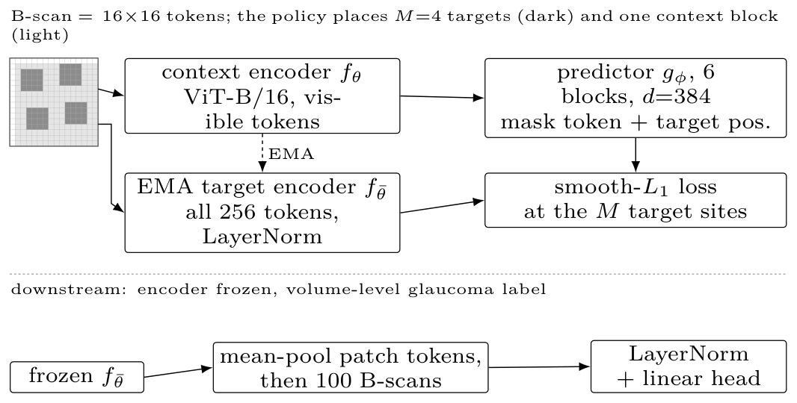  (a) pipeline | 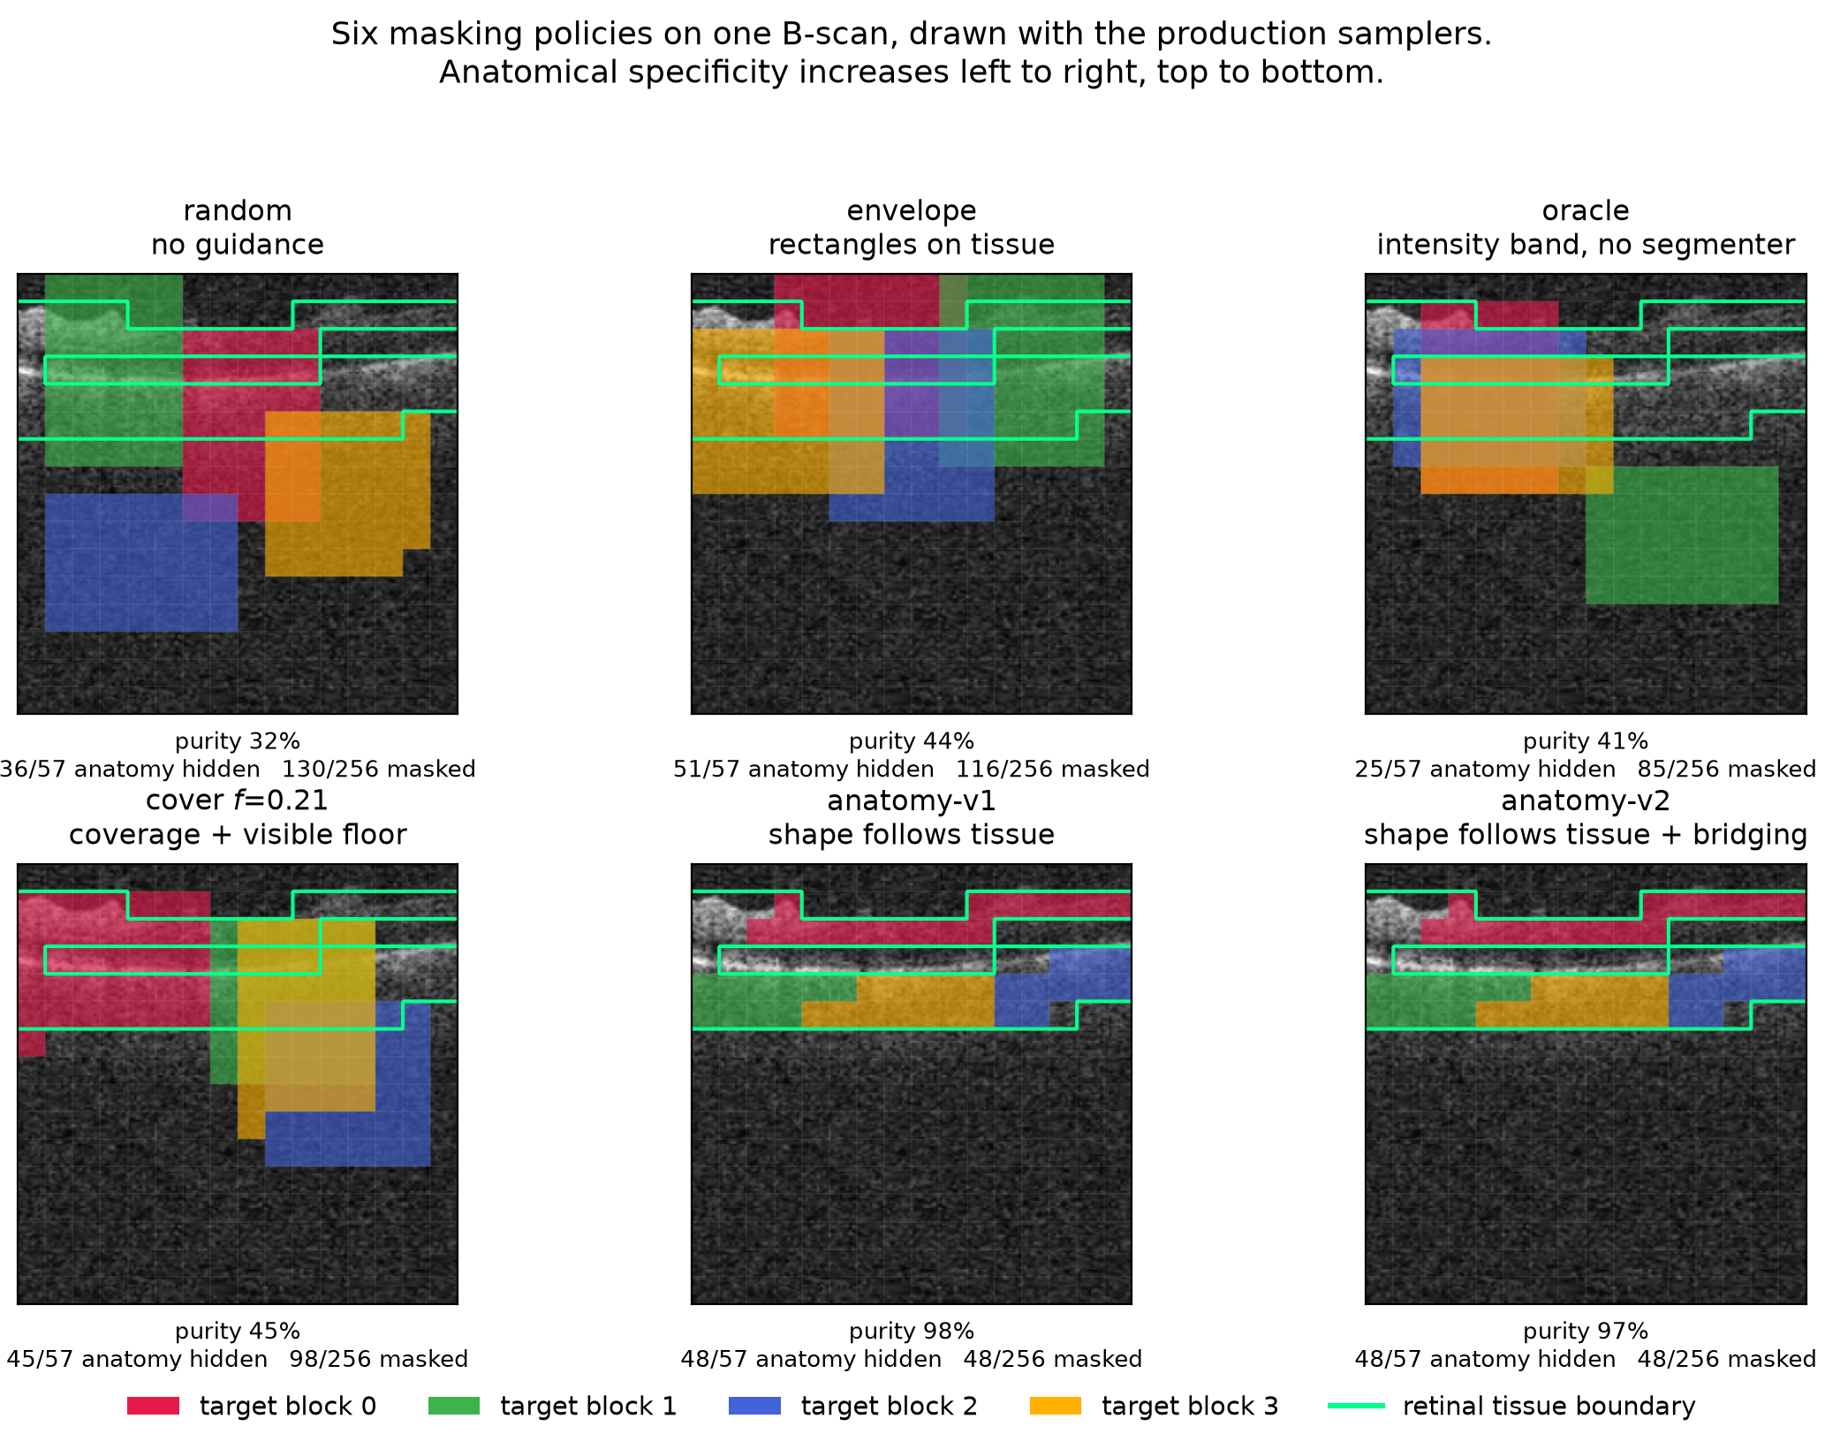  (b) the six policies
(a) The pipeline: the predictor is queried with each target’s position and regresses the EMA target encoder’s features; below the rule, the frozen-encoder probe. (b) The six masking policies on one identical B-scan, drawn with the production samplers; each target block has its own colour and the green contour is the anatomy reference. Anatomical specificity increases along the ladder, while downstream AUC does not (Table 1); Figure 4 repeats this over five B-scans.

Hypotheses
The ladder yields three testable statements:
Avoiding background helps. envelope $>$ random.
Anatomical precision helps further. anatomy arms $>$ envelope.
Any benefit is due to anatomical targeting, not to incidental changes in mask area, target count, or context size.

Experimental setup

Data.
FairVision (Luo, Khan, et al. 2024) glaucoma OCT volumes. Each volume is a 3D scan resampled to 100 B-scans of $256×256$ after transform. The label is a binary glaucoma diagnosis. Splits are fixed and patient-disjoint as released. Downstream evaluation uses a held-out test split of $N=3000$ volumes (1466 positive / 1534 negative), seed 42, fixed loader order. No test volume is used to fit or select the probe head, which is selected on a separate validation split. The study’s choices of policy, checkpoint, analysis and stopping horizon were made after repeated inspection of that same test split (Section 6). Labels are byte-identical across arms, so any two arms are paired-comparable on the same cases. Self-reported demographic attributes are used only for the subgroup analysis in Section 5.5 and never as model inputs.

Pretraining.
Patch-level I-JEPA, ViT-Base, $256×256$ crops, patch size 16, predictor depth 6, EMA target encoder. Every arm resumes from the same epoch-25 checkpoint and continues with identical optimiser, learning-rate and weight-decay schedules, and effective batch size (512 for all arms). Guidance is ramped linearly from epoch 25 to 30 and held at full strength thereafter. Within the rectangle family the only difference between arms is the mask sampler (Section 3). The anatomy family also differs in collation, and we quantify that in Section 5.
Arms differ in how far they were carried. random, centroid and envelope reach epoch 100. anatomy-v2 reaches epoch 75 (its epoch-75 and epoch-92 probes under an earlier target-precision splice are excluded and replaced by a clean fp32 continuation, Appendix 13). We stopped that arm having seen its epoch-75 deficit, which is a selective stopping horizon and a real weakness: a trajectory can recover, and its epoch-100 value is unmeasured, not known to be worse. anatomy-v1 has only epoch 30. cover $f=0.21$ reaches epoch 100, with an extra probe at its epoch-73 peak. Epoch 50 is therefore the only epoch at which five policies are simultaneously available, and it carries every cross-policy comparison that involves the anatomy or coverage arms.

Evaluation.
The frozen encoder is the EMA target branch, not the online context encoder. Per-slice features are mean-pooled over the volume, followed by LayerNorm and a linear head. The head is selected by validation AUC and reported on the held-out test split. We report percentile bootstrap intervals for primary AUCs and paired deltas (10,000 class-stratified subject resamples; fitted heads fixed and each draw shared across arms) and DeLong tests for correlated ROC curves (DeLong et al. 1988), both of which are valid here because all arms are evaluated on the same cases in the same order. Each test volume is a distinct subject, so case-level resampling is already subject-level and no cluster correction is required (Obuchowski 1997; Rutter 2000). We follow Maier-Hein et al. (2024) in reporting the operating-point metrics alongside AUC rather than AUC alone (Appendix 18).

Numerical precision.
The probe harness defaults to mixed precision. The random, centroid and envelope long-horizon probes were fitted under that default (fp16). The anatomy-v1, anatomy-v2, cover and ancestor probes were fitted with autocast explicitly disabled (fp32). Protocol is therefore not uniform across probes, so we partition the comparisons: all headline contrasts in Table 1 are drawn from arms sharing both epoch and precision, and any contrast that would cross the precision boundary is marked as such and excluded from headline claims. Section 5.6 measures the precision effect.

Results
Region matters. How much anatomy a policy covers is not identified here. Each policy was pretrained once, so the intervals below are sampling error over test subjects, not seed-to-seed variance (Section 6).

Region matters: where you aim beats not aiming at all
Frozen MeanPool probe, FairVision test ($N=3000$, 1466 positive). All arms continue from one epoch-25 ancestor (AUC $0.8487$). $Δ$ is versus random at the matched epoch. The upper block is precision-matched (fp16 throughout) and carries every headline claim; the lower block is fp32, each $Δ$ taken against an fp32 null re-probed at the same epoch. The measured fp16/fp32 gap is at most $2×{10}^{−4}$ (Appendix 22).
 |  | epoch 50 |  | epoch 75 |  | epoch 100
3-4(lr)5-6(lr)7-8 policy | guidance signal | AUC | $Δ$ | AUC | $Δ$ | AUC | $Δ$
random | none (null) | 0.8641 | — | 0.8723 | — | 0.8746 | —
envelope | segmenter (location only) | 0.8761 | $+0.0120$ | 0.8803 | $+0.0080$ | 0.8807 | $+0.0062$
centroid | intensity centroid, no segmenter | 0.8740 | $+0.0099$ | 0.8836 | $+0.0113$ | 0.8855 | $+0.0109$
anatomy-v2 | segmenter (target shape) | 0.8654 | $+0.0013$ | 0.8612 | $−0.0111$ | — | —
cover $f=.21$ | segmenter (coverage) | 0.8643 | $+0.0002$ | 0.8639 | $−0.0084$ | 0.8577 | $−0.0168$
H1 holds, and the study’s cleanest control carries it. envelope’s policy differs from the unguided null in location alone (Section 3), though aiming makes the rectangles overlap, so delivered context moves with it ($24.7\%$ to $30.7\%$, Table 5). Moving the same rectangles onto tissue is worth $+0.0120$ AUC at epoch 50, and centroid, a band located from a first-order intensity statistic with no segmentation model anywhere, is worth $+0.0109$ at epoch 100. Every envelope and centroid interval excludes zero at all three epochs, and all six contrasts survive Benjamini–Hochberg correction over that family of nine ($q≤0.0299$; Figure 2b, with the full paired inference on all nine precision-matched contrasts in Table 14, Appendix 21).
Aiming is not containment: the rectangles are large, so fewer than half of envelope’s masked cells land on tissue (Table 2). Guidance changes where the predictor is repeatedly sent, not what it is forbidden to see. Why the unguided null nonetheless stays close has an answer of its own (Section 5.3).
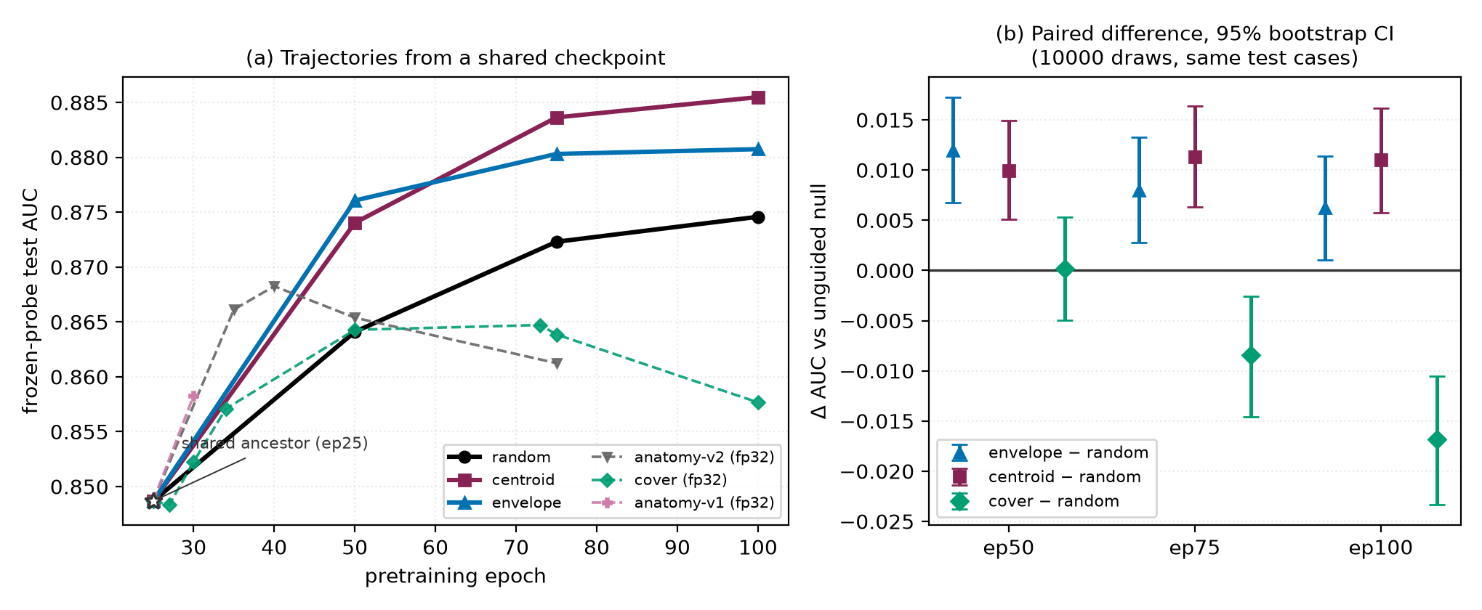
(a) Frozen-probe test AUC against pretraining epoch; note the truncated AUC axis. All arms fork from the same epoch-25 checkpoint (open star). Solid lines are the precision-matched fp16 family; dashed lines are fp32 arms and must not be compared vertically against the solid lines. (b) The actual inference: paired differences against the unguided null on identical test cases, 10,000-resample percentile bootstrap intervals. Every envelope and centroid interval excludes zero; cover straddles zero at epoch 50 and is negative thereafter. Paired differences replace per-arm error bars, whose between-case variance cancels in a pairing and would understate the evidence.
Precision beyond location does not add, and the evidence is mixed rather than uniformly negative. H2 predicts that the anatomy arms exceed envelope. Tested directly at the matched epoch 50, anatomy-v2 sits $−0.0107$ below envelope (CI $[−0.0167, −0.0046]$). At epoch 30, however, anatomy-v1 sits $+0.0044$ above it (CI $[+0.0009, +0.0078]$). These are different implementations at different epochs, so we do not read either as settling H2. What the pair rules out is a uniform advantage for anatomical precision, not the possibility that some shaped policy helps somewhere. Nor is anatomy-v2 or cover worse than the null at the matched epoch: both sit within a paired interval that comfortably contains zero (Figure 2b), so the data rule out monotone improvement with anatomical precision, not harm.

Carried to epoch 100 the coverage arm degrades.
cover is the only policy that uses the segmenter to choose how much to hide, and carried to the full horizon it produces the study’s one negative result. It climbs normally to epoch 50, peaks at epoch $73$, then falls, losing $−0.0071$ from its own peak ($p$<$0.0001$) while the unguided null keeps improving (Figure 2). Its gap against the null widens monotonically across the three matched epochs (Table 1).
We cannot read this as evidence that high coverage is harmful. An audit found that the collator shortens predictor targets after cover chooses its placement, so its delivered masks hide less anatomy than envelope’s (Table 2, Figure 3) and the arm never realised the coverage it was configured for. Appendix 14 gives the full account.
The strongest policy consults no segmentation model. centroid finds its band from a per-column intensity centroid: no model and no annotation. Its margin over the null is the largest at epoch 100 and does not decay with training, whereas envelope’s does (Table 1), and it exceeds the segmenter-guided envelope arm at epoch 100 by $+0.0047$ (CI $[+0.0004, +0.0091]$), though their paired intervals span zero at epochs 50 and 75.

Aim, and the coverage this design cannot isolate
Measured mask geometry, 600 training slices, production samplers. “purity” is the fraction of masked cells lying on tissue; “loss slots” is the number of predictor target cells entering the loss, summed over the $M$ targets. AUC is quoted at the matched epoch 50, so the geometry-to-AUC association is not read across mixed epochs.
policy | anatomy hidden | purity | mask ratio | context kept | loss slots | AUC @ep50
random | 54.0% | 31.5% | 44.5% | 41.9% | 159.9 | 0.8641
centroid | 62.1% | 40.0% | 40.3% | 45.5% | 159.0 | 0.8740
envelope | 77.6% | 43.3% | 46.5% | 40.6% | 159.7 | 0.8761
cover | 73.5% | 44.2% | 43.2% | 43.2% | 159.1 | 0.8643
anatomy-v2 | 79.9% | 97.1% | 21.3% | 67.7% | 64.0 | 0.8654
The highest epoch-100 endpoint hides the least anatomy. Of the four guided arms the one that hides the most (masking almost nothing but tissue, at $97.1\%$ purity) does not separate from the null. Both readings come from running each production sampler on 600 training slices and measuring the realised masks (Table 2, Figures 13 and 14; provenance in Appendix 11). What centroid does instead is leave more visible: it retains more context than any other rectangle arm, and the background stays maskable. Rank correlations over these arms are positive for both anatomy hidden and purity, but at $n=4$–$5$ arms they resolve nothing in either direction and we draw no inference from them. Occlusion attribution on the fine-tuned probes is correspondingly diffuse (Appendix 17).
The anatomy arms are confounded on several axes simultaneously. anatomy-v2 retains more context still, but it also hides far less of the grid and collapses to $64$ predictor loss slots against about $159$ for every rectangle arm (Table 2, Figure 15), a much easier prediction task. They and cover also differ from envelope in guide provenance (Appendix 23). Any of these could account for its deficit without invoking target shape at all. H3 is therefore not identified by this design, and we do not claim that irregular target shape is harmful.
These are not consequences of target shape: the anatomy arms resample every target to a fixed $K=16$ cells, so $4×16=64$ loss slots follows by construction, while the rectangle arms do not set $K$. The two families are collated differently, which weakens “everything else held fixed” for the anatomy-versus-rectangle comparison specifically. Contrasts within the rectangle family are unaffected (Appendix 14).

Background matters: for pretraining, not for the classifier
Unguided masking spends most of its targets on background, and they are not wasted. At epoch 100 the null’s predictor beats a per-position, no-context reference by $0.680$ on background targets, above its $0.633$ on anatomy: predicting a background token takes more than knowing where it sits, even though such tokens start out nearly pure position ($90.8\%$ of across-position input variance there comes from pos_embed, against $40.8\%$ at tissue). Pretraining spends real capacity on them: under envelope, the one arm measured, self-similarity falls from $0.784$ untrained to $0.346$. Yet almost none of it reaches the classifier. Pooled background features are $95.2\%$ linearly reconstructible from pooled anatomy features. Residualised, background predicts glaucoma at test AUC $0.5515$ (barely above chance, though the interval excludes it), and appending it to anatomy lowers test AUC for the null arm. That split (a useful pretraining target, a near-useless classification feature) is why unguided masking is such a strong baseline, and why aiming at tissue buys a gain that is real but bounded. The mechanism is described rather than established: the two controls that would settle it were not run (Appendix 15).

The advantage concentrates where labels are scarce
The observed margin is larger with fewer labels: at $5\%$ of the labelled set ($n=300$) centroid leads the null by $+0.0496$, against $+0.0108$ at full supervision, more than four times the advantage. A policy that only helps when labels are plentiful is of limited clinical use, so we withdrew supervision and re-fitted the same probe, holding protocol and label subsets fixed, and, across all four arms in this sweep, the full-supervision fits reproduce their corresponding epoch-100 entries in Table 1 to within $0.0009$. Whether the gap genuinely widens as labels are withdrawn we did not test. The ordering across fractions is a point-estimate observation, and the absolute gains at full supervision are small. Appendix 16 gives the full curve.

Subgroups: the ordering is stable
Across seven stratifications and 23 probes spanning aggregate AUC $0.8483$ to $0.8855$, one group is worst-served in every probe for five of seven attributes. Predictions are joined to the released FairVision metadata in deterministic loader order, validated by exact label reconstruction (3000/3000 cases, every probe). Probes that the exclusion rules of Appendix 13 remove are removed here too.

The same group is worst served every time.
The worst-performing group is the same in every one of the 23 probes for sex (female), race (black), ethnicity (hispanic) and disease severity (mild ($−6$,$−2$]). The probes share a test set, an epoch-25 ancestor and a probe seed, and several are different epochs of one branch, so they are not independent. We report this as a descriptive regularity and attach no $p$-value. What it shows is that no policy we tried removes or reorders the disparity, not that policy has no part in its origin.

Point estimates rise everywhere. Few gaps reliably move.
A widening max–min gap is easy to misread as harm, and is not: at epoch 100 the strongest policy raises the point estimate for every race stratum over the null, and the max–min gap widens only because the already-best asian subgroup gains most. Family-wise simultaneous paired intervals exclude zero only for the white subgroup (CI $[+0.00286, +0.01972]$). The black and asian intervals include it, the smaller strata being noisier (Table 8). The gains are therefore consistent in sign across race, not provably positive in every group. Nor is there a defensible gap trend. Across checkpoints the race gap correlates with aggregate AUC at $ρ=+0.473$ ($q=0.0668$ after Benjamini–Hochberg over the seven attributes tested), but those checkpoints are not independent: they are 23 probes drawn from only 7 pretraining branches, so a branch probed at four epochs contributes four correlated points. Collapsing to one point per branch, the association disappears ($ρ=+0.321$). The checkpoint-level correlation is pseudo-replicated and does not show that better models are less fair. The same holds for severity in the opposite direction ($ρ=−0.449$ per checkpoint, $−0.821$ per branch). Only the sex gap survives checkpoint-level correction, and it narrows (branch-level $ρ=−0.821$, raw $p=0.0234$; checkpoint-level $q=0.0038$). Neither harm nor benefit to equity is established here. A property of threshold transfer, not of masking policy, matters more at deployment: a validation-selected threshold aimed at a fixed specificity does not transfer evenly, and the smaller stratum absorbs a higher false-positive rate under both arms (Appendix 18).

Severity point estimates rise. Differential benefit is unresolved.
Scoring each severity stratum against the shared pool of all negatives, the strongest policy has a mild-disease point estimate of $+0.0137$ at matched epoch 100, with smaller moderate and severe estimates (Table 7). These are paired differences on the same subjects. All three point estimates are positive, but after adjustment over the declared 10-contrast family only the mild interval excludes zero. The moderate and severe intervals no longer do (Table 8). Whether mild improves more we did not test: that needs a paired contrast between the gains, not three contrasts against zero. What does not move is the difficulty ordering itself: the severe-to-mild gap stays within $0.0114$ of constant across all 23 probes while aggregate AUC spans the full range above. For equity the quantity that matters is the paired difference between groups’ gains. Between the worst- and best-served race strata it is $−0.00091$ (CI $[−0.03285, +0.03104]$), and by sex the interval likewise contains zero, so at these subgroup sizes we cannot resolve whether the improvement is evenly distributed. Appendix 12 gives every stratum, Appendix 12.1 the race-by-sex cells, whose gap exceeds the race margin in every arm. No policy here is a fairness intervention and none should be presented as one.

Controls: the effect is not a precision artefact
A full re-fit of the probe pipeline at fp32 shifts every arm by less than $2×{10}^{−4}$, orders of magnitude below the effects in Table 1, so the differing autocast settings of Section 4 are not the effect and every contrast is matched on precision (Appendix 22). The generating script, the epoch-100 centroid encoder, its head and its stored per-case predictions are released (links withheld for anonymity). Re-encoding the test split from those weights on different hardware, at fp32 rather than fp16 and with a different encoder chunk size, reproduces the reported AUC to $9.8×{10}^{−6}$: 22 discordant pairs out of $2,248,844$.

Discussion and limitations

What the evidence supports.
Two things about a masking policy matter in these runs, and two cannot be separated. Region matters: restricting the same rectangles to tissue is worth $+0.0120$ at the matched epoch, and an intensity-located band is worth $+0.0109$ at epoch 100, with paired intervals excluding zero at every epoch measured. Background matters as a pretraining target. Using the segmenter more aggressively (to shape targets or to maximise coverage) did not add and can subtract, and the arm hiding the most anatomy loses to the null. Whether coverage caused that is not separable here, any more than whether what the mask leaves visible matters: those arms also differ in mask ratio, retained context and loss slots. For this task the segmentation stage bought no more than location, and a one-line intensity statistic recovered the whole benefit. We would not generalise that to tasks where anatomy is the output, such as layer segmentation or lesion localisation.

What it does not support.
We cannot claim anatomy-shaped masking is harmful: at the matched epoch it sits $+0.0013$ from the null with an interval ($[−0.0055, +0.0082]$) that comfortably contains zero, so it is not resolved as worse. Nor is target shape identified as the operative variable (Table 2), nor is centroid’s mechanism. Two explanations remain live: consistency of location (the encoder is repeatedly forced to represent the same region), and masking ratio or task difficulty. Distinguishing them requires an arm that randomises the band’s vertical position while holding area and context fixed, which we did not run.

One pretraining run per policy, and a replication in progress.
This design holds the ancestor checkpoint, optimiser, schedule, effective batch size and probe protocol fixed across arms. The mask sampler is the intended difference, though it also moves delivered mask ratio, retained context and loss slots, and across families collation and guide provenance (Section 5.2). What it does not resample is pretraining stochasticity, so each arm is one continuation. The paired bootstrap bounds sampling error on a fixed test set, so the intervals support statements about these continuations rather than an expected ranking over retrainings, which pairwise significance on one test set does not establish (Bouthillier et al. 2021). Probe-seed variance is outside the design too: an earlier multi-seed probe check is not reproducible from retained artifacts, so we state no bound on probe noise. A replication addressing the first gap is running, with no result of it reported here: six continuations (random, envelope and centroid at two further seeds) resume from the same epoch-25 ancestor, SHA-256 verified before each leg, under configurations asserted to differ only in the seed, and run to epoch 50, giving three continuations per policy at an endpoint where every arm already carries a frozen probe. Seeds do not randomise data visitation order, so the unit of inference is post-fork optimisation noise at a fixed data order. The analysis is fixed before any value is visible (Appendix 9), and either outcome is informative: an ordering that does not reproduce establishes that Table 1 describes these runs rather than the policies.

Scope, coverage and an incomplete arm.
All results are glaucoma classification from FairVision OCT. Generality to other modalities, diseases, or segmentation-quality regimes is untested, and the anatomy arms depend on MIRAGE’s prediction quality on this data, so a better segmenter might change the conclusion. Only $f=0.21$ was pretrained for cover, so we report no dose-response over the visible-tissue floor and make no claim that any floor is optimal. That arm reaches epoch 100, but the collation defect above (Appendix 14) means its trajectory is not evidence about aggressive coverage. Its epoch-50 value is retained as a matched-epoch comparison against every other arm. Finally, one dataset and one test split were reused throughout this programme’s history, and policies, checkpoints and analyses were chosen after repeated inspection of that split. The intervals we report are therefore best read as descriptive rather than as confirmatory inference.

Broader impact and ethics.
This study uses a public, de-identified retinal dataset under its release terms and involves no new data collection or human subjects, and no model reported here is clinically validated or intended for deployment (Appendix 19).

Conclusion
In these runs anatomy mattered for where targets are aimed. How much anatomy they cover is not identified by this design. Under a matched schedule, effective batch size and shared ancestor checkpoint, aiming ordinary rectangles at retinal tissue beat unguided masking, and the best policy consulted no segmentation model, matching the segmenter-guided arm at epochs 50 and 75 and exceeding it at 100, while shaping targets to trace the segmented retina did not separate from unguided masking at epoch 50 and fell below it by epoch 75. Nor are the null’s background targets wasted. They carry pretraining signal that barely reaches the classifier. A subgroup audit shows every positive disease-stage point estimate rises, but only the adjusted mild interval excludes zero; race gains consistent in sign, and the difficulty ordering untouched. What makes the best policy work is not identified here: this design cannot separate consistent target placement from mask ratio and task difficulty.

All frozen probes
Table 3 lists every frozen MeanPool probe in the study. It has 37 rows: 31 valid probes, plus two probes excluded and four retracted for the reasons in Appendix 13. Two further counts follow from those 31. Eight of them are fp32 re-probes of an encoder already probed at fp16, and the subgroup audit collapses each such pair to the single encoder it scores twice, leaving 23 distinct encoder–epoch units (Section 5.5); 19 of those carry a stored per-group race summary. The two race analyses therefore run on different subsets by construction: the gap-trend test in Table 6 uses all 23 probes, since every one carries a race gap, while the scatter in Figure 5 needs a per-group AUC for all three groups and so uses the 19 probes that have one. The four that do not are cover at epochs 73, 75 and 100 and anatomy-v2 at epoch 75: each was probed after the per-group race artifact was generated, and that artifact was not recomputed, so their absence is one of artifact chronology and not a property of those runs, whose race gaps are present and do enter the 23-probe trend test.
Every frozen probe in the study, including runs excluded from the analysis and the reasons. The probe protocol is otherwise the same for every row (FairVision test $N=3000$, seed 42, frozen encoder, MeanPool + LayerNorm + Linear) and differs only in the precision column. “Precision” is the probe-time numerical precision, inferred from the stored prediction dtype, and is distinct from the pretraining target precision discussed in Appendix 13.
policy | epoch | precision | test AUC | 95% CI
anatomy-v1 | 30 | fp32 | 0.8583 | [0.8450, 0.8712]
anatomy-v2 | 35 | fp32 | 0.8661 | [0.8531, 0.8787]
anatomy-v2 | 40 | fp32 | 0.8683 | [0.8553, 0.8807]
anatomy-v2 | 50 | fp32 | 0.8654 | [0.8522, 0.8781]
anatomy-v2 | 75 | fp32 | 0.8612 | [0.8477, 0.8740]
ancestor | 25 | fp32 | 0.8487 | [0.8349, 0.8621]
cover | 27 | fp32 | 0.8483 | [0.8346, 0.8617]
cover | 30 | fp32 | 0.8522 | [0.8386, 0.8654]
cover | 34 | fp32 | 0.8571 | [0.8437, 0.8700]
cover | 50 | fp32 | 0.8643 | [0.8513, 0.8768]
cover | 73 | fp32 | 0.8647 | [0.8517, 0.8772]
cover | 75 | fp32 | 0.8639 | [0.8507, 0.8763]
cover | 100 | fp32 | 0.8577 | [0.8443, 0.8707]
envelope | 30 | fp32 | 0.8539 | [0.8405, 0.8669]
envelope | 50 | fp16 | 0.8761 | [0.8635, 0.8879]
envelope | 50 | fp32 | 0.8761 | [0.8635, 0.8879]
envelope | 75 | fp16 | 0.8803 | [0.8677, 0.8922]
envelope | 75 | fp32 | 0.8803 | [0.8677, 0.8922]
envelope | 100 | fp16 | 0.8807 | [0.8683, 0.8926]
envelope | 100 | fp32 | 0.8808 | [0.8683, 0.8927]
centroid | 50 | fp16 | 0.8740 | [0.8615, 0.8862]
centroid | 50 | fp32 | 0.8740 | [0.8614, 0.8862]
centroid | 75 | fp16 | 0.8836 | [0.8714, 0.8955]
centroid | 100 | fp16 | 0.8855 | [0.8735, 0.8971]
centroid | 100 | fp32 | 0.8853 | [0.8732, 0.8971]
random | 50 | fp16 | 0.8641 | [0.8510, 0.8769]
random | 50 | fp32 | 0.8641 | [0.8511, 0.8769]
random | 75 | fp16 | 0.8723 | [0.8593, 0.8849]
random | 75 | fp32 | 0.8723 | [0.8593, 0.8849]
random | 100 | fp16 | 0.8746 | [0.8618, 0.8869]
random | 100 | fp32 | 0.8745 | [0.8617, 0.8868]
anatomy-v2 | 75 | fp32 | 0.8625 | excluded
anatomy-v2 | 92 | fp32 | 0.8604 | excluded
random | 30 | fp32 | 0.8558 | retracted
random | 50 | fp32 | 0.8590 | retracted
random | 75 | fp32 | 0.8612 | retracted
random | 100 | fp32 | 0.8607 | retracted

Continuation-level replication
Status at submission: no result reported. No result of this replication is reported anywhere in this paper. What follows is the design and the analysis rules, both fixed before any value is visible, so that they cannot be chosen after seeing the outcome.

Design.
Six continuations (random, envelope and centroid, each at two further seeds) resume from the same epoch-25 ancestor used by every arm in this paper. The ancestor is locked by content: SHA-256 e5ad5b0c2aadfa15449409786afbfa39d8b5405b699be8f02f2e540195e97e7b, 1,507,519,602 bytes, re-hashed immediately before each leg, and a mismatch aborts the leg rather than continuing from an unverified starting point. The six configurations are generated by a script that asserts they are identical outside the mask curriculum except for the seed and logging fields. Each leg runs to epoch 50 (the endpoint at which every arm already carries a frozen probe) with the optimiser, cosine learning-rate, weight-decay and EMA schedules still sized for 100 epochs, so the trajectory is the one this paper measures and not a shorter, differently-scheduled substitute. Each completed leg is then probed under the frozen-probe protocol of Section 4, with the encoder hashed before and after the probe. Together with the continuations reported here, this yields three continuations per policy at a matched endpoint.

Pre-committed analysis.
(i) All nine epoch-50 continuation AUCs are reported in one table, whatever they show. No continuation is dropped for any reason other than a documented crash, and a crash is reported. (ii) We report the per-policy mean and full range, and the two paired-by-seed differences envelope$−$random and centroid$−$random, one per seed. (iii) At three continuations we report point estimates and ranges only: no $t$-test, no $p$-value and no confidence interval at the continuation level, because three continuations bound direction and not magnitude. (iv) The fixed-data-order caveat below is restated wherever the result is.

What the seed does and does not randomise.
The seed randomises random-resized-crop draws, target and context block sampling (including the envelope rejection sampler and the centroid band sampler), dropout, and worker streams. It does not randomise the order in which slices are visited: the distributed sampler is constructed with its own fixed seed and advanced per epoch, which is true of the originally reported continuations as well. The unit of inference is therefore post-fork stochastic optimisation noise at a fixed data order, which is narrower than independent retraining, and it is not a replication of the data pipeline.

The failure case, written in advance.
If the epoch-50 ordering does not reproduce (a paired difference changes sign, or the three-continuation range for either contrast spans zero), the reported conclusion becomes that the single-continuation contrasts of Table 1 describe those particular runs and not the policies, and every policy-level statement in this paper is downgraded to a run-level one. Table 1 is not withdrawn in that case: it remains a correct description of the runs it measures. That outcome is an anticipated and informative result of this design rather than a failure of it, which is why the rules above are fixed now.

What this replication does not do.
It does not supply an untouched evaluation cohort. The comparison still runs on the same test split, which has been inspected repeatedly across this programme, so the replication bounds run-to-run variability and not adaptive selection. The number of times that split was inspected while choosing policies, checkpoints and analyses was not logged and cannot now be reconstructed, which is why every interval in this paper is described as descriptive rather than confirmatory. An untouched evaluation would require a labelled cohort from a different scanner or population, thresholds and checkpoints selected on that cohort’s own validation split, a single evaluation, and no iteration afterwards. No such cohort was available to us.

Masking policies across the volume
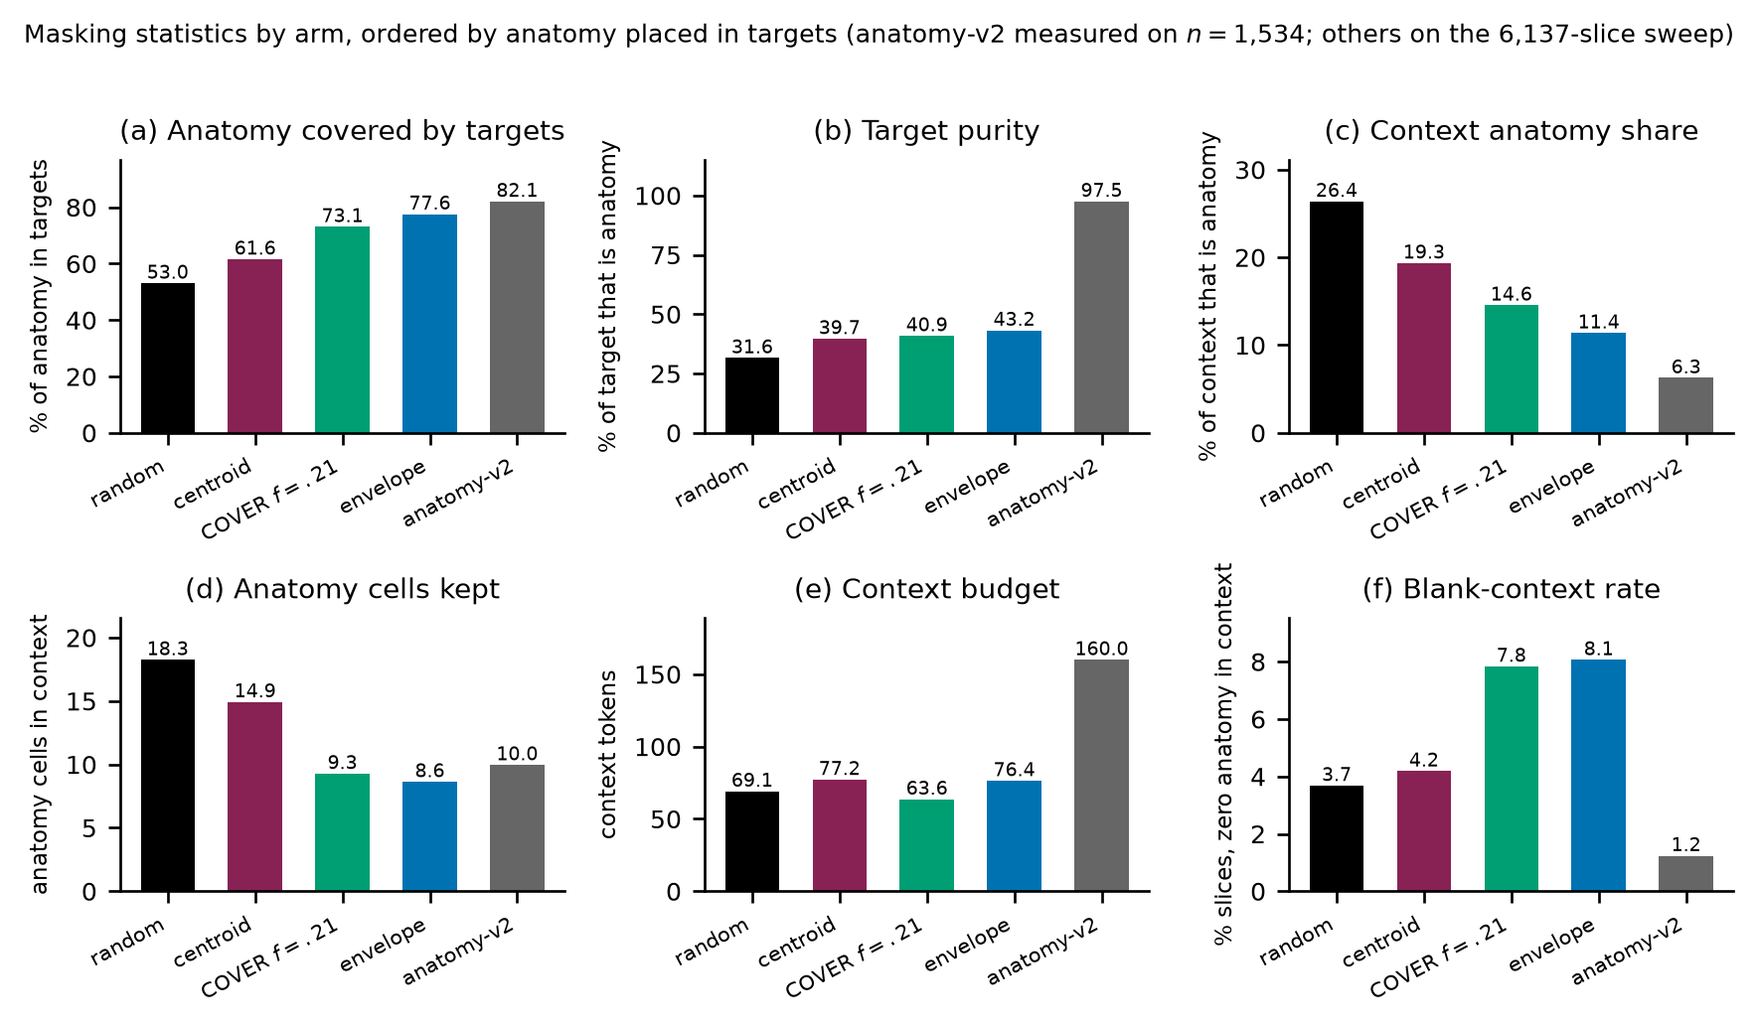
What each sampler actually does, measured on the 6,137-slice sweep (anatomy-v2 on $n=1,534$). Panel (a) is the quantity the cover arm was built to maximise: it reaches $73.1\%$, below envelope’s $77.6\%$, which is the discrepancy Appendix 14 explains. Panel (b) shows the ordering this paper tests: target purity rises monotonically from random to anatomy-v2, while downstream AUC does not follow it. Panels (c)–(f) give the confounds we do not disentangle: how much anatomy survives in the context (c, d), the context budget (e), and how often a slice is left with no anatomy visible at all (f). Every bar starts at zero and is a mean over the sweep, with no interval drawn; panel scales differ, so bars should be compared only within a panel.
Figure 1(b) shows one B-scan for legibility. Figure 4 repeats the same rendering on five B-scans sampled across the depth of a volume, so that the stability of each policy under changing retinal geometry can be inspected. The samplers, the colour assignment, and the anatomy contour are identical to Figure 1(b).
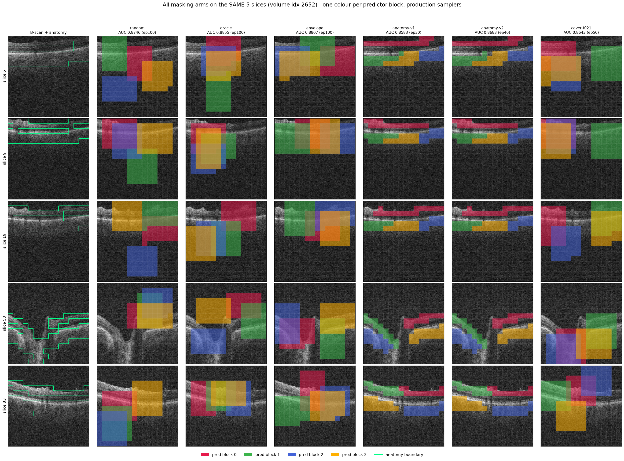
All six masking policies (columns) on five B-scans (rows) spanning one volume, drawn with the production samplers. Leftmost column is the unmasked B-scan. Each predictor target block has its own colour; the green contour is the anatomy reference. The random, centroid, envelope and cover arms place axis-aligned rectangles; the anatomy arms grow cell-wise targets that follow the retinal band and therefore change shape from slice to slice. Column headings carry each arm’s own probe epoch, which differs between arms, so the AUCs printed there are not a matched-epoch comparison and only Table 1 should be read that way. Panel headings use the artefact name oracle for centroid.

Mask-geometry provenance
Table 2 was regenerated from the production samplers rather than carried forward from an earlier draft, and this appendix records how, together with two facts the table itself cannot show: how much of each cell is measurement noise, and how one configuration constant moves the correlation quoted in Section 5.2.

How the geometry was measured.
Each production sampler was run on the same 600 FairVision Training slices (24 volumes, 25 slices each), one image at a time, with the cover visible-tissue floor at its production value $f=0.21$, on the $16×16$ patch grid, with anatomy taken from the MIRAGE guide occupancy channel at threshold $0.25$. The measurement was repeated with three independent draws (seeds 42, 1234 and 2026). Training slices are not a choice: the cached anatomy guides exist for the Training split only, so three of the five production samplers cannot be run on held-out slices at all.

Cell-level agreement and seed noise.
Table 2 now carries the regenerated values, so the question is how stable they are across draws. 18 of the 25 cells fall inside the three-seed range of the measurement and do not exceed observed re-draw variation. Across the four rectangle arms the loss slots spread is smaller than the per-arm seed spread (Table 4), so that column’s ordering carries no information and no claim in this paper depends on it. The rank order of the arms on anatomy hidden and on purity is identical across all three draws, which is what the rank correlations in the main text rely on.
Stability of two Table 2 columns across three independent draws of the same 600-slice measurement. “sd” is the standard deviation over seeds 42, 1234 and 2026. The loss-slot differences between rectangle arms are smaller than this noise.
 | anatomy hidden (%) |  | loss slots
2-3(lr)4-5 policy | value | sd | value | sd
random | 53.95 | 0.71 | 159.91 | 1.15
centroid | 62.13 | 0.64 | 158.99 | 0.43
envelope | 77.58 | 0.38 | 159.68 | 1.00
cover | 73.55 | 0.30 | 159.09 | 0.45
anatomy-v2 | 79.89 | 0.39 | 64.00 | 0.00

The delivered context is not the per-image context.
The “context kept” column of Table 2 is per-image geometry, measured before collation. In training, every context mask in a batch is truncated to the batch minimum, so what the encoder actually receives at the production batch size is smaller, and unevenly so (Table 5). The context confound between the anatomy arm and the rectangle arms that Section 5.2 declines to explain away is consequently larger than the printed table suggests: roughly a doubling rather than a $1.6×$ ratio. This strengthens the verdict that H3 is not identified by this design.
Visible context as a fraction of the patch grid, same 600 slices and same seed, measured per image and as delivered to the encoder at the production batch size of 64. The per-image column reproduces Table 2’s “context kept” to within $0.4$ points.
policy | per image | delivered at batch 64
random | 41.9% | 24.7%
centroid | 45.5% | 32.9%
envelope | 40.6% | 30.7%
cover | 43.2% | 30.1%
anatomy-v2 | 67.7% | 63.5%

The rank correlation depends on a configuration constant.
The $+0.80$ anatomy-hidden/AUC Spearman coefficient of Section 5.2 is computed at the production cover floor $f=0.21$. Re-measured on the same slices with the floor at $0.15$, cover hides $79.5\%$ of anatomy instead of $73.4\%$ at the same batch size and overtakes envelope, which reorders the four rectangle arms and moves the same coefficient to $+0.40$. A rank statistic over four arms that a single configuration constant can move by that much is not evidence about anatomy, in either direction, which is why Section 5.2 draws its conclusion from the direct comparison instead.

What would identify target shape.
An arm that isolated target shape would have to match envelope on the axes that currently differ, and those requirements are numeric, not rhetorical. anatomy-v2 sets four predictor targets resampled to a fixed $K=16$ cells, giving exactly 64 loss slots. Matching the rectangle arms’ $158$–$160$ slots at four targets requires $K≈40$ (inferred arithmetic on those measured values). It would also have to deliver a mask ratio of $40$–$46\%$ of the grid rather than the $21\%$ that the anatomy arms deliver, roughly twice the target area, which for a shape-following sampler means more or larger connected components and therefore changes the very shape statistics being tested, and it would have to pass through the rectangle collation path, including the batch-minimum truncation above. It would then need the same replicated continuation design and the same endpoint as Appendix 9. We did not run it. Naming its specification is what we can offer instead.

Subgroup and severity analysis
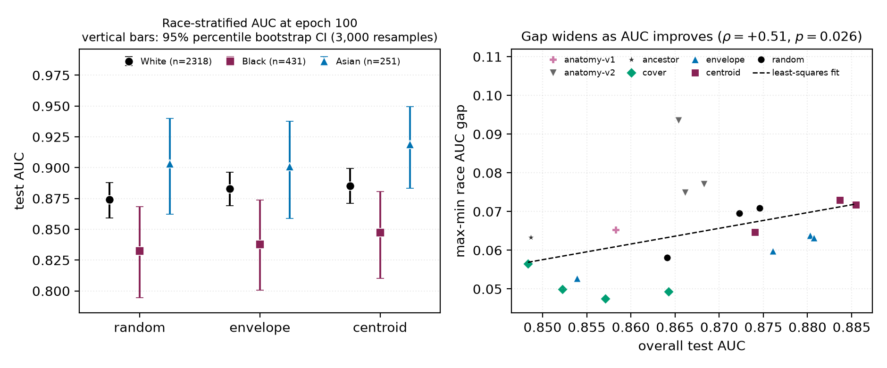
Left: race-stratified AUC at epoch 100. Points are group AUCs and vertical bars are 3,000-resample class-stratified percentile bootstrap intervals within each group, with fitted heads fixed and per-group $n$ in the legend. The black subgroup is lowest under every policy, yet every group point estimate rises from random to centroid. Right: max–min race gap against aggregate AUC, one point per probe over the 19 probes that carry a race summary; the legend keys colour and marker to policy. The dashed line is a least-squares fit while the quoted correlation is Spearman. The slope is positive but fails multiplicity correction at checkpoint level and does not survive branch-level aggregation (Table 6), so we draw no trend conclusion from it.
All numbers below come from saved test predictions joined to FairVision’s released metadata in deterministic loader order. The join is validated by exact label reconstruction (3000/3000 labels recovered in every probe). The 23 probes used here are exactly those the inventory marks valid: the four retracted random probes of Appendix 13 and the two precision-spliced anatomy-v2 probes are excluded here as everywhere else in the paper.

Missing data.
No case is dropped for a missing attribute anywhere in this paper and no value is imputed, so the per-group denominators sum to the full test split rather than to a complete-case subset. The released metadata carries every attribute we use for all 3000 test subjects, whose identifiers are all distinct, and the label is complete at 1466 positive and 1534 negative. Race is 251 asian, 431 black and 2318 white; sex is 1,716 female and 1,284 male; ethnicity is 2,894 non-hispanic and 106 hispanic; language is 2,782 english, 174 other and 44 spanish; marital status is 1,741 married or partnered, 776 single, 199 widowed, 191 divorced, 71 unknown and 22 legally separated; age is present and numeric for all 3000, spanning $9.5$–$98.0$ years. Each of those five categorical breakdowns sums to 3000 exactly, which is the check a reader should apply to the tables below.
One level is non-substantive rather than absent: 71 of 3000 subjects ($2.4\%$) carry marital status unknown in the release. We keep it as its own category rather than dropping those subjects or folding them into a substantive group, so it is subject only to the same underpowering rule as every other level. Severity is derived from visual-field mean deviation, and its 334 severe, 460 moderate and 672 mild strata sum to all 1466 positives, so no positive is lost at a stratum boundary. The release uses a mean-deviation sentinel of $−1$ in 3 of the 3000 test records. All 3 carry a negative label, and because every severity stratum is scored against the undifferentiated pool of all 1534 negatives, that sentinel never enters a stratum definition.
Separately from missingness, a group with fewer than 50 cases, or fewer than 10 of either class, is still computed and reported but is marked underpowered and held out of the max–min gap summaries. That is an exclusion from the fairness claim, not from the data, and it is the only place a group is set aside.

Why we report two sample sizes.
The 23 probes span only 7 pretraining branches, because several are different epochs of one training run. Probes within a branch share an encoder lineage, a seed and the test split, so treating them as 23 independent observations is pseudo-replication. Table 6 therefore reports each trend twice: once per checkpoint, and once after averaging within each branch. Where the two disagree, the branch-level figure is the one to believe.
Subgroup gap trends. “gap range” is the max–min subgroup AUC gap observed across the 23 valid probes. $q$ is Benjamini–Hochberg across the seven checkpoint-level tests. Branch $p$-values are unadjusted across the same seven and, at $n=7$, descriptive only. Only sex survives checkpoint-level correction at the conventional $0.05$ level, and it narrows as aggregate AUC rises. Race, ethnicity and disease severity share the same $q$ just above that level, so no threshold admits race and severity without also admitting ethnicity. Race is the one attribute whose checkpoint-level trend does not persist under branch aggregation ($p=0.4821$), where the effective sample is 7 independent branches rather than 23 probes; we therefore draw no trend conclusion for race.
 |  |  | per checkpoint ($n=23$) |  |  | per branch ($n=7$)
4-6(lr)7-8 attribute | worst group | gap range | $ρ$ | $p$ | $q$ | $ρ$ | $p$
sex | female (23/23) | 0.0272–0.0407 | -0.664 | 0.0005 | 0.0038 | -0.821 | 0.0234
race | black (23/23) | 0.0391–0.0935 | +0.473 | 0.0225 | 0.0668 | +0.321 | 0.4821
ethnicity | hispanic (23/23) | 0.0180–0.0661 | +0.435 | 0.0381 | 0.0668 | +0.679 | 0.0938
language | other languages (19/23) | 0.0518–0.0805 | +0.311 | 0.1483 | 0.1730 | +0.786 | 0.0362
marital status | single (23/23) | 0.0286–0.0654 | -0.210 | 0.3351 | 0.3351 | -0.679 | 0.0938
age | $<$60 (22/23) | 0.0430–0.0704 | +0.399 | 0.0591 | 0.0828 | +0.357 | 0.4316
disease severity | mild ($−6$,$−2$] (23/23) | 0.1286–0.1400 | -0.449 | 0.0318 | 0.0668 | -0.821 | 0.0234

Race.
The black subgroup has the lowest AUC in every one of the 23 probes ($n=431$ black, $n=251$ asian, $n=2318$ white; Figure 5). At matched epoch 100 the black subgroup improves from $0.8325$ under random to $0.8472$ under centroid ($+0.0147$), a larger absolute gain than the white subgroup’s ($0.8741→0.8853$). The max–min gap nonetheless widens slightly, because the asian subgroup (already the highest) gains most ($0.9033→0.9189$). A widening max–min gap with universally rising subgroup AUCs is not evidence of harm. The checkpoint-level correlation between aggregate AUC and racial gap is $ρ=+0.473$ ($p=0.0225$). It does not pass Benjamini–Hochberg correction at the stated conventional threshold ($q=0.0668$), and it vanishes once probes are aggregated to their pretraining branches ($ρ=+0.321$, $p=0.4821$), and the checkpoint-level test is pseudo-replicated because the 23 probes come from only 7 branches.

Disease severity.
FairVision’s label is defined by visual-field mean deviation (md): every test volume with md $≤−2$ is positive. Severity therefore cannot be used as an ordinary subgroup axis, because within-bin AUC is undefined, a trap that silently yields nothing under naive stratification. Instead each positive stratum is scored against the shared pool of all 1534 negatives (Table 7).
Severity-stratified AUC at matched epoch 100. Each positive stratum is scored against the shared pool of all 1534 negatives. Each point estimate rises; the gains were not tested against one another.
stratum | $n_{+}$ | random | envelope | centroid | $Δ$
severe (md $≤−12$) | 334 | 0.9525 | 0.9559 | 0.9588 | +0.0063
moderate ($−12<$ md $≤−6$) | 460 | 0.9030 | 0.9103 | 0.9131 | +0.0102
mild ($−6<$ md $≤−2$) | 672 | 0.8164 | 0.8232 | 0.8301 | +0.0137
The severe-to-mild gap is $0.1361$ for the null and $0.1286$ for the strongest policy, and stays within $0.0114$ ($0.1286$–$0.1400$) across all 23 probes while aggregate AUC spans $0.8483$–$0.8855$. All three point estimates rise, but family-wise simultaneous adjustment leaves only mild excluding zero. Moderate and severe no longer do (Table 8). The largest point estimate is at mild disease ($+0.01372$, CI $[+0.00204, +0.02541]$) and the smallest at severe ($+0.00626$). That ordering is descriptive only: we did not test the paired difference between strata, so it does not establish that mild disease benefits most. Mild functional loss is harder to separate from normal OCT by construction, so the difficulty ordering is expected clinically. What the data add is that no masking policy we tested changes it.
Paired change in subgroup AUC from random to centroid at matched epoch 100. The eight rows plus two gain-difference contrasts in the text form one exploratory family. Reported CIs are 95% single-step max-$|t|$ simultaneous intervals from 10,000 outcome-stratified paired subject resamples shared across both fixed heads and every stratum (family-wise $α=0.05$). Four of ten exclude zero: mild severity, white race, and both sex strata.
stratum | $n$ | $Δ$ AUC | simultaneous 95% CI | excludes 0
severity, mild | 2206 | +0.01372 | [+0.00204, +0.02541] | yes
severity, moderate | 1994 | +0.01016 | [-0.00029, +0.02061] | no
severity, severe | 1868 | +0.00626 | [-0.00135, +0.01386] | no
race, White | 2318 | +0.01129 | [+0.00286, +0.01972] | yes
race, Black | 431 | +0.01467 | [-0.00742, +0.03676] | no
race, Asian | 251 | +0.01558 | [-0.00766, +0.03882] | no
sex, Female | 1716 | +0.01152 | [+0.00100, +0.02204] | yes
sex, Male | 1284 | +0.01006 | [+0.00067, +0.01945] | yes

Limitations.
The $p$-values here are descriptive, for the reasons given in Section 6. Race and ethnicity are self-reported categories inherited from FairVision’s coding. A race-by-sex intersectional breakdown is reported, in Appendix 12.1. Its limits are that two of its six cells hold fewer than $130$ cases and that it carries no paired per-cell intervals, so it describes the disparity and tests no per-cell change. All figures are frozen mean-pool linear probes. Subgroup sensitivity, specificity and race-stratified expected calibration error at a transferred threshold are reported in Appendix 18. What is absent is subgroup predictive values, reliability curves, and calibration stratified by any attribute other than race, so this is not a complete fairness evaluation. Disparities could differ under fine-tuning or a stronger head.

Intersectional breakdown: race by sex
The audit above crosses no attributes, so on its own it cannot say whether a group disadvantaged on two axes at once is worse served than either margin implies. We therefore also computed AUC for all six race-by-sex cells of the test split, from the same saved predictions, under the same exact-label join proof, with per-arm, 2,000-resample class-stratified percentile intervals within each cell and fitted heads fixed. The second axis is FairVision’s self-reported gender coding, which this paper reports as sex throughout. The artifact behind this subsection covers 22 arms, 18 of them non-retracted. Those 18 are a strict subset of the 23 probes of Table 6. Five are absent: cover at epochs 50, 73, 75 and 100, and the anatomy-v2 epoch-75 probe, whose run directory carries the internal name blob, an artifact label for the anatomy-shaped family that this paper calls anatomy-v2, and the only place that label survives here. All five were probed after this artifact was generated and it was not recomputed, so their absence is artifact chronology rather than an analytic exclusion. The four retracted arms the artifact does contain are dropped for the reasons in Appendix 13. Every count in this subsection is therefore out of 18 arms, not 23.
Race-by-sex AUC at matched epoch 100 on the 3000 test volumes, with per-cell counts and per-arm bootstrap percentile intervals. $Δ$ is centroid minus random as a difference of point estimates. The artifact stores per-arm intervals only and no paired per-cell resampling, so no $Δ$ in this table is tested against zero; per-cell significance is not reported. The 18 intervals are marginal, not simultaneous. The two asian cells are small ($n=123$ and $n=128$) and their intervals are correspondingly wide.
cell | $n$ | $n_{+}$ | random | envelope | centroid | $Δ$
asian $×$ female | 123 | 52 | 0.8761 [0.8024, 0.9342] | 0.8762 [0.8042, 0.9366] | 0.8904 [0.8245, 0.9423] | $+0.0144$
asian $×$ male | 128 | 66 | 0.9245 [0.8752, 0.9655] | 0.9145 [0.8565, 0.9626] | 0.9409 [0.8983, 0.9751] | $+0.0164$
black $×$ female | 250 | 149 | 0.8195 [0.7668, 0.8679] | 0.8155 [0.7632, 0.8638] | 0.8309 [0.7790, 0.8783] | $+0.0114$
black $×$ male | 181 | 119 | 0.8435 [0.7822, 0.8994] | 0.8652 [0.8091, 0.9141] | 0.8663 [0.8132, 0.9149] | $+0.0228$
white $×$ female | 1343 | 610 | 0.8641 [0.8441, 0.8826] | 0.8728 [0.8530, 0.8910] | 0.8762 [0.8570, 0.8943] | $+0.0121$
white $×$ male | 975 | 470 | 0.8864 [0.8650, 0.9062] | 0.8958 [0.8744, 0.9148] | 0.8962 [0.8746, 0.9153] | $+0.0099$
max$−$min gap |  |  | 0.1050 | 0.0990 | 0.1100

The ordering compounds, and it never reorders.
The black $×$ female cell has the lowest AUC in all 18 non-retracted arms and the asian $×$ male cell the highest in all 18. Within each race the female cell sits below the male cell in all $54$ race-by-arm combinations, and within each sex the black cell sits below the white cell in all $36$. These 18 arms share one test split, one epoch-25 ancestor and one probe seed, and several are different epochs of a single branch, so this unanimity is a consistency check across checkpoints, not 18 replications. We attach no $p$-value to it, exactly as for the marginal ordering above.

The marginal race gap understates the worst cell.
Averaged over the 18 arms, the max$−$min gap is $0.0340$ by sex alone, $0.0653$ by race alone, and $0.1046$ across the six race-by-sex cells, and the intersectional gap exceeds that arm’s marginal race gap in all 18. The race margin therefore understates the spread a race-by-sex reading exposes by $60.1\%$ on average, arithmetic on those two means, not a separate measurement. The same pattern holds at the matched epoch of Table 9: under centroid the marginal race gap is $0.0717$ while the race-by-sex gap is $0.1100$, and the worst cell, black $×$ female at $0.8309$, sits $0.0163$ below the marginal black figure $0.8472$ that the marginal audit above reports. An audit that stops at the margins reports a worst-group number that is optimistic relative to the worst cell. The compounding is close to additive and we do not claim more: the sex and race means sum to $0.0993$ against an observed $0.1046$, a ratio of $1.053$, which is not evidence of a super-additive interaction.

Not every cell improves.
The statement elsewhere in this appendix that every subgroup point estimate rises from random to centroid is a statement about marginal strata at the matched epoch, and it does not extend to cells at every epoch. At epoch 100 all six point estimates rise (Table 9), but at epoch 50 the asian $×$ female cell falls by $0.0020$, and envelope minus random is negative in three of six cells at epoch 75 (asian $×$ female $−0.0148$, asian $×$ male $−0.0031$, black $×$ female $−0.0025$) and in two of six at epoch 100 (asian $×$ male $−0.0100$, black $×$ female $−0.0040$, with asian $×$ female at $+0.0001$). No policy we tested raises every intersectional cell at every epoch, and the exceptions fall in the small asian cells and in the worst cell.

What this does not establish.
There are no paired per-cell bootstrap intervals in the artifact, so every $Δ$ above is a difference of point estimates and none of them is separated from zero. Per-cell delta significance is not computed here, though it is computable from the retained per-arm predictions. Two cells carry $n=123$ and $n=128$, so their intervals overlap almost everything. Cells with a single class or fewer than $40$ cases would have been dropped. None were, so all six race-by-sex cells are reported. Nothing here is a fairness intervention: as with the margins, no policy reorders the cells, and the worst-served cell is the same under the unguided null and under every guided policy we tested.

Excluded runs
Four probes of an earlier null run are excluded from all analysis. They are unguided-masking controls from a superseded coverage campaign: the inventory lists them under random, and their run tags begin frozen_cover_random because of that campaign, not because they use a coverage policy. They were trained with half-precision EMA targets and a different encoder-truncation policy from the arms they would be compared against, so their deficit is not attributable to masking. Similarly, the anatomy-v2 probes at epochs 75 and 92 follow a change of target precision partway through that arm’s training. They are listed in Table 3 but excluded from the matched-epoch comparisons in Table 1.

A collation defect in the coverage arm, and what it invalidates
We audited the cover sampler after its epoch-100 result and found a defect. It invalidates the reading of that arm and weakens one cross-family comparison.

The defect.
Predictor targets are collated by truncating every target to the length of the shortest target anywhere in the microbatch. cover chooses its placement before this happens: it greedily maximises hidden anatomy subject to a visible-tissue floor, evaluated on full rectangles, and the collator then shortens those rectangles. The optimisation is therefore defeated after the fact.

Measured consequences.
A one-off audit found that collation reduced cover’s anatomy coverage. An independent sweep over $6,137$ slices gives $73.1\%$ against $77.6\%$ for envelope. The arm intended to hide more anatomy than envelope in fact hides less. Across $24,000$ emitted targets only $73.4\%$ remain perfect rectangles. Because target cells are enumerated row-major, truncation keeps the top of each rectangle and discards the bottom, so the loss is directional rather than a neutral shrink. Provenance: the one-off CPU audit of 194 accepted slices that first exposed the defect was not persisted, so its pre- and post-truncation figures are no longer asserted. The $73.1\%$ against $77.6\%$ comparison, which is the only figure the body relies on, is backed by the stored floor sweep and is unaffected.

Why it went unnoticed.
Realised coverage is recorded before truncation. Every training log therefore reported the intended figure, and the instrument agreed with the design rather than with the data.

What it invalidates.
We cannot claim that cover tests aggressive anatomy coverage, nor that its decline shows over-covering anatomy is harmful. On delivered masks it does not out-cover envelope. Its measured trajectory remains a real property of the policy as implemented. The mask geometry in Table 2 is unaffected, having been measured on delivered masks.

Scope.
envelope shares the same collation path and the same directional clipping, but sets no exact coverage target, so it has no comparable optimisation to defeat. The anatomy arms instead resample every target to a fixed $K=16$ cells. Contrasts within the rectangle family are collated identically and are unaffected. The anatomy-versus-rectangle contrast is not, and we treat it accordingly in Section 5. A corrected coverage arm must be retrained from the shared ancestor, since patching mid-trajectory would splice two masking policies into one curve.

Status of a corrected run.
At submission the corrected arm is not run. Until it exists, the question this arm was built to answer (whether hiding most of the anatomy is harmful) remains open.

Why unguided masking is such a strong baseline
Unguided masking spends most of its predictor targets on background, yet it reaches within $+0.0109$ of the best policy. We investigated whether background carries diagnostic signal, and whether position embeddings are the mechanism.

Background is a real pretraining signal.
At epoch 100 the random arm’s predictor beats a per-position, no-context reference by $0.680$ on background targets, above its $0.633$ on anatomy targets: predicting a background token requires more than knowing where it is. Pretraining also spends capacity reorganising background: background self-similarity falls from $0.784$ untrained to $0.346$ at epoch 100.

But it does not help the classifier.
Pooled background features are $95.2\%$ linearly reconstructible from pooled anatomy features. On $n=1000$ test subjects, with fitted transforms and probes fixed, residual background has AUC $0.5515$ (2,000-resample case-percentile CI $[0.5165,0.5893]$). A paired bootstrap of the same size puts the change from appending background at $−0.0076$ (CI $[−0.0139,−0.0012]$) for the random arm and under $±0.002$ for every other. A background-only probe scores $0.867$. Self-attention mixes tissue information into background tokens, so that figure cannot be read as background signal, and we did not measure how much mixing occurs.

Position dominates background tokens, but is not the whole story.
At layer 0, $90.8\%$ of the across-position variance of the encoder input at background cells comes from pos_embed, against $40.8\%$ at tissue cells (stable across six thresholds and both checkpoints). Mechanically a background token is close to its position code. That the predictor still beats a per-position reference shows the pretraining signal is not purely positional. The causal chain from this mechanism to downstream AUC remains open.

The two controls that would settle it, neither of which was run.
First, a regional probe on an eroded background region (background cells at a fixed minimum distance from any tissue cell), which removes the tokens most exposed to local mixing while keeping the probe protocol fixed. Second, a background-content shuffle in which background token contents are permuted across images while positions and token count are held fixed: if the background-only AUC survives that, the signal is positional rather than content-bearing. Neither has been run, so this appendix reports a mechanism that is described but not established.

Label efficiency
We measured each policy as supervision is withdrawn (Section 5.4). We subsample the labelled training set to fractions of its size, fit the same frozen linear probe on cached epoch-100 features, and repeat 5 times per fraction. The per-fraction seed depends only on fraction and repeat, never on arm, so all arms see identical label subsets and the comparison is paired.

Protocol parity.
This sweep uses the same probe protocol as Table 1: minibatches of 256, AdamW at $4×{10}^{−4}$, weight decay 0.05, 50 epochs with 5 warmup and cosine decay, and the epoch selected on validation AUC. An earlier cheaper full-batch fit disagreed with the primary protocol. Under matched protocols, restricting this check to the null and centroid, their full-supervision results agree to within $0.0003$ ($0.8748$ against $0.8746$ for the null, $0.8856$ against $0.8855$ for centroid), so the curve below and the headline table describe one probe, not two. This two-arm bound is distinct from the four-arm bound reported in Section 5.4.
The advantage of guided masking is concentrated where labels are scarce (Table 10, Figure 6). At $5\%$ of labels ($n=300$) centroid leads the null by $+0.0496$ ($0.8335$ against $0.7839$), against $+0.0108$ at full supervision, more than four times the margin. At $1\%$ the gap is wider still ($0.7576$ against $0.6961$), though the standard deviations there ($0.0359$–$0.0368$ across arms) are large enough that we read the ordering but not its precise size.
The defective cover arm (Appendix 14) is the worst arm at every fraction, reaching only $0.6879$ at $1\%$ against $0.6961$ for the null, consistent with its targets being degraded rather than merely differently placed.
Label efficiency: frozen-probe test AUC against the fraction of the labelled training set used. All values measured, 5 repeats per fraction except at full data, which is deterministic.
labels | $n$ | random | centroid | envelope | cover
1% | 60 | 0.6961 | 0.7576 | 0.7471 | 0.6879
5% | 300 | 0.7839 | 0.8335 | 0.8197 | 0.7484
10% | 600 | 0.8169 | 0.8490 | 0.8404 | 0.7743
25% | 1500 | 0.8497 | 0.8732 | 0.8654 | 0.8162
100% | 6000 | 0.8748 | 0.8856 | 0.8813 | 0.8586
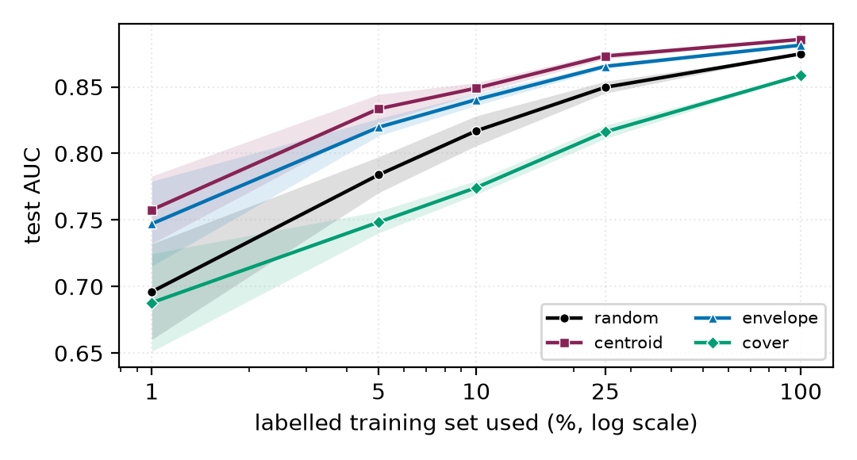
The policies converge as labels are added and separate as they are removed. Shading is one standard deviation over 5 label subsets, with every arm seeing identical subsets. At full supervision the four arms lie within $0.027$ of one another; at $5\%$ the spread is $0.085$.

Occlusion attribution: where the classifier looks
The analyses in this appendix were run on the three fine-tuned probes (mean-pool, cross-attention pool, and a depth-1 attentive probe) that tie at test AUC $≈0.887$, not on the frozen probes used for the arm comparison in the main text. They characterise what the downstream classifier uses, and they are reported here because two of the findings are cautionary rather than positive. Every number in this appendix is computed from archived per-volume attribution arrays that are not part of the released artifact set, so unlike the rest of the paper these values cannot be recomputed from the release. Only the diffuse-attribution result at the end of the appendix is cited by the main text.

Method.
Attribution is by occlusion, which is architecture-agnostic and interventional on the model. It measures the model’s sensitivity to deleting a token, not a causal effect of anatomy on disease. Gradient$×$input is not used because two of the three probes are non-linear in the slice-token matrix, where gradient attribution is misleading. For slice-level attribution each slice token is zeroed in turn and $Δ$logit recorded (Figure 7); for window-level, seven consecutive slices (Figure 8); for patch-level, leave-one-out over the 256 patch tokens of a target slice.
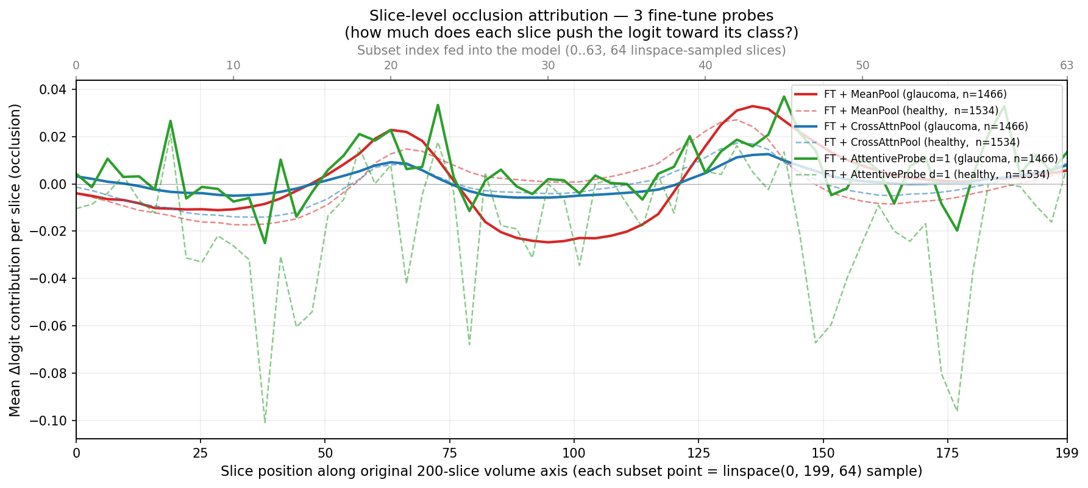
Single-slice occlusion attribution against native slice position, for all three fine-tuned probes. Each probe contributes two curves, a mean over the glaucoma volumes (solid) and a mean over the healthy volumes (dashed), with each $n$ in the legend and no interval drawn. Despite spanning zero to 7.14M probe parameters they converge on the same structure. The $y$-axis is signed $Δ$logit: peaks are slices whose removal lowers the logit, the central dip is slices whose removal raises it, and only slices near zero are genuinely unused.
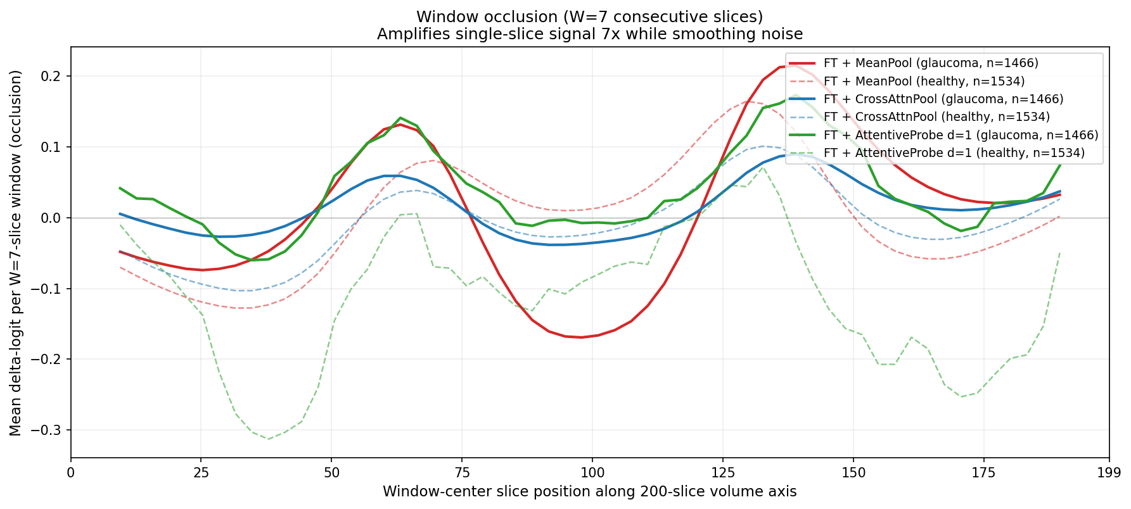
Window occlusion ($W=7$) amplifies the same signal roughly sevenfold and suppresses single-volume noise. For mean-pooled models, single-slice occlusion systematically under-estimates attributed signal; the windowed variant recovers more signal. As in Figure 7, each probe contributes a glaucoma mean (solid) and a healthy mean (dashed) with no interval drawn, and the curve stops where a full window no longer fits.

A bimodal attribution curve that is an artefact, not anatomy.
The population-averaged curve is bimodal with a central dip. The tempting reading (that the model has discovered the superior and inferior optic disc rim) is wrong, and we report it because it is exactly the kind of claim a plausible-looking attribution figure invites. Three tests reject it. First, if the two peaks were bilateral anatomy then within a diseased eye they should co-occur, giving positive per-volume correlation between them. The peak contributions are not positively correlated across volumes. Second, clustering the per-volume curves into two groups yields clusters that are near-perfect mirror images along the slice axis for the two well-structured probes. Third, using that cluster label as pseudo-laterality and flipping one cluster collapses the bimodality asymmetrically (Figure 9). What these three tests support is an orientation or storage mixture consistent with OD/OS: each eye carries its dominant signal on one side of the disc, the two groups are stored with opposite axial orientation, and population averaging manufactures an illusion of symmetry. The released metadata carries no eye-laterality label, so the OD/OS reading is inferred from the mirror structure and is not validated against ground truth.
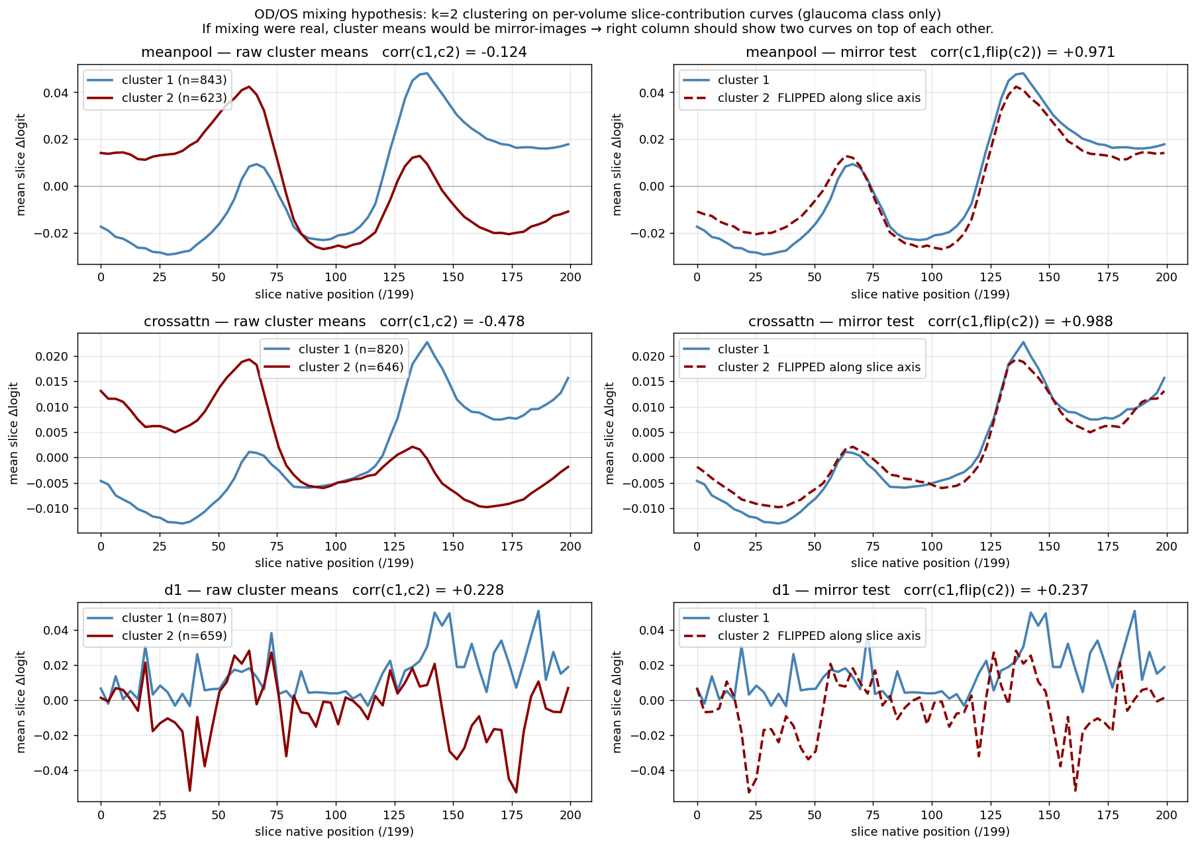
The two-peak structure is an OD/OS storage artefact. Clustering per-volume attribution curves into two groups returns near-perfect mirror images of one another for the two well-structured probes, which is what laterality flipping would produce, rather than bilateral anatomy; the d1 row does not show that structure. Glaucoma volumes only, cluster $n$ in each legend, no interval drawn, and the $y$ range differs by row.

Errors are weaker signal, not different anatomy.
Stratifying by outcome, false-negative curves are scaled-down true-positive curves with the same shape, and false positives likewise mirror true negatives (Figure 10). Attribution structure is also near-invariant to prediction confidence. The error rate at threshold $0.5$ therefore reflects signal-strength saturation on hard cases, not the model attending to the wrong structures.
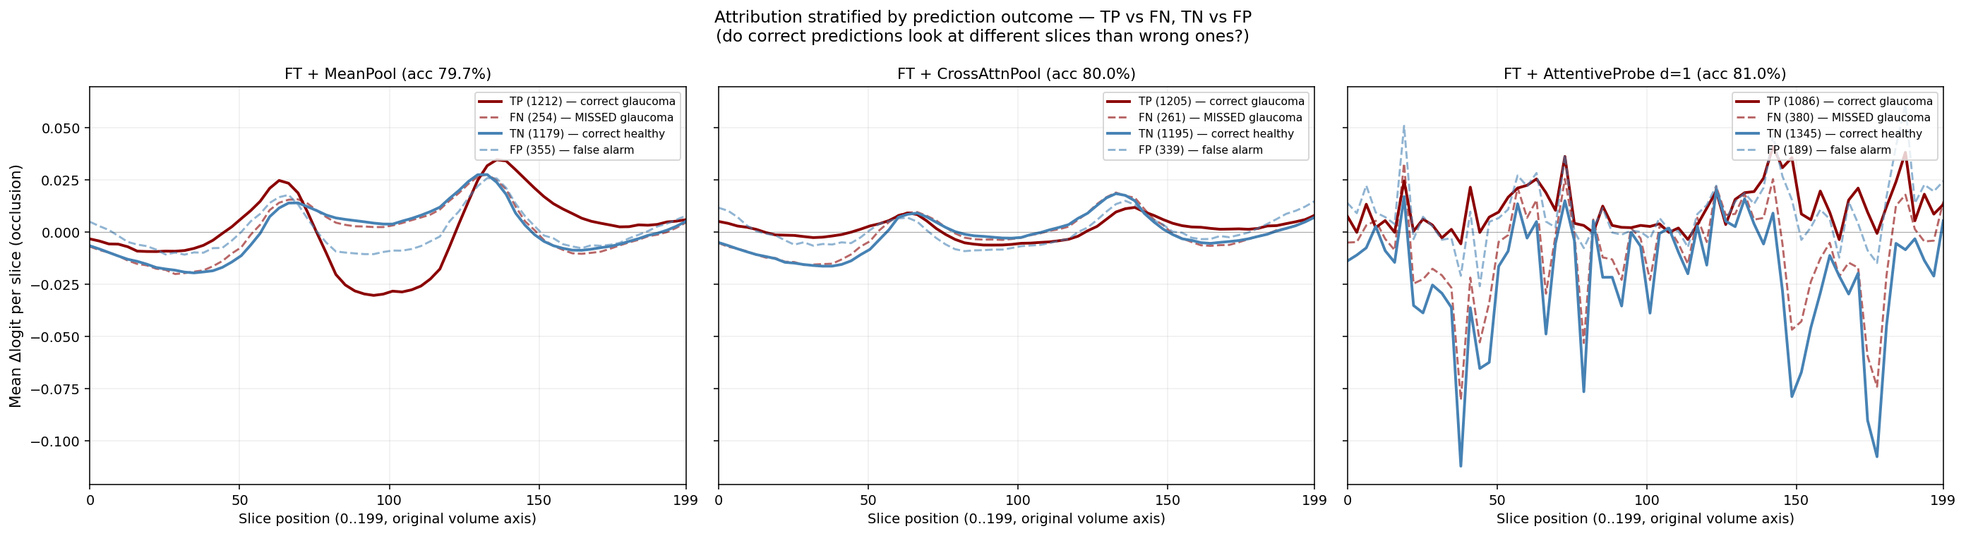
Attribution stratified by TP / FN / TN / FP. Errors reproduce the correct pattern at lower amplitude rather than selecting different anatomy. Curves are per-outcome means with the $n$ in each legend; panels share a $y$ range and no interval is drawn.
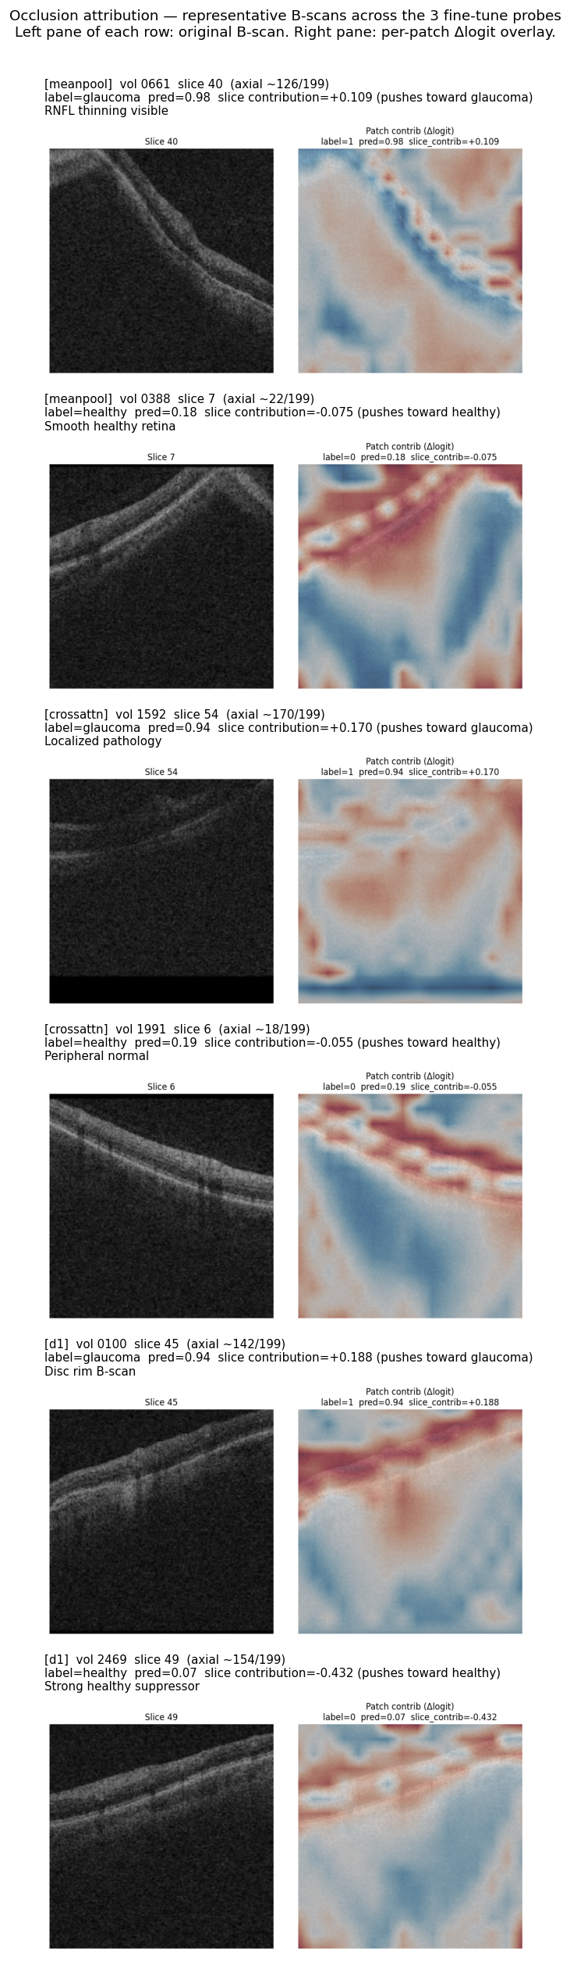
Per-patch occlusion heat maps on individual B-scans, drawn on a shared scale with the slice mean subtracted so that maps are comparable across volumes. Attribution is broadly distributed rather than concentrated in a few patches. Agreement is stronger at slice than patch level. These are hand-picked illustrative volumes rather than a sample, the overlay is the patch grid rendered with smoothing and so carries no detail finer than a patch, and no colour bar is drawn, so the maps show sign and spatial pattern but no readable magnitude.

Diffuse attribution supports the main claim.
The classifier’s evidence is spread across the middle two-thirds of the volume and across most patches within a slice (Figure 11), rather than concentrated on a compact anatomical target. A masking policy that sharpens targets onto a precise anatomical boundary is therefore optimising for a spatial prior the downstream task does not appear to need, which is consistent with Section 5.2 finding no relationship between anatomical specificity and downstream AUC. The OD/OS result is a methodological caution: a figure that looks anatomically meaningful can be an artefact of data storage.

Clinical operating points and calibration
AUC is threshold-free, but a screening tool is deployed at a threshold. The threshold is selected on the random arm’s validation split at a fixed target specificity and then applied unchanged to every arm on the test split: one shared deployed threshold rather than a per-arm one, which simulates a fielded screen and is conservative for the guided arms, since they are not permitted to retune. The achieved test specificity shows whether the threshold survives the shift. Cohort prevalence is $0.4887$.
Operating points at matched epoch 100. One threshold, chosen on the random validation split to hit the target specificity, is applied unchanged to all arms on test. ECE is a 15-bin expected calibration error.
policy | target spec. | sens. | spec. (test) | PPV | NPV | Brier | ECE
random | 0.85 | 0.7701 | 0.8259 | 0.8087 | 0.7899 | 0.1416 | 0.0355
random | 0.90 | 0.7162 | 0.8794 | 0.8502 | 0.7643 | 0.1416 | 0.0355
envelope | 0.85 | 0.7735 | 0.8351 | 0.8176 | 0.7942 | 0.1364 | 0.0361
envelope | 0.90 | 0.7306 | 0.8807 | 0.8541 | 0.7738 | 0.1364 | 0.0361
centroid | 0.85 | 0.7851 | 0.8318 | 0.8169 | 0.8020 | 0.1341 | 0.0320
centroid | 0.90 | 0.7428 | 0.8696 | 0.8448 | 0.7797 | 0.1341 | 0.0320
Two observations (Table 11). First, the threshold transfers imperfectly: a validation target of $0.90$ yields test specificity $0.8696$ to $0.8807$ across the three arms, so the operating point moves by roughly one point between arms and the comparison below is at a shared threshold rather than at a shared false-positive rate. Second, the AUC advantage survives as a usable sensitivity gain. At a target specificity of $0.90$, centroid detects $0.7428$ of cases against $0.7162$ for the unguided null, a paired difference of $+0.0266$ (CI $[+0.0136, +0.0396]$, excluding zero), with the specificity caveat above. At a target of $0.85$ the gain is $+0.0150$ (CI $[+0.0020, +0.0280]$). These four arm-by-target CIs use 10,000 class-stratified percentile subject resamples with fitted heads and thresholds fixed. They are one unadjusted exploratory family. centroid is also the best-calibrated arm (Brier $0.1341$ versus $0.1416$; ECE $0.0320$ versus $0.0355$), which matters because a screening score that is used as a probability must be trustworthy as one.
A $+0.011$ AUC difference is hard to interpret clinically, and the ROC curves are nearly superimposed (Figure 12), whereas a change in cases detected at a fixed threshold is not. We state that comparison carefully: transferring one threshold moves achieved specificity from $0.8794$ to $0.8696$, so the arms are not compared at an identical false-positive rate and the sensitivity change partly reflects that shift. A deployment-grade comparison would select each arm’s threshold on validation to meet the same specificity, lock it, and evaluate on an untouched cohort. One dataset, one split, one pretraining run per policy.

Who receives the benefit at the deployed threshold.
Subgroup AUC is also threshold-free, so it cannot answer the question a deployment actually raises: a screen ships one threshold shared by everyone, and a model can lift every subgroup’s AUC while delivering the gain unevenly at that single operating point. We therefore fix the threshold on validation at specificity $0.90$ ($0.5552$), transfer it unchanged, and measure the change in sensitivity within each stratum (Table 12). Overall sensitivity rises from $0.7162$ to $0.7428$.
The point estimates alone suggest the gain is concentrated in the largest group: $+0.0343$ for white patients against $+0.0037$ for black patients, an apparent ninefold difference. The intervals do not support that reading. The black interval ($[−0.0375, +0.0449]$) reaches almost exactly the white point estimate, so the two are not separated. What distinguishes them is positive count ($1080$ versus $268$), not demonstrated benefit. Only the white, female and male gains exclude zero. All three remain after simultaneous adjustment over the five-contrast family, and they are the three largest strata. This is a power limitation of the cohort: the study cannot certify that the smaller strata benefit, and equally cannot show they do not. Certifying subgroup benefit at a deployed threshold would need a cohort with more positives in the smaller strata.

The threshold itself does not transfer evenly across strata.
The same table answers a question the sensitivity column does not. A threshold selected on validation to achieve specificity $0.90$ does not achieve it uniformly on test: under random it realises $0.895$ specificity in the white stratum but $0.736$ in the black stratum, a shortfall of roughly sixteen points, and under centroid the same threshold realises $0.879$ and $0.761$. The shortfall is therefore a property of transferring one threshold to a cohort whose strata have different score distributions, and it is present under both arms. No masking policy here causes it and none of them repairs it. For a screening context this is a larger effect than any AUC difference in this paper.

The sensitivity gain is not a uniform trade.
Reporting sensitivity alone would make the change from random to centroid look like pure benefit where it is in fact a trade. In the white stratum sensitivity rises by $+0.034$ while specificity falls by $−0.016$. In the black stratum specificity rises by $+0.025$ and in the asian stratum by $+0.008$, alongside sensitivity changes ($+0.004$ and $+0.008$) whose intervals contain zero. By sex, both strata gain sensitivity ($+0.026$ female, $+0.027$ male) and lose specificity ($−0.008$ and $−0.013$). Subgroup calibration moves the same way and not entirely in our favour: expected calibration error improves overall ($0.0355$ to $0.0320$) and in the white ($0.0382$ to $0.0321$) and asian ($0.0832$ to $0.0729$) strata, but worsens in the black stratum ($0.0525$ to $0.0569$). Race is the only attribute for which we report stratified calibration. All values in these two paragraphs are measured at the same shared threshold as Table 12, and the comparison remains at a shared threshold rather than at a shared realised false-positive rate.
Change in sensitivity from random to centroid at one shared validation-selected threshold, by stratum. The five contrasts form one exploratory family. Reported CIs are 95% single-step max-$|t|$ simultaneous intervals from 10,000 paired positive-subject resamples shared across both fixed heads and all five overlapping race and sex strata, with heads and threshold fixed (family-wise $α=0.05$). White, female and male remain above zero after adjustment. Epoch 100.
stratum | positives | $Δ$ sensitivity | simultaneous 95% CI | excludes 0
Asian | 118 | $+0.0085$ | $[−0.0485, +0.0654]$ | no
Black | 268 | $+0.0037$ | $[−0.0375, +0.0449]$ | no
White | 1080 | $+0.0343$ | $[+0.0149, +0.0536]$ | yes
Female | 811 | $+0.0259$ | $[+0.0020, +0.0498]$ | yes
Male | 655 | $+0.0275$ | $[+0.0043, +0.0507]$ | yes
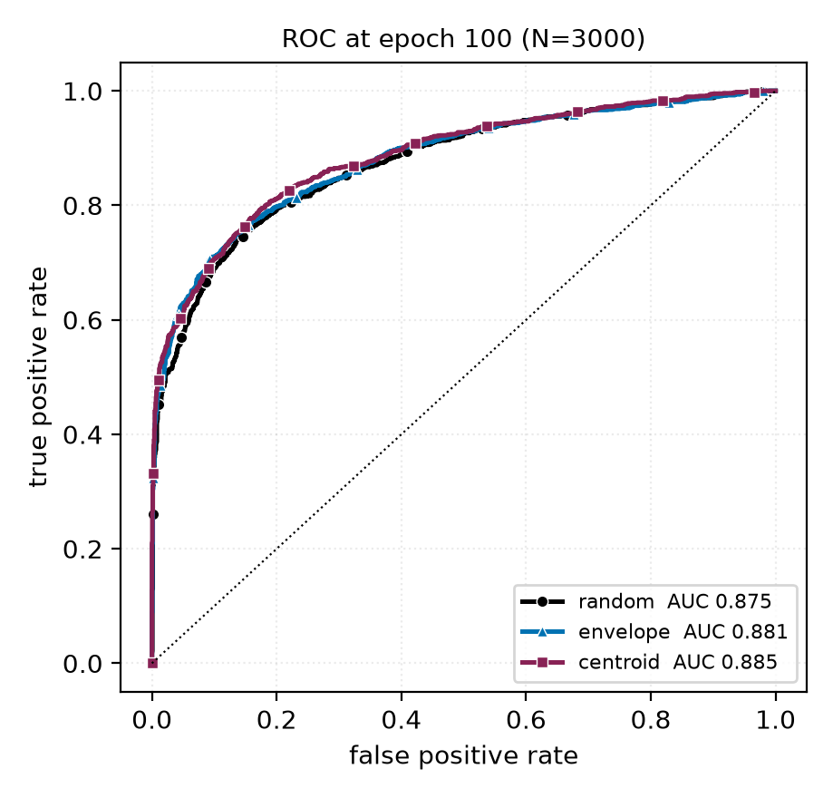
ROC curves at epoch 100 on the 3000 test volumes. The three arms plotted are nearly superimposed: the separation reported throughout this paper is a small, consistent shift in the high-specificity region rather than a difference visible in the curve as a whole. We include this so the effect size is not overstated by tables alone.

Broader impact and ethics
This study uses a public, de-identified retinal dataset (FairVision) under its release terms and involves no new data collection and no human subjects. No model reported here is clinically validated or intended for deployment: the frozen-probe AUCs are research measurements on one dataset and one task, and are not evidence of clinical utility.

Dataset provenance and licence.
We name the governing terms explicitly rather than leave “release terms” to stand on its own. The cohort is the glaucoma arm of Harvard-FairVision (Luo, Khan, et al. 2024): 10,000 subjects distributed with a fixed 6,000/1,000/3000 training, validation and test partition, and every number in this paper is measured on the 3000-subject test partition. The distribution states a data licence of CC BY-NC-ND 4.0, which permits non-commercial research and states that the data are not to be used for clinical decisions or patient care. The accompanying code repository carries a separate MIT software licence that covers code only and does not relax the data terms. Our use is non-commercial research measurement with no clinical deployment, which is what those terms allow. The data were taken from the public release. No application, data use agreement or credentialed-access step is recorded for this dataset in our project record. The release is distributed de-identified: each subject archive holds an OCT volume, a binary label, a visual-field mean deviation and coded demographic attributes, with no name, date or free text. We added no identifying field, attempted no re-identification, and linked to no external source. The artifacts we release are encoder weights, a fitted probe head and per-case prediction scores. We redistribute no image data.

What our ethics record does not contain.
This project holds no IRB or ethics-committee approval number, no consent documentation, and no written non-human-subjects or exemption determination for this secondary analysis. None was recorded at the time, and we will not assert one after the fact. The statement above is therefore narrower than a governance statement: it is what the release says and what we did with it. The approval and consent record for the underlying data collection belongs to the FairVision authors’ primary publication and the institutional record behind it (Luo, Khan, et al. 2024), which we did not obtain. Closing this gap would require citing that ethics statement directly and obtaining a written determination from our own institution. A venue requiring a formal determination should treat this item as outstanding rather than satisfied.
The subgroup analysis in Section 5.5 is a caution, not a contribution. For five of seven attributes every policy we tested leaves the same group worst-served, and the best-performing policy narrows none of them reliably, even though every subgroup point estimate rises at the matched epoch. We would regard deployment of any encoder reported here, without a dedicated and prospective fairness evaluation on the target population, as inappropriate. We also stress that the audit is incomplete: beyond AUC, the transferred-threshold sensitivity, specificity and calibration of Appendix 18 (whose expected calibration error is stratified by race, the only attribute for which we report it) and the race-by-sex breakdown of Appendix 12.1, it contains no predictive-value analysis, no reliability curves, and no calibration stratified by sex, ethnicity or severity, and the intersectional cells carry no paired per-cell intervals, so no per-cell change there is tested against zero.
Releasing pretrained weights carries the usual dual-use consideration that they may be applied to populations unlike the training cohort. We document the cohort composition (Appendix 12) so that such a mismatch is detectable by anyone reusing the weights. The demographic attributes are self-reported categories inherited from the dataset’s coding. They are used only for the subgroup audit and are never model inputs.

Published ablations on informed versus random masking
Random masking is a strong baseline in the published record and informed masking wins only under some objectives and protocols, the deficit largest under frozen evaluation. Our result should be read against those comparisons (Table 13), collected while positioning this work.
Published ablations comparing a random or simple baseline against an informed or structured masking scheme. Numbers are as reported by the cited papers; metrics differ across rows and are not comparable between rows.
study | baseline | informed variant | interpretation
MAE (He et al. 2022) | random-75: 84.9 FT / 73.5 lin | block-75: 82.8 / 63.9; grid-75: 84.0 / 66.0 | random decisively better
SimMIM (Xie et al. 2022) | 83.0 top-1 | best block 82.7; square 82.6 | random modestly better
SemMAE (Li et al. 2022) | random 66.8 lin | within-part 66.5; whole-part 52.9; adaptive 68.7 | naive semantics hurt; scheduled semantics help
SemMAE part quality (Li et al. 2022) | no parts 63.7 | raw parts 63.6; refined 65.0 | an imperfect semantic model adds nothing
AutoMAE (H. Chen et al. 2023) | MAE 83.26 FT | AutoMAE 83.32 | effectively tied
HPM (Wang et al. 2023) | random 82.49 | moderate 82.95; hardest-only 81.40 | benefit only with retained randomness
AttMask (Kakogeorgiou et al. 2022) | random 43.4 $k$-NN | high 43.5; hint 43.6 | nearly indistinguishable
AttG-MAE (Sick et al. 2025) | MAE 78.5 @10% labels | guided 78.1 | guidance loses in this protocol
SSiT (Huang et al. 2024) | no saliency 79.48 $κ$ | 25% mask 77.53; 50% 79.97 | dataset-dependent, non-monotonic
Read together, these say that the direction of our finding is not new. What we add is the controlled measurement, not the sign of the result.

Full paired-contrast table
Primary contrasts: matched epoch and matched precision. $Δ$ is a paired difference on identical test cases; the interval is a 10,000-resample paired bootstrap and $p$ is a DeLong test for correlated ROC curves. $q$ is Benjamini–Hochberg over these nine contrasts. All $p$ and $q$ values here are descriptive (Section 6). Every comparison against the null excludes zero.
contrast | epoch | $Δ$ AUC | 95% CI | $p$ | $q$
envelope $−$ random | 50 | +0.0120 | [+0.0068, +0.0173] | $<$0.0001 | $<$0.0001
envelope $−$ random | 75 | +0.0080 | [+0.0028, +0.0132] | 0.0025 | 0.0045
envelope $−$ random | 100 | +0.0062 | [+0.0010, +0.0113] | 0.0199 | 0.0299
centroid $−$ random | 50 | +0.0099 | [+0.0051, +0.0149] | $<$0.0001 | 0.0001
centroid $−$ random | 75 | +0.0113 | [+0.0063, +0.0164] | $<$0.0001 | $<$0.0001
centroid $−$ random | 100 | +0.0109 | [+0.0057, +0.0160] | $<$0.0001 | $<$0.0001
centroid $−$ envelope | 50 | -0.0020 | [-0.0069, +0.0029] | 0.4114 | 0.4114
centroid $−$ envelope | 75 | +0.0033 | [-0.0013, +0.0079] | 0.1491 | 0.1677
centroid $−$ envelope | 100 | +0.0047 | [+0.0004, +0.0091] | 0.0294 | 0.0378
Benjamini–Hochberg is applied within a declared primary family consisting of exactly these nine contrasts (the fp16 comparisons among random, centroid and envelope at epochs 50, 75 and 100) and the remaining 25 exploratory contrasts in the stored statistics are corrected as a separate family. The two families are never pooled, and the $q$ values printed above are those of the nine-contrast family only. Declaring the family fixes what is corrected together. It does not make these contrasts confirmatory, because the test split was inspected repeatedly before the family was fixed, and the paper reports them as descriptive throughout.

Full fp32 re-probe
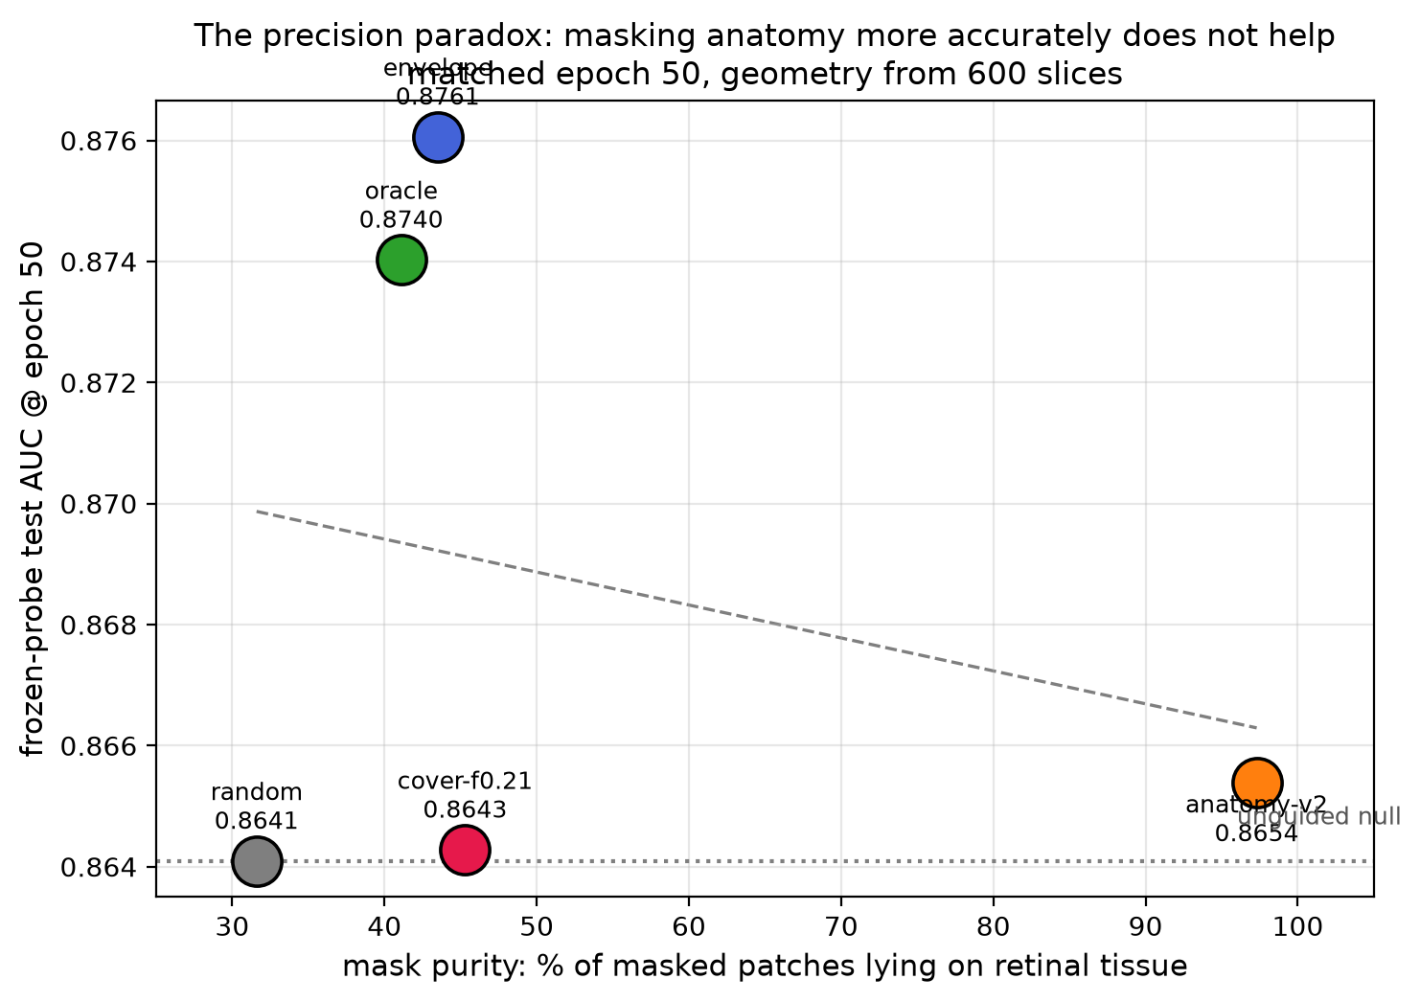
Downstream AUC at matched epoch 50 against mask purity, the fraction of masked patches lying on retinal tissue. The policy whose masks are $97\%$ on-tissue does not separate from the null, while policies at $40$–$43\%$ purity gain the most. The ordering does not support the intuition that more accurate anatomical masking yields better representations. The AUC axis is truncated and no interval is drawn, and the dashed line is a least-squares fit through the arms shown; with four to five arms this is descriptive, not inferential. The point labelled oracle is centroid.
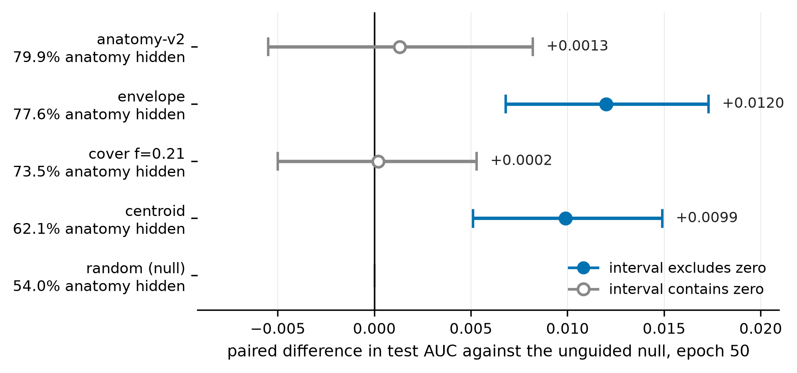
The matched-epoch-50 result arranged as a ladder of increasing anatomical specificity, measured as the share of tissue each policy’s targets hide (Table 2). Points are paired differences in test AUC against the unguided null on identical cases, with 10,000-resample percentile bootstrap intervals. The axis is centred on zero, a meaningful baseline for a difference, so unlike a truncated AUC axis it cannot exaggerate the spacing. Filled markers denote intervals excluding zero. The two arms that separate from the null are not the two that hide the most anatomy, which is the observation Section 5.2 develops. Per-arm error bars are drawn nowhere in this paper, because between-case variance cancels in a pairing and would understate the evidence. Companion to Figure 13.
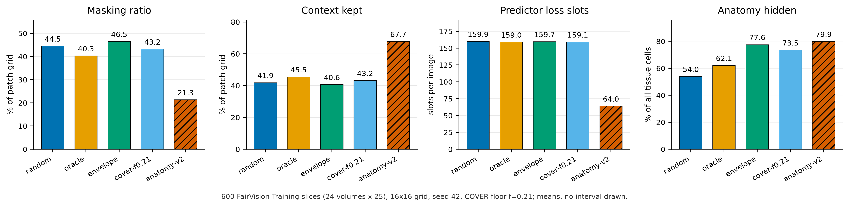
Measured mask geometry per policy, 600 training slices. Bars start at zero and no interval is drawn; each is a mean over those slices. The four rectangle policies are closely matched on masking ratio, context kept and predictor loss slots, and separate only on the manipulated axis, how much anatomy the targets hide, so their comparison is near single-variable. The anatomy policy diverges on all four simultaneously (half the masking ratio, $1.6×$ the context, $0.4×$ the predictor loss slots), so its deficit cannot be attributed to target shape. Bars labelled oracle and cover-f0.21 are centroid and cover.
The random, centroid and envelope long-horizon probes were originally fitted under the harness default, which enables autocast. To assess whether the headline effect is a precision artifact, we re-ran the complete probe pipeline for those arms with autocast disabled, so that feature extraction, head optimisation and test evaluation are all fp32, under the exact protocol already used by the anatomy and cover arms (Table 15). The encoder checkpoint is SHA-256 hashed before and after each run and verified unchanged, so no result here can be contaminated by an accidental encoder update.
Full fp32 re-probe against the original fp16 result, same frozen encoder in each row. The eight DeLong $p$-values are unadjusted diagnostics, not a family-wise test. The largest difference is $2×{10}^{−4}$.
policy | epoch | fp16 AUC | fp32 AUC | $Δ$ | $p$
envelope | 50 | 0.876064 | 0.876063 | -0.000001 | 0.964
envelope | 75 | 0.880307 | 0.880305 | -0.000002 | 0.806
envelope | 100 | 0.880743 | 0.880761 | +0.000018 | 0.167
centroid | 50 | 0.874030 | 0.874015 | -0.000015 | 0.412
centroid | 100 | 0.885485 | 0.885293 | -0.000192 | 0.767
random | 50 | 0.864097 | 0.864121 | +0.000024 | 0.128
random | 75 | 0.872302 | 0.872302 | -0.000001 | 0.962
random | 100 | 0.874581 | 0.874485 | -0.000096 | 0.000

Reproducibility and numeric provenance

Software and hardware environment.
Every number in this paper was produced under one environment, and the versions below were read from the live interpreter rather than recalled. Python 3.11.9 on 64-bit Windows (build 10.0.26200); PyTorch 2.7.1 compiled against CUDA 12.8 with cuDNN 9.7.1; one NVIDIA GeForce RTX 3090 with 24 GiB of memory, driver 610.62. The statistics and figures use NumPy 2.4.4, SciPy 1.17.1 and scikit-learn 1.9.0, and the manuscript is compiled by Tectonic 0.17.0. A lock file pinning 87 distributions accompanies the artifact. We re-resolved it against the live interpreter and every pin matches the installed version exactly, with no conflict. That interpreter also carries 16 further packages (test, plotting and PDF-inspection tools such as pytest 9.1.1, statsmodels 0.14.6 and seaborn 0.13.2), which are deliberately absent from the lock file because no reported number depends on them. The chain from stored per-case predictions through macros, tables and figures to the compiled archive runs as one ordered script, so the released predictions, the released head and the numbers printed here are joined by code rather than by transcription. We did not re-verify these results under a second CUDA or PyTorch version, so the fp32 re-encode of Appendix 22 on different hardware is the only cross-environment evidence we have.

Why the intervals are non-parametric.
The estimator choice was checked against the data rather than assumed. The per-case paired differences are strongly non-normal with heavy tails (Shapiro–Wilk $W=0.968$–$0.981$, $p<{10}^{−10}$), and the raw within-arm scores more so ($p≈{10}^{−37}$). Levene’s test also rejects equal variance across arms ($F=21.4$, $p<0.001$), though the variance ratio is only $1.16$ and is detectable mainly because $n=9,000$. None of this invalidates what we report: a percentile bootstrap makes no distributional assumption about the deltas, which is the reason for choosing it, and an AUC is rank-based, so DeLong’s variance is built from placement values rather than from Gaussian scores. The diagnostics are recorded here because “the intervals are non-parametric” is a claim a reader should be able to check, not take on trust. Where $n$ is small (the five-arm and four-arm correlations), a normality test has essentially no power, so we treat those as descriptive throughout and draw no inference from them.

Guide provenance differs across the segmenter arms.
The three segmenter-driven policies do not all read the same anatomy guide. envelope samples the unmodified MIRAGE occupancy map. anatomy-v1 and cover instead read pre-computed soft guides produced by a MIRAGE whose segmentation path carries a frozen residual adapter, trained label-free to align MIRAGE’s patch-similarity structure with the pretraining teacher’s. That adapter was an abandoned line of work: it reduced its own training objective but never improved segmentation, and the experiment that would have settled its downstream effect was not run, so we make no claim about it here. We record it because it is a further axis on which the anatomy arms and cover differ from envelope, beyond the geometric axes in Section 5.2, and because the guide directory names embed the adapter configuration and would otherwise be unexplained to anyone reproducing this work. centroid and random consult no guide of either kind.

What is checked mechanically.
Every quantity in this paper resolves through a generated macro file produced by one script from stored per-case predictions, so prose, tables and figures cannot disagree. Three further gates run on every build: a consistency check that fails on an undefined or duplicated macro, a dangling reference or citation, or a banned overclaiming phrase; a provenance check that resolves each AUC macro’s arm and epoch from its own name and fails if the value does not match that arm’s stored probe, which makes reporting one arm’s number under another arm’s name a build error; and an archive check that compiles the submission from a clean extraction and enforces the page limit and anonymity.

Checkpoint identity.
The shared epoch-25 ancestor is identified by SHA-256 (e5ad5b0c2aadfa15449409786afbfa39d8b5405b699be8f02f2e540195e97e7b), which three independent copies reproduce, and the replication chain of Appendix 9 re-hashes it before each leg. Every frozen probe hashes its encoder before and after fitting and invalidates the run if the hash moves, so no reported probe can have been contaminated by an accidental encoder update. The six replication configurations are generated by a script that asserts they differ only in the seed and logging fields.

An audit of hand-typed numbers, and what it found.
Generated macros are verified by the gates above. Numbers typed directly into the manuscript source are not, and that gap is where our errors have been. We therefore audited every numeric quantity typed into the source: 310 occurrences, of which 234 were confirmed against a stored artifact, 75 had no producing artifact that we could locate, and one was wrong: a probe parameter count quoted for the wrong probe configuration, since corrected. Two unbacked quantities carried interpretive weight: a per-cell concentration statistic used to argue that the best arm was the most spatially consistent, and a probe-seed noise bound. Both have been removed from this version rather than restated, and the mechanism claim that rested on the first has been withdrawn with it (Sections 5.2 and 6). The rule we adopted, and recommend, is that a numeric claim which is not machine-generated is treated as unverified until it is recomputed.

Fine-tuning narrows the observed gap
Under full fine-tuning rather than a frozen probe, centroid reaches $0.8947$ (mean-pool head) against random’s $0.8868$, a gap of $+0.0079$ compared with $+0.0109$ frozen. Taking each arm’s best head instead, the gap is $+0.0069$. The observed gap is smaller after supervised adaptation. These test-set-selected head point estimates do not distinguish representation quality from optimisation. These runs used a different head and schedule from the frozen probes and are never pooled with them (Table 16).
Full fine-tuning, same test split: every arm/head combination, ordered by test AUC. Head comparisons are descriptive point estimates, reported separately from frozen probes and never pooled with them.
policy | head | test AUC
centroid | mean-pool | 0.894668
centroid | cross-attention | 0.893717
centroid | attentive | 0.890100
random | attentive | 0.887763
random | cross-attention | 0.887178
random | mean-pool | 0.886756
Assran, Mahmoud, Quentin Duval, Ishan Misra, et al. 2023. “Self-Supervised Learning from Images with a Joint-Embedding Predictive Architecture.” Proceedings of the IEEE/CVF Conference on Computer Vision and Pattern Recognition, 15619–29. https://doi.org/10.1109/CVPR52729.2023.01499.
Azizi, Shekoofeh, Basil Mustafa, Fiona Ryan, et al. 2021. “Big Self-Supervised Models Advance Medical Image Classification.” Proceedings of the IEEE/CVF International Conference on Computer Vision.
Baevski, Alexei, Wei-Ning Hsu, Qiantong Xu, Arun Babu, Jiatao Gu, and Michael Auli. 2022. “Data2vec: A General Framework for Self-Supervised Learning in Speech, Vision and Language.” Proceedings of the 39th International Conference on Machine Learning, Proceedings of machine learning research, vol. 162: 1298–312. https://proceedings.mlr.press/v162/baevski22a.html.
Balestriero, Randall, and Yann LeCun. 2025. LeJEPA: Provable and Scalable Self-Supervised Learning Without the Heuristics. https://doi.org/10.48550/arXiv.2511.08544.
Bao, Hangbo, Li Dong, Songhao Piao, and Furu Wei. 2022. “BEiT: BERT Pre-Training of Image Transformers.” International Conference on Learning Representations. https://openreview.net/forum?id=p-BhZSz59o4.
Bardes, Adrien, Quentin Garrido, Jean Ponce, et al. 2024. “Revisiting Feature Prediction for Learning Visual Representations from Video.” Transactions on Machine Learning Research. https://openreview.net/forum?id=QaCCuDfBk2.
Bouthillier, Xavier, Pierre Delaunay, Mirko Bronzi, et al. 2021. “Accounting for Variance in Machine Learning Benchmarks.” Proceedings of Machine Learning and Systems 3: 747–69. https://proceedings.mlsys.org/paper_files/paper/2021/hash/0184b0cd3cfb185989f858a1d9f5c1eb-Abstract.html.
Ceballos Arroyo, Alberto M., Jisoo Kim, Chu-Hsuan Lin, Lei Qin, Geoffrey S. Young, and Huaizu Jiang. 2026. “Anatomically-Guided Masked Autoencoder Pre-Training for Aneurysm Detection.” Proceedings of the IEEE/CVF Winter Conference on Applications of Computer Vision, 5693–702. https://doi.org/10.1109/WACV61042.2026.00552.
Chen, Haijian, Wendong Zhang, Yunbo Wang, and Xiaokang Yang. 2023. “Improving Masked Autoencoders by Learning Where to Mask.” Pattern Recognition and Computer Vision, 377–90. https://doi.org/10.1007/978-981-99-8543-2_31.
Chen, Zekai, Devansh Agarwal, Kshitij Aggarwal, Wiem Safta, Mariann Micsinai Balan, and Kevin Brown. 2023. “Masked Image Modeling Advances 3D Medical Image Analysis.” Proceedings of the IEEE/CVF Winter Conference on Applications of Computer Vision, 1970–80. https://doi.org/10.1109/WACV56688.2023.00201.
DeLong, Elizabeth R., David M. DeLong, and Daniel L. Clarke-Pearson. 1988. “Comparing the Areas Under Two or More Correlated Receiver Operating Characteristic Curves: A Nonparametric Approach.” Biometrics 44 (3): 837–45. https://doi.org/10.2307/2531595.
Gichoya, Judy Wawira, Imon Banerjee, Ananth Reddy Bhimireddy, et al. 2022. “AI Recognition of Patient Race in Medical Imaging: A Modelling Study.” The Lancet Digital Health 4 (6): e406–14. https://doi.org/10.1016/S2589-7500(22)00063-2.
Guo, Han, Ramtin Hosseini, Ruiyi Zhang, et al. 2025. “Downstream Task Guided Masking Learning in Masked Autoencoders Using Multi-Level Optimization.” Transactions on Machine Learning Research.
He, Kaiming, Xinlei Chen, Saining Xie, Yanghao Li, Piotr Dollár, and Ross Girshick. 2022. “Masked Autoencoders Are Scalable Vision Learners.” Proceedings of the IEEE/CVF Conference on Computer Vision and Pattern Recognition, 16000–16009. https://doi.org/10.1109/CVPR52688.2022.01553.
He, Xiangteng, Shunsuke Sakai, Shivam Chandhok, et al. 2025. DSeq-JEPA: Discriminative Sequential Joint-Embedding Predictive Architecture. https://doi.org/10.48550/arXiv.2511.17354.
Huang, De-Xing, Xiao-Hu Zhou, Mei-Jiang Gui, et al. 2026. “VasoMIM: Vascular Anatomy-Aware Masked Image Modeling for Vessel Segmentation.” Proceedings of the AAAI Conference on Artificial Intelligence 40: 4985–93. https://doi.org/10.1609/aaai.v40i6.42503.
Huang, Yijin, Junyan Lyu, Pujin Cheng, Roger Tam, and Xiaoying Tang. 2024. “SSiT: Saliency-Guided Self-Supervised Image Transformer for Diabetic Retinopathy Grading.” IEEE Journal of Biomedical and Health Informatics 28 (5): 2806–17. https://doi.org/10.1109/JBHI.2024.3362878.
Jin, Ruinan, Zikang Xu, Yuan Zhong, et al. 2024. “FairMedFM: Fairness Benchmarking for Medical Imaging Foundation Models.” Advances in Neural Information Processing Systems 37: 111318–57. https://doi.org/10.52202/079017-3535.
Kakogeorgiou, Ioannis, Spyros Gidaris, Bill Psomas, et al. 2022. “What to Hide from Your Students: Attention-Guided Masked Image Modeling.” Computer Vision – ECCV 2022, 300–318. https://doi.org/10.1007/978-3-031-20056-4_18.
Larrazabal, Agostina J., Nicolás Nieto, Victoria Peterson, Diego H. Milone, and Enzo Ferrante. 2020. “Gender Imbalance in Medical Imaging Datasets Produces Biased Classifiers for Computer-Aided Diagnosis.” Proceedings of the National Academy of Sciences 117 (23): 12592–94. https://doi.org/10.1073/pnas.1919012117.
Lee, Jin, Vu Dang, Gwang-Hyun Yu, et al. 2025. “HU-Based Foreground Masking for 3D Medical Masked Image Modeling.” Medical Image Computing and Computer Assisted Intervention (MICCAI). https://doi.org/10.1007/978-3-032-09569-5_13.
Li, Gang, Heliang Zheng, Daqing Liu, Chaoyue Wang, Bing Su, and Changwen Zheng. 2022. “SemMAE: Semantic-Guided Masking for Learning Masked Autoencoders.” Advances in Neural Information Processing Systems 35: 14290–302. https://doi.org/10.52202/068431-1039.
Li, Yuheng, Tianyu Luan, Yizhou Wu, Shaoyan Pan, Yenho Chen, and Xiaofeng Yang. 2024. “AnatoMask: Enhancing Medical Image Segmentation with Reconstruction-Guided Self-Masking.” Computer Vision – ECCV 2024, 146–63. https://doi.org/10.1007/978-3-031-73027-6_9.
Liu, Zixuan, Hanwen Xu, Addie Woicik, et al. 2026. “A Three-Dimensional Multi-Modal Foundation Model for Optical Coherence Tomography.” Nature Biomedical Engineering, ahead of print. https://doi.org/10.1038/s41551-026-01662-2.
Luo, Yan, Muhammad Osama Khan, Yu Tian, et al. 2024. FairVision: Equitable Deep Learning for Eye Disease Screening via Fair Identity Scaling. https://doi.org/10.48550/arXiv.2310.02492.
Luo, Yan, Yu Tian, Min Shi, et al. 2024. “Harvard Glaucoma Fairness: A Retinal Nerve Disease Dataset for Fairness Learning and Fair Identity Normalization.” IEEE Transactions on Medical Imaging 43 (7): 2623–33. https://doi.org/10.1109/TMI.2024.3377552.
Maetschke, Stefan, Bhavna Antony, Hiroshi Ishikawa, Gadi Wollstein, Joel Schuman, and Rahil Garnavi. 2019. “A Feature Agnostic Approach for Glaucoma Detection in OCT Volumes.” PLOS ONE 14 (7).
Maier-Hein, Lena, Annika Reinke, Patrick Godau, et al. 2024. “Metrics Reloaded: Recommendations for Image Analysis Validation.” Nature Methods 21 (2): 195–212. https://doi.org/10.1038/s41592-023-02151-z.
Mao, Jiawei, Shujian Guo, Yuanqi Chang, Xuesong Yin, and Binling Nie. 2023. Medical Supervised Masked Autoencoders: Crafting a Better Masking Strategy and Efficient Fine-Tuning Schedule for Medical Image Classification. https://doi.org/10.48550/arXiv.2305.05871.
Morano, José, Botond Fazekas, Emese Sükei, et al. 2025. “Multimodal Foundation Model and Benchmark for Comprehensive Retinal OCT Image Analysis.” Npj Digital Medicine 8: 576. https://doi.org/10.1038/s41746-025-01852-3.
Noury, Erfan, Suria S. Mannil, Robert T. Chang, et al. 2022. “Deep Learning for Glaucoma Detection and Identification of Novel Diagnostic Areas in Diverse Real-World Datasets.” Translational Vision Science & Technology 11 (5): 11. https://doi.org/10.1167/tvst.11.5.11.
Obuchowski, Nancy A. 1997. “Nonparametric Analysis of Clustered ROC Curve Data.” Biometrics 53 (2): 567–78. https://doi.org/10.2307/2533958.
Pissas, Theodoros, Pablo Márquez-Neila, Sebastian Wolf, Martin S. Zinkernagel, and Raphael Sznitman. 2024. “Masked Image Modelling for Retinal OCT Understanding.” Ophthalmic Medical Image Analysis, 115–25. https://doi.org/10.1007/978-3-031-73119-8_12.
Qiu, Jianing, Jian Wu, Hao Wei, et al. 2024. “Development and Validation of a Multimodal Multitask Vision Foundation Model for Generalist Ophthalmic Artificial Intelligence.” NEJM AI 1 (12). https://doi.org/10.1056/AIoa2300221.
Ran, An Ran, Carol Y. Cheung, Xi Wang, et al. 2019. “Detection of Glaucomatous Optic Neuropathy with Spectral-Domain Optical Coherence Tomography: A Retrospective Training and Validation Deep-Learning Analysis.” The Lancet Digital Health 1 (4): e172–82. https://doi.org/10.1016/S2589-7500(19)30085-8.
Rutter, Carolyn M. 2000. “Bootstrap Estimation of Diagnostic Accuracy with Patient-Clustered Data.” Academic Radiology 7 (6): 413–19. https://doi.org/10.1016/S1076-6332(00)80381-5.
Seyyed-Kalantari, Laleh, Haoran Zhang, Matthew B. A. McDermott, Irene Y. Chen, and Marzyeh Ghassemi. 2021. “Underdiagnosis Bias of Artificial Intelligence Algorithms Applied to Chest Radiographs in Under-Served Patient Populations.” Nature Medicine 27 (12): 2176–82. https://doi.org/10.1038/s41591-021-01595-0.
Shi, Min, Yan Luo, Yu Tian, et al. 2025. “Equitable Artificial Intelligence for Glaucoma Screening with Fair Identity Normalization.” Npj Digital Medicine 8 (1). https://doi.org/10.1038/s41746-025-01432-5.
Shi, Yuge, N. Siddharth, Philip H. S. Torr, and Adam R. Kosiorek. 2022. “Adversarial Masking for Self-Supervised Learning.” Proceedings of the 39th International Conference on Machine Learning, Proceedings of machine learning research, vol. 162: 20026–40. https://proceedings.mlr.press/v162/shi22d.html.
Sick, Leon, Dominik Engel, Pedro Hermosilla, and Timo Ropinski. 2025. “Attention-Guided Masked Autoencoders for Learning Image Representations.” Proceedings of the IEEE/CVF Winter Conference on Applications of Computer Vision, 836–46. https://doi.org/10.1109/WACV61041.2025.00091.
Taleb, Aiham, Winfried Loetzsch, Noel Danz, et al. 2020. “3D Self-Supervised Methods for Medical Imaging.” Advances in Neural Information Processing Systems 33: 18158–72. https://proceedings.neurips.cc/paper/2020/hash/d2dc6368837861b42020ee72b0896182-Abstract.html.
Wang, Haochen, Kaiyou Song, Junsong Fan, Yuxi Wang, Jin Xie, and Zhaoxiang Zhang. 2023. “Hard Patches Mining for Masked Image Modeling.” Proceedings of the IEEE/CVF Conference on Computer Vision and Pattern Recognition, 10375–85. https://doi.org/10.1109/CVPR52729.2023.01000.
Wang, Ruilang, Shuotong Xu, Bowen Liu, Runlin Huang, Donglong Chen, and Weifeng Su. 2025. Mask What Matters: Controllable Text-Guided Masking for Self-Supervised Medical Image Analysis. https://doi.org/10.48550/arXiv.2509.23054.
Xie, Zhenda, Zheng Zhang, Yue Cao, et al. 2022. “SimMIM: A Simple Framework for Masked Image Modeling.” Proceedings of the IEEE/CVF Conference on Computer Vision and Pattern Recognition, 9653–63. https://doi.org/10.1109/CVPR52688.2022.00943.
Yu, Kai, Yang Zhou, Yang Bai, et al. 2024. “UrFound: Towards Universal Retinal Foundation Models via Knowledge-Guided Masked Modeling.” Medical Image Computing and Computer Assisted Intervention – MICCAI 2024, 753–62. https://doi.org/10.1007/978-3-031-72390-2_70.
Zhou, Jinghao, Chen Wei, Huiyu Wang, et al. 2022. “iBOT: Image BERT Pre-Training with Online Tokenizer.” International Conference on Learning Representations.
Zhou, Yukun, Mark A. Chia, Siegfried K. Wagner, et al. 2023. “A Foundation Model for Generalizable Disease Detection from Retinal Images.” Nature 622: 156–63. https://doi.org/10.1038/s41586-023-06555-x.

