Where to Predict in Retinal OCT? Anatomy-Guided Target Selection for I-JEPA
Abstract
Learning transferable representations from retinal optical coherence tomography (OCT) is challenging because disease-related changes can be subtle and large, consistently labelled datasets require substantial expert annotation. Self-supervised learning offers a way to use unlabelled scans and reduce dependence on diagnostic labels. Image-based Joint-Embedding Predictive Architecture (I-JEPA) learns by predicting target-region representations from visible context rather than reconstructing pixels. However, its uniform target placement does not account for the layered organization of retinal OCT, where retinal tissue occupies only part of each B-scan. We investigate anatomy-guided target selection using image intensity and predicted retinal segmentation while retaining the I-JEPA architecture and latent prediction objective. We compare tissue-directed rectangular targets, anatomy-shaped targets and coverage-constrained placement with uniform masking, and evaluate the learned representations through frozen-encoder glaucoma classification on FairVision. Tissue-directed rectangle placement improves the observed classification results, including with segmentation-free intensity guidance, while more anatomically specific strategies do not consistently provide further gains. Analysis of the actual masks shows that target selection, target size and visible context are coupled. Our findings motivate anatomy-guided predictive learning for retinal OCT and better-controlled comparisons of what to predict and what to keep visible.
Table of Contents

Working copy for comment and editing.
The LaTeX source is authoritative. Generated 2026-09-10 11:59 UTC. Numeric evidence coverage is recorded separately; conversion is not scientific validation. Please raise numeric changes as comments.
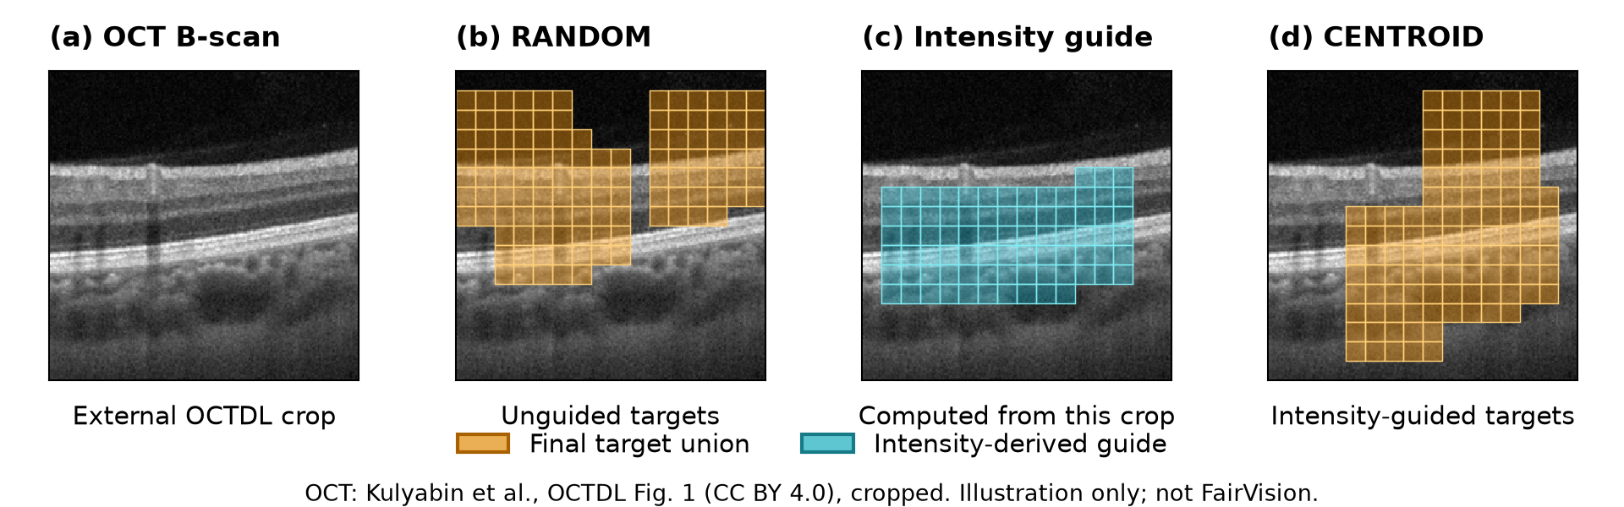
Target-selection intuition on an external OCT example, not FairVision data. (a) One annotation-free crop from the real OCT B-scan in Kulyabin et al., OCTDL, Fig. 1 (arXiv:2312.08255v3), adapted under CC BY 4.0. (b) random final target union. (c) centroid’s intensity-derived guide. (d) centroid final target union. The same crop is downsampled to 256 by 256 pixels without contrast enhancement; masks use the production samplers, matched block-size draws and fixed seed. Overlays show exact delivered indices; encoder context is omitted. This single illustrative replay is not a segmentation annotation, historical training batch, evaluation sample or performance comparison. Source and license: https://arxiv.org/abs/2312.08255v3 and https://creativecommons.org/licenses/by/4.0/.

Introduction
Optical coherence tomography (OCT) reveals the layered structure of the retina and supports glaucoma assessment (Maetschke et al. 2019; Ran et al. 2019; Noury et al. 2022). Self-supervised pretraining offers a way to learn from these images without requiring a diagnosis for every training scan (Azizi et al. 2021; Zhou et al. 2023; Qiu et al. 2024). The spatial organization of OCT makes the choice of pretraining task particularly relevant: retinal tissue forms a relatively narrow region within a B-scan, surrounded by vitreous and other background.
Image-based Joint-Embedding Predictive Architecture (I-JEPA) (Assran et al. 2023) learns by predicting hidden image representations rather than reconstructing hidden pixels. A context encoder processes visible patches. A predictor uses these features and the target positions to estimate representations supplied by a target encoder. The target encoder is updated by an exponential moving average (EMA) of the context encoder. This creates a prediction task without diagnosis labels. Unlike masked autoencoders (He et al. 2022; Xie et al. 2022), I-JEPA does not require the predictor to reproduce each pixel.
Our interest in anatomical guidance also arose from an exploratory feature-occlusion analysis of glaucoma classifiers initialized from uniform-masking I-JEPA and subsequently fine-tuned with diagnosis labels. Selected attribution maps showed prediction sensitivity near retinal structures: removing patch features from the pooled representation changed the classifier logit. This observation motivated asking whether retinal anatomy could guide target selection during pretraining (Appendix D).
Standard I-JEPA places rectangular targets uniformly across the image. In retinal OCT, many such targets include little retinal tissue. This raises our central question: can I-JEPA benefit from selecting prediction targets according to retinal anatomy rather than uniformly across the image? Figure 1 illustrates the change in target placement. Semantic and anatomy-guided masked modelling provide positive motivation for this question (Li et al. 2022; Kakogeorgiou et al. 2022; Li et al. 2024; Wang et al. 2025). However, selecting a target also removes information from the context. The useful learning task depends on both what is predicted and what remains visible.
We investigate this question through five masking families, including segmentation-free intensity guidance and retinal segmentation from MIRAGE (Morano et al. 2025). These strategies vary target location, shape, or anatomical coverage while retaining the I-JEPA architecture and latent prediction objective. We evaluate the resulting B-scan representations by pooling them across an OCT volume and fitting a linear glaucoma classifier. The study includes six implementations, with two versions of anatomy-shaped masking.
Tissue-directed rectangle placement gives higher AUC than uniform masking in the reported runs. More detailed anatomical targeting does not consistently improve on these simpler strategies. To understand what the comparisons test, we measure the target and context patches that actually reach the model. This analysis identifies differences in target size, retained context and repeated target indices, as well as a coverage-scoring mismatch. We therefore present comparisons of implemented masking strategies, not controlled ablations of anatomical coverage.

Contributions.
- An empirical comparison of intensity-guided, segmentation-guided and uniform target selection for I-JEPA on retinal OCT.
- Frozen-probe results showing gains from tissue-directed rectangle placement, alongside mixed results for more specific anatomical targeting.
- An analysis of the actual target and context masks that identifies implementation constraints for better-controlled guided-masking studies.

Related work

Masked image modelling and JEPAs.
Masked autoencoders reconstruct pixels (He et al. 2022; Xie et al. 2022), whereas BEiT predicts discrete visual tokens (Bao et al. 2022) and iBOT distils teacher outputs at masked patch positions (Zhou et al. 2022). Data2vec and I-JEPA learn by predicting latent representations (Baevski et al. 2022; Assran et al. 2023). Related approaches extend masked prediction to video and volumetric data (Bardes et al. 2024; Z. Chen et al. 2023; Taleb et al. 2020). JEPA formulations also differ in their objectives and prediction structure (Balestriero and LeCun 2025; He et al. 2025); we retain the I-JEPA objective and study target selection.

Region selection and prediction structure.
DSeq-JEPA combines attention-derived region selection with sequential prediction (He et al. 2025). Its highest-ranked region supplies context for predicting subsequent regions. Its component ablation favors the joint design rather than region selection alone. Our study instead uses retinal anatomy and parallel I-JEPA prediction. This distinction matters: a guidance map, the selected targets and the available context jointly define the learning task. I-JEPA’s own masking analysis emphasizes both sufficiently large targets and informative context (Assran et al. 2023).

Medical region-conditioned prediction.
US-JEPA uses a frozen ultrasound teacher, and its region-conditioned variant restricts both context and target sampling to valid ultrasound content (Radhachandran et al. 2026). Our study addresses a different question: how intensity-based and retinal-segmentation guidance change target selection within the EMA-based I-JEPA framework for OCT. We compare simple rectangle placement with anatomy-shaped and coverage-constrained targets, without introducing sequential prediction or a new teacher architecture. The contribution is this OCT comparison and analysis of the resulting prediction tasks, not the general idea of informed masking.

Informed masking.
ADIOS learns adversarial masks (Shi et al. 2022); SemMAE uses semantic parts (Li et al. 2022); AttMask selects high-attention patches (Kakogeorgiou et al. 2022); and HardPatches and AutoMAE adapt masking to prediction difficulty (Wang et al. 2023; H. Chen et al. 2023). Medical approaches include AnatoMask, AnatomyMAE, MSMAE and VasoMIM (Li et al. 2024; Ceballos Arroyo et al. 2026; Mao et al. 2023; Huang et al. 2026). These studies motivate informed masking, but their objectives, guidance sources and context construction differ. SemMAE, for example, gradually changes from within-part to whole-part prediction rather than masking whole parts from the start. We study anatomy-guided target selection under latent prediction on retinal OCT.

Retinal foundation models and OCT.
RETFound (Zhou et al. 2023), VisionFM (Qiu et al. 2024), URFound (Yu et al. 2024), and OCTCube (Liu et al. 2026) pretrain on large retinal corpora. OCT-specific masked modelling is explored by Pissas et al. (2024). MIRAGE (Morano et al. 2025) provides multimodal OCT segmentation and supplies the anatomical guidance used by several of our arms, and deep glaucoma detection from OCT is established (Maetschke et al. 2019; Ran et al. 2019; Noury et al. 2022). FairVision provides the glaucoma-labelled OCT data used for our downstream comparison (Luo et al. 2024).

Background and target-selection framework
We first define the I-JEPA prediction task, then describe how each masking strategy selects its targets. The architecture and latent prediction loss are shared; differences in guide sources, target size and final context are part of the strategy comparisons.

I-JEPA preliminaries
Let $x$ be a B-scan partitioned into $N$ patches, and let $C$ denote the indices of the patches supplied to the context encoder. Target group $T_{m}$ contains $K_{m}$ patch indices, with $m=1,…,M$. We treat $T_{m}$ as an index list because some implementations repeat indices when equalizing target lengths. The context excludes the union of target positions. Writing $p_{C}$ and $p_{T_{m}}$ for the corresponding positional embeddings, the context and prediction paths are
$$h_{C}=f_{θ}(x;C), {\hat{z}}_{m}=g_{ϕ}(h_{C},p_{C},p_{T_{m}}).$$
Here $f_{θ}(x;C)$ embeds only the selected patches at their original image positions. The predictor projects $h_{C}$ to its own feature dimension and adds its own positional embeddings $p_{C}$; target queries combine a learned mask token with $p_{T_{m}}$. The target encoder sees the full B-scan. Its output is normalized per patch before selecting the target positions:
$$z_{m}=sg​\left([LN(f_{\overset{‾}{θ}}(x))]_{T_{m}}\right), \overset{‾}{θ}←μ\overset{‾}{θ}+(1−μ)θ.$$
The operator $sg$ stops gradients, $LN$ is LayerNorm across feature dimensions, and $μ$ is the EMA coefficient. The predictor uses the same context for each target group; predictions are not conditioned on earlier target predictions.
Each target and prediction is a $K_{m}×D$ matrix. For feature dimension $D$, the implementation minimizes the mean Smooth-L1 loss over target instances and feature coordinates:
$$L=\frac{1}{D\sum_{m=1}^{M}{K_{m}}}\sum_{m=1}^{M}{\sum_{k=1}^{K_{m}}{\sum_{d=1}^{D}{ρ}}}​\left({\hat{z}}_{m,k,d}−z_{m,k,d}\right).$$
The Smooth-L1 function $ρ$ uses the standard unit transition between its quadratic and linear regions. Repeated indices contribute repeated loss terms. The code equalizes target lengths within a batch and applies a single mean reduction to the stacked prediction and target tensors, including averaging over images. Figure 2 shows the pretraining and evaluation paths.

Anatomy-guided target selection
For strategy $s$, let $A_{s}(x)$ denote its patch-grid guidance: an intensity-derived band for centroid, a repaired segmentation envelope for envelope, or soft retinal-class score maps for the anatomy-shaped and coverage strategies. These signals need not have the same channel structure. centroid is an intensity-guided tissue-localization baseline, not a segmentation model. We write the joint masking procedure as
$$(C,T)∼Π_{s}( ⋅∣A_{s}(x)), T=(T_{1},…,T_{M}).$$
The random baseline uses geometric block sampling without consulting image guidance. $Π_{s}$ includes target placement and context construction, including batch-dependent token equalization. A candidate context block is sampled, target positions are excluded, and token lists are shortened as needed for batching. Only the remaining context tokens enter $f_{θ}$. Consequently, tissue outside the target union need not be visible to the encoder. We define mask ratio as the number of unique target positions divided by $N$, and tissue coverage as the fraction of guide-positive patches included in that union. Neither is the fraction of the image supplied as context.

Compared masking strategies
All policies request $M=4$ target blocks and one context block. Rectangle policies share nominal scale and aspect-ratio ranges, but placement and collation can change unique target area and encoder-visible context.
Stock I-JEPA multiblock. Four rectangles placed uniformly at random anywhere in the grid. No image content is consulted.
The same nominal rectangle count, scale and aspect-ratio distributions as random, but rejection-sampled onto the MIRAGE-derived repaired retinal envelope (Morano et al. 2025). The predicted inner-retina and choroid union is repaired across the unlabeled middle-retina gap in native label space, then transformed jointly with the image. This changes the placement policy, not target shape. Overlap and delivered context are consequences of that intervention, not independently matched controls.
A band whose vertical position is located per slice by a per-column intensity-weighted row centroid, smoothed across columns, with no segmentation model and no ground-truth annotation of any kind. This band guides the placement of four rectangular targets; it is not itself the target shape.
Ragged connected components grown on the MIRAGE score map, so target shape follows tissue rather than being rectangular. v2 also bridges diagonal adjacencies.
Targets chosen greedily to cover anatomy while leaving a fraction $f$ of supported soft guide mass outside the target union. The historical run uses $f=0.21$. This condition does not guarantee the same fraction survives final encoder-context collation, and post-placement target truncation changes the intended coverage (Appendix B).
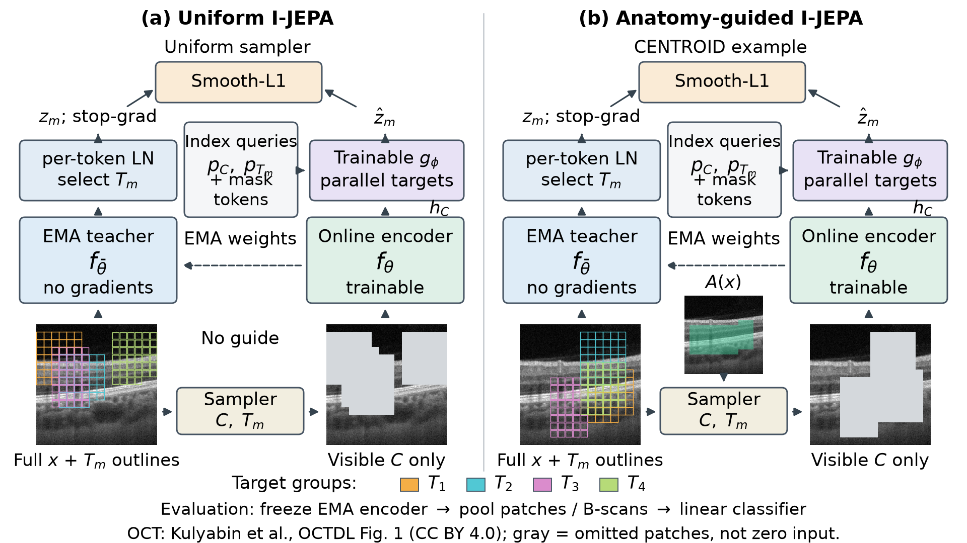
Uniform and anatomy-guided target selection within the same I-JEPA framework. In both panels, the context encoder and predictor are trainable. The EMA target encoder receives the full image; normalized target embeddings are selected afterward with gradients stopped. The predictor uses visible context and positional queries to predict each target group in parallel, with the same Smooth-L1 objective. The panels differ in target selection and the resulting visible context, not the architecture or loss. The guided panel illustrates centroid, not a relevance-ranking or sequential-prediction method. Masked views visualize omitted tokens rather than zero-filled encoder inputs. The image and exact masks reuse the licensed example in Figure 1; colours identify target groups, not relevance. The shared footer shows frozen-encoder evaluation.

Experimental setup

Data.
We use FairVision OCT volumes with binary glaucoma labels (Luo et al. 2024) and the fixed released splits. Training and validation contain 6,000 and 1,000 volumes, respectively. Each volume contributes 100 B-scans, resized to $256×256$. The test split contains $N=3000$ volumes (1466 positive). Diagnosis labels are used only for downstream evaluation, not JEPA pretraining. Demographic attributes are not model inputs.

Pretraining.
Patch-level I-JEPA, ViT-Base, $256×256$ crops, patch size 16, predictor depth 6, EMA target encoder. The reference fork is the epoch-25 checkpoint, with matched nominal optimiser, learning-rate and weight-decay schedules and effective batch size (512). Guidance is ramped linearly from epoch 25 to 30 and held at full strength thereafter. The early anatomy-v1 result has incomplete launch documentation; its configuration resumes an envelope epoch-27 checkpoint rather than directly documenting an epoch-25 fork. The encoder processes B-scans independently, without learned cross-slice attention. Rectangle strategies share nominal target scales, but the guide products and realized masks are not identical. anatomy-v2 also uses fixed-length targets. These differences are documented in Appendix A.
random, centroid, envelope and cover reach epoch 100. anatomy-v2 reaches epoch 75; its epoch-100 result is unmeasured. anatomy-v1 has only an epoch-30 result. We compare strategies at matched pretraining epochs, with epoch 50 as the common endpoint for the five main policies. Excluded continuations are listed separately in Appendix A.

Evaluation.
The EMA target encoder is frozen. We average patch features within each B-scan, then average across the volume and train a LayerNorm–linear head. Each head uses a 50-epoch budget and is selected by validation AUC. We report test AUC with percentile bootstrap intervals and paired differences (10,000 class-stratified resamples, fitted heads fixed), together with DeLong tests (DeLong et al. 1988). Paired analyses rely on the documented shared split and deterministic loader ordering; historical prediction files lack independent case-ID manifests. These intervals describe test-case sampling, not variation across pretraining runs.

Numerical precision.
The original rectangle-policy probes use mixed precision, while the anatomy-shaped and coverage-policy probes use fp32. All primary differences in Table 1 use a baseline matched in both epoch and probe precision. Re-probes quantify the small numerical differences (Appendix F); probe precision is distinct from pretraining target-encoder precision.

Results and analysis
We first compare downstream classification, then examine the actual masks to determine which properties changed. These are strategy comparisons, not factorial ablations: each policy has one pretraining continuation, and some policies change several aspects of the prediction task.

Comparison of target-selection strategies
Frozen MeanPool probe, FairVision test ($N=3000$, 1466 positive). The reference ancestor is epoch 25 (AUC $0.8487$); continuation provenance is described in Section 4. $Δ$ is versus random at the matched epoch. The upper block is precision-matched (fp16 throughout) and carries every headline claim; the lower block is fp32, each $Δ$ taken against an fp32 null re-probed at the same epoch. The measured fp16/fp32 gap is at most $2×{10}^{−4}$ (Appendix F).
 |  | epoch 50 |  | epoch 75 |  | epoch 100
3-4(lr)5-6(lr)7-8 policy | guidance signal | AUC | $Δ$ | AUC | $Δ$ | AUC | $Δ$
random | none (null) | 0.8641 | — | 0.8723 | — | 0.8746 | —
envelope | segmenter (location only) | 0.8761 | $+0.0120$ | 0.8803 | $+0.0080$ | 0.8807 | $+0.0062$
centroid | intensity centroid, no segmenter | 0.8740 | $+0.0099$ | 0.8836 | $+0.0113$ | 0.8855 | $+0.0109$
anatomy-v2 | segmenter (target shape) | 0.8654 | $+0.0013$ | 0.8612 | $−0.0111$ | — | —
cover $f=.21$ | segmenter (coverage) | 0.8643 | $+0.0002$ | 0.8639 | $−0.0084$ | 0.8577 | $−0.0168$

Tissue-directed rectangles.
envelope exceeds uniform masking by $+0.0120$ AUC at epoch 50. The segmentation-free centroid strategy exceeds it by $+0.0109$ at epoch 100. Both strategies have positive paired differences from random at all three evaluated epochs (Figure 3). The full intervals and multiple-comparison adjustment are reported in Appendix E. These gains support tissue-directed target placement in the observed runs. They do not require targets to contain only retinal tissue: the large rectangles also include background (Table 2).
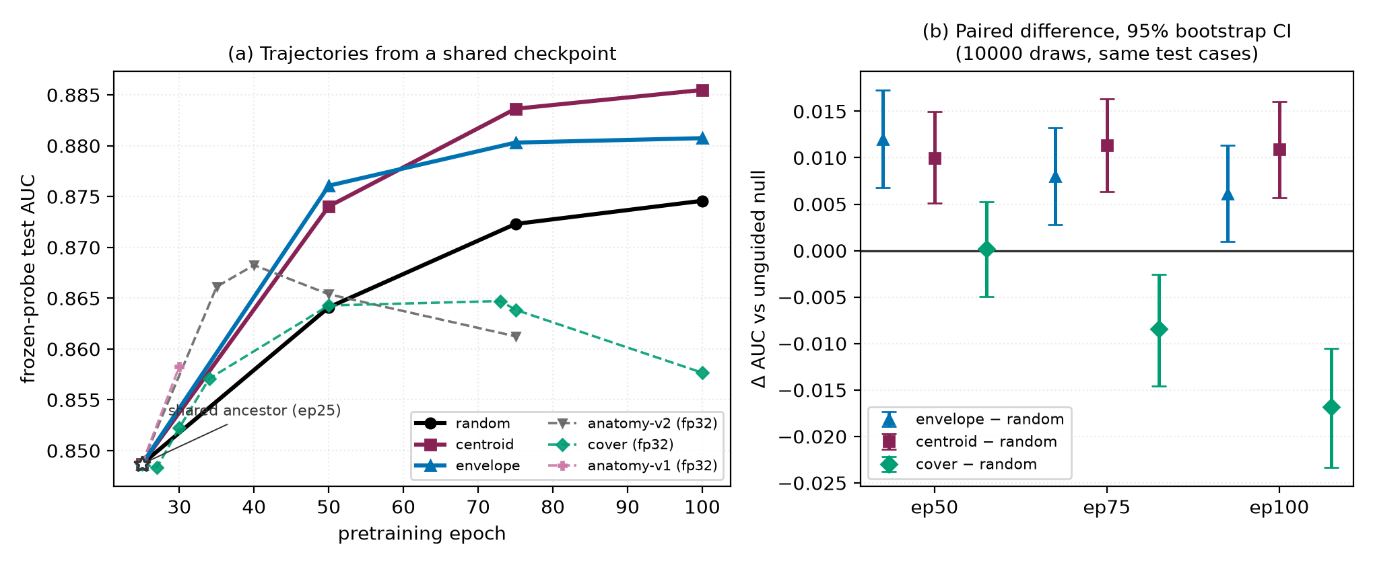
(a) Frozen-probe test AUC against pretraining epoch; note the truncated AUC axis. The open star marks the shared epoch-25 ancestor. Solid lines are the precision-matched fp16 family; dashed lines are fp32 arms and must not be compared vertically against the solid lines. (b) The actual inference: paired differences against the unguided null on identical test cases, 10,000-resample percentile bootstrap intervals. Every envelope and centroid interval excludes zero; cover straddles zero at epoch 50 and is negative thereafter. Paired differences account for the covariance of predictions on shared test cases; individual-arm intervals answer a different question.

Anatomy-shaped targets.
At the matched epoch 50, anatomy-v2 has lower AUC than envelope ($Δ=−0.0107$; CI $[−0.0167, −0.0046]$). At epoch 30, however, anatomy-v1 sits $+0.0044$ above it (CI $[+0.0009, +0.0078]$), with the early continuation’s lineage uncertainty described in Section 4. At epoch 50, the intervals for both anatomy-v2 and cover versus random include zero.

Coverage-constrained placement.
cover improves to epoch 50, peaks at epoch $73$, then falls, losing $−0.0071$ from its own peak ($p$<$0.0001$) while the unguided null keeps improving (Figure 3). Although cover selects rectangles by anatomical coverage, batching shortens the targets after placement. Its final masks therefore hide less anatomy than envelope’s (Table 2), rather than providing a higher-coverage comparison. Appendix B describes this target-sizing behavior.
centroid has the highest epoch-100 point estimate, exceeding envelope by $+0.0047$ (CI $[+0.0004, +0.0091]$). The paired centroid–envelope difference intervals include zero at epochs 50 and 75. Thus a simple intensity-based strategy is a useful comparator for segmentation-guided methods, not an anatomical oracle.

Analysis of target and context masks
Per-image mask geometry on 600 training slices using the production samplers, before batch-level context truncation. Tissue statistics use a thresholded MIRAGE-derived proxy, not ground-truth retinal annotations. “purity” is the fraction of masked cells lying on tissue; “loss slots” counts supervised target-token instances, summed over the $M$ targets and including duplicates. AUC is quoted at the matched epoch 50, so the geometry-to-AUC association is not read across mixed epochs. Final encoder-context fractions at the production batch size are reported in Table 3.
policy | anatomy hidden | purity | mask ratio | context kept | loss slots | AUC @ep50
random | 54.0% | 31.5% | 44.5% | 41.9% | 159.9 | 0.8641
centroid | 62.1% | 40.0% | 40.3% | 45.5% | 159.0 | 0.8740
envelope | 77.6% | 43.3% | 46.5% | 40.6% | 159.7 | 0.8761
cover | 73.5% | 44.2% | 43.2% | 43.2% | 159.1 | 0.8643
anatomy-v2 | 79.9% | 97.1% | 21.3% | 67.7% | 64.0 | 0.8654
The samplers do not differ only in how much tissue they target. anatomy-v2 has high tissue purity but a smaller target union and more total context than the rectangle strategies (Table 2). Its fixed $K=16$ indices per target give $4×16=64$ prediction instances, compared with about $159$ for the rectangle strategies. This is an explicit target-length choice, not an inherent property of irregular shapes. Repeated target indices also affect loss weighting. The anatomy-shaped and coverage strategies use different guide products from the historical envelope run (Appendix A).
We therefore report target and context geometry alongside AUC. Appendix A gives the per-image measurement protocol; Appendix C measures the final masks in complete training-sized batches. Together, these distinguish tissue outside the target union from tissue actually supplied to the context encoder.

Discussion and limitations
The positive rectangle-policy results motivate anatomy-guided target selection without requiring a new encoder architecture. The segmentation-free centroid strategy is particularly useful as a simple baseline. More specific strategies also changed target size, guide source and retained context. Future comparisons should control these factors while varying the target-selection rule.

Experimental limits.
Each policy has one pretraining continuation, so test-case confidence intervals do not establish a ranking over retrainings (Bouthillier et al. 2021). The early anatomy-shaped result has incomplete continuation documentation, and anatomy-v2 was stopped after inspecting its epoch-75 deficit. Its later trajectory is unknown. Probe optimization and initialization can also affect frozen-probe comparisons; the reported fixed-budget protocol is not a measurement of the best achievable classifier for each encoder. Repeated pretraining comparisons remain future work.
The study uses one dataset and one downstream task. Policies, checkpoints and analyses were chosen after repeated inspection of the same test split, although probe heads were fitted on training data and selected on validation data. Reported intervals are therefore descriptive rather than confirmatory. Segmentation accuracy on the OCT pretraining data is not independently established. Only the specified coverage setting was pretrained, so we identify neither an optimal coverage level nor a mechanism for its AUC decline.

Broader impact and ethics.
This study uses a public, de-identified retinal dataset under its release terms and involves no new recruitment or data collection, and no model reported here is clinically validated or intended for deployment (Appendix A).

Conclusion
We investigated where I-JEPA should predict in retinal OCT. Tissue-directed rectangle placement improves frozen-probe glaucoma AUC in the observed runs, including a simple intensity-centroid strategy. More anatomically specific targeting does not consistently improve these results, and the implementations differ in more than target location. The next step is to compare target selection under matched guidance, target sizes and visible context across repeated pretraining runs.

Additional experimental details

Pretraining and linear evaluation.
The input crop is $256×256$, with patch size 16 and a ViT-Base encoder. The predictor has depth 6 and hidden dimension 384. Pretraining uses AdamW with peak learning rate $0.00025$, a five-epoch warmup, final learning rate $0.000001$, weight decay scheduled from $0.04$ to $0.4$, and EMA coefficient from $0.996$ to $1.0$. The effective batch size is 512, formed from batches of 64 with gradient accumulation. Rectangle target scales are $0.15$–$0.20$ of image area, aspect ratios $0.75$–$1.5$, and context scales $0.85$–$1.0$. Random resized crops use area scale $0.3$–$1.0$. The guidance probability increases over the epoch-25 to epoch-30 continuation window; fixed-length anatomy targets use $K=16$ throughout. The frozen linear head uses AdamW, learning rate $0.0004$, weight decay $0.05$, batch size 256, seed 42, and a 50-epoch budget with validation-AUC selection and patience 15.

Guide sources.
envelope uses the MIRAGE-derived repaired hard retinal envelope. The anatomy-shaped and coverage strategies use precomputed soft guides from MIRAGE with frozen residual adapters. The anatomy-v1 guide uses a decoder-feature adapter; anatomy-v2 and cover use an encoder-feature adapter. These guide products are not independently controlled in the cross-strategy comparison. centroid uses image intensity rather than a segmentation model. The adapters optimize feature-similarity objectives on FairVision-derived image caches, not a glaucoma classification loss, and are frozen during I-JEPA training. The retained provenance does not independently establish subject-level non-overlap for all data used to train the guidance models.

Included and excluded continuations.
The early anatomy-v1 configuration resumes an envelope epoch-27 checkpoint; its producing launch record is incomplete. Anatomy-v2 results use the continuation with full-precision target-encoder outputs. Probes from its earlier mixed-target-precision continuation are excluded, as are earlier uniform controls that used different target precision and context selection. The main table retains the comparable policy endpoints, including the adverse cover trajectory.

Mask measurement.
Table 2 uses the seed-42 measurement on 600 training slices from 24 volumes, with 25 slices per volume. The samplers are evaluated one image at a time on a $16×16$ patch grid, using guide occupancy at threshold $0.25$. The “context kept” column is the per-image context; batching can shorten it further. Table 3 records that difference.
Visible context as a fraction of the patch grid, same 600 slices and same seed, measured per image and as delivered to the encoder at the production batch size of 64. The per-image column reproduces Table 2’s “context kept” to within $0.4$ points.
policy | per image | delivered at batch 64
random | 41.9% | 24.7%
centroid | 45.5% | 32.9%
envelope | 40.6% | 30.7%
cover | 43.2% | 30.1%
anatomy-v2 | 67.7% | 63.5%

Data use and ethics.
This is secondary research on the public, de-identified FairVision release under its CC BY-NC-ND 4.0 data licence. No new participants were recruited or identifying fields added. A separate institutional ethics or exemption determination is not recorded for this project. The models are not clinically validated or intended for patient care. The illustrative OCT image in the main paper comes from the separately attributed CC BY 4.0 OCTDL publication, not from the FairVision evaluation cohort.

Target sizing and visible context

Batch equalization.
Predictor targets are shortened to the minimum target length in the microbatch. cover chooses placements using the anatomical mass inside full candidate rectangles before this equalization. Because target indices are ordered row-major, shortening removes the lower portion of each rectangle rather than a spatially random subset. Coverage at placement time can consequently differ from coverage at the loss.

Measured geometry.
The retained floor sweep over $6,137$ slices gives anatomical coverage of $73.1\%$ for cover and $77.6\%$ for envelope. Across $24,000$ emitted targets, $73.4\%$ remain perfect rectangles. Thus the trained cover policy is not a higher-coverage counterpart to envelope. Table 2 reports the final target sets, and Appendix C provides a fixed-crop batch replay.
envelope shares the same shortening rule but does not optimize an exact coverage level. The anatomy-shaped strategies instead resample targets to a fixed $K=16$ indices. Equalization therefore has different consequences across the strategies, even when nominal target counts agree.

Final target and context masks

Scope.
We replayed the actual guided dataset, paired transforms, DataLoader worker collator and returned mask tensors on the existing 600-view Training scope (24 volumes, 25 views each), using fixed new crop draws shared across policies. These are not reconstructed historical training crops. Drawn block sizes were injected independently of placement; equal seeds alone do not pair policy-dependent rejection sampling. The production-size subset contains 576 views in complete batches of 64, with 573 valid post-crop guides. The shorter final batch is excluded from Table 4. Views within volumes are correlated, so these are descriptive mask statistics, not independent training replications.

What is measured.
Target coverage is measured both at scoring and after target collation. Encoder-visible tissue is counted only in the final encoder indices, not in the full-grid target complement. Tissue is a guide occupancy thresholded at $0.25$, not clinical ground truth. The context criterion is at least $max(⌈0.21N_{tissue}⌉,min(4,N_{tissue}))$ non-target tissue cells. This occupancy-cell diagnostic is distinct from the policy’s soft-mass constraint on the target complement.
Final masks from the trained cover strategy on 576 fixed training views. Context-criterion misses count only the 573 valid guides. Scored and final coverage refer to supported soft guide mass; context counts include all views.
Measurement | COVER
Views losing tissue targets during equalization | 300
Valid-guide context-criterion misses | 358
Views with zero tissue context | 55
Scored hidden guide mass (%) | 78.51
Final hidden guide mass (%) | 74.57
Mean encoder-visible tissue cells | 10.13

Random fill is not a background quota.
At full ramp all usable targets take the guided branch, while the random_legal fill mechanism is conditional on unused target blocks. Some views have no random-fill blocks. Such blocks can include tissue, and guided blocks can include background, so branch labels cannot stand in for background supervision. Target composition is therefore measured from the returned token indices rather than inferred from the branch name.

Motivating attribution analysis and evidence limits

Origin of the target-selection question.
Before studying anatomy-guided masking, we inspected feature-occlusion maps from glaucoma classifiers initialized with the uniformly masked I-JEPA baseline and then fine-tuned. The analysis compared mean pooling, cross-attention pooling and an attentive probe. At the B-scan level, a slice representation was zeroed before re-evaluating the classifier. At the patch level, an encoded patch was omitted from its B-scan’s patch mean, the mean was recomputed from the remaining patches, and the altered slice representation was passed to the pooling module and classification head. The change in logit measures sensitivity to this feature intervention; it is not pixel occlusion or an attention map.
Let $F$ denote the sequence of B-scan representations supplied to the classifier and $ℓ(F)$ its glaucoma logit. If $F^{(−s,p)}$ replaces the representation of B-scan $s$ with the mean of its remaining patch features after omitting patch $p$, the attribution is
$$Δ_{s,p}=ℓ(F)−ℓ​\left(F^{(−s,p)}\right).$$
Positive values mean that removing the feature lowers the glaucoma logit; negative values mean that removal raises it. Both signs indicate prediction sensitivity. Figure 4 shows selected archived examples of the resulting spatial patterns.
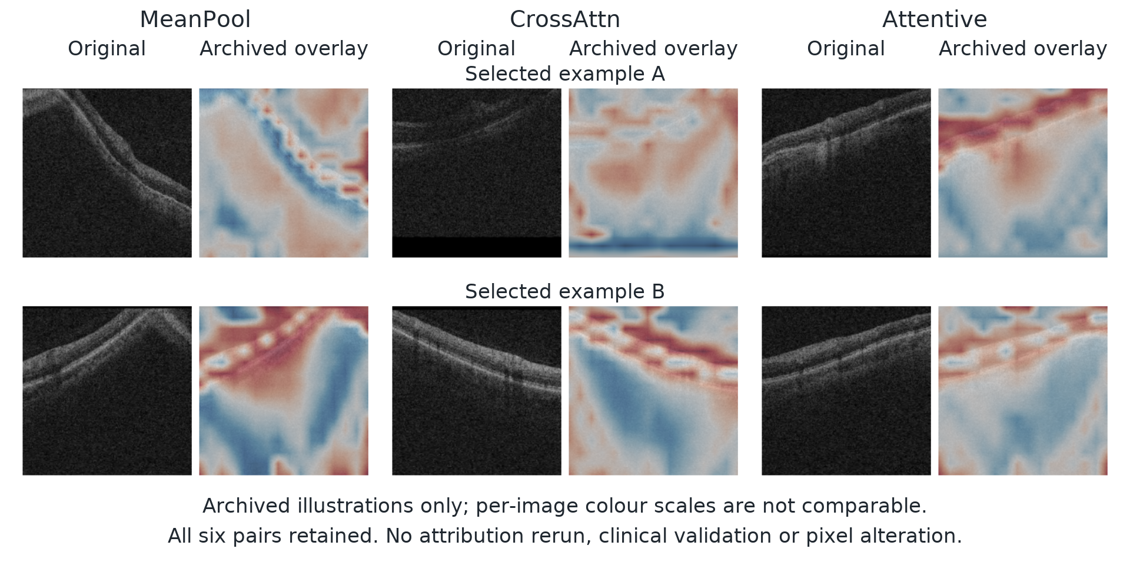
Selected archived feature-occlusion examples from fine-tuned classifiers initialized with uniform-masking I-JEPA. Each pair shows an OCT B-scan and its patch-attribution overlay. Red denotes positive $Δ_{s,p}$ and blue negative $Δ_{s,p}$ as defined in Equation 5. The archived plotting procedure interpolates patch values and uses a separate symmetric colour scale for each image; colour intensity is therefore not comparable across examples. Image panels are reproduced without recolouring. Original numerical headers and clinical annotations are omitted. These selected visualizations provide context for the retinal-targeting motivation, not a quantitative localization comparison.
The historical report and selected overlays prompted us to investigate retinal regions as prediction targets. Those examples were selected from correctly classified cases and informative slices, so they are not a population-level estimate of anatomical localization. Nor does a response to feature removal establish a clinically causal region or show which pretraining mask is best. Fine-tuning used diagnosis labels, so the maps cannot separate the contribution of self-supervised pretraining from subsequent supervised adaptation.

Available evidence.
Archived occlusion curves and heat maps remain available, but the underlying per-volume numerical arrays and a complete normalization record are not retained in the evidence used for this submission. The historical record also documents sensitivity of patch-level displays to numerical precision and colour scaling. The selected image panels are retained as archived visualizations, without restoring their numerical summaries as validated results. We make no spatial-consistency, laterality or clinical landmark claim from those displays. Recovering the producing arrays, checkpoint identities and plotting transforms would be necessary for a reproducible quantitative analysis. No new attribution campaign was run, and the saved frozen-probe AUC comparisons are unchanged.

Full paired-contrast table
Primary contrasts: matched epoch and matched precision. $Δ$ is a paired difference on identical test cases; the interval is a 10,000-resample paired bootstrap and $p$ is a DeLong test for correlated ROC curves. $q$ is Benjamini–Hochberg over these nine contrasts. All $p$ and $q$ values here are descriptive (Section 6). Every comparison against the null excludes zero.
contrast | epoch | $Δ$ AUC | 95% CI | $p$ | $q$
envelope $−$ random | 50 | +0.0120 | [+0.0068, +0.0173] | $<$0.0001 | $<$0.0001
envelope $−$ random | 75 | +0.0080 | [+0.0028, +0.0132] | 0.0025 | 0.0045
envelope $−$ random | 100 | +0.0062 | [+0.0010, +0.0113] | 0.0199 | 0.0299
centroid $−$ random | 50 | +0.0099 | [+0.0051, +0.0149] | $<$0.0001 | 0.0001
centroid $−$ random | 75 | +0.0113 | [+0.0063, +0.0164] | $<$0.0001 | $<$0.0001
centroid $−$ random | 100 | +0.0109 | [+0.0057, +0.0160] | $<$0.0001 | $<$0.0001
centroid $−$ envelope | 50 | -0.0020 | [-0.0069, +0.0029] | 0.4114 | 0.4114
centroid $−$ envelope | 75 | +0.0033 | [-0.0013, +0.0079] | 0.1491 | 0.1677
centroid $−$ envelope | 100 | +0.0047 | [+0.0004, +0.0091] | 0.0294 | 0.0378
Benjamini–Hochberg is applied within a declared primary family consisting of exactly these nine contrasts (the fp16 comparisons among random, centroid and envelope at epochs 50, 75 and 100) and the remaining 25 exploratory contrasts in the stored statistics are corrected as a separate family. The two families are never pooled, and the $q$ values printed above are those of the nine-contrast family only. Declaring the family fixes what is corrected together. It does not make these contrasts confirmatory, because the test split was inspected repeatedly before the family was fixed, and the paper reports them as descriptive throughout.

Probe precision control
We repeated the recorded mixed-precision probes with autocast disabled in feature extraction, head fitting and evaluation. Each comparison uses the same frozen encoder. The recorded changes are smaller than the principal policy differences.
Full fp32 re-probe against the original fp16 result, same frozen encoder in each row. The eight DeLong $p$-values are unadjusted diagnostics, not a family-wise test. The largest difference is $2×{10}^{−4}$.
policy | epoch | fp16 AUC | fp32 AUC | $Δ$ | $p$
envelope | 50 | 0.876064 | 0.876063 | -0.000001 | 0.964
envelope | 75 | 0.880307 | 0.880305 | -0.000002 | 0.806
envelope | 100 | 0.880743 | 0.880761 | +0.000018 | 0.167
centroid | 50 | 0.874030 | 0.874015 | -0.000015 | 0.412
centroid | 100 | 0.885485 | 0.885293 | -0.000192 | 0.767
random | 50 | 0.864097 | 0.864121 | +0.000024 | 0.128
random | 75 | 0.872302 | 0.872302 | -0.000001 | 0.962
random | 100 | 0.874581 | 0.874485 | -0.000096 | 0.000

References
Assran, Mahmoud, Quentin Duval, Ishan Misra, et al. 2023. “Self-Supervised Learning from Images with a Joint-Embedding Predictive Architecture.” Proceedings of the IEEE/CVF Conference on Computer Vision and Pattern Recognition, 15619–29. https://doi.org/10.1109/CVPR52729.2023.01499.
Azizi, Shekoofeh, Basil Mustafa, Fiona Ryan, et al. 2021. “Big Self-Supervised Models Advance Medical Image Classification.” Proceedings of the IEEE/CVF International Conference on Computer Vision.
Baevski, Alexei, Wei-Ning Hsu, Qiantong Xu, Arun Babu, Jiatao Gu, and Michael Auli. 2022. “Data2vec: A General Framework for Self-Supervised Learning in Speech, Vision and Language.” Proceedings of the 39th International Conference on Machine Learning, Proceedings of machine learning research, vol. 162: 1298–312. https://proceedings.mlr.press/v162/baevski22a.html.
Balestriero, Randall, and Yann LeCun. 2025. LeJEPA: Provable and Scalable Self-Supervised Learning Without the Heuristics. https://doi.org/10.48550/arXiv.2511.08544.
Bao, Hangbo, Li Dong, Songhao Piao, and Furu Wei. 2022. “BEiT: BERT Pre-Training of Image Transformers.” International Conference on Learning Representations. https://openreview.net/forum?id=p-BhZSz59o4.
Bardes, Adrien, Quentin Garrido, Jean Ponce, et al. 2024. “Revisiting Feature Prediction for Learning Visual Representations from Video.” Transactions on Machine Learning Research. https://openreview.net/forum?id=QaCCuDfBk2.
Bouthillier, Xavier, Pierre Delaunay, Mirko Bronzi, et al. 2021. “Accounting for Variance in Machine Learning Benchmarks.” Proceedings of Machine Learning and Systems 3: 747–69. https://proceedings.mlsys.org/paper_files/paper/2021/hash/0184b0cd3cfb185989f858a1d9f5c1eb-Abstract.html.
Ceballos Arroyo, Alberto M., Jisoo Kim, Chu-Hsuan Lin, Lei Qin, Geoffrey S. Young, and Huaizu Jiang. 2026. “Anatomically-Guided Masked Autoencoder Pre-Training for Aneurysm Detection.” Proceedings of the IEEE/CVF Winter Conference on Applications of Computer Vision, 5693–702. https://doi.org/10.1109/WACV61042.2026.00552.
Chen, Haijian, Wendong Zhang, Yunbo Wang, and Xiaokang Yang. 2023. “Improving Masked Autoencoders by Learning Where to Mask.” Pattern Recognition and Computer Vision, 377–90. https://doi.org/10.1007/978-981-99-8543-2_31.
Chen, Zekai, Devansh Agarwal, Kshitij Aggarwal, Wiem Safta, Mariann Micsinai Balan, and Kevin Brown. 2023. “Masked Image Modeling Advances 3D Medical Image Analysis.” Proceedings of the IEEE/CVF Winter Conference on Applications of Computer Vision, 1970–80. https://doi.org/10.1109/WACV56688.2023.00201.
DeLong, Elizabeth R., David M. DeLong, and Daniel L. Clarke-Pearson. 1988. “Comparing the Areas Under Two or More Correlated Receiver Operating Characteristic Curves: A Nonparametric Approach.” Biometrics 44 (3): 837–45. https://doi.org/10.2307/2531595.
He, Kaiming, Xinlei Chen, Saining Xie, Yanghao Li, Piotr Dollár, and Ross Girshick. 2022. “Masked Autoencoders Are Scalable Vision Learners.” Proceedings of the IEEE/CVF Conference on Computer Vision and Pattern Recognition, 16000–16009. https://doi.org/10.1109/CVPR52688.2022.01553.
He, Xiangteng, Shunsuke Sakai, Shivam Chandhok, et al. 2025. DSeq-JEPA: Discriminative Sequential Joint-Embedding Predictive Architecture. https://doi.org/10.48550/arXiv.2511.17354.
Huang, De-Xing, Xiao-Hu Zhou, Mei-Jiang Gui, et al. 2026. “VasoMIM: Vascular Anatomy-Aware Masked Image Modeling for Vessel Segmentation.” Proceedings of the AAAI Conference on Artificial Intelligence 40: 4985–93. https://doi.org/10.1609/aaai.v40i6.42503.
Kakogeorgiou, Ioannis, Spyros Gidaris, Bill Psomas, et al. 2022. “What to Hide from Your Students: Attention-Guided Masked Image Modeling.” Computer Vision – ECCV 2022, 300–318. https://doi.org/10.1007/978-3-031-20056-4_18.
Li, Gang, Heliang Zheng, Daqing Liu, Chaoyue Wang, Bing Su, and Changwen Zheng. 2022. “SemMAE: Semantic-Guided Masking for Learning Masked Autoencoders.” Advances in Neural Information Processing Systems 35: 14290–302. https://doi.org/10.52202/068431-1039.
Li, Yuheng, Tianyu Luan, Yizhou Wu, Shaoyan Pan, Yenho Chen, and Xiaofeng Yang. 2024. “AnatoMask: Enhancing Medical Image Segmentation with Reconstruction-Guided Self-Masking.” Computer Vision – ECCV 2024, 146–63. https://doi.org/10.1007/978-3-031-73027-6_9.
Liu, Zixuan, Hanwen Xu, Addie Woicik, et al. 2026. “A Three-Dimensional Multi-Modal Foundation Model for Optical Coherence Tomography.” Nature Biomedical Engineering, ahead of print. https://doi.org/10.1038/s41551-026-01662-2.
Luo, Yan, Muhammad Osama Khan, Yu Tian, et al. 2024. FairVision: Equitable Deep Learning for Eye Disease Screening via Fair Identity Scaling. https://doi.org/10.48550/arXiv.2310.02492.
Maetschke, Stefan, Bhavna Antony, Hiroshi Ishikawa, Gadi Wollstein, Joel Schuman, and Rahil Garnavi. 2019. “A Feature Agnostic Approach for Glaucoma Detection in OCT Volumes.” PLOS ONE 14 (7).
Mao, Jiawei, Shujian Guo, Yuanqi Chang, Xuesong Yin, and Binling Nie. 2023. Medical Supervised Masked Autoencoders: Crafting a Better Masking Strategy and Efficient Fine-Tuning Schedule for Medical Image Classification. https://doi.org/10.48550/arXiv.2305.05871.
Morano, José, Botond Fazekas, Emese Sükei, et al. 2025. “Multimodal Foundation Model and Benchmark for Comprehensive Retinal OCT Image Analysis.” Npj Digital Medicine 8: 576. https://doi.org/10.1038/s41746-025-01852-3.
Noury, Erfan, Suria S. Mannil, Robert T. Chang, et al. 2022. “Deep Learning for Glaucoma Detection and Identification of Novel Diagnostic Areas in Diverse Real-World Datasets.” Translational Vision Science & Technology 11 (5): 11. https://doi.org/10.1167/tvst.11.5.11.
Pissas, Theodoros, Pablo Márquez-Neila, Sebastian Wolf, Martin S. Zinkernagel, and Raphael Sznitman. 2024. “Masked Image Modelling for Retinal OCT Understanding.” Ophthalmic Medical Image Analysis, 115–25. https://doi.org/10.1007/978-3-031-73119-8_12.
Qiu, Jianing, Jian Wu, Hao Wei, et al. 2024. “Development and Validation of a Multimodal Multitask Vision Foundation Model for Generalist Ophthalmic Artificial Intelligence.” NEJM AI 1 (12). https://doi.org/10.1056/AIoa2300221.
Radhachandran, Ashwath, Vedrana Ivezić, Shreeram Athreya, Corey W. Arnold, and William Speier. 2026. US-JEPA: A Joint Embedding Predictive Architecture for Ultrasound. https://doi.org/10.48550/arXiv.2602.19322.
Ran, An Ran, Carol Y. Cheung, Xi Wang, et al. 2019. “Detection of Glaucomatous Optic Neuropathy with Spectral-Domain Optical Coherence Tomography: A Retrospective Training and Validation Deep-Learning Analysis.” The Lancet Digital Health 1 (4): e172–82. https://doi.org/10.1016/S2589-7500(19)30085-8.
Shi, Yuge, N. Siddharth, Philip H. S. Torr, and Adam R. Kosiorek. 2022. “Adversarial Masking for Self-Supervised Learning.” Proceedings of the 39th International Conference on Machine Learning, Proceedings of machine learning research, vol. 162: 20026–40. https://proceedings.mlr.press/v162/shi22d.html.
Taleb, Aiham, Winfried Loetzsch, Noel Danz, et al. 2020. “3D Self-Supervised Methods for Medical Imaging.” Advances in Neural Information Processing Systems 33: 18158–72. https://proceedings.neurips.cc/paper/2020/hash/d2dc6368837861b42020ee72b0896182-Abstract.html.
Wang, Haochen, Kaiyou Song, Junsong Fan, Yuxi Wang, Jin Xie, and Zhaoxiang Zhang. 2023. “Hard Patches Mining for Masked Image Modeling.” Proceedings of the IEEE/CVF Conference on Computer Vision and Pattern Recognition, 10375–85. https://doi.org/10.1109/CVPR52729.2023.01000.
Wang, Ruilang, Shuotong Xu, Bowen Liu, Runlin Huang, Donglong Chen, and Weifeng Su. 2025. Mask What Matters: Controllable Text-Guided Masking for Self-Supervised Medical Image Analysis. https://doi.org/10.48550/arXiv.2509.23054.
Xie, Zhenda, Zheng Zhang, Yue Cao, et al. 2022. “SimMIM: A Simple Framework for Masked Image Modeling.” Proceedings of the IEEE/CVF Conference on Computer Vision and Pattern Recognition, 9653–63. https://doi.org/10.1109/CVPR52688.2022.00943.
Yu, Kai, Yang Zhou, Yang Bai, et al. 2024. “UrFound: Towards Universal Retinal Foundation Models via Knowledge-Guided Masked Modeling.” Medical Image Computing and Computer Assisted Intervention – MICCAI 2024, 753–62. https://doi.org/10.1007/978-3-031-72390-2_70.
Zhou, Jinghao, Chen Wei, Huiyu Wang, et al. 2022. “iBOT: Image BERT Pre-Training with Online Tokenizer.” International Conference on Learning Representations.
Zhou, Yukun, Mark A. Chia, Siegfried K. Wagner, et al. 2023. “A Foundation Model for Generalizable Disease Detection from Retinal Images.” Nature 622: 156–63. https://doi.org/10.1038/s41586-023-06555-x.

