### **Submission Guidelines**

Provide the following:

* **Deliverable for Task 1:** Take a screenshot of all the GPOs created for this homework assignment. To find these, launch the Group Policy Management tool, select **Group Policy Objects**, and take a screenshot of the GPOs you've created.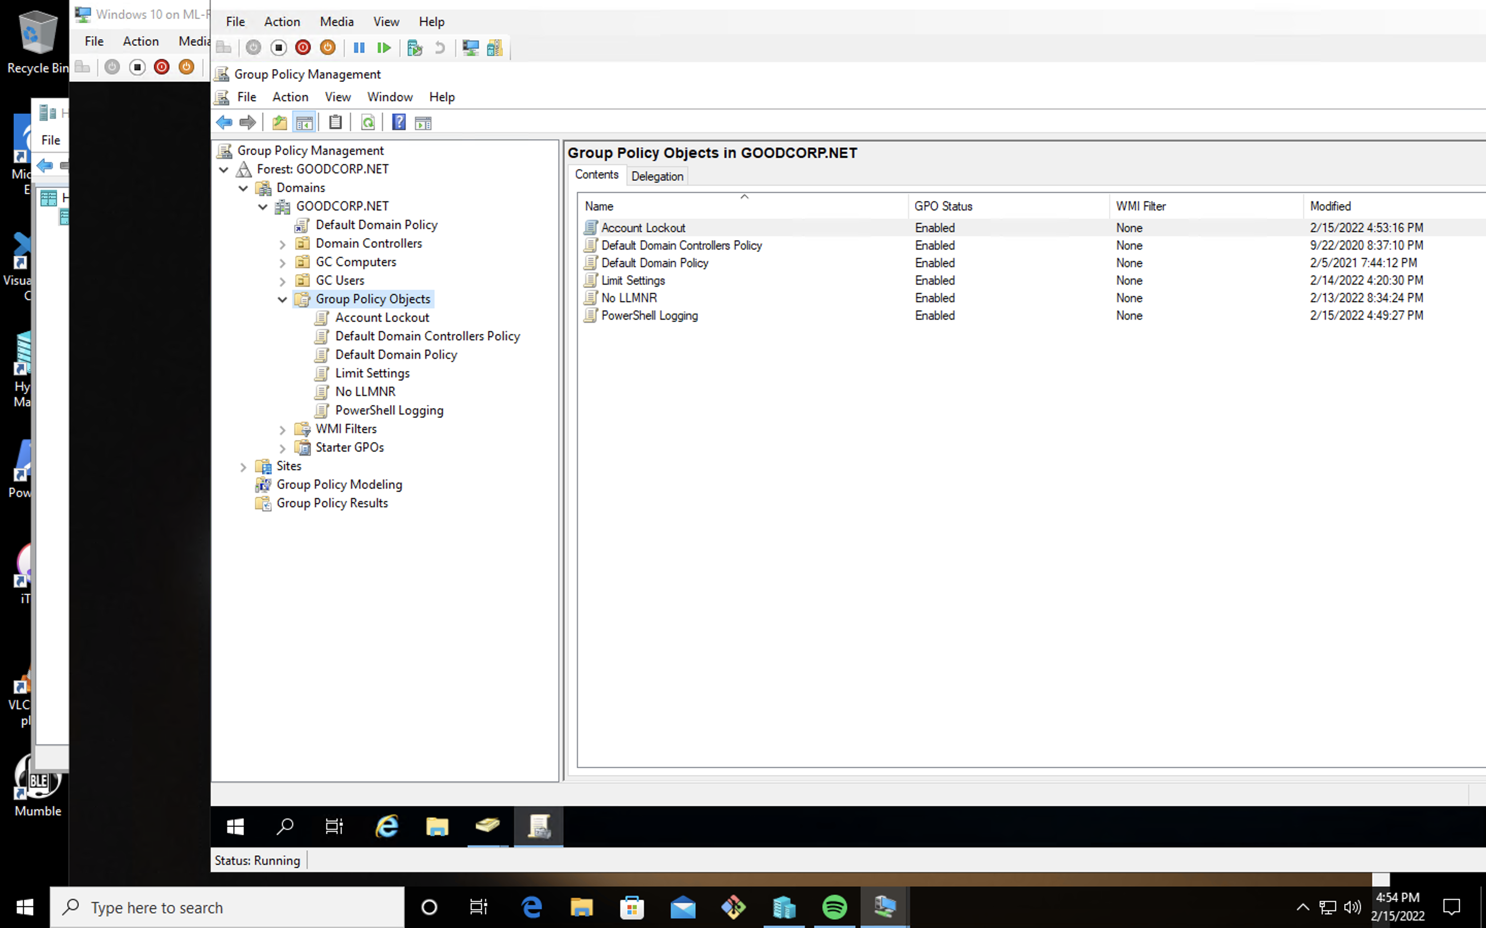

* **Deliverable for Task 2:** Submit a screenshot of the different Account Lockout policies in Group Policy Management Editor. It should show the three values you set under the Policy and Policy Setting columns.

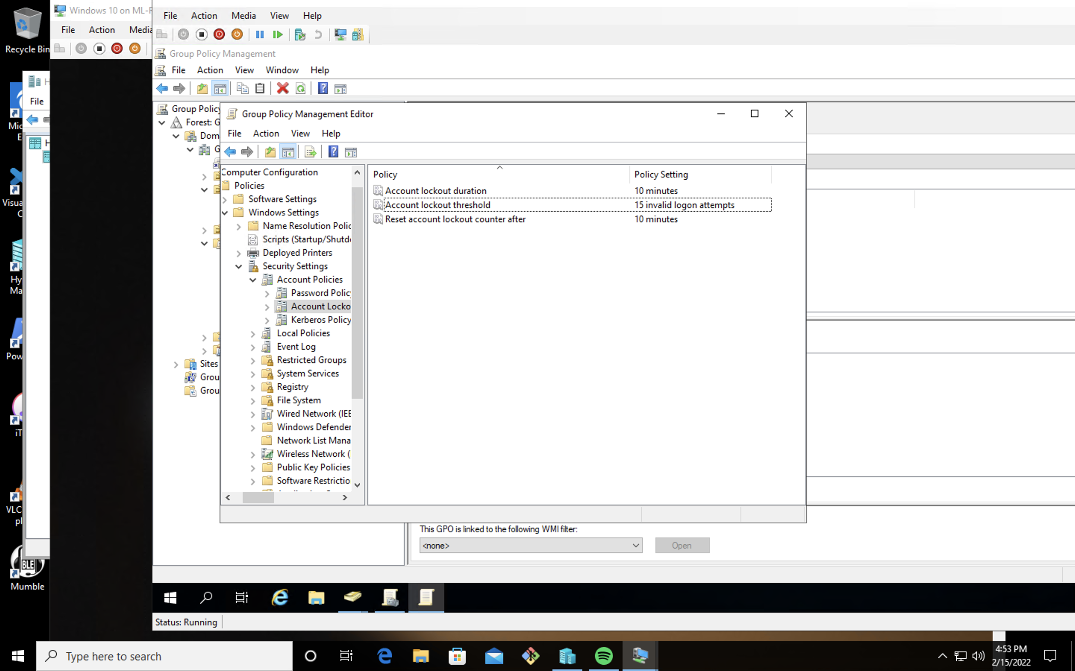

* **Deliverable for Task 3:** Submit a screenshot of the different Windows PowerShell policies within the Group Policy Management Editor. Four of these should be enabled.

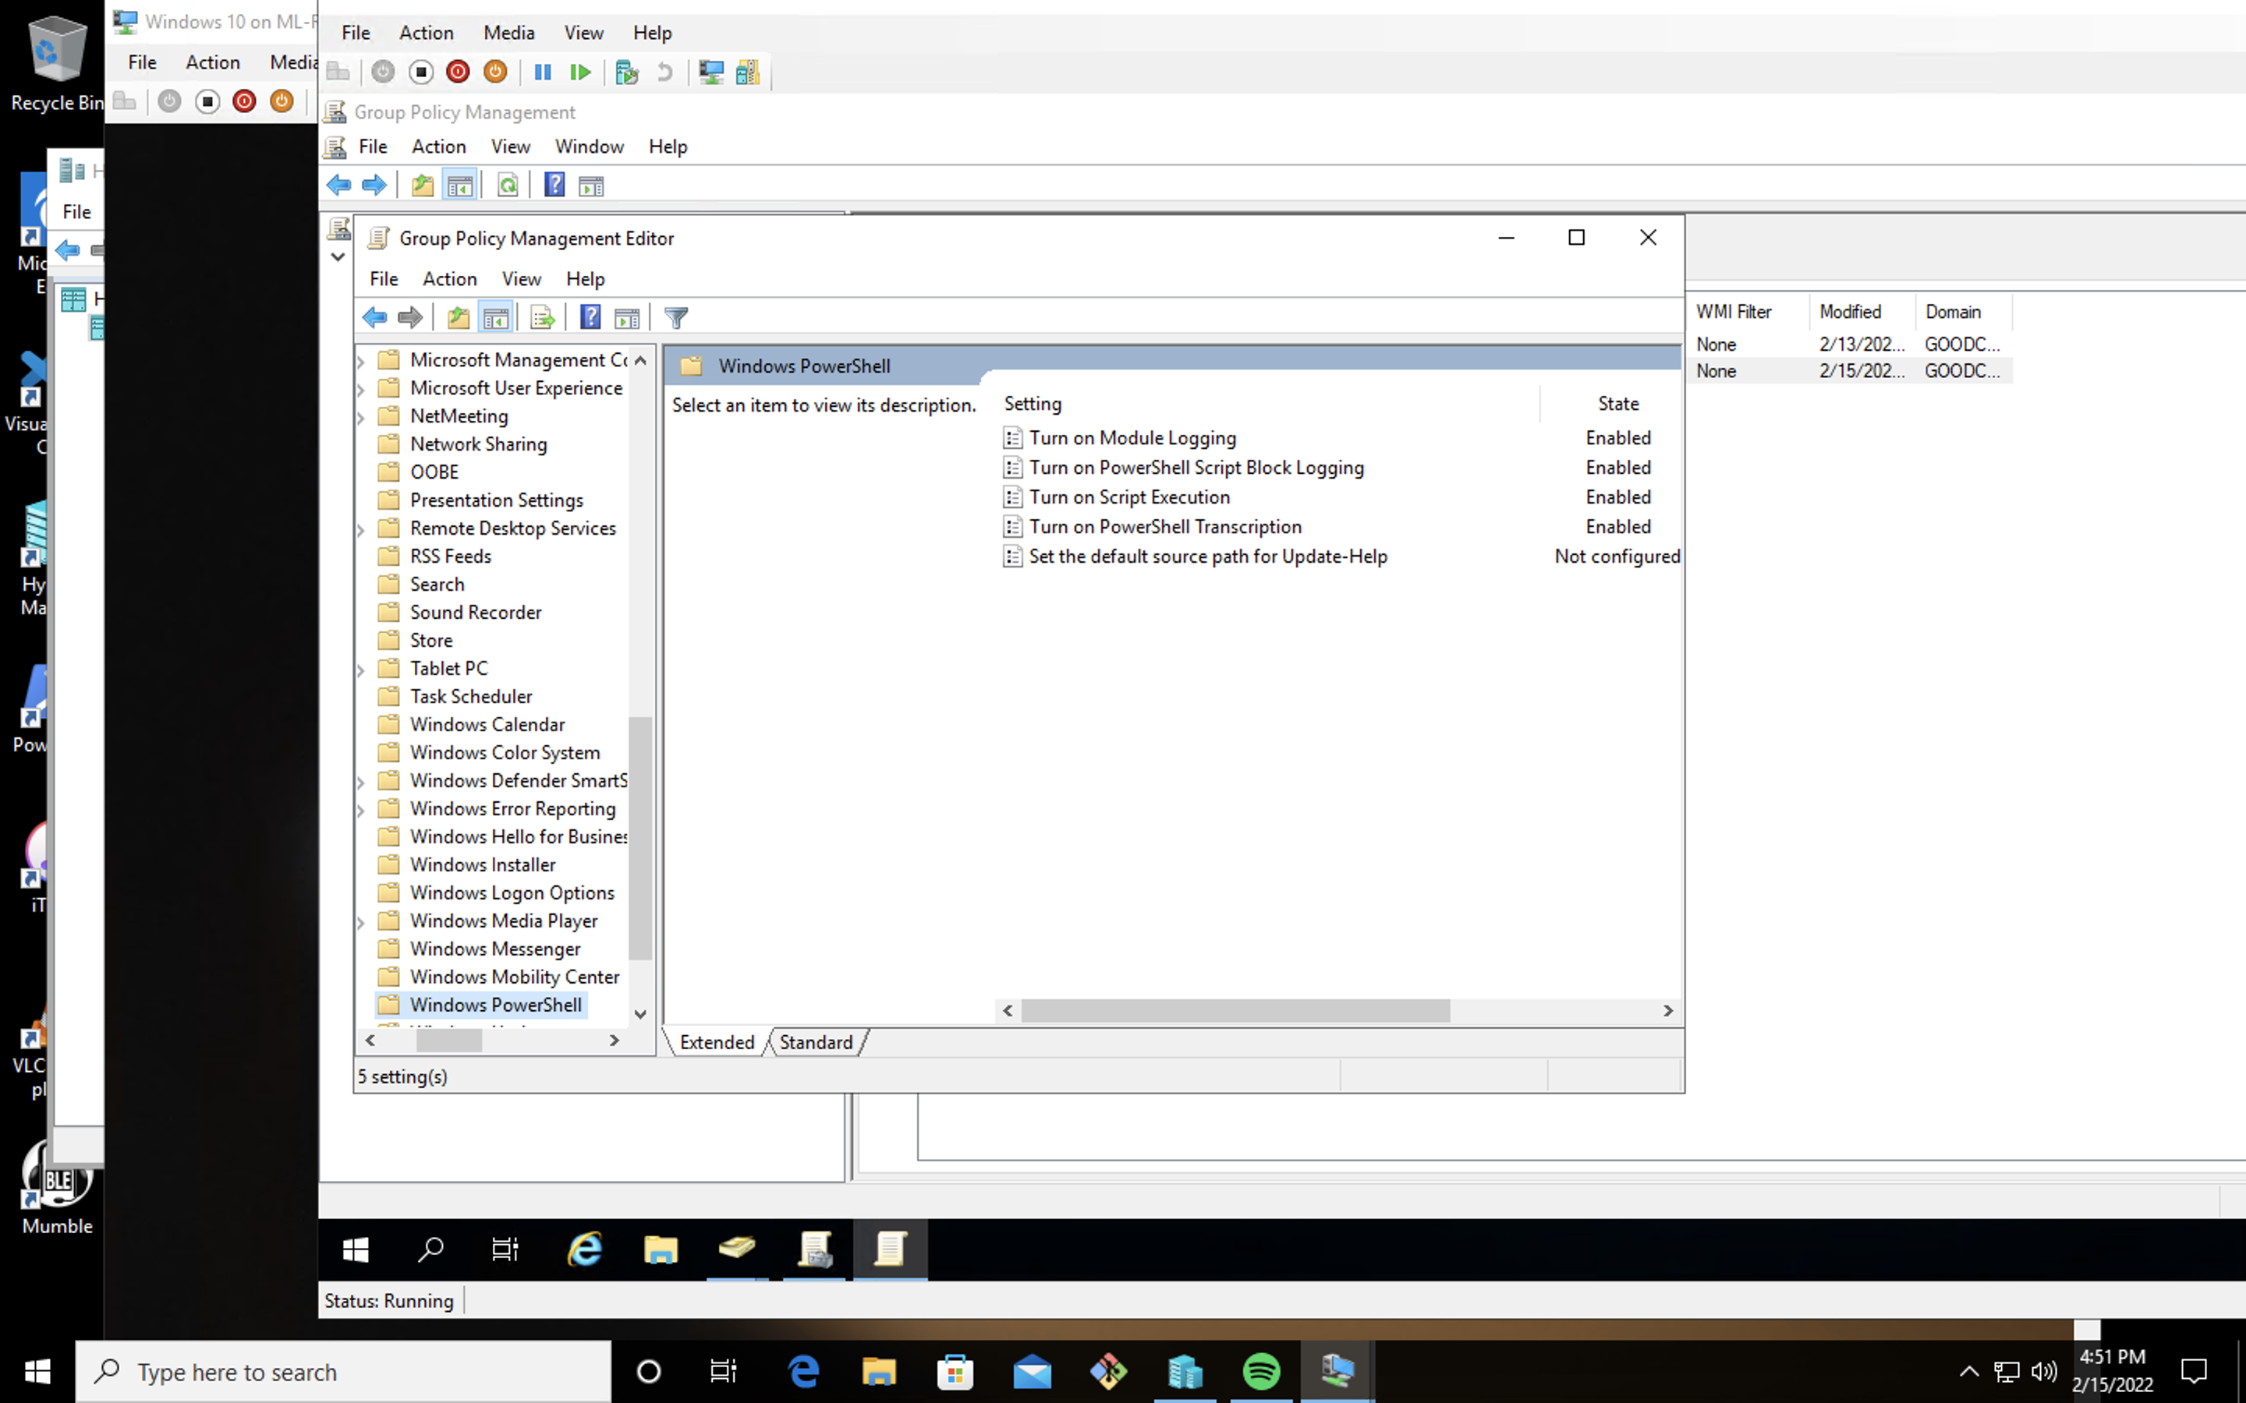

* **Deliverable for Task 4:** Submit a copy of your enum_acls.ps1 script.

`$directory=dir

foreach ($item in $directory) {

Get-acl $item

}`

* **Deliverable for Bonus Task 5:** Submit a screenshot of the contents of one of your transcribed PowerShell logs or a copy of one of the logs.