《恶意代码分析》实验报告

年级、专业、班级 |  | 信安02 |  |  | 姓名 | 姚凡
实验题目 | 感染目标解析
实验时间 | 2025.4.11 |  | 实验地点 | DS3 305
实验成绩 |  |  | 实验性质 | ☑验证性 □设计性 □综合性
教师评价：
☑算法/实验过程正确； ☑源程序/实验内容提交 ☑程序结构/实验步骤合理；
□实验结果正确； □语法、语义正确； ☑报告规范；
其他：
评价教师签名：杨吉云
一、实验目的
1.验证感染目标搜索过程
2.验证感染目标解析过程
3.验证感染内容隐藏过程
二、实验项目内容
- 借助工具完成
- 利用实验二的程序搜索FAT32文件系统下根目录里的.exe文件；
- 读取其中一个PE，解析并列举文件头中的AddressOfEntryPoint、ImageBase、SectionAlignment、FileAlignment、NumberOfSections；
- 解析并列举每个节的Name、VirtualSize、VirtualAddress、SizeOfRawData、PointerToRawData、Characteristics；
- 将该PE文件的.text节内容写入该文件系统下的隐藏扇区中。
- 节表免疫、节间免疫
- 编程实现

- 实验过程或算法（源程序）
寻找exe文件的代码
实验二中已根据FAT1和目录项等方法可以找到对应的文件名。然后只需要将这些文件名及其首簇号还有文件类型等参数构成一个fileInfo结构体，用一个名为fileVector，类型为fileInfo的容器，将这些结构体全部push_back进去之后作为全局变量，利用showExe函数，通过判断拓展名是否为exe或EXE，来判断该文件是否为可执行文件。最终全部遍历完，得到整个根目录下的exe文件目录。
具体源代码如下：
#include <windows.h>
#include <winioctl.h>
#include <stdio.h>
#include <math.h>
#include <stdlib.h>
#include <stdint.h>
#include<iostream>
#include<string>
#include<iomanip>
#include<sstream>
#include<vector>
using namespace std;
#define BufferLength 1024
struct BPB {
uint8_t bytes_per_sector[2];//扇区字节数
uint8_t secotrs_per_cluster;//每簇扇区数
uint8_t reserve_sectors[2];//包括DBR自己在内的FAT之前的扇区个数,即保留扇区数
uint8_t FATnum;//FAT个数，一般为2
uint8_t unimportant1[11];
uint8_t DBR_LBA[4];//该分区的DBR所在的相对扇区号，如果是扩展分区，是相对于扩展分区首
uint8_t totalsectors[4];//本分区的总扇区数
uint8_t sectors_per_FAT[4];//每个FAT的扇区数
uint8_t unimportant2[4];
uint8_t root_cluster_number[4];//根目录簇号
uint8_t file_info[2];
uint8_t backup_DBR[2];//备份引导扇区的相对于DBR的扇区号，一般为6，内容和DBR一模一样
uint8_t zero1[12];
uint8_t extBPB[26];//扩展BPB
};
struct DBR {
uint8_t jumpcode[3];//EB 58 90
uint8_t OEM[8];//OEM代号
BPB bpb;
uint8_t osboot[422];//引导代码和55AA
};
struct shortfile {
uint8_t FileName[8];//文件名
uint8_t ExtendName[3];//扩展名
uint8_t attributeOfFile;//属性字节
uint8_t SystemReserve;//系统保留
uint8_t CreateTime_ms;//创建时间的10毫秒位
uint8_t CreateTime[2];//创建时间
uint8_t CreateDate[2];//创建日期
uint8_t LastAccess[2];//最后访问日期
uint8_t HighCluster[2];//文件起始簇号高16位
uint8_t LastModifyTime[2];//最近修改时间
uint8_t LastModifyDate[2];//最近修改时间
uint8_t LowCluster[2];//文件起始簇号低16位
uint8_t FileSize[4];//文件长度
};
//rootdir（512字节）
struct rootdir {
shortfile shortfile[16];//因为每次只能读512字节
};
//簇号链
struct clusterChain {
uint32_t cluster[128];//每个clusterchain有128个目录项
};
struct fileInfo {
std::string fileName;//文件名字
uint32_t firstCluster;//首簇号
uint8_t fileClass;
};
vector<fileInfo>fileVector;
void store()
{
fileInfo f1;
f1.fileName = "替代密码.exe";
f1.firstCluster = 3;
f1.fileClass = 1;
fileVector.push_back(f1);
fileInfo f2;
f2.fileName = "test.txt";
f2.firstCluster = 3;
f2.fileClass = 2;
fileVector.push_back(f2);
fileInfo f3;
f3.fileName = "QQ.exe";
f3.firstCluster = 3;
f3.fileClass = 3;
fileVector.push_back(f3);
}
uint32_t getbyte(unsigned char a[], int num)
{
uint32_t sum = 0UL;
uint32_t temp = 0UL;
cout << a[0] << endl;
cout << a[1] << endl;
for (int i = num - 1; i >= 0; i--)
{
temp = a[i];
temp = temp << int(pow(2, num - 1) * (num - 1 - i));
sum = sum | temp;

}
return sum;
}
uint32_t H_D(uint8_t a[], int num)
{
string t = "";
for (int i = num - 1; i >= 0; i--)
{
stringstream ss;
string temp = "";
ss << hex << std::setfill('0') << std::setw(2) << int(a[i]);
t += ss.str();
}
return (stoi(t, nullptr, 16));
}
bool HexOutput(char* buf, size_t len, ULONGLONG* baseaddr, ULONGLONG* nextaddr, int EBRnum)
{
cout << endl;
cout << "本次实验我们将利用编程来实现读取分区信息以及具体某个文件的簇号链及DATA区信息。" << endl;
cout << endl;
cout << endl;
bool mbrflag = 1;
unsigned char a = buf[0];
printf("--------------------------DBR------------------\n");
int flag = 0;
char temp[79];
for (size_t i = 0; i < len; ++i)
{
unsigned char c = buf[i];
flag++;
if (c < 16)
printf("0%x ", c);
else
printf("%x ", c);

if ((flag) % 16 == 0)
printf("\n");
if (flag >= 12 && flag <= 90)
{
temp[flag - 12] = buf[i];
}
}
DBR dbr;
BPB bpb;
cout << "以下是DBR中读取到的一些重要的消息:" << endl;
memcpy(&dbr, buf, sizeof(BPB));
cout << "每扇区的字节数：";
if (dbr.bpb.bytes_per_sector[1] < 16)
printf("0%x", dbr.bpb.bytes_per_sector[1]);
else
printf("%x ", dbr.bpb.bytes_per_sector[1]);
if (dbr.bpb.bytes_per_sector[0] < 16)
printf("0%x ", dbr.bpb.bytes_per_sector[0]);
else
printf("%x ", dbr.bpb.bytes_per_sector[0]);
cout << H_D(dbr.bpb.bytes_per_sector, 2) << "字节" << endl;
cout << endl;
cout << "每簇的扇区数: ";
cout << hex << setfill('0') << setw(2) << int(dbr.bpb.secotrs_per_cluster) << " ";
cout << uint32_t(stoi(to_string(int(dbr.bpb.secotrs_per_cluster)), nullptr, 16)) << "个" << endl;
cout << endl;
cout << "DOS保留扇区数: ";
cout << setfill('0') << setw(2) << int(dbr.bpb.reserve_sectors[1]) << "";
cout << setfill('0') << setw(2) << int(dbr.bpb.reserve_sectors[0]) << " ";
cout << dec << H_D(dbr.bpb.reserve_sectors, 2) << "个" << endl;
cout << endl;
cout << "FAT表个数: ";
cout << hex << setfill('0') << setw(2) << int(dbr.bpb.FATnum) << " ";
cout << uint32_t(stoi(to_string(int(dbr.bpb.FATnum)), nullptr, 16)) << "个" << endl;
cout << endl;
cout << "每FAT扇区数: ";
cout << hex << setfill('0') << setw(2) << int(dbr.bpb.sectors_per_FAT[3]);
cout << hex << setfill('0') << setw(2) << int(dbr.bpb.sectors_per_FAT[2]);
cout << hex << setfill('0') << setw(2) << int(dbr.bpb.sectors_per_FAT[1]);
cout << hex << setfill('0') << setw(2) << int(dbr.bpb.sectors_per_FAT[0]) << " ";
cout << dec << H_D(dbr.bpb.sectors_per_FAT, 4) << "个" << endl;
cout << endl;
cout << "根目录首簇号: ";
cout << hex << setfill('0') << setw(2) << int(dbr.bpb.root_cluster_number[3]);
cout << hex << setfill('0') << setw(2) << int(dbr.bpb.root_cluster_number[2]);
cout << hex << setfill('0') << setw(2) << int(dbr.bpb.root_cluster_number[1]);
cout << hex << setfill('0') << setw(2) << int(dbr.bpb.root_cluster_number[0]) << " ";
cout << "第" << dec << H_D(dbr.bpb.root_cluster_number, 4) << "号" << endl;
cout << endl;
cout << "到这里，DBR中的重要信息我们已经读取完了，接下来就是根据得到的保留扇区数，跳转到FAT1中去。" << endl;
cout << "--------------------------------------------FAT1---------------------------------------------" << endl;
DISK_GEOMETRY* pdg = 0;
HANDLE hDevice; // 设备句柄
BOOL bResult; // results flag
DWORD junk; // discard resultscc
char buf_new[BufferLength] = { 0 };

//通过CreateFile来获得设备的句柄
hDevice = CreateFile(TEXT("\\\\.\\E:"),
GENERIC_READ,
FILE_SHARE_READ | FILE_SHARE_WRITE,
NULL,
OPEN_EXISTING,
0,
NULL);

//通过DeviceIoControl函数与设备进行IO
bResult = DeviceIoControl(hDevice, // 设备的句柄
IOCTL_DISK_GET_DRIVE_GEOMETRY, // 控制码，指明设备的类型
NULL,
0, // no input buffer
pdg,
sizeof(*pdg),
&junk, // # bytes returned
(LPOVERLAPPED)NULL); // synchron
LARGE_INTEGER offset;
offset.QuadPart = H_D(dbr.bpb.reserve_sectors, 2) * (ULONGLONG)512;
SetFilePointer(hDevice, offset.LowPart, &offset.HighPart, FILE_BEGIN);

DWORD dwCB;
//从这个位置开始读
BOOL bRet = ReadFile(hDevice, buf_new, 512, &dwCB, NULL);
flag = 0;
for (size_t i = 0; i < len; ++i)
{
unsigned char c = buf_new[i];
flag++;
if (c < 16)
printf("0%x ", c);
else
printf("%x ", c);

if ((flag) % 16 == 0)
printf("\n");
if (flag >= 12 && flag <= 90)
{
temp[flag - 12] = buf_new[i];
}
}
cout << "这一点我们之后再看，然后我们根据每个FAT所占的扇区数，再一次跳跃到FAT2中。" << endl;
cout << "--------------------------------------------FAT2---------------------------------------------" << endl;
offset.QuadPart = (H_D(dbr.bpb.reserve_sectors, 2) + H_D(dbr.bpb.sectors_per_FAT, 4)) * (ULONGLONG)512;//0
SetFilePointer(hDevice, offset.LowPart, &offset.HighPart, FILE_BEGIN);
//从这个位置开始读
bRet = ReadFile(hDevice, buf_new, 512, &dwCB, NULL);
flag = 0;
for (size_t i = 0; i < len; ++i)
{
unsigned char c = buf_new[i];
flag++;
if (c < 16)
printf("0%x ", c);
else
printf("%x ", c);

if ((flag) % 16 == 0)
printf("\n");
if (flag >= 12 && flag <= 90)
{
temp[flag - 12] = buf_new[i];
}
}
cout << "可以看到FAT2与FAT1中的内容相同，因为它本来就是FAT1的备份，所以在这里验证了我们正确性。接下来就是跳转到根目录去查看文件的目录项，由于我这个U盘只有一个文件所以原始的读512个字节已经足够了，因此就不需要循环读。" << endl;
cout << "--------------------------------------------根目录项---------------------------------------------" << endl;
offset.QuadPart = (H_D(dbr.bpb.reserve_sectors, 2) + 2 * H_D(dbr.bpb.sectors_per_FAT, 4)) * (ULONGLONG)512;//0
SetFilePointer(hDevice, offset.LowPart, &offset.HighPart, FILE_BEGIN);
bRet = ReadFile(hDevice, buf_new, 512, &dwCB, NULL);
flag = 0;
for (size_t i = 0; i < len; ++i)
{
unsigned char c = buf_new[i];
flag++;
if (c < 16)
printf("0%x ", c);
else
printf("%x ", c);

if ((flag) % 16 == 0)
printf("\n");
if (flag >= 12 && flag <= 90)
{
temp[flag - 12] = buf_new[i];
}
}
cout << "由于我的U盘中只有一个文件,名字为test.txt是个短文件，因此我就只把那个文件的目录信息提取出来进行一个打印。" << endl;
cout << "之所以根目录项中前面有数据，那些数据都是无意义，因此我们只需要从第五条开始读，即我编写的test.txt文件开始写。" << endl;
cout << endl;
char information[32];
shortfile s_f;
for (int i = 128; i < 160; i++)
{
information[i - 128] = buf_new[i];
}
memcpy(&s_f, information, sizeof(shortfile));
cout << "文件名为(注意，在这种名称的时候，如果要想呈现正确的名字，那么就不必将字节倒着写了): " << endl;
cout << hex << setfill('0') << setw(2) << int(s_f.FileName[0]);
cout << hex << setfill('0') << setw(2) << int(s_f.FileName[1]);
cout << hex << setfill('0') << setw(2) << int(s_f.FileName[2]);
cout << hex << setfill('0') << setw(2) << int(s_f.FileName[3]);
cout << hex << setfill('0') << setw(2) << int(s_f.FileName[4]);
cout << hex << setfill('0') << setw(2) << int(s_f.FileName[5]);
cout << hex << setfill('0') << setw(2) << int(s_f.FileName[6]);
cout << hex << setfill('0') << setw(2) << int(s_f.FileName[7]) << " ";
cout << char(s_f.FileName[0]);
cout << char(s_f.FileName[1]);
cout << char(s_f.FileName[2]);
cout << char(s_f.FileName[3]);
cout << char(s_f.FileName[4]);
cout << char(s_f.FileName[5]);
cout << char(s_f.FileName[6]);
cout << char(s_f.FileName[7]) << endl;
cout << endl;
cout << "扩展名为(和文件同理，不需要倒着写): " << endl;
cout << hex << setfill('0') << setw(2) << int(s_f.ExtendName[0]);
cout << hex << setfill('0') << setw(2) << int(s_f.ExtendName[1]);
cout << hex << setfill('0') << setw(2) << int(s_f.ExtendName[2]) << " ";
cout << char(s_f.ExtendName[0]);
cout << char(s_f.ExtendName[1]);
cout << char(s_f.ExtendName[2]);
cout << endl;
cout << endl;
cout << "文件属性为: ";
cout << hex << setfill('0') << setw(2) << int(s_f.attributeOfFile) << " ";
cout << uint32_t(stoi(to_string(int(s_f.attributeOfFile)), nullptr, 16)) << " ";
int r = stoi(to_string(int(s_f.attributeOfFile)), nullptr, 10);
if (r == 0)
{
cout << "读写" << endl;
}
else if (r == 1)
{
cout << "只读" << endl;
}
else if (r == 2)
{
cout << "隐藏" << endl;
}
else if (r == 4)
{
cout << "系统" << endl;
}
else if (r == 8)
{
cout << "卷标" << endl;
}
else if (r == 16)
{
cout << "子目录" << endl;
}
else if (r == 32)
{
cout << "归档" << endl;
}
cout << endl;
cout << "文件的起始簇号为: ";
uint8_t cluster[4];
cluster[0] = s_f.LowCluster[0];
cluster[1] = s_f.LowCluster[1];
cluster[2] = s_f.HighCluster[0];
cluster[3] = s_f.HighCluster[1];
cout << hex << setfill('0') << setw(2) << int(cluster[3]);
cout << hex << setfill('0') << setw(2) << int(cluster[2]);
cout << hex << setfill('0') << setw(2) << int(cluster[1]);
cout << hex << setfill('0') << setw(2) << int(cluster[0]) << " ";
cout << "第" << dec << H_D(cluster, 4) << "号" << endl;
cout << endl;
cout << "文件的长度为: ";
cout << hex << setfill('0') << setw(2) << int(s_f.FileSize[3]);
cout << hex << setfill('0') << setw(2) << int(s_f.FileSize[2]);
cout << hex << setfill('0') << setw(2) << int(s_f.FileSize[1]);
cout << hex << setfill('0') << setw(2) << int(s_f.FileSize[0]) << " ";
cout << dec << H_D(s_f.FileSize, 4) << "个字节" << endl;
cout << endl;
cout << "由于本分区只有这一个文件，因此到这里我的根目录表也就分析完了,接着我就以test.txt为例去查看其簇号链，并找到他的DATA数据区。";
offset.QuadPart = (H_D(dbr.bpb.reserve_sectors, 2)) * (ULONGLONG)512;
SetFilePointer(hDevice, offset.LowPart, &offset.HighPart, FILE_BEGIN);
bRet = ReadFile(hDevice, buf_new, 512, &dwCB, NULL);
flag = 0;
cout << "由于初始簇号是5，因此我们从第五个簇号开始寻找." << endl;
cout << endl;
clusterChain c;
c.cluster[0] = 5;
uint8_t zansi[4];
for (int i = 20; i < 24; i++)
{
zansi[i - 20] = buf_new[i];
}
cout << "第五号簇号的信息为:";
cout << hex << setfill('0') << setw(2) << int(zansi[3]);
cout << hex << setfill('0') << setw(2) << int(zansi[2]);
cout << hex << setfill('0') << setw(2) << int(zansi[1]);
cout << hex << setfill('0') << setw(2) << int(zansi[0]) << endl;
cout << endl;
cout << "由于当某个簇处的值为0fffffff时，就说明文件结束了，在这里由于我的文件很小，所以只需要一个簇就可以到达。" << endl;
cout << "该文件的簇号链为: ";
cout << c.cluster[0] << endl;
cout << endl;
cout << "然后我们只需要去寻找该簇的位置便可以得到该文件的数据区了，由于根目录项的起始位置是第二号簇，于是我们只需要跳转到根目录项，然后再跳转3个簇就可以了" << endl;
cout << "--------------------------------------------DATA---------------------------------------------" << endl;
offset.QuadPart = (H_D(dbr.bpb.reserve_sectors, 2) + 2 * H_D(dbr.bpb.sectors_per_FAT, 4) + 3 * uint32_t(stoi(to_string(int(dbr.bpb.secotrs_per_cluster)), nullptr, 10))) * (ULONGLONG)512;//0
SetFilePointer(hDevice, offset.LowPart, &offset.HighPart, FILE_BEGIN);
bRet = ReadFile(hDevice, buf_new, 512, &dwCB, NULL);
flag = 0;
for (size_t i = 0; i < len; ++i)
{
unsigned char c = buf_new[i];
flag++;
if (c < 16)
printf("0%x ", c);
else
printf("%x ", c);

if ((flag) % 16 == 0)
printf("\n");
if (flag >= 12 && flag <= 90)
{
temp[flag - 12] = buf_new[i];
}
}
return (mbrflag);
}
void showExe() {
cout << "exe file as follows:" << endl;
int size = fileVector.size();
for (int i = 0; i < size; i++) {
int filesize = fileVector[i].fileName.size();
string extendName = fileVector[i].fileName.substr(filesize - 3, 3);
if (extendName.compare("EXE") == 0 || extendName.compare("exe") == 0) {
cout << "\t" << fileVector[i].fileName << endl;
}
}
}
BOOL GetDriveGeometry(DISK_GEOMETRY* pdg, int addr)
{
HANDLE hDevice; // 设备句柄
BOOL bResult; // results flag
DWORD junk; // discard resultscc
char the_mbr[BufferLength] = { 0 };
store()
//通过CreateFile来获得设备的句柄
hDevice = CreateFile(TEXT("\\\\.\\E:"),
GENERIC_READ,
FILE_SHARE_READ | FILE_SHARE_WRITE,
NULL,
OPEN_EXISTING,
0,
NULL);

//通过DeviceIoControl函数与设备进行IO
bResult = DeviceIoControl(hDevice, // 设备的句柄
IOCTL_DISK_GET_DRIVE_GEOMETRY, // 控制码，指明设备的类型
NULL,
0, // no input buffer
pdg,
sizeof(*pdg),
&junk, // # bytes returned
(LPOVERLAPPED)NULL); // synchronous I/O

LARGE_INTEGER offset;//long long signed
offset.QuadPart = (ULONGLONG)addr * (ULONGLONG)512;//0
SetFilePointer(hDevice, offset.LowPart, &offset.HighPart, FILE_BEGIN);//从0开始读DBR

DWORD dwCB;
//从这个位置开始读
BOOL bRet = ReadFile(hDevice, the_mbr, 512, &dwCB, NULL);
bool finished = 0;
int EBRnum = 0;
ULONGLONG* baseaddr = new ULONGLONG, * nextaddr = new ULONGLONG;
*baseaddr = (ULONGLONG)0;
*nextaddr = (ULONGLONG)0;
finished = HexOutput(the_mbr, 512, baseaddr, nextaddr, EBRnum);
return bResult;
}
int main()
{
DISK_GEOMETRY pdg; // 保存磁盘参数的结构体
BOOL bResult; // generic results flag
ULONGLONG DiskSize; // size of the drive, in bytes
bResult = GetDriveGeometry(&pdg, 0);

if (bResult)
{
DiskSize = pdg.Cylinders.QuadPart * (ULONG)pdg.TracksPerCylinder *
(ULONG)pdg.SectorsPerTrack * (ULONG)pdg.BytesPerSector;
}
return ((int)bResult);
showExe();
}
对PE文件进行解析并写入隐藏扇区操作
首先用CreateFile函数创建exe文件的句柄，用CreateFileMapping将该exe文件的PE文件映射到内存。再利用MapCiewOfFile返回该map的开始地址，这就是PE文件的开始位置。
但由于本次实验要求读取的属性位于OptionalHeader和FileHeader里，所以先将pMapping指针指向DOS_header，然后利用变量dosheader去保存它，dosheader中的e_lfanew的值指向了nt_header的起始位置，需要读取的属性也都在nt_header中，于是利用一个变量nt_header来指向nt_header的内容，可以读取AddressOfEntryPoint、ImageBase、SectionAlignment、FileAlignment、NumberOfSections。
通过windows提供的API（IMAGE_FIRST_SECTION）来获得第一个节表的内容，而节表大小是固定的，利用这个API可以直接通过对第一个节表的参数++，就能直接跳转下一个节表的内容并循环输出。
首先创建一个变量名字为section_header存放第一个节表内容，利用一个for循环，循环次数等于Fileheader中的NumberOfSectionns。在每一轮循环中cout section_header的内容包括节名，节的真实大小，节在内存中的偏移位置，节文件对齐后的大小，节在文件后的偏移量，节的属性等。
由于TEXT节在这个文件中是第一个节表，因此只需要通过IMAGE_FIRST_SECTION可以直接得到该节具体信息。创建一个数组，该数组大小等于SizeOfRawData，利用memcpy将text代码节的内容写入到这个数组中，随后需要写入到该磁盘的隐藏扇区。
具体代码如下：
#include <windows.h>
#include <winioctl.h>
#include <stdio.h>
#include <math.h>
#include <stdlib.h>
#include <stdint.h>
#include<iostream>
#include<string>
#include<iomanip>
#include<sstream>
#include<vector>
using namespace std;
#define BufferLength 1024
LPCWSTR stringToLPCWSTR(string orig)
{
size_t origsize = orig.length() + 1;
const size_t newsize = 100;
size_t convertedChars = 0;
wchar_t* wcstring = new wchar_t[sizeof(wchar_t) * (orig.length() - 1)];
mbstowcs_s(&convertedChars, wcstring, origsize, orig.c_str(), _TRUNCATE);
return wcstring;
}
int main()
{
HANDLE hFile;
HANDLE hMapping;
LPVOID pMapping;
hFile = CreateFile(TEXT("E:/QQ.exe"), GENERIC_READ, FILE_SHARE_READ, NULL, OPEN_EXISTING,
FILE_ATTRIBUTE_NORMAL, NULL);
if (INVALID_HANDLE_VALUE == hFile) {
cout << "invalid" << endl;
return 0;
}
//将PE文件映射到内存
hMapping = CreateFileMapping(hFile, NULL, PAGE_READONLY, 0, 0, 0);
if (!hMapping) {
return 0;
}
pMapping = MapViewOfFile(hMapping, FILE_MAP_READ, 0, 0, 0);//返回的是map的开始地址
if (!pMapping) {
return 0;
}
PIMAGE_DOS_HEADER dosheader;
dosheader = (PIMAGE_DOS_HEADER)pMapping;
if (dosheader->e_magic != IMAGE_DOS_SIGNATURE) {
cout << "无效的PE文件" << endl;
return 0;
}
PIMAGE_NT_HEADERS nt_header = (PIMAGE_NT_HEADERS)((BYTE*)pMapping + dosheader->e_lfanew);
if (nt_header->Signature != IMAGE_NT_SIGNATURE) {
cout << "无效的PE文件" << endl;
return 0;
}
cout << "NumberOfSeciton等于:" << endl;
cout << nt_header->FileHeader.NumberOfSections << endl;
cout << endl;
cout << "AddressOfEntryPoint等于:" << endl;
cout << nt_header->OptionalHeader.AddressOfEntryPoint << endl;
cout << endl;
cout << "ImageBase等于:" << endl;
cout << nt_header->OptionalHeader.ImageBase << endl;
cout << endl;
cout << "SectionAlignment等于:" << endl;
cout << nt_header->OptionalHeader.SectionAlignment << endl;
cout << endl;
cout << "FileAlignment等于:" << endl;
cout << nt_header->OptionalHeader.FileAlignment << endl;
cout << endl;
PIMAGE_SECTION_HEADER section_header;
section_header = IMAGE_FIRST_SECTION(nt_header);
for (int i = 0; i < nt_header->FileHeader.NumberOfSections;
i++, section_header++) {
cout << "name: " << section_header->Name << setw(32) << "virtualsize: " << section_header->Misc.VirtualSize
<< setw(32) << "virtualaddress: " << section_header->VirtualAddress << setw(32) << "sizeofrawdata: " <<
section_header->SizeOfRawData << setw(32)
<< "pointertorawdata: " << section_header->PointerToRawData << setw(16) << "characteristics: " << section_header->Characteristics << endl;
}
DWORD PointerToRawData = IMAGE_FIRST_SECTION(nt_header)->PointerToRawData;
DWORD SizeOfRawData = IMAGE_FIRST_SECTION(nt_header)->SizeOfRawData;
UINT8* textContent = new UINT8[SizeOfRawData];
memcpy(textContent, (UINT8*)pMapping + PointerToRawData, SizeOfRawData);
OVERLAPPED overLap = { 0 };
overLap.Offset = 512;
DWORD writeByte;
DWORD readsize = 0;
LARGE_INTEGER offset;//long long signed
HANDLE hDevice = CreateFile(TEXT("\\\\.\\PhysicalDrive1:"),
GENERIC_WRITE,
FILE_SHARE_READ | FILE_SHARE_WRITE,
NULL,
OPEN_EXISTING,
0,
NULL);
DeviceIoControl(hDevice, FSCTL_LOCK_VOLUME, NULL, 0, NULL, 0, NULL, NULL);
offset.QuadPart = (ULONGLONG)0 * (ULONGLONG)512;//0
SetFilePointer(hDevice, offset.LowPart, &offset.HighPart, FILE_BEGIN);
if (!WriteFile(hDevice, textContent, SizeOfRawData, &writeByte, &overLap)) {
cout << dec << "error code" << GetLastError() << endl;
}
return 0;
}
实现节表免疫和节间免疫
节表免疫：需要复制整个ntheader和节表头，首先需要获取ntheader的大小，ntheader大小等于可选头大小加上24。然后由于要使用memcpy函数，因此需要知道起始地址、目的地址以及长度。再计算节表头大小，节表头大小每一项是固定的40，只需读出numberofsection，乘上40。利用memcpy函数将原来部分整体复制过来即可。最后将DOS头中程序入口改为计算得到的目的地址就行。
节间免疫：利用实验三中遍历节表头的代码遍历，并且将virtualsize改为和文件对齐后的大小相同。
#include <iostream>
#include <Windows.h>
#include <tchar.h>
#include <bitset>
#include <winioctl.h>
#include <iostream>
#include <vector>
#include <string>
#include <imagehlp.h>
using namespace std;

void section_immune() {
HANDLE hFile;
HANDLE hMapping;
LPVOID pMapping;
hFile = CreateFile(L"\\\\.\\F://HelloWorld.exe", GENERIC_READ| GENERIC_WRITE, FILE_SHARE_READ| FILE_SHARE_WRITE, NULL, OPEN_EXISTING,
FILE_ATTRIBUTE_NORMAL, NULL);
if (INVALID_HANDLE_VALUE == hFile) {
return;
}
//将PE文件映射到内存
hMapping = CreateFileMapping(hFile, NULL, PAGE_READWRITE, 0, 0, 0);
if (!hMapping) {
return;
}
pMapping = MapViewOfFile(hMapping, FILE_MAP_WRITE, 0, 0, 0);//返回的是map的开始地址
if (!pMapping) {
return;
}

PIMAGE_DOS_HEADER dosheader;
dosheader = (PIMAGE_DOS_HEADER)pMapping;
if (dosheader->e_magic != IMAGE_DOS_SIGNATURE) {
cout << "无效的PE文件" << endl;
return;
}

PIMAGE_NT_HEADERS nt_header = (PIMAGE_NT_HEADERS)((BYTE*)pMapping + dosheader->e_lfanew);
if (nt_header->Signature != IMAGE_NT_SIGNATURE) {
cout << "无效的PE文件" << endl;
return;
}

PIMAGE_SECTION_HEADER section_header;
section_header = IMAGE_FIRST_SECTION(nt_header);

DWORD optionHeaderSize = nt_header->FileHeader.SizeOfOptionalHeader;
DWORD NTHeaderSize = optionHeaderSize + 24;//获取nt header大小
DWORD HeaderCheckSum = nt_header->OptionalHeader.CheckSum; //PE头里的校验值
nt_header->OptionalHeader.CheckSum = 0;
DWORD PointerToRawData = section_header->PointerToRawData;
DWORD numOfSections = nt_header->FileHeader.NumberOfSections;
DWORD PointerCopy = PointerToRawData-(40 * numOfSections + NTHeaderSize);
memcpy((UINT8*)pMapping + PointerCopy, (UINT8*)nt_header, 40 * numOfSections + NTHeaderSize);
dosheader->e_lfanew = PointerCopy;
DWORD CheckSum = 0; //计算下来的校验值
MapFileAndCheckSum(L"\\\\.\\F://HelloWorld.exe", &HeaderCheckSum, &CheckSum);
nt_header->OptionalHeader.CheckSum = CheckSum;

//节间免疫
for (int i = 0; i < nt_header->FileHeader.NumberOfSections;
i++, section_header++) {
section_header->Misc.VirtualSize = static_cast<int>(section_header->SizeOfRawData);
}

CloseHandle(hFile);
CloseHandle(hMapping);

int main() {
section_immune();
}
四、实验结果及分析和（或）源程序调试过程
（一）借助工具完成
- 打开对应.exe文件，读取可知：
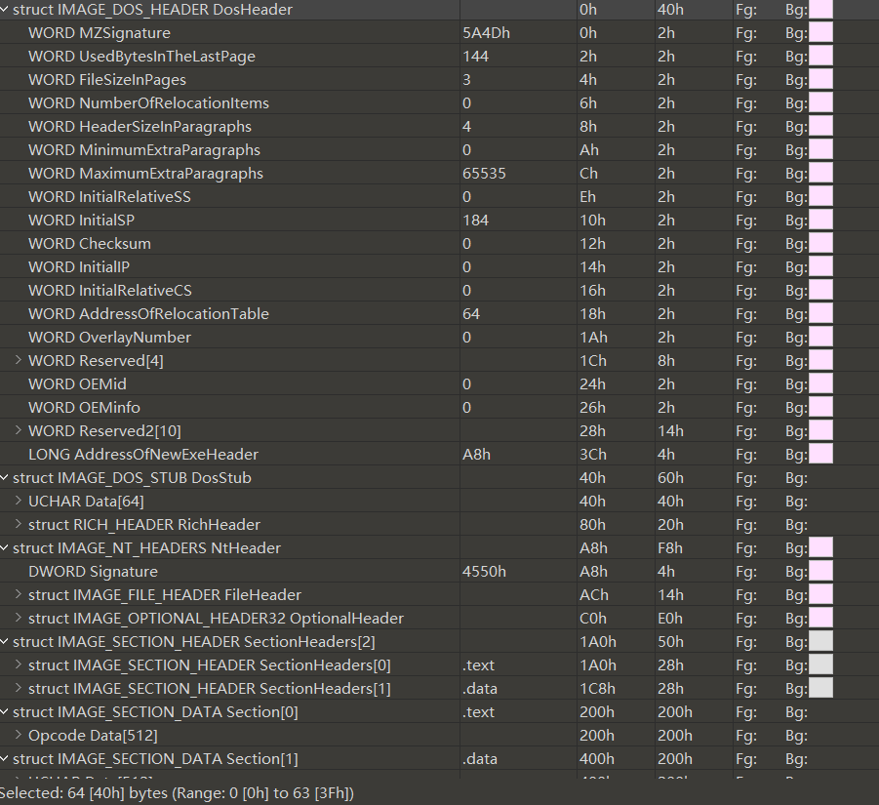
- 读取其中一个PE，解析并列举文件头中的AddressOfEntryPoint、ImageBase、SectionAlignment、FileAlignment、NumberOfSections；

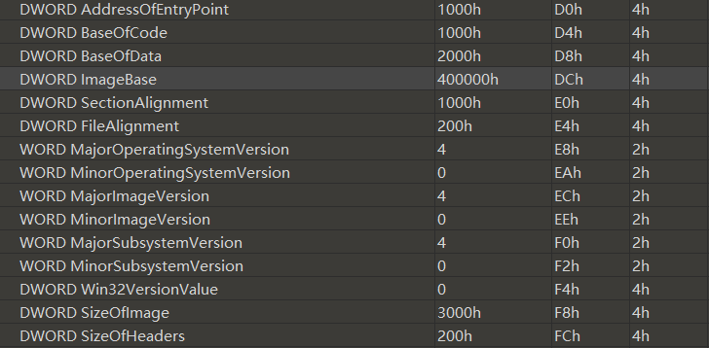
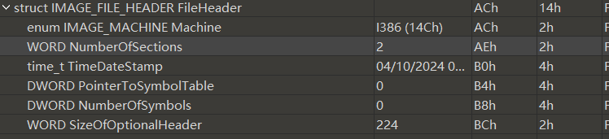
AddressOfEntryPoint | 1000h
ImageBase | 400000h
SectionAlignment | 1000h
FileAlignment | 200h
NumberOfSections | 2
代码读取PE文件解析并列举文件头中的AddressOfEntryPoint、ImageBase、SectionAlignment、FileAlignment、NumberOfSections的结果截图请见3）中；
- 解析并列举每个节的Name、VirtualSize、VirtualAddress、SizeOfRawData、PointerToRawData、Characteristics；
读取每个节Name、VirtualSize、VirtualAddress、SizeOfRawData、PointerToRawData，以便后面验证使用：
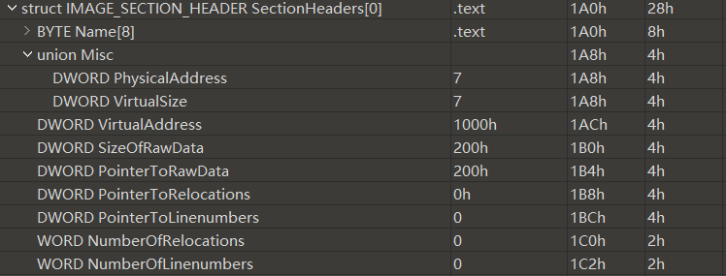
Name | .text
VirtualSize | 7
VirtualAddress | 1000h
SizeOfRawData | 200h
PointerToRawData | 200h

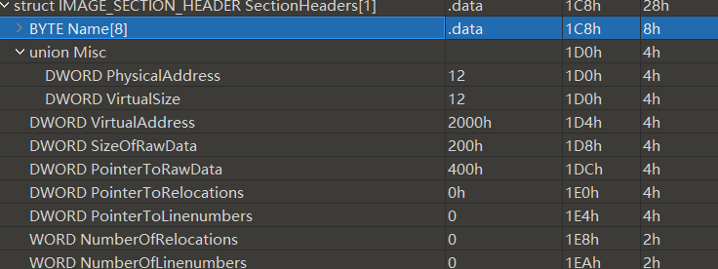
Name | .data
VirtualSize | 12
VirtualAddress | 2000h
SizeOfRawData | 200h
PointerToRawData | 400h

如图所示，可以看到根目录下的exe文件，在本次实验中选取QQ.exe作为读取的PE文件目标；
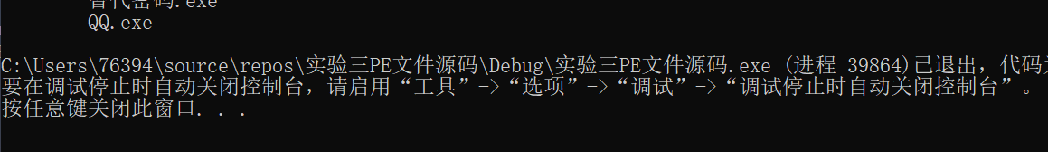
运行代码读取PE解析并列举文件头中的AddressOfEntryPoint、ImageBase、SectionAlignment、FileAlignment、NumberOfSections和列举每个节的Name、VirtualSize、VirtualAddress、SizeOfRawData、PointerToRawData、Characteristics，验证相关文件头的属性，以及所有节表的详细信息：
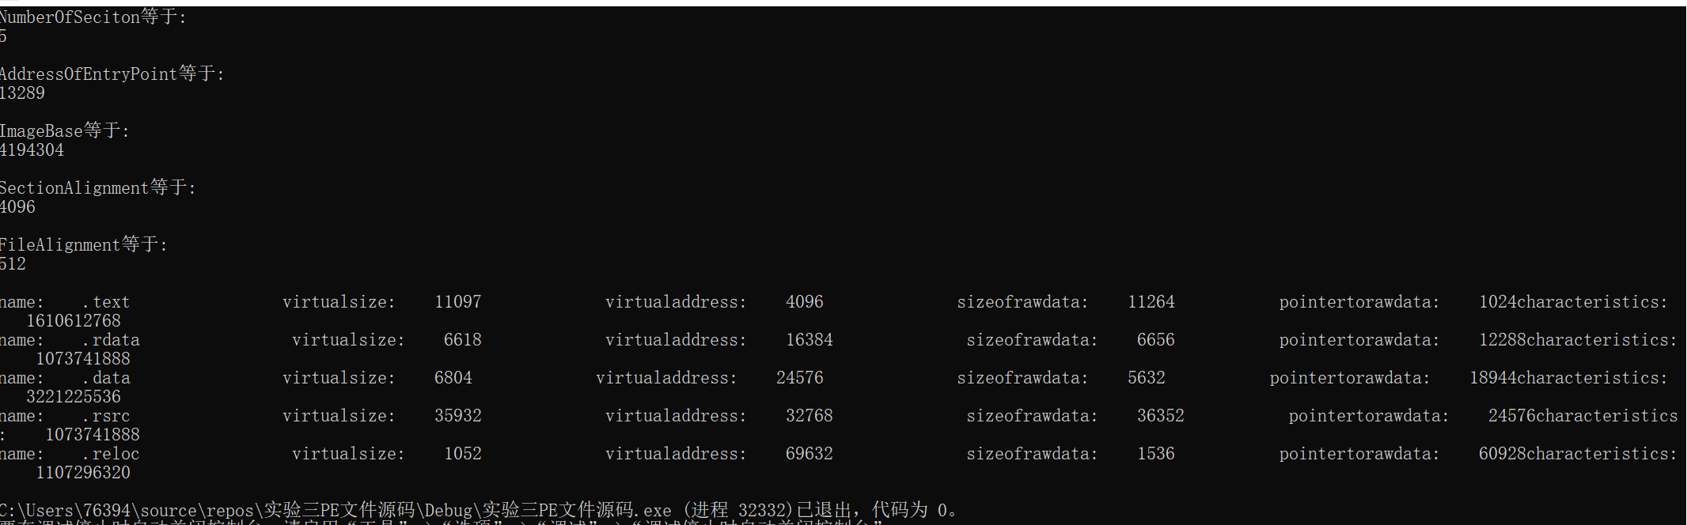
- 将该PE文件的.text节内容写入该文件系统下的隐藏扇区中。
将text节的内容写入物理磁盘E中，text节的内容成功的被写到了该物理磁盘的第二个扇区：
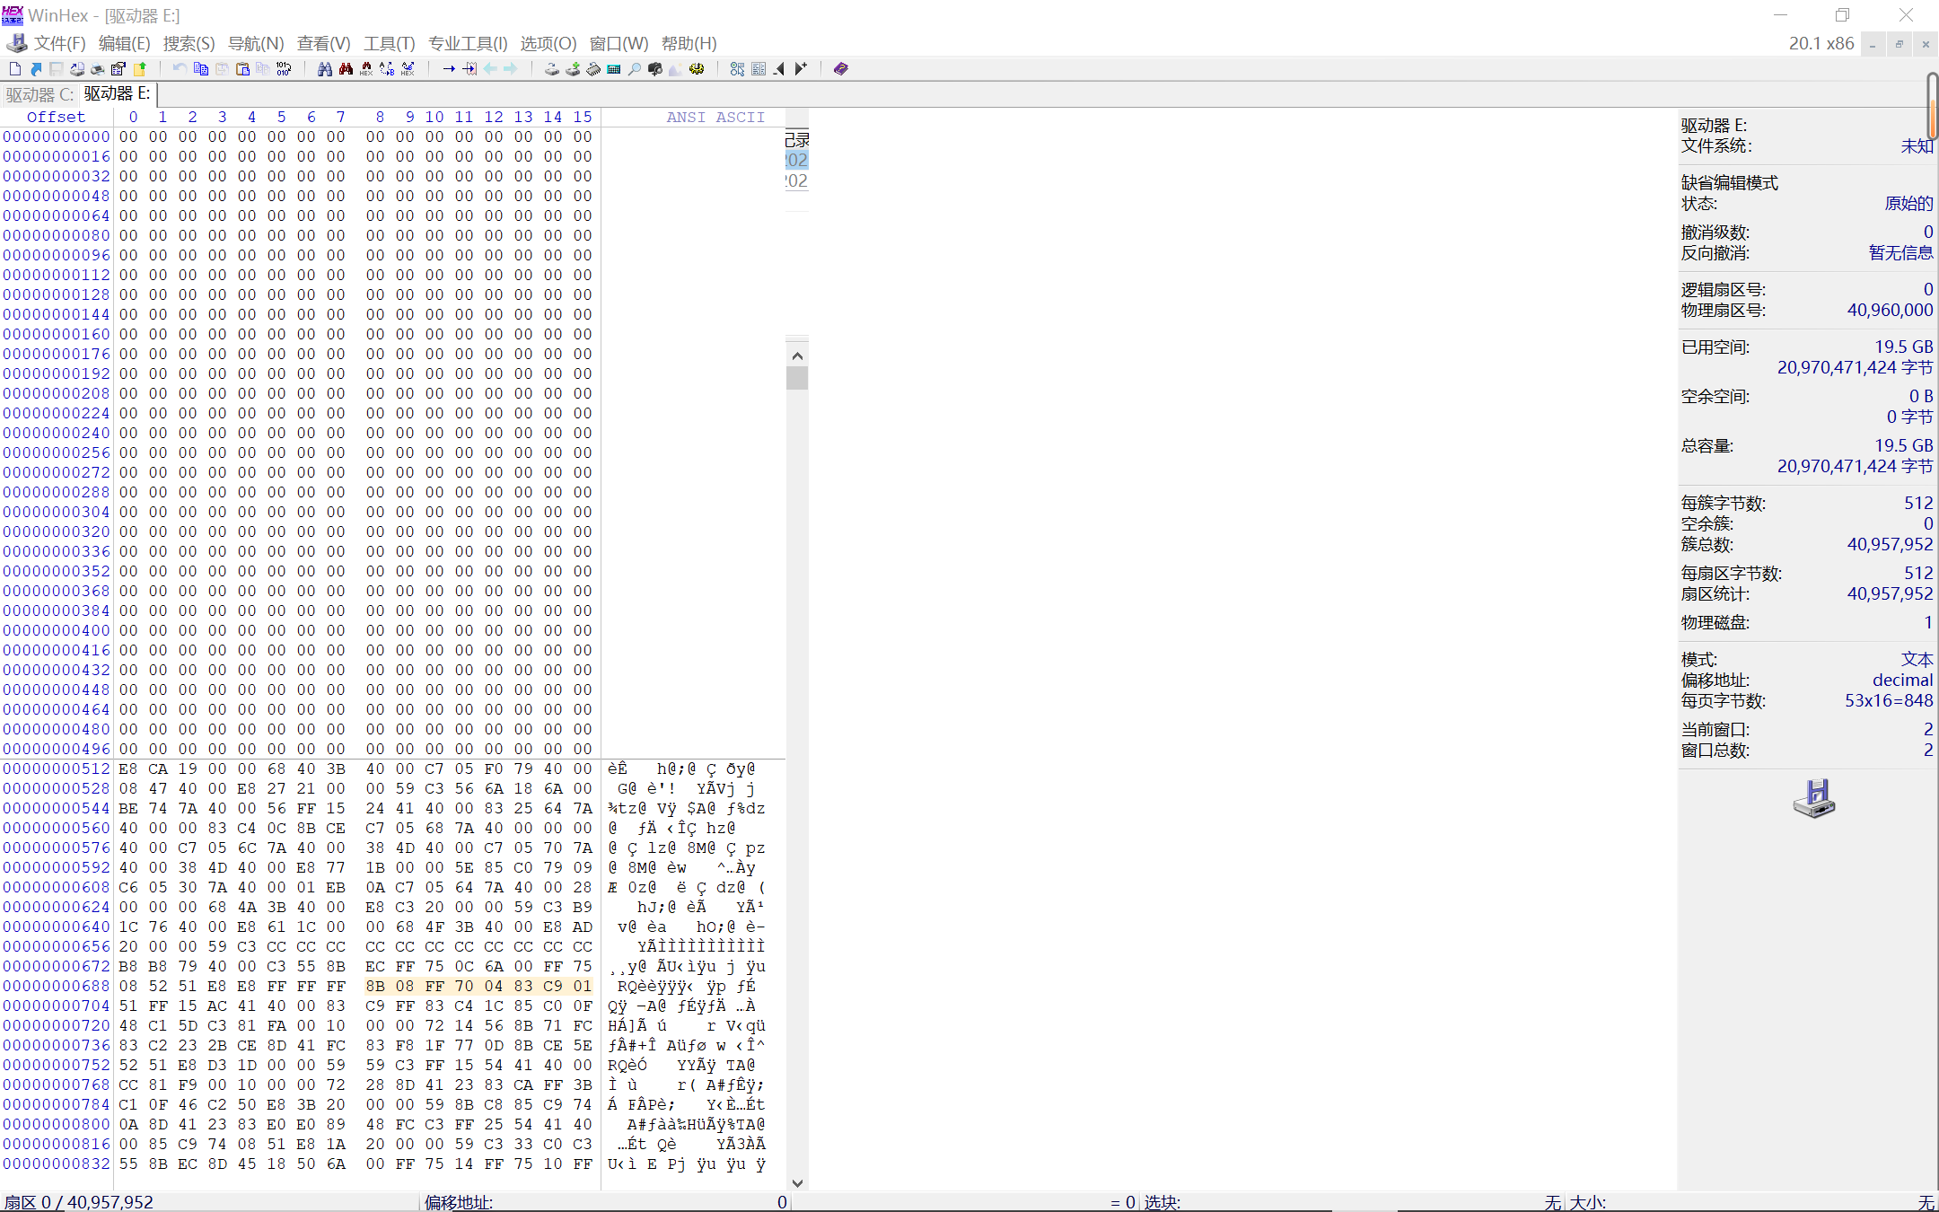
- 节表免疫
节表免疫的工作原理是将节表项目下移至.text内容的前面，然后修改optionHeader的大小，大小为原来的大小加上节表项偏移的大小。
运行前节表免疫代码前截图如下：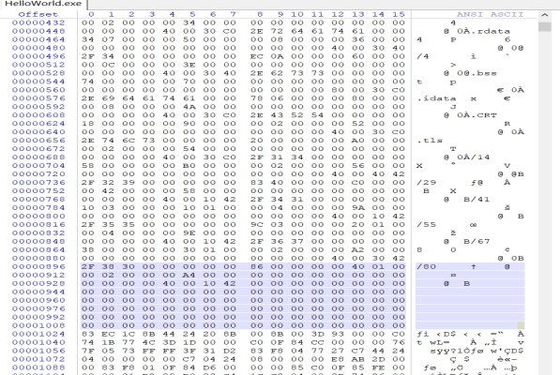
由图可知，节表距离第一个数据区有一定的空闲空间。
运行后节表免疫代码前截图如下：
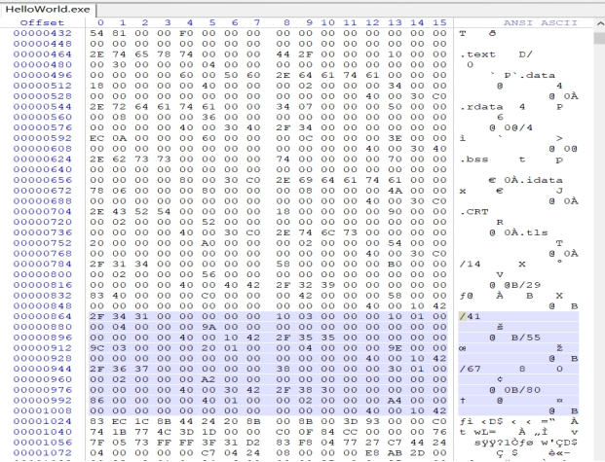
由图可知，剩余空间被填满。
- 节间免疫
节间免疫的思想很简单，就只需要将每个节表的virtualSize修改为文件对齐大小。
对virtualsize值进行修改，修改后部分节表内容：
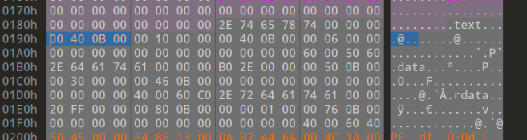
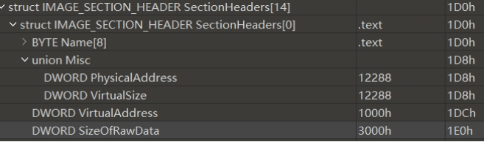
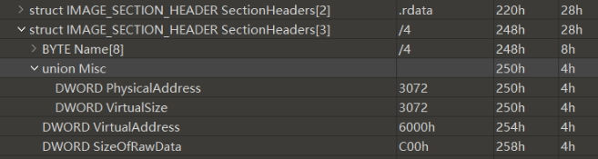
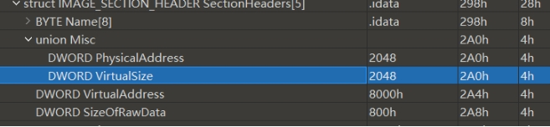
可知，节表的virtualsize值修与为sizeofrowdata值一致实现节间免疫。
- 编程实现
对应源代码及其相应解释已经放在三、实验过程或算法（源程序）中，这里不再赘述。
这里仅放上部分代码截图，如下图所示：

