《数据库系统》实验报告

年级、专业、班级 |  |  |  |  | 姓名
实验题目 | 数据库设计与应用
实验时间 | 2024.3.26～2024.4.14 |  | 实验地点 | DS33401
实验成绩 |  |  | 实验性质 | □验证性 □设计性 ■综合性
教师评价：
□算法/实验过程正确； □源程序/实验内容提交 □程序结构/实验步骤合理；
□实验结果正确； □语法、语义正确； □报告规范；
其他：
评价教师签名：
一、实验目的
1. 了解数据库系统的开发过程。
2. 掌握概念模型设计的方法和步骤。
3. 掌握SQL基本操作。
4. 学习并掌握多条件查询和多表查询。

- 实验项目内容

1.为了更好的为游客服务，某平台准备开发一个民宿预定系统，请进行充分的资料查询、调研，该为民宿预定系统设计并实现一个合理的数据库解决方案，包括：概念模型、逻辑数据模型，并使用SQL完成数据库表创建、数据的添加。
2.基本SQL操作，基于1数据库表，进行如下操作：
1）创建的各表需要添加至少5条记录;
2）将民宿“壹号民宿”的房间编号为“101”的面积由原来的100平方米修改为150平方米;
- 删除民宿“十号民宿”的房间。
3.数据查询
1）找出“壹号民宿”所有房间类型和单价；
- 列出所有可预定的民宿名称（不重复）；
- 查询游客“张三”预定的房间信息；
- 查询“壹号民宿”单价在300和500之间的房间信息。
- 查询每一个民宿拥有的房间数量。
- 查询总费用在1000以上的预定订单信息。
- 查询“壹号民宿”房间的平均单价。
- 查询平均单价在500和800之间的民宿名称和平均单价。
4. 为民宿创建一个触发器，当删除某一民宿时，同时删除该民宿的所有房间信息。
5.定义一存储过程，实现查询目前可预订的民宿和房间信息。并调用进行测试。

- 实验过程或算法（源程序）
1.设计
1）概念模型设计
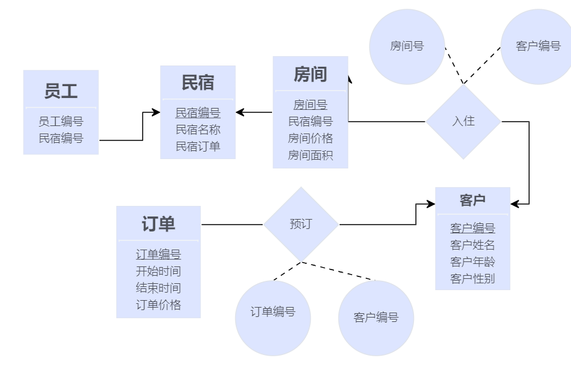

2）关系模型
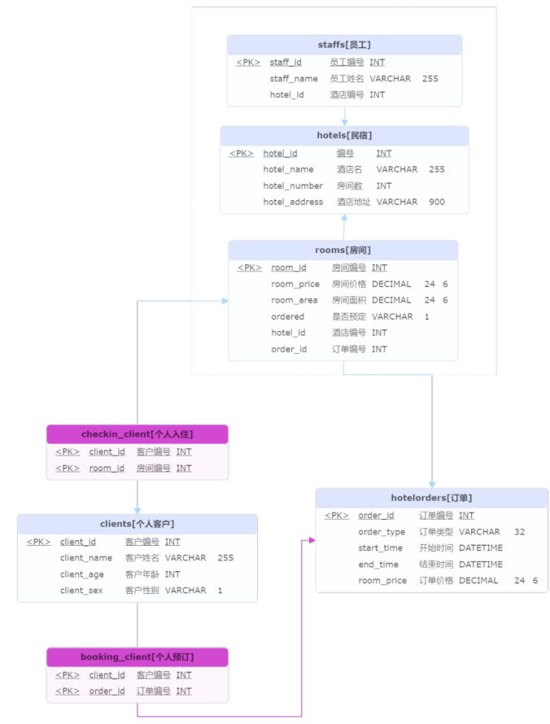

3）数据库表创建
DROP TABLE IF EXISTS booking_client;
DROP TABLE IF EXISTS booking_team;
DROP TABLE IF EXISTS checkin_client;
DROP TABLE IF EXISTS checkin_team;
DROP TABLE IF EXISTS clients;
DROP TABLE IF EXISTS staffs;
DROP TABLE IF EXISTS rooms;
DROP TABLE IF EXISTS hotels;
DROP TABLE IF EXISTS teams;
DROP TABLE IF EXISTS hotelorders;
CREATE TABLE hotels
(
hotel_id INT AUTO_INCREMENT COMMENT '编号',
hotel_name VARCHAR(255) NOT NULL COMMENT '酒店名',
hotel_number INT NOT NULL COMMENT '房间数',
hotel_address VARCHAR(900) NOT NULL COMMENT '酒店地址',
PRIMARY KEY (hotel_id)
) COMMENT = '民宿;';
CREATE TABLE clients
(
client_id INT AUTO_INCREMENT COMMENT '客户编号',
client_name VARCHAR(255) COMMENT '客户姓名',
client_age INT COMMENT '客户年龄',
client_sex VARCHAR(1) COMMENT '客户性别',
PRIMARY KEY (client_id)
) COMMENT = '个人客户';
CREATE TABLE hotelorders
(
order_id INT AUTO_INCREMENT COMMENT '订单编号',
order_type VARCHAR(32) COMMENT '订单类型',
start_time DATETIME COMMENT '开始时间',
end_time DATETIME COMMENT '结束时间',
order_price DECIMAL(24, 6) COMMENT '订单价格',
PRIMARY KEY (order_id)
) COMMENT = '订单';
CREATE TABLE rooms
(
room_id INT AUTO_INCREMENT COMMENT '房间编号',
room_type VARCHAR(32) NOT NULL COMMENT '房间类型',
room_price DECIMAL(24, 6) NOT NULL COMMENT '房间价格',
room_area DECIMAL(24, 6) COMMENT '房间面积',
ordered VARCHAR(1) NOT NULL default 0 COMMENT '是否预定',
hotel_id INT NOT NULL COMMENT '酒店编号;外键',
order_id INT COMMENT '订单编号;外键',
PRIMARY KEY (room_id),
#FOREIGN KEY (order_id) REFERENCES hotelorders (order_id),
FOREIGN KEY (hotel_id) REFERENCES hotels (hotel_id)
) COMMENT = '房间';
CREATE TABLE staffs
(
staff_id INT AUTO_INCREMENT COMMENT '员工编号',
staff_name VARCHAR(255) NOT NULL COMMENT '员工姓名',
hotel_id INT COMMENT '酒店编号;外键',
PRIMARY KEY (staff_id),
FOREIGN KEY (hotel_id) REFERENCES hotels (hotel_id)
) COMMENT = '员工';
CREATE TABLE booking_client
(
client_id INT NOT NULL COMMENT '客户编号',
order_id INT NOT NULL COMMENT '订单编号',
PRIMARY KEY (client_id, order_id),
FOREIGN KEY (client_id) REFERENCES clients (client_id),
FOREIGN KEY (order_id) REFERENCES hotelorders (order_id)
) COMMENT = '个人预订';
CREATE TABLE checkin_client
(
client_id INT NOT NULL COMMENT '客户编号',
room_id INT NOT NULL COMMENT '房间编号',
PRIMARY KEY (client_id, room_id),
FOREIGN KEY (client_id) REFERENCES clients (client_id),
FOREIGN KEY (room_id) REFERENCES rooms (room_id)
) COMMENT = '个人入住';

- 数据添加
INSERT INTO hotels (hotel_name, hotel_number, hotel_address)
VALUES ('壹号民宿', '3', '虎溪'),
('二号民宿', '3', '重庆'),
('三号民宿', '3', '沙坪坝'),
('四号民宿', '3', '重庆大学'),
('十号民宿', '3', '重庆大学'),
('五号民宿', '3', '西街');
INSERT INTO hotelorders (start_time, end_time)
VALUES ('2023-01-01 15:00:00', '2023-01-02 12:00:00'),
('2023-02-10 18:00:00', '2023-02-12 14:00:00'),
('2023-03-15 09:00:00', '2023-03-22 11:00:00'),
('2023-04-25 08:00:00', '2023-04-27 17:00:00'),
('2023-05-12 19:00:00', '2023-05-15 11:00:00'),
('2023-06-01 10:00:00', '2023-06-03 16:00:00'),
('2023-07-10 14:00:00', '2023-07-12 10:00:00'),
('2023-08-15 07:00:00', '2023-08-20 19:00:00'),
('2023-09-22 12:00:00', '2023-09-25 06:00:00'),
('2023-10-01 00:00:00', '2023-10-07 23:59:59');
INSERT INTO rooms (room_type, room_price, room_area, hotel_id, order_id,ordered)
VALUES (1, 50 + rand() * 100, 10, 1, 10,1),
(1, 50 + rand() * 100, 10, 2, 9,1),
(1, 50 + rand() * 100, 10, 3, 8,1),
(1, 50 + rand() * 100, 10, 4, 7,1),
(1, 50 + rand() * 100, 10, 5, 6,1),
(2, 50 + rand() * 100, 20, 1, 5,1),
(2, 50 + rand() * 100, 20, 2, 4,1),
(2, 50 + rand() * 100, 20, 3, 3,1),
(2, 50 + rand() * 100, 20, 4, 2,1),
(2, 50 + rand() * 100, 20, 5, 1,1),
(3, 50 + rand() * 100, 30, 1,NULL,0),
(3, 50 + rand() * 100, 30, 2,NULL,0),
(3, 50 + rand() * 100, 30, 3,NULL,0),
(3, 50 + rand() * 100, 30, 4,NULL,0),
(3, 50 + rand() * 100, 30, 5,NULL,0);
INSERT INTO clients (client_name, client_age, client_sex)
VALUES ('张三', 5 + floor(rand() * 30), FLOOR(RAND() * 2)),
('李四', 5 + floor(rand() * 30), FLOOR(RAND() * 2)),
('王五', 5 + floor(rand() * 30), FLOOR(RAND() * 2)),
('王麻子', 5 + floor(rand() * 30), FLOOR(RAND() * 2)),
('张四', 5 + floor(rand() * 30), FLOOR(RAND() * 2)),
('李五', 5 + floor(rand() * 30), FLOOR(RAND() * 2)),
('王八', 5 + floor(rand() * 30), FLOOR(RAND() * 2)),
('琴九', 5 + floor(rand() * 30), FLOOR(RAND() * 2)),
('柯南', 5 + floor(rand() * 30), FLOOR(RAND() * 2)),
('道夫', 5 + floor(rand() * 30), FLOOR(RAND() * 2));
INSERT INTO checkin_client (client_id, room_id)
VALUES (1, 2),
(2, 3),
(3, 4),
(4, 5),
(5, 6),
(6, 7),
(7, 8),
(8, 9),
(9, 10),
(10, 1);
INSERT INTO booking_client (client_id, order_id)
VALUES (1, 2),
(2, 3),
(3, 4),
(4, 5),
(5, 6),
(6, 7),
(7, 8),
(8, 9),
(9, 10),
(10, 1);

2.基本SQL操作
（1）创建的各表需要添加至少5条记录;
（前面已进行过添加，这里进行补充）
insert into staffs (staff_id,staff_name,hotel_id)
values
(1,'贾三',1),
(2,'贾四',1),
(3,'甄九',2),
(4,'甄八',3),
(5,'莉莉',4),
(6,'鲍勃',6);

（2）将民宿“壹号民宿”的房间编号为“1”的面积由原来的100平方米修改为150平方米;
UPDATE rooms SET room_area = 150 WHERE room_id = 1 AND hotel_id = (SELECT hotel_id FROM hotels WHERE hotel_name = '壹号民宿');

（3）删除民宿“十号民宿”的房间。
DELETE FROM rooms WHERE hotel_id = (SELECT hotel_id FROM hotels WHERE hotel_name = '十号民宿');

- 数据查询
- 找出“壹号民宿”所有房间类型和单价
SELECT room_type, room_price FROM rooms WHERE hotel_id = (SELECT hotel_id FROM hotels WHERE hotel_name = '壹号民宿');
- 列出所有可预定的民宿名称（不重复）
SELECT DISTINCT hotel_name FROM hotels WHERE hotel_id IN (SELECT hotel_id FROM rooms WHERE ordered = '0');
（3）查询游客“张三”预定的房间信息
SELECT * FROM rooms WHERE order_id IN (SELECT order_id FROM hotelorders WHERE order_id IN (SELECT order_id FROM booking_client WHERE client_id = (SELECT client_id FROM clients WHERE client_name = '张三')));

（4）查询“壹号民宿”单价在300和500之间的房间信息
SELECT * FROM rooms WHERE hotel_id = (SELECT hotel_id FROM hotels WHERE hotel_name = '壹号民宿') AND room_price BETWEEN 300 AND 500;

（5）查询每一个民宿拥有的房间数量
SELECT hotel_name, COUNT(*) AS room_count FROM hotels JOIN rooms ON hotels.hotel_id = rooms.hotel_id GROUP BY hotel_name;

（6）查询总费用在1000以上的预定订单信息
SELECT * FROM hotelorders WHERE (SELECT SUM(room_price) FROM rooms WHERE rooms.order_id = hotelorders.order_id) > 1000;

（7）查询“壹号民宿”房间的平均单价
SELECT AVG(room_price) AS average_price FROM rooms WHERE hotel_id = (SELECT hotel_id FROM hotels WHERE hotel_name = '壹号民宿');

（8）查询平均单价在500和800之间的民宿名称和平均单价
SELECT hotel_name, AVG(room_price) AS average_price FROM hotels JOIN rooms ON hotels.hotel_id = rooms.hotel_id GROUP BY hotel_name HAVING AVG(room_price) BETWEEN 500 AND 800;

- 触发器
create trigger delete_trigger
after delete on hotels
for each row
delete from rooms where hotel_id = old.hotel_id;

- 存储过程
DELIMITER //
create procedure CHECKING1()
BEGIN
select *from(select * from rooms where ordered='0') as subquery
natural join hotels;
END //
DELIMITER ;

call CHECKING1();

- 实验结果及分析和（或）源程序调试过程

1.数据库表创建后的结果
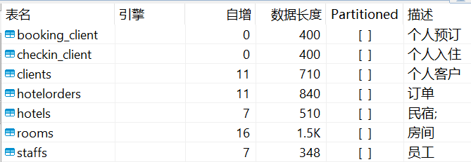

2.数据添加结果
添加记录
（1）booking_client
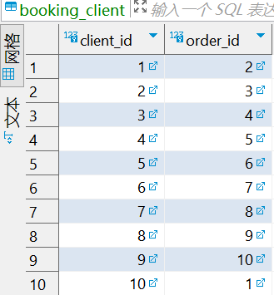
（2）checkin_client
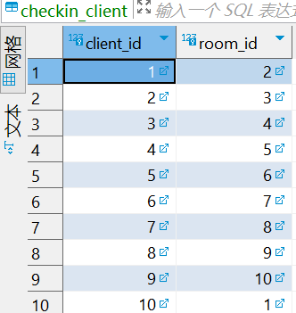
（3）clients
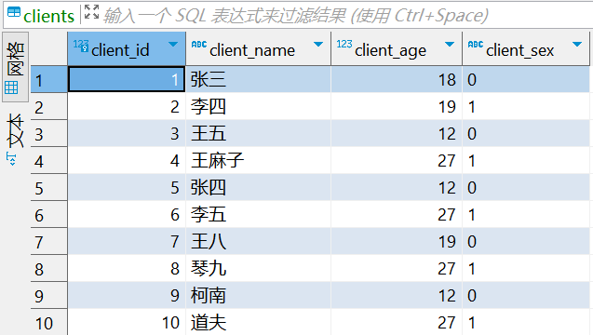
（4）hotelorders
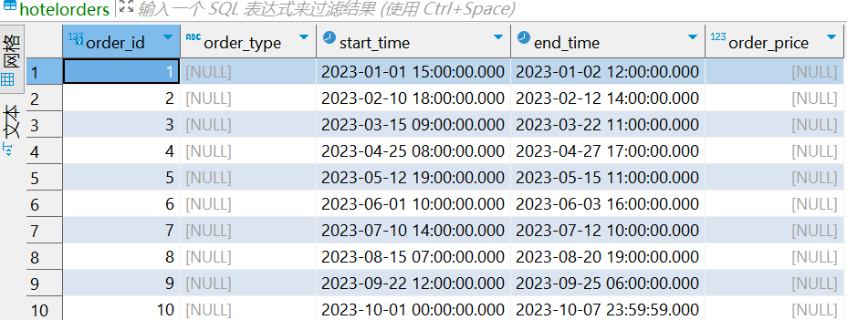
（5）hotels
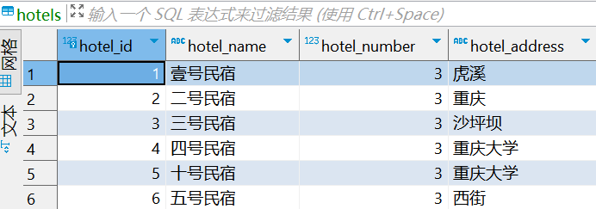
（6）rooms
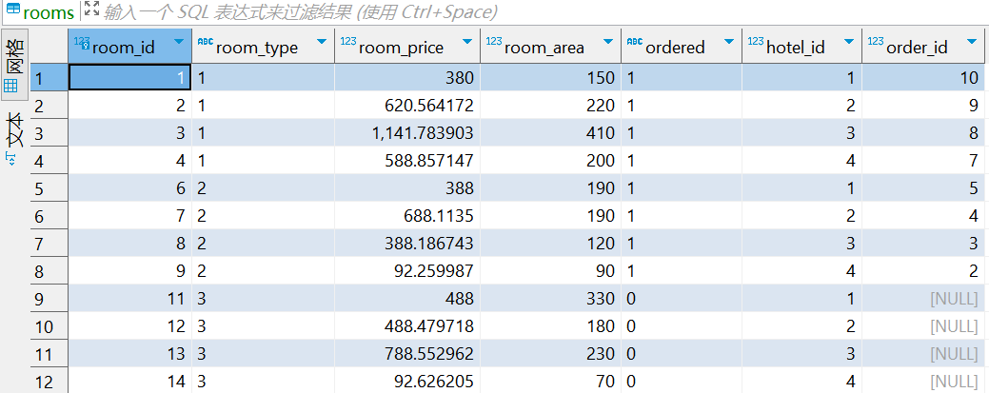
（7）staffs
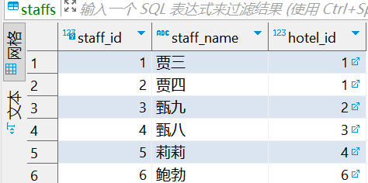

3.基本SQL结果
（1）将民宿“壹号民宿”的房间编号为“1”的面积由原来的100平方米修改为150平方米;
UPDATE rooms SET room_area = 150 WHERE room_id = 1 AND hotel_id = (SELECT hotel_id FROM hotels WHERE hotel_name = '壹号民宿');
修改前：
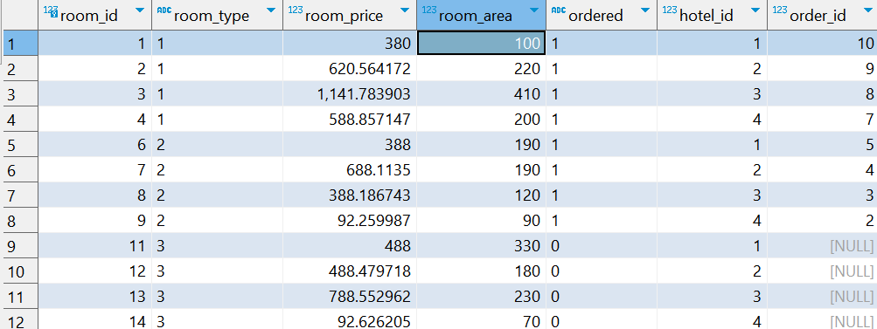
修改后：
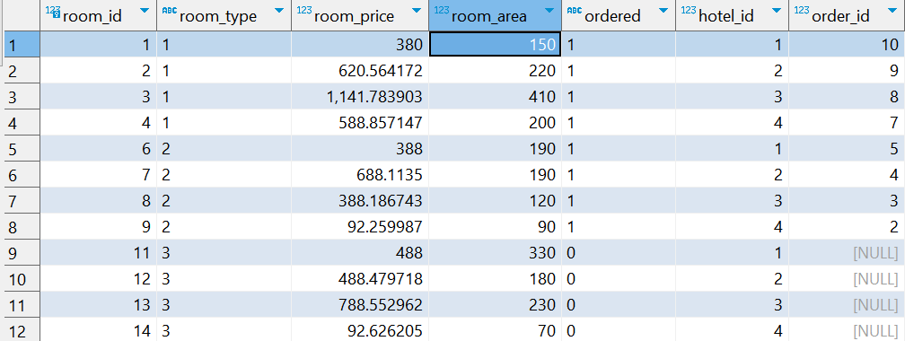

（2）删除民宿“十号民宿”的房间。
DELETE FROM rooms WHERE hotel_id = (SELECT hotel_id FROM hotels WHERE hotel_name = '十号民宿');
删除前：（十号民宿对应的hotel_id=5）
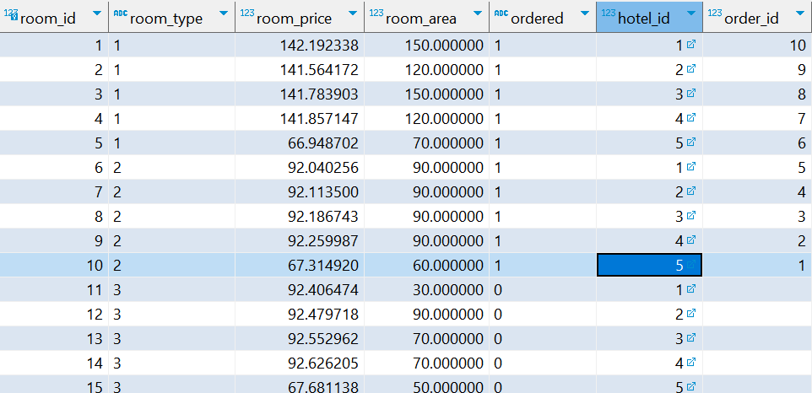
删除后：
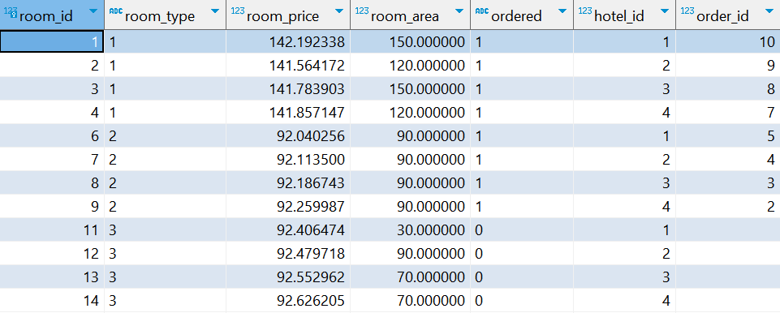

4.数据查询结果
（1）找出“壹号民宿”所有房间类型和单价
SELECT room_type, room_price FROM rooms WHERE hotel_id = (SELECT hotel_id FROM hotels WHERE hotel_name = '壹号民宿');
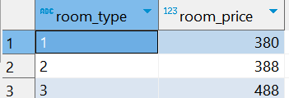

（2）列出所有可预定的民宿名称（不重复）
SELECT DISTINCT hotel_name FROM hotels WHERE hotel_id IN (SELECT hotel_id FROM rooms WHERE ordered = '0'); 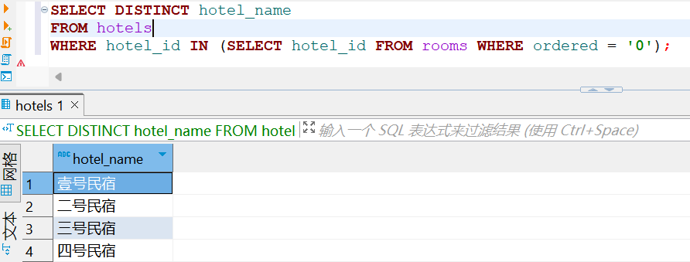

（3）查询游客“张三”预定的房间信息
SELECT * FROM rooms WHERE order_id IN (SELECT order_id FROM hotelorders WHERE order_id IN (SELECT order_id FROM booking_client WHERE client_id = (SELECT client_id FROM clients WHERE client_name = '张三')));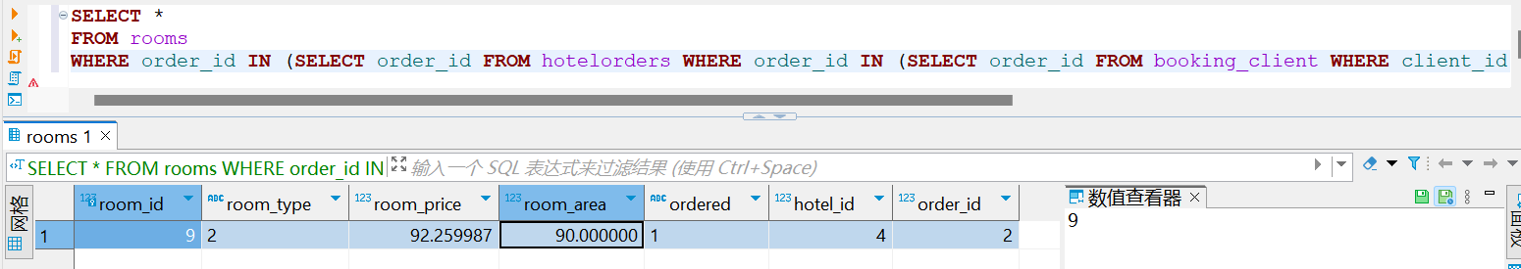

（4）查询“壹号民宿”单价在300和500之间的房间信息
SELECT * FROM rooms WHERE hotel_id = (SELECT hotel_id FROM hotels WHERE hotel_name = '壹号民宿') AND room_price BETWEEN 300 AND 500;
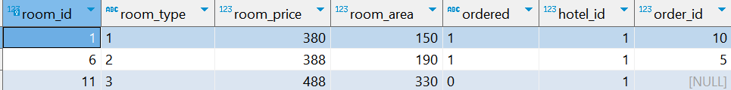

（5）查询每一个民宿拥有的房间数量
SELECT hotel_name, COUNT(*) AS room_count FROM hotels JOIN rooms ON hotels.hotel_id = rooms.hotel_id GROUP BY hotel_name; 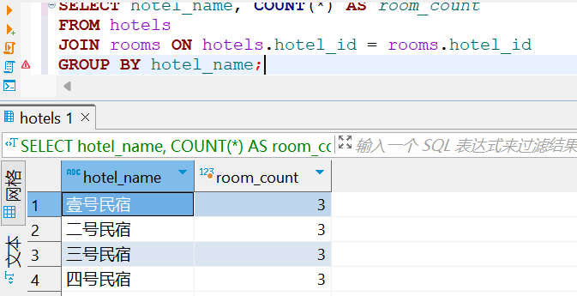

（6）查询总费用在1000以上的预定订单信息
SELECT * FROM hotelorders WHERE (SELECT SUM(room_price) FROM rooms WHERE rooms.order_id = hotelorders.order_id) > 1000; 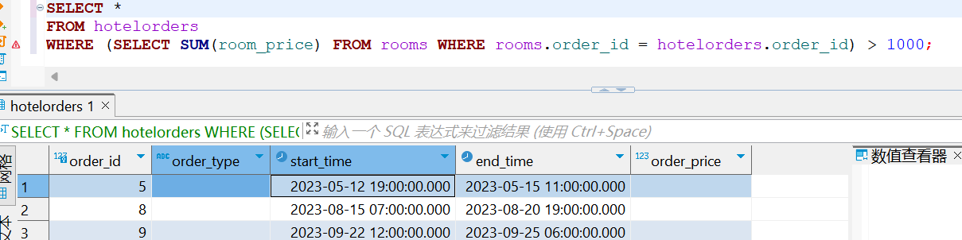

（7）查询“壹号民宿”房间的平均单价
SELECT AVG(room_price) AS average_price FROM rooms WHERE hotel_id = (SELECT hotel_id FROM hotels WHERE hotel_name = '壹号民宿');
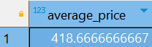

（8）查询平均单价在500和800之间的民宿名称和平均单价
SELECT hotel_name, AVG(room_price) AS average_price FROM hotels JOIN rooms ON hotels.hotel_id = rooms.hotel_id GROUP BY hotel_name HAVING AVG(room_price) BETWEEN 500 AND 800; 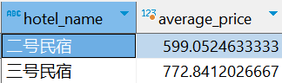

5.触发器触发结果
删除hotel_id为1的民宿
delete from hotels where hotel_id = '1';
删除前：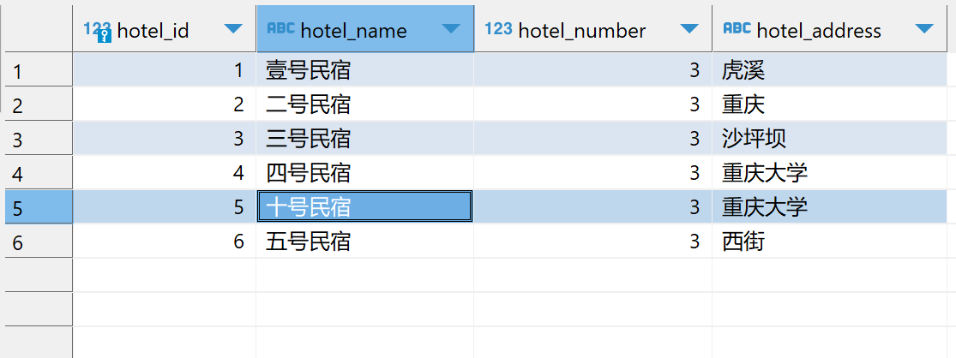
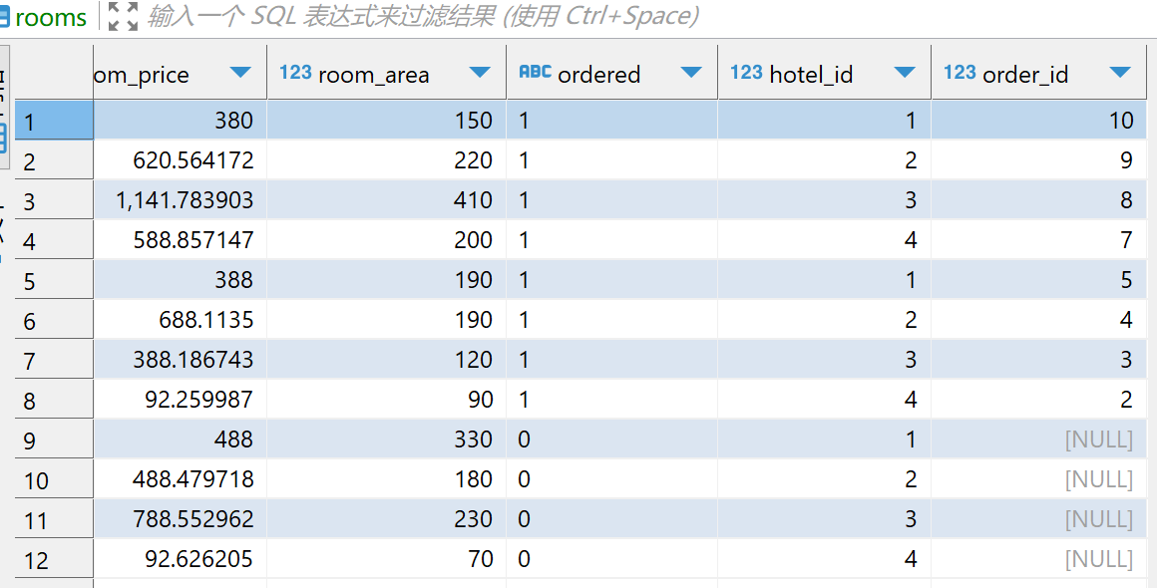
删除后：
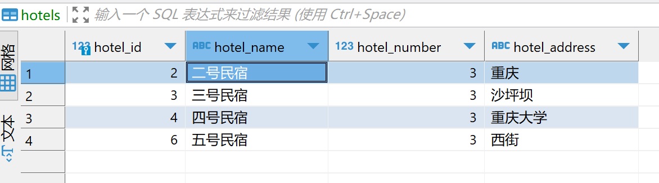
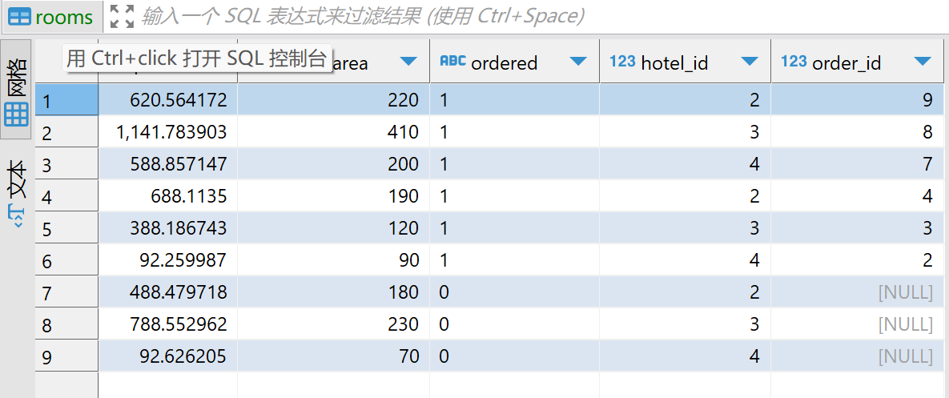

- 存储过程调用结果
