Time series analysis application : BFAST

Open the time series application

* + 1. Go to the processing tools 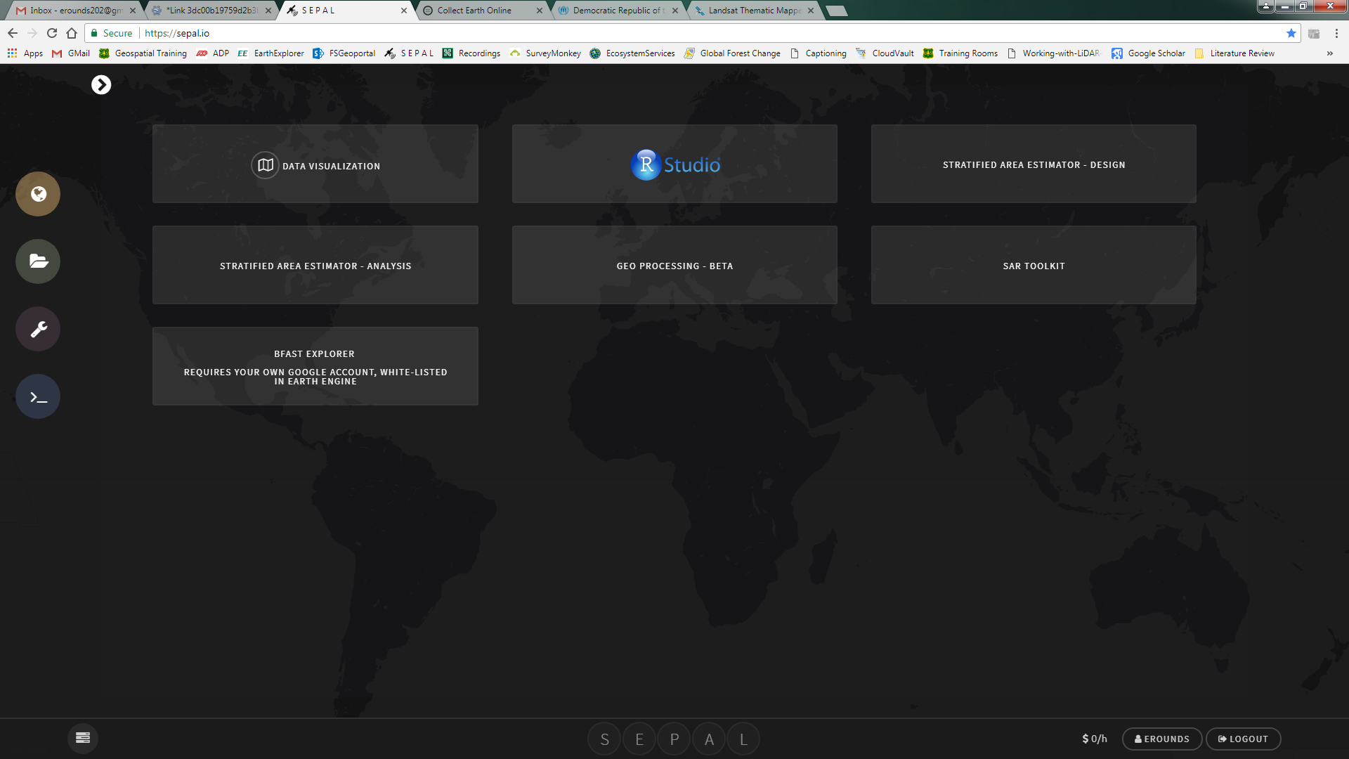
    2. Select **Time series analysis**

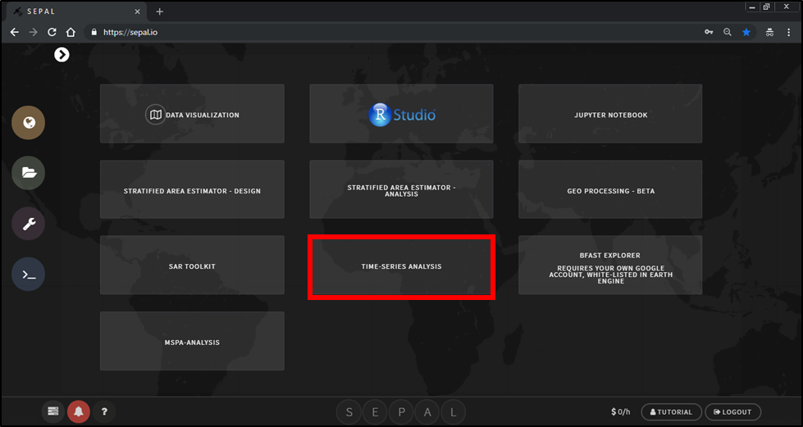

* + 1. The application is split between 2 pages, the introduction and the analysis.
    2. In the introduction section: the welcome, intro to BFAST and parameterization tabs provide additional information about the mechanics of the algorithm. It is recommended to read the text in these tabs.

Note: the application is only available in English at the moment. French and Spanish translations will be updated shortly. If you are interested in translating the application into your own language contact [remi.dannunzio@fao.org](mailto:remi.dannunzio@fao.org) or [yelena.finegold@fao.org](mailto:yelena.finegold@fao.org)

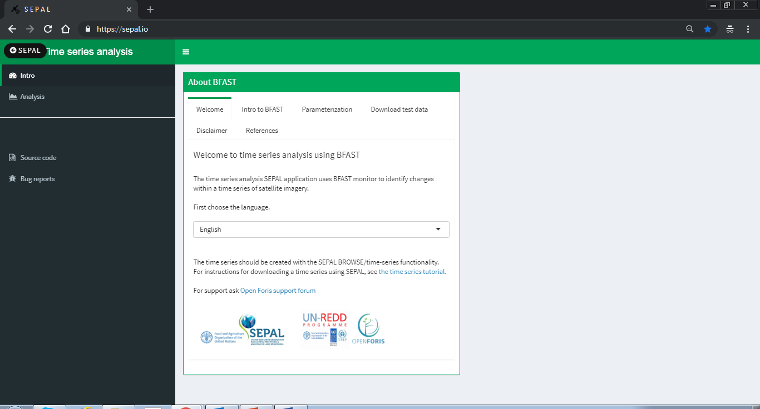

Download the test data set

* + 1. If this is your first time using the time series analysis tool it is recommended that you first try with the example data set.The example data set can be downloaded in the ‘*download test data’* tab.

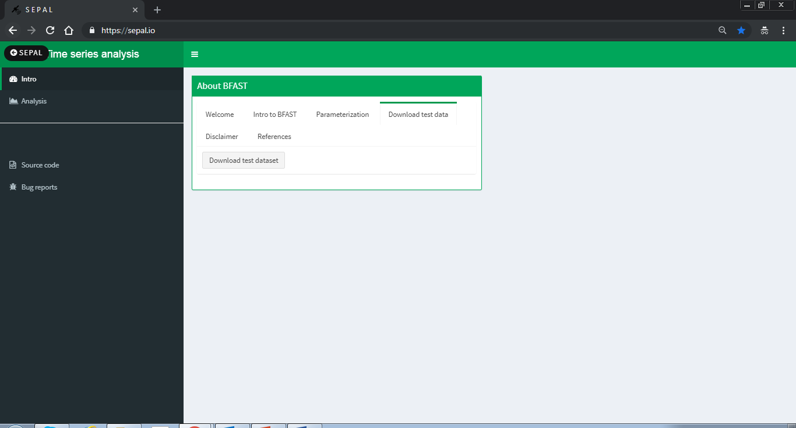

1. Click on the ‘Download test dataset’ button. The data is downloaded into the bfast_data_test folder in your root directory. The file location and information about the download will appear in the bottom right corner.

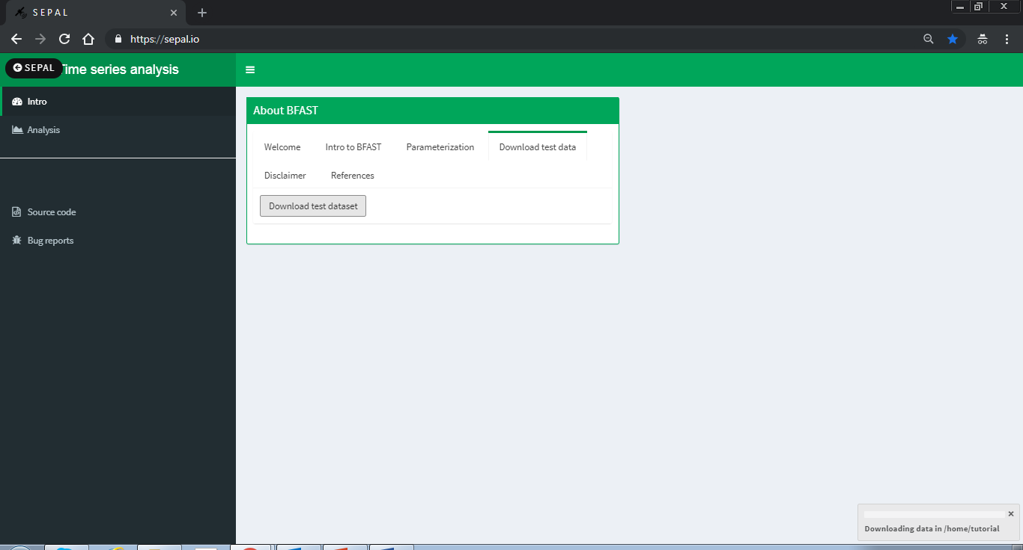

Run time series analysis over your area of interest

* + 1. Click on the Analysis tab in the left column

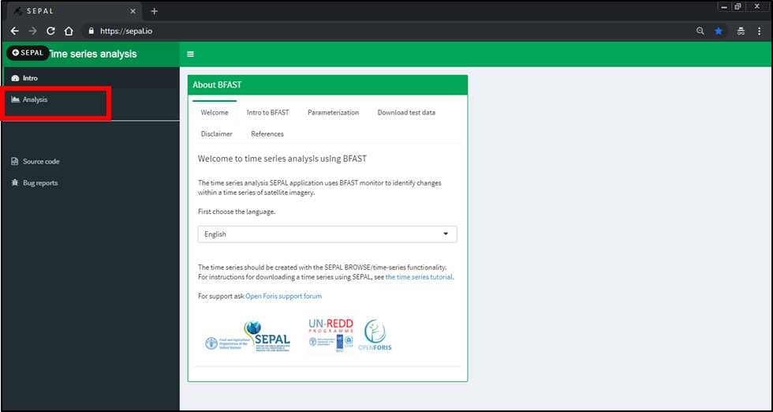

* + 1. First you need to select the time series folder. Click on the Time Series Folder button to navigate to the folder with your downloaded data (either downloaded from the SEPAL search option or the test data set)

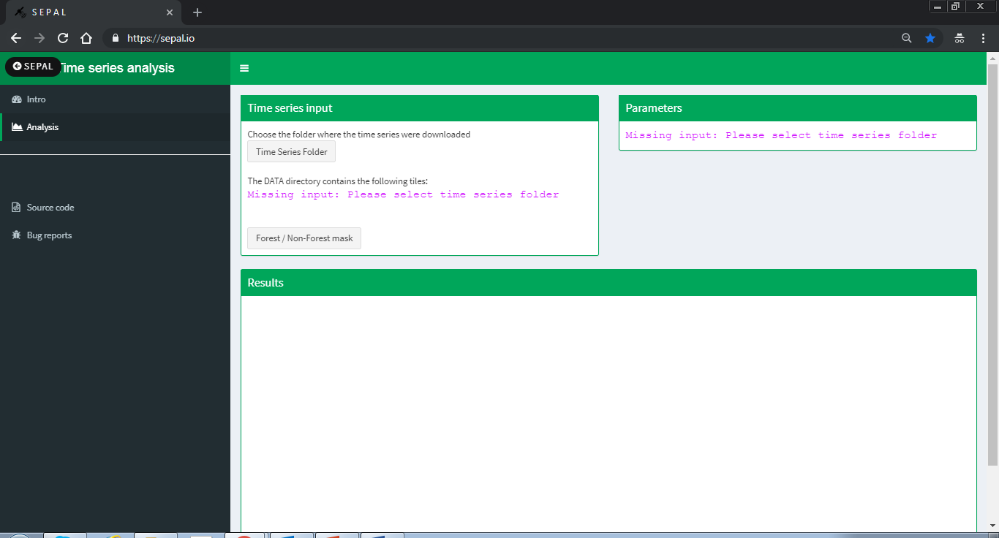

* + 1. The file structure will always be timeseriesdownload/1/. Select the timeseriesdownload and not the numerical folder. In the case of the example dataset, select the bfast_data_test folder which is downloaded in your home drive.

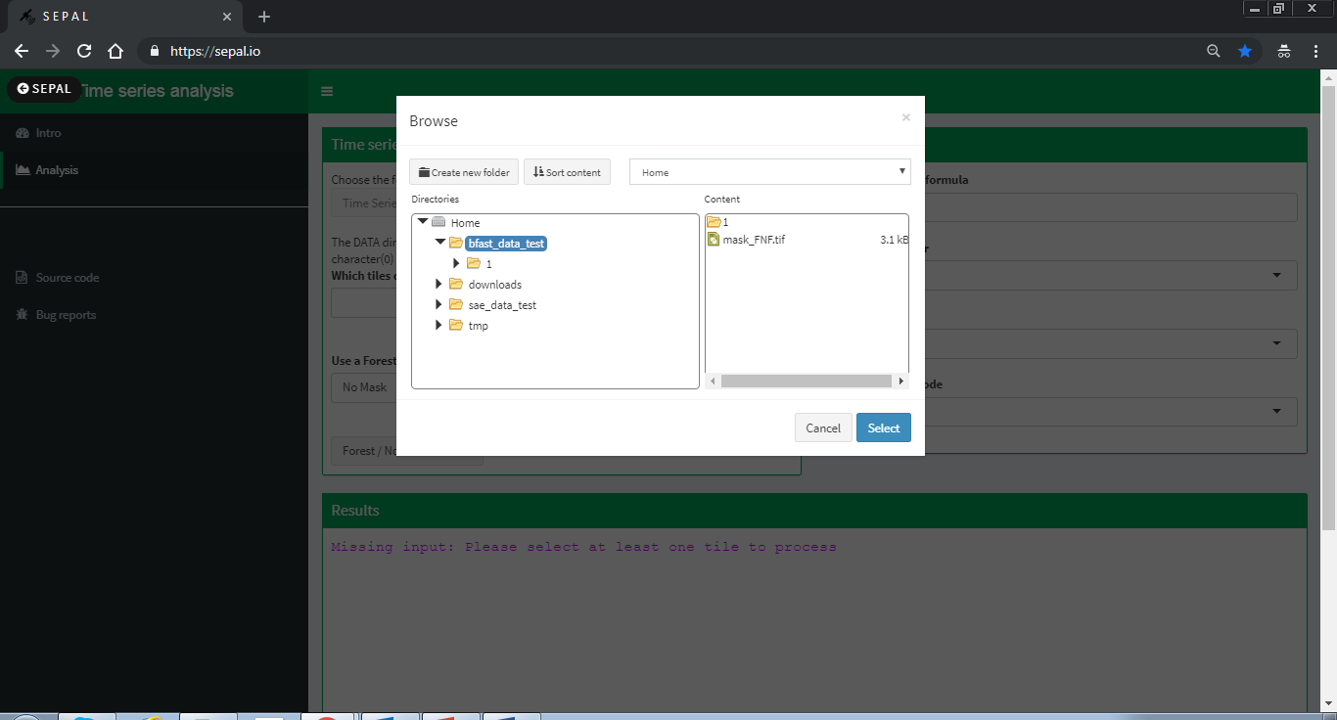

* + 1. There is an option apply a mask and run BFAST only on areas outside the mask. You can select a file with 0 and 1 values. 0 values will be excluded and 1 included in the computation.

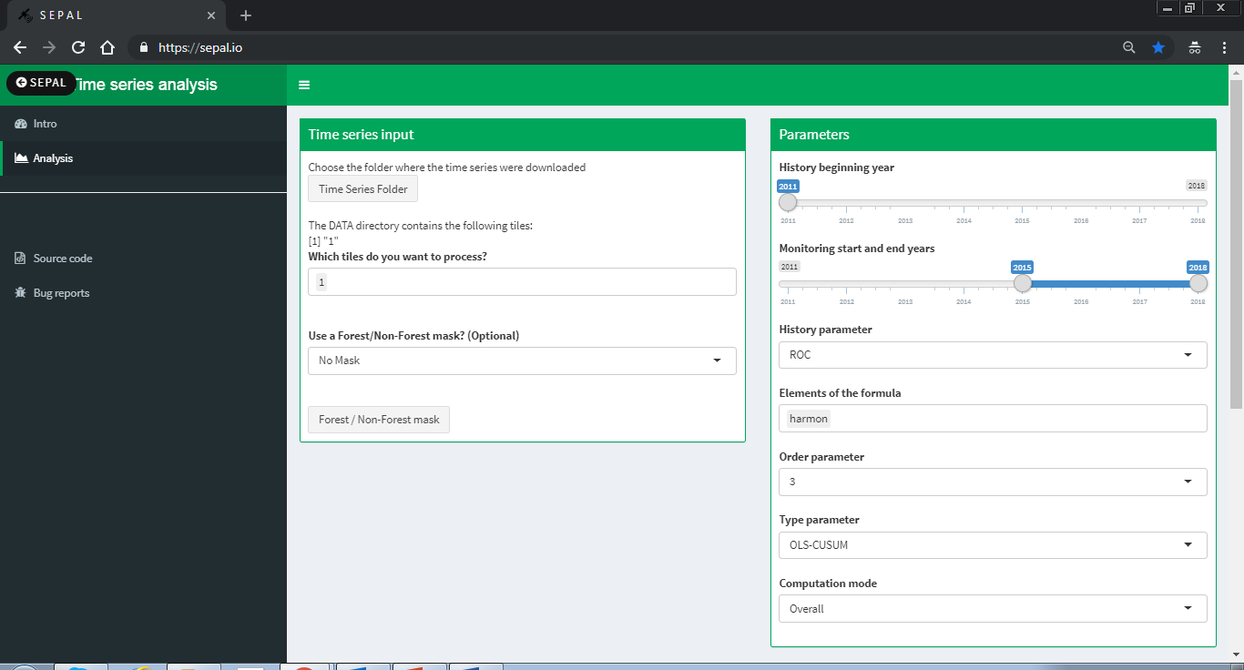

* + - 1. If you would like to use a mask, select **FNF mask** and then select the raster file by clicking on the **forest/non-forest mask** button and navigating to and selected the mask file.

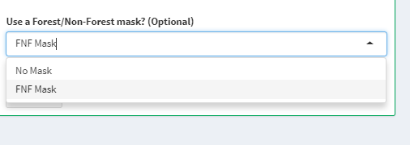

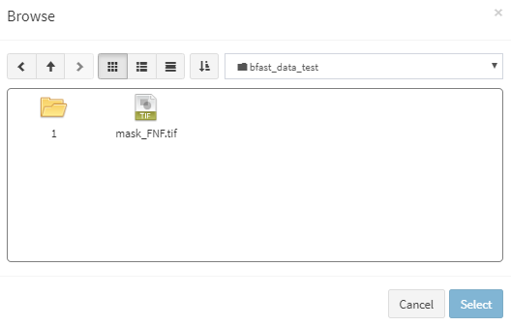

* + 1. Next change the parameters for your study area. If you are not sure which parameters to use follow Exercise 2, where you can run BFAST monitor for 1 pixel to test different parameters. The parameters include:

1. **History beginning year**–The year that marks the start of the historical period. The actual start date will depend on the history parameter chosen.
2. **Monitoring start and end years**–The monitoring start year is the year that marks the end of the historical period and the start of the monitoring period. The monitoring end year marks the end of the monitoring period.
3. **History parameter**–Specifies the start of the stable history period. The options are:
   1. reverse-ordered CUSUM (ROC), looks backward in time, using a stepwise approach, to identify a stable history period
   2. Bai and Perron breakpoint estimation (BP), also identifies a stable history period and can additionally be used to identify disturbances in the history period.
   3. all, uses all available observations.
   4. numeric, i.e., 2011 , the start date can be specified using the year.
4. **Elements of the formula**–The formula describes the type of regression model applied. The options are:
   1. trend + harmon, a linear trend and a harmonic season component
   2. harmon, a harmonic season component
   3. trend, a linear trend
5. **Order parameter**–Specifies the order of the harmonic term, defaulting to 3.
6. **Type parameter** –Specifies the type of monitoring process. For additional documentation on the type parameter see the strucchange package documentation (strucchange package documentation.) The options are:
   1. moving sums of residuals (MOSUM), where residuals are calculated as the difference between expected values and actual observations in a monitoring period based on OLS residuals.
   2. cumulative sum (CUSUM), cumulative sums of standardized residuals (MOSUM uses a moving sum, while CUSUM uses a cumulative of the same residuals)
   3. moving estimates (ME), the moving estimates process is returned
   4. fluctuation, returns the recursive estimates process
7. **Raster band outputs**–Result layers to be returned. Can be any combination of *breakpoint, magnitude, error, history, r.squared, adj.r.squared, coefficients*. By default, *breakpoint, magnitude* and *error* are returned by the function. It is important to know which layers have been requested and in which order they will be exported because the layer names are not specified. Note that if "*coefficients*" is included, the output will include the following: "(*Intercept*)" and any trend and/or harmonic coefficients depending on the values of *formula* and *order*.
8. **Computation mode**–chose between running the calculation for the entire monitoring period (overall) or for each year of the monitoring period (sequential)
   1. Overall-runs BFAST one time for the monitoring period and provides maximum one breakpoint for the entire monitoring period
   2. Sequential-runs BFAST for each year of the monitoring period. The output will be per year of the monitoring period and provides maximum one breakpoint per year in the monitoring period. This option does not create the thresholded output and will not display the output within the application. To view the results use the visualizer in SEPAL or download the results to your local computer.

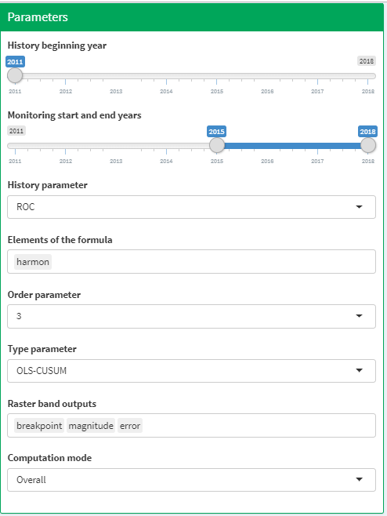

* + 1. Once you have decided on your parameters, run BFAST by clicking on the **Launch BFAST calculation** button in the results box.

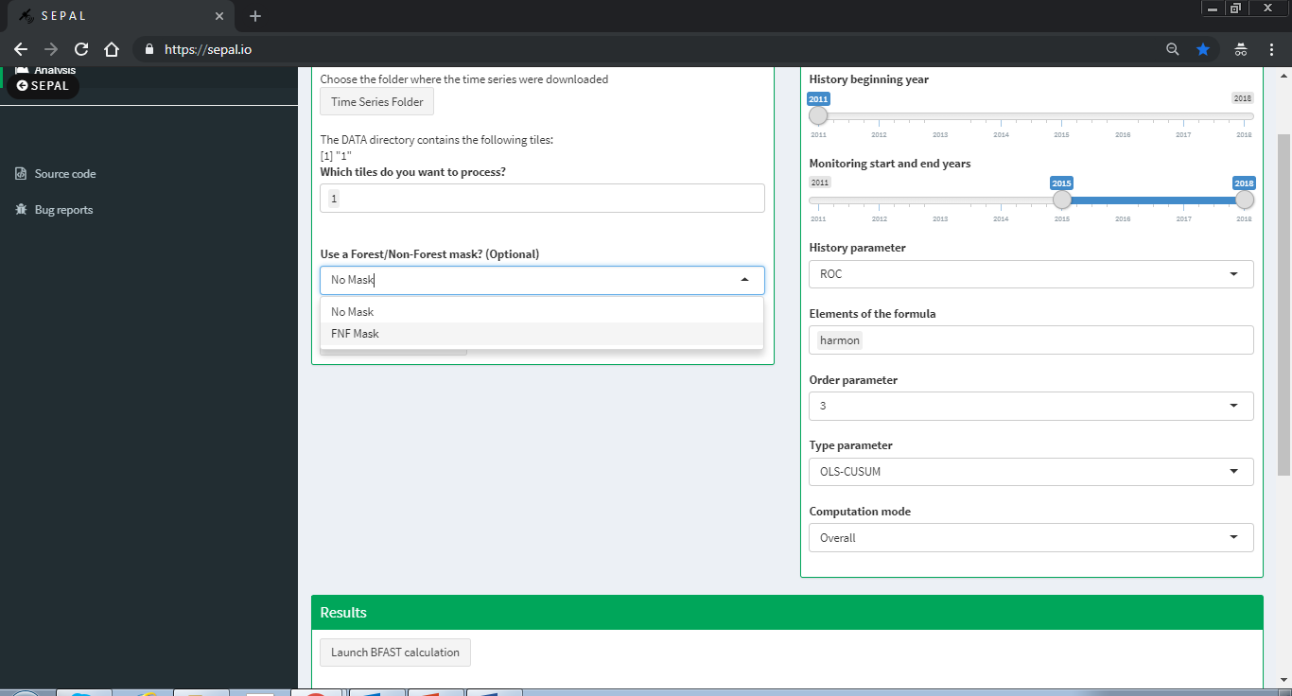

* + 1. Depending on the size of your area and the size of your instance, BFAST can take a long time run. It is not necessary to keep this application open for the results to be created, it is only necessary to make sure that the instance is running.

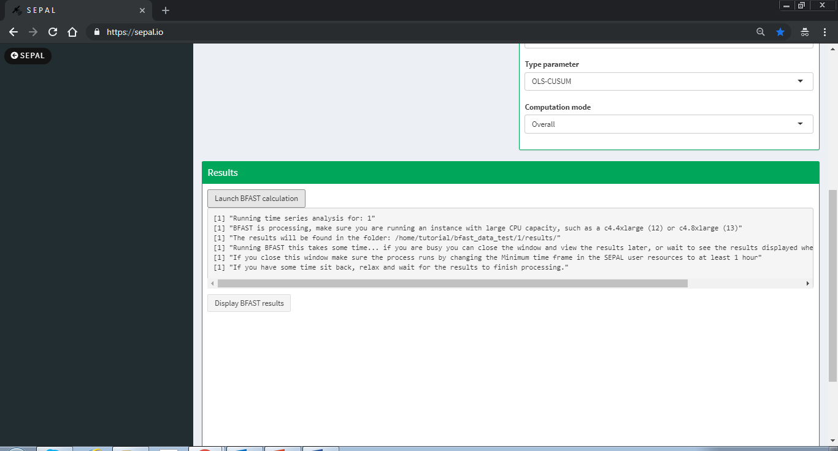

* + - 1. If your AOI has multiple polygons and contains many numeric folders, i.e. 1, 2, 3, etc, it will run the BFAST calculation for each of the folders, recursively.
      2. If you are running a large area or have a weak internet connection which might cause the application to disconnect you can go to your user resources in SEPAL and set the amount of time your session should stay open (see image below). This way you can shutdown SEPAL and the calculation will continue.

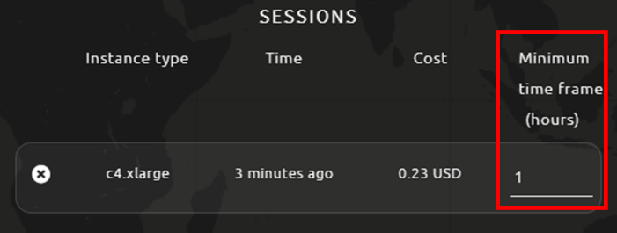

* + - 1. If the page goes gray and you see **Disconnected from the server**, don’t worry. The process is still running and you can follow the previous step to make sure your session remains active. You can follow the process in an indirect way with the TOP command in the terminal.

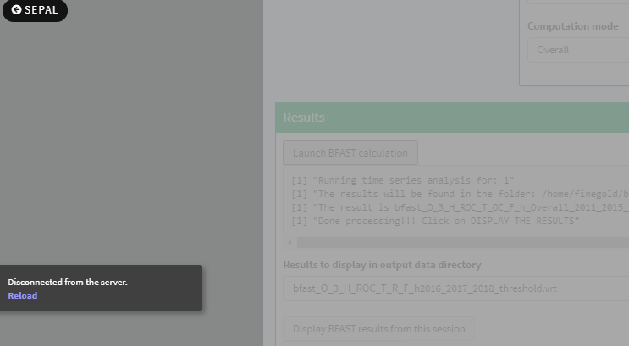

* + 1. If you are feeling patient or have a small study area, you can wait for the algorithm to finish running and view one of the outputs, the thresholded magnitude.
    2. When the calculation finishes running you will see the text **“Done processing. Click on DISPLAY THE RESULTS”**. You can now click on the **Display BFAST results from this session** button to display the threshold magnitude.

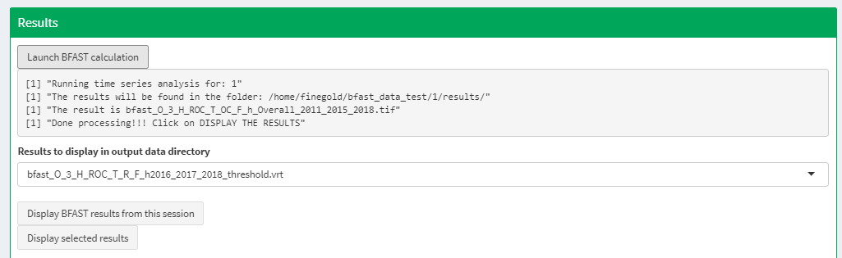

* + 1. The output from BFAST by default include 3 bands, the breakpoint, the magnitude and error (see 5vii). An additional output is calculated in this application, which is the thresholded magnitude. The thresholded magnitude is calculated using the magnitude output, calculating the mean magnitude value over the AOI and applying thresholds up to +/- 4 standard deviations from the mean.

