Download/Upload data from/to SEPAL to/from your computer

Connect FileZilla to your SEPAL account

Download FileZilla from this [link](https://filezilla-project.org/)

Accessing files in SEPAL is easy using FileZilla. To use FileZilla, open the application and connect to the SEPAL server by selecting Menu File --> Site Manager in the menu tab.

In the site manager pop-up click on the ‘New Site’ button. Use the screenshot below as a guide for filling in the form:

* + - 1. Host: sepal.io
      2. Port: 443
      3. Protocol: SFTP – SSH File Transfer Protocol
      4. Logon Type: Normal
      5. User: your SEPAL username
      6. Password: your SEPAL password

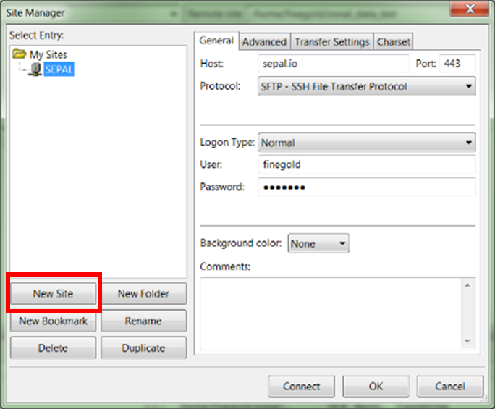

Click Connect and your SEPAL drive will appear in the right panel, parallel to the panel on the left with the files on your computer.

Using FileZilla

Here is a quick introduction from the [FileZilla online tutorial](https://wiki.filezilla-project.org/FileZilla_Client_Tutorial_(en)) corresponding to the image below:

1. the toolbar (1)
2. quick connect bar (2),
3. the message log (3) displays transfer and connection related messages. Below, you can find the file listings.
4. The left column (local pane, 4) displays the local files and directories, i.e. the stuff on the PC you're using FileZilla on. Make sure you are located in the right folder. Ideally, you should have a folder on your computer that will store all data related to this process, point to that folder
5. The right column (server pane, 5) displays the files and directories on the server you are connected to. Both columns have a directory tree at the top and a detailed listing of the currently selected directory's contents at the bottom. You can easily navigate either of the trees and lists by clicking around like in any other file manager.
6. At the bottom of the window, the transfer queue (6) lists the to-be-transferred and already transferred files.

