Run scripts in Rstudio

Check your budget, kill any “t2 instance”, Open the terminal and start a **#4 instance.** Go to Process / RStudio

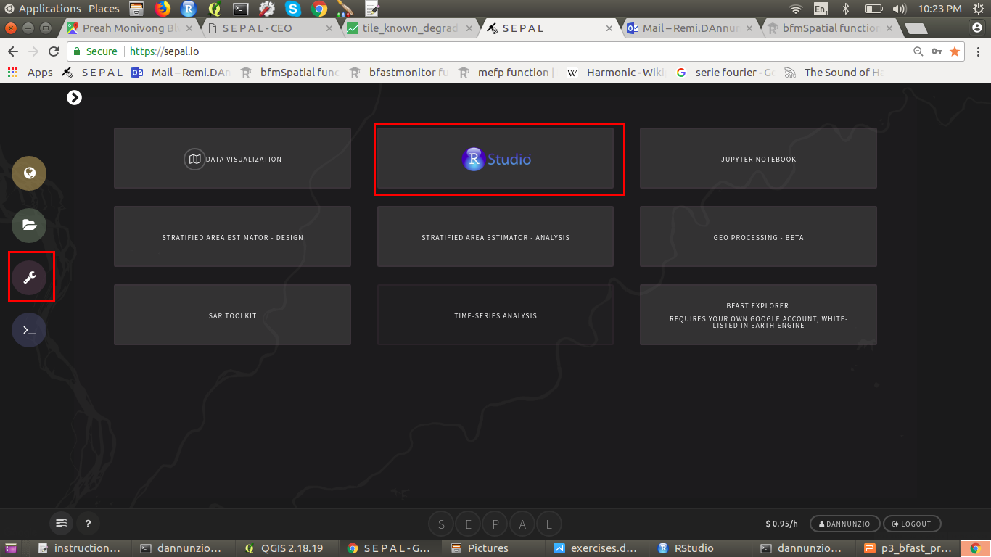

The rstudio interface proposes a SCRIPT environment that can be used to run lines (simple cursor on the command to run) or blocks of code (highlighted block) in an interactive manner (use the RUN button or CTRL+Enter).

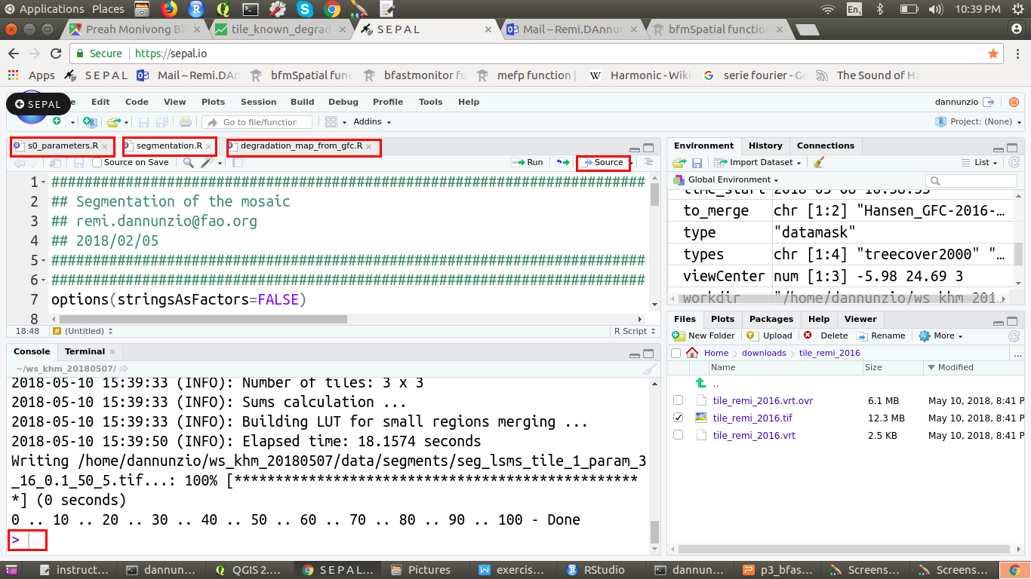

You can also choose to run the full script with the SOURCE button. A command has finished running when the little red STOP button is not showing anymore and there is a blue prompt (>) at the head of line.