Introduction to BFAST: the explorer

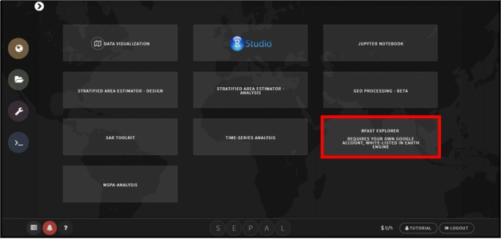

Connect SEPAL to your Google account

* 1. Check if your SEPAL account is already connected to your Google account
     1. Click on your username



* + 1. In the **User** box, there is a row that says **Google account**. There are 2 options here
       1. **Use my account**—you need to connect your SEPAL account to google. Proceed with the following steps

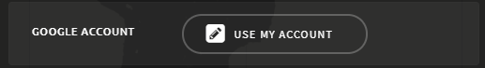

* + - 1. **Use SEPAL’s account**—you are already connected! You can skip the rest of this part and proceed to part 3.

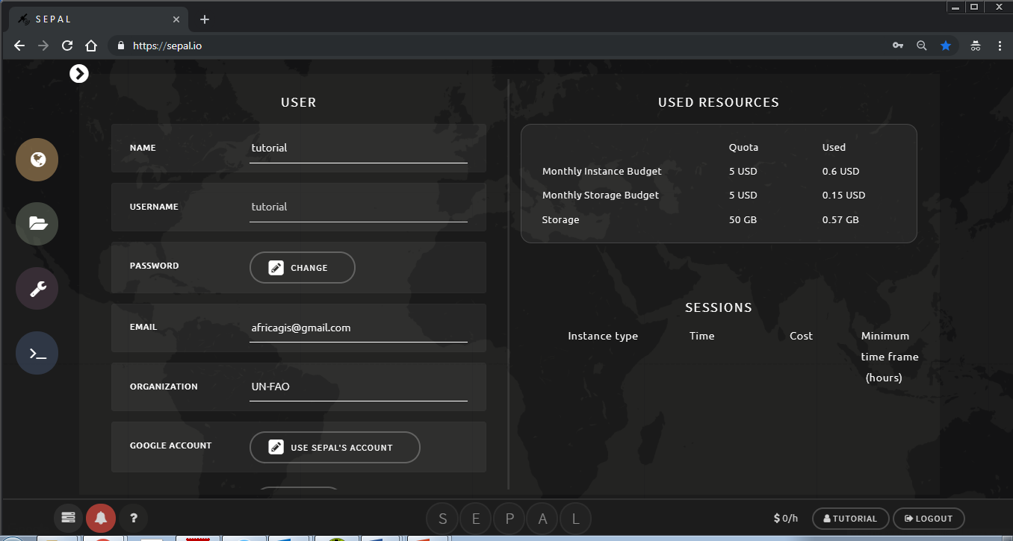

* + 1. Click on **Use my account** from step 2i.
    2. You will be redirected to a Google sign in. Please sign in with your google account that is approved for Google Earth Engine access.

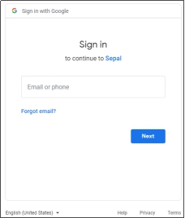

* + 1. After successful sign in, SEPAL will ask for permission to access your google drive, fusion tables and Earth Engine data. Click the **Allow** button to continue. 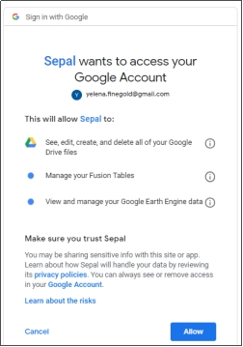

This will take you back to SEPAL and you have connected SEPAL to your Google account.

BFAST explorer

Open BFAST explorer

* + 1. Go to the processing tools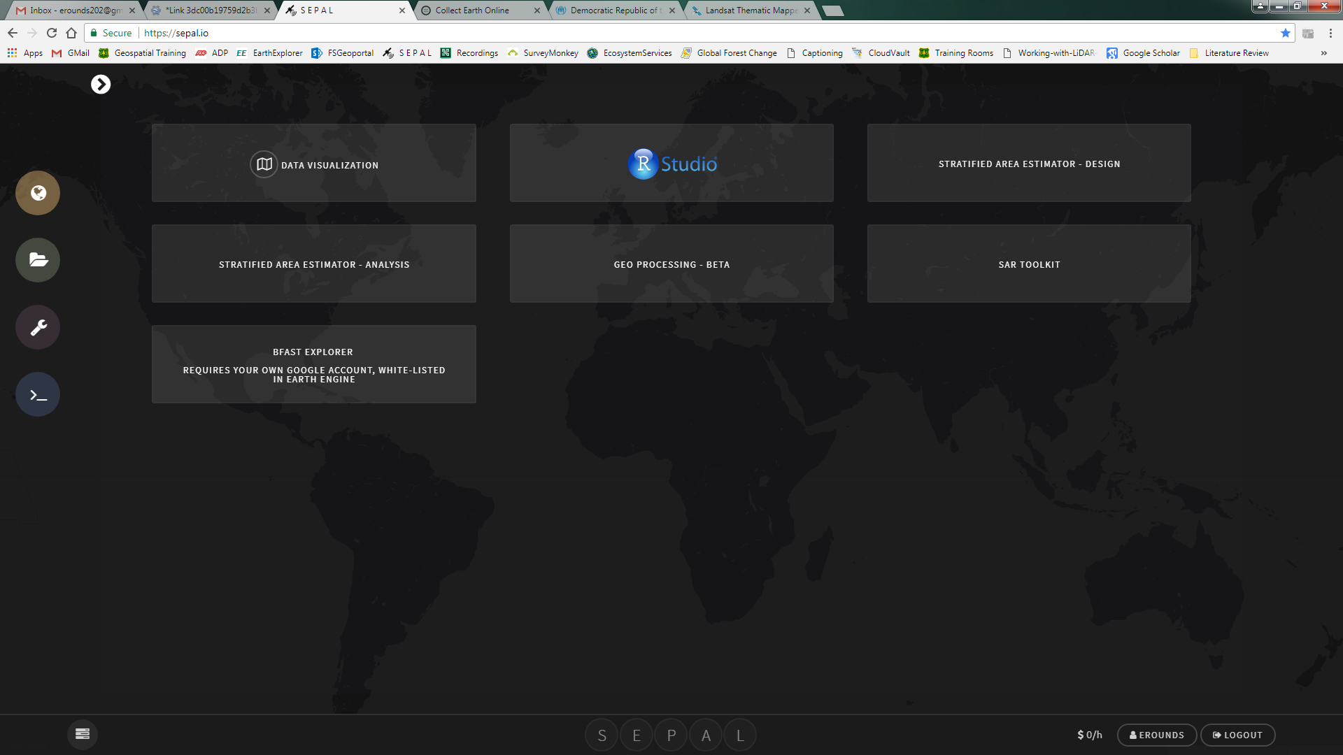
    2. Click on BFAST explorer



* + 1. If you do not already have an instance running (indicated by the $0/h next to your user name), the smallest instance will automatically start.

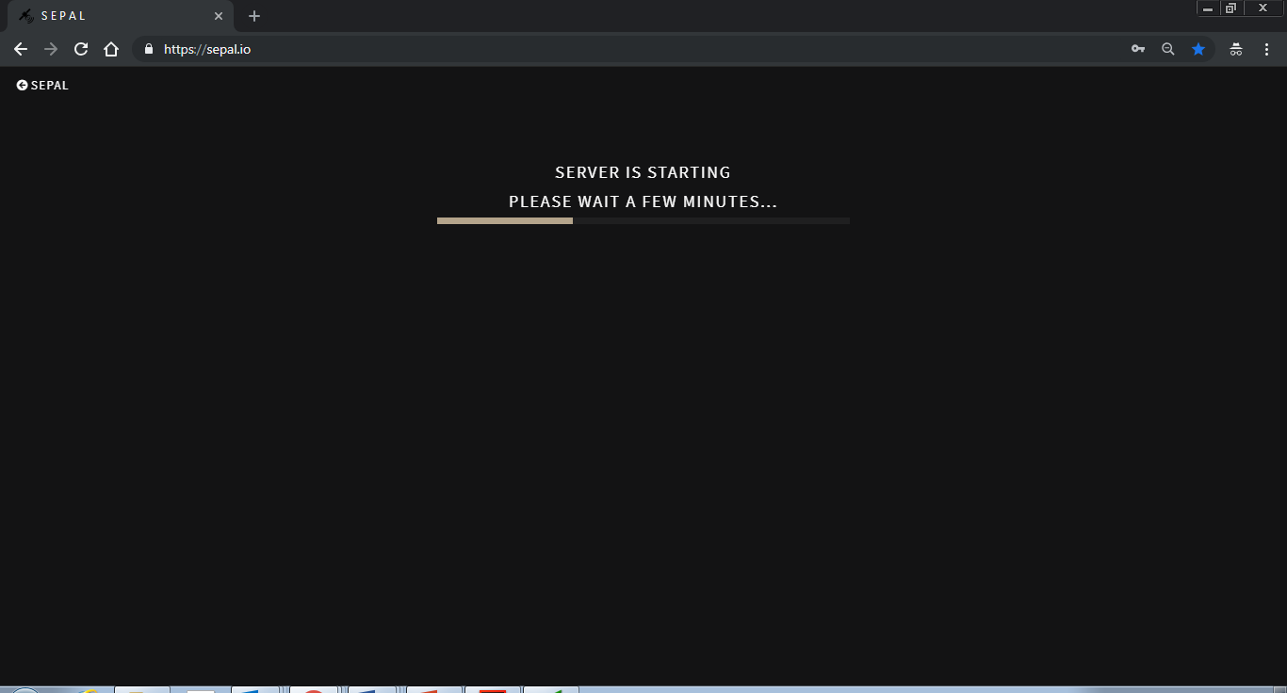

Map Tab

* + 1. This is the starting tab, which we first see when we run the tool. The tab is composed of an interactive map (rendered using Google Maps engine) and a navigation toolbar. Feel free to zoom and pan the map.

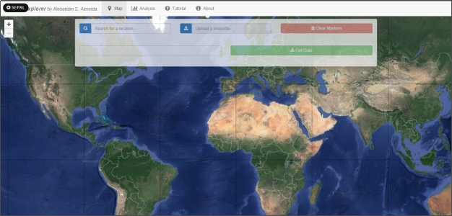

* + 1. To place a marker, simply click on the map. If we want to, we can also place multiple markers.
    2. We may also wish to clear all the placed markers. To do that, click on the **[**o, trash icon**Clear Markers]** red button on the left side of the toolbar.
    3. After that, we need to select one of the markers in order download its Landsat pixel data. To do that, simply click on an already placer marker, and it will be highlighted, in blue. Only one marker may be selected at a time.

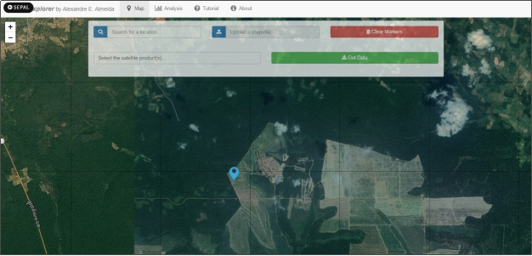

* + 1. By selecting a marker, we can now choose a combination of which satellites to download from using the drop-down menu, located on the bottom of the toolbar. For example, let's choose all the available satellites products: Landsat 5, 7 and 8 SR.

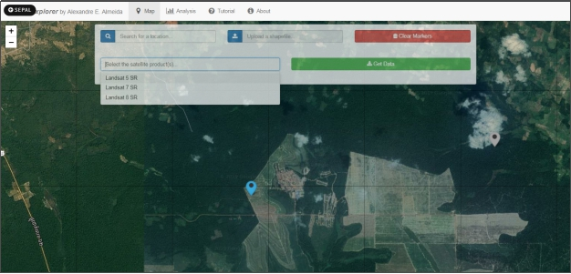

* + 1. Then, we press the **[ C:\Users\finegold\Documents\delete\kisspng-font-awesome-download-computer-icons-computer-soft-awesome-5acf37037d20f1.7870440615235294755125.png Get Data]** blue button, located on the right side of the toolbar. By pressing that button, the download will start. We can keep track of the download progress by looking to the lower right corner. All the historical data available are downloaded, which should take less than 10 seconds for the three products selected.

Note: as of the writing of this guide, not all Surface Reflectance data are available from GEE. So, depending on where we place our markers, we may face a message indicating that 'No data available for the chosen satellite(s) and/or region… Please change your query and try again.’ Since we rely heavily on GEE to download the data, there's nothing we can do yet. We're sorry for that.

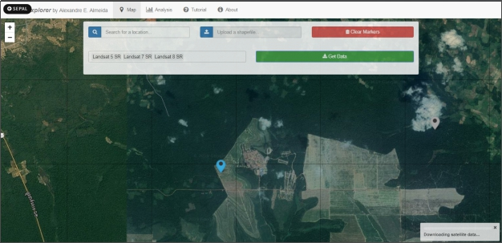

* + 1. If the download is successful, we'll receive a message directing to the 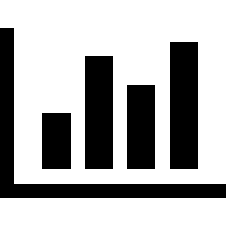**Analysis** tab.

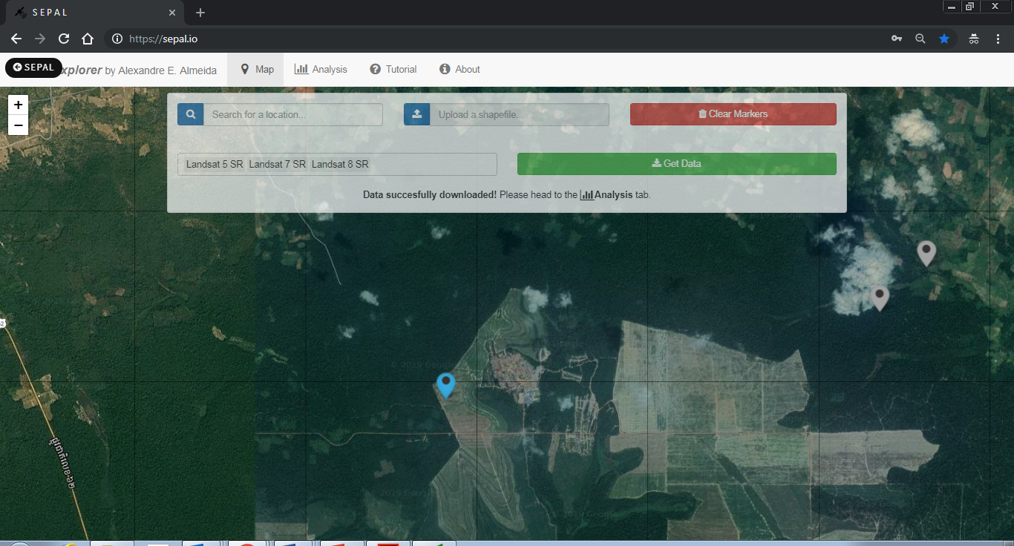

 Analysis Tab

* + 1. In this tab, we can analyze the downloaded data and, then, locally save the results as files.

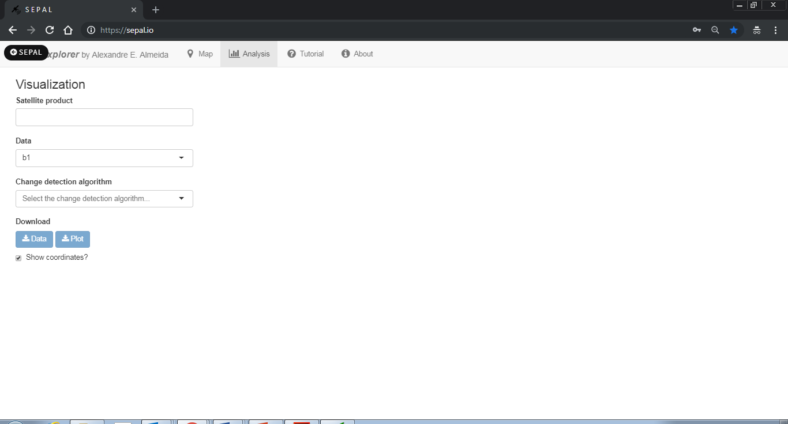

* + 1. First, let's choose which satellite time series date to visualize. Note that, even though we downloaded data from Landsat 5, 7 and 8 SR, we're can still analyze them separately. However, let's proceed by choosing all of them.

1. As we can see, the time series of the first spectral band (b1) is plotted for all satellites. A colored legend distinguishes the different sources.

Note: be careful when comparing spectral bands data from different satellites, as they may not correspond to the same wavelength range! Read more about this [here](https://landsat.usgs.gov/what-are-band-designations-landsat-satellites).

* + 1. Apart from the spectral bands, there are also four spectral-bands-derived indexes available: NDVI, NDMI, EVI and EVI2. Let's check, for example, the NDMI time series.
    2. If we want to, we can also download all the time series data as a file. To do that, press the **[ Data]** blue button. All the data will be downloaded as a .CSV, ordered by the acquisition date. Also, an additional column is included, in order to distinguish the satellite sources.
    3. We may download the time series plot as an image, by pressing the **[ Plot]** blue button. A window will appear offering some raster (.JPEG, .PNG) and a vectorial (.SVG) image output formats.

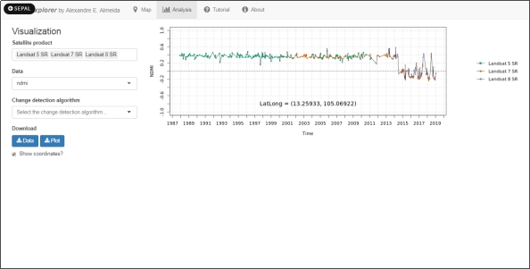

* + 1. Next, we select the change detection algorithm. Three options are available: **bfastmonitor**, **bfast01** and **bfast**. More information about these algorithms can be found [here](http://bfast.r-forge.r-project.org/).
    2. By selecting **bfast01**, we can tweak two parameters: formula, and harmonic order. Here, the maximum value of the harmonic order is dynamically set depending on the time series data length and the choice of the formula parameter.

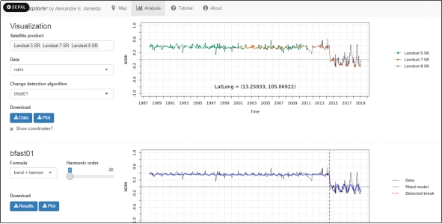

* + 1. By selecting **bfastmonitor**, we are able to tweak four parameters on the left side-bar: formula, history period type, harmonic order, and start of monitoring. These parameters have different impacts on the results, which can be verified on the right side plot. Here, we set the maximum value of the harmonic order to 9 to avoid some problems.
    2. Similar to the time series, we can also download the results of the change detection algorithms as .RDS data files, by clicking on the **[ Results]** blue button. If we wish to download the plot, we can press the **[ Plot]** blue button.
    3. For more information on how to load .RDS files on R, please check this [link](http://www.fromthebottomoftheheap.net/2012/04/01/saving-and-loading-r-objects/).

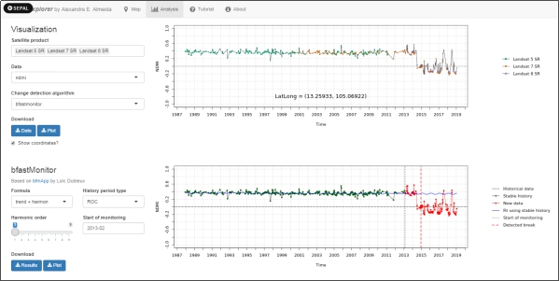

* + 1. Finally, by selecting **bfast**, we may tweak two parameters: h (minimal segment size), and season type. Please note that, since **bfast** can detect multiple breakpoints, it may take a couple of seconds to process, in comparison to the previous two algorithms.

Tutorial Tab

* + 1. This tutorial can be viewed inside of the application in the tutorial tab.

