Generate a fusion table

Fusion tables are the vector format of geospatial data used by Google Earth Engine (up to 03-12-2019).

You can convert a CSV or a KML file to a Fusion Table to use in the GEE API.

Sign in and open your Google Drive. Click NEW and select Fusion Table. If it is not active, you have to connect it to your apps first.

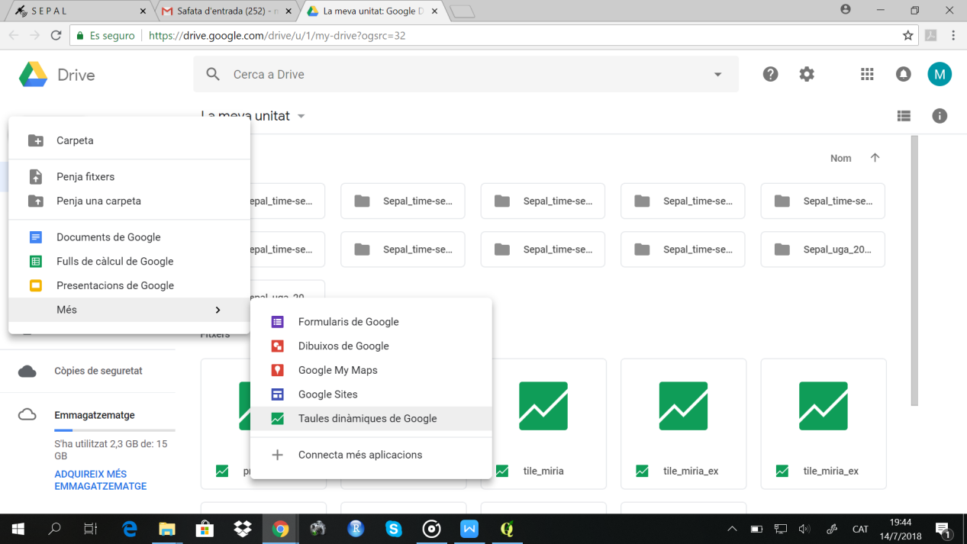

Click on **Choose FIle** and select a previously saved CSV or KML file.

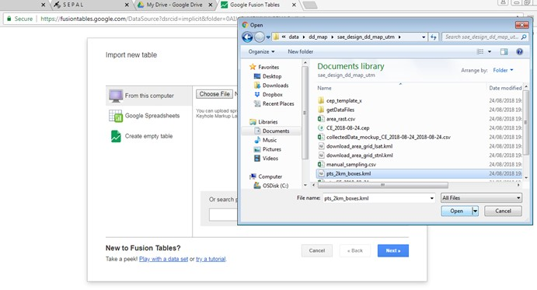

Once they are created, make the Fusion Table public (Tools/Publish/Change visibility)

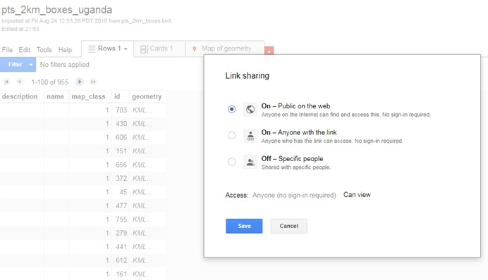

The Fusion Table ID can be found under “File/About this Table”. It is also in the URL, between the “=” and the “#” signs.

