Download time series for BFAST analysis

Search for data

* + 1. Go to the Search module 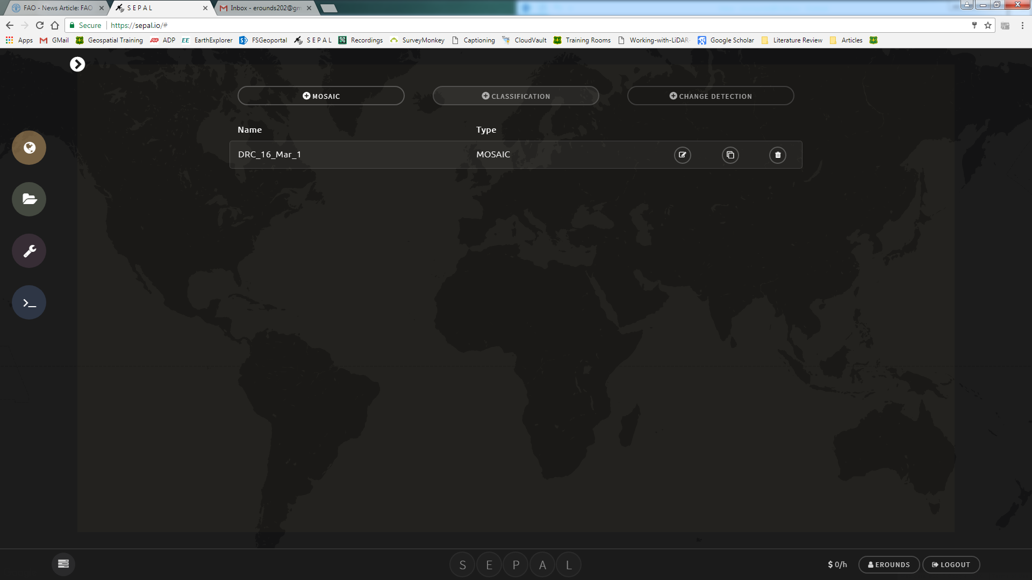
    2. Select the Time Series tab

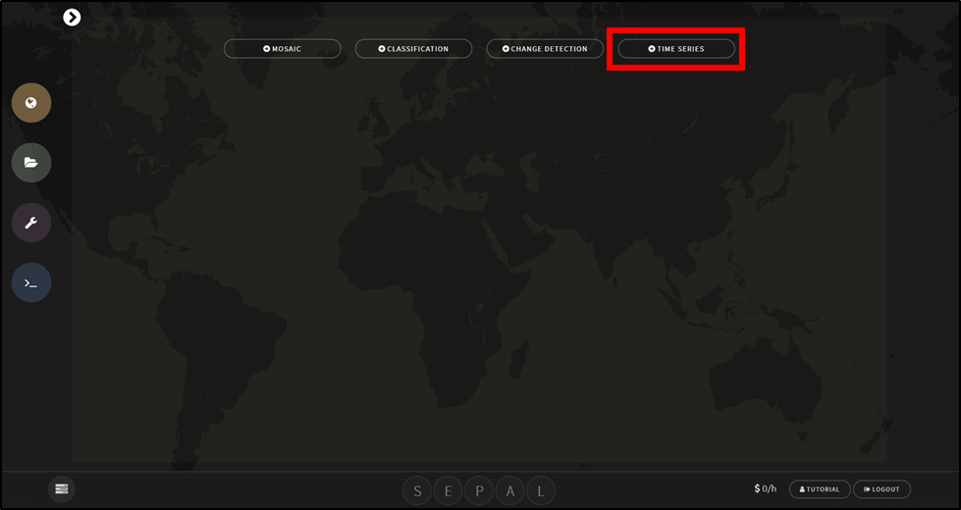

* + 1. Specify the parameters (see image below):
       1. First give the time series a custom name, this will be the name of the folder in the downloads folder where you will be able to find the downloaded time series data
       2. Country boundaries, a custom polygon or a fusion table ID can be used as the area of interest. For more information about fusion tables see the [Change detection in SEPAL manual](https://drive.google.com/file/d/1pTjItfECUt1mhQCxwrHwaAVVM7GoCFiK/view?usp=drive_open).
       3. Landsat 5, 7 and/or 8 can be included in the time series
       4. Choose the ‘from’ and ‘to’ dates. The time series will start at the *from* date and end at the *to* date
       5. The indicator is the vegetation index that is calculated for each satellite image acquisition.
          1. NDVI= normalized vegetation index
          2. NDMI= normalized moisture index
          3. EVI= enhanced vegetation index
          4. EVI2= enhanced vegetation index (2 bands)
       6. Options to mask snow and correct for view and illumination angle effects using BRDF
       7. Final step is to export the time series stack to SEPAL

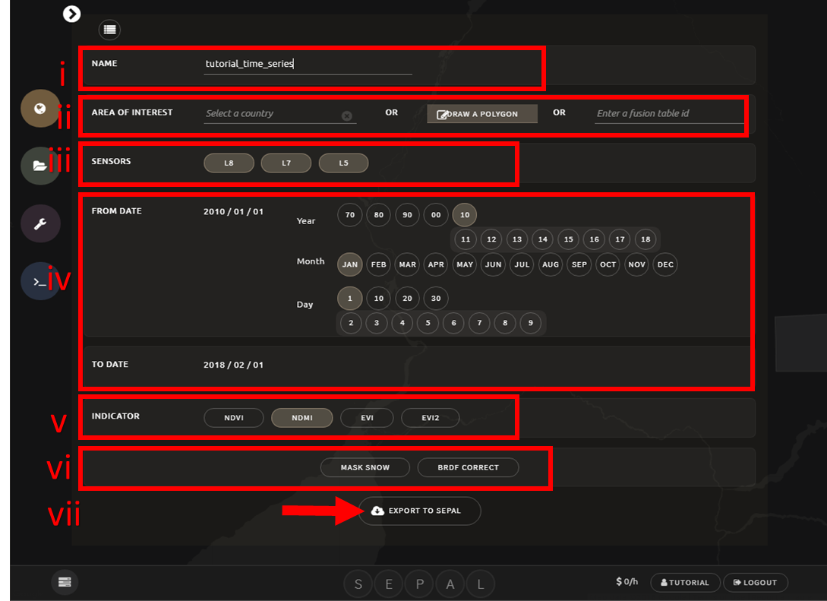

* + 1. The time series tab creates a stack of images for the chosen indicator and time span for the area of interest. In the result each band in the image represents a unique date

1. Once the download is initiated you can monitor the progress of the download by clicking on the spinning wheel  in the bottom left corner

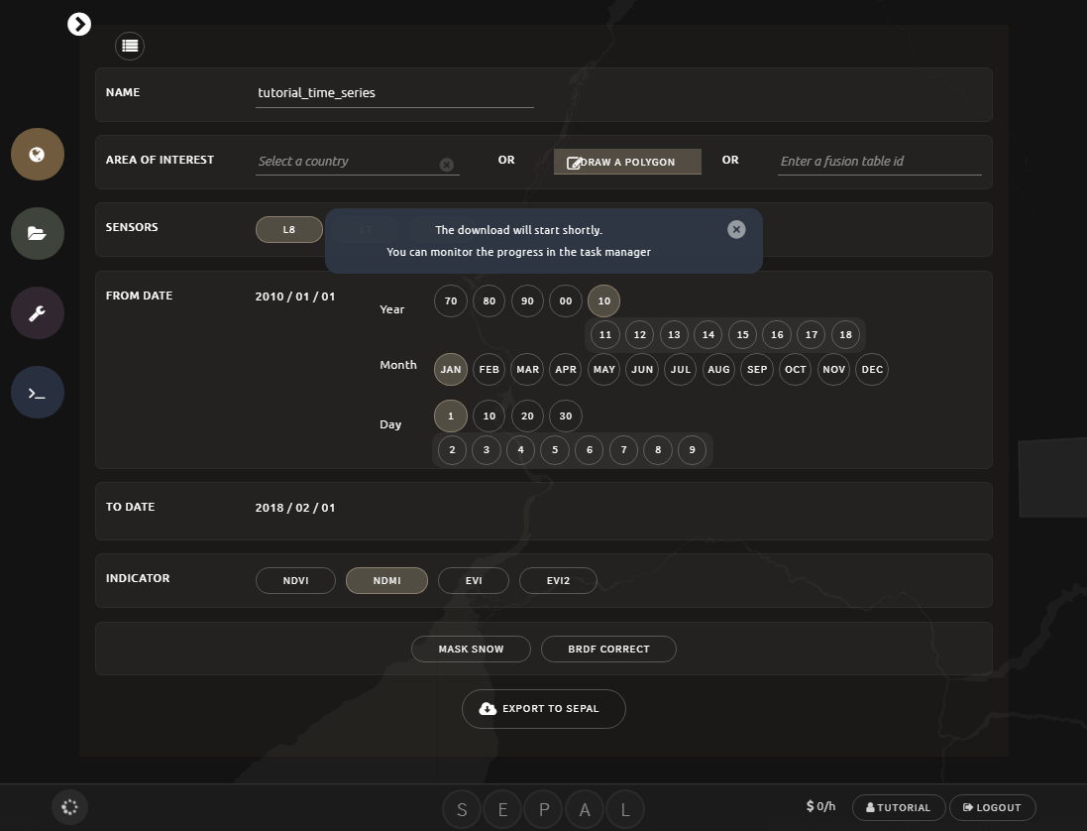

Downloaded data in SEPAL

* + 1. The time series stack will download into the download folder in your SEPAL account. Click on the folder icon to see the files. 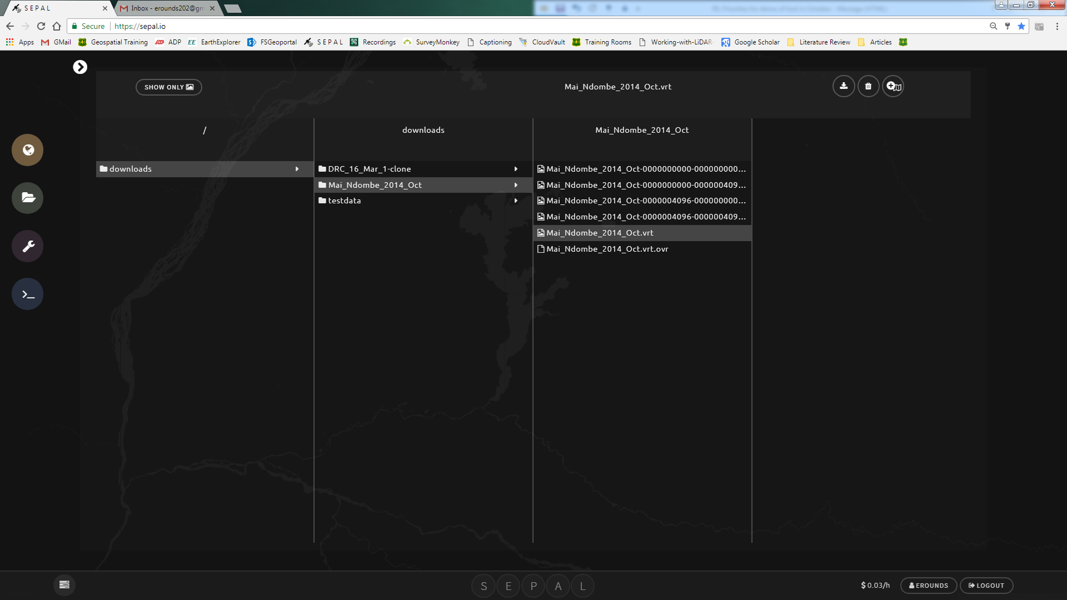
    2. When the download is complete the time series stack is saved as a [.vrt](https://www.gdal.org/gdal_vrttut.html) file in the downloads folder in a folder that has the same name specified in the download parameters (i)

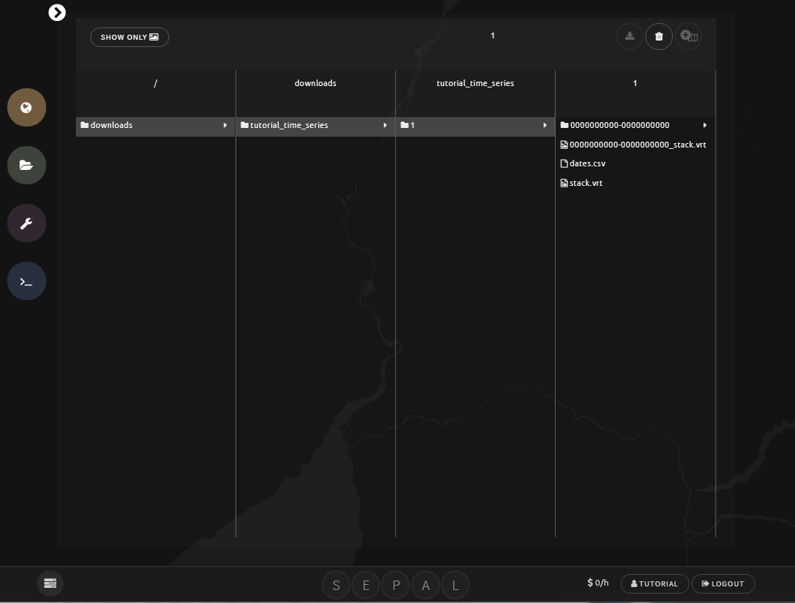

* + 1. The two main outputs are stack.vrt and dates.csv

1. **stack.vrt** stores the vegetation index for each date in the bands
2. **dates.csv** stores the date corresponding to each band

The data is ready for time series analysis