

**期末项目设计报告**

|  |  |  |  |
| --- | --- | --- | --- |
| 题 目 | 基于Oracle的通信系统的数据库设计 | | |
| 课程 | Oracle数据库应用 | | |
| 学 院 | 信息科学与工程学院 | | |
| 专 业 | 软件工程 | 年级 | 2018级 |
| 学生姓名 | 杨永涛 | 学号 | 201810414127 |
| 指导教师 | 赵卫东 | 职称 | 副教授 |

|  |  |  |  |
| --- | --- | --- | --- |
| **评分项** | **评分标准** | **满分** | **得分** |
| 文档整体 | 文档内容详实、规范，美观大方 | 10 |  |
| 表设计 | 表，表空间设计合理，数据合理 | 20 |  |
| 用户管理 | 权限及用户分配方案设计正确 | 10 |  |
| PL/SQL设计 | 存储过程和函数设计正确 | 25 |  |
| 备份方案 | 备份方案设计正确 | 25 |  |
| 容灾方案 | DataGuard设计正确 | 10 |  |
| **得分合计** | | |  |

2021 年 6 月 5 日

目录

通信系统数据库设计 3

一.引言 3

二. 实现步骤 3

1.表空间设计 3

2.权限及用户分配方案设计 4

2.1创建用户 4

2.2创建角色 5

2.3分配权限 5

2.4分配空间 6

3.表设计 7

3.1用户表设计 7

3.2 好友表设计 8

3.3 群组表设计 9

3.4 管理员表设计 10

3.5聊天消息表设计 11

3.6查看表空间 13

3.7插入用户表数据 14

3.8插入关系 15

4.存储过程和函数设计 16

5.备份方案设计 18

5.1全备份 18

5.2备份后模拟数据库文件损坏、数据库完全恢复 19

# 通信系统数据库设计

# 一.引言

随着整个时代的信息化，产业的逐渐信息化已经成为了必不可少的潮流。同时，在各大中小型企业中，用计算机管理企业的信息已经变得十分的普遍。通过系统来完成通信的方式不仅可以提高工作效率，同时也能节省很多的人力物力。对于企业内部的资料也具有更高的安全性。通信系统的使用可以满足企业对大量信息的快速传递和处理的需求。本数据库是基于Oracle的通信系统数据，主要包括数据库表设计，用户管理设计，存储过程及函数设计以及备份方案的设计。

# 二. 实现步骤

## 1.表空间设计

手工增加两个表空间USERS00和USERS01

Create Tablespace Users00  
datafile  
'/home/oracle/app/oracle/oradata/YYTDB/pdbtest_users00_1.dbf'  
 SIZE 100M AUTOEXTEND ON NEXT 256M MAXSIZE UNLIMITED,  
'/home/oracle/app/oracle/oradata/YYTDB/pdbtest_users00_2.dbf'  
 SIZE 100M AUTOEXTEND ON NEXT 256M MAXSIZE UNLIMITED  
EXTENT MANAGEMENT LOCAL SEGMENT SPACE MANAGEMENT AUTO;  
Create Tablespace Users01  
datafile  
'/home/oracle/app/oracle/oradata/YYTDB/pdbtest_users01_1.dbf'  
 SIZE 100M AUTOEXTEND ON NEXT 256M MAXSIZE UNLIMITED,  
'/home/oracle/app/oracle/oradata/YYTDB/pdbtest_users01_2.dbf'  
 SIZE 100M AUTOEXTEND ON NEXT 256M MAXSIZE UNLIMITED  
EXTENT MANAGEMENT LOCAL SEGMENT SPACE MANAGEMENT AUTO;

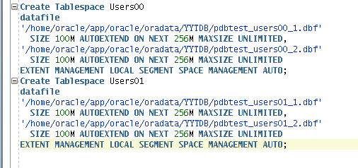

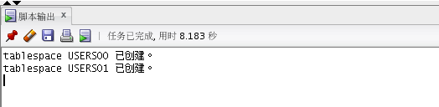

## 2.权限及用户分配方案设计

### 2.1创建用户

创建用户YYT,YYT01并赋予用户表空间使用权限

CREATE USER YYT IDENTIFIED BY 123  
DEFAULT TABLESPACE "USERS01"  
TEMPORARY TABLESPACE "TEMP";  
CREATE USER YYT01 IDENTIFIED BY 123  
DEFAULT TABLESPACE "USERS00"  
TEMPORARY TABLESPACE "TEMP";

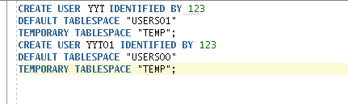

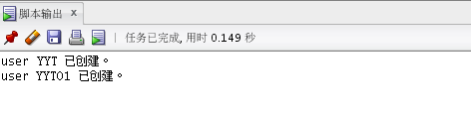

### 2.2创建角色

创建角色yyt*role,yyt*role01

CREATE ROLE yyt_role;  
CREATE ROLE yyt_role01;

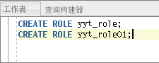

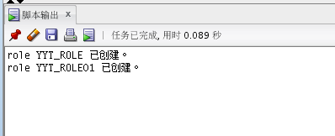

### 2.3分配权限

赋予用户分区表的权限

ALTER USER YYT QUOTA UNLIMITED ON USERS00;  
ALTER USER YYT QUOTA UNLIMITED ON USERS01;  
ALTER USER YYT ACCOUNT UNLOCK;  
GRANT "CONNECT" TO YYT WITH ADMIN OPTION;  
GRANT "RESOURCE" TO YYT WITH ADMIN OPTION;  
ALTER USER YYT DEFAULT ROLE "CONNECT","RESOURCE";

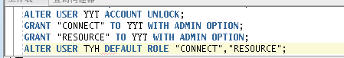

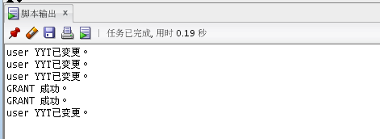

### 2.4分配空间

赋予角色权限和空间并把角色使用权限给用户

GRANT connect,resource,CREATE VIEW TO yyt_role;  
ALTER USER YYT QUOTA 50M ON users01;  
GRANT yyt_role TO yyt;

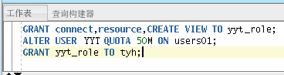

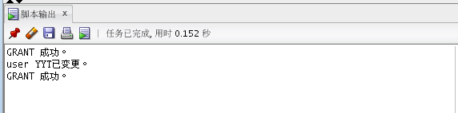

## 3.表设计

### 3.1用户表设计

UUID为主键并根据注册日期进行分区，分为2020和2021两个分区并且每个分区按照4个季度进行划分

CREATE TABLE TABLE_USERS  
(  
"UUID" NUMBER(20,0) DEFAULT 1 NOT NULL ENABLE,  
"ACCOUNT" NUMBER(20,0) NOT NULL ENABLE,   
"PASSWORD" VARCHAR2(80 BYTE) NOT NULL ENABLE,  
"STATE" NUMBER(1,0) DEFAULT 0,   
"NAME" VARCHAR2(40 BYTE),   
"REGISTRATIONDATE" DATE NOT NULL ,  
 CONSTRAINT U_PK PRIMARY KEY   
 (  
 UUID  
 )  
 USING INDEX   
 (  
 CREATE UNIQUE INDEX U_PK ON TABLE_USERS(UUID ASC)   
 LOGGING   
 TABLESPACE USERS00  
 PCTFREE 10   
 INITRANS 2   
 STORAGE   
 (   
 BUFFER_POOL DEFAULT   
 )   
 NOPARALLEL   
 )  
 ENABLE   
)   
TABLESPACE USERS00  
PCTFREE 10   
INITRANS 1   
STORAGE   
(   
 BUFFER_POOL DEFAULT   
)   
NOCOMPRESS   
NOPARALLEL   
PARTITION BY RANGE (REGISTRATIONDATE)   
SUBPARTITION BY RANGE (REGISTRATIONDATE)   
(  
 PARTITION DATE2020 VALUES LESS THAN (TO_DATE(' 2020-12-31 00:00:00', 'SYYYY-MM-DD HH24:MI:SS', 'NLS_CALENDAR=GREGORIAN'))   
 TABLESPACE USERS00  
 PCTFREE 10   
 INITRANS 1   
 STORAGE   
 (   
 BUFFER_POOL DEFAULT   
 )   
 NOCOMPRESS NO INMEMORY   
 (  
 SUBPARTITION DATE2020_3 VALUES LESS THAN (TO_DATE(' 2020-03-31 00:00:00', 'SYYYY-MM-DD HH24:MI:SS', 'NLS_CALENDAR=GREGORIAN'))   
 NOCOMPRESS NO INMEMORY   
 , SUBPARTITION DATE2020_6 VALUES LESS THAN (TO_DATE(' 2020-06-30 00:00:00', 'SYYYY-MM-DD HH24:MI:SS', 'NLS_CALENDAR=GREGORIAN'))   
 NOCOMPRESS NO INMEMORY   
 , SUBPARTITION DATE2020_9 VALUES LESS THAN (TO_DATE(' 2020-09-30 00:00:00', 'SYYYY-MM-DD HH24:MI:SS', 'NLS_CALENDAR=GREGORIAN'))   
 NOCOMPRESS NO INMEMORY   
 , SUBPARTITION DATE2020_12 VALUES LESS THAN (TO_DATE(' 2020-12-31 00:00:00', 'SYYYY-MM-DD HH24:MI:SS', 'NLS_CALENDAR=GREGORIAN'))   
 NOCOMPRESS NO INMEMORY   
 )   
, PARTITION DATE2021 VALUES LESS THAN (TO_DATE(' 2021-12-31 00:00:00', 'SYYYY-MM-DD HH24:MI:SS', 'NLS_CALENDAR=GREGORIAN'))   
 TABLESPACE USERS01  
 PCTFREE 10   
 INITRANS 1   
 STORAGE   
 (   
 BUFFER_POOL DEFAULT   
 )   
 NOCOMPRESS NO INMEMORY   
 (  
 SUBPARTITION DATE2021_3 VALUES LESS THAN (TO_DATE(' 2021-03-31 00:00:00', 'SYYYY-MM-DD HH24:MI:SS', 'NLS_CALENDAR=GREGORIAN'))   
 NOCOMPRESS NO INMEMORY   
 , SUBPARTITION DATE2021_6 VALUES LESS THAN (TO_DATE(' 2021-06-30 00:00:00', 'SYYYY-MM-DD HH24:MI:SS', 'NLS_CALENDAR=GREGORIAN'))   
 NOCOMPRESS NO INMEMORY   
 , SUBPARTITION DATE2021_9 VALUES LESS THAN (TO_DATE(' 2021-09-30 00:00:00', 'SYYYY-MM-DD HH24:MI:SS', 'NLS_CALENDAR=GREGORIAN'))   
 NOCOMPRESS NO INMEMORY   
 , SUBPARTITION DATE2021_12 VALUES LESS THAN (TO_DATE(' 2021-12-31 00:00:00', 'SYYYY-MM-DD HH24:MI:SS', 'NLS_CALENDAR=GREGORIAN'))   
 NOCOMPRESS NO INMEMORY   
 )   
);

### 3.2 好友表设计

CREATE TABLE TABLE_FRIEND  
(  
 "ID" NUMBER(11,0) NOT NULL ENABLE,  
 "MAINUUID" NUMBER(20,0) DEFAULT 1 NOT NULL ENABLE,   
 "FIRENDUUID" NUMBER(20,0) DEFAULT 1 NOT NULL ENABLE,   
 "FRIENDNAME" VARCHAR2(40 BYTE),   
 "FRIENDGROUP" VARCHAR2(40 BYTE),   
 CONSTRAINT ADMINISTRATOR_PK PRIMARY KEY   
 (  
 ID   
 )  
 USING INDEX   
 (  
 CREATE UNIQUE INDEX TABLE_FRIEND_PK ON TABLE_FRIEND(ID ASC)   
 LOGGING   
 TABLESPACE USERS00  
 PCTFREE 10   
 INITRANS 2   
 STORAGE   
 (   
 BUFFER_POOL DEFAULT   
 )   
 NOPARALLEL   
 )  
 ENABLE   
)   
LOGGING   
TABLESPACE USERS00  
PCTFREE 10   
INITRANS 1   
STORAGE   
(   
 BUFFER_POOL DEFAULT   
)   
NOCOMPRESS   
NO INMEMORY   
NOPARALLEL;

### 3.3 群组表设计

CREATE TABLE TABLE_GROUP  
(  
"UUID" NUMBER(20,0) NOT NULL ENABLE,   
"ACCOUNT" NUMBER(20,0) NOT NULL ENABLE,   
"NAME" VARCHAR2(40 BYTE) NOT NULL ENABLE,   
"CREATOR" NUMBER(20,0) NOT NULL ENABLE,   
"CREATETIME" DATE,   
CONSTRAINT TABLE_GROUP_PK PRIMARY KEY   
 (  
 UUID   
 )  
 USING INDEX   
 (  
 CREATE UNIQUE INDEX TABLE_GROUP_PK ON COMMODITY (UUID ASC)   
 LOGGING   
 TABLESPACE USERS01  
 PCTFREE 10   
 INITRANS 2   
 STORAGE   
 (   
 BUFFER_POOL DEFAULT   
 )   
 NOPARALLEL   
 )  
 ENABLE   
)   
LOGGING   
TABLESPACE USERS01  
PCTFREE 10   
INITRANS 1   
STORAGE   
(   
 BUFFER_POOL DEFAULT   
)   
NOCOMPRESS   
NO INMEMORY   
NOPARALLEL;

### 3.4 管理员表设计

CREATE TABLE ADMINISTRATOR   
(  
"ID" NUMBER(*, 0) NOT NULL,   
"PASSWORD" VARCHAR2(20 BYTE) NOT NULL,   
"ADMIN" VARCHAR2(20 BYTE) NOT NULL,   
CONSTRAINT ADMINISTRATOR_PK PRIMARY KEY   
 (  
 ID   
 )  
 USING INDEX   
 (  
 CREATE UNIQUE INDEX ADMINISTRATOR_PK ON ADMINISTRATOR (ID ASC)   
 LOGGING   
 TABLESPACE USERS00   
 PCTFREE 10   
 INITRANS 2   
 STORAGE   
 (   
 BUFFER_POOL DEFAULT   
 )   
 NOPARALLEL   
 )  
 ENABLE   
)   
LOGGING   
TABLESPACE USERS00   
PCTFREE 10   
INITRANS 1   
STORAGE   
(   
 BUFFER_POOL DEFAULT   
)   
NOCOMPRESS   
NO INMEMORY   
NOPARALLEL;

### 3.5聊天消息表设计

SENDERUUID为用户表的外键，聊天消息分区采用的是引用用户表分区

CREATE TABLE TABLE_CHATMSG  
(  
"MSGID" VARCHAR2(20 BYTE) NOT NULL ENABLE,   
"SENDERUUID" NUMBER(20,0) NOT NULL ENABLE,   
"TARGETUUID" NUMBER(20,0) NOT NULL ENABLE,   
"COLUMN1" VARCHAR2(1024 BYTE),   
"MSGTIME" DATE,  
 CONSTRAINT TABLE_CHATMSG_PK PRIMARY KEY   
 (  
 MSGID   
 )  
 USING INDEX   
 (  
 CREATE UNIQUE INDEX TABLE_CHATMSG_PK ON CARTMSG (MSGID ASC)   
 LOGGING   
 TABLESPACE USERS01  
 PCTFREE 10   
 INITRANS 2   
 STORAGE   
 (   
 BUFFER_POOL DEFAULT   
 )   
 NOPARALLEL   
 )  
 ENABLE   
, CONSTRAINT MSG_USERUUID FOREIGN KEY  
 (  
 SENDERUUID  
 )  
 ENABLE   
)   
PCTFREE 10   
PCTUSED 40   
INITRANS 1   
STORAGE   
(   
 BUFFER_POOL DEFAULT   
)   
NOCOMPRESS   
NOPARALLEL   
PARTITION BY REFERENCE (MSG_USERUUID )   
(  
 PARTITION DATE2020_3   
 LOGGING   
 TABLESPACE USERS00  
 PCTFREE 10   
 INITRANS 1   
 STORAGE   
 (   
 BUFFER_POOL DEFAULT   
 )   
 NOCOMPRESS NO INMEMORY   
, PARTITION DATE2020_6   
 LOGGING   
 TABLESPACE USERS00  
 PCTFREE 10   
 INITRANS 1   
 STORAGE   
 (   
 BUFFER_POOL DEFAULT   
 )   
 NOCOMPRESS NO INMEMORY   
, PARTITION DATE2020_9   
 LOGGING   
 TABLESPACE USERS00  
 PCTFREE 10   
 INITRANS 1   
 STORAGE   
 (   
 BUFFER_POOL DEFAULT   
 )   
 NOCOMPRESS NO INMEMORY   
, PARTITION DATE2020_12   
 LOGGING   
 TABLESPACE USERS00  
 PCTFREE 10   
 INITRANS 1   
 STORAGE   
 (   
 BUFFER_POOL DEFAULT   
 )   
 NOCOMPRESS NO INMEMORY   
, PARTITION DATE2021_3   
 LOGGING   
 TABLESPACE USERS01  
 PCTFREE 10   
 INITRANS 1   
 STORAGE   
 (   
 BUFFER_POOL DEFAULT   
 )   
 NOCOMPRESS NO INMEMORY   
, PARTITION DATE2021_6   
 LOGGING   
 TABLESPACE USERS01  
 PCTFREE 10   
 INITRANS 1   
 STORAGE   
 (   
 BUFFER_POOL DEFAULT   
 )   
 NOCOMPRESS NO INMEMORY   
, PARTITION DATE2021_9   
 LOGGING   
 TABLESPACE USERS01  
 PCTFREE 10   
 INITRANS 1   
 STORAGE   
 (   
 BUFFER_POOL DEFAULT   
 )   
 NOCOMPRESS NO INMEMORY   
, PARTITION DATE2021_12   
 LOGGING   
 TABLESPACE USERS01  
 PCTFREE 10   
 INITRANS 1   
 STORAGE   
 (   
 BUFFER_POOL DEFAULT   
 )   
 NOCOMPRESS NO INMEMORY   
);

### 3.6查看表空间

SELECT a.tablespace_name "表空间名",  
total "表空间大小",  
free "表空间剩余大小",  
(total - free) "表空间使用大小",  
total / (1024 * 1024 * 1024) "表空间大小(G)",  
free / (1024 * 1024 * 1024) "表空间剩余大小(G)",  
(total - free) / (1024 * 1024 * 1024) "表空间使用大小(G)",  
round((total - free) / total, 4) * 100 "使用率 %"  
FROM (SELECT tablespace_name, SUM(bytes) free  
FROM dba_free_space  
GROUP BY tablespace_name) a,  
(SELECT tablespace_name, SUM(bytes) total  
FROM dba_data_files  
GROUP BY tablespace_name) b  
WHERE a.tablespace_name = b.tablespace_name

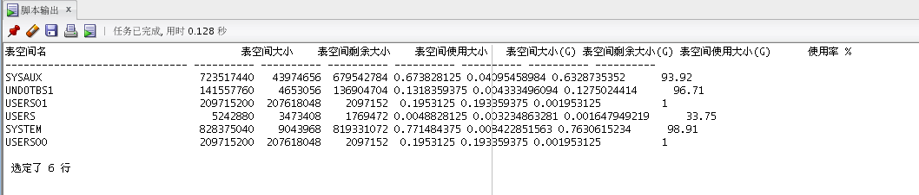

### 3.7插入用户表数据

declare  
 uuid number(20,0);  
 name varchar2(40);  
 password varchar2(80);  
 state number(1,0);  
 account number(20,0)  
 REGISTRATIONDATE date;  
 MSG_ID varchar2(50);  
  
begin  
 for i in 1..20000  
 loop  
 if i mod 2 =0 then  
 REGISTRATIONDATE:=to_date('2020-5-6','yyyy-mm-dd')+(i mod 60);  
 else  
 REGISTRATIONDATE:=to_date('2021-5-6','yyyy-mm-dd')+(i mod 60);  
 end if;  
  
 uuid:=SEQ_ORDER_ID.nextval;  
 name := 'yang' || i;  
 password := name || i || uuid;  
 state :=(i mod 2);  
 account:=(i mod 5);  
 insert into TABLE_USERS   
 (uuid,account,password,state,name,REGISTRATIONDATE,msg_id)  
 values   
 (uuid,account,password,state,name,REGISTRATIONDATE,msg_id);  
end;  
......

### 3.8插入关系

declare  
mainuuid number(20,0);  
firenduuid number(20,0);  
indexid number(8,0);  
begin  
mainuuid:=10013;  
firenduuid :=10013;  
for i in 1.. 12  
loop  
 if i mod 2 = 0 then  
 indexid :=2;  
 else  
 indexid := 1;  
 end if;  
 insert into table_friend(mainuuid,firenduuid) values(mainuuid,firenduuid+i);  
 insert into table_friend(mainuuid,firenduuid) values(mainuuid+1,firenduuid+i);  
 insert into table_friend(mainuuid,firenduuid) values(mainuuid+2,firenduuid+i);  
 insert into table_friend(mainuuid,firenduuid) values(mainuuid+3,firenduuid+i);  
 insert into table_friend(mainuuid,firenduuid) values(mainuuid+4,firenduuid+i);  
 insert into table_friend(mainuuid,firenduuid) values(mainuuid+5,firenduuid+i);  
 insert into table_friend(mainuuid,firenduuid) values(mainuuid+6,firenduuid+i);  
 insert into table_friend(mainuuid,firenduuid) values(mainuuid+7,firenduuid+i);  
 insert into table_friend(mainuuid,firenduuid) values(mainuuid+8,firenduuid+i);  
 insert into table_friend(mainuuid,firenduuid) values(mainuuid+9,firenduuid+i);  
 insert into table_friend(mainuuid,firenduuid) values(mainuuid+10,firenduuid+i);  
 insert into table_friend(mainuuid,firenduuid) values(mainuuid+11,firenduuid+i);  
 insert into table_friend(mainuuid,firenduuid) values(mainuuid+12,firenduuid+i);  
end loop;  
end;  
  
3.9插入消息(5万)  
declare  
mainuuid number(20,0);  
firenduuid number(20,0);  
begin  
mainuuid:=10013;  
firenduuid :=10013;  
for i in 1.. 5000  
loop  
 insert into table_chatmsg(SENDERUUID,TARGETUUID) values(mainuuid,firenduuid+2);  
 insert into table_chatmsg(SENDERUUID,TARGETUUID) values(mainuuid+1,firenduuid+3);  
 insert into table_chatmsg(SENDERUUID,TARGETUUID) values(mainuuid+2,firenduuid+4);  
 insert into table_chatmsg(SENDERUUID,TARGETUUID) values(mainuuid+3,firenduuid+5);  
 insert into table_chatmsg(SENDERUUID,TARGETUUID) values(mainuuid+4,firenduuid+6);  
 insert into table_chatmsg(SENDERUUID,TARGETUUID) values(mainuuid+5,firenduuid+7);  
 insert into table_chatmsg(SENDERUUID,TARGETUUID) values(mainuuid+6,firenduuid+8);  
 insert into table_chatmsg(SENDERUUID,TARGETUUID) values(mainuuid+7,firenduuid+9);  
 insert into table_chatmsg(SENDERUUID,TARGETUUID) values(mainuuid+8,firenduuid+10);  
 insert into table_chatmsg(SENDERUUID,TARGETUUID) values(mainuuid+9,firenduuid+11);  
 insert into table_chatmsg(SENDERUUID,TARGETUUID) values(mainuuid+10,firenduuid+1);  
end loop;  
end;

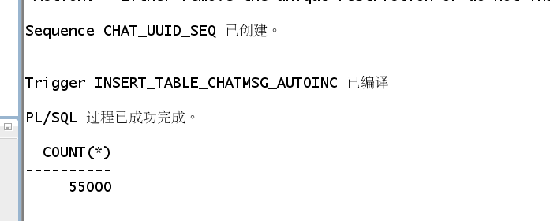

## 4.存储过程和函数设计

### 4.1在数据库中建立一个程序包，在包中用PL/SQL语言设计一些存储过程和函数

创建一个包为TPack

函数Get_UserRegisTime为获取用户注册时间的函数

存储过程ADD_User是插入用户信息

create or replace PACKAGE TPack IS  
 FUNCTION Get_UserRegisTime(V_UUID NUMBER) RETURN DATE;  
 PROCEDURE ADD_User(account number,password varchar2,state number,name varchar2,REGISTRATIONDATE VARCHAR2);  
END TPack;

### 4.2在包中创建一个函数，存储过程

create or replace PACKAGE BODY TPACK IS  
FUNCTION Get_UserRegisTime(UUID NUMBER) RETURN DATE  
AS  
Res DATE;   
BEGIN  
 select REGISTRATIONDATE into Res from table_users where V_UUID=UUID;  
 RETURN Res;  
END;  
 procedure ADD_User(account number,password varchar2,state number,name varchar2,registerdate VARCHAR2) as  
begin  
 declare maxId number;  
begin  
 select max(id) into maxId from TABLE_USERS;  
 insert into TABLE_USERS   
 values(maxId+1,account,password,state,name,to_date(registerdate,'yyyy-mm-dd'));  
commit;  
end;  
end ADD_User;  
END TPACK;

创建成功后包结构如下

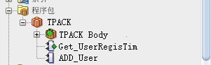

使用自定义函数Get_UserRegisTime()查询uuid号为11111的注册时间

select TPACK.Get_UserRegisTime(11111) from dual;

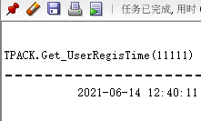

使用存储过程ADD_User插入数据

set serveroutput on  
declare  
begin  
TPACK.ADD_User('666','123','1','wuhu','2021-06-01');  
end;



### 4.3执行计划分析

select * from TABLE_USERS a,TABLE_CHATMSG b where a.uuid=b.SENDERUUID and a.REGISTRATIONDATE between to_date('2020-1-1','yyyy-mm-dd') and to_date('2020-6-1','yyyy-mm-dd');

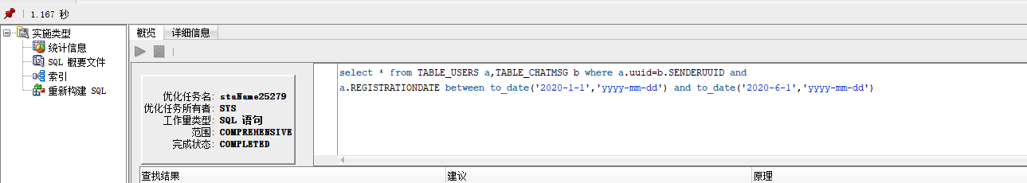

## 5.备份方案设计

### 5.1全备份

[[oracle@oracle-pc ~]$ cat yyt_level0.sh  
#yyt_level0.sh   
#!/bin/sh  
  
export NLS_LANG='SIMPLIFIED CHINESE_CHINA.AL32UTF8'  
export ORACLE_HOME=/home/oracle/app/oracle/product/12.1.0/dbhome_1   
export ORACLE_SID=orcl   
export PATH=$ORACLE_HOME/bin:$PATH   
  
  
yyt target / nocatalog msglog=/home/oracle/yyt_backup/lv0_`date +%Y%m%d-%H%M%S`_L0.log << EOF  
run{  
configure retention policy to redundancy 1;  
configure controlfile autobackup on;  
configure controlfile autobackup format for device type disk to '/home/oracle/yyt_backup/%F';  
configure default device type to disk;  
crosscheck backup;  
crosscheck archivelog all;  
allocate channel c1 device type disk;  
backup as compressed backupset incremental level 0 database format '/home/oracle/yyt_backup/dblv0_%d_%T_%U.bak'  
 plus archivelog format '/home/oracle/yyt_backup/arclv0_%d_%T_%U.bak';  
report obsolete;  
delete noprompt obsolete;  
delete noprompt expired backup;  
delete noprompt expired archivelog all;  
release channel c1;  
}  
EOF  
  
exit  
[oracle@oracle-pc ~]$ ./yyt_level0.sh   
[oracle@oracle-pc ~]$ cd yyt_backup/  
[oracle@oracle-pc yyt_backup]$ ls  
arclv0_ORCL_20210525_90ugiejc_1_1.bak dblv0_ORCL_20210511_8uugiegr_1_1.bak  
arclv1_ORCL_20210525_92ugiel4_1_1.bak dblv0_ORCL_20210525_8vugieii_1_1.bak  
arclv1_ORCL_20210525_96ugielk_1_1.bak dblv1_ORCL_20210525_93ugiel5_1_1.bak  
c-1392946895-20210525-02 dblv1_ORCL_20210525_94ugield_1_1.bak  
c-1392946895-20210525-00 lv0_20210525-003303_L0.log  
c-1392946895-20210525-01 lv0_20210525-174530_L0.log  
dblv0_ORCL_20210525_8tugiefo_1_1.bak lv1_20210525-003650_L0.log

### 5.2备份后模拟数据库文件损坏、数据库完全恢复

