**\*\*\*\*\*\*\*\*\*\*\*\*\*\*\*\*\*\*\*\*\*\*\*Notes for running Simpact on VSC\*\*\*\*\*\*\*\*\*\*\*\*\*\*\*\*\*\*\*\*\*\*\***

**Accessing VSC with Windows**

1. Run Xming
2. Run PuTTy
3. Open tunnel with Pegeant

Source: <https://vscentrum.be/neutral/documentation/cluster-doc/access-data-transfer>

**Accessing VSC with MAC**

Login to HPC in debug mode

*$ ssh -vv vsc30534@login1.vic3.cc.kuleuven.be*

**Working Flow**

1. Test codes on log-in nodes
2. Prepare parameters file: see ***run_parameters.txt***

eg:

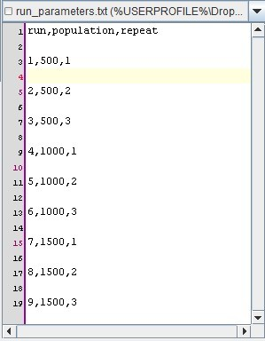

1. Prepare the ‘.pbs’ file: see ***simpact.pbs***

*eg.*

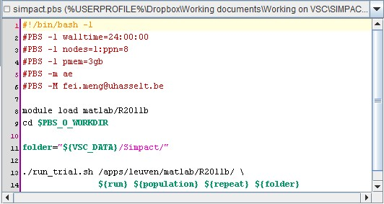

1. Compile Matlab files with ‘mcc’ command: see ***compile.sh***

*eg. $ compile.sh*

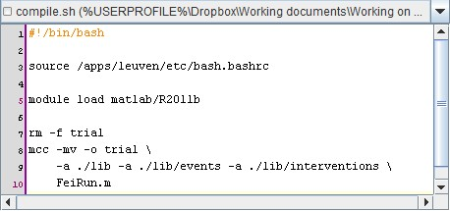

1. Run simulations with *Worker* framework:

*eg. $ module load worker/1.2*

*$ wsub -A* lp_h_hiv_prevention *-batch simpact.pbs -data run_parameters.txt*

**\*\*\*\*\*\*\*\*\*\*\*\*\*\*\*\*\*\*\*\*\*\*\*Important Notes for Coding\*\*\*\*\*\*\*\*\*\*\*\*\*\*\*\*\*\*\*\*\*\*\***

1. There are several MatLab versions on HPC.

The default version is 2009, which is too old for most projects. Thus a specific version should be loaded.

eg. *module load matlab/2011b*

1. All ‘addpath’ or ‘path’ function should only be used when a ‘~isdeployed’ check returns ‘true’. ** In our case, in jproject.m, modelHIV.m, and simpact.m as well.

eg.

*if ~isdeployed*

*addpath(…)*

*end*

1. In multiple Simpact runs, variables such as population size, index of run, should always be a parameter.

eg. Instead of using loops like ‘for population = 500:500:1500 …’, the top level function should ALWAYS be like function(population,…).

1. Parameters are ALWAYS strings, or converted to strings.

eg. *p = num2str(population)*

1. NO SPACES in any file names.
2. Instead of adding output structures to a ‘main structure’ and save them later in a loop, save them after EACH RUN. Thus the outputs from completed runs will be achievable even if the simulation is interrupted later.
3. Remove the ‘*fprint’* function.
4. Remove the buffer.
5. Reset the random seed for EACH RUN using a UNIQUE parameter.

*eg. index parameter ‘run’ in the modified code*

1. While compiling the code, ALL paths should be added.
2. Use ABSOLUTE paths/directors instead of relative paths/directors.
3. Use Worker efficiently. For example, assigning 2 large jobs to one node and 2 smalle ones to another node is not as smart as assigning 1 large job and 1 small job to each node.
4. To check on the job status, use:

*$ qstat <id>*

*$ checkjob <id>*

To delete a job from the queue, use

*$ qdel <id>*

1. Other modifications to the .pbs/.sh/.m file: see the new .pbs/.sh/.m files.