COMP9417 Machine Learning and Data Mining

Final Examination: SAMPLE QUESTIONS 15S01

Question 1 [20 marks]

Association Rule Learning & and ILP

A) [7 marks]

An association rule has the form A ! C where A is the antecedent and C is the consequent.

Suppose you have a database of one million transactions.

1) If an association rule has 90% support, how many transactions contain all the items

in A ?

2) For the same rule, how many transactions contain all the items in C ?

3) For the same rule, how many transactions contain all the items in both A and C ?

4) If another rule has 40% support and 100% confidence, how many transactions contain

all the items in A ?

5) If yet another rule has 40% support and 50% confidence, how many transactions

contain all the items in A ?

B) [3 marks]

You are mining a data warehouse. In three sentences or less propose a method to derive

all candidate item sets of size k + 1 from the k-item sets with at least minimum support.

C) [4 marks]

Consider the following two clauses:



Using inverse resolution, provide at least one solution for C2. [Show all substitutions].

D [6 marks]

Construct the Relative Least General Generalisation (RLGG) of two observations: likes(alan,sushi) and likes(alan,curry), given the background predicates

food(sushi) and food(curry). Now suppose you are given two more observations:

likes(bettina,sushi) and likes(bettina,curry). Will the RLGG of the four observations, given the same background predicates, change ? If you think the answer is yes,

give the new RLGG, otherwise give an argument why it will not have changed. [Show all

Working].

Question 2 [20 marks]

Comparing Lazy and Eager Learning

The following truth table gives an “m-of-n function" for three Boolean variables, where “1"

denotes true and “0" denotes false. In this case the target function is: \exactly two out of three

variables are true".

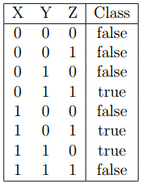

A) [4 marks]

Construct a decision tree which is complete and correct for the examples in the table. [Hint:

draw a diagram.]

B) [4 marks]

Construct a set of ordered classification rules which is complete and correct for the examples in the table. [Hint: use an if{then{else representation.]

C) [10 marks]

Suppose we define a simple measure of distance between two equal length strings of Boolean

values, as follows. The distance between two such strings B1 and B2 is:



where Bi is simply the number of variables with value 1 in string Bi. For example:



and



What is the LOOCV (“Leave-one-out cross-validation") error of 2{Nearest Neighbour

using our distance function on the examples in the table ? [Show your working.]

D) [2 marks]

Compare your three models. Which do you conclude provides a better representation for

this particular problem ? Give your reasoning (one sentence).

4 Please see over

Question 3 [20 Marks]

Mistake Bounds

Consider the following learning problem on an instance space which has only one feature, i.e.,

each instance is a single integer. Suppose instances are always in the range [1; 5]. The hypothesis

space is one in which each hypothesis is an interval over the integers. More precisely, each

hypothesis h in the hypothesis space H is an interval of the form a ≤ x ≤ b, where a and b are

integer constants and x refers to the instance. For example, the hypothesis 3 ≤ x ≤ 5 classifies

the integers 3, 4 and 5 as positive and all others as negative.

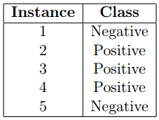

A) [15 marks]

Apply the Halving Algorithm to the five examples in the order in which they appear

in the table above. Show each class prediction and whether or not it is a mistake, plus the

initial G and S sets and those at the end of each iteration.

B) [5 marks]

What is the worst-case mistake bound for the Halving Algorithm given the hypothesis

space described above ? Give an informal derivation of your bound.

Question 4 [20 marks]

Evaluation of Learning

A) [3 marks]

You have implemented a new two-class classifier learning algorithm that outputs a "score"

to indicate how strongly it believes an input instance to be in the positive class. Explain

how you could use a margin-based approach to penalise incorrect classifications.

B) [3 marks]

The AUC (area under the ROC curve) measure originated in signal detection theory. For

the evaluation of classifier learning on a two-class prediction problem, can you think of a

probabilistic interpretation of this measure?

C) [14 marks]

Suppose the following decision tree has been learned on a training set of 10 positive and

10 negative examples for a \play sport" task.

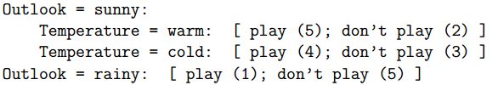

The three leaves of the tree each show the number of positive (play) and negative (don’t

play) examples in each leaf. Using a scoring function based on the ratio of positive to

negative examples in each leaf node, generate the ranking of the training set produced by

this scoring function. Then compute the ranking error for the tree on the training data.

Question 5 [20 Marks]

Computational Learning Theory

A) [8 marks]

An instance space X is defined using m Boolean attributes. Let the hypothesis space H

be the set of decision trees defined on X (you can assume two classes). What is the largest

set of instances in this setting which is shattered by H ? [Show your reasoning.]

B) [10 marks]

Suppose we have a consistent learner with a hypothesis space restricted to conjunctions

of exactly 8 attributes, each with values ftrue; false; don’t careg. What is the size of this

learner’s hypothesis space ? Give the formula for the number of examples sufficient to learn

with probability at least 95% an approximation of any hypothesis in this space with error

of at most 10%. [Note: you are not required to compute the solution.]

C) [2 marks]

Informally, which of the following are consequences of the No Free Lunch theorem:

a) averaged over all possible training sets, the variance of a learning algorithm dominates

its bias

b) averaged over all possible training sets, no learning algorithm has a better off-training

set error than any other

c) averaged over all possible target concepts, the bias of a learning algorithm dominates

its variance

d) averaged over all possible target concepts, no learning algorithm has a better offtraining set error than any other

e) averaged over all possible target concepts and training sets, no learning algorithm is

independent of the choice of representation in terms of its classification error

Question 6 [20 marks]

Ensemble Learning

A) [8 marks]

As model complexity increases from low to high, what effect does this have on:

1) Bias ?

2) Variance ?

3) Predictive accuracy on training data ?

4) Predictive accuracy on test data ?

B) [3 marks]

Is decision tree learning relatively stable ? Describe decision tree learning in terms of bias

and variance in no more than two sentences.

C) [3 marks]

Is nearest neighbour relatively stable ? Describe nearest neighbour in terms of bias and

variance in no more than two sentences.

D) [3 marks]

Bagging reduces bias. True or false ? Give a one sentence explanation of your answer.

E) [3 marks]

Boosting reduces variance. True or false ? Give a one sentence explanation of your answer.

Question 7 [20 marks]

Bayesian Learning

A) [4 marks]

Explain the difference between the maximum a posteriori hypothesis HMAP and the maximum likelihood hypothesis HML.

B) [2 marks]

Consider a two-class learning problem to “Play tennis", with two Boolean attributes,

“Cloudy" and “Windy". Draw the Bayesian network corresponding to a Naive Bayes

classifier for this problem.

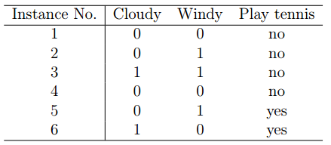

C) [10 marks]

Given the following examples, calculate all the probabilities required for your Naive Bayes

classifier to be able to decide whether to play or not:

D) [4 marks]

To which class would your Naive Bayes classifier assign each of the following instances ?

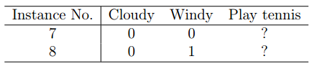

END OF PAPER