RIDE Fall 2026 · Group 6
Wi-Fi Sensing Using Channel State Information
Midterm Report
Yusuf Shaikh, Thomas Alcorn, Karl Wara, Vihaan Vuppala
October 19, 2026

1. Project Objectives
When a person moves through a room, they change how Wi-Fi signals travel between two radios. A Wi-Fi receiver already measures this change for its own use: the Channel State Information (CSI), a per-frequency estimate of how the room altered each frame. This project uses CSI from low-cost ESP32-C6 boards to sense people in a room without cameras, wearables, or any device carried by the person.

1.1 Objectives
- Measurement platform (Module 1). Build a repeatable CSI capture system from ESP32-C6 boards and characterize it against known physical conditions.
- Presence and motion detection (Module 2). Classify a recording as empty, occupied and still, or occupied and moving.
- Zone localization (Module 3). Identify which of three labeled zones a person is in, using several receivers.
- Scalability. Add receivers through configuration only, with no code changes, so the same system grows from one link to many.

1.2 Expected Outcomes
At the end of the semester the project will deliver a documented capture platform, a characterization of the channel across distance, obstruction, and receiver position, a presence and motion detector with accuracy measured on recordings not used for tuning, a three-zone classifier, and a live demonstration of real-time detection in the room. Section 6 lists these deliverables and their current status.

2. Fundamental Theory

2.1 Multipath Propagation
A Wi-Fi signal reaches the receiver along many paths at once: the direct line of sight, and reflections off walls, furniture, and people (Figure 1). Each path arrives with its own attenuation and delay, and the receiver sees their sum. A static room produces a stable sum. A person moving changes the length of the paths that reflect off them, so the sum changes over time.
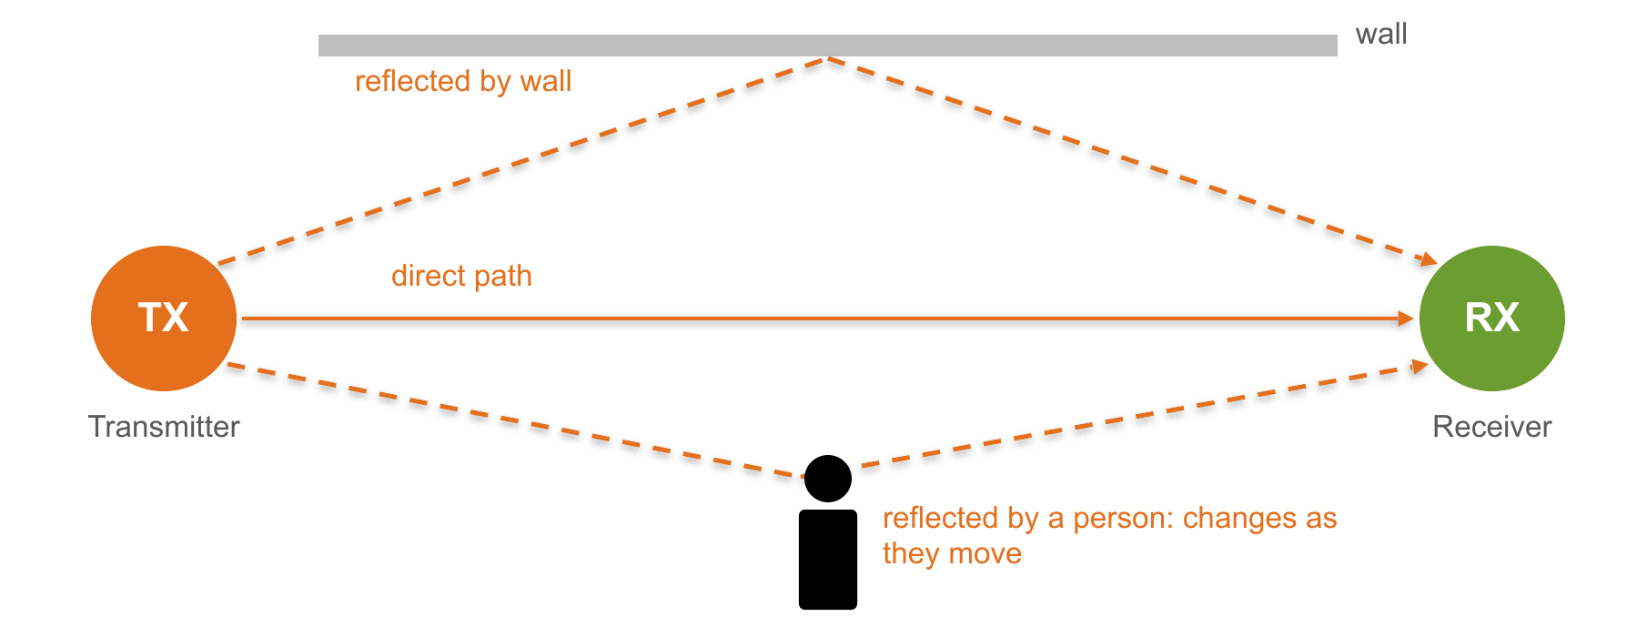
Figure 1. Multipath between a transmitter and a receiver. The direct and wall-reflected paths are fixed; the path reflected by a person changes as they move.

2.2 OFDM Subcarriers and Channel State Information
802.11n Wi-Fi uses orthogonal frequency-division multiplexing (OFDM): a 20 MHz channel is divided into 64 subcarriers spaced 312.5 kHz apart. Each frame begins with training symbols whose content the receiver already knows. Comparing the received training symbol Y with the known transmitted symbol X on each subcarrier k gives the channel estimate:
Y(fₖ) = H(fₖ) · X(fₖ) + N(fₖ), H(fₖ) = |H(fₖ)| · e^{jθ(fₖ)}
The set of complex values H(fₖ) across all subcarriers is the CSI. Because the received signal is the sum of L paths with gains aᵢ and delays τᵢ, the channel at each frequency is
H(f) = Σᵢ aᵢ · e^{−j2πfτᵢ}
The paths add constructively at some frequencies and cancel at others, so the amplitude varies across subcarriers (frequency-selective fading). Figure 2 shows one real frame captured by our receiver: the deep dip around subcarrier slots 33 to 45 is multipath cancellation. Changing any path, for example by a person walking, changes this pattern, which is why CSI carries much more information than a single signal-strength (RSSI) number.
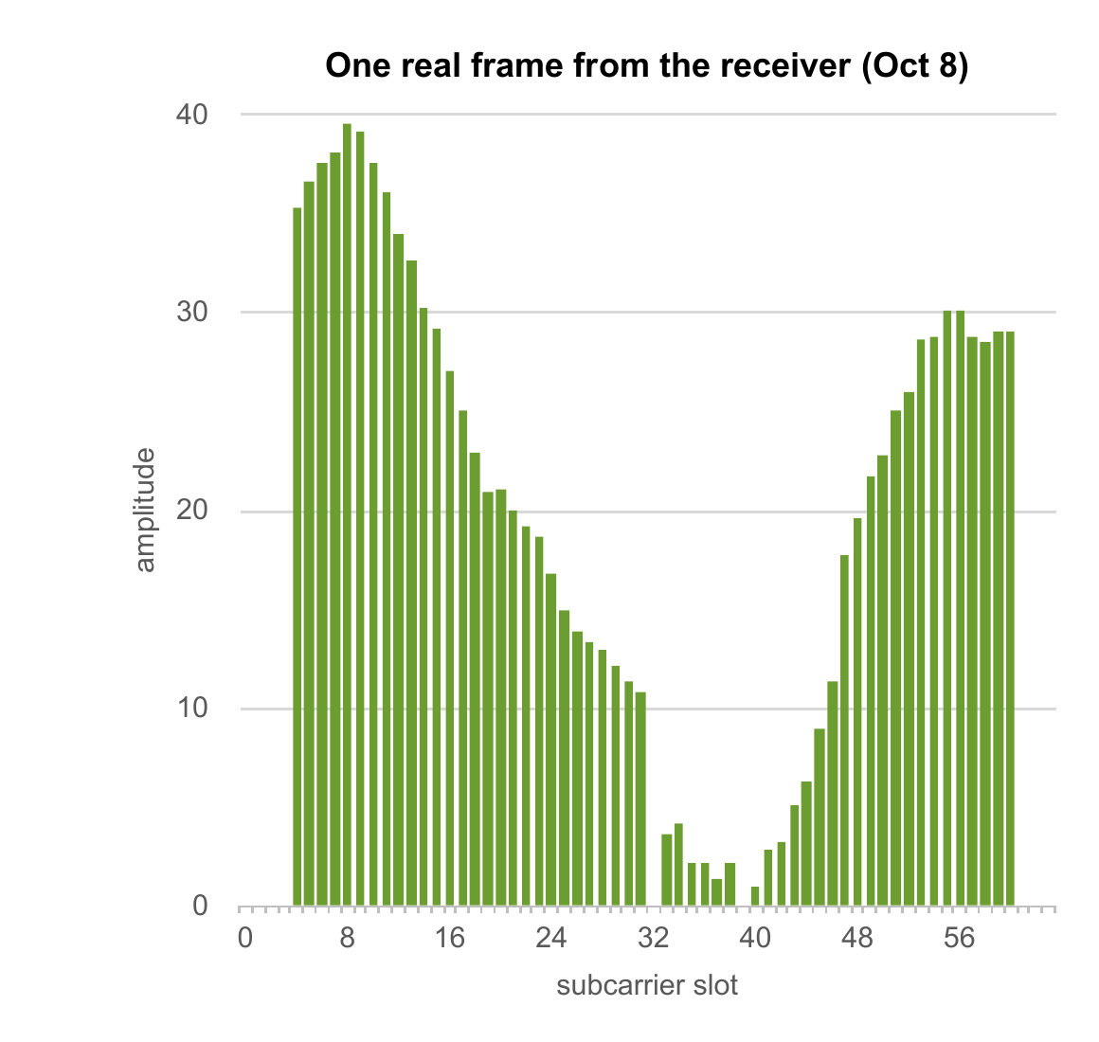
Figure 2. Amplitude of the 64 subcarrier slots in one frame captured by the receiver (October 8). 56 slots carry signal; the empty slots are guard bands and the center (DC) slot.

2.3 Practical Considerations on the ESP32-C6
- Usable subcarriers. Of the 64 slots in a 20 MHz 802.11n frame, 56 carry signal; slots 0–3, 32 (DC), and 61–63 are always zero.
- Amplitude, not phase. Each slot gives an amplitude √(I² + Q²) and a phase. On a single-antenna ESP32, the phase is shifted on every frame by carrier and sampling frequency offsets between the two boards, so this project uses amplitude.
- Automatic gain control. The radio rescales every frame to a convenient level, which moves all subcarriers up or down together. Dividing each frame by its mean amplitude cancels this.
- Single radio. Each board can listen only on the channel it is connected to, which shapes the network design in Section 3.

2.4 Motion Score
For a first detector we use a motion score that measures how much the subcarriers change relative to each other. With aₖ(t) the amplitude of subcarrier k in frame t, each frame is first normalized by its mean across subcarriers, ãₖ(t) = aₖ(t) / meanₖ aₖ(t). The score is the standard deviation of each normalized subcarrier over a rolling window of W = 50 frames (about half a second), averaged across the K active subcarriers:
score(t) = (1/K) · Σₖ std_{t−W<s≤t} ãₖ(s)
The score is near its baseline in a still room and rises when someone moves through the link. The normalization makes it insensitive to the gain changes described above. A test in the code base checks both properties: a simulated gain step does not raise the score, and simulated movement does.

2.5 Toward Localization
One transmitter and one receiver form a single link: a single path through the room, which can detect motion but not locate it. With several receivers, each link is sensitive mainly to motion near the line between its two boards. Combining which links are disturbed gives a coarse map of where a person is, an approach known as radio tomographic imaging [4]. This is the basis for Module 3.

3. System Design

3.1 Architecture
Figure 3 shows the system. One transmitter broadcasts a short frame 100 times per second. Every receiver measures CSI from each frame and publishes one record per frame over MQTT to a hub on a laptop. The hub stamps each record with its arrival time, writes one CSV file per receiver, and drives a live plot. All boards and the laptop join the same 2.4 GHz Wi-Fi network; because each board has one radio, this network's channel is also the sensing channel.
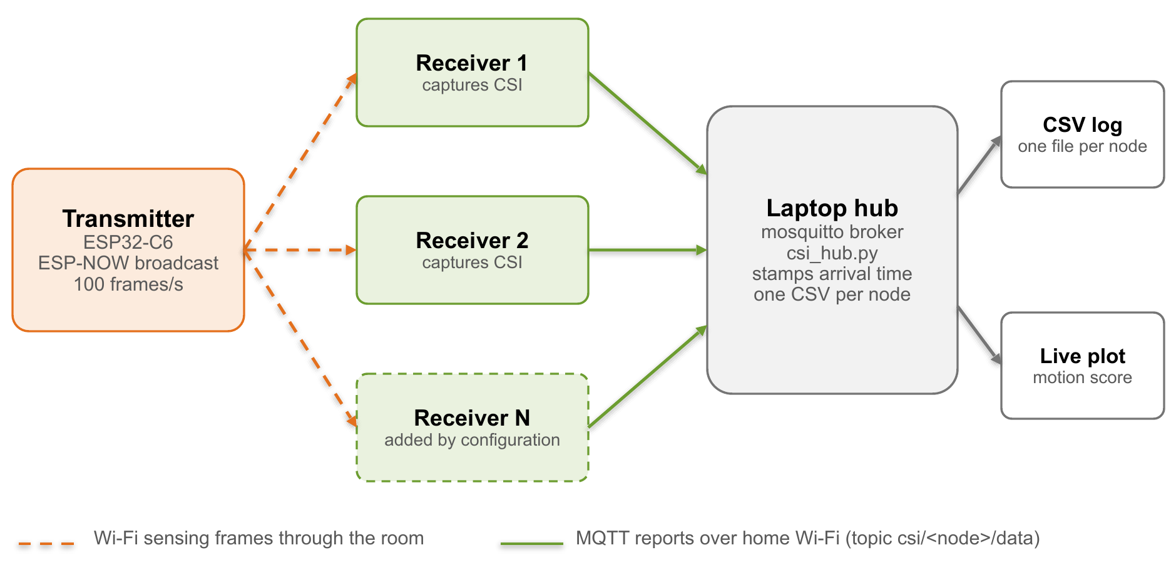
Figure 3. System block diagram. Dashed orange: Wi-Fi sensing frames through the room. Solid green: MQTT reports over the home Wi-Fi network.

3.2 Hardware Configuration
Table 1. Hardware configuration.
Item | Configuration
Boards | ESP32-C6 development boards (ESP32-C6-1-N4 module, 4 MB flash). One transmitter and one receiver in use; seven boards on hand.
Radio | Single antenna, 2.4 GHz only. Wi-Fi 6 capable; operated in 802.11n mode at 20 MHz.
Power and interface | 5 V over USB. Flashed and configured through the board's COM (CH343 USB-to-serial) port at 921600 baud.
Placement | Boards 2–3 m apart at waist height with a clear line of sight.
Hub | Laptop running the mosquitto MQTT broker and the Python hub (paho-mqtt, NumPy, Matplotlib).

3.3 Firmware Design
Both boards run C++ firmware on ESP-IDF 5.5.5, Espressif's framework built on the FreeRTOS real-time operating system, compiled with PlatformIO. Each board's firmware is one annotated source file.
- Transmitter. Joins the Wi-Fi network (which sets its channel) and broadcasts a 4-byte counter using ESP-NOW, Espressif's connectionless protocol. Frames are forced to 802.11n at MCS0, because ESP-NOW's default 802.11b format has no OFDM subcarriers and would produce no CSI. A fixed-period scheduler (vTaskDelayUntil) keeps the interval at exactly 1/RATE seconds. The transmitter uses a fixed address, 1a:00:00:00:00:01.
- Receiver. Joins the same network and listens to every frame on the channel (promiscuous mode). The CSI callback discards any frame whose sender does not start with 1a:00:00:00:00, so a new receiver needs no transmitter-specific setup. Only 802.11n 20 MHz frames produce CSI, so every record has the same 128-value shape.
- Non-blocking reporting. The CSI callback runs inside the Wi-Fi driver's task and must never wait on the network, or the radio stalls. It copies each record into a 32 KB ring buffer and returns immediately; a separate low-priority task publishes records to the broker. If the buffer fills, records are dropped rather than queued without limit, and the gap appears in the sequence number.
- Configuration. Per-board settings (Wi-Fi name and password, node ID, hub address, packet rate) are typed over the serial console and stored in the board's flash. Every receiver runs identical firmware; only these settings differ.

3.4 Data Format
Each receiver publishes to the MQTT topic csi/<node_id>/data. The hub subscribes to csi/+/data, so new receivers are picked up without changes. Each CSV row has 28 fixed columns; the most important are listed in Table 2. Adding a receiver adds a file, never a column.
Table 2. Key columns of the CSV record.
Column | Meaning
arrival_epoch | Arrival time on the hub's clock (seconds). The shared timeline across boards, whose own clocks are not synchronized.
node_id, seq | Receiver name and per-board frame counter. A gap in seq marks dropped records.
mac | Sender of the frame (the transmitter).
rssi, noise_floor | Received signal strength and noise floor (dBm).
local_timestamp | Receiver radio timestamp (µs). Frames arrive 10 ms apart at 100 frames/s.
csi | 128 signed values: 64 subcarriers × (imaginary, real).

4. Preliminary Results

4.1 Platform Performance
Table 3 summarizes measurements of the capture platform. The first three come from the receiver's serial output with the broadcast design (1,139 frames, October 8). The hub delivery rate comes from the hub's log on the same day with the original single-receiver design, in which the receiver ran its own Wi-Fi network.
Table 3. Platform measurements.
Measurement | Result
Frame rate at the receiver (target 100/s) | 100.1 frames/s, from the receiver's radio timestamps
Spacing between frames | 99.3% exactly 10 ms; 100% within ±1 ms
Frames kept from the transmitter | 100%, each with 128 CSI values
Records logged by the hub over MQTT | 85.7 records/s (original single-receiver design)

Bring-up uncovered three problems, all fixed:
- The hub received only one record per second. Records were handed to the MQTT library's own queue, which sends one queued message per pass of a loop that can wait up to a second. The ring buffer and dedicated publish task (Section 3.3) fixed this.
- The transmitter ran at about 86 frames/s instead of 100, because its delay did not account for the time spent sending. Fixed-period scheduling brought it to 100.1 frames/s.
- The transmitter firmware, written for the dual-core original ESP32, assigned a task to a second processor core. The ESP32-C6 has one main core, so the board rebooted in a loop until the task was left unassigned.
The original design also limited the system to one receiver per transmitter and took the hub laptop off the internet, since it had to join the receiver's own network. The broadcast design removes both limits. Its hub delivery rate over a home Wi-Fi network has not yet been measured.

4.2 First Motion Recording
Figure 4 shows a 97-second recording on a single link from October 8, using about 52 transmitter frames per second. The top panel shows the amplitude of the 56 active subcarriers over time; the bottom panel shows the motion score. In still periods the pattern is steady and the score stays near its baseline. During movement the pattern breaks up across subcarriers and the score rises sharply.
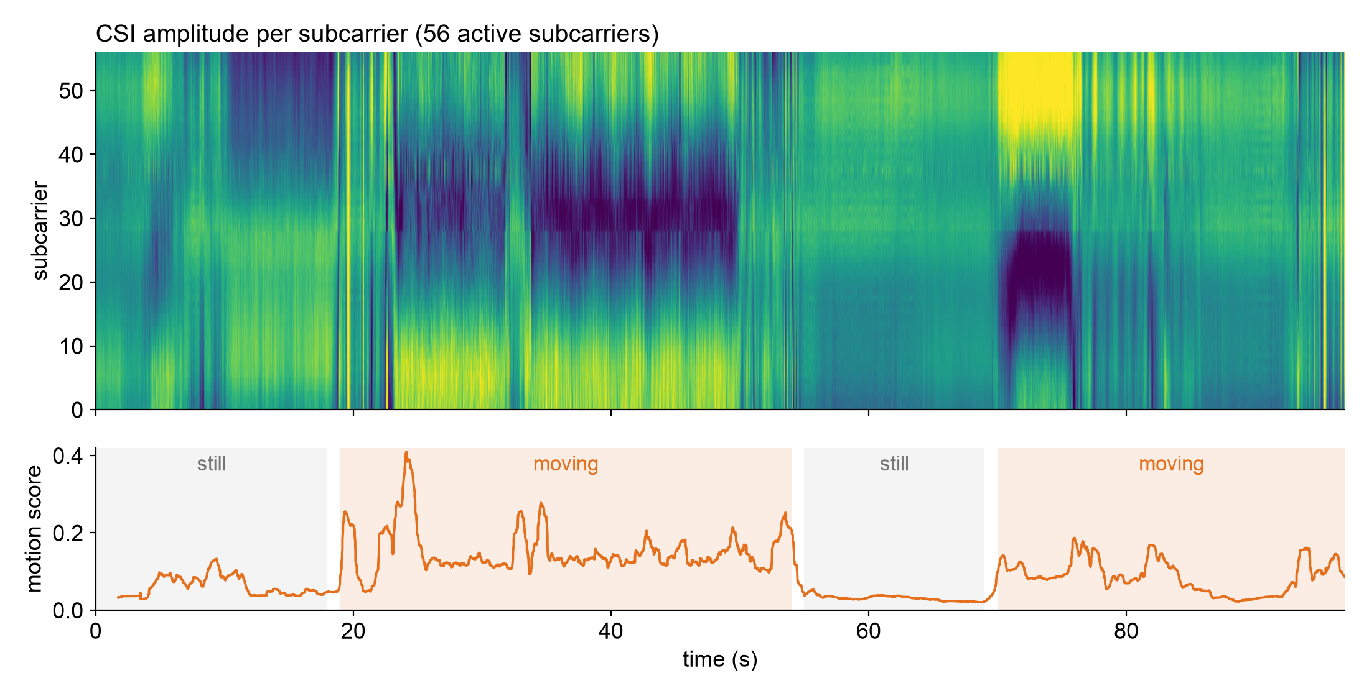
Figure 4. CSI amplitude (top) and motion score (bottom) for a 97 s recording. Shaded stretches were labeled from this timeline after the recording.

4.3 Still Versus Moving
Figure 5 and Table 4 compare the motion score in the still and moving stretches. The median score while moving is roughly three to four times the median while still, so even a fixed threshold would separate the two in this recording.
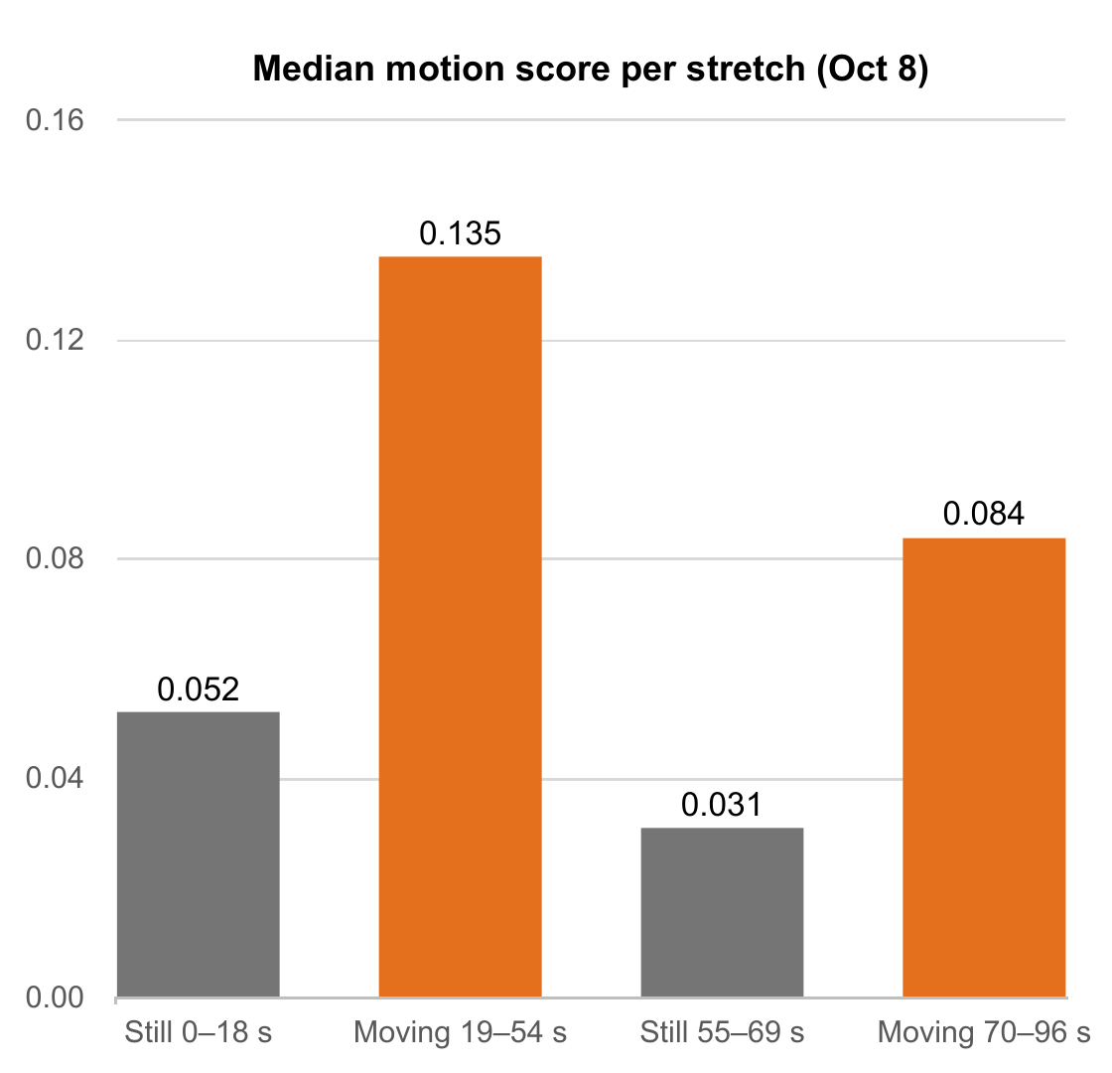
Figure 5. Median motion score for each stretch of the October 8 recording.
Table 4. Motion score by stretch.
Stretch | State | Median score | 95th percentile
0–18 s | Still | 0.052 | 0.107
19–54 s | Moving | 0.135 | 0.261
55–69 s | Still | 0.031 | 0.044
70–96 s | Moving | 0.084 | 0.161

Limitations. These are early results from one recording on one link. The still and moving stretches were labeled from the timeline afterwards rather than logged during the test, and about 40% of the frames in this recording came from other devices on the network and were filtered out. The next step is labeled recording sessions (empty, occupied and still, occupied and moving) so that accuracy can be measured on data not used to tune the detector.

5. Project Completion Plan

5.1 Remaining Tasks
- Hardware. Verify multi-receiver reporting over the home Wi-Fi network end to end; add two to three receivers at fixed, marked positions; measure delivery rate and dropped records per receiver.
- Data collection. Record labeled sessions (empty, still, moving) with per-run metadata; characterize the channel across transmitter–receiver distance, with and without obstruction, and at different receiver positions.
- Analysis. Following the Week 1 methodology: remove outlier readings, filter to human-movement rates, reduce the correlated subcarriers to a few components, start with a threshold detector and move to a trained classifier; report accuracy on held-out sessions.
- Localization, demo, and report. Train the three-zone classifier on multiple receivers; show detection output live on the hub; write the final report.

5.2 Timeline
Table 5. Milestones. Channel characterization, first planned for mid-October, now follows the multi-receiver firmware.
Milestone | Target | Status
Hardware platform working, first CSI captures | End of September | Done
Multi-receiver firmware: broadcast and Wi-Fi reporting | Mid-October | In progress
Labeled recordings: empty, still, moving | Late October | Planned
Channel characterization: distance, obstruction, position | Early November | Planned
Presence and motion detector, accuracy on held-out data | Mid-November | Planned
Additional receivers and three-zone classification | Late November | Planned
Live demonstration | December 7 | Planned
Final report | December 11 | Planned

5.3 Risks
- Still occupants. A perfectly still person changes the channel very little. If empty versus still proves unreliable, it will be reported as a characterized limitation.
- Shared channel. Sensing uses the home network's channel, so other traffic shares the air. The receiver's sender filter removes other devices' frames; delivery rate will be monitored per receiver.
- Room dependence. Zone localization is valid only for the room and layout it was trained in, and degrades when furniture or boards move. Fixed, marked board positions keep sessions comparable.

6. Final Deliverables
Table 6. Final deliverables and current status.
# | Deliverable | Description | Status
1 | Capture platform | ESP32-C6 firmware and hub, with a documented data format and per-run metadata | Working
2 | Channel characterization | CSI measured across distance, with and without obstruction, and at different receiver positions | Planned
3 | Presence and motion detector | Empty, still, or moving, with accuracy reported on recordings not used for tuning | First results
4 | Zone classifier | Three labeled zones using multiple receivers, tested on a separate recording session | Planned
5 | Live demonstration | Real-time detection running in the room at the final presentation | Partly working
6 | Final report | Methodology, results, and limitations, with the code repository | Planned

References
- S. M. Hernandez and E. Bulut, “Lightweight and Standalone IoT Based WiFi Sensing for Active Repositioning and Mobility,” in Proc. IEEE WoWMoM, 2020.
- Espressif Systems, “ESP-CSI: Applications based on Wi-Fi Channel State Information,” github.com/espressif/esp-csi.
- D. Halperin, W. Hu, A. Sheth, and D. Wetherall, “Tool Release: Gathering 802.11n Traces with Channel State Information,” ACM SIGCOMM Computer Communication Review, vol. 41, no. 1, 2011.
- J. Wilson and N. Patwari, “Radio Tomographic Imaging with Wireless Networks,” IEEE Transactions on Mobile Computing, vol. 9, no. 5, 2010.

