ANA515 Assignment 2_week 5

Fang Tham

2022-09-23

This is a graph that shows the frequency of airplane passengers that recline their seats

ggplot(data = newetq2) +   
 geom_bar(mapping = aes(x = Recline_Freq))

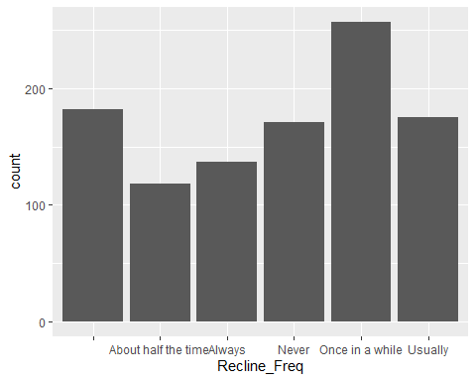

This is a graph that shows the relationship between age and whether they think reclining seas on an airplena is rude

ggplot(newetq2,  
 aes(x = Recline_Rude,  
 fill = Age)) +  
 geom_bar(position = "stack")

