1. This report reorganizes the RF section around validation rigor, spatial and temporal evaluation, external generalization, and interpretability. RF now follows the same 5-fold TimeSeriesSplit protocol as the latest XGBoost and MLP pipelines.
2. Data, features, and model configuration. RF is trained on the shared Chicago 2015-2024 dataset and evaluated on Chicago 2025 plus Texas/NIBRS. The final parameter setting remains stable to preserve continuity with the earlier RF baseline.
3. Validation protocol. Training rows are sorted by iso_year, iso_week, and grid_id before TimeSeriesSplit. This makes the cross-validation genuinely chronological and therefore more realistic for a forecasting task.
Table 1. TimeSeriesSplit cross-validation summary.
Task | CV Precision (mean+/-std) | CV Recall (mean+/-std) | CV F1 (mean+/-std) | CV AUC (mean+/-std)
THEFT | 0.7998 +/- 0.0221 | 0.7759 +/- 0.0379 | 0.7876 +/- 0.0299 | 0.8461 +/- 0.0120
BATTERY | 0.7872 +/- 0.0135 | 0.7864 +/- 0.0221 | 0.7866 +/- 0.0151 | 0.8570 +/- 0.0063
CRIMINAL DAMAGE | 0.6585 +/- 0.0061 | 0.7523 +/- 0.0345 | 0.7020 +/- 0.0175 | 0.8067 +/- 0.0023
4. Main performance on Chicago 2025 and Texas/NIBRS. RF remains strong on Chicago 2025 and still transfers meaningfully to Texas/NIBRS.
Table 2. Chicago 2025 and Texas/NIBRS detailed results.
Task | Chicago P | Chicago R | Chicago F1 | Chicago AUC | Texas P | Texas R | Texas F1 | Texas AUC
THEFT | 0.8027 | 0.7777 | 0.7900 | 0.8510 | 0.8672 | 0.6330 | 0.7318 | 0.8767
BATTERY | 0.7761 | 0.7816 | 0.7789 | 0.8508 | 0.8545 | 0.5700 | 0.6838 | 0.8511
CRIMINAL DAMAGE | 0.6291 | 0.7462 | 0.6827 | 0.7933 | 0.6847 | 0.4775 | 0.5626 | 0.8372
5. Spatial accuracy evaluation on Chicago 2025. Spatial performance is now reported through historical risk-group summaries, hotspot hit-rate / coverage, and per-grid error exports. RF performs much better in historically high-risk grids than in low-risk grids.
Table 3. Chicago spatial risk-group summary.
Task | Low Risk F1 | Medium Risk F1 | High Risk F1 | High/Low F1 Ratio
THEFT | 0.0163 | 0.5485 | 0.9338 | 57.1331
BATTERY | 0.0133 | 0.5225 | 0.9289 | 70.0941
CRIMINAL DAMAGE | 0.0041 | 0.3943 | 0.8150 | 200.6033
Table 4. Chicago hotspot hit-rate and coverage summary.
Task | HitRate@5 | Coverage@5 | HitRate@10 | Coverage@10 | HitRate@20 | Coverage@20
THEFT | 0.2000 | 0.0136 | 0.3000 | 0.0271 | 0.5000 | 0.0542
BATTERY | 0.0000 | 0.0141 | 0.2000 | 0.0282 | 0.6000 | 0.0561
CRIMINAL DAMAGE | 1.0000 | 0.0174 | 0.7000 | 0.0333 | 0.5500 | 0.0642
6. Temporal accuracy measures on Chicago 2025. Quarterly ranges remain relatively narrow, especially for THEFT and BATTERY, which supports temporal stability across the 2025 holdout year.
Table 5. Quarterly temporal stability summary.
Task | Quarterly F1 Range | Quarterly AUC Range | Quarterly Recall Range
THEFT | 0.7818-0.7992 | 0.8483-0.8541 | 0.7736-0.7858
BATTERY | 0.7616-0.7903 | 0.8380-0.8573 | 0.7647-0.7965
CRIMINAL DAMAGE | 0.6537-0.7022 | 0.7846-0.8003 | 0.7150-0.7742
7. Texas/NIBRS spatial generalization. Agency-level group summaries show the same pattern seen in Chicago: RF is strongest in the highest-risk units and weakest in the lowest-risk ones.
Table 6. Texas observed-risk grouping summary.
Task | Low Risk F1 | Medium Risk F1 | High Risk F1
THEFT | 0.0031 | 0.1694 | 0.8658
BATTERY | 0.0006 | 0.1371 | 0.8278
CRIMINAL DAMAGE | 0.0000 | 0.0546 | 0.5956
8. Feature importance and interpretation. RF remains mainly driven by medium-term rolling activity variables, which fits the earlier interpretation that sustained local crime intensity matters more than isolated short-term spikes.
Table 7. Top five features for each task.
Task | Top1 | Top2 | Top3 | Top4 | Top5
THEFT | roll_12w_total | roll_12w_THEFT | roll_26w_THEFT | roll_4w_total | roll_26w_total
BATTERY | roll_12w_total | roll_12w_BATTERY | roll_26w_BATTERY | roll_4w_total | roll_26w_total
CRIMINAL DAMAGE | roll_12w_total | roll_4w_total | roll_26w_total | roll_12w_CRIMINAL_DAMAGE | roll_12w_BATTERY
9. Limitations and next steps. The model has not yet been extensively re-tuned under the new TimeSeriesSplit protocol, and low-risk spatial units remain difficult under the default threshold.
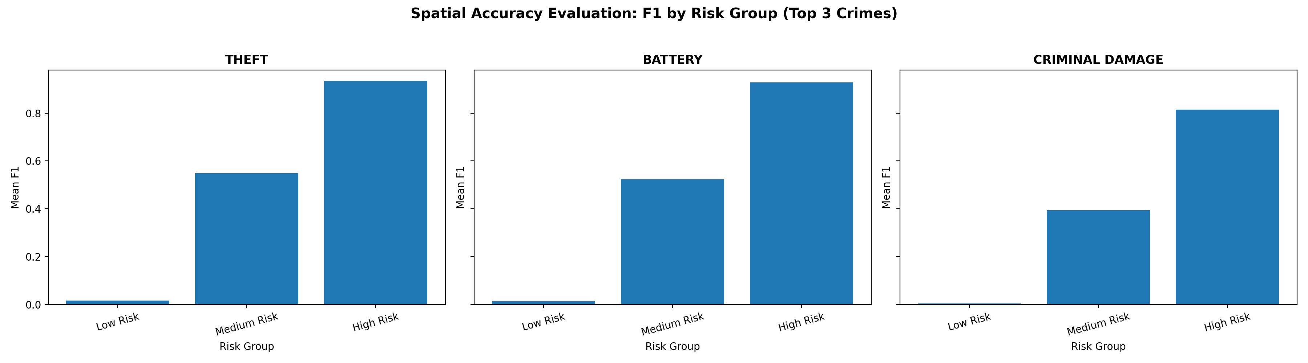
Figure 1. Chicago spatial risk-group summary.
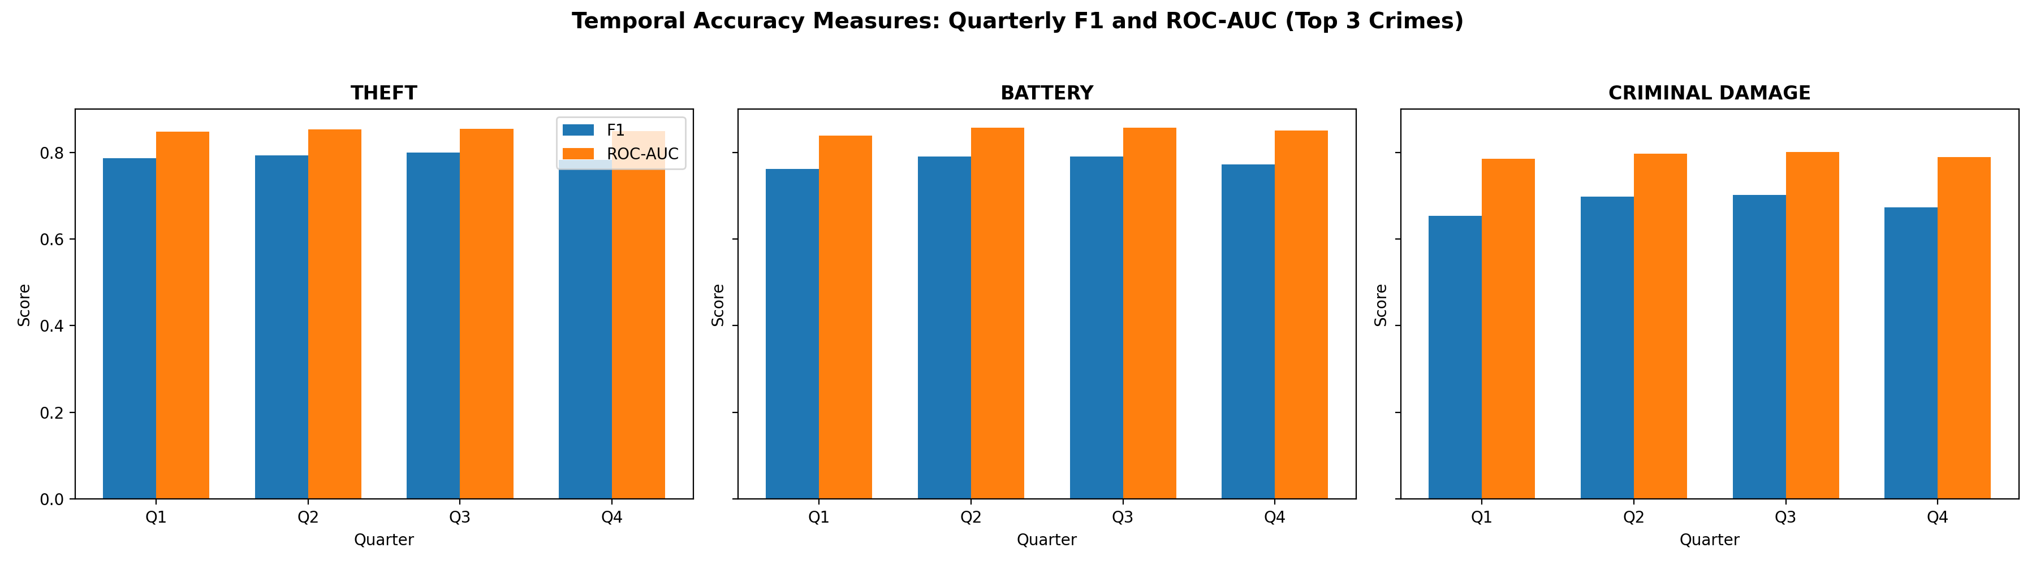
Figure 2. Quarterly temporal performance summary.
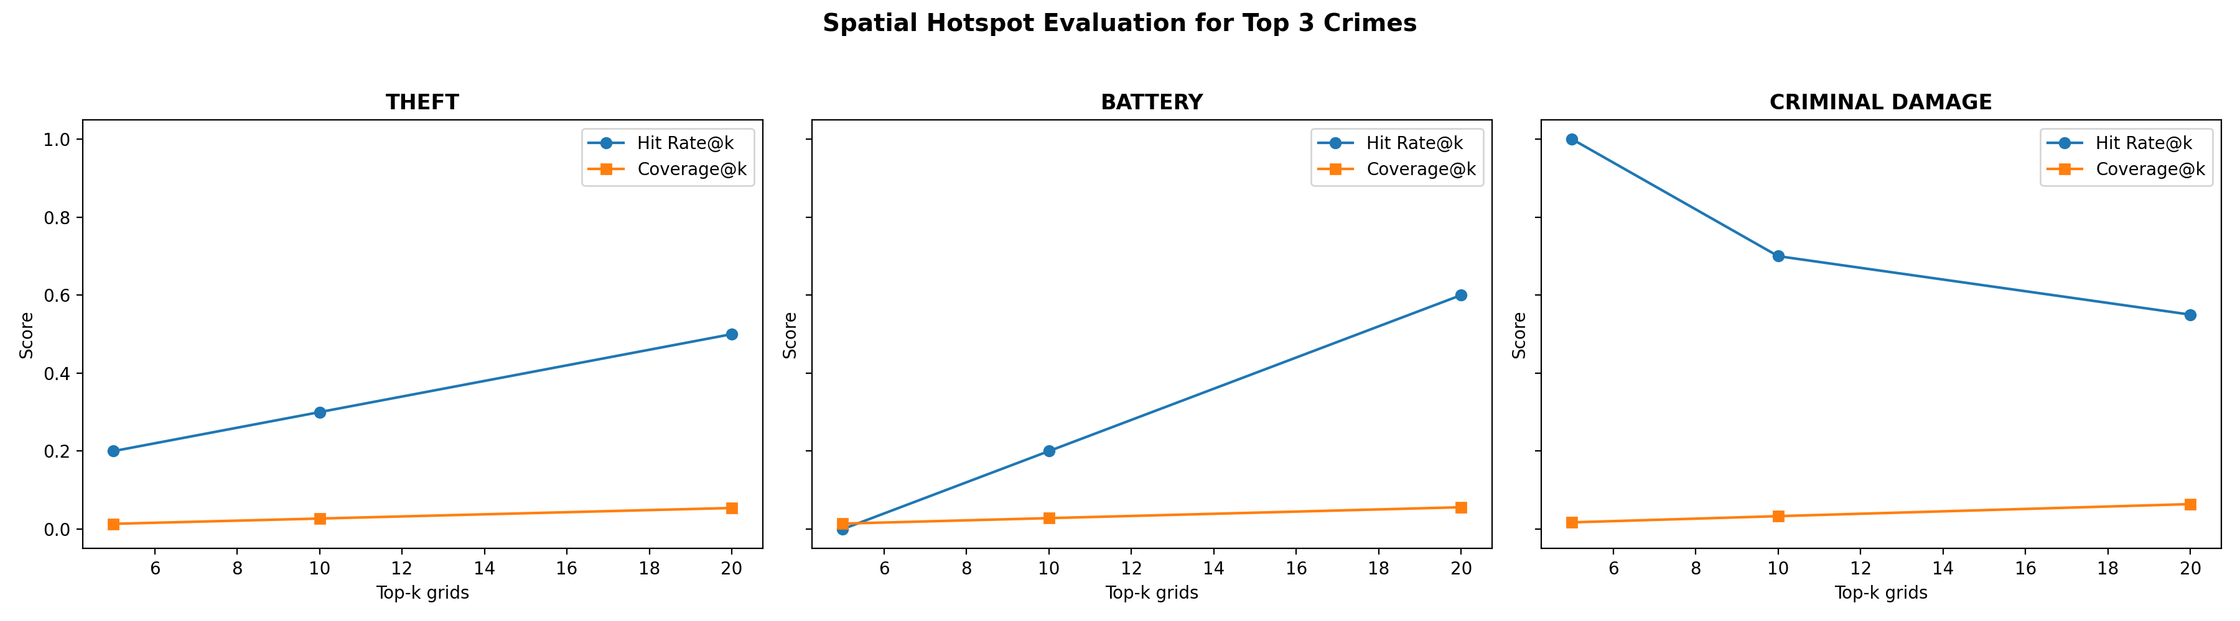
Figure 3. Hotspot hit-rate and coverage summary.
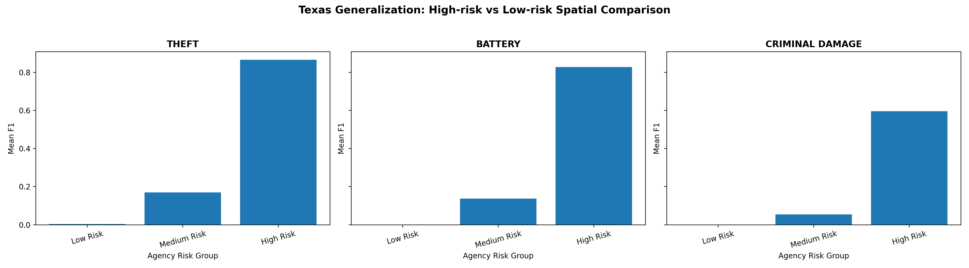
Figure 4. Texas observed-risk grouping summary.
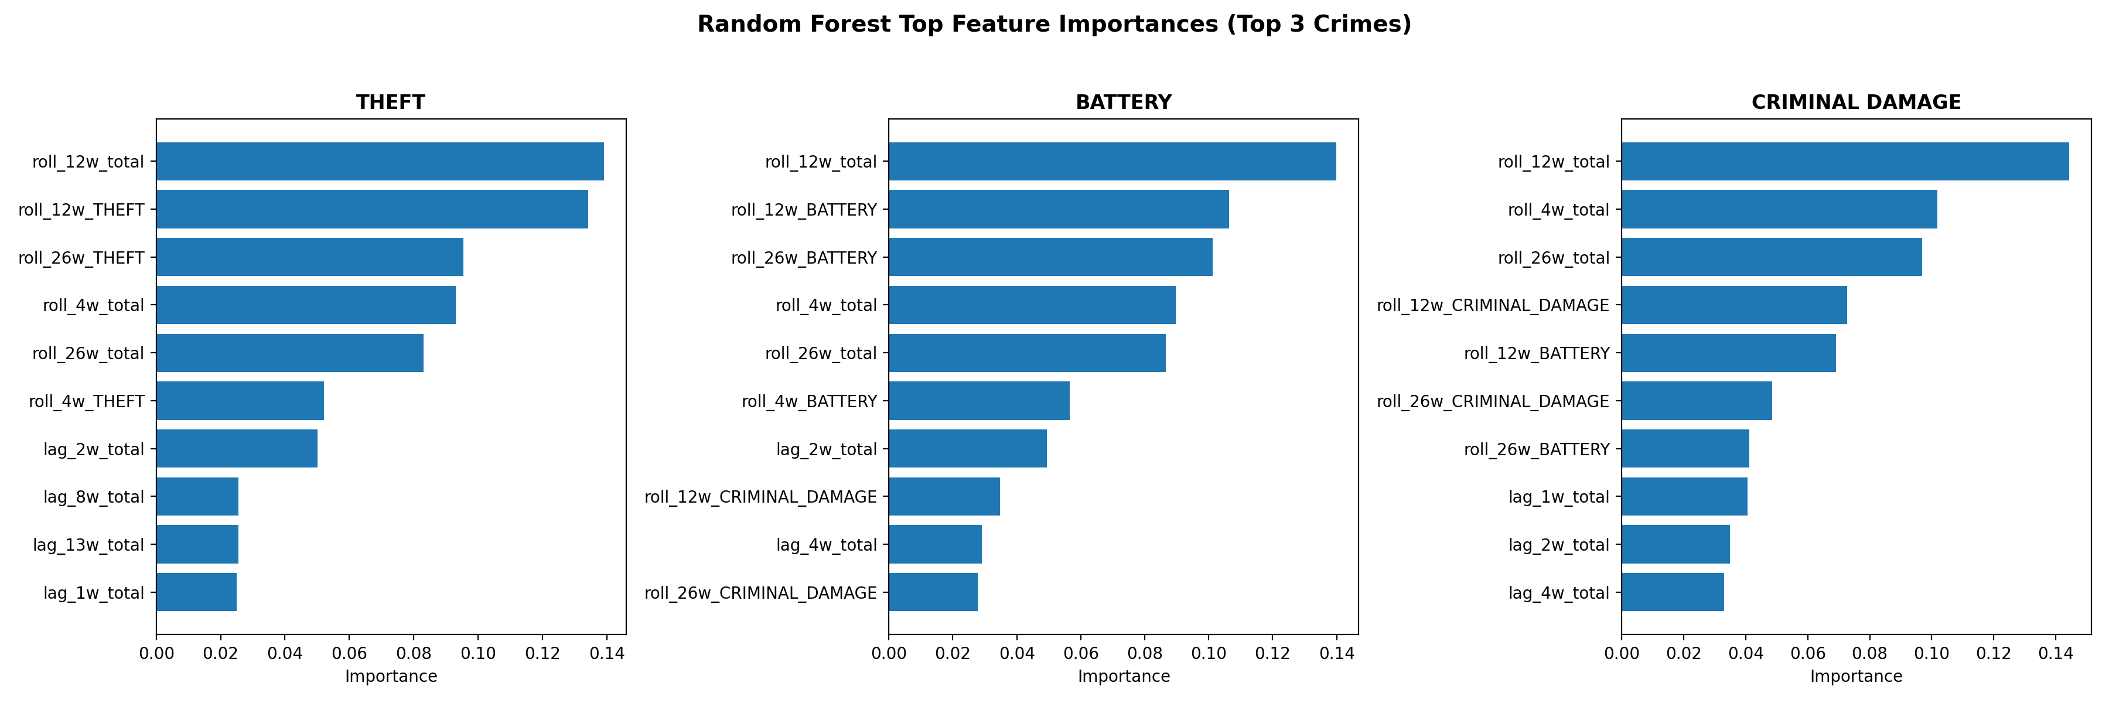
Figure 5. Top feature-importance summary.

1. 研究目标与评分要求对齐。本报告围绕验证严谨性、空间与时间评估、外部泛化以及模型解释重写 RF 部分。RF 现在采用与最新版 XGBoost 和 MLP 一致的 5-fold TimeSeriesSplit。
2. 数据、特征与模型配置。RF 使用共享的 Chicago 2015-2024 数据训练，并在 Chicago 2025 与 Texas/NIBRS 上评估。最终参数保持不变，以保证与此前 RF 工作的连续性。
3. 验证协议。在做 TimeSeriesSplit 之前，先按 iso_year、iso_week 和 grid_id 排序，使交叉验证真正符合时间推进预测场景。
表 1. TimeSeriesSplit 交叉验证结果。
Task | CV Precision (mean+/-std) | CV Recall (mean+/-std) | CV F1 (mean+/-std) | CV AUC (mean+/-std)
THEFT | 0.7998 +/- 0.0221 | 0.7759 +/- 0.0379 | 0.7876 +/- 0.0299 | 0.8461 +/- 0.0120
BATTERY | 0.7872 +/- 0.0135 | 0.7864 +/- 0.0221 | 0.7866 +/- 0.0151 | 0.8570 +/- 0.0063
CRIMINAL DAMAGE | 0.6585 +/- 0.0061 | 0.7523 +/- 0.0345 | 0.7020 +/- 0.0175 | 0.8067 +/- 0.0023
4. Chicago 2025 与 Texas/NIBRS 总体表现。整体来看，RF 在域内未来时期与域外迁移两种场景下都维持了较稳健的表现。
表 2. Chicago 2025 与 Texas/NIBRS 详细结果。
Task | Chicago P | Chicago R | Chicago F1 | Chicago AUC | Texas P | Texas R | Texas F1 | Texas AUC
THEFT | 0.8027 | 0.7777 | 0.7900 | 0.8510 | 0.8672 | 0.6330 | 0.7318 | 0.8767
BATTERY | 0.7761 | 0.7816 | 0.7789 | 0.8508 | 0.8545 | 0.5700 | 0.6838 | 0.8511
CRIMINAL DAMAGE | 0.6291 | 0.7462 | 0.6827 | 0.7933 | 0.6847 | 0.4775 | 0.5626 | 0.8372
5. Chicago 空间精度评估。当前空间结果通过历史风险分组、hotspot 命中率/覆盖率，以及逐网格空间误差导出表来呈现。RF 在高风险网格中的表现显著优于低风险网格。
表 3. Chicago 空间风险分组摘要。
Task | Low Risk F1 | Medium Risk F1 | High Risk F1 | High/Low F1 Ratio
THEFT | 0.0163 | 0.5485 | 0.9338 | 57.1331
BATTERY | 0.0133 | 0.5225 | 0.9289 | 70.0941
CRIMINAL DAMAGE | 0.0041 | 0.3943 | 0.8150 | 200.6033
表 4. Chicago hotspot 命中率与覆盖率摘要。
Task | HitRate@5 | Coverage@5 | HitRate@10 | Coverage@10 | HitRate@20 | Coverage@20
THEFT | 0.2000 | 0.0136 | 0.3000 | 0.0271 | 0.5000 | 0.0542
BATTERY | 0.0000 | 0.0141 | 0.2000 | 0.0282 | 0.6000 | 0.0561
CRIMINAL DAMAGE | 1.0000 | 0.0174 | 0.7000 | 0.0333 | 0.5500 | 0.0642
6. Chicago 时间精度评估。季度结果整体波动较小，尤其是 THEFT 和 BATTERY，说明模型在 2025 年内具有较好稳定性。
表 5. 季度时间稳定性摘要。
Task | Quarterly F1 Range | Quarterly AUC Range | Quarterly Recall Range
THEFT | 0.7818-0.7992 | 0.8483-0.8541 | 0.7736-0.7858
BATTERY | 0.7616-0.7903 | 0.8380-0.8573 | 0.7647-0.7965
CRIMINAL DAMAGE | 0.6537-0.7022 | 0.7846-0.8003 | 0.7150-0.7742
7. Texas 空间泛化。外部空间分组结果与 Chicago 模式一致：RF 在高风险单元中最强，在低风险单元中最保守。
表 6. Texas 观测风险分组摘要。
Task | Low Risk F1 | Medium Risk F1 | High Risk F1
THEFT | 0.0031 | 0.1694 | 0.8658
BATTERY | 0.0006 | 0.1371 | 0.8278
CRIMINAL DAMAGE | 0.0000 | 0.0546 | 0.5956
8. 特征重要性与解释。RF 的主要驱动因素仍然是中期 rolling activity 变量，这与之前的解释保持一致。
表 7. 各任务 Top-5 特征。
Task | Top1 | Top2 | Top3 | Top4 | Top5
THEFT | roll_12w_total | roll_12w_THEFT | roll_26w_THEFT | roll_4w_total | roll_26w_total
BATTERY | roll_12w_total | roll_12w_BATTERY | roll_26w_BATTERY | roll_4w_total | roll_26w_total
CRIMINAL DAMAGE | roll_12w_total | roll_4w_total | roll_26w_total | roll_12w_CRIMINAL_DAMAGE | roll_12w_BATTERY
9. 局限性与后续改进。模型尚未在新的 TimeSeriesSplit 协议下做大规模调参，且低风险空间单元在默认阈值下仍然较难预测。

图 1. Chicago 空间风险分组摘要。

图 2. 季度时间表现摘要。

图 3. Hotspot 命中率与覆盖率摘要。

图 4. Texas 观测风险分组摘要。

图 5. 特征重要性摘要。

