Table S1. Six-item acceptance gate for the window-consistent ERA5 target. M1/M2 document target construction and grid; V1–V4 verify the domain-mean GFS/ERA5 ratio, annual basin precipitation, ≥20 mm/3h grid-point parity, and domain-mean time-series correlation against the paired GFS f003 times.  Item | Check | Acceptance criterion | Measured value | Status
M1 | Target construction: ERA5 hourly tp re-downloaded (2015-2025) and summed over 3-h windows [tp(t-2h)+tp(t-1h)+tp(t)]; units m (x1000 = mm) | 3-h sums built from hourly tp; no reliance on the monthly-archive stepUnits=1 attribute; dt=3h; units m | hourly-derived 3-h sums; units m; dt=3h | PASS
M2 | Grid: 25 x 37, 40-46N / 117-126E, 0.25 deg | lat=25, lon=37 | 25 x 37 | PASS
V1 | Domain-mean GFS f003 / ERA5 ratio (03/09/15/21Z paired) | 0.9 - 1.1 | 0.961 (3.038 under unaligned 3-h/1-h pairing) | PASS
V2 | Annual basin precipitation estimate | 600 - 900 mm yr-1 | 727 mm yr-1 (235 under unaligned pairing) | PASS
V3 | Grid-point count at ≥20 mm/3h, ERA5/GFS ratio (July 2024, 124 paired times) | 0.3 - 3.0 | 1.27 (907 vs 712; ~0.012 under unaligned pairing) | PASS
V4 | Domain-mean time-series correlation (paired times) | r > 0.8 | 0.940 | PASS
Supplementary notes: (i) V1 and V4 are computed on the warm-season months (July-August 2024) using the paired-time intersection with GFS f003 (124 paired times per month); V3 is computed on July 2024 (124 paired times; 907 ERA5 versus 712 GFS grid-point-times at ≥20 mm/3h, ratio 1.27); V2 is an annual-basin estimate obtained by extrapolating the warm-season daily-mean rate (× 8 steps per day × 365 days), as implemented in verify_era5_target.py; (ii) the paired-time intersection confirms the 03/09/15/21Z alignment used throughout the main text; (iii) intermediate per-year and per-month gate values are archived with the code package (verify_era5_target.py --year YYYY) for full reproducibility.
Table S2. Checkpoints selected by the composite criterion of Section 2a for the three seeds (validation window 2022–2023, ERA5 reference). S is the composite score S = 3.0·ETS20 + 1.8·POD20 − 0.45·FAR20 + 1.4·ETS15 + 0.9·POD15 − 0.20·FAR15 − 0.003·L_val − 2.0·max(0, 0.20 − POD20); L_val is the validation loss (normalized MSE units); ΔL is the relative distance of the selected checkpoint’s L_val from the global minimum over both training stages. FAR15 values are rounded from the per-epoch log metrics. Table S2 and Table S3 derive from two independent training runs with the same seeds; because the early-stopping and checkpoint-selection criteria differ, the trajectories diverge at the stage-2 switch and the L_val values of the two tables are not directly comparable. Table S3 lists the stage-1/stage-2 switch epochs (7, 6, 7) and the MSE-selected epochs (2, 7, 1) for seeds 42, 40, 41. The final row reports the raw GFS forecast (no correction; L_val and Delta L not applicable). Its composite S of 1.33 exceeds all selected checkpoints (1.06-1.29), so the criterion never selects a network that beats the uncorrected forecast on its own score; the hinge term is inactive because POD20 > 0.20 in every run.
Seed | Selected epoch | Stage | ETS20 | POD20 | FAR20 | ETS15 | POD15 | FAR15 | S | L_val | ΔL vs global min (%)
42 | 3 | stage 2 | 0.1983 | 0.3852 | 0.7093 | 0.2156 | 0.4682 | 0.7143 | 1.2879 | 87.18 | 1.17
40 | 1 | stage 2 | 0.1712 | 0.3734 | 0.7591 | 0.2009 | 0.4201 | 0.7215 | 1.0638 | 98.46 | 2.39
41 | 6 | stage 1 | 0.1811 | 0.3971 | 0.7495 | 0.2067 | 0.4382 | 0.7165 | 1.1743 | 95.65 | 0.20
GFS (no correction) | — | — | 0.1797 | 0.3450 | 0.7265 | 0.2117 | 0.3712 | 0.6684 | 1.3300 | — | —
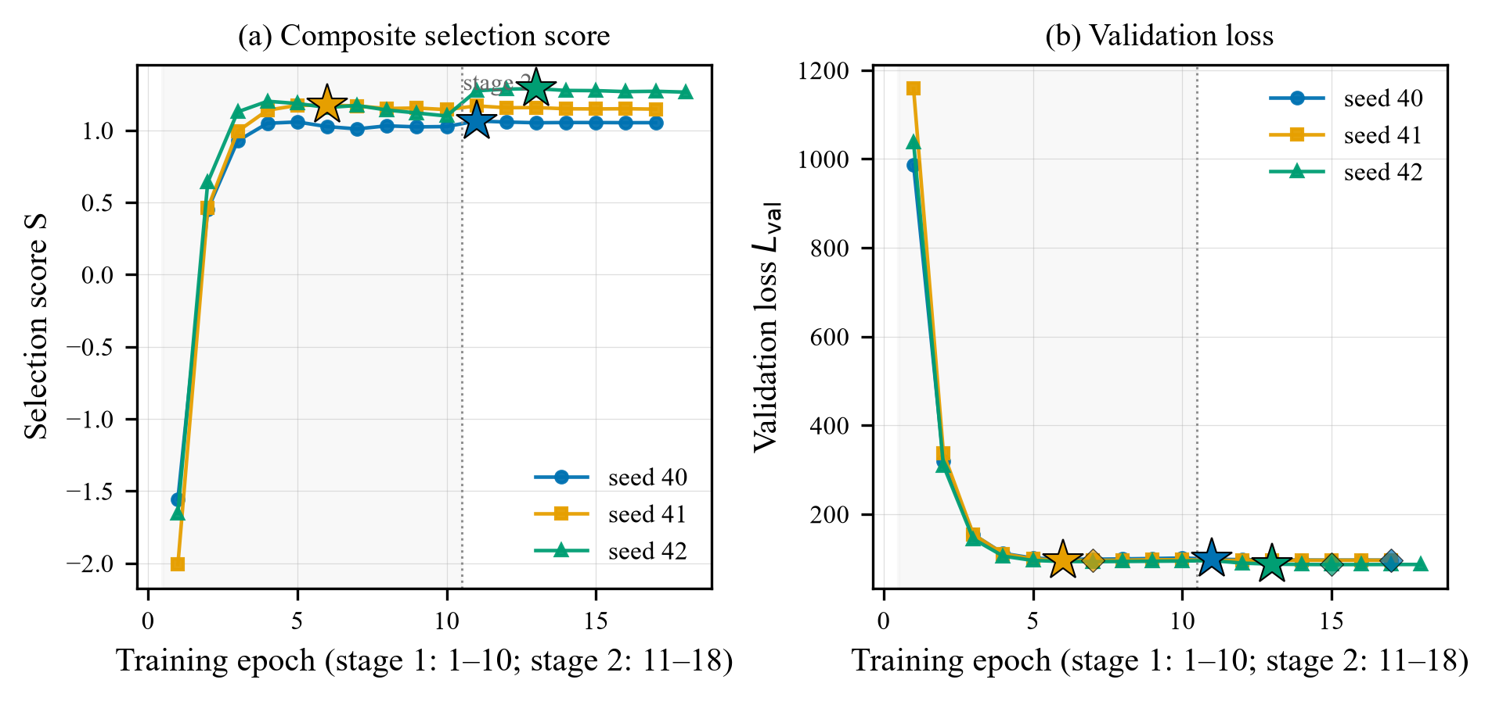
Table S3. MSE-selected real-data rerun: checkpoints are chosen on the validation residual MSE with all other training components identical to the main experiment (Section 3b; three seeds). Test-period (2024–2025) 3-h MSE improvement relative to raw GFS on the ERA5 reference; 95% CIs are block-bootstrap (28-sample blocks, 2,000 draws). For comparison, the composite-score selection of the main experiment gives −14.5%/−46.7%/−82.8% (three-seed mean −48.0%), with per-seed differences of only +1.3/+2.8/+8.1 pct-pts from the composite-score values. The stage-1/stage-2 switch epochs are 7/6/7 and the MSE-selected epochs are 2/7/1 for seeds 42/40/41.
Seed | Selected epoch (stage 2) | L_val | MSE impr. (%) | 95% CI
42 | 2 | 78.55 | −15.8 | [−26.0, −9.3]
40 | 7 | 82.37 | −43.9 | [−60.1, −33.8]
41 | 1 | 81.96 | −74.7 | [−95.0, −61.0]
Mean (42/40/41) | — | — | −44.8 | —
Figure S1. Per-epoch selection score S (a) and validation loss L_val (b) for the three seeds over both training stages. Dots: per-epoch values; stars: the checkpoint selected by the composite criterion (Table S2); diamonds: the epoch of the global validation-loss minimum. The selected checkpoints lie within 0.2–2.4% of the global L_val minimum.
Table S4. Pure-MSE-loss real-data rerun (Section 3b, Section 4d). Training protocol identical to Table S3 except that the multi-term composite loss is replaced by plain mean squared error on the network residual. Test-period (2024–2025) 3-h MSE improvement relative to raw GFS on the ERA5 reference; 95% CIs are block-bootstrap (28-sample blocks, 2,000 draws). The composite-loss main experiment gives −14.5/−46.7/−82.8 (three-seed mean −48.0%); the pure-MSE rerun gives +8.1/−11.0/−4.6 (mean −2.5%), removing about 95% of the degradation: the composite loss is the dominant amplifier of the negative 3-h skill on the real task, consistent with the synthetic experiment (Section 3b).
Seed | MSE impr. (%) | 95% CI
42 | +8.1 | [+1.8, +12.3]
40 | −11.0 | [−18.5, −5.6]
41 | −4.6 | [−8.6, −1.8]
Mean (42/40/41) | −2.5 | —

