Skill limits and transferability of deep-learning precipitation post-processing trained on reanalysis targets: scale-dependent skill across ERA5, CHM, and GPM verification over Northeast China

Lin Tian,^{*ab}, Feifan Cui,^{ab}, Xin Huang,^{ab}, Yuhan Jiang,^{ab}, Jintao Yu,^{ab}, Yaoxi Wang,^{ab}, Jiacheng Ni,^{ab}

ªChangchun Institute of Technology, Changchun 130012, China
^{b}Jilin Provincial Key Laboratory of Safe Hydraulic Engineering in Cold Regions, Changchun Institute of Technology, Changchun 130012, China

Corresponding Author: *Lin Tian, tianlin@ccit.edu.cn, Huxi Campus, Changchun Institute of Technology, Chaoyang District, Changchun City, Jilin Province, China.

Abstract
Deep-learning (DL) post-processing of NWP precipitation increasingly uses reanalysis products such as ERA5 as training targets. Over the Liaohe basin in Northeast China, we test whether the reanalysis is an unbiased learning reference. First, we discovered and corrected an ERA5-target cumulation-window mismatch that produced a spurious 3× offset; all results are recomputed on the corrected target. Second, a controlled experiment shows the same network learns a noise-free identity almost perfectly (correlation 0.998) but degrades with target noise, worst at the observed residual level (−28.5%): negative skill reflects target noise and the learning procedure, not the architecture. Third, the boundary is independent of the training reference: GPM-target retraining leaves the sign of the 3-h result unchanged (Table S3), as an MSE-selected real-data rerun confirms. At the native 3-h scale the point estimates are negative on all three references: a bin-based benchmark improves MSE by +27.3% on ERA5 and +22.6% against GPM, whereas the DL networks are the only methods with negative point estimates on every reference (−14.5% to −82.8% on ERA5; −20.8% to −49.6% against CHM; −16.5% against GPM, a contrast not reaching conventional significance), while quantile mapping (+8.3%) and linear regression (+19.6%) remain positive. The failure is scale-dependent: at accumulated scales of 24–120 h the same networks gain observationally confirmed skill (MSE +12.2% to +20.4% on ERA5; RMSE +4.7% to +7.6% against CHM), whereas quantile mapping collapses to near-zero gain. Reanalysis-trained DL correction thus inherits reference noise at fine scales but becomes the best-performing correction family at accumulated scales.

Significance Statement
Deep-learning precipitation correction trained on reanalysis data (ERA5) makes 3-hour forecasts worse over Northeast China, while simple quantile mapping and linear regression improve them, because the networks inherit the smoothness and noise of their training reference. At 24–120 h the same networks gain skill: value is scale-dependent.

1. Introduction
Numerical weather prediction (NWP) precipitation carries systematic biases in intensity and location, and statistical post-processing is the standard remedy in operational forecasting (Vannitsem et al. 2021). Classical approaches—quantile mapping (QM; Hamill et al. 2017; Hamill and Scheuerer 2018; Zhu and Luo 2015), model output statistics (MOS), and grid-point regression—remain widely used. Deep learning (DL) has been proposed as a more powerful alternative: convolutional, U-Net, and generative architectures have improved post-processing on reanalysis or analysis targets (Ben Bouallègue et al. 2024; Espeholt et al. 2022; Harris et al. 2022; Hess and Boers 2022; Shi et al. 2015; Zheng et al. 2024).
A shared design choice in most DL precipitation post-processing studies is the training target: because long, high-resolution gridded observations are often unavailable, reanalysis products—most commonly ERA5—are used as the learning reference. The justification is pragmatic: reanalyses are spatially complete, physically consistent, and share the model grid (Tarek et al. 2020; Sha et al. 2022); over China, ERA5 has been extensively evaluated against gauges (Jiang et al. 2021; Zhou et al. 2023) but captures extremes only partially (Lei et al. 2022; Wu et al. 2022; Wu et al. 2024). The implicit assumption is that the reanalysis is an unbiased surrogate for the truth and that a model trained against it transfers to the real world.
This assumption deserves scrutiny: reanalysis precipitation is itself a model product, smooth in space and time, with systematic differences from gauge- and satellite-merged observations. Several recent studies report that reanalysis-trained DL correction underperforms on independent verification, or that simple baselines remain competitive (Hess and Boers 2022; Sun and Lan 2021; Worsnop et al. 2024; Zhang et al. 2024), whereas CNN post-processing on long reforecast–observation pairs can beat classical MOS (Badrinath et al. 2023). Two questions remain open: what limits a DL architecture trained on a reanalysis target, and whether a DL correction that fails on the training reference can succeed at the observation scale.
We address both questions over the Liaohe basin in Northeast China, a region dominated by the Northeast China cold vortex (NECV) and its organized precipitation (Chen et al. 2023; Fang et al. 2021; Yang et al. 2024). We use 11 years (2015–2025) of operational GFS f003 forecasts as input, ERA5 as the training reference, and two independent verification products: CHM gauge-merged daily rates and GPM IMERG half-hourly satellite precipitation aggregated to 3 h (2024–2025). Here we attribute the negative skill of reanalysis-trained DL correction to the combination of target noise and the learning procedure, verify the boundary against two independent products, and document a scale-dependent DL-versus-baseline ranking inversion between 3 h and 24–120 h over one basin and one NWP system.
Our main contributions are fourfold. (1) Data integrity. We discovered and corrected a cumulation-window mismatch in the ERA5 target used in earlier versions (1-h accumulations sampled at 3-hourly steps paired against true 3-h GFS accumulations), a spurious 3× scale offset that invalidated all previous quantitative claims, including a previously reported 46.9% MSE reduction; every result here is recomputed from the corrected, gate-verified target (Section 2d). (2) Causal diagnosis. A controlled experiment adding Gaussian noise to the training target shows that the same network learns an identity mapping almost perfectly (correlation 0.998) but degrades with noise, with skill worst at the observed residual level (−28.5%): the negative skill is a property of the target noise and the learning procedure, not of the architecture; rerunning the worst-case arm with a pure MSE loss reduces the degradation from −28.5% to about −0.9% (three-seed mean). (3) Transferability boundary. On every reference, simple baselines dominate the network (ERA5: BinCM +27.3%, OLS +22.2%, QM +11.1% vs APCNet −14.5% to −82.8%; CHM: +3.6% and +12.2% vs −20.8% to −49.6%; GPM: +22.6%, +8.3%, and +19.6% vs −16.5%), so grid-point baselines remain the strongest operational choice at the 3-h scale. (4) Scale dependence. At accumulated leads of 24–120 h the ranking inverts: the DL corrections gain observationally confirmed skill (+12.2% to +20.4% MSE on ERA5; +4.7% to +7.6% RMSE against CHM) while QM collapses to near-zero gain: the reanalysis-training ceiling is a property of the fine 3-h scale.

2. Study Area, Data, and Methods

a. Study Area and Data
The Liaohe basin (40–46°N, 117–126°E) covers 25 × 37 grid points at 0.25° resolution. Precipitation is strongly modulated by the NECV and organized mesoscale systems (Fig. 1). Both convective extremes and long-duration light rain occur, and deterministic NWP precipitation carries systematic errors that degrade short-range quantitative precipitation forecasts (Gaudet et al. 2024; Zhang et al. 2021; Zhu et al. 2018).
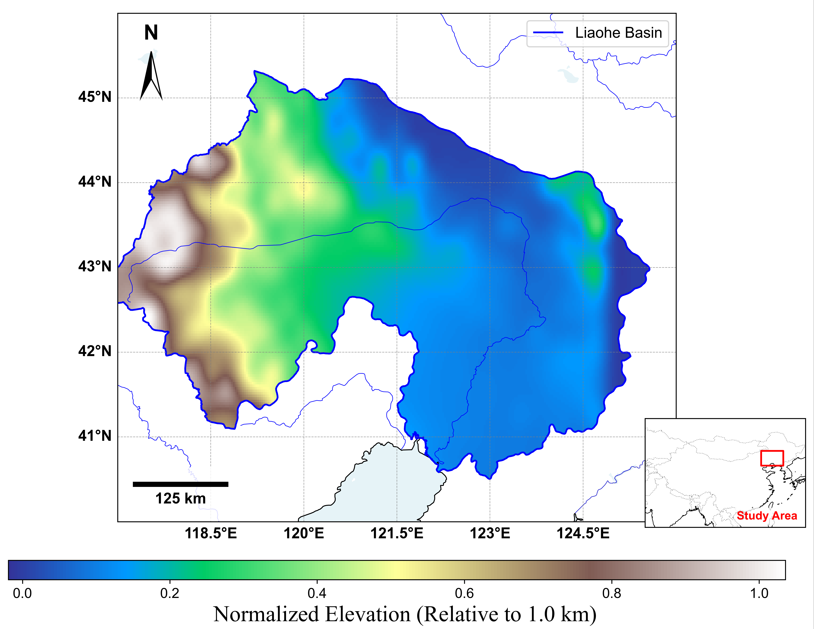
Fig. 1. Topographic map of the Liaohe River Basin showing the spatial domain (40-46°N, 117-126°E). Color shading denotes normalized elevation (relative to 1.0 km); the complex terrain configuration strongly modulates local precipitation processes in this typical East Asian monsoon region.
Input: GFS f003. Operational GFS forecasts at 0.25° resolution for 2015–2025 (16,056 files; 4 cycles per day at 00/06/12/18Z). The precipitation variable A_PCP_L1_Accum_1 (kg m⁻²) is a true 3-h accumulation (time_bnds = [0,3]), valid at 03/09/15/21Z. Eight input channels are used: CAPE, PWAT, U850, V850, U500, V500, VVEL, and precipitation, plus six prior times at 6-h intervals (from t − 30 h to t). Table 1 lists the variables and units.
Table 1. Meteorological forecast variables and units of GFS and ERA5 data.
GFS Variable | Unit | ERA5 Variable | Unit
Convective Available Potential Energy (CAPE) | J·kg⁻¹ | CAPE | J·kg⁻¹
Precipitable Water (PWAT) | kg·m⁻² | Total Column Water Vapour (tcwv) | kg·m⁻²
U/V wind at 850 hPa | m·s⁻¹ | U/V wind at 850 hPa | m·s⁻¹
U/V wind at 500 hPa | m·s⁻¹ | U/V wind at 500 hPa | m·s⁻¹
Total Precipitation | mm (3h)⁻¹ | Total Precipitation | mm (3h)⁻¹
Vertical Velocity | Pa·s⁻¹ | Vertical Velocity | Pa·s⁻¹
Target: ERA5 (reconstructed). ERA5 total precipitation tp (Hersbach et al. 2020) was downloaded at hourly resolution from the CDS and reconstructed into true 3-h accumulations by summing the three hourly values within each window, TP_3h(t) = tp(t−2h) + tp(t−1h) + tp(t), for t in {03, 09, 15, 21}Z (Section 2d).
Independent verification 1: CHM. The China Meteorological Administration Multisource Precipitation Merging System (CHM) daily product (0.1°; gauge–satellite merged; Shen et al. 2014), 2024–2025, bilinearly interpolated to the study grid. Coverage mismatch: model fields cover 12 h per day whereas CHM is a full 24-h daily accumulation; comparisons are therefore made on a rate basis (mm h⁻¹) and are interpreted relatively, not absolutely (Section 4d).
Independent verification 2: GPM IMERG. NASA GPM IMERG Final half-hourly precipitation (V07B, 0.1°; Huffman et al. 2023 document the IMERG algorithm and its V07B reprocessing), 2024-01-15 to 2025-09-30 for the 3-h verification (the 24–120 h verification additionally uses 2024-01-01 onward), aggregated to 3-h accumulations matching the GFS f003 valid times (six 30-min files summed per 3-h window). This verification makes no coverage assumption and is the primary observation-scale test at the native forecast scale; IMERG is most reliable in warm seasons and less so in cold seasons and for snowfall (Pan et al. 2023; Tang et al. 2020; Zhao et al. 2023).
Data partitioning. The 2015–2025 record is split strictly by year: training 2015–2021, validation 2022–2023, test 2024–2025 (Table 2). The validation period is used only for learning-rate scheduling, early stopping, and gating calibration (training stops when the validation composite score S = 3.0·ETS20 + 1.8·POD20 − 0.45·FAR20 + 1.4·ETS15 + 0.9·POD15 − 0.20·FAR15 − 0.003·L_val − 2.0·max(0, 0.20 − POD20) has not improved for eight consecutive epochs, or POD20 has not improved for sixteen; the POD20 criterion guards against stagnation of the rare-extreme component that the threshold-weighted score S is designed to prioritize. ETS, POD and FAR are the equitable-threat, probability-of-detection and false-alarm-ratio scores at the 15 and 20 mm/3h thresholds, and L_val is the validation loss); no test-period information enters model selection. Normalization statistics are estimated on the training period only, and the validation and test sets are never oversampled.
Table 2. Dataset partitioning by year for training, validation, and independent testing.
Dataset | Period | Purpose | Samples
Training | Jan 2015 - Dec 2021 | Establish climatological mapping | 10,157
Validation | Jan 2022 - Dec 2023 | Early stopping, learning-rate scheduling, and gating calibration | 2,841
Test | Jan 2024 - Dec 2025 | Two-year independent blind test | 2,839
Input preprocessing. The GFS precipitation channel is clipped to [0, 100] mm, non-zero values are capped at the 99.9th percentile, and light Gaussian smoothing (sigma = 0.6) is applied when the field maximum is below 10 mm. This cleaning applies to the GFS input only; the ERA5 target is not cleaned, and the other channels are standardized only.

b. The Correction Network (APCNet)
The precipitation correction network (APCNet) is a two-branch encoder with kinematics-oriented channel grouping: a motion/topology branch processes wind and vertical velocity, and a moisture/precipitation branch processes CAPE, PWAT, and precipitation; branch outputs are fused with squeeze-excitation weighting, and a gated residual connection adds the correction to the input precipitation (Fig. 2). We explicitly do not claim physics-constrained learning. The network predicts the residual between the ERA5 target and the GFS precipitation; the loss and training setup are detailed below.
Channel attention weights are computed as (Eq. 1)
$$\begin{aligned}W_{attn}=\text{Hardsigmoid}\left(\text{MLP}\left(\text{Pool}\left(E_{phys}\right)\right)\right)(\left(1)\right)\end{aligned}$$
and applied to the physics embedding (Eq. 2):
$$\begin{aligned}E_{filtered}=E_{phys}⊙W_{attn}(\left(2)\right)\end{aligned}$$
Thermodynamic channels are modulated by (Eq. 3)
$$\begin{aligned}F_{modulated}=F⊙\left(1+\tanh\left(γ\right)\right)+β(\left(3)\right)\end{aligned}$$
The atrous spatial pyramid applies per-dilation convolutions (Eq. 4):
$$\begin{aligned}y\left[i\right]=\sum_{k}{x\left[i+r⋅k\right]w\left[k\right]}(\left(4)\right)\end{aligned}$$
The output reconstructs the total precipitation from the GFS baseline:
$$\begin{aligned}P_{pred}=\text{ReLU}\left(P_{GFS}+ΔP\right)(\left(5)\right)\end{aligned}$$
Loss. The reported network uses the symmetric configuration, in which the asymmetric weight wasym,i of Eq. (11) below is set to unity to remove the miss-versus-false-alarm asymmetry that earlier diagnostic versions showed to induce a systematic wet bias; the asymmetric weighting is retained only for diagnostic comparison. Training uses AdamW (weight decay 8 × 10⁻⁶), batch size 64, and up to 12 epochs in two stages: the first stage learns at a learning rate of 8 × 10⁻⁵ with early stopping on the composite criterion defined in Section 2a (eight-epoch patience), and the second stage fine-tunes the prediction heads at 3 × 10⁻⁵ with the trunk frozen. An exponential moving average (decay 0.999) of the weights is used at inference; three random seeds (42, 40, 41) are trained.
The total loss is (Eq. 6)
$$\begin{aligned}L_{total}=L_{reg}+L_{mse}+λ_{1}D_{10}+λ_{2}D_{20}+λ_{rain}L_{rain}+λ_{storm}L_{storm}+ \\ λ_{ets}(L_{ets,10}+m·L_{ets,20})+λ_{CC}·L_{CC}+L_{stormMSE}+L_{peak}+λ_{res}‖ΔP‖²(6)\end{aligned}$$
where λ1 = 2.0, λ2 = 3.0m, λrain = 0.3, λstorm = 0.1, λ_ets = 1.5, λ_CC = 1.2, and λres = 0.02. The factor m = min(max(Mmax/20, 1), 3), with Mmax the maximum observed precipitation in the mini-batch (mm per 3 h), scales the D20 and ETS20 terms. D10 and D20 are neighbourhood mean-square-error ratios on 5 × 5 pooling at the 10 and 20 mm per 3 h thresholds (0-1, lower is better; they are the complements of the conventional fractions skill score FSS evaluated on the same 5 × 5 neighbourhoods and thresholds, D = 1 − FSS); Lrain is the binary cross-entropy of the occurrence head and Lstorm the cross-entropy of the five-class intensity head (class weights 1.0, 1.2, 2.5, 6.0, 15.0); L_ets,10 and L_ets,20 are soft ETS losses; L_CC = 1 − ρ̄s, with ρ̄s the mean per-sample spatial Pearson correlation; LstormMSE multiplies pixels at ≥ 10 and ≥ 20 mm by 9 and 21; Lpeak = 0.5⟨max(0, 0.5Oi − Pi)⟩ averaged over pixels with Oi ≥ 10 mm preserves heavy-rain peaks; and ‖ΔP‖² is the mean squared network residual of Eq. (5), regularized toward zero (λres) to counteract its right-skewed distribution. All weight maps in Eqs. (7) and (8) are normalized by their batch mean, and the focal weight is detached (treated as a constant) during backpropagation. Eq. (9) adds multiplicative factors 1.5, 2, 10, 30 and 80 for pixels exceeding 0.1, 3, 10, 20 and 50 mm/3h, so a single ≥50 mm/3h pixel carries a weight of 72,000 (= 1.5 × 2 × 10 × 30 × 80), and λ2 = 3.0m scales the D20/ETS20 terms by at most 9. The pure-MSE rerun of the controlled experiment (Section 3b) provides the sensitivity to this intensity weighting: at σ = 1.16 mm/3h the degradation shrinks from −28.5% to about −0.9%.
with the regression terms (Eq. 7)
$$\begin{aligned}L_{reg}=\frac{1}{N}\sum_{i}{\left|P_{i}−O_{i}\right|}⋅w_{precip,i}⋅\left(1+w_{focal,i}\right)⋅w_{asym,i}(7)\end{aligned}$$
and mean-square term (Eq. 8)
$$\begin{aligned}L_{mse}=½\frac{1}{N}\sum_{i}{{\left(P_{i}−O_{i}\right)}^{2}}⋅w_{precip,i}⋅w_{asym,i}(8)\end{aligned}$$
The precipitation-intensity weight is (Eq. 9)
$$\begin{aligned}wprecip,i=1.5^{I(Oi≥0.1)}·2^{I(Oi≥3)}·{10}^{I(Oi≥10)}·30^{I(Oi≥20)}·80^{I(Oi≥50)}(9)\end{aligned}$$
the focal term (Eq. 10)
$$\begin{aligned}w_{focal,i}={\left(\frac{\left|P_{i}−O_{i}\right|}{O_{i}+2}\right)}^{2}(10)\end{aligned}$$
and the asymmetric weight
$$\begin{aligned}w_{asym,i}=\left\{\begin{aligned}1+\min_{}\left(1.5+1.5{1.5}^{I(Oi≥10)}+{2.0}^{I(Oi≥20)},\frac{O_{i}−P_{i}}{10}\right) ifO_{i}≥5andP_{i}<O_{i}, \\ 1+\min_{}\left(1.5,\frac{P_{i}}{2}\right) ifO_{i}<0.5andP_{i}>O_{i}, \\ 1 otherwise.\end{aligned}\right.(11)\end{aligned}$$
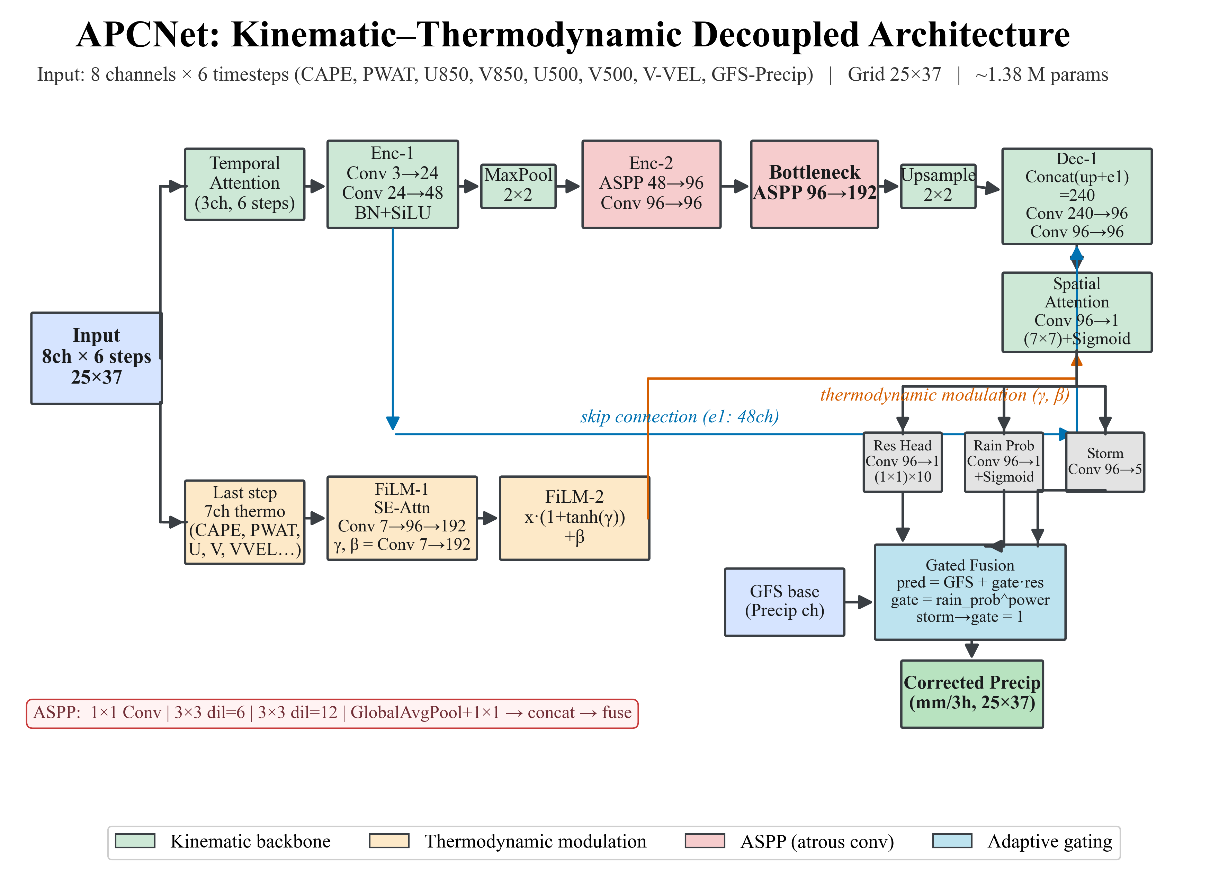
Fig. 2. Architecture of the precipitation correction network (APCNet). A kinematics-oriented encoder processes the dynamics channel group through temporal attention and atrous spatial pyramids; a thermodynamic branch extracts the last-step moist variables and modulates the decoder features through FiLM (gamma, beta); the adaptive gated fusion combines the network residual with raw GFS precipitation. Grid 25 × 37; about 1.38 million parameters.

c. Baselines
BinCM (bin conditional mean): the empirical conditional-expectation benchmark E[ERA5|GFS]. The GFS precipitation range is discretized into 11 bins ([0, 0.05, 0.1, 0.2, 0.5, 1, 2, 5, 10, 20, 40, 100] mm); for each bin the training-period mean of the ERA5 target is stored and applied to the test period. A per-grid-point variant falls back to the global table where fewer than 30 training samples exist. BinCM has no spatial context, no loss weighting, and no free parameters besides the bin table.
QM: grid-point quantile mapping (Cannon et al. 2015; Hamill and Scheuerer 2018; Jiang and Johnson 2023; Zhu and Luo 2015), calibrated on the training period (2015–2021), applied blind to the test period. OLS: grid-point-wise linear regression ERA5 = a·GFS + b, fitted on the training period, applied blind. U-Net: standard U-Net (hidden channels 32), same data, loss, and seeds, retrained on the corrected target with the symmetric loss (seed 42). Clim: training-period grid-point climatology (supplementary only).

d. Target Correction, Evaluation Protocol, and Controlled Experiment
Discovery and evidence. Raw-file attributes showed the mismatch: GFS A_PCP_L1_Accum_1 has time_bnds = [0,3] and cell_methods = time: sum over hours (a true 3-h accumulation), whereas the ERA5 monthly tp files carry GRIB_stepType = accum with GRIB_stepUnits = 1 (1-h accumulation stored at 3-hourly steps). Direct comparison over July 2024 (124 common times) gives domain-mean GFS 0.9064 mm/3h versus ERA5 0.2984 mm/h (ratio 3.038, r = 0.936); scaling ERA5 by 3 restores ratio 1.013 over July 2024 (the warm-season (July–August 2024) corrected gate ratio is 0.961; Table S1). Apparent annual precipitation was 235 mm yr-1 before correction (versus GFS 671 and CHM 642) and 727 mm yr-1 after.
Correction procedure. ERA5 hourly tp was re-downloaded from the CDS and true 3-h accumulations were reconstructed (old monthly files archived). The corrected target passes a six-item acceptance gate (Table S1): warm-season (July–August 2024) domain-mean GFS/ERA5 ratio 0.961 (was 3.038), annual basin precipitation 727 mm yr-1 (was 235), grid-point ratio at ≥20 mm/3h 1.27 (July 2024), and domain-mean time-series correlation 0.940. The erroneous target was used in all earlier versions of this manuscript; every number here is recomputed from the corrected target.
Deterministic: MSE/RMSE improvement relative to unprocessed GFS; spatial correlation (all-point and per-sample); categorical POD/FAR/ETS at 0.1/3/10/20 mm per 3 h; area bias; daily aggregation (12-h coverage). Independent verification: CHM daily rates and GPM IMERG 3-h accumulations. Probabilistic: CRPS for deterministic and dressed predictions (zero-inflated Gaussian for the network; Gaussian dressing for QM); Brier score and BSS for occurrence. Significance: block bootstrap (2,000 resamples; monthly blocks for CHM, 60-/90-day sensitivity; 16-window blocks for GPM).
To isolate the effect of target signal-to-noise ratio (SNR), we train the identical network on a synthetic target Y = GFS + epsilon, epsilon ~ N(0, sigma^2), for sigma in {0.5, 1.16, 2.0} mm/3h, with sigma = 1.16 equal to the observed std of the GFS-ERA5 residual. An identity run (target = GFS) provides the upper bound of learnability; the zero-correction baseline (output = GFS) defines the improvement metric. To separate the effect of the training loss from the target SNR, each noisy arm is also rerun with a pure MSE loss on the residual, with all other training components unchanged (Section 3b). In every controlled-experiment run (the full multi-term loss and the pure-MSE rerun), checkpoints are selected on the validation residual MSE.

3. Results

a. Corrected Target and Skill on the Training Reference
After target correction (Section 2d), the warm-season (July–August 2024) domain-mean GFS/ERA5 ratio over common 03/09/15/21Z times is 0.961, annual basin precipitation 727 mm yr-1 (versus 235 before; consistent with GFS 671 and CHM 642), grid points ≥20 mm/3h are of the same order in both fields in July 2024 (907 versus 712 grid-point-times, ratio 1.27; gate V3 of Table S1), and the domain-mean time-series correlation is 0.940. There is no systematic wet bias of GFS relative to ERA5 once the accumulation windows are aligned: the previously reported systematic wet bias was entirely an artefact of the mismatched target (Fig. 3).
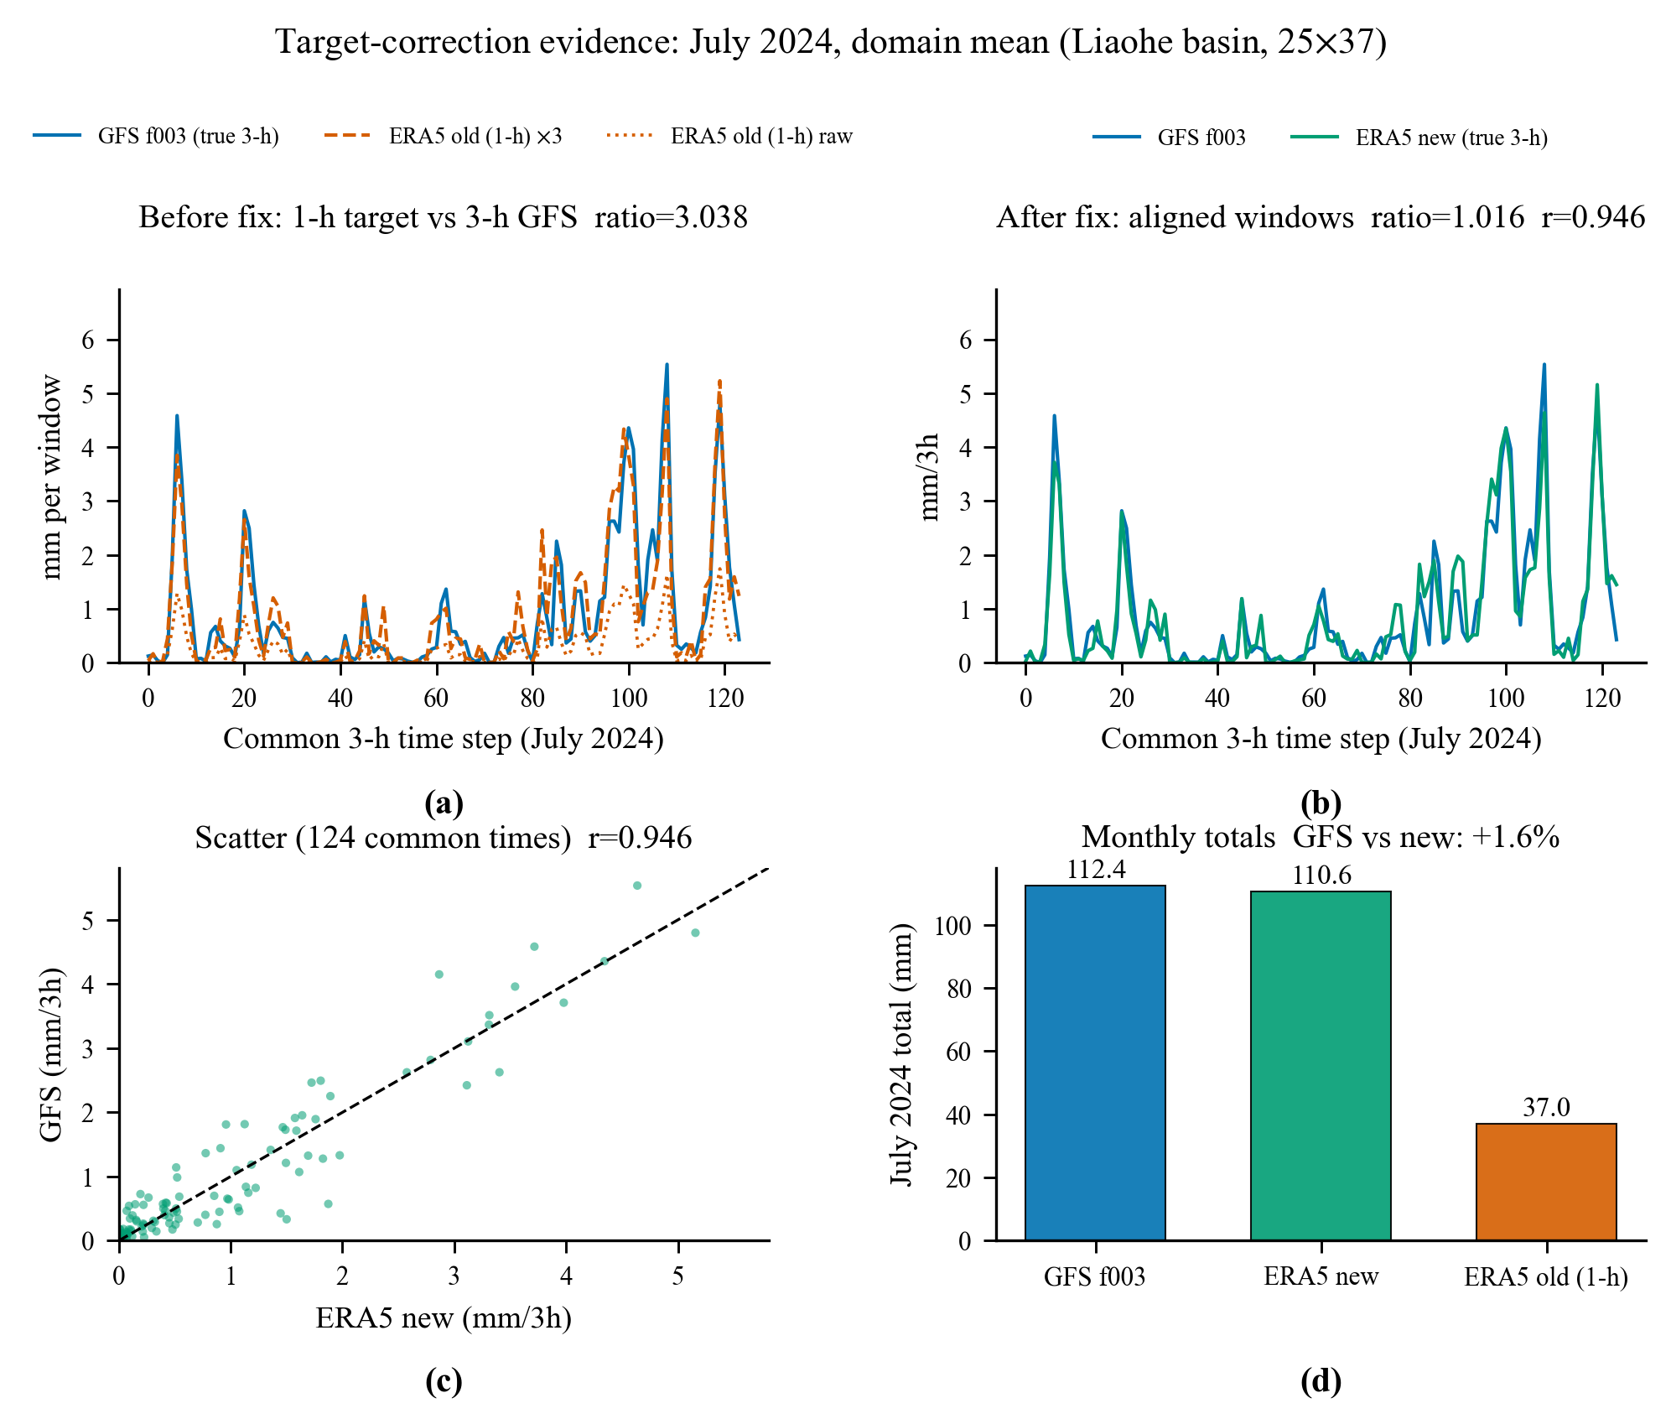
Fig. 3. Target-correction evidence for July 2024: (a) domain-mean GFS/ERA5 ratio before correction (3.038); (b) ratio after correction (1.016, correlation 0.946); (c) scatter of corrected ERA5 vs GFS; (d) monthly totals GFS 112.4 vs corrected ERA5 110.6 mm (+1.6%) vs old target 37.0 mm.
The multi-year mean spatial bias fields (Fig. 4) show that raw GFS is nearly unbiased against ERA5 (−0.011 mm/3h, spatial std 0.028) and that QM is likewise (−0.021, std 0.033), whereas the network adds +0.180 mm/3h with strong spatial structure (std 0.107, local maxima +0.80): this is spatially non-uniform wetting, not uniform rescaling.
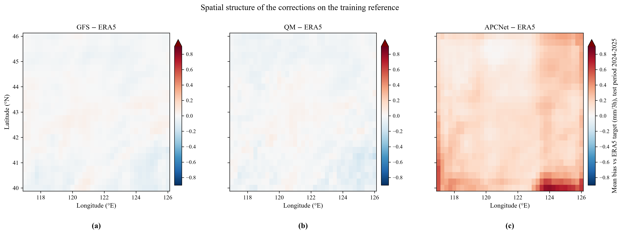
Fig. 4. Multi-year mean spatial bias fields (mm/3h) of (a) raw GFS, (b) QM-corrected, and (c) APCNet-corrected precipitation against the ERA5 reference. The DL network adds a spatially structured wet bias (+0.180 mm/3h domain mean, std 0.107), an order of magnitude larger than raw GFS (-0.011 mm/3h) and QM (-0.021 mm/3h).
Table 3 reports the 3-h MSE improvement over raw GFS on the ERA5 reference (test period 2024–2025, 2,839 samples).
Table 3. Deterministic skill on the ERA5 reference (2024-2025 test period). MSE improvement relative to raw GFS; spatial correlation in two definitions (Section 2d).
Method | MSE | Improvement | All-point CC | Per-sample space CC
GFS (raw) | 1.3462 | - | 0.5987 | 0.470
BinCM | 0.9791 | +27.3% | 0.6235 | 0.387
PerGrid-BinCM | 0.9781 | +27.3% | 0.6243 | 0.373
OLS | 1.0472 | +22.2% | 0.5964 | 0.354
QM | 1.1970 | +11.1% | 0.6114 | 0.451
U-Net (retrained) | 2.0885 | −55.1% | 0.6332 | 0.232
APCNet sym (S42/S40/S41) | 1.541/1.975/2.461 | −14.5/−46.7/−82.8% | 0.628 (S42) | 0.276
Simple baselines dominate the network on the training reference: BinCM achieves the largest MSE reduction (+27.3%), ahead of OLS (+22.2%) and QM (+11.1%); APCNet reductions are consistently negative across seeds (−14.5% to −82.8%). Monthly block bootstrap confirms every contrast (BinCM [+20.7, +33.1]%, OLS [+16.1, +27.7]%, QM [+2.6, +16.5]%, APCNet [−25.7, −10.3]%, U-Net [−79.7, −46.4]%; P < 0.005). The conditional structure of the ERA5 residual is strongly learnable by the simplest nonparametric estimator, yet the network fails to capture it. Per-sample spatial correlation is below raw GFS for every correction method (GFS 0.470; QM 0.451; OLS 0.354; BinCM 0.387; APCNet 0.276; U-Net 0.232; Fig. 5).
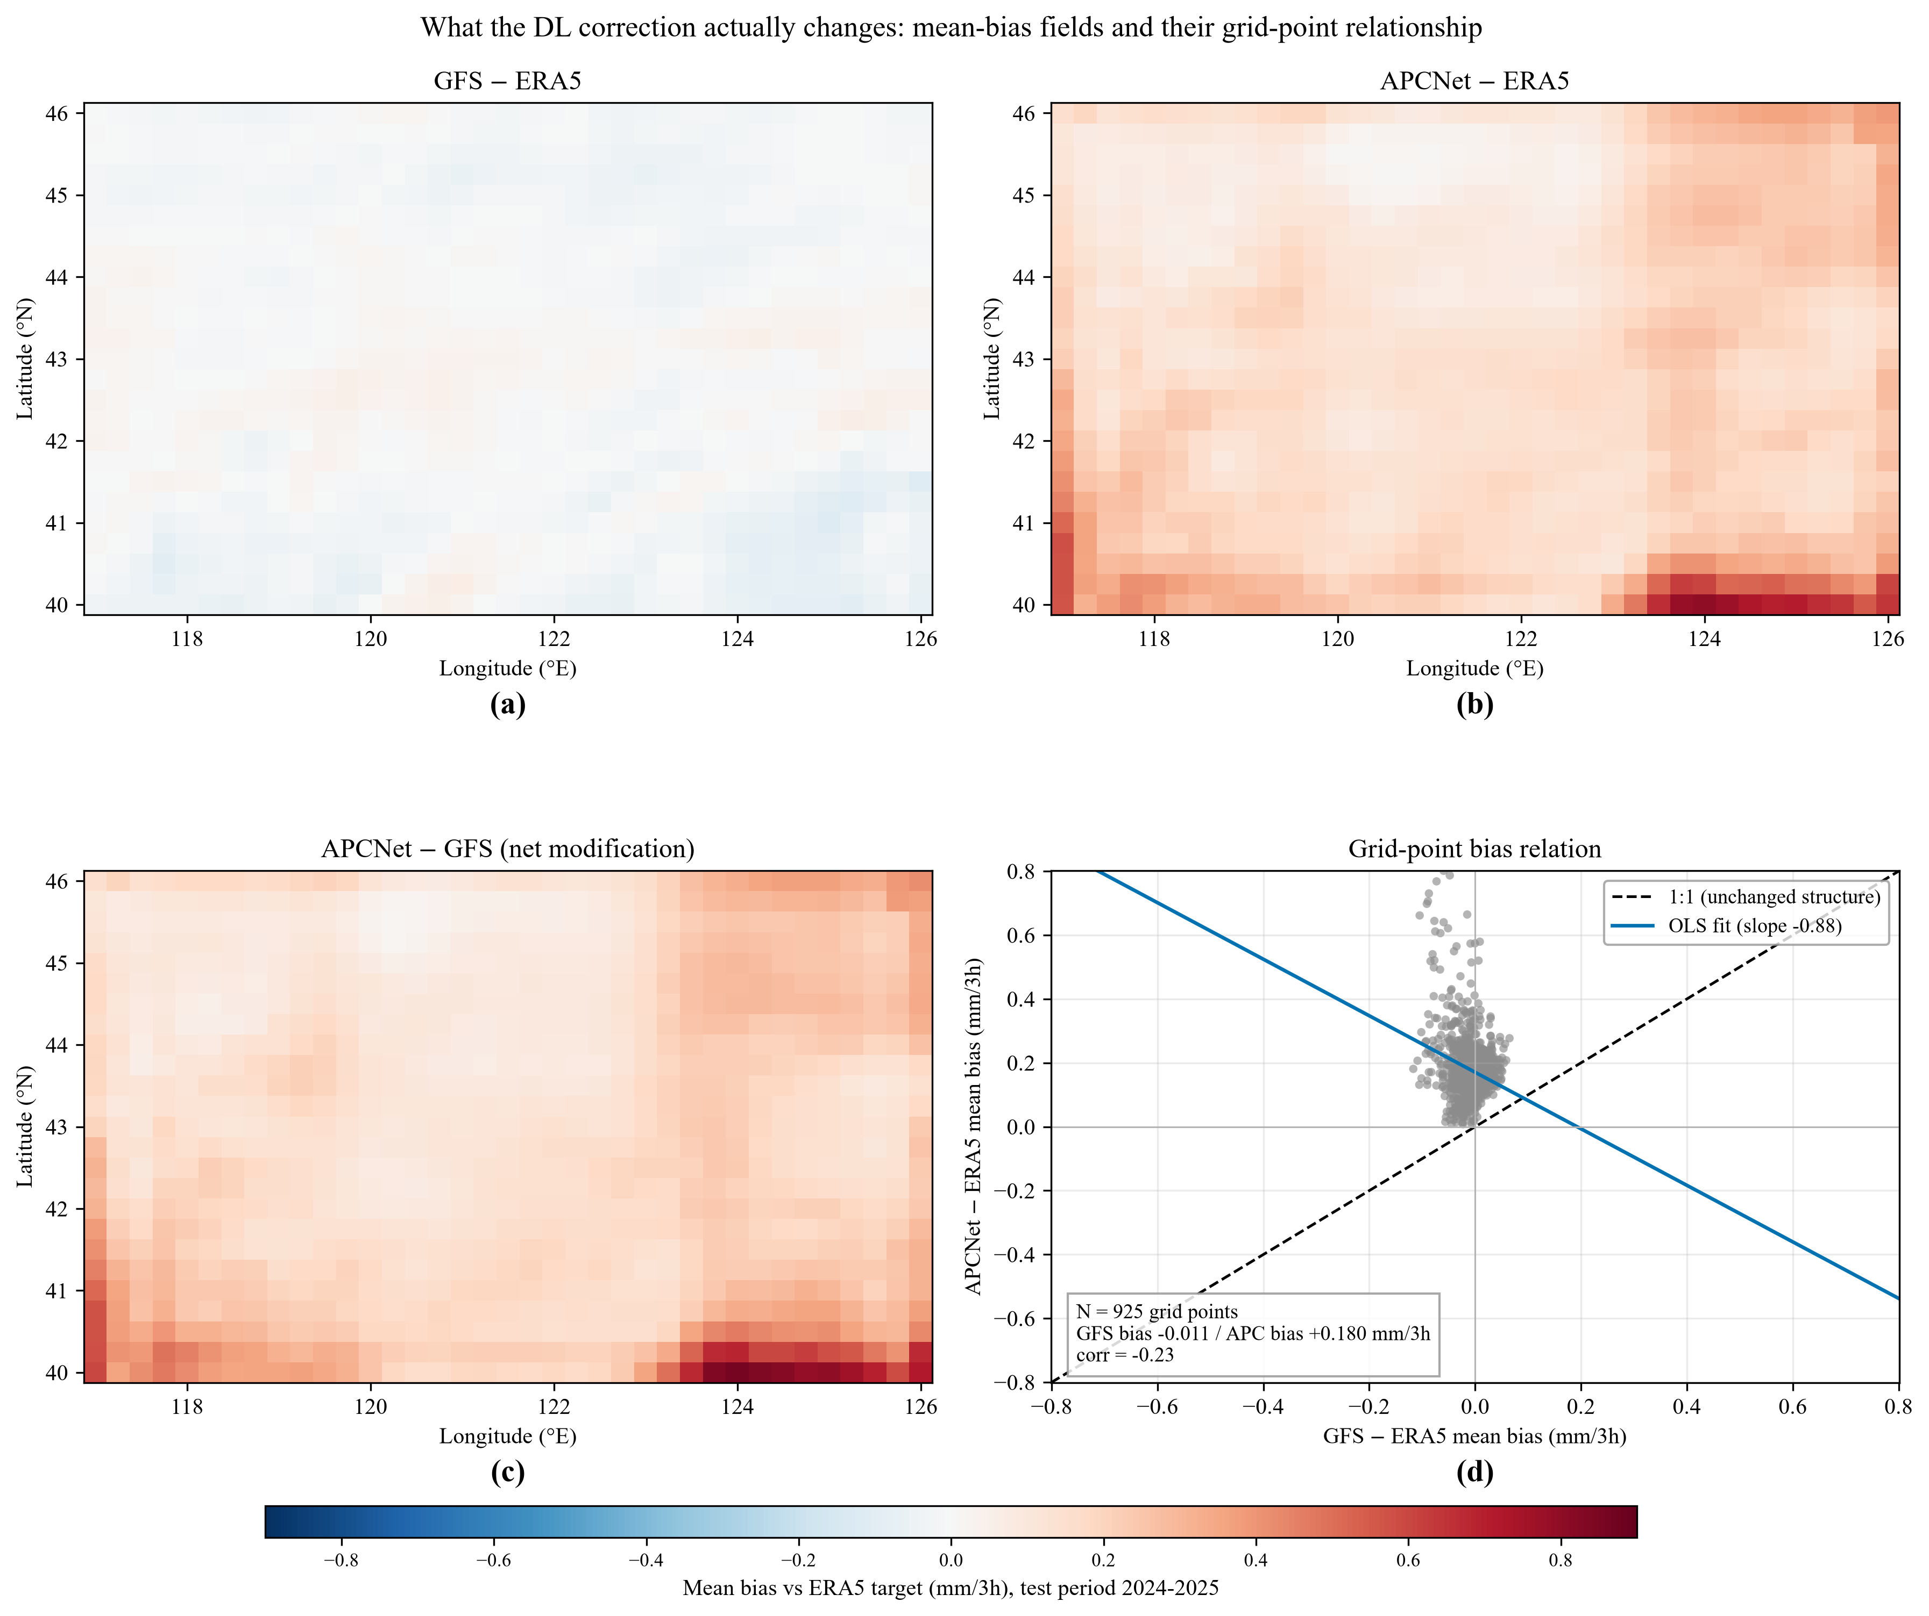
Fig. 5. What the DL correction actually changes. (a)-(c) Multi-year mean bias fields on the ERA5 training reference (test period 2024-2025, mm/3h): (a) raw GFS (domain mean -0.011, s.d. 0.028); (b) APCNet (mean +0.180, s.d. 0.107); (c) net modification APCNet - GFS (mean +0.192, s.d. 0.117). (d) Grid-point scatter of the APCNet vs GFS mean bias with 1:1 line and OLS fit (slope -0.88, correlation -0.23): the network over-corrects wherever GFS is locally dry.

b. Controlled Experiment: Target Noise and Loss Design Set the Skill Ceiling
Fig. 6 and Table 4 show the controlled experiment (seed 42, zero-correction baseline):
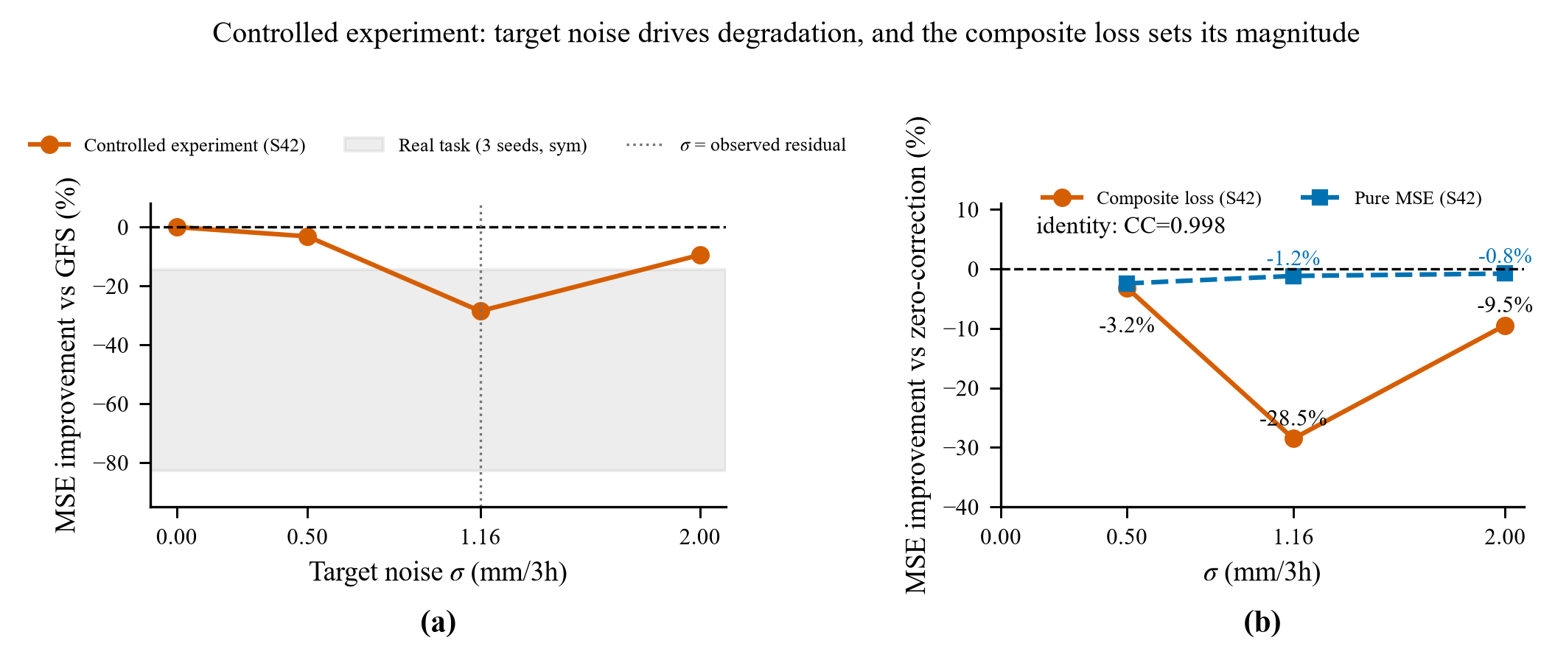
Fig. 6. Controlled experiment (Section 2d). (a) MSE improvement relative to the raw GFS forecast as a function of the added Gaussian target noise (sigma); the grey band marks the real-task range across the three seeds. (b) The same skill against the zero-correction baseline for the composite loss (seed 42) and for a pure-MSE rerun (seed 42): the composite loss sets the magnitude of the degradation, while the pure-MSE rerun nearly eliminates it (Section 4a). The identity run (sigma = 0) learns the mapping almost perfectly (correlation 0.998); under the composite loss, skill is worst at the observed residual level (sigma = 1.16 mm/3h, -28.5%).
Table 4. Controlled experiment (Section 2d). MSE improvement relative to the zero-correction baseline (output = GFS). The last three rows repeat the noisy arms with a pure MSE loss (all other training components unchanged).
Target | Sigma (mm/3h) | Val MSE convergence | MSE improvement | r(pred, noise)
GFS (identity) | 0 | 0.0083 | 0.0 (identity; CC 0.9984) | -
GFS + noise | 0.5 | 0.26 | −3.2% | 0.0005
GFS + noise | 1.16 (= observed residual std) | 1.73 | −28.5% | 0.0010
GFS + noise | 2.0 | 4.38 | −9.5% | 0.0008
GFS + noise (MSE-only) | 0.5 | 0.26 | −2.4% | 0.0001
GFS + noise (MSE-only) | 1.16 (= observed residual std) | 1.36 | −1.2% | 0.0006
GFS + noise (MSE-only) | 2.0 | 4.03 | −0.8% | 0.0002
Three facts follow. (i) The architecture is not the bottleneck: with a noise-free target the network learns the identity mapping almost perfectly (correlation 0.9984). (ii) It learns essentially nothing from an independent noise component (r ≈ 0 in all noisy runs). (iii) Despite this, it degrades MSE relative to the zero-correction baseline, most strongly at sigma = 1.16 (−28.5%, within the real-task range). The non-monotonicity is explained by a ratio effect: the network output is a small-mean correction uncorrelated with the injected noise, so the improvement is approximately −var(pred)/sigma^2; the correction variance grows and saturates (0.007 at 0.5, 0.366 at 1.16, 0.385 at 2.0) while sigma^2 keeps growing. Critically, the magnitude of the degradation is set by the training loss, not by the target SNR alone: rerunning each noisy arm with a pure MSE loss keeps the improvement near the mathematical floor of zero across all sigma (three-seed means of −2.1%, −0.9%, and −0.6% at sigma = 0.5, 1.16, and 2.0 mm/3h; seed-42 values −2.4%, −1.2%, and −0.8% in Table 4), whereas the full multi-term loss (seed 42) amplifies it to −3.2%, −28.5%, and −9.5%. The negative skill is thus causally tied to the combination of target noise and the learning procedure, with the loss design as the dominant amplifier.

c. Daily-Scale Diagnostics and Independent Verification against CHM and GPM IMERG
The spatial bias fields (Section 3a, Fig. 4) already show that the network wets the domain non-uniformly. At the daily scale (12-h coverage; 713 complete days) the conclusions are stronger (Table 5): the network degrades daily MSE by −54.9% (domain-mean daily rate 1.68 versus 0.916 mm/12h; Table 5), QM (+9.4%) and OLS (+11.2%) retain positive skill, and the retrained U-Net degrades daily MSE by −110.7%—the same over-wetting integrated over the day.
Table 5. Daily-scale deterministic skill (12-h coverage; four 3-h windows per UTC day; 713 complete days).
Method | MSE | Improvement | CC | Daily-mean rate (mm/12h) | >=10 mm bias
GFS | 5.6918 | - | 0.726 | 0.916 | 1.27
APCNet (sym S42) | 8.8186 | −54.9% | 0.747 | 1.68 | 1.82
QM | 5.1562 | +9.4% | 0.737 | 0.878 | 1.20
OLS | 5.0515 | +11.2% | 0.722 | 0.882 | 0.87
U-Net (retrained) | 11.9931 | −110.7% | 0.756 | 1.67 | 2.07
Table 6 reports the CHM daily verification (713 common days, 2024–2025, mm h⁻¹ rate basis; model fields cover 12 h and CHM covers 24 h, so only rate comparisons are made):
Table 6. CHM daily verification (rate basis, 713 common days). RMSE improvement relative to raw GFS; negative means degradation.
Method | RMSE (mm/h) | MAE | CC | Bias (fcst-obs) | RMSE improvement vs GFS
GFS | 0.2720 | 0.0801 | 0.4924 | +0.0055 | -
APCNet (sym, S42) | 0.3286 | 0.1220 | 0.5222 | +0.0691 | −20.82%
APCNet (sym, S40/S41) | 0.3525/  0.4069 | 0.1533/  0.1578 | 0.4930/  0.4901 | +0.1052/  +0.1097 | −29.59%/  −49.60%
U-Net (retrained) | 0.3722 | 0.1240 | 0.5205 | +0.0681 | −36.84%
QM | 0.2622 | 0.0790 | 0.4962 | +0.0024 | +3.58%
OLS | 0.2389 | 0.0840 | 0.4869 | +0.0027 | +12.15%
Monthly block bootstrap (24 month-blocks, 2,000 resamples) gives APCNet −20.82% (CI [−27.02, −16.78]%, P(improvement > 0) = 0.000), QM +3.58% (CI [+1.47, +5.12]%), and OLS +12.15% (CI [+9.80, +15.86]%; both P < 0.001): the DL networks are the only methods with significantly negative skill at the observation scale, and the retrained U-Net is even worse (−36.84%, bias +0.0681 mm/h). The conclusion is insensitive to block length (60-/90-day blocks). The network increases the mean absolute bias by an order of magnitude (from +0.006 to +0.069 mm/h for S42), over-wetting by about 2.0× (0.140 versus CHM 0.071 mm/h; Fig. 7).
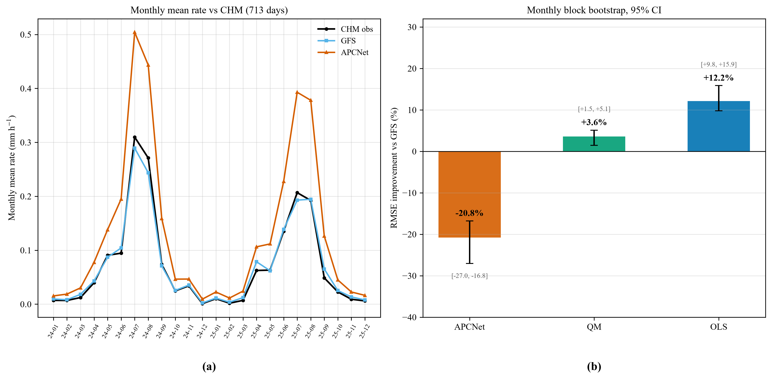
Fig. 7. CHM verification: (a) monthly mean precipitation rate of GFS, APCNet, and CHM; (b) RMSE improvement relative to GFS with 95% monthly-block bootstrap intervals. The DL networks (APCNet and U-Net) are the only methods with significantly negative skill at the observation scale (-20.8%, CI [-27.0, -16.8]); QM (+3.6%) and OLS (+12.2%) are significantly positive.
Error decomposition by observed intensity (Table 7). Binning the errors by the CHM observed rate shows that the network improves only the heaviest bin (≥1.0 mm/h; RMSE −0.195) and degrades every other bin: the dry/trace bin (<0.02 mm/h; 78% of samples) suffers a MAE increase of +0.067 mm/h from over-wetting; 15.8% of samples improve and 63.7% degrade.
Table 7. CHM error decomposition by observed intensity bin. Delta RMSE = APCNet - GFS; the network improves only the heaviest bin and degrades all others. Samples are pooled over 713 common days and all 925 GFS grid points (25 × 37); the co-located CHM subset used for domain-mean verification in Tables 14 and 16 retains 884 grid points.
Observed rate bin (mm/h) | Samples | GFS RMSE | APCNet RMSE | Delta RMSE
0-0.02 | 514,427 | 0.1450 | 0.2533 | +0.108
0.02-0.1 | 59,517 | 0.2498 | 0.4268 | +0.177
0.1-0.3 | 42,682 | 0.3380 | 0.5203 | +0.182
0.3-1.0 | 32,538 | 0.5461 | 0.6794 | +0.133
>=1.0 | 10,361 | 1.3783 | 1.1834 | −0.195
Interpretation. The raw GFS is nearly unbiased against CHM (+8% in rate), not under-forecasting; the network learned amplification therefore moves the field in the wrong direction at the observation scale. ERA5 itself is close to CHM in climatological mean (QM-corrected domain-mean rate 0.0732 versus CHM 0.0708 mm/h, within about 3%), which is why QM transfers well; the network non-uniform amplification destroys this climatological fidelity.
The degradation is not a warm-season artefact: splitting the 713 common days into the warm season (June–August; 184 days) and the remaining seasons gives the same ranking and negative sign for both networks (APCNet RMSE improvement −16.2% and −23.3%; U-Net −35.9% and −40.0%), whereas OLS remains positive in both (+9.9% and +14.4%) and QM is marginally positive only in the warm season (+3.7%), echoing the regionally contrasting warm-season rainfall trends reported by Dong et al. (2018).
Table 8 reports the GPM verification at the native 3-h scale (2,475 samples, 2024-01-15 to 2025-09-30; six 30-min IMERG files summed per 3-h window; no coverage-mismatch assumption):
Table 8. GPM IMERG verification at the native 3-h scale (2,475 samples). MSE improvement relative to raw GFS.
Method | MSE | RMSE | MAE | CC | Bias (fcst-obs) | MSE improvement vs GFS
GFS | 2.2635 | 1.5045 | 0.3014 | 0.4682 | +0.0106 | -
ERA5 (target) | 2.1593 | 1.4695 | 0.3021 | 0.4733 | +0.0226 | +4.60%
BinCM (trained on ERA5) | 1.7521 | 1.3237 | 0.3039 | 0.4846 | −0.0075 | +22.60%
APCNet (sym, S42) | 2.6366 | 1.6238 | 0.4625 | 0.4738 | +0.2245 | −16.48%
U-Net (retrained) | 3.3338 | 1.8259 | 0.4560 | 0.4796 | +0.2243 | −47.29%
QM | 2.0767 | 1.4411 | 0.2963 | 0.4774 | +0.0002 | +8.25%
OLS | 1.8193 | 1.3488 | 0.3150 | 0.4695 | −0.0069 | +19.63%
OLS (GPM-trained) | 1.7438 | 1.3205 | 0.3147 | 0.4929 | −0.0012 | +22.96%
APCNet (GPM-trained, S42) | 8.6370 | 2.9389 | 1.5578 | 0.1579 | +1.2910 | −281.58%
The GPM result confirms the CHM result at the native forecast scale without any daily-coverage assumption: BinCM trained on ERA5 transfers almost perfectly (+22.6%, bias −0.008), OLS and QM improve MSE by +19.6% and +8.3%, the ERA5 target itself is slightly better than GFS (+4.6%), and the network degrades MSE by −16.5%, over-wetting the domain (predicted rate 0.470 versus observed 0.246 mm/3h); a standard U-Net retrained under the same protocol is even worse (−47.3%), so the failure is shared by the regression-based DL family. The ranking OLS > QM > GFS > APCNet holds on all three references, with BinCM ahead (Fig. 8). Retraining the per-grid-point regression on GPM targets (2018–2023) leaves the verdict unchanged (+23.0% versus +19.6%). Training APCNet directly on GPM targets does not recover skill: the test-period network degrades MSE by −281.6% (P(improvement < 0) = 1.00) with a +1.29 mm/3h wet bias.
Significance under autocorrelation-aware inference. Because consecutive 3-h samples are strongly autocorrelated, contrasts were re-tested with block bootstrap (block length 16 windows = 48 h, 2,000 resamples; 8/32-window sensitivity in the supplement). Point estimates are unchanged, but 95% intervals are wide (APCNet [−50.5, +13.2]%; QM [−18.8, +32.6]%; OLS [−6.2, +42.2]%). On the GPM record no contrast reaches conventional significance; the CHM daily record carries the significance statements of Section 3c.
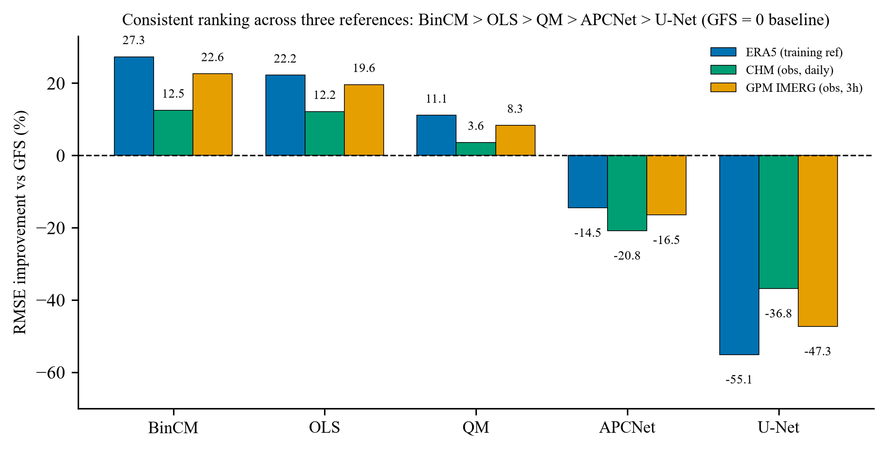
Fig. 8. MSE/RMSE improvement relative to raw GFS across the three references (ERA5 training reference, CHM daily observations, GPM IMERG 3-h observations). The ranking BinCM > OLS > QM > GFS > APCNet holds on every 3-h-scale reference; the DL networks (APCNet and U-Net) are the only methods with negative skill on all references.
Categorical scores at the 3-h scale (Table 9): at ≥1 and ≥3 mm/3h the network has the highest POD but also the highest FAR and the lowest ETS; at ≥10 mm/3h the network ETS (0.155) is statistically indistinguishable from GFS (0.149); at ≥20 mm/3h it is significantly worse (0.062 versus 0.071; P = 0.021). The extreme-detection advantage on the ERA5 reference does not transfer to observations; the conclusions are robust to interpolation (area-average remapping: BinCM +19.2%, OLS +16.5%, QM +8.0%, APCNet −12.2%).
Event-level verification. The five strongest summer (JJA) episodes (peak domain-mean 4.2–5.8 mm/3h) confirm the same ranking at the process scale: QM reproduces the observed event totals within about 9% (−9.4%), raw GFS within about 4% (−4.0%), the DL networks over-wet every event (APCNet +36%, U-Net +58%), and OLS under-forecasts by about 34%. Peak-window spatial correlation with GPM is highest for QM (0.45) and comparable for GFS (0.42) and APCNet (0.42), so the network apparent event-scale match of domain totals is an areal-inflation artefact (Fig. 9).
The same signature is visible at the event scale (Fig. 9): in a typical NECV heavy-rain episode (peak window 2024-08-09 21Z, domain-mean GPM 5.83 mm/3h), GFS, QM, and OLS reproduce the observed core (domain means 3.4–3.5), APCNet approaches the observed total (5.40) by inflating the areal extent of light-to-moderate precipitation rather than the core intensity, and U-Net over-forecasts (6.30).
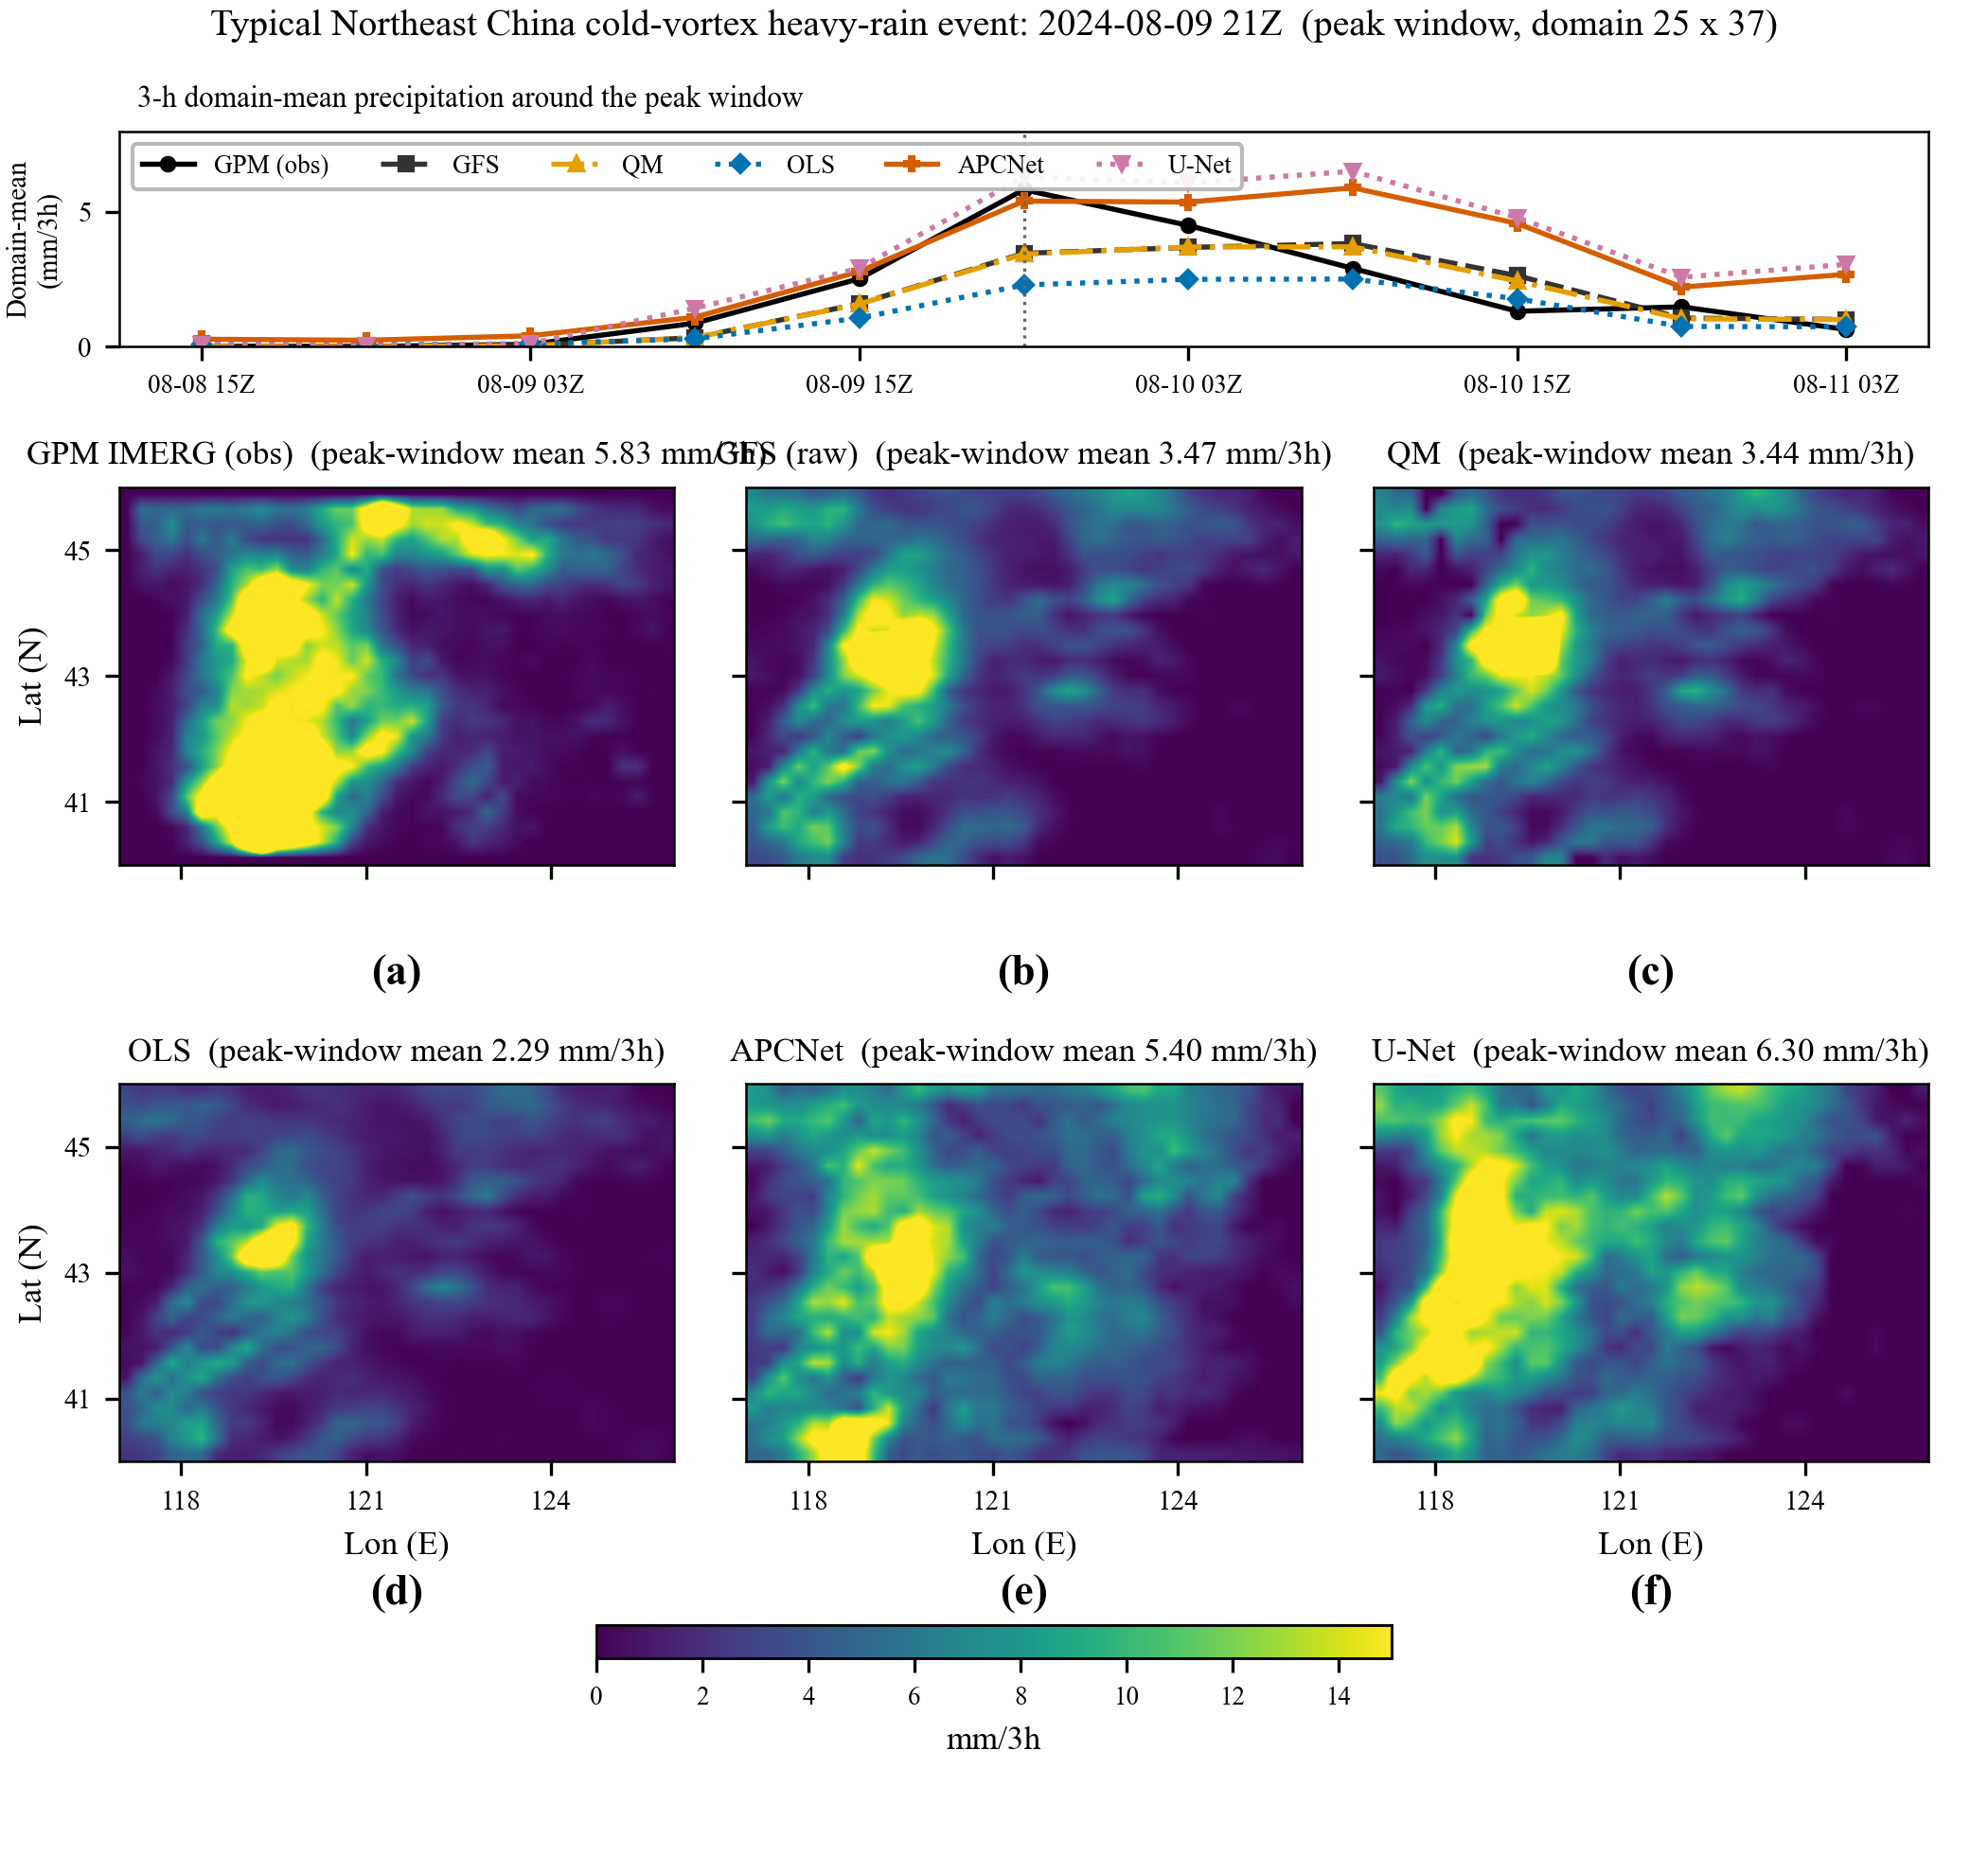
Fig. 9. Typical NECV heavy-rain event (2024-08-09 21Z, domain 25 × 37): GPM IMERG observation and corrected forecasts at the 3-h scale. Top: 3-h domain-mean precipitation around the event. Bottom: (a) GPM IMERG, (b) GFS, (c) QM, (d) OLS, (e) APCNet and (f) U-Net spatial fields (mm/3h, domain means in parentheses). GFS, QM and OLS reproduce the observed core (3.4-3.5); APCNet approaches the domain total (5.40 vs 5.83 mm/3h) by inflating the areal extent rather than the core intensity; U-Net over-forecasts (6.30).
The same picture holds at the 3-h scale against GPM: APCNet loses skill in both the warm season (June–August; n = 1,326; −15.7%) and the remaining months (n = 1,149; −25.0%), as does U-Net (−45.6% and −65.0%), whereas OLS is positive in both (+19.6% and +20.3%) and QM is positive only in the warm season (+9.5%). The 3-h failure is thus not seasonally selective.
Table 9. Categorical scores at 3-h scale against GPM IMERG. At >=10 and >=20 mm the network ETS is equal to or significantly worse than GFS. Observed events: 11,779 (>=10) and 2,478 (>=20) grid-point-hours.
Threshold (mm/3h) | POD  (GFS/APCNet) | FAR  (GFS/APCNet) | ETS  (GFS/APCNet)
>=1 | 0.521/0.654 | 0.573/0.726 | 0.282/0.206
>=3 | 0.416/0.545 | 0.579/0.707 | 0.254/0.221
>=10 | 0.227/0.288 | 0.688/0.741 | 0.149/0.155
>=20 | 0.120/0.104 | 0.851/0.865 | 0.071/0.062
Focusing the GPM verification on extreme samples preserves the ranking: per-sample RMSE improvements are +9.6%/+8.1% (OLS), +4.8%/+5.9% (QM), −17.2%/−11.2% (U-Net), and −4.0%/−1.3% (APCNet) at ≥10/≥20 mm/3h, so both DL networks degrade on extreme samples; the network domain-mean rates are 1.62/2.13 mm/3h versus 1.03/1.48 observed (+57%, +44%), while GFS stays near the observed rate (1.01, 1.36).

d. Extreme Precipitation and Probabilistic Post-Processing
On the ERA5 reference (Table 10, symmetric APCNet S42) the network achieves the highest ETS at ≥10 and ≥20 mm/3h (0.204 versus 0.193; 0.110 versus 0.086) with higher POD, at the cost of 2.0× over-wetting of the light-rain area (area bias 2.01); the ≥20 mm ETS advantage (delta = +0.0244) is statistically significant (Table 10), whereas the ≥10 mm one (0.204 versus 0.193) is not. This advantage does not survive observation-scale verification: against GPM the network ETS equals GFS at ≥10 mm and is significantly worse at ≥20 mm (Section 3c). The reference-relative extreme pattern is thus a reference-internal artefact.
Table 10. Categorical scores on the ERA5 reference (test period). The network's ETS advantage at >=20 mm is significant on the reference but does not transfer to observations (Section 3c). Events: 8,935 (>=10) and 1,402 (>=20) grid-point-hours.
Threshold (mm/3h) | POD (GFS/APCNet) | FAR (GFS/APCNet) | ETS (GFS/APCNet) | Area bias (GFS/APCNet)
>=0.1 | 0.693/0.732 | 0.292/0.636 | 0.486/0.229 | 0.98/2.01
>=3 | 0.497/0.656 | 0.432/0.601 | 0.351/0.317 | 0.88/1.64
>=10 | 0.319/0.421 | 0.667/0.714 | 0.193/0.204 | 0.96/1.47
>=20 | 0.192/0.234 | 0.866/0.828 | 0.086/0.110 | 1.43/1.36
Table 11 reports probabilistic scores on the second half of the test period (n = 1,420; symmetric APCNet S42; ERA5 reference):
On the ERA5 reference the deterministic CRPS equals the MAE column (Table 11: GFS 0.2026, QM 0.2029, APCNet 0.3336); Gaussian dressing of QM gives 0.3377 and the network CRPS improves to 0.3080 with the climatological wet frequency (constant p0) and 0.3337 with the adaptive-p0 variant. The occurrence Brier score is 0.0815 (BSS +0.297) and the extreme-threshold BSS remains negative (−0.34 at ≥10 mm, −0.69 at ≥20 mm); the reliability diagram (Fig. 10a) shows that the network over-forecasts the wet frequency at every bin, and the sharpness histogram is shown in Fig. 10b.
Table 11. Probabilistic scores (second half of test period, n = 1,420; ERA5 reference). CRPS for deterministic forecasts equals MAE; Brier and BSS values are given in Section 3d.
Method | CRPS
GFS (deterministic) | 0.2026
QM (deterministic) | 0.2029
APCNet (deterministic) | 0.3336
QM + Gaussian dressing | 0.3377
APCNet + ZIG (const p0) | 0.3080
APCNet + ZIG (adaptive p0) | 0.3337
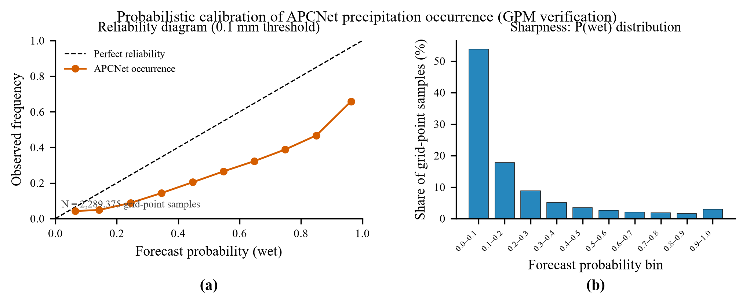
Fig. 10. (a) Reliability diagram for the APCNet precipitation-occurrence probability (≥0.1 mm) after adaptive ZIG calibration; point size scales with bin sample count (labels show counts), and the dotted line marks the climatological wet frequency. (b) Sharpness: histogram of forecast probabilities.
Probabilistic verification against GPM at the native 3-h scale (2,475 samples; dressing calibrated on ERA5) confirms the failure (Table 12): deterministic CRPS equals the MAE column of Table 8 (GFS 0.3014, QM 0.2964, APCNet 0.4625). QM + Gaussian dressing gives 0.4185; APCNet + ZIG with constant p0 gives 0.3373; the adaptive-p0 variant gives 0.4204. Occurrence Brier skill is +0.079, and extreme-threshold BSS remains negative (−0.28 at ≥10, −0.39 at ≥20); reliability over-forecasts at every bin.
Table 12. Probabilistic scores against GPM IMERG at the native 3-h scale (2,475 samples; dressing parameters calibrated on the ERA5 reference). Brier and BSS values are given in Section 3d.
Method (GPM IMERG, 3-h) | CRPS
GFS (deterministic) | 0.3014
QM (deterministic) | 0.2964
APCNet (deterministic) | 0.4625
QM + Gaussian dressing | 0.4185
APCNet + ZIG (const p0) | 0.3373
APCNet + ZIG (adaptive p0) | 0.4204

e. Terrain Stratification and Physical-Consistency Diagnostics
Complex terrain strongly modulates precipitation in this basin (Fig. 1). Elevation is not an input channel of either network; it is used here only to stratify the verification. We stratified both verifications by elevation: SRTM 90-m elevation aggregated to the GFS grid (25 × 37) ranges from 0 to 1608 m over 764 valid land points, the stratification set defined by valid SRTM land elevation, while the CHM and GPM domain means cover their full valid subsets of 884 and 828 grid points respectively (Tables 16–17), split into equal one-third quantile tiers (low ≤252 m, mid 257–835 m, high 840–1608 m); the CHM 713 common days and GPM 2,475 samples are reused (Table 13).
Table 13. RMSE against each observation product, stratified by SRTM elevation tier on the GFS grid (764 valid land points split into equal one-third quantiles). CHM rows: daily rate, mm/h; GPM rows: 3-h accumulation, mm/3h. In every tier and on both references the DL networks have the largest RMSE; QM and OLS are the only methods with systematically lower RMSE than GFS, and the DL over-forecasting bias is largest in the high (complex-terrain) tier.
Terrain tier / reference | Observed rate | GFS | QM | OLS | APCNet | U-Net
CHM low (<=252 m) | 0.0821 | 0.2872 | 0.2780 | 0.2586 | 0.3506 | 0.3951
CHM mid (257-835 m) | 0.0666 | 0.2348 | 0.2284 | 0.2082 | 0.2711 | 0.3404
CHM high (840-1608 m) | 0.0599 | 0.2138 | 0.2057 | 0.1793 | 0.2407 | 0.2981
GPM low (<=252 m) | 0.2706 | 1.5523 | 1.4649 | 1.3726 | 1.7107 | 1.9120
GPM mid (257-835 m) | 0.2259 | 1.3376 | 1.2924 | 1.2047 | 1.4199 | 1.6977
GPM high (840-1608 m) | 0.1830 | 1.2166 | 1.1751 | 1.0458 | 1.2663 | 1.5116
Diurnal and area diagnostics confirm structural damage at the observation scale (Fig. 11): GFS and QM follow the observed diurnal cycle (domain-mean 0.21–0.28 mm/3h), whereas APCNet raises every slot to 0.44–0.50 and U-Net to 0.44–0.54, flattening the cycle (09Z peak 0.501 versus 0.261 observed). Wet-area fractions behave similarly: at ≥0.1 mm/3h the observed fraction is 0.102, GFS 0.145, QM 0.140, but APCNet 0.294 (2.9×); at ≥10 mm/3h U-Net doubles the observed fraction (0.011 versus 0.005).
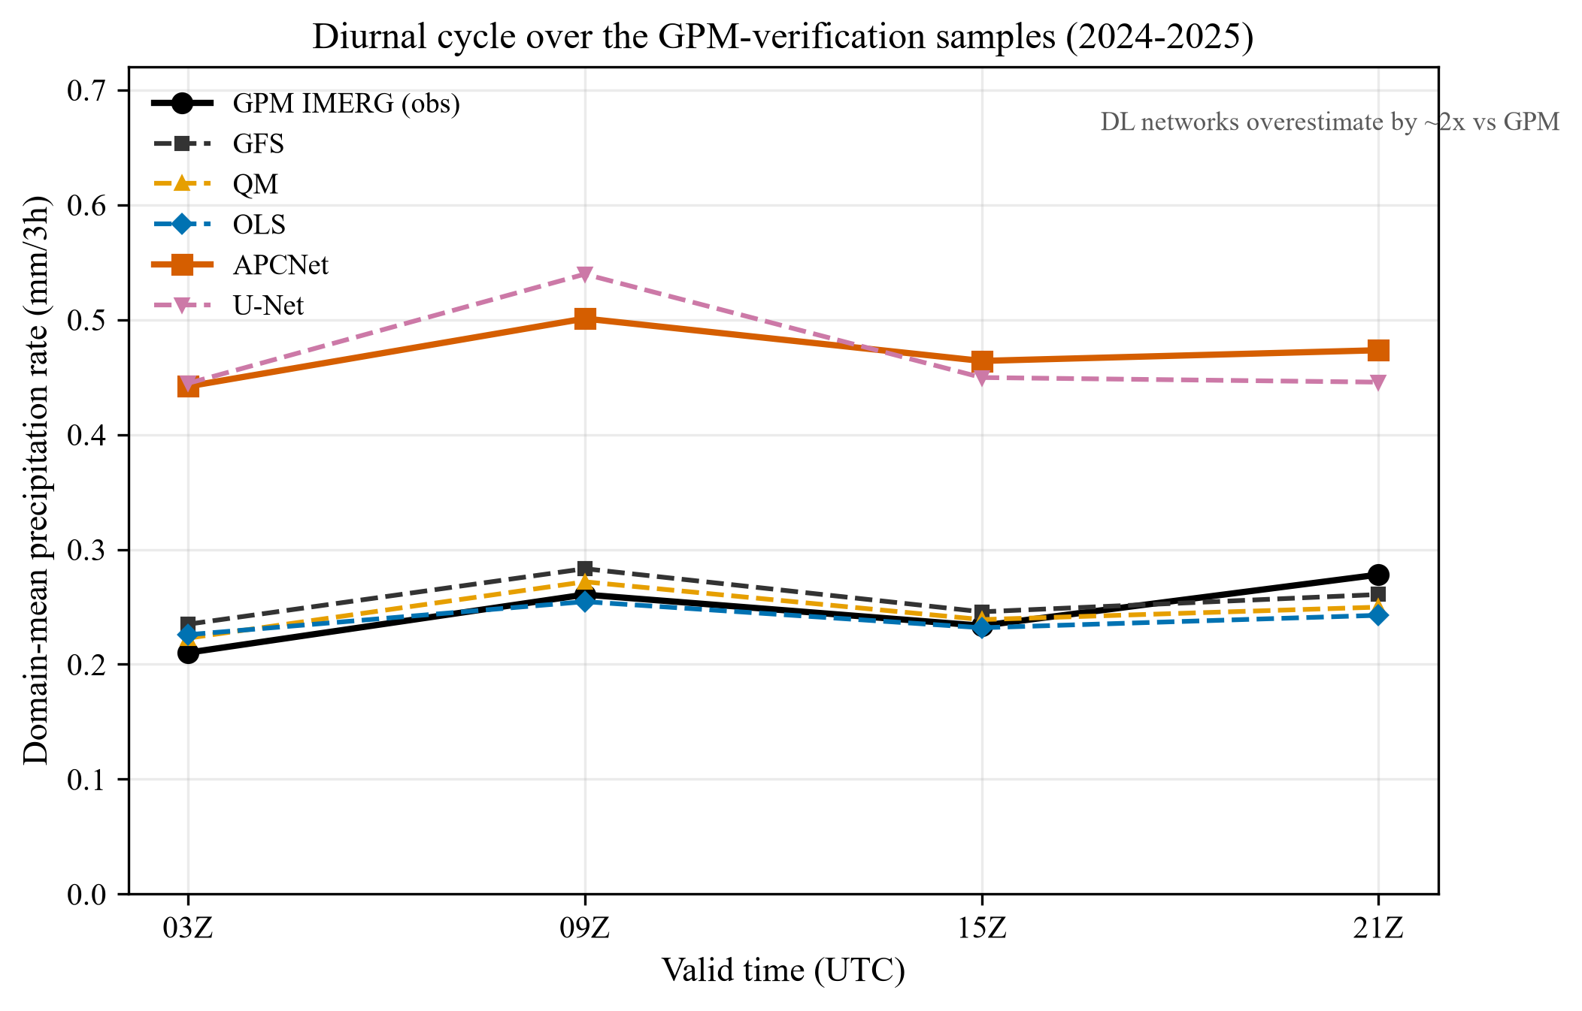
Fig. 11. Diurnal cycle of the domain-mean precipitation rate over the GPM-verification samples (2,475 samples, 2024-2025): GPM IMERG (black), raw GFS (blue), QM (green), OLS (orange), APCNet (red), U-Net (purple). The DL networks over-forecast by a factor of about two at every valid time and flatten the daytime peak.
We additionally evaluated the same networks over an earlier CHM period (2022–2023, 712 common days; Table 14). This window is not fully out-of-sample (it served for early stopping and hyperparameter selection), so its numbers are a favourable-case bound: even then the DL networks do not overtake the baselines (60-day block bootstrap; APCNet +9.4% RMSE, CI [+7.5, +11.2]; U-Net +6.5%; QM +3.9%; OLS +12.0%; all P < 0.01), but the DL rate bias is again the largest (−32% deficit: 0.0441 versus 0.0648 mm/h). On the fully independent window the bias sign reverses: the same APCNet checkpoint is systematically wet (forecast-minus-observed bias +0.0691 mm/h with 20.8% RMSE degradation, versus a near-zero GFS bias of +0.0055 mm/h; Table 6). The sign flip is not a data inconsistency—both windows use the same checkpoints and the same rate-based evaluation—but the fingerprint of a checkpoint selected on the validation window: variance is compressed in-sample and amplified out-of-sample. The same networks degrade to negative skill on the fully independent 2024–2025 test period (−55% to −111% on ERA5 daily; −21% to −50% against CHM), while OLS and QM retain positive skill.
Table 14. Validation-period (in-selection) CHM verification (2022-2023, 712 common days, 12-h daily coverage, domain mean over the 884 CHM-valid GFS grid points). Observed domain-mean rate 0.0648 mm/h. Delta RMSE is the RMSE improvement relative to raw GFS (positive = improvement); dRMSE intervals are 95% block-bootstrap confidence intervals (60-day blocks, 2,000 draws). Per-sample spatial CC against the ERA5 reference: GFS 0.349, QM 0.299, OLS 0.313, APCNet 0.228, U-Net 0.174. The 3.2× rate contrast between this window (APCNet 0.0441 mm/h) and the independent 2024-2025 CHM window (Section 3c) reflects checkpoint selection on the former window (Section 4b, Table S2).
Method (CHM 2022-2023, daily rate, mm/h) | RMSE | dRMSE vs GFS (95% CI, 60-d block) | CC | Bias | Domain-mean rate
GFS | 0.2414 | - | 0.547 | +0.0012 | 0.0660
QM | 0.2320 | +3.9% (+0.8, +6.4) | 0.549 | −0.0019 | 0.0629
OLS | 0.2126 | +12.0% (+9.9, +13.7) | 0.544 | +0.0017 | 0.0665
APCNet | 0.2188 | +9.4% (+7.5, +11.2) | 0.520 | −0.0207 | 0.0441
U-Net | 0.2258 | +6.5% (+4.8, +7.8) | 0.528 | −0.0192 | 0.0456

f. Accumulation-Scale Dependence
To test whether the negative 3-h skill is specific to the fine scale, we built accumulated-forecast experiments at 24-, 72-, and 120-h leads using GFS direct accumulations (time_bnds [init, init+fhr]) and ERA5 hourly tp aggregated over the identical window, with the same gate-verified checks (Table S1). The same APCNet and U-Net were retrained for each lead (training scripts provided in the code repository) on an identical year-based split (train/val/test 3,734/2,919/2,916 at 24 h; 2019–2021/2022–2023/2024–2025, the start year set by the direct-accumulation GFS archive beginning June 2019), alongside QM, BinCM, and OLS, and evaluated on the fully independent 2024–2025 test period.
Table 15 reports the ERA5-reference results. The ranking flips with accumulation scale. At 3 h the DL networks degrade MSE (−14.5%) while QM, BinCM, and OLS improve it. At 24–120 h every DL method shows substantial positive skill (APCNet +20.4%/+16.0%/+12.2%; U-Net +23.0%/+19.3%/+17.2%) whereas QM collapses to near zero (+2.3%/+1.1%/+3.0%) and BinCM/OLS retain only roughly +4% to +6%. Month-block bootstrap confirms the DL gains (CI [+19.7, +21.1] at 24 h, [+14.3, +17.5] at 72 h, [+10.7, +13.5] at 120 h, all excluding zero); a three-seed retrain of APCNet at 24 h gives +19.5% ± 0.9% (spatial CC 0.811 ± 0.005), so the long-lead gain is not a lucky initialization.
Table 15. ERA5-reference deterministic skill across accumulation scales (fully independent 2024-2025 test period; 2,839 / 2,916 / 2,909 / 2,900 samples at 3 / 24 / 72 / 120 h). Delta MSE is the MSE improvement relative to raw GFS (positive = improvement). Month-block bootstrap 95% confidence intervals for the APCNet improvement are [+19.7, +21.1] (24 h), [+14.3, +17.5] (72 h) and [+10.7, +13.5] (120 h). CC is the all-grid-point-time correlation with the ERA5 reference.
Scale | GFS MSE | APCNet dMSE (%) | U-Net dMSE (%) | QM dMSE (%) | BinCM dMSE (%) | OLS dMSE (%) | APCNet CC | U-Net CC
3 h | 1.346 | −14.5 | −55.1 | +11.1 | +27.3 | +22.2 | 0.628 | 0.633
24 h | 17.52 | +20.4 | +23.0 | +2.3 | +5.6 | +6.4 | 0.813 | 0.821
72 h | 71.85 | +16.0 | +19.3 | +1.1 | +5.0 | +4.0 | 0.810 | 0.817
120 h | 159.39 | +12.2 | +17.2 | +3.0 | +6.2 | +4.0 | 0.779 | 0.793
Independent gauge verification confirms the long-lead DL skill (Table 16, Fig. 12b): against CHM daily rates (init 00Z only; 730/728/725 common days; 884 valid grid points), APCNet improves RMSE by +5.5%/+5.4%/+4.7% (month-block 95% CIs [+3.9,+6.8]/[+3.1,+7.0]/[+2.1,+8.7]) and U-Net by +6.9%/+6.6%/+7.6% (CIs [+6.2,+8.0]/[+3.5,+9.4]/[+4.0,+10.3]) at 24/72/120 h, with spatial-CC gains of +0.03 to +0.05 over GFS; the ERA5 reference changes by −1.9%/+4.6%/+14.8%, so the trained networks exceed their training reference at 24–72 h; at 120 h the reference itself improves more (+14.8%) than either network (+4.7%/+7.6%). At the daily scale ETS10 is negative for every method including raw GFS (−0.22 to −0.12).
Table 16. CHM independent verification at accumulated leads (init 00Z; 730 / 728 / 725 common UTC days; domain mean over the 884 CHM-valid GFS grid points; mm day-1). Delta RMSE is the RMSE improvement relative to raw GFS (positive = improvement); 95% block-bootstrap confidence intervals (24 monthly blocks, 2,000 draws) in brackets. ETS10 at the daily scale is negative for every method (GFS -0.224 to -0.123).
Lead | Common days | GFS RMSE (mm/day) | APCNet dRMSE (%) | U-Net dRMSE (%) | ERA5 dRMSE (%) | APCNet CC | U-Net CC
24 h | 730 | 6.07 | +5.5 [+3.9, +6.8] | +6.9 [+6.2, +8.0] | −1.9 [−4.7, +2.4] | 0.548 | 0.571
72 h | 728 | 9.37 | +5.4 [+3.1, +7.0] | +6.6 [+3.5, +9.4] | +4.6 [+1.1, +12.8] | 0.753 | 0.760
120 h | 725 | 13.04 | +4.7 [+2.1, +8.7] | +7.6 [+4.0, +10.3] | +14.8 [+10.3, +23.8] | 0.758 | 0.776
Independent satellite verification against GPM IMERG (V07B; 30-min rates summed over the identical windows; init 00Z only; 638/636/633 samples; 828 of 925 grid points) confirms the reversal (Table 17, Fig. 12b): the DL corrections improve MSE by +14.0%/+15.5%/+13.2% (APCNet; 95% CIs [+9.1,+18.7]/[+12.1,+17.6]/[+9.6,+20.2]) and +18.4%/+16.7%/+18.0% (U-Net; CIs [+15.0,+23.0]/[+14.0,+20.1]/[+16.4,+20.3]), exceeding all statistical baselines (QM +3.0%/−0.1%/+1.3%; BinCM +9.0%/+5.5%/+2.6%; OLS +7.6%/+6.4%/+4.0%). Together with the 3-h GPM result (APCNet −16.5%), the two products bound the scale dependence.
Table 17. GPM IMERG independent verification at accumulated leads (init 00Z; 30-min IMERG rates aggregated over [init, init+fhr]; 638 / 636 / 633 samples; domain mean over the 828 GPM-covered grid points; mm per lead). Delta MSE is the MSE improvement relative to raw GFS (positive = improvement); 95% block-bootstrap confidence intervals (24 monthly blocks, 2,000 draws) in brackets. QM / BinCM / OLS are the grid-point baselines of Section 2c.
Lead | Samples | GFS RMSE (mm) | APCNet dMSE (%) | U-Net dMSE (%) | QM dMSE (%) | BinCM dMSE (%) | OLS dMSE (%)
24 h | 638 | 5.30 | +14.0 [+9.1, +18.7] | +18.4 [+15.0, +23.0] | +3.0 [+0.9, +4.2] | +9.0 [+6.5, +13.1] | +7.6 [+4.9, +13.3]
72 h | 636 | 10.23 | +15.5 [+12.1, +17.6] | +16.7 [+14.0, +20.1] | −0.1 [−3.9, +3.3] | +5.5 [−0.4, +14.2] | +6.4 [+1.1, +16.4]
120 h | 633 | 14.85 | +13.2 [+9.6, +20.2] | +18.0 [+16.4, +20.3] | +1.3 [−0.5, +3.6] | +2.6 [−4.3, +11.5] | +4.0 [−2.0, +15.8]
The mechanism is the same target-SNR argument as in Section 3b, now across scales. At 3 h the GFS–ERA5 residual has a standard deviation of about 1.16 mm/3h, roughly 0.8 times the field standard deviation, with about 36% of the reference variance predictable from GFS (Section 4a); the network fails to learn the strong downward heavy-bin correction and adds +75% over-wetting. At 24 h, time averaging removes much of the convective randomness (residual std 4.18 versus a 25.4 mm/24h mean): the network domain-mean bias drops from +75% to +8.5%, and its heavy-bin prediction (29.3 versus 28.9 mm) is nearly correct. Time averaging converts the target from noise-dominated to systematic-bias-dominated—the regime in which a flexible learned mapping adds value and a monotone baseline (QM) has almost nothing left to learn.
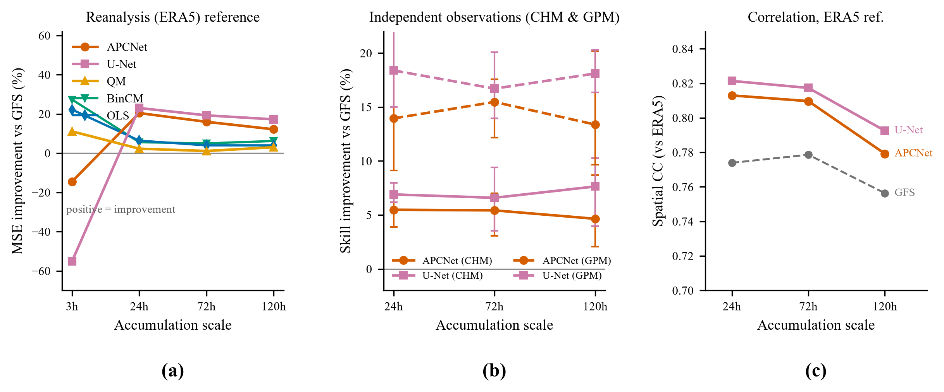
Fig. 12. Accumulation-scale dependence of correction skill. (a) MSE improvement relative to raw GFS on the ERA5 reference across the four scales (3-h, 24-h, 72-h, 120-h) for APCNet, U-Net, QM, BinCM and OLS (positive = improvement). (b) skill improvement in independent verification (CHM gauge: RMSE; GPM IMERG: MSE) at 24- / 72- / 120-h leads for APCNet and U-Net (error bars: month-block bootstrap 95% confidence intervals). (c) Spatial correlation with the ERA5 reference. The DL ranking flips from strongly negative at 3 h to strongly positive at >= 24 h, while the baselines lose skill.

4. Discussion

a. Why a DL Correction Cannot Exceed Its Training Reference at the 3-h Scale
Two experiments bound the mechanism. The controlled experiment (Section 3b) provides the target-noise part: the GFS–ERA5 residual has std about 1.16 mm/3h against a domain-mean rate of 0.24 mm/3h. The residual is not an independent additive noise of unit SNR: with an all-point correlation of 0.60 between GFS and ERA5, the squared correlation implies that roughly 36% of the reference variance is predictable from GFS, and the residual std is about 0.8 times the field std. The bin benchmark below shows that the predictable part (the conditional mean) is learnable in principle (+27.3% on the reference), so target noise sets a ceiling for residual-amplifying regression, not for correction per se. A loss-minimizing network that amplifies part of the unpredictable residual increases error; the intensity-weighted loss biases the correction toward amplification (over-wetting), reproduced by the sigma = 2.0 arm as a ratio effect; consistent with this, rerunning the worst-case arm with a pure MSE loss reduces the degradation at sigma = 1.16 from −28.5% to about −0.9% (three-seed mean; seed 42 −1.2%; Section 3b).
The bin benchmark adds the structure part: E[ERA5|GFS] is strongly learnable—a table of training-period bin means reduces MSE by +27.3% on the reference and +22.6% on GPM, the largest reduction of any method. The learnable structure is therefore not absent; it is simply not captured by the network, whose residual-amplifying regression trades away exactly the conditional-mean behaviour that BinCM implements by construction. The failure is one of the learning procedure under a noisy reference, not an absence of signal or a capacity ceiling.
Object-based verification (Davis et al. 2006) at the 3-h scale separates the intensity correction from the spatial structure: for matched objects at ≥10 mm the network raises the detection rate relative to raw GFS (POD 0.445 versus 0.414) and lowers the intensity error (0.107 versus 0.138), but the area error worsens markedly (0.965 versus 0.462); at ≥20 mm the detection-rate gain disappears (POD 0.313 versus 0.364) while the intensity error still improves (0.049 versus 0.091) and the area error remains degraded (0.367 versus 0.319). The correction is therefore amplitude-driven rather than structural: the network sharpens the rain-rate field toward the reference conditional mean without acquiring its spatial organization, consistent with the residual-amplifying regression mechanism discussed above.
The training-reference hypothesis can be tested directly by retraining on observation-based targets. At 3 h, retraining the per-grid-point regression on GPM IMERG targets (2018–2023) leaves the verdict unchanged (+23.0% versus +19.6% against GPM; Section 3c), and training APCNet on GPM targets does not recover skill (−281.6%; Section 3c). The scale dependence of Section 3f is therefore robust to the training reference.
Fig. 13 summarizes the distributional structure behind the 24-h skill: both DL networks raise the high quantiles toward the observed GPM distribution, and the GPM-trained U-Net stays closest to the 1:1 line in the heavy tail.
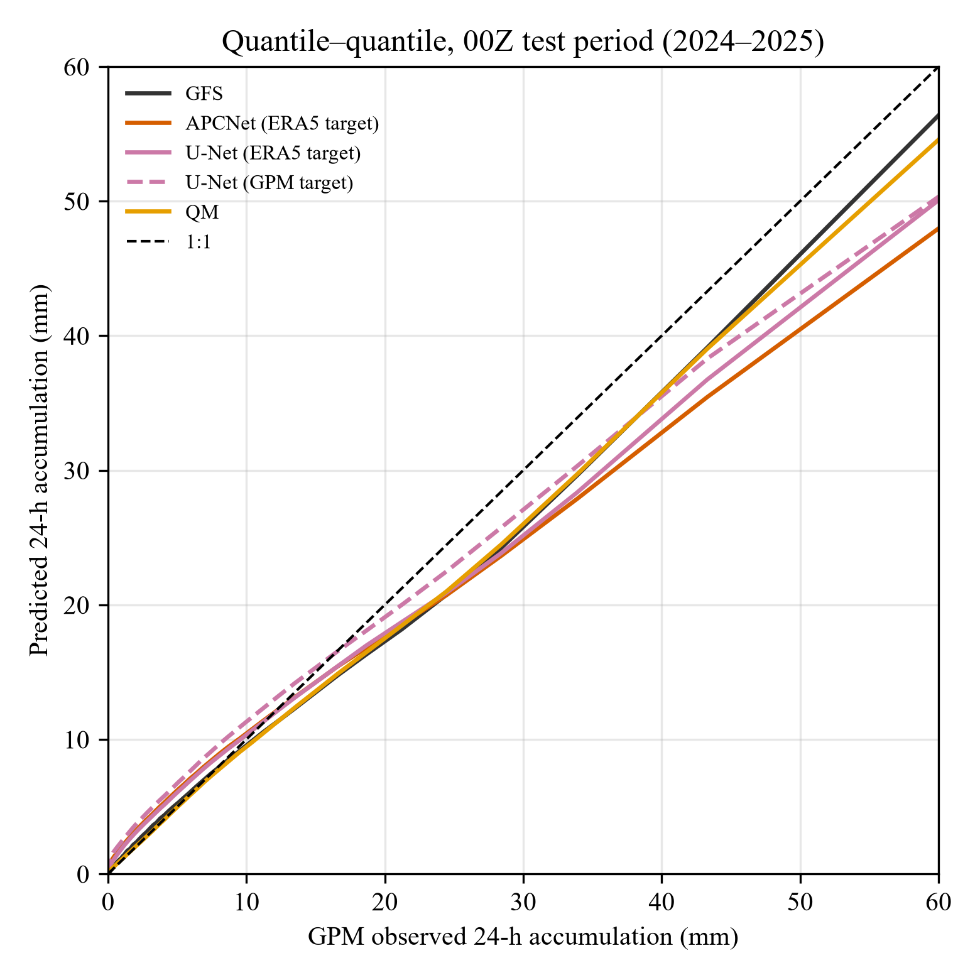
Fig. 13. Quantile-quantile comparison of 24-h accumulated precipitation against GPM IMERG observations (00Z test period, 2024-2025; 200 quantiles over the 828 GPM-covered grid points). U-Net trained on GPM targets tracks the 1:1 line most closely above ~20 mm; the reanalysis-trained U-Net is close behind, while raw GFS and QM remain near the climatological mapping.

b. Why Simple Baselines Win at the 3-h Scale, and Why the Ranking Flips at Accumulated Scales
Deterministic CRPS (=MAE) on the ERA5 reference confirms the deterministic findings. Probabilistic dressing improves the network CRPS: with the climatological wet frequency the ZIG CRPS drops below the QM-dressed value (Section 3d), while the adaptive-p0 variant matches the deterministic network (Haynes et al. 2023; Song et al. 2024; Stovern et al. 2023; Worsnop et al. 2024). All probabilistic scores in this paragraph are against the ERA5 reference (Table 11); the GPM-reference values are reported in Table 12. The network occurrence probability is systematically over-forecast: at every bin the observed wet frequency falls below the forecast probability (0.050 versus 0.064 at the lowest bin, to 0.898 versus 0.963 at the highest; Fig. 10a). The Gaussian dressing spread is about 3.5× wider than QM (3.04 versus 0.86 mm/3h). Occurrence Brier is 0.0815 (BSS +0.297), but at ≥10 and ≥20 mm the occurrence BSS is negative (−0.34, −0.69).
QM, OLS, and BinCM implement the conditional climatology of the training reference, and three properties make them robust at the observation scale. They are monotone value-to-value mappings, so they cannot create the large non-uniform over-wetting that a nonlinear network produces. The ERA5 reference is climatologically close to the observations here (QM-corrected rate 0.0732 versus CHM 0.0708 mm/h), so a mapping fitted to ERA5 remains approximately correct. Their simplicity prevents overfitting to the reference noise: the bin table has no free parameters beyond its means, and neither method can amplify the residual the way a flexible network does. The network, by contrast, amplifies the ERA5 residual—mostly noise plus a small positive bias—producing about 2× domain-mean over-wetting (Table 10) and inflating the field variance (Fig. 14). QM is not a universal remedy: it can degrade when the input–reference correlation is weak (Zhao et al. 2017) and its extreme quantiles overfit short samples (Holthuijzen et al. 2022).
The practical lesson is to evaluate on independent verification and report simple baselines, echoing existing guidance (Vannitsem et al. 2021; Cannon et al. 2015); the pattern is not unique to deep learning (Ghazvinian et al. 2022; Sun and Lan 2021; Voisin et al. 2010).
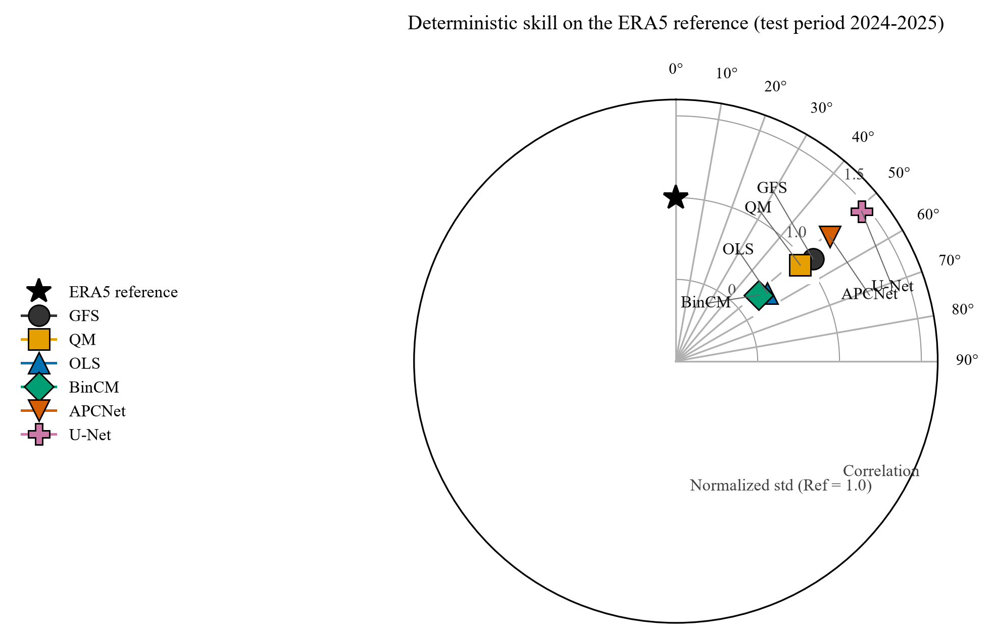
Fig. 14. Taylor diagram of deterministic skill on the ERA5 training reference (test period 2024-2025). The raw GFS and the simple baselines (QM, OLS, BinCM) sit close to the reference with normalized standard deviation near 1; the DL networks reach the highest all-point correlation but inflate the field variance (normalized std 1.21 and 1.46), the over-wetting signature quantified in the spatial fields above. The figure is placed in the Discussion because it summarises this variance-inflation signature in the context of the ranking-reversal argument developed here.
The cross-window comparison (Table 14) sharpens the point. On the window used for early stopping and hyperparameter selection the networks reach significantly positive skill (APCNet +9.4% RMSE, CI [+7.5, +11.2]), yet remain below OLS (+12.0%). On the fully independent test window the same networks turn negative (−21% to −50% against CHM; −15% to −83% on ERA5), while OLS and QM keep positive skill. Significant skill in the selection window and strongly negative skill out-of-sample are the fingerprint of learning the reference noise.
Seed sensitivity. The negative result is not an artefact of a single initialization. Retraining APCNet under three seeds reveals two behaviours. First, the MSE improvement is strongly seed-dependent (−14.5%, −46.7%, −82.8% for seeds 42/40/41), yet negative in every case: the sign of the ceiling is thus robust. Second, the heavy-rainfall complementarity is stable across seeds (ETS20 rises from GFS 0.086 to 0.110/0.096/0.098): the placement advantage is seed-stable. A three-member ensemble mean of seeds 40–42 does not rescue the 3-h result (MSE improvement −21.8% on ERA5, −22.6% against GPM), because all members over-wet the domain (0.47–0.61 versus 0.25 mm/3h). Multi-seed averaging, like loss re-weighting and post-hoc quantile mapping, cannot recover the lost extreme skill.

c. A Scale-Dependent Boundary, Robust to the Training Reference
Our results bound what can be achieved by training DL precipitation correction on ERA5 in this region under the loss and selection configuration used here: the correction inherits the reference smoothness and noise (Wu et al. 2024; Lei et al. 2022), cannot exceed the reference on its own metric at the 3-h scale (at 24–72 h accumulated scales the same networks do exceed it; at 120 h they no longer do), is outperformed by a one-dimensional conditional-mean table, and loses its climatological fidelity through amplification at the observation scale. Switching to observation-based training targets does not remove this boundary (3-h regression +23.0% versus +19.6%; 3-h APCNet on GPM targets −281.6%). The ceiling is scale-dependent: at 3 h the noisy reference sets the skill ceiling under the training configuration used here, while at accumulated scales (≥24 h) the same networks gain skill; the synthetic experiment (Section 3b) attributes the degradation magnitude to the loss design, and a pure-MSE rerun on the real task confirms the composite loss is the dominant amplifier of the negative skill (from −48.0% to −2.5%; Section 4d; Tables S3–S4). Notably, the simpler U-Net consistently outperforms APCNet at 24–120 h on all three references (Tables 15–17; e.g. +18.4% versus +14.0% against GPM at 24 h), so the long-lead gains do not depend on APCNet-specific design; conversely, at 3 h both architectures fail under the same loss, reinforcing that the 3-h failure is a property of the training configuration rather than of one architecture.

d. Limitations
CHM verification covers 2 years (713 days) with a 12-h versus 24-h coverage mismatch, forcing rate-based comparisons; GPM removes the mismatch but covers only 2024-01 to 2025-09. The study is limited to a single region, a single NWP system (GFS), and a single family of regression architectures. The controlled diagnosis (Section 3b) was performed with APCNet only; the same multi-term loss and selection criterion produce the same negative signature in both architectures at 3 h (Sections 3c–3e), so the failure is not architecture-specific, although the controlled experiment was not repeated for U-Net. Where long observation-based training targets exist, DL post-processing has been reported to beat MOS (Badrinath et al. 2023); our results bound the reanalysis-trained setting, not DL in general. Independent here means independent of the training target, not of all observations. All conclusions are stated for the NECV-dominated Liaohe basin (Yang et al. 2024). A further caveat concerns the attribution of the real-data 3-h result. The negative real-data skill is produced by the multi-term loss under the checkpoint-selection criterion of Section 2a; an MSE-selected real-data rerun (checkpoints chosen on the validation residual MSE with all other training components unchanged, three seeds) now rules out selection as the dominant source: the test-period skill remains strongly negative (−15.8%, −43.9%, −74.7%; three-seed mean −44.8%, 95% block-bootstrap CIs excluding zero), differing from the composite-score selection by only +1.3/+2.8/+8.1 pct-pts (−48.0%; Table S3). The synthetic experiment (Section 3b) bounds the loss contribution; the MSE-selected rerun demonstrates that the negative real-data skill is not an artefact of checkpoint selection.
A further caveat applies to the 2022–2023 CHM evaluation (Table 14): that window participated in early stopping and hyperparameter selection, so its positive DL skill is a favourable-case bound and does not substitute for the fully independent 2024–2025 test period, on which the same networks are strongly negative.
Operational guidance. For 3-h GFS precipitation post-processing over this region, deploy QM or OLS rather than reanalysis-trained DL correction: QM is the safest default (smallest bias; +3.6% on CHM, +8.3% on GPM), OLS the best point estimate in RMSE, and BinCM the best transferable benchmark. DL correction should be considered only when trained or fine-tuned on observation-based targets with skill demonstrated on independent verification.

5. Conclusions
We re-examined a deep-learning precipitation correction system over Northeast China after discovering and correcting a target-data error (a cumulation-window mismatch producing a spurious 3× scale offset); all results are recomputed from the corrected, gate-verified target.
1. Data integrity is a precondition for claims. A corrected, gate-verified target (Section 2d) removes the apparent GFS wet bias, and the DL network skill on the training reference is consistently negative (−14.5% to −82.8%).
2. Negative skill is causal: a failure of the learning procedure, not of capacity. A controlled experiment shows that the network learns an identity mapping almost perfectly and degrades with target noise, reproducing the real-task magnitude at the observed residual level; a bin-based conditional-expectation benchmark achieves the largest improvement on the reference (+27.3%) and transfers to observations (+22.6% on GPM), proving that the conditional structure exists but is not captured by the network. Target noise plus residual-amplifying bias, not capacity, set the practical ceiling; in the synthetic experiment a pure-MSE rerun shows that the loss design, rather than the target signal-to-noise ratio per se, sets the magnitude; an MSE-selected rerun and a pure-MSE rerun confirm the negative skill is not an artefact of checkpoint selection and that the composite loss is its dominant amplifier (Section 4d; Tables S3–S4).
3. The ceiling is scale-dependent. At 3 h reanalysis-trained DL correction is consistently negative while the simple baselines win; at 24–120 h the same networks gain observationally confirmed skill (ERA5 +12.2% to +20.4%, CHM +4.7% to +7.6%, GPM +13.2% to +18.4%) while quantile mapping collapses to near-zero gains.
We recommend that DL precipitation post-processing studies (i) verify targets and document data provenance with acceptance gates, (ii) always report simple grid-point baselines, and (iii) evaluate against independent verification products: skill on the training reference does not predict observation-scale skill.

Acknowledgments.
This work was supported by the Jilin Provincial Natural Science Foundation (Grant YZDJ202201ZYTS492) and the Jilin Provincial Key Laboratory of Safe Hydraulic Engineering in Cold Regions at Changchun Institute of Technology. ERA5 data were obtained from the Copernicus Climate Change Service, GPM IMERG from NASA GES DISC, and CHM from the China Meteorological Administration. The authors declare no competing interests.

CRediT authorship contribution statement
Lin Tian: Supervision, Funding acquisition, Writing - review & editing.
Feifan Cui: Conceptualization, Methodology, Software, Writing - original draft.
Xin Huang: Data curation, Validation, Formal analysis.
Yuhan Jiang: Formal analysis, Investigation.
Jintao Yu: Resources, Software.
Yaoxi Wang: Validation, Visualization.
Jiacheng Ni: Data curation, Software.

Availability Statement
The GFS 0.25° historical forecast data are publicly available from NCEP via the NCAR Research Data Archive (https://rda.ucar.edu/); the ERA5 reanalysis data from the Copernicus Climate Data Store (https://cds.climate.copernicus.eu/); and the source code for APCNet, the U-Net baseline, and the evaluation scripts on GitHub (https://github.com/yg181112-a11y/APCNet-PrecipCorrection) and Zenodo (https://doi.org/10.5281/zenodo.20271614).
Reproducibility. The complete processing chain is archived with the code: (i) ERA5 hourly re-download and true 3-h reconstruction (aggregate_era5_tp.py) with the six-item acceptance gate (verify_era5_target.py, output in Table S1); (ii) dataset assembly, training, and inference for all networks and baselines; (iii) the evaluation suite producing every table, including block-bootstrap significance tests and probabilistic, diurnal, terrain-stratified, and event-level diagnostics; and (iv) the figure scripts. Archived outputs can regenerate every quantitative claim without rerunning the training.

References
Badrinath, A., L. Delle Monache, N. Hayatbini, W. Chapman, F. Cannon, and F. M. Ralph, 2023: Improving precipitation forecasts with convolutional neural networks. Wea. Forecasting, 38, 291-306, doi:10.1175/WAF-D-22-0002.1.
Ben Bouallègue, Z., J. A. Weyn, M. C. A. Clare, J. Dramsch, P. Dueben, and M. Chantry, 2024: Improving medium-range ensemble weather forecasts with hierarchical ensemble transformers. Artif. Intell. Earth Syst., 3, e230027, doi:10.1175/AIES-D-23-0027.1.
Cannon, A. J., S. R. Sobie, and T. Q. Murdock, 2015: Bias correction of simulated precipitation by quantile mapping: how well do methods preserve relative changes in quantiles and extremes? J. Climate, 28, 6938-6959, doi:10.1175/JCLI-D-14-00754.1.
Chen, X., X. Zhuge, X. Zhang, and Coauthors, 2023: Objective identification and climatic characteristics of heavy-precipitation northeastern China cold vortexes. Adv. Atmos. Sci., 40, 305-316, doi:10.1007/s00376-022-2037-y.
Davis, C., B. Brown, and R. Bullock, 2006: Object-based verification of precipitation forecasts. Part I: Methodology and application to mesoscale rain areas. Mon. Wea. Rev., 134, 1772-1784, doi:10.1175/MWR3145.1.
Dong, W., and Coauthors, 2018: Regional disparities in warm season rainfall changes over arid eastern-central Asia. Sci. Rep., 8, 13051, doi:10.1038/s41598-018-31246-7.
Espeholt, L., and Coauthors, 2022: Deep learning for twelve hour precipitation forecasts. Nat. Commun., 13, 5145, doi:10.1038/s41467-022-32483-x.
Fang, Y.-H., and Coauthors, 2021: The characteristics of Northeast China cold vortex with different active paths in June and their relationship with precipitation. Front. Environ. Sci., 9, 665394, doi:10.3389/fenvs.2021.665394.
Gaudet, L. C., K. J. Sulia, R. D. Torn, and N. P. Bassill, 2024: Verification of the Global Forecast System, North American Mesoscale Forecast System, and High-Resolution Rapid Refresh model near-surface forecasts by use of the New York State Mesonet. Wea. Forecasting, 39, 369-386, doi:10.1175/WAF-D-23-0094.1.
Ghazvinian, M., Y. Zhang, T. M. Hamill, D.-J. Seo, and N. Fernando, 2022: Improving probabilistic quantitative precipitation forecasts using short training data through artificial neural networks. J. Hydrometeor., 23, 1365-1382, doi:10.1175/JHM-D-22-0021.1.
Hamill, T. M., E. Engle, D. Myrick, M. Peroutka, M. Finan, and M. Scheuerer, 2017: The U.S. National Blend of Models for statistical postprocessing of probability of precipitation and deterministic precipitation amount. Mon. Wea. Rev., 145, 3441-3463, doi:10.1175/MWR-D-16-0331.1.
Hamill, T. M., and M. Scheuerer, 2018: Probabilistic precipitation forecast postprocessing using quantile mapping and rank-weighted best-member dressing. Mon. Wea. Rev., 146, 4079-4098, doi:10.1175/MWR-D-18-0147.1.
Harris, L., A. T. T. McRae, M. Chantry, P. D. Dueben, and T. N. Palmer, 2022: A generative deep learning approach to stochastic downscaling of precipitation forecasts. J. Adv. Model. Earth Syst., 14, e2022MS003120, doi:10.1029/2022MS003120.
Haynes, A., and Coauthors, 2023: Creating and evaluating uncertainty estimates with neural networks for postprocessing of ensemble precipitation forecasts. Artif. Intell. Earth Syst., 2, e220061, doi:10.1175/AIES-D-22-0061.1.
Hersbach, H., and Coauthors, 2020: The ERA5 global reanalysis. Quart. J. Roy. Meteor. Soc., 146, 1999-2049, doi:10.1002/qj.3803.
Hess, P., and N. Boers, 2022: Deep learning for improving numerical weather prediction of heavy rainfall. J. Adv. Model. Earth Syst., 14, e2021MS002765, doi:10.1029/2021MS002765.
Holthuijzen, M., and Coauthors, 2022: Robust bias-correction of precipitation extremes using a novel hybrid empirical quantile-mapping method: Advantages of a linear correction for extremes. Theor. Appl. Climatol., 149, 863-882, doi:10.1007/s00704-022-04035-2.
Huffman, G. J., E. F. Stocker, D. T. Bolvin, E. J. Nelkin, and J. Tan, 2023: GPM IMERG Final Precipitation L3 Half Hourly 0.1 degree x 0.1 degree V07B. Greenbelt, MD, Goddard Earth Sciences Data and Information Services Center (GES DISC), accessed 2025, doi:10.5067/GPM/IMERG/3B-HH/07.
Jiang, Y., and Coauthors, 2021: Evaluation of the ERA5 reanalysis precipitation dataset over Chinese mainland. J. Hydrol., 595, 125660, doi:10.1016/j.jhydrol.2020.125660.
Jiang, Z., and F. Johnson, 2023: A new method for postprocessing numerical weather predictions using quantile mapping in the frequency domain. Mon. Wea. Rev., 151, 1909-1925, doi:10.1175/MWR-D-22-0217.1.
Lei, X., and Coauthors, 2022: How well does the ERA5 reanalysis capture the extreme climate events over China? Part I: Extreme precipitation. Front. Environ. Sci., 10, 921658, doi:10.3389/fenvs.2022.921658.
Pan, X., and Coauthors, 2023: Evaluation and applicability analysis of GPM satellite precipitation over mainland China. Remote Sens., 15, 2866, doi:10.3390/rs15112866.
Sha, Y., D. J. Gagne II, G. West, and R. Stull, 2022: A hybrid analog-ensemble, convolutional-neural-network method for postprocessing precipitation forecasts. Mon. Wea. Rev., 150, 1495-1515, doi:10.1175/MWR-D-21-0154.1.
Shen, Y., P. Zhao, Y. Pan, and J. Yu, 2014: A high spatiotemporal gauge-satellite merged precipitation analysis over China. J. Geophys. Res. Atmos., 119, 3063-3075, doi:10.1002/2013JD020686.
Shi, X., Z. Chen, H. Wang, D.-Y. Yeung, W.-K. Wong, and W.-C. Woo, 2015: Convolutional LSTM network: A machine learning approach for precipitation nowcasting. Adv. Neural Inf. Process. Syst., 28, 802-810.
Song, M., and Coauthors, 2024: Non-crossing quantile regression neural network as a calibration tool for ensemble weather forecasts. Adv. Atmos. Sci., 41, 1417-1437, doi:10.1007/s00376-024-3178-y.
Stovern, D. R., T. M. Hamill, and L. L. Smith, 2023: Improving National Blend of Models probabilistic precipitation forecasts using long time series of reforecasts and precipitation reanalyses. Part II: Results. Mon. Wea. Rev., 151, 1535-1550, doi:10.1175/MWR-D-22-0310.1.
Sun, L., and Y. Lan, 2021: Statistical downscaling of daily temperature and precipitation over China using deep learning neural models: Localization and comparison with other methods. Int. J. Climatol., 41, 1128-1147, doi:10.1002/joc.6769.
Tang, G., M. P. Clark, S. M. Papalexiou, Z. Ma, and Y. Hong, 2020: Have satellite precipitation products improved over the last two decades? A comprehensive comparison of GPM IMERG with nine satellite and reanalysis datasets. Remote Sens. Environ., 240, 111697, doi:10.1016/j.rse.2020.111697.
Tarek, M., F. P. Brissette, and R. Arsenault, 2020: Evaluation of the ERA5 reanalysis as a potential reference dataset for hydrological modelling over North America. Hydrol. Earth Syst. Sci., 24, 2527-2544, doi:10.5194/hess-24-2527-2020.
Vannitsem, S., and Coauthors, 2021: Statistical postprocessing for weather forecasts: Review, challenges, and avenues in a big data world. Bull. Amer. Meteor. Soc., 102, E681-E699, doi:10.1175/BAMS-D-19-0308.1.
Voisin, N., J. C. Schaake, and D. P. Lettenmaier, 2010: Calibration and downscaling methods for quantitative ensemble precipitation forecasts. Wea. Forecasting, 25, 1603-1627, doi:10.1175/2010WAF2222367.1.
Worsnop, R. P., M. Scheuerer, T. M. Hamill, T. A. Smith, and J. Schlör, 2024: RUFCO: a deep learning framework to postprocess subseasonal precipitation accumulation forecasts. Artif. Intell. Earth Syst., 3, e240020, doi:10.1175/AIES-D-24-0020.1.
Wu, G., S. Qin, Y. Mao, Z. Ma, and C. Shi, 2022: Validation of precipitation events in ERA5 to gauge observations during warm seasons over eastern China. J. Hydrometeor., 23, 807-822, doi:10.1175/JHM-D-21-0195.1.
Wu, G., P. Lv, Y. Mao, and K. Wang, 2024: ERA5 precipitation over China: Better relative hourly and daily distribution than absolute values. J. Climate, 37, 1581-1596, doi:10.1175/JCLI-D-23-0302.1.
Yang, Y., X. Cui, Y. Li, L. Huang, and J. Tian, 2024: Statistical analysis of moisture sources and quantitative contribution of cold vortex rainstorms in Northeast China during the warm season. J. Hydrometeor., 25, 1027-1043, doi:10.1175/JHM-D-23-0226.1.
Zhang, J., Z. Gao, Y. Li, and Coauthors, 2024: Deep-learning correction methods for WRF precipitation: a case study of the Zhengzhou 2021.7.20 rainstorm. Atmosphere, 15, 631, doi:10.3390/atmos15060631.
Zhang, X., Y. Yang, B. Chen, and W. Huang, 2021: Operational precipitation forecast over China using the Weather Research and Forecasting (WRF) model at a gray-zone resolution: impact of convection-permitting modeling. Wea. Forecasting, 36, 915-928, doi:10.1175/WAF-D-20-0210.1.
Zhao, B., D. Hudak, P. Rodriguez, E. Mekis, D. Brunet, E. Eckert, and S. Melo, 2023: Assessment of IMERG v06 satellite precipitation products in the Canadian Great Lakes region. J. Hydrometeor., 24, 1017-1037, doi:10.1175/JHM-D-22-0214.1.
Zhao, T., J. C. Bennett, Q. J. Wang, and Coauthors, 2017: How suitable is quantile mapping for postprocessing GCM precipitation forecasts? J. Climate, 30, 3185-3196, doi:10.1175/JCLI-D-16-0735.1.
Zheng, Y., and Coauthors, 2024: Improving the short-range precipitation forecast of NWP through a deep learning-based mask approach. Adv. Atmos. Sci., 41, 1601-1613, doi:10.1007/s00376-023-3085-7.
Zhou, Z., S. Chen, Z. Li, and Y. Luo, 2023: An evaluation of CRA40 and ERA5 precipitation products over China. Remote Sens., 15, 5300, doi:10.3390/rs15225300.
Zhu, K., M. Xue, B. Zhou, K. Zhao, Z. Sun, P. Fu, Y. Zheng, X. Zhang, and Q. Meng, 2018: Evaluation of real-time convection-permitting precipitation forecasts in China during the 2013-2014 summer season. J. Geophys. Res. Atmos., 123, 1037-1064, doi:10.1002/2017JD027445.
Zhu, Y., and Y. Luo, 2015: Precipitation calibration based on the frequency-matching method. Wea. Forecasting, 30, 1109-1124, doi:10.1175/WAF-D-13-00049.1.

