Urban Change Detection in Hong Kong
Group 8: Fangzhou Wang, Jing Tan, Yuhua Pang, Yanmin Gui, Yuxi Shen

Introduction
Urban change detection is a fundamental task in remote sensing, enabling large-scale monitoring of land use dynamics, infrastructure development, and environmental transformation. With the increasing availability of high-resolution satellite and aerial imagery, there is a growing need for automated methods to detect changes across time. Traditional approaches based on manual interpretation or simple image differencing are inefficient and difficult to scale, particularly in complex urban environments (Zhan et al., 2017; Zhu et al., 2017).
Deep learning has significantly improved performance in image analysis tasks such as semantic segmentation and change detection. Convolutional neural networks (CNNs), including U-Net, have been widely adopted for pixel-level prediction due to their encoder–decoder structure and ability to capture local spatial features (Ronneberger et al., 2015). More advanced models such as DeepLabV3+ incorporate convolution and multi-scale context modeling, improving performance in scenes with objects of varying sizes (Chen et al., 2018). Recently, Transformer-based architectures such as SegFormer have demonstrated strong performance by capturing long-range dependencies and global context (Xie et al., 2021; Dosovitskiy et al., 2021).
Despite these advances, urban change detection remains challenging in high-density cities such as Hong Kong, where changes vary significantly in scale, geometry, and spatial distribution. In addition to large-scale construction, subtle and fragmented changes such as road expansion and building updates are common, requiring models to capture both fine-grained details and global structure (Cheng & Han, 2016). Another important consideration is the trade-off between model accuracy and computational efficiency. While more complex models may achieve higher performance, they often require greater computational resources, which may limit their practical use in large-scale monitoring systems (Tan & Le, 2019).
In this project, we investigate urban change detection in Hong Kong using the SYSU-CD dataset (Liu, 2018). We compare three representative deep learning models: U-Net, DeepLabV3+, and SegFormer, which reflect the evolution from classical CNN-based architectures to more advanced Transformer-based approaches. The goal is to analyze their performance differences in terms of detection accuracy, spatial sensitivity, and practical applicability.

Related Work
Change Detection in Remote Sensing
Change detection aims to identify differences between multi-temporal images of the same geographic region. Early methods relied on traditional techniques such as image differencing and thresholding, which are sensitive to noise and environmental variation (Lu & Weng, 2007). With the development of deep learning, change detection has increasingly been treated as a supervised segmentation problem (Zhan et al., 2017). Siamese network architectures further improve performance by learning representations from paired images and emphasizing temporal differences (Daudt et al., 2018).
CNN-based Segmentation Models
CNN-based models remain widely used in change detection tasks. U-Net is a common baseline due to its encoder–decoder structure and skip connections, which enable effective recovery of spatial details (Ronneberger et al., 2015). DeepLabV3+ improves segmentation performance by incorporating atrous convolution and multi-scale feature extraction, making it suitable for complex scenes with varying object sizes (Chen et al., 2018).
Transformer-based Models
Transformer-based models have recently gained attention in computer vision due to their ability to capture global dependencies. Vision Transformer (ViT) demonstrated the effectiveness of this approach for image understanding (Dosovitskiy et al., 2021). SegFormer extends this idea to semantic segmentation by combining hierarchical Transformer encoders with efficient decoding, achieving strong performance in complex visual tasks (Xie et al., 2021).

Data
Data Collection
This study uses the SYSU Change Detection (SYSU-CD) dataset, a large-scale benchmark for supervised change detection in remote sensing (Liu, 2018). The dataset consists of bi-temporal high-resolution aerial images collected over Hong Kong, along with pixel-level binary annotations indicating areas of change.
The dataset contains approximately 20,000 image pairs with a spatial resolution of 0.5 meters. Each image is divided into patches of size 256 × 256 pixels, which serve as input samples for model training and evaluation. The data spans from 2007 to 2014, covering a period of significant urban development.
Hong Kong represents a complex urban environment with high density and diverse spatial patterns. Changes include both large-scale developments and small, fragmented modifications such as road adjustments and building updates. These characteristics make the dataset suitable for evaluating model performance across different types of spatial change. The dataset is publicly available and can be accessed via its official repository on GitHub (https://github.com/liumency/SYSU-CD), making it a standard benchmark for comparing the performance of different spatial change detection methods, including convolutional neural networks, attention-based models, and transfer learning approaches.

Preliminary Analysis
Prior to formal modelling, this study conducted a preliminary analysis and visual inspection of the data. Firstly, a sample-level examination was carried out on the paired-time-series images and their corresponding change annotations to verify the validity of the spatial alignment between the images and labels. At the same time, this provided an initial understanding of the types of changes and their spatial distribution characteristics within the urban landscape of Hong Kong. As shown in Figure 1, the areas of change within this dataset encompass a range of forms, including large-scale urban development, minor road adjustments, and partial building renovations. This suggests that the task requires the model not only to recognise significant changes but also to capture small-scale changes characterised by complex boundaries and dispersed patterns.
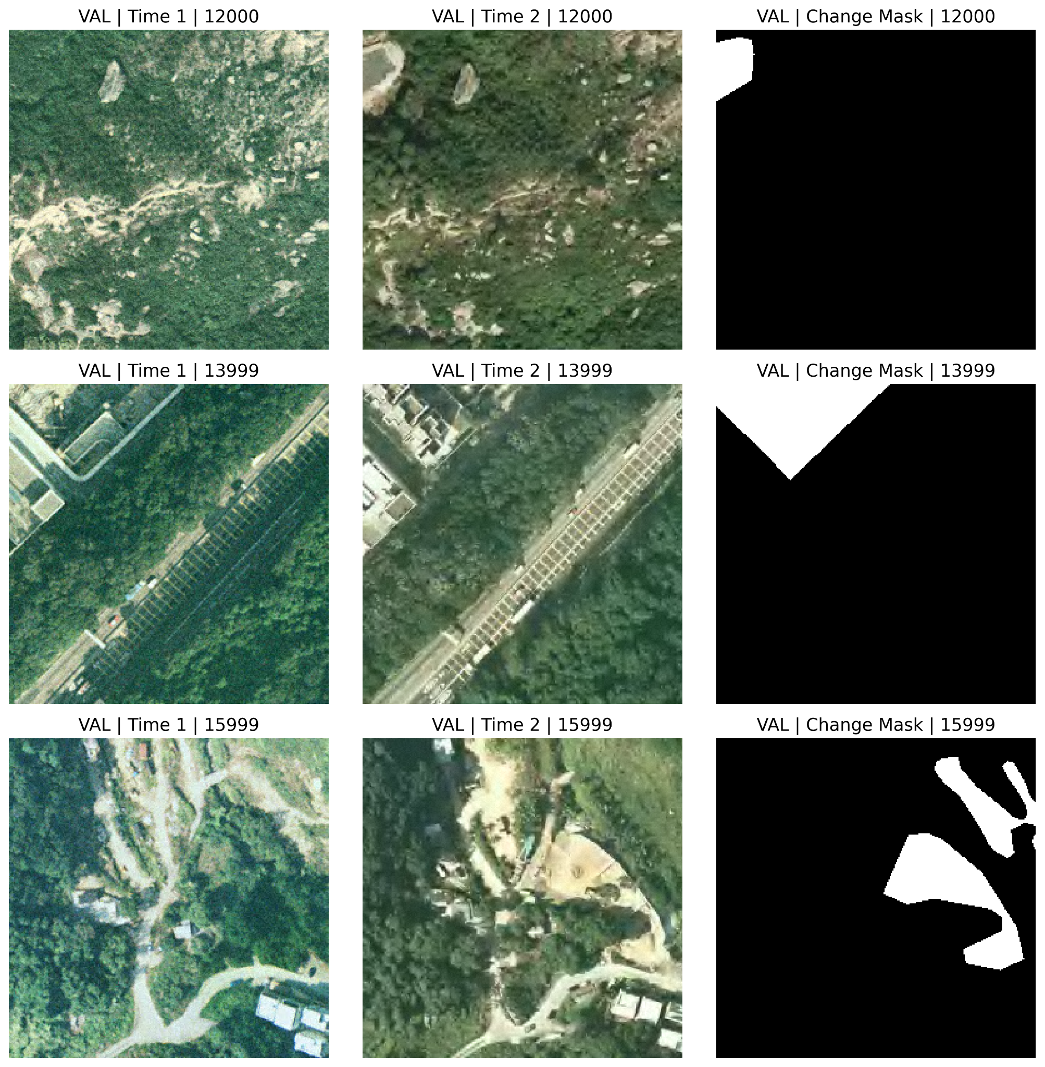
Figure 1. Representative samples from the SYSU-CD dataset
This grid plot shows Time 1 images, Time 2 images, and corresponding binary change masks. The examples illustrate the spatial diversity of urban change patterns in Hong Kong.
Moreover, a preliminary statistical analysis of the binary change masks indicates that, in the majority of samples, the proportion of changed pixels is generally lower than that of unchanged pixels, suggesting that the unchanged background remains dominant in the images. However, this distribution is not uniform across different samples but exhibits significant heterogeneity. Specifically, across the three data splits: train, validation and test, the mean proportion of changed pixels is approximately 21%-24%, while the median is approximately 12%-14%. This implies a right-skewed distribution, meaning that in most samples the areas of change are relatively limited, whereas a minority of samples contain areas of change covering a larger range. Thereby, this task exhibits a moderate degree of class imbalance, rather than an extremely sparse distribution of the positive class. This also implies that relying solely on overall accuracy is insufficient to adequately reflect the model’s actual capability in identifying regions of change. This implies that relying solely on overall accuracy is insufficient to fully reflect the model’s true capability in identifying changed regions. Therefore, in subsequent model evaluations, this study focuses on using IoU, F1-score, precision and recall as core metrics. These metrics assist this study in more comprehensively assessing the model’s segmentation quality of changed regions, ability to control false positives, and changes detection capability.

Methods
To systematically evaluate model performance on spatial change detection, this study selects three representative architectures with increasing complexity: U-Net (Ronneberger et al., 2015), DeepLabV3+ (Chen et al., 2018), and SegFormer (Xie et al., 2021). These architectures reflect key concepts discussed in the course. U-Net follows the classical encoder–decoder framework derived from convolutional neural networks, where hierarchical feature extraction is combined with spatial reconstruction through skip connections. DeepLabV3+ extends this paradigm by introducing multi-scale feature learning using atrous convolution, which increases the receptive field without reducing resolution. SegFormer represents a Transformer-based approach, where self-attention enables global context modeling beyond local convolutional operations.
The rationale for this selection is twofold. First, all three models have stable implementations and strong empirical support, enabling fair and reproducible comparison. Second, they are selected to represent different architectural paradigms, allowing comparison of how representation learning strategies influence change detection performance in urban environments.
All models take concatenated bi-temporal images as a 6-channel input and produce a single-channel binary change map(Figure 2).
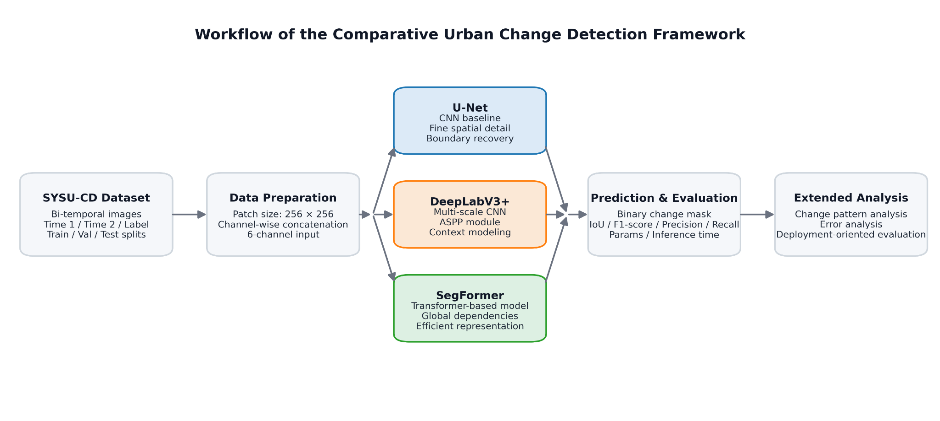
Figure 2. Workflow of the comparative urban change detection framework.
The SYSU-CD dataset is preprocessed into 6-channel bi-temporal inputs, which are then used to train U-Net, DeepLabV3+, and SegFormer under a unified experimental setting. Predictions are evaluated using segmentation and efficiency metrics, and extended analyses further examine change patterns, error characteristics, and deployment-oriented suitability.
U-Net Model Description
U-Net serves as the baseline model because of its simple structure, strong training stability, and broad use in pixel-level segmentation tasks (Ronneberger et al., 2015). In our study, U-Net is implemented as a standard encoder–decoder network with skip connections between corresponding resolution levels. The model takes the concatenated bi-temporal images as a 6-channel input and produces a single-channel binary change map as output. The encoder progressively extracts local spatial features, while the decoder restores spatial resolution and fuses low-level and high-level information through skip connections. The final output layer was a 1 × 1 convolution that maps the decoder features to a one-channel probability map. Since the input has 6 channels instead of the standard 3, the first convolutional block was adjusted accordingly.
Our study uses U-Net primarily as a stable and interpretable baseline for comparison. U-Net is particularly useful in the comparison between models because its skip connections preserve fine spatial information and edge details, which are important for detecting narrow roads, building boundaries, and other small urban changes. At the same time, its relatively local receptive field means it may not model large contextual changes as effectively as more advanced architectures. For this reason, U-Net provides a strong but interpretable baseline against which the gains from more complex models can be measured.
DeepLabV3+ Model Description
DeepLabV3+ is used as the intermediate model because it extends CNN-based segmentation with stronger multi-scale contextual learning (Chen et al., 2018). Like U-Net, the model took the same 256 × 256 × 6 concatenated bi-temporal input and produced a pixel-level binary change map. However, instead of a symmetric encoder–decoder structure, DeepLabV3+ uses a more powerful feature extractor backbone together with atrous convolution and an Atrous Spatial Pyramid Pooling (ASPP) module. In this project, the encoder was a custom CNN backbone rather than a pretrained ResNet-50. It consisted of four convolutional stages and was designed to accept 6-channel bi-temporal input. Because the original backbone is designed for 3-channel input, the first convolutional layer was modified from 3 input channels to 6 input channels. The backbone extracted progressively deeper semantic features, while the ASPP module applied parallel atrous convolutions at multiple dilation rates, such as rates 6, 12, and 18, together with image-level pooling to capture contextual information at different effective receptive field sizes.
After the ASPP module, DeepLabV3+ includes a lightweight decoder that combines high-level semantic features with low-level spatial features from earlier backbone layers. This decoder helps recover sharper object boundaries, which is beneficial for detecting roads, rooftops, and irregular urban structures. The key training hyperparameters included the learning rate, batch size, number of epochs, weight decay, early-stopping patience, and prediction threshold. Architecturally, the ASPP atrous rates and decoder channel sizes were also important design choices. DeepLabV3+ enhances multi-scale feature learning and expands the receptive field, enabling effective detection of both small and large change regions. It serves as an intermediate architecture between classical encoder–decoder models and more advanced approaches.
SegFormer Model Description
SegFormer is used as the advanced model because it represents a transformer-based approach to semantic segmentation capable of capturing both local and global dependencies efficiently (Xie et al., 2021). Unlike traditional CNNs, SegFormer employs a hierarchical Transformer encoder to learn multi-scale feature representations, for example, the 6-channel input in the current study.
The encoder consists of four hierarchical stages with embedding dimensions of approximately 32, 64, 160, and 256, and depths of [2, 2, 2, 2]. Each stage contains Transformer blocks composed of layer normalization, efficient self-attention, and feed-forward layers. The decoder is lightweight, projecting multi-scale encoder features into a shared dimension, fusing them, and generating a final segmentation prediction. The model contains approximately 3.72 million trainable parameters, making it the most parameter-efficient architecture among the three models. Compared to CNN-based approaches, SegFormer provides stronger global context modeling while maintaining computational efficiency.
In this study, SegFormer is included to evaluate whether Transformer-based global feature modeling improves urban change detection performance compared to convolution-based architectures. Its design is particularly relevant for dense urban environments such as Hong Kong, where spatial dependencies extend beyond local neighborhoods.

Table 1. Summary of Model Architectures
Summary of the three model architectures compared in this study, including architectural type, core modeling strengths, and intended role in the comparative urban change detection framework.
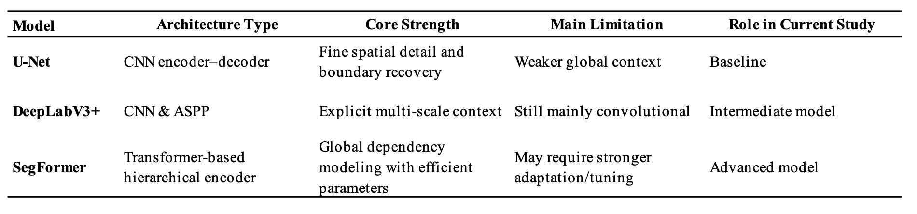
Training Configuration
All three models were trained under the same setting (Table 2). The main comparison focuses on architectural differences rather than extensive hyperparameter search. Most core training settings are kept fixed across models, while only a small number of model-specific choices, such as training duration, patience, and decision threshold, are adjusted where necessary.
Table 2. Model Training Configuration and Evaluation Settings
Unified training configuration and evaluation settings used for U-Net, DeepLabV3+, and SegFormer to ensure a fair comparative benchmark.
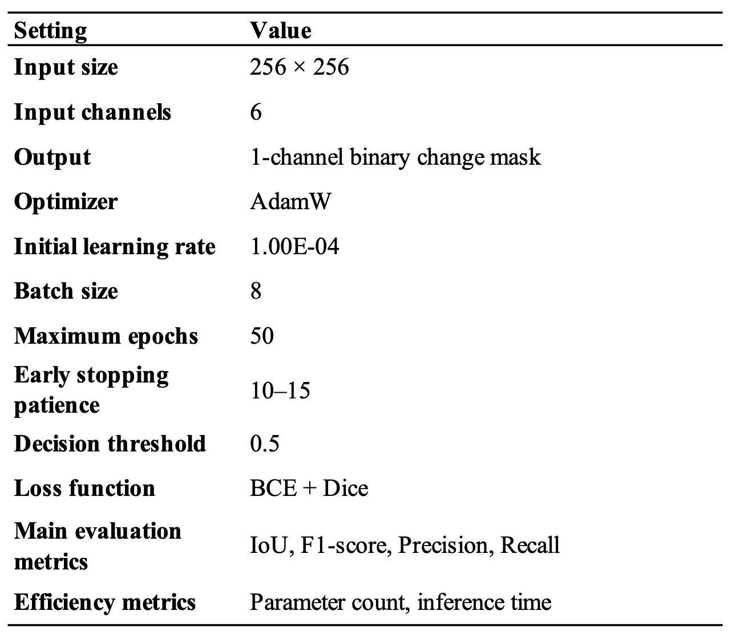

Comparative Rationale
These three models are intentionally complementary rather than redundant. U-Net offers a strong and interpretable baseline for local feature extraction and boundary recovery. DeepLabV3+ extends the comparison by introducing explicit multi-scale context, which is important for changes that appear at different object sizes. SegFormer adds the capacity to model global spatial structure and long-range dependencies, which may be especially beneficial in dense urban environments with heterogeneous land-use patterns. Together, they form a coherent comparison framework from low to high architectural complexity. This makes it possible to examine whether the additional parameters and modeling flexibility of more advanced networks produce meaningful improvements in change detection accuracy, or whether simpler CNN-based methods remain competitive for this dataset.
Model Performance Evaluation
To ensure a fair comparison, all models share the same 6-channel input formulation (channel-wise concatenation of bi-temporal images) and are trained under comparable settings (Table 2).
While the overall training framework for each model is standardized, certain model-specific settings are subject to minor adjustments based on validation behavior.
Performance Evaluation and Comparative Analysis
Following the completion of independent training on U-Net, DeepLabV3+, and SegFormer, the objective is to standardize the three models and integrate them into a unified framework. This process encompassed the unification of metrics such as IoU, F1-score, precision, recall, number of parameters, inference time, training history, and representative prediction results. Utilizing these unified metrics, a comparative table and a visual representation of results were constructed to address discrepancies in overall performance, precision-recall behavior, and efficiency-performance trade-offs. It is important to note that this step does not constitute a new model method, but rather serves as a comprehensive comparative process. This process provided a consistent foundation for subsequent analysis of Results, particularly in terms of addressing research questions.
Change Pattern Analysis
To examine how different model architectures respond to distinct urban change geometries, the test patches were grouped according to the morphology of their ground-truth change masks. This design keeps the comparison consistent across models. It isolates architectural differences under the same training setup and avoids bias from model-specific outputs.
For each test patch, let the binary ground-truth change mask be denoted by M $ϵ {\{0,1\}}^{H×W}$, where $H$ and $W$ are the patch height and width. We computed five morphology descriptors from $M$.
The first descriptor is the change ratio,
$$r = \frac{\left|M\right|}{H×W}$$
where $\left|M\right|$ is the number of changed pixels in the patch. This quantity measures the overall spatial extent of change.
The second descriptor is the number of connected components, denoted by $n_{c}$. It measures how many spatially separated change regions are present in the mask. Larger values of $n_{c}$ indicate more fragmented changes.
The third descriptor is the largest component ratio,
$$r_{max} = \frac{A_{max}}{\left|M\right|}$$
where $A_{max}$ is the area of the largest connected component. This quantity measures the degree to which the total change is dominated by a single contiguous region.
The fourth descriptor is elongation, denoted by $e$, which characterizes the linearity of the largest connected component. In this study, $e$ is defined as the major-to-minor axis ratio of the component under an ellipse-based approximation. Larger values of $e$ indicate more elongated or line-like structures.
The fifth descriptor is boundary complexity, denoted by $b$, which quantifies the geometric irregularity of the largest connected component:
$$b = \frac{P^{2}}{4πA}$$
where $P$ and $A$ are the perimeter and area of the largest connected component. Larger values of $b$ indicate less compact and more irregular boundaries.
Instead of using fixed thresholds, we define categories based on the empirical distribution of these descriptors. Specifically, the 25th, 50th, and 75th percentiles were used as reference thresholds.
Based on these measures, test patches were divided into three morphology categories.A patch was assigned to the large-scale contiguous change category if
$$r≥Q_{75}(r), n_{c}≤Q_{50}(n_{c}),r_{max}≥0.7$$
This category represents large, spatially continuous changes dominated by a single major region.A patch was assigned to the fragmented or linear change category if either
$n_{c}≥Q_{75}(n_{c})$ or $e≥Q_{75}(e)$
This category captures either highly fragmented changes composed of multiple small components or elongated changes with line-like geometry.A patch was assigned to the complex-boundary change category if
$$b≥Q_{75}(b), r≥Q_{25}(r)$$
This category includes patches whose dominant change region has irregular or highly curved boundaries, while excluding trivial very small changes.
A single image patch may satisfy multiple criteria. To avoid overlap, we employ a fixed prioritization rule to ensure that each image patch is assigned to only one group. The order of assignment is as follows: large-scale continuous changes, fragmented or linear changes, and changes in areas with complex boundaries. Image patches that do not meet any of the above criteria are retained in the test set. But they are excluded from comparative analyses targeting specific morphological features.
This classification method allows us to conduct comparative evaluations of model performance across different patterns of change. It helps identify which architectures demonstrate superior performance when handling large-scale continuous regions, fragmented or linear patterns, and areas with complex boundaries.
Error Analysis and Deployment-Oriented Evaluation
This study further examined the differences among the three model types in terms of false positives and false negatives, to assess their practical applicability in routine urban planning monitoring operations. Specifically, the best-performing checkpoints of U-Net, DeepLabV3+, and SegFormer were reloaded. After loading the model parameters that performed best on the validation set, predictions were completed on the same fixed test subset. To eliminate inconsistencies caused by partial saved outputs, all three models were applied to the same fixed test subset consisting of 500 image patches. This subset was defined using a shared index file to guarantee one-to-one correspondence between samples.
During the prediction phase, the model's output was first converted into a pixel-level probability map via a sigmoid function. Then a binary mask was generated based on a predefined threshold. Subsequently, the study aligned the prediction results with the ground-truth labels on a pixel-by-pixel basis. Next, it counted true positives, false positives, false negatives, and true negatives. Finally, it calculated metrics such as Precision, Recall, F1-score, and IoU. In contrast to the comprehensive accuracy analysis, this section places greater emphasis on the behavioral characteristics of diverse models with respect to false positives and false negatives.
Furthermore, the study established a correlation between error performance and actual business requirements. Models with high recall and low false negative rate are less prone to overlooking areas of genuine change, rendering them more suitable for large-scale automated alerts. Models characterized by high precision and a low rate of false positives, attributable to their conservative output, are better suited to assist in high-precision manual verification. This, in turn, has the effect of reducing the additional review costs associated with false alarms. In addition to quantitative statistics, this study constructed error maps to highlight areas of discrepancy between the model and ground truth. In this case, red indicates false positives and blue indicates false negatives. Consequently, it can provide a more substantial foundation for subsequent discussions concerning the suitability of model deployment.

Result
Descriptive Setup and Baseline Model Outputs

U-Net Model Outputs
Under a unified experimental framework, the U-Net baseline model was initially trained and evaluated, exhibiting commendable training stability. The training loss demonstrated a consistent downward trend, while the validation loss remained within an acceptable range. The model exhibited proficiency in recognizing change patterns in dual-temporal remote sensing imagery, with no discernible indications of training failure. As a whole, U-Net has exhibited competitive baseline performance in the present urban change detection task.
Figure 3 shows a representative prediction example produced by the U-Net baseline. The results demonstrate that, despite the relative simplicity of the U-Net architecture, the classic convolutional encoder-decoder framework retains practical value in high-resolution urban remote sensing change detection. U-Net serves as the baseline model in this study, providing a stable and interpretable starting point for comparison. It also serves as a necessary reference for subsequent evaluations of whether DeepLabV3+ and SegFormer can deliver consistent and significant performance gains. The experimental results of U-Net demonstrate that the classic convolutional architecture remains competitive in this task. In summary, the architecture serves as a crucial reference foundation for evaluating the magnitude of performance gains achieved by multi-scale models and Transformer-based models.
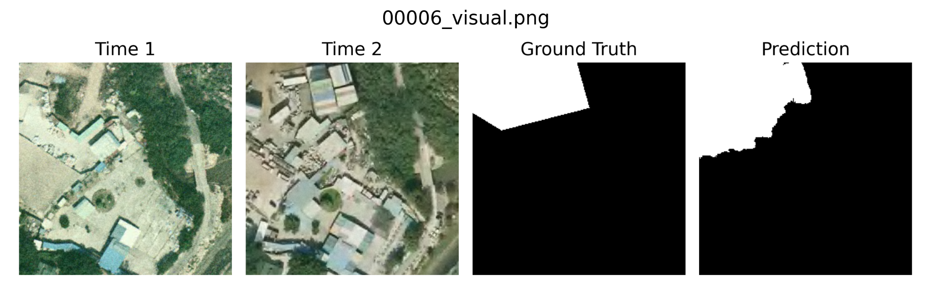Figure 3. Representative prediction result of the U-Net baseline on a test sample (No. 00006)
Time 1 shows the initial state of the area, and Time 2 shows the same region after the change. The model successfully captures the overall changed region; however, minor deviations along the boundaries are observed compared to the ground truth.

DeepLabV3+ Model Outputs
DeepLabV3+ was trained and evaluated under the same experimental settings. The training process was generally stable, with both the training and validation set losses showing a steady downward trend. No significant divergence or failure to converge was observed.
Figure 4 shows a representative prediction result from DeepLabV3+. As the figure shows, the model is able to clearly identify the overall regions of change with relatively complete coverage of these areas. In particular, large continuous change areas are well detected, and fewer regions are missed. This reflects the advantage of DeepLabV3+ in integrating multi-scale context, which helps it to better understand spatial structures that span beyond local scales.
Regarding boundary performance, the model maintains a relatively stable overall level. Although slight over-prediction occurs at the edges of some regions, the overall shape of the regions is consistent. There are no obvious fragmentation or discontinuity issues. The model maintains good spatial connectivity. It performs more stably especially when the regions of change are continuous.
In terms of behavioral characteristics, DeepLabV3+ tends toward a relatively aggressive detection strategy. It identifies as many potential regions of change as possible. This helps to reduce the probability of missed detections. However, it may also result in a small number of additional false positives. This characteristic aligns with its high recall performance in quantitative evaluations. In practical applications, this means the model prioritizes covering all possible changes rather than minimizing false positives.
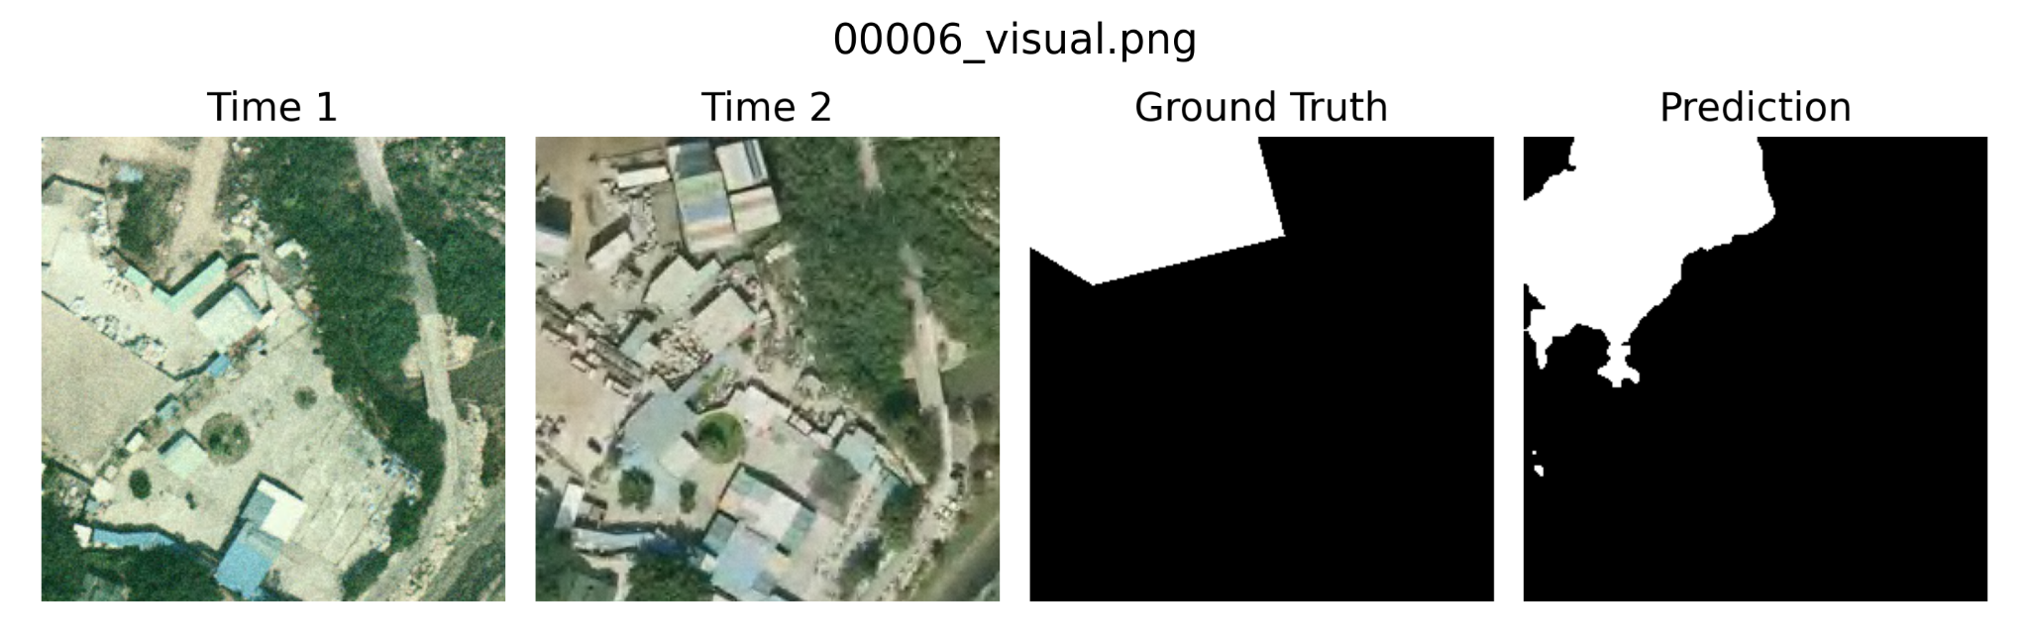
Figure 4. Representative prediction result of the DeepLabV3+ model on a test sample (No. 00006).
Time 1 shows the initial state of the area, and Time 2 shows the same region after the change. The model captures the overall changed region and demonstrates improved boundary delineation compared to the U-Net baseline, although minor inconsistencies remain in complex or irregular areas.

SegFormer Model Outputs
SegFormer was trained and evaluated under the same experimental setting as the other two models. Overall, the training process remained stable, and the loss curves indicate that the model learned useful feature representations for binary urban change detection. Although it is lighter than the CNN-based architectures, the model was still able to generate meaningful segmentation results on the test set.
A representative prediction result is shown in Figure 5. The figure suggests that SegFormer can detect the main changed area, but its prediction is often narrower than the ground truth. In other words, the model usually captures the core part of the changed region, while leaving out some of the surrounding changed pixels. This gives the output a cleaner appearance, but also means that part of the true changed area is not fully recovered.
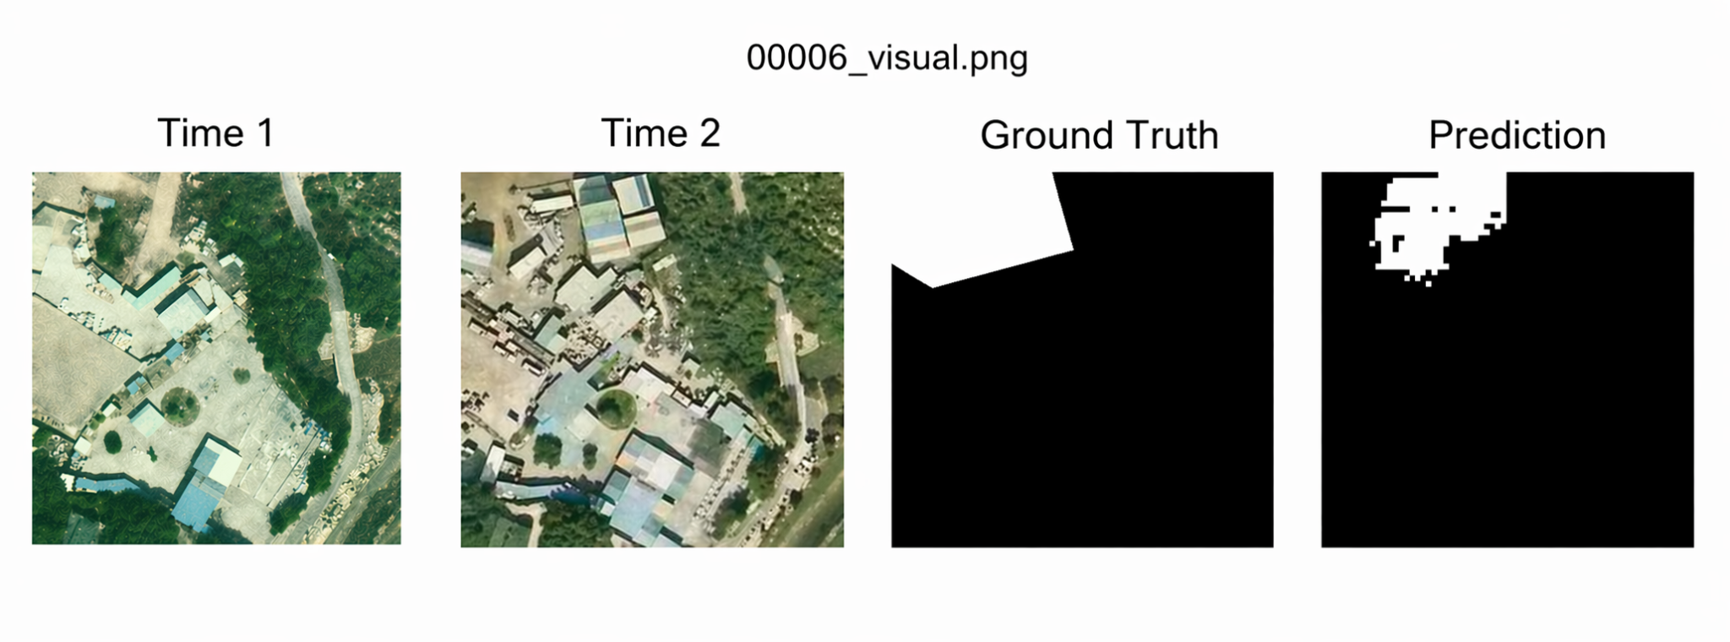
Figure 5. Representative prediction result of SegFormer on a test sample (No. 00006).
Time 1 shows the initial state of the area, and Time 2 shows the same region after the change. The predicted mask is relatively clean, but part of the true changed area is not fully captured compared with the ground truth.
From a spatial perspective, SegFormer tends to generate smoother and less noisy masks. Compared with the other models, it is less likely to spread into nearby unchanged regions, which helps control false positives. However, this also makes the model more likely to under-segment broad or irregularly shaped changes, particularly when the boundary is weak or visually subtle. As a result, its predictions often appear more restrained than those of U-Net or DeepLabV3+.
This behavior is consistent with the quantitative results. Among the three models(Table 3), SegFormer achieved the highest precision but the lowest recall, indicating that it is more selective when identifying changed pixels. In practical use, this makes SegFormer a better fit for tasks where false alarms need to be reduced, such as manual inspection or human-in-the-loop verification, rather than situations where capturing every possible change is the primary goal.
Table 3. Overall performance and efficiency comparison of U-Net, DeepLabV3+, and SegFormer on the test set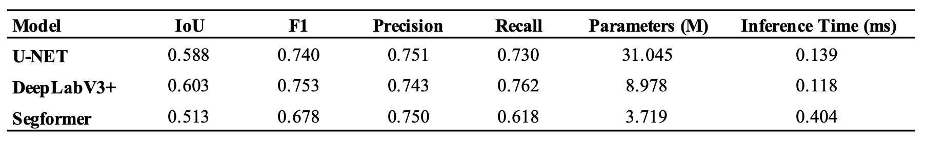
Under a unified input format, unified subset division, and a unified primary training framework, the three models exhibited distinct hierarchical differences in the urban change detection task. Overall, DeepLabV3+ demonstrated the best comprehensive performance, followed by U-Net, with SegFormer performing the weakest. This ranking remained consistent across the two core segmentation metrics, IoU and F1-score. They indicated that the overall comparison results in this experiment exhibit strong consistency rather than being driven by a single metric by chance.
In terms of overall segmentation performance (Figure 6 and Figure 7), DeepLabV3+ achieved the highest IoU (0.6033) and F1-score (0.7525) on the test set. They indicated the strongest overall segmentation quality in identifying pixel-level change regions. U-Net’s IoU and F1-score were 0.5876 and 0.7403, respectively. Although slightly lower than DeepLabV3+, the gap was generally modest. U-Net remains highly competitive as a baseline model and has not been significantly outperformed by more complex architectures. In contrast, SegFormer’s IoU and F1-score were only 0.5126 and 0.6778, significantly lower than those of the other two models. It failed to demonstrate its expected overall advantages under the current experimental setup.
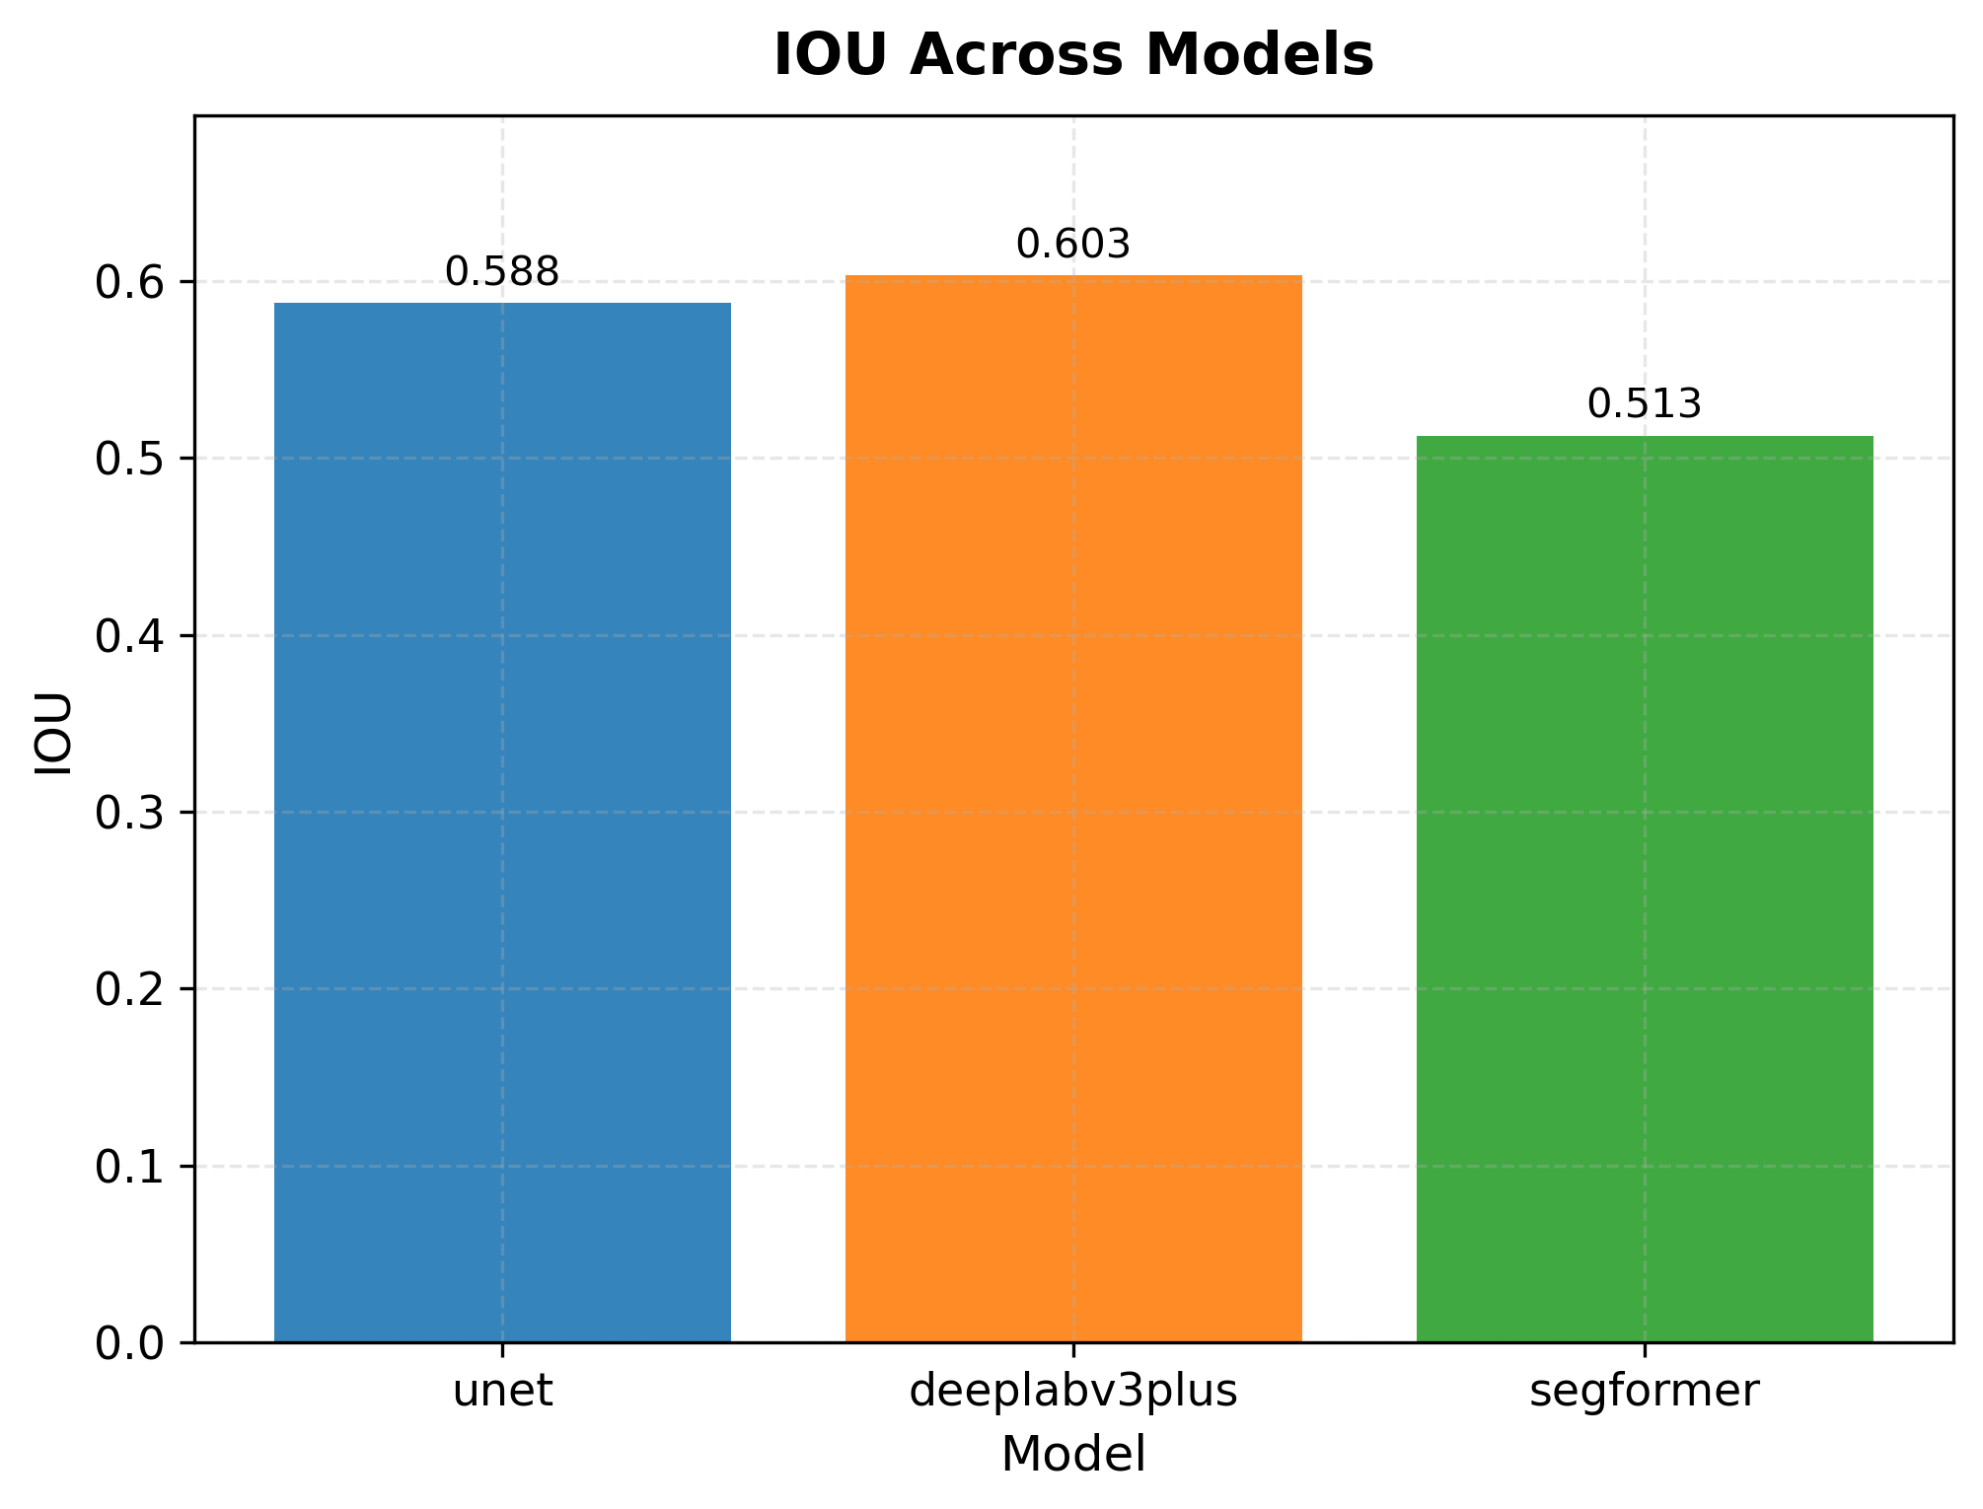
Figure 6. Test-set IoU scores for U-Net, DeepLabV3+, and SegFormer
Higher values indicate better overlap between predicted and ground-truth change regions.

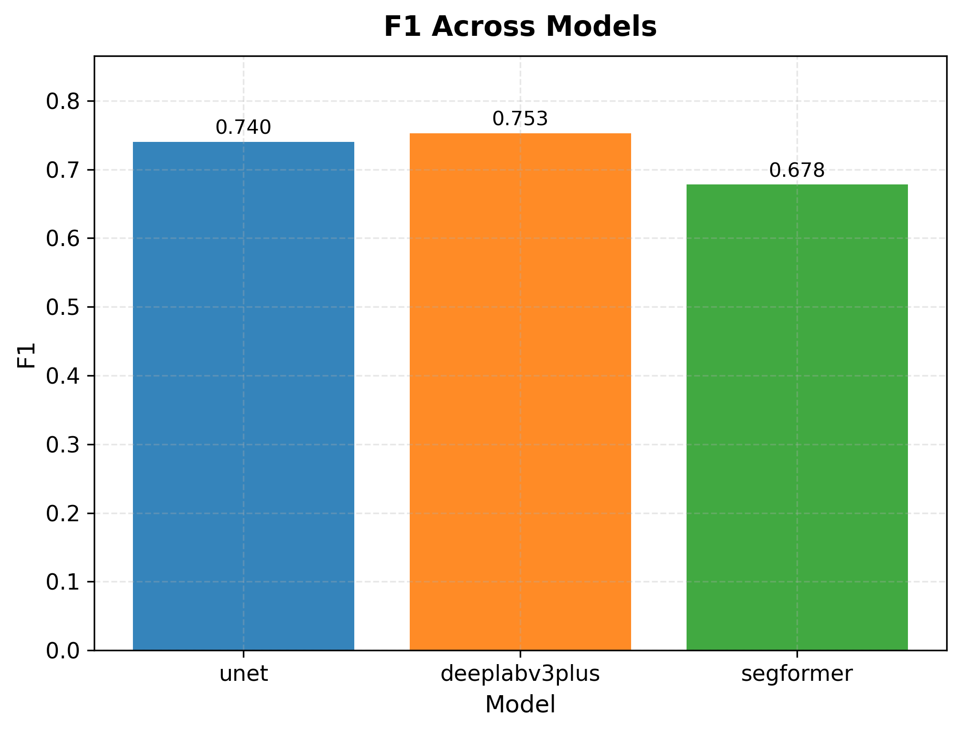
Figure 7. Test-set F1-scores for U-Net, DeepLabV3+, and SegFormer
Higher values indicate better overall balance between precision and recall.
Further analysis of Precision (Figure 8) and Recall (Figure 9) reveals significant differences in the prediction styles of the three models. DeepLabV3+ achieved the highest Recall (0.7621), indicating that it tends to identify as many true change regions as possible and possesses stronger change recall capabilities. The precision of DeepLabV3+ was 0.7432. Although it was slightly lower than that of U-Net, it still remained at a high level. This suggests that DeepLabV3+ uses a relatively more aggressive prediction strategy in the current experiment, striving to minimize false negatives while maintaining overall accuracy. U-Net has the highest Precision (0.7512) and a Recall of 0.7296. This finding shows that it achieves a stable trade-off between false positives and false negatives. Although SegFormer also achieved a high Precision (0.7500), its Recall was notably low (0.6183). This result indicates a more conservative prediction style that likely missed a significant number of regions with actual changes, which is a primary factor for its notably lower IoU and F1-score.
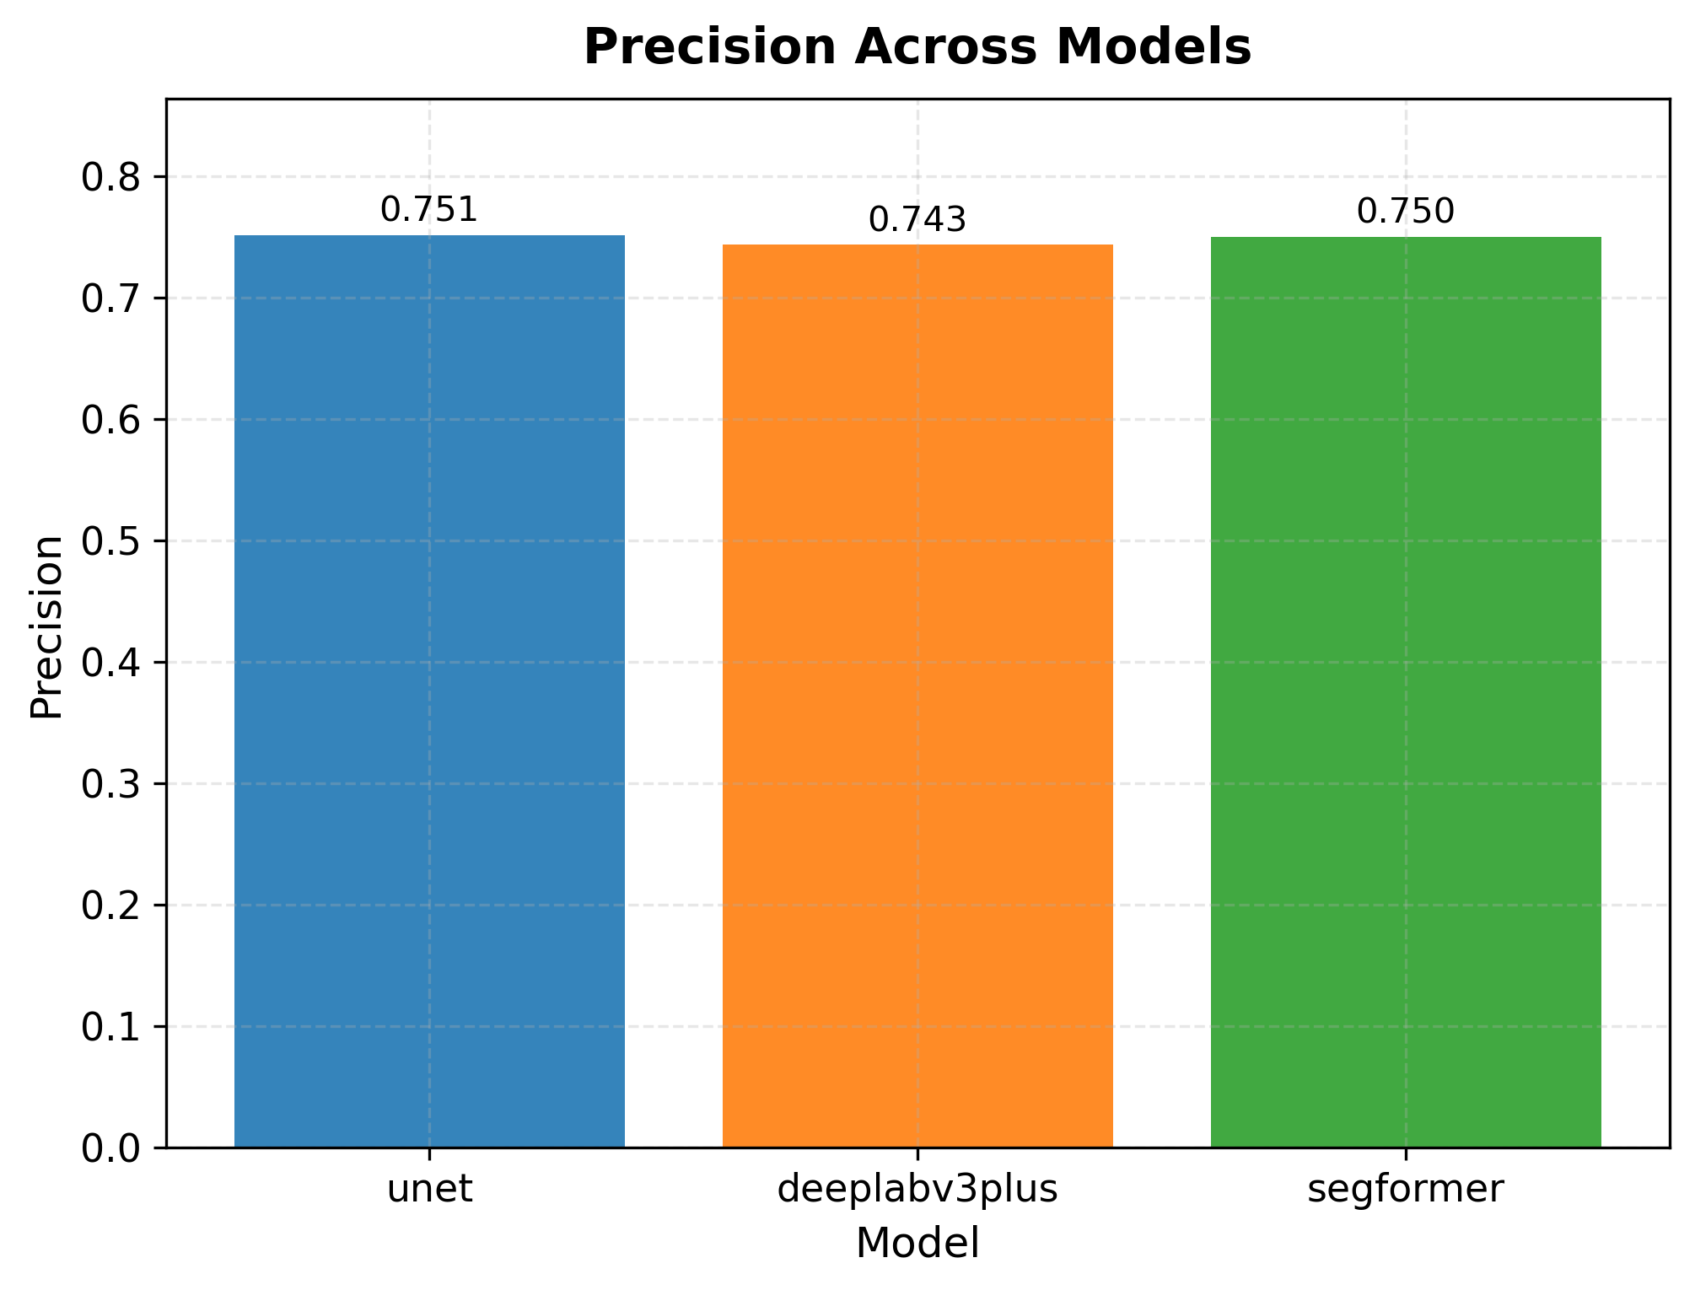
Figure 8. Test-set precision scores for U-Net, DeepLabV3+, and SegFormer.
Higher values indicate fewer false positive change predictions.
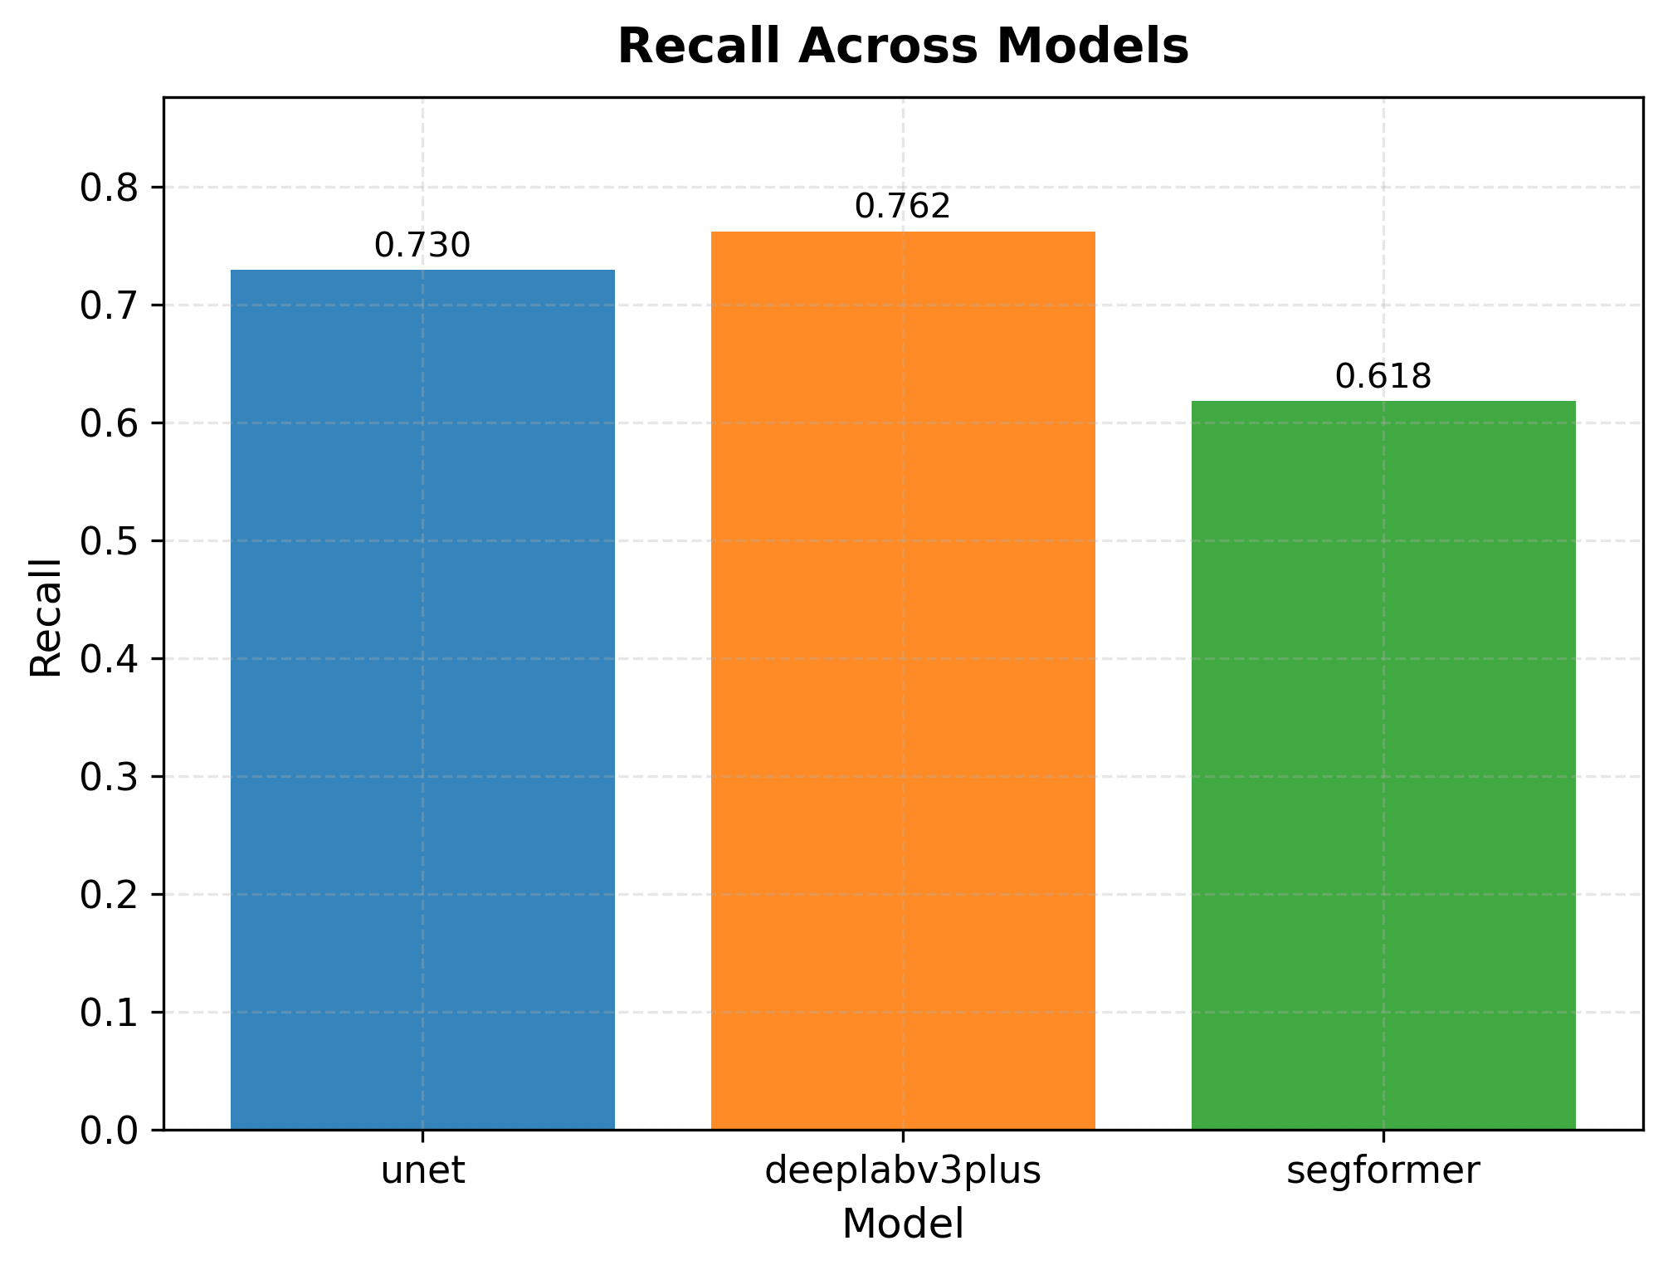
Figure 9. Test-set recall scores for U-Net, DeepLabV3+, and SegFormer.
Higher values indicate better detection of actual change regions.

In terms of the relationship between the results and the original research expectations, the current experiment only partially supports the preliminary judgment made during the research design phase. The study originally anticipated that SegFormer might achieve the highest precision in complex urban backgrounds by leveraging stronger global modeling capabilities, but this expectation was not validated in the current experiment. Conversely, DeepLabV3+ emerged as the model with the best overall performance, while U-Net maintained strong baseline competitiveness. This finding supports the hypothesis that under the current fixed subsets and unified experimental framework, multi-scale contextual modeling may be more effective than more complex Transformer architectures. Furthermore, it is evident that stronger global modeling capabilities do not necessarily translate into higher change detection performance.

When efficiency is factored into the comparison, DeepLabV3+ also demonstrates the optimal overall trade-off. Not only does it achieve the highest F1-score, but it also has the lowest inference time (0.1178 ms) among the three models. This means that, under the current experimental conditions, DeepLabV3+ does not exhibit the typical trade-off where higher accuracy necessarily entails higher computational cost. Although U-Net is slightly slower than DeepLabV3+ in terms of inference speed, it still maintains high overall performance. SegFormer, on the other hand, has the longest inference time (0.4042 ms) and the lowest overall accuracy. Therefore, it does not demonstrate sufficient deployment advantages in this round of comparison.

In summary, the current results imply that DeepLabV3+ is the solution with the best overall performance and highest efficiency among the three models. U-Net is a stable, reliable, and competitive baseline model. SegFormer has not yet demonstrated the theoretical advantages of its complex architecture under the current settings. This conclusion provides a clear quantitative foundation for further analysis regarding error patterns, boundary fidelity, and suitability for operational deployment.

Boundary Fidelity and Geometric Sensitivity

To further investigate how these three frameworks respond to different geometric patterns of urban change, this study conducted a subgroup analysis based on morphology using a shared test subset. Figure 10 illustrates the distribution of morphological categories. Among the 500 shared test patches, fragmented or linear changes formed the largest group, while large-scale continuous changes and changes with complex boundaries accounted for a relatively small proportion. This distribution pattern suggests that narrow, scattered, or elongated change types are more common in the current test data.

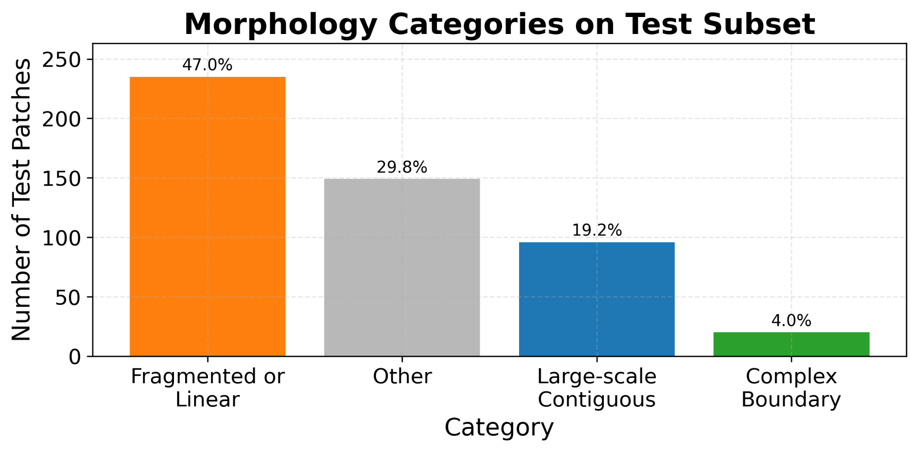
Figure 10. Morphology category distribution on the shared test subset
Figure 11 illustrates a representative patch exhibiting fragmented or linear changes. In this example, although all three models successfully detected the primary change regions, their predicted shapes differed significantly. The U-Net model predicted a relatively broad region and exhibited obvious over-expansion. The DeepLabV3+ model produced a more compact prediction that better aligned with the primary target region. In contrast, the SegFormer model’s detection results appeared fragmented and discontinuous. Overall, the DeepLabV3+ model performed best in this case, as it effectively controlled the extent of prediction area expansion while preserving the integrity of the primary change structure.
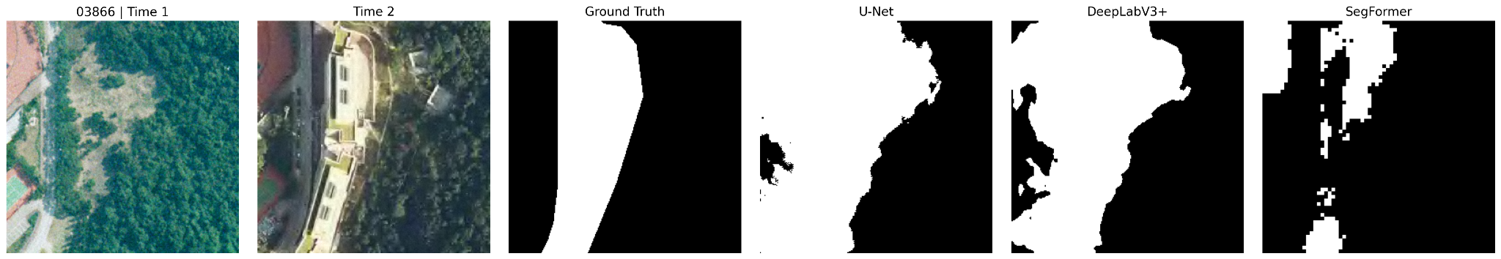
Figure 11. Representative example of fragmented or linear changes
Figure 12 shows a representative large-scale continuous change pattern. In this case, the primary change region occupies a large, contiguous area of the image. Both the U-Net and DeepLabV3+ models successfully reconstruct the primary change boundaries; while the SegFormer model also captures the overall change region, it introduces more local irregularities and fine internal gaps in the details. In this case, both U-Net and DeepLabV3+ perform well, with DeepLabV3+ showing a slight advantage because it restores boundaries more naturally and stably while maintaining overall connectivity.
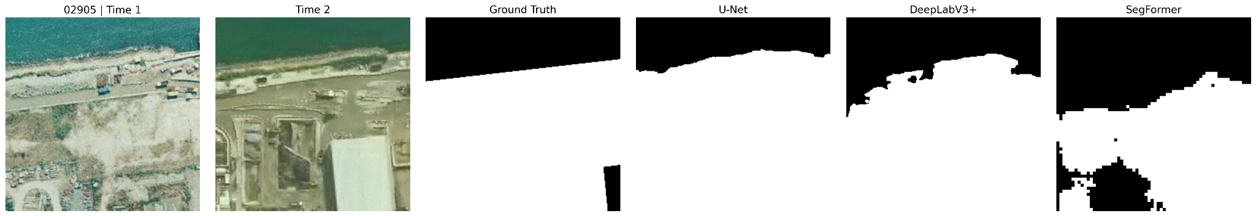
Figure 12. Representative example of large-scale contiguous changes
Figure 13 illustrates a representative patch with complex boundary variations. In this example, the target region exhibits an irregular and non-compact geometric shape. The DeepLabV3+ model is able to preserve the overall shape of the target region more completely. The region predicted by the U-Net model is too large and exhibits a certain degree of distortion in shape, while the SegFormer model segments the target region into several fragmented vertical structures. In summary, the DeepLabV3+ model performs best in this case because it preserves complex boundaries more completely, and its predictions are closer to the ground truth in terms of both shape and connectivity.
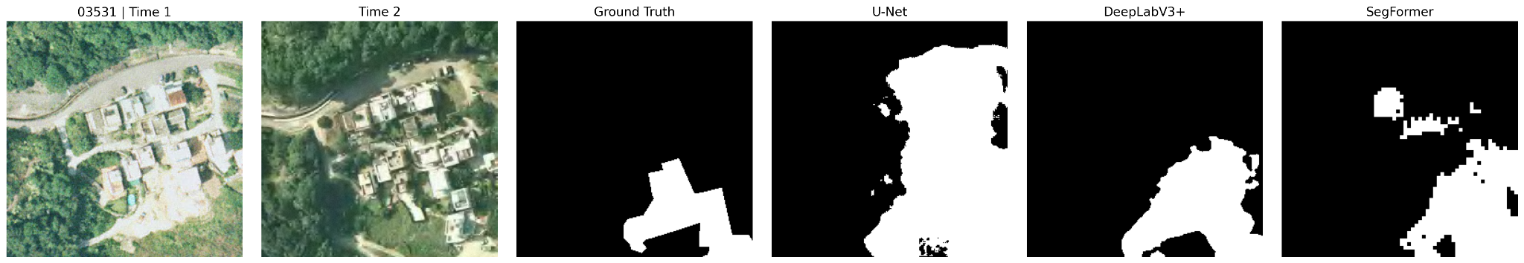
Figure 13. Representative example of complex-boundary changes
The results at the category level indicate that model performance varies depending on the type of geometric morphology. For all three models, large-scale continuous changes are the easiest category to identify, while fragmented or linear changes and changes with complex boundaries are more challenging. These results show that overall average scores alone do not fully capture model behavior. A morphology-aware evaluation gives a clearer and more practical view of model strengths and weaknesses, especially when boundary complexity increases.
False Positives, False Negatives, and Deployment Suitability
The prediction-based evaluation was conducted on a shared test subset of 500 image patches to ensure that all three models were compared under the same conditions. Figures 14 and 15 show representative prediction examples together with their corresponding error maps, while Figure 16 summarizes the overall precision and recall results. The qualitative examples reveal clear differences in model behavior. U-Net is able to capture most of the changed regions, but it also introduces more false positive areas, indicating a tendency toward over-prediction. SegFormer shows the opposite pattern: its outputs are visually cleaner and contain fewer false positives, but parts of the true changed regions are often missed, resulting in more false negatives. DeepLabV3+ falls between these two extremes and produces predictions that are more balanced in both spatial coverage and boundary consistency.
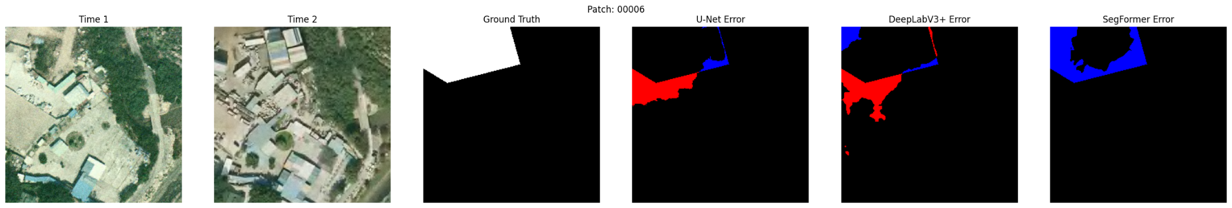
Figure 14. Representative prediction results and error maps for Patch 00006.
Time 1 and Time 2 show the input images, followed by the ground truth and model-specific error maps. Red regions indicate false positives, while blue regions indicate false negatives. U-Net shows more over-prediction along boundaries, while SegFormer exhibits more missed detections. DeepLabV3+ demonstrates a more balanced error pattern.

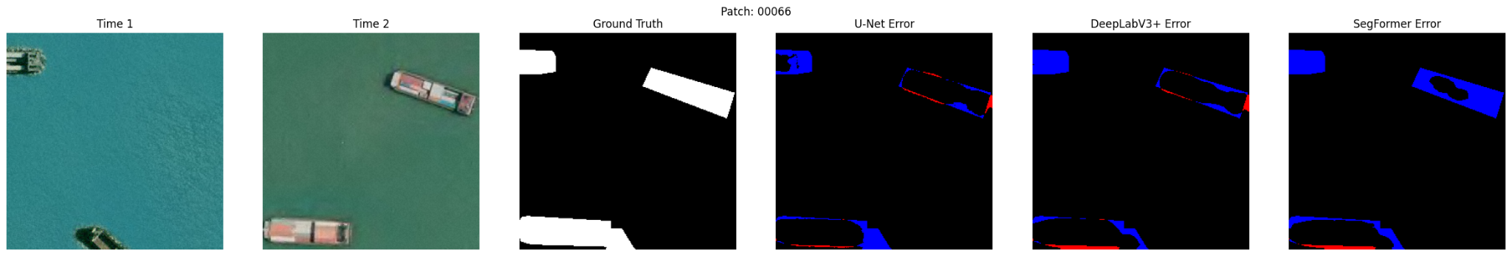
Figure 15. Representative prediction results and error maps for Patch 00066
Similar patterns are observed as in Figure 14. U-Net produces more false positives, while SegFormer shows more false negatives. DeepLabV3+ maintains a relatively balanced performance across this scene.
These visual observations are consistent with the quantitative results. U-Net achieves the highest recall, meaning that it is more effective at detecting true change pixels, although this comes at the cost of lower precision. SegFormer achieves the highest precision, which indicates that its predictions are more reliable but less complete. DeepLabV3+ maintains a stronger balance between precision and recall, making it the most stable overall model among the three. Taken together, these findings suggest that U-Net is more suitable for applications where missing a change is costly, SegFormer is better suited to settings where reducing false alarms is more important, and DeepLabV3+ provides the most practical compromise for general urban change detection tasks.

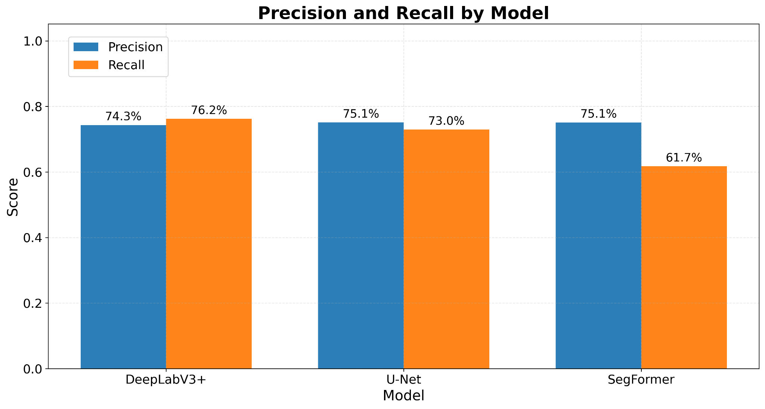
Figure 16. Precision and recall comparison across the three models on the shared 500-image test subset.
U-Net achieves the highest recall, SegFormer achieves the highest precision, and DeepLabV3+ shows the most balanced overall performance.

Conclusion
This study demonstrates that while U-Net, DeepLabV3+, and SegFormer are all capable of detecting urban change, their architectural differences lead to distinct performance trade-offs. DeepLabV3+ achieves the best overall performance, showing the highest IoU and F1-score together with a strong balance between precision and recall. U-Net remains a competitive baseline, effectively capturing most change regions but tending to over-predict. In contrast, SegFormer produces cleaner predictions with fewer false positives, but misses more true changes, resulting in lower overall accuracy under the current setting.
These results highlight the importance of model design in spatial change detection. U-Net’s encoder–decoder structure with skip connections supports strong recovery of local spatial details. DeepLabV3+ improves upon this by incorporating multi-scale contextual modeling through atrous convolution and ASPP, enabling better handling of changes across different spatial scales. SegFormer, as a Transformer-based model, introduces global dependency modeling through self-attention, but its performance suggests that global context alone may not be sufficient without strong local feature preservation in this task.
Further analysis shows that model performance is closely related to the geometric characteristics of urban change. While large and continuous changes are relatively easy to detect, fragmented patterns and complex boundaries remain challenging for all models. This demonstrates that evaluation should go beyond overall metrics and consider spatial structure and error patterns to better understand model behavior.
From a practical perspective, these findings suggest that model selection should depend on application needs. U-Net is suitable for large-scale monitoring where missing changes is costly. SegFormer is more appropriate for scenarios requiring high precision and fewer false alarms. DeepLabV3+, by effectively combining local detail and multi-scale context, provides the most reliable overall performance for general urban change detection. In practice, a multi-stage system that combines these models could further improve efficiency and accuracy.
This study also has several limitations, including dataset imbalance, fixed training configurations, and the focus on a single urban environment. Future work can extend this research by incorporating more diverse datasets, exploring improved training strategies, and integrating temporal or multi-stage modeling approaches. Overall, this study shows that effective urban change detection depends not only on model complexity, but on how well architectural design aligns with spatial characteristics and real-world requirements.

References
Cheng, G., & Han, J. (2016). A survey on object detection in optical remote sensing images. ISPRS Journal of Photogrammetry and Remote Sensing, 117, 11–28. https://doi.org/10.1016/j.isprsjprs.2016.03.014
Chen, L.-C., Zhu, Y., Papandreou, G., Schroff, F., & Adam, H. (2018). Encoder-decoder with atrous separable convolution for semantic image segmentation. In Proceedings of the European Conference on Computer Vision (ECCV). https://doi.org/10.1007/978-3-030-01234-2_49
Daudt, R. C., Le Saux, B., & Boulch, A. (2018). Fully convolutional siamese networks for change detection. In 2018 IEEE International Conference on Image Processing (ICIP) (pp. 4063–4067). https://doi.org/10.1109/ICIP.2018.8451652
Daudt, R. C., Le Saux, B., & Boulch, A. (2018). Urban change detection for multispectral earth observation using convolutional neural networks. IEEE Transactions on Geoscience and Remote Sensing, 56(6), 3492–3505. https://doi.org/10.48550/arXiv.1810.08468
Dosovitskiy, A., Beyer, L., Kolesnikov, A., Weissenborn, D., Zhai, X., Unterthiner, T., Dehghani, M., Minderer, M., Heigold, G., Gelly, S., Uszkoreit, J., & Houlsby, N. (2021). An image is worth 16×16 words: Transformers for image recognition at scale. International Conference on Learning Representations (ICLR). https://arxiv.org/abs/2010.11929
Liu, M. (2018). SYSU Change Detection Dataset. GitHub repository. https://github.com/liumency/SYSU-CD
Liu, M., Jiao, L., Liu, F., Yang, S., Zhang, B., & Zhao, J. (2018). Building change detection for remote sensing images using a dual-task constrained deep Siamese convolutional network model. IEEE Geoscience and Remote Sensing Letters, 15(5), 811–815. https://doi.org/10.1109/LGRS.2018.2802944
Lu, D., & Weng, Q. (2007). A survey of image classification methods and techniques for improving classification performance. International Journal of Remote Sensing, 28(5), 823–870. https://doi.org/10.1080/01431160600746456
Ronneberger, O., Fischer, P., & Brox, T. (2015). U-Net: Convolutional networks for biomedical image segmentation. In International Conference on Medical Image Computing and Computer-Assisted Intervention (MICCAI) (pp. 234–241). https://doi.org/10.1007/978-3-319-24574-4_28
Tan, M., & Le, Q. (2019). EfficientNet: Rethinking model scaling for convolutional neural networks. In International Conference on Machine Learning (ICML). https://arxiv.org/abs/1905.11946
Xie, E., Wang, W., Yu, Z., Anandkumar, A., Alvarez, J. M., & Luo, P. (2021). SegFormer: Simple and efficient design for semantic segmentation with transformers. Advances in Neural Information Processing Systems (NeurIPS). https://arxiv.org/abs/2105.15203
Zhan, Y., Fu, K., Yan, M., Sun, X., Wang, H., & Fu, X. (2017). Change detection based on deep learning: A review. Remote Sensing, 9(6), 1–21. https://doi.org/10.3390/rs9060557
Zhu, X. X., Tuia, D., Mou, L., Xia, G.-S., Zhang, L., Xu, F., & Fraundorfer, F. (2017). Deep learning in remote sensing: A comprehensive review. IEEE Geoscience and Remote Sensing Magazine, 5(4), 8–36. https://doi.org/10.1109/MGRS.2017.2762307

