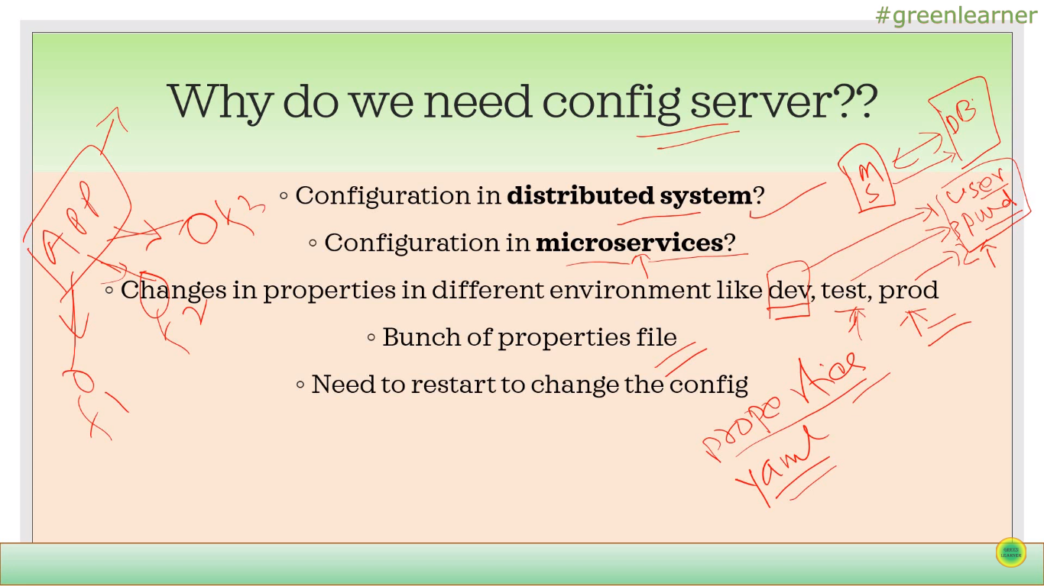

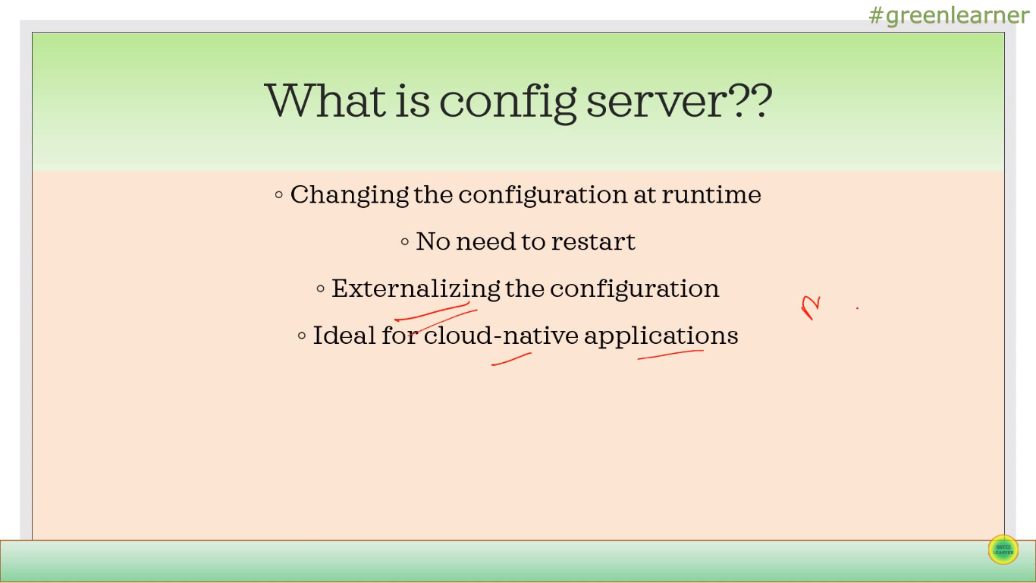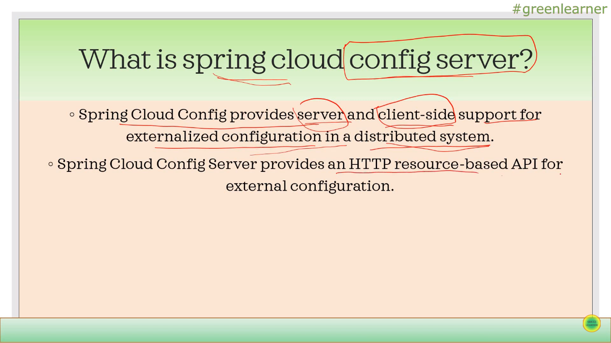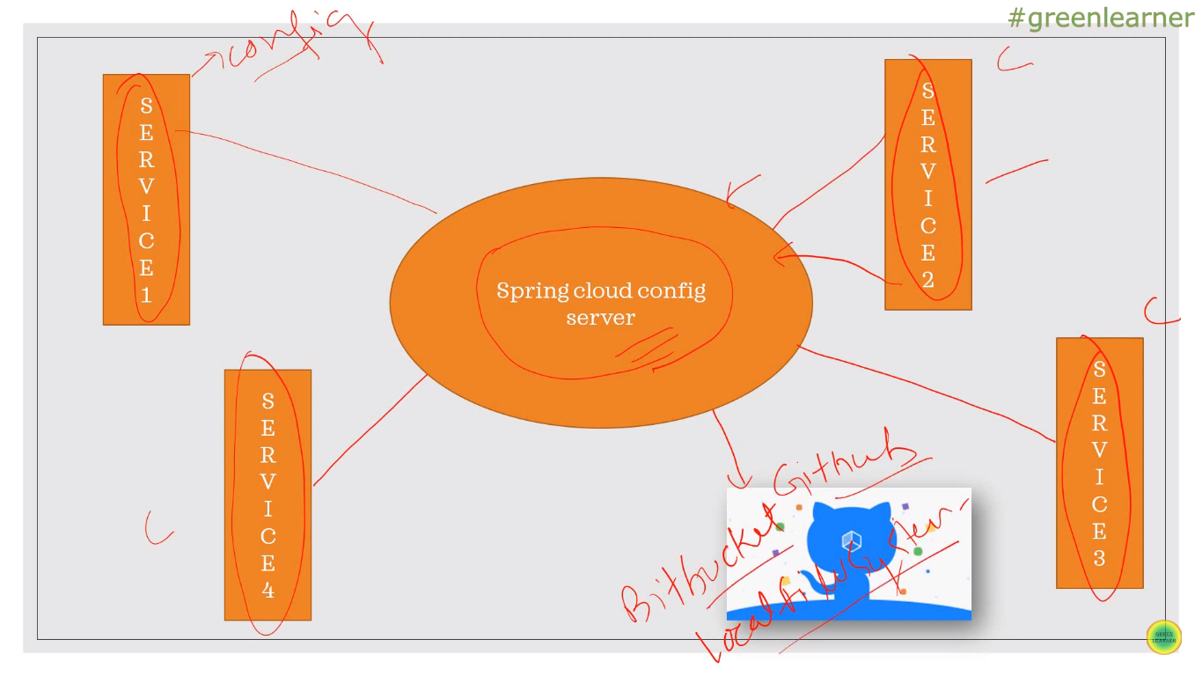

Cloud Config Server :

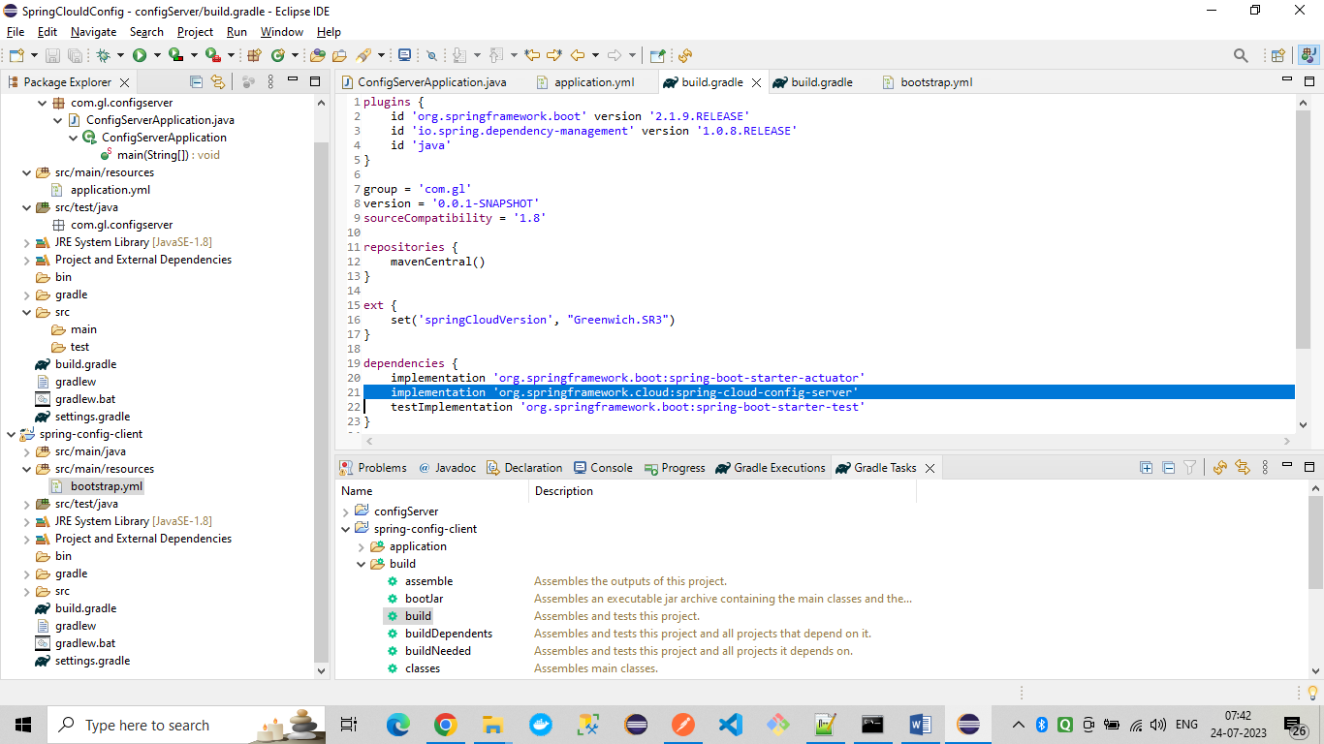

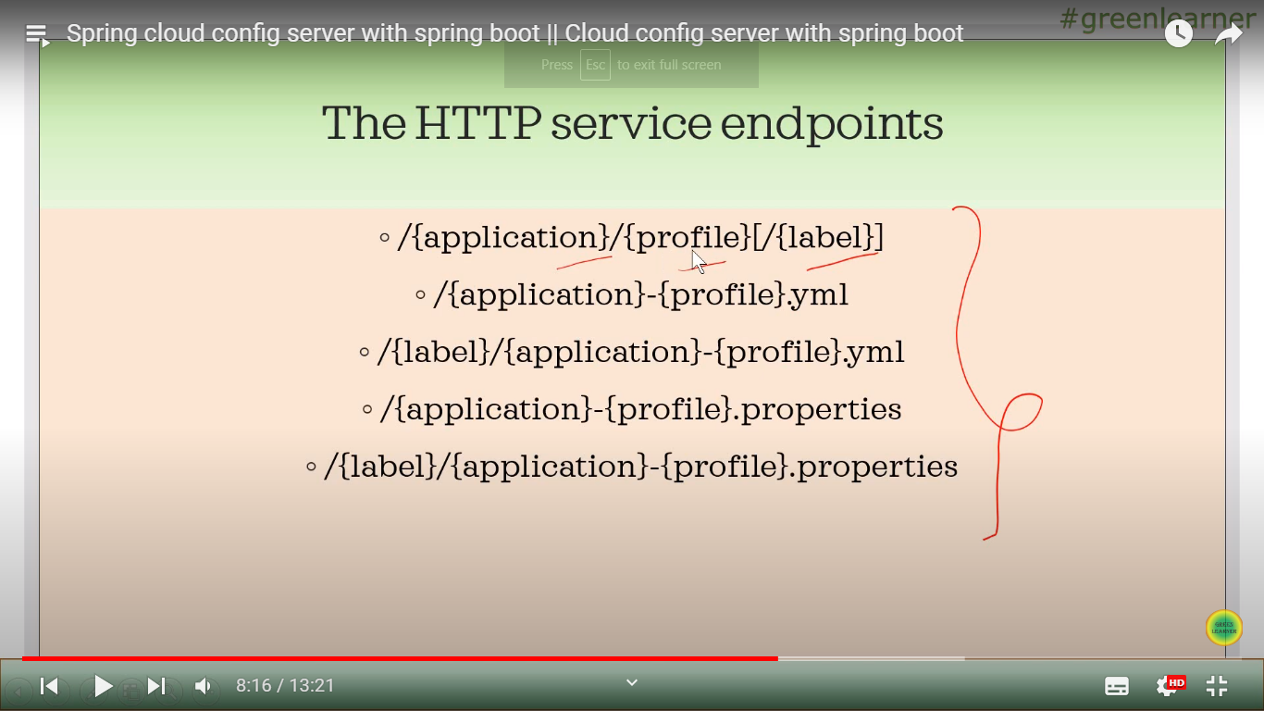

**Cloud config client :**

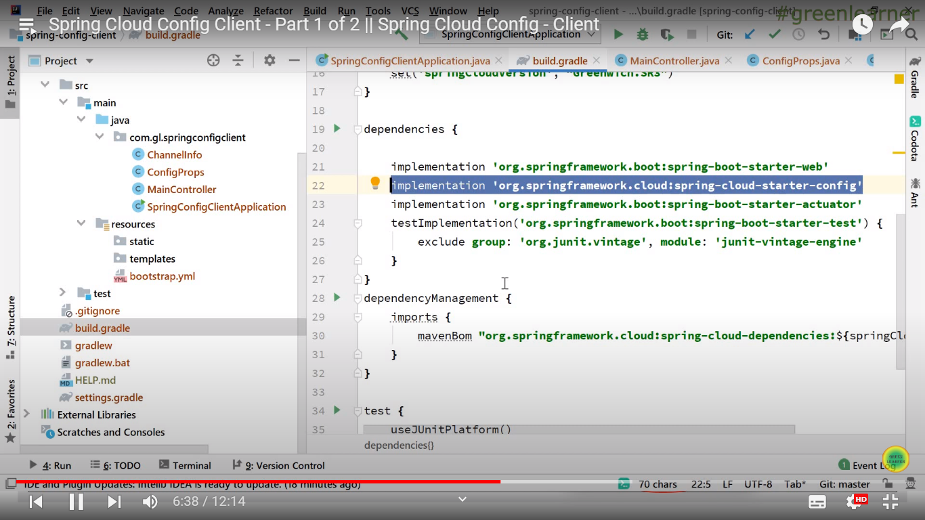

Config Client service is connecting with config server when we add below dependency in build.gradle

org.springframework.cloud:spring-cloud-starter-config

Config server service connects with GIT to fetch the properties .

We need to add below in application.properties

spring:

cloud:

config:

server:

git:

uri: <https://github.com/yogeshluck27/GreenLearner>

and also add @EnableConfigServer on SpringBootApp main class.

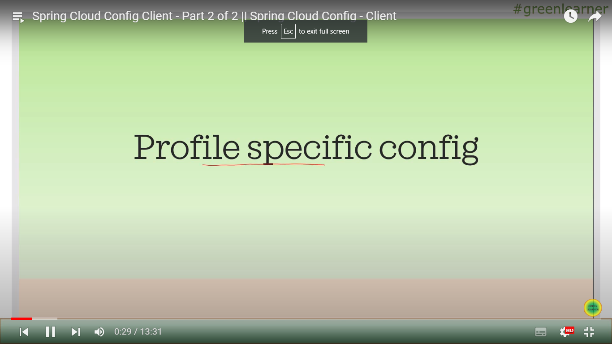

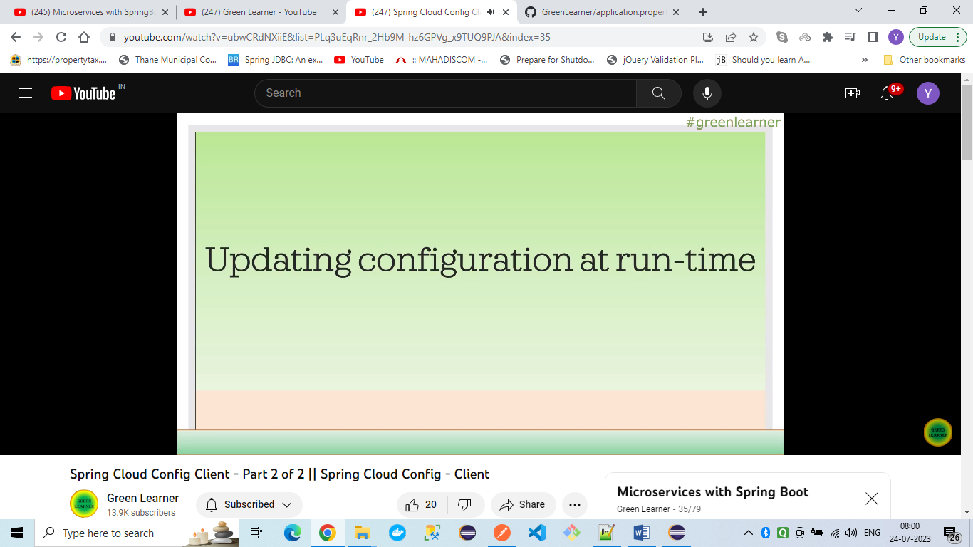

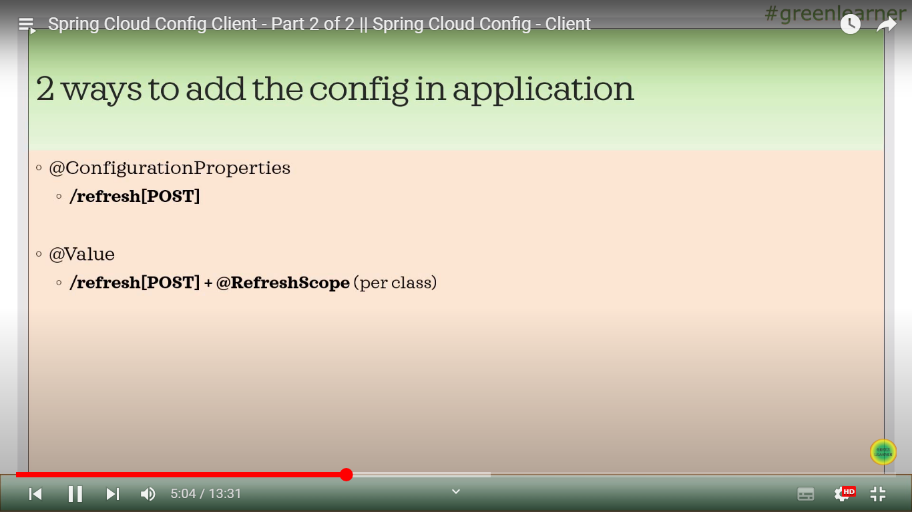

When we update the properties file on GIT , we don’t need to restart Client application.

But we have to call above endpoints so that changes will be reflected .

@RefreshScope on Controller also

We have to add refresh actuator endpoint also :

management:

endpoints:

web:

exposure:

include:

- health

- refresh

<https://docs.spring.io/spring-cloud-config/docs/current/reference/html/>

**1>Config server properties are**

server.port=8888

spring.application.name = config-service

spring.cloud.config.server.git.uri=https://github.com/riteshpanigrahi03/all-services-configs

spring.cloud.config.server.git.default-label=main

2>Add @EnableConfigServer on SpringBoot main class

3>We can add below configuration to connect to config server using other microservices:

server.port = 8080

spring.application.name = message-service

spring.config.import=optional:configserver:http://localhost:8888

4>Add below dependency in both config server and other client microservice

<dependency>

<groupId>org.springframework.cloud</groupId>

<artifactId>spring-cloud-starter-config</artifactId>

</dependency>

5>We have two properties present at git location

message-service-dev.properties

message-service.properties

6>How to access default properties ?

<http://localhost:8888/message-service/default>

@Value("${greeting.message}")

String message;

7>If we make dev profile active then we will get message value from dev.properties file

spring.profiles.active=dev

refer below link:

https://medium.com/@panigrahiritesh03/spring-cloud-config-part-1-533d6a9c3939

<https://medium.com/@panigrahiritesh03/spring-cloud-config-part-2-1aebe7bdf32c>