<https://haris-zujo.medium.com/spring-cloud-gateway-request-filtering-and-redirection-9e4b6d559d1a>

<https://www.javainuse.com/spring/cloud-filter>

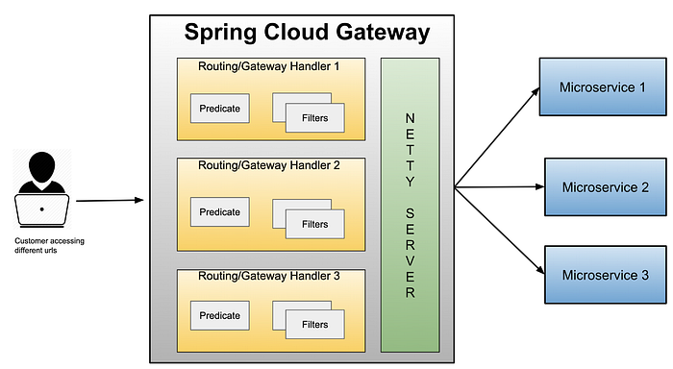

**Route** — contain URL of the service to which request will be forwarded, ad the predicates and filters for the request

**Predicate** — some set of criteria that needs to match for the incoming request predicates: — Cookie=chocolate, ch.p

**Filter** — components where you can manipulate incoming and outgoing requests and responses

**Gateway filters:**

Filters are components where you can modify incoming requests and responses.

Filters can be global the for the entire gateway, every request, or tied to a route. Filters can also be “pre” and “post”, since some of them can be activated after the request is proxied to the service.

Gateway filters have their order, so for global ones, there is no order since they will be triggered on every request,

but for filters that are tied to the route, there is an order in the filter chain.

|  |
| --- |
| //@Configuration |
|  | public class GatewayConfiguration { |
|  |  |
|  | //@Bean |
|  | public RouteLocator routeLocator(RouteLocatorBuilder routeLocatorBuilder) { |
|  | return routeLocatorBuilder.routes() |
|  | .route("client-portal", r -> r.path("/portal/**") |
|  | .and().method("POST", "PUT", "DELETE") |
|  | .and().host("localhost*") |
|  | .uri("http://localhost:8081")) |
|  | .build(); |
|  | } |
|  | } |

|  |
| --- |
| @Component |
|  | public class BeforeRedirectionFilter extends AbstractGatewayFilterFactory<BeforeRedirectionFilter.Config> { |
|  | private final Logger logger = LoggerFactory.getLogger(RedirectionFilter.class); |
|  |  |
|  | public BeforeRedirectionFilter() { |
|  | super(Config.class); |
|  | } |
|  | @Override |
|  | public GatewayFilter apply(Config config) { |
|  | return new OrderedGatewayFilter((exchange, chain) -> { |
|  | logger.info("BEFORE REDIRECTION-------------------"); |
|  | return chain.filter(exchange); |
|  | }, 0); |
|  | } |
|  |  |
|  | public static class Config { |
|  | private String name; |
|  |  |
|  | public Config(String name) { |
|  | this.name = name; |
|  | } |
|  |  |
|  | public String getName() { |
|  | return name; |
|  | } |
|  |  |
|  | public void setName(String name) { |
|  | this.name = name; |
|  | } |
|  | } |