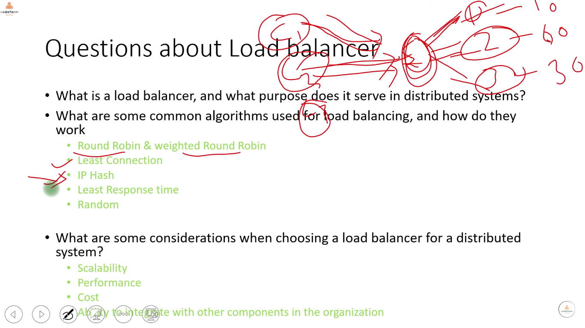

[**https://docs.spring.io/spring-cloud-commons/reference/spring-cloud-commons/loadbalancer.html**](https://docs.spring.io/spring-cloud-commons/reference/spring-cloud-commons/loadbalancer.html)

**ReactorLoadBalancer**

**ServiceInstanceListSupplier**

public class CustomLoadBalancerConfiguration {

@Bean

public ServiceInstanceListSupplier discoveryClientServiceInstanceListSupplier(

ConfigurableApplicationContext context) {

return ServiceInstanceListSupplier.builder()

.withDiscoveryClient()

.withWeighted()

.withCaching()

.build(context);

}

}

@Configuration

@LoadBalancerClient(value = "stores", configuration = CustomLoadBalancerConfiguration.class)

public class MyConfiguration {

@Bean

@LoadBalanced

public WebClient.Builder loadBalancedWebClientBuilder() {

return WebClient.builder();

}

}

