**Experiment 1-** Design an automatic night lighting system

Circuit Diagram:

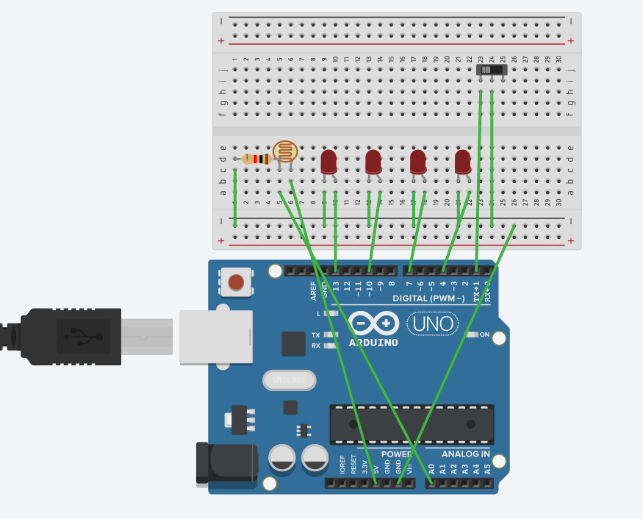

**Theory-**

Concepts Used:

1. Working of Arduino UNO
2. Coding in Arduino IDE and syntax of the same
3. Working of LEDs (Light emitting diodes) and LDR (Light detecting resistor)
4. Making connections on a Breadboard.

Learning & Observations:

Use of Arduino board and coding in Arduino IDE: Arduino board is very systematical way to show how the circuit is working. Coding syntax is this is similar to the coding in C language which we already know. I learnt the importance of delay function as the micro-controller is fast and capable.

I observed that there are many other interesting functions we can perform with Arduino like blinking of LED with LDR .

Problems & Troubleshooting-

I encountered a problem in making connections on the breadboard and while uploading the code and I rectified by retrying and removing all the errors.

Precautions-

1. Remember to declare all the ports in use in digital input/output in the right way.
2. Check whether all your wire connections are correct and tight.
3. Delay gap should be correct for testing the program .

Learning Outcomes-

Skills that I have acquired are knowledge of how to use Arduino UNO with components like LDR to make systems like automatic night lighting.