**Experiment 0** –**BREADBOARD & MULTIMETER**

**Diagram:**

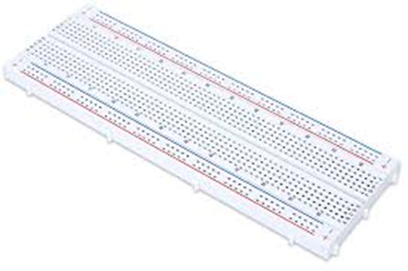Breadboard

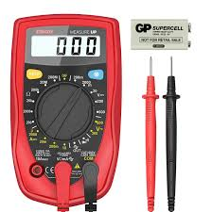 Multimeter

**Theory**

BREADBOARD:-

A breadboard is a rectangular plastic board with a bunch of tiny holes in it. These holes let you easily insert electronic components to prototype (meaning to build and test an early version of an electronic circuit, like this one with a battery, switch, resistor, and an LED (light-emitting diode).

The connections are not permanent, so it is easy to remove a component if you make a mistake, or just start over and do a new project. This makes breadboards great for beginners who are new to electronics. You can use breadboards to make all sorts of fun electronics projects, from different types of robots or an electronic drum set, to an electronic rain detector to help conserve water in a garden, just to name a few.

MULTIMETER:-

A multimeter, also known as a VOM (volt-ohm-milliammeter), is an electronic measuring instrument that combines several measurement functions in one unit. A typical multimeter can measure voltage, current, and resistance. Analog multimeters use a microammeter with a moving pointer to display readings. Digital multimeters (DMM, DVOM) have a numeric display, and may also show a graphical bar representing the measured value. Digital multimeters are now far more common due to their lower cost and greater precision, but analog multimeters are still preferable in some cases, for example when monitoring a rapidly varying value.A multimeter is has three parts:

• Display

• Selection Knob

• Ports

**Learning & Observations:**

A breadboard is a platform you can use to build and test electronic circuits, usually without having to do any soldering. Certain parts of the breadboard are wired together so that electricity can flow from component to component in orderly rows.

**Problems & Troubleshooting:**

I had problem in understanding the internal connections in breadboard and also how to use multimeter at the starting but after using it in some experiments I got the hang of it.

**Precautions:-**

1. Be certain the multimeter is switched to ac before attempting to measure ac circuits.

2. Always start with the highest voltage or current range.

3. Be certain to read ac measurements on the ac scale of a multimeter

**Learning Outcomes:-**

From this experiment we learn and acquire skills about:

1. Circuit can be made in a clean manner.

2. Multiple things can be checked using multi meter.