**Exp. 3** **Manipulating LED using Push Button Switch**

Circuit Diagram:

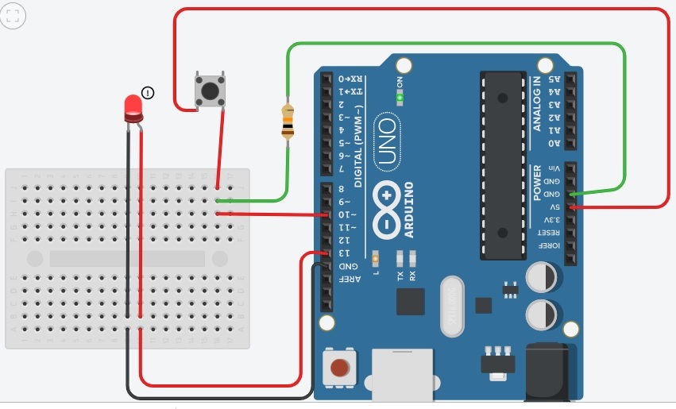

**Theory**

Concepts Used:

1. Working of Arduino UNO
2. Circuitry of Push button Switch
3. Circuitry of Breadboard and it’s use
4. Coding in Arduino IDE and syntax of the same
5. Working of LEDs (Light emitting diodes)
6. Making connections on a Breadboard
7. “if” Condition syntax and use.

Learning & Observations:

Coding in Arduino IDE:

Coding syntax is very similar to the coding in C language which we are being taught, hence easy to use and work with. I learnt the importance of calculated delay as the micro-controller is very fast and capable.

To install a switch and to use “for” loop accordingly to achieve the required results.

Problems & Troubleshooting

I encountered problem in making the proper connections which I later rectified.

Precautions

1. Remember to declare all the ports in use in digital input/output in the right way.
2. Remember to connect Ground through resistance in right way, to achieve LOW state in the concerned pin(Faraday’s Law effect).
3. Remember to connect Negative end of device (in this case LED) to GND (ground) in Arduino Uno to ensure potential difference.

Learning Outcomes

Skills that I have acquired are:

1. Sound knowledge of using switches with respect to Arduino UNO.

2. I have learnt the way to achieve perfect LOW state by using connection to Ground i.e. Current flows from High potential to Low potential.