**Experiment 3- Bluetooth interface- Smart phone controlled light system**

Circuit Diagram:

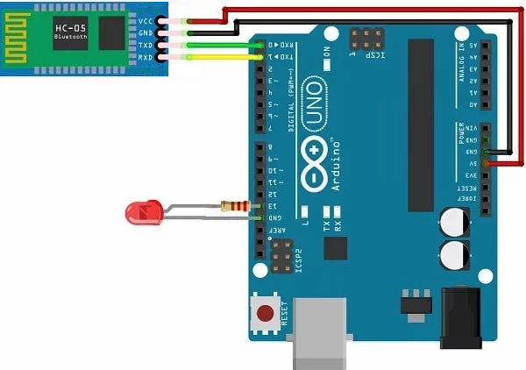

**Theory**

Concepts Used:

1. Bluetooth is a wireless port which provides connectivity between two devices through transmitter and receiver modules.

2. The digital pins in arduino UNO of D0 and D1 number as receiver and transmitter module port respectively.

3. A different Device is linked to Bluetooth module HC 05 by pairing Bluetooth method, we use serial port to identify the process going on in the order no at the moment by placing certain outputs for the serial box.

4. HC 05 has 4 pins namely input power grounding pin transmitter and receiver pin 3055C is connected to the receiver digital pen that is D0.

5. Serial port when initialised in the setup loop is begin with the bitrate value 9600 which is the default metric value for arduino microprocessor.

6. Connecting of PushButton Switch

7. Using of LEDs (Light emitting diodes) and Breadboard and it’s use

8. Coding in Arduino IDE and syntax

9. Working of Bluetooth (HC05 IC)

Learning & Observations:

Use of HC-05 IC (Bluetooth module)

I learnt to make use of HC-05 IC for communication between a device and Arduino by connecting them wirelessly through their Bluetooth ports.

Pairing is successful when the blinking rate of HC-05 becomes slow.

Use of Tx and Rx digital pins (D1 & D0)

I learned that the first two digital pins d0 and d1 possess the capabilities to perform actions of receiver and transmitter respectively.

Uploading code in Arduino

I learned that the communicating digital pins ( 0 & 1 ) need to be left unconnected while uploading the code to Arduino board, otherwise the upload fails.

Problems & Troubleshooting

The wire I had picked turned out to be faulty, as the code was being compiled but not uploaded and also I was not able to connect Bluetooth module with my phone’s Bluetooth.

I borrowed another wire and used it to upload the code into Arduino uno board .

Precautions

1. Remember to disconnect the communication wires from digital pins 0 & 1 while UPLOADING the code to the Arduino board.
2. Remember to declare all the ports in use in digital input/output in the right way.
3. Remember to connect Ground through resistance in right way, to achieve LOW state in the concerned pin(Faraday’s Law effect).
4. Remember to connect Negative end of device (in this case LED) to GND (ground) in Arduino Uno to ensure potential difference.
5. Declare the Serial port beginning with bit rate value 9600 (Standrad bit rate of Arduino boards).

Learning Outcomes

Skills that I have acquired are:

1. To be able to connect HC-05 Bluetooth module to circuit.
2. Using HC-05 as a communicator between two different devices. Slightly like Remote control.