**Experiment 5-** **Use Ultrasonic sensor to find distances**

Circuit Diagram:

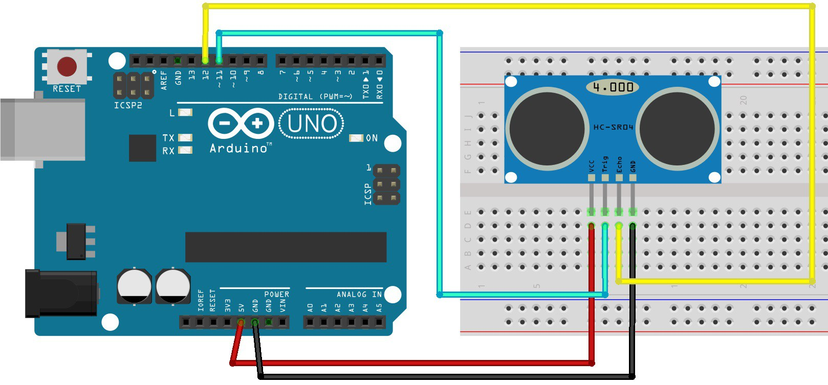**Theory**

Concepts Used:

1. Ultrasonic sensor is a device which provides two units : first one, which sends out signal and second one, which receives the bounced back signal (echo) .

2. The concept of SONAR is used in this experiment. Basic formula : speed = distance * time or distance = speed / time.

3. Pulse signal:

HIGH

LOW 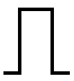 LOW

4. Use of pulseIn() function in Arduino coding.

5. Serial port when initialized in the setup loop is begin with the bitrate value 9600 which is the default metric value for Arduino microprocessor.

6. Connecting of Pushbutton Switch

7. Using of LEDs (Light emitting diodes) and Breadboard and it’s use

8. Coding in Arduino IDE and syntax

Learning & Observations:

Use of Ultrasonic sensor

I learnt to make use of the sensor to find the distance between the sensor and firs object in LINE OF SIGHT (LOS) of the sensor.

Use of ECHO pin

Whenever echo signal is received the respective digital pin connected to it has state HIGH.

Use of pulseIn() function

It gives the time between trigger and echo receiving at the sensor.

Problems & Troubleshooting

Code worked fine with ‘1’ and ‘0’ but I then tried using 1 and 0 in comparing statements whereas I missed the fact that the conversion occurs to ASCII and hence I then used their ASCII values and problem was resolved.

Precautions

1. Remember to add LOW signals to your pulse signal, so that when you trigger the signal is a pulse signal and not a continuous one.
2. Remember to declare all the ports in use in digital input/output in the right way.
3. Remember to connect Negative end of device (in this case LED) to GND (ground) in Arduino Uno to ensure potential difference.
4. Declare the Serial port beginning with bit rate value 9600 (Standrad bit rate of Arduino boards).

Learning Outcomes

Skills that I have acquired are:To be able to use ultrasonic to detect an object and the distance to it.