**Experiment 6-** Design a LDR interface which acts an automatic night lamp.

Circuit Diagram:

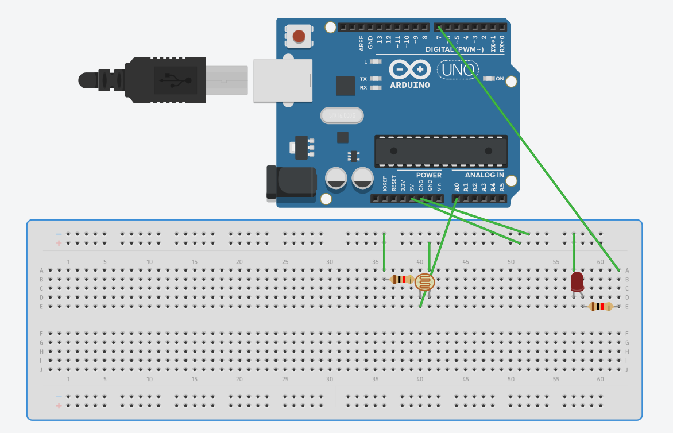

**Theory**

Concepts Used:

1.A light dependent resistor (LDR) or a photoresistor is a device whose resistivity is a function of the incident electromagnetic radiation.

2. The arduino board can supply a power of 5V as digital output signals through 14 pins present in it as digital input or output pins.

3. LED which glows whenever LDR switches resistor to least resistance

Learning & Observations:

1.I learnt about different components in an Arduino.

2.The basic importance of Arduino was known.

3.I also learnt the function of LDR in sensing electromagnetic radiation

Observations:-

When we pass electrical signals to the Arduino through our code, the LED glows when no light falls over the LDR

Precautions

1.Attach the USB cable and connecting wires carefully.

2.Once the USB cable has been inserted then the Arduino connected to the USB cable should not be touched with bare hands.

Learning Outcomes

1.I learnt how to make connections using breadboard and Arduino.

2.I learnt how to use LDR and connect it with LED, making it act as a night lamp which glows when no light falls over the LDR